Experiment 6
AIM: Set Up NGINX Load Balancing

C:\Users\kisha>mkdir load-balance-demo

C:\Users\kisha>cd load-balance-demo

C:\Users\kisha\load-balance-demo>npm init -y
Wrote to C:\Users\kisha\load-balance-demo\package.json:

{
"name": "load-balance-demo",
"version": "1.0.0",
"main": "index.js",
"scripts": {
"test": "echo \"Error: no test specified\" && exit 1"
},
"keywords": [],
"author": "",
"license": "ISC",
"description": ""
}

C:\Users\kisha\load-balance-demo>npm install express

added 65 packages, and audited 66 packages in 4s

22 packages are looking for funding
run `npm fund` for details

found 0 vulnerabilities

C:\Users\kisha\load-balance-demo>notepad server.js

C:\Users\kisha\load-balance-demo>node server.js
Server running on port 3000
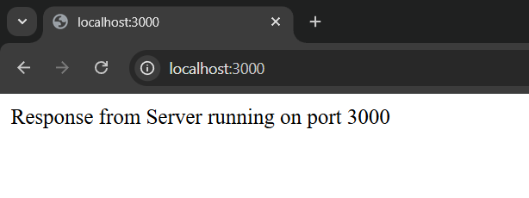

C:\Users\kisha\load-balance-demo>cd load-balancing

C:\Users\kisha\load-balance-demo\load-balancing>cd server1

C:\Users\kisha\load-balance-demo\load-balancing\server1>npm init -y
Wrote to C:\Users\kisha\load-balance-demo\load-balancing\server1\package.json:

{
"name": "server1",
"version": "1.0.0",
"main": "index.js",
"scripts": {
"test": "echo \"Error: no test specified\" && exit 1",
"start": "node server.js"
},
"keywords": [],
"author": "",
"license": "ISC",
"dependencies": {
"express": "^5.2.1"
},
"devDependencies": {},
"description": ""
}

C:\Users\kisha\load-balance-demo\load-balancing\server1>npm install express

up to date, audited 66 packages in 1s

22 packages are looking for funding
run `npm fund` for details

found 0 vulnerabilities

C:\Users\kisha\load-balance-demo\load-balancing\server1>notepad server.js
const express = require('express');
const app = express();

const PORT = process.env.PORT || 3000;

// Route
app.get('/', (req, res) => {
res.send('Response from Server 1 (Port 3000)');
});

// Start server
app.listen(3000, () => {
console.log('Server 1 running on port 3000');
});

C:\Users\kisha\load-balance-demo\load-balancing\server1>cd ..

C:\Users\kisha\load-balance-demo\load-balancing>cd server2

C:\Users\kisha\load-balance-demo\load-balancing\server2>npm init -y
Wrote to C:\Users\kisha\load-balance-demo\load-balancing\server2\package.json:

{
"name": "server2",
"version": "1.0.0",
"main": "index.js",
"scripts": {
"test": "echo \"Error: no test specified\" && exit 1"
},
"keywords": [],
"author": "",
"license": "ISC",
"dependencies": {
"express": "^5.2.1"
},
"devDependencies": {},
"description": ""
}

C:\Users\kisha\load-balance-demo\load-balancing\server2>npm install express

up to date, audited 66 packages in 1s

22 packages are looking for funding
run `npm fund` for details

found 0 vulnerabilities

C:\Users\kisha\load-balance-demo\load-balancing\server2>notepad server.js
const express = require('express');
const app = express();

const PORT = process.env.PORT || 3001;

// Route
app.get('/', (req, res) => {
res.send('Response from Server 2 (Port 3001)');
});

// Start server
app.listen(3001, () => {
console.log('Server 2 running on port 3001');
});

C:\Users\kisha\load-balance-demo\load-balancing\server2>node server.js
Server 2 running on port 3001

C:\Users\kisha\load-balance-demo\load-balancing\server2>cd ..

C:\Users\kisha\load-balance-demo\load-balancing>cd server1

C:\Users\kisha\load-balance-demo\load-balancing\server1>node server.js
Server 1 running on port 3000

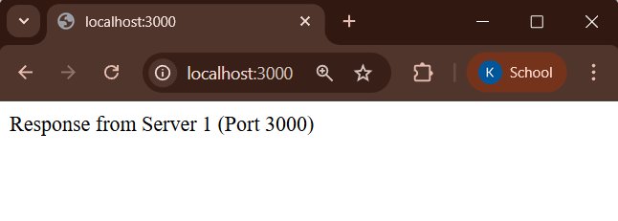


C:\Users\kisha\load-balance-demo>cd ..
C:\Users\kisha>cd..
C:\Users>cd..
C:\>cd nginx-1.29.5
C:\nginx-1.29.5>cd conf
C:\nginx-1.29.5\conf>nginx.conf
worker_processes 1;
events {
worker_connections 1024;
}
http {
upstream myapp {

server localhost:3000;
server localhost:3001;
}
server {
listen 8080;
server_name localhost;
location / {
proxy_pass http://myapp;
}
}
}
C:\nginx-1.29.5\conf>cd ..
C:\nginx-1.29.5>nginx -s stop
C:\nginx-1.29.5>nginx





C:\Users\kisha\load-balance-demo\load-balancing\server1> notepad server.js
const express = require("express");
const app = express();
const PORT = 3000;
app.get("/", (req,res)=>{
setTimeout(()=>{
res.send("Slow Server - Port 3000");
},5000);
});
app.listen(PORT,()=>{
console.log("Server 1 running on port 3000");
});
C:\Users\kisha\load-balance-demo\load-balancing\server1> node server.js
Server 1 running on port 3000

C:\Users\kisha\load-balance-demo\load-balancing\server2> notepad server.js
const express = require("express");
const app = express();
const PORT = 3001;
app.get("/",(req,res)=>{
res.send("Fast Server - Port 3001");
});

app.listen(PORT,()=>{
console.log("Server 2 running on port 3001");
});
C:\Users\kisha\load-balance-demo\load-balancing\server2> node server.js
Server 2 running on port 3001




C:\>cd nginx-1.29.5
C:\nginx-1.29.5>cd conf
C:\nginx-1.29.5\conf>nginx.conf
worker_processes 1;
events {
worker_connections 1024;
}
http {
upstream myapp {

server localhost:3000;
server localhost:3001;
}
server {
listen 8080;
server_name localhost;
location / {

proxy_pass http://myapp;
}
}
}
C:\nginx-1.29.5\conf>cd ..
C:\nginx-1.29.5>nginx





