Experiment 9

AIM: Use pytest to test python application
- Objective
  - Understand unit testing concepts
  - Write test cases using PyTest
  - Execute and analyze test results
  - Handle edge cases and exceptions
  - Use parameterized testing

Prerequisites
  - Python
  - PyTest

Installation
Install pytest using pip:
pip install pytest

Verify it :
pytest –version

Create a Python module with basic mathematical operations and write PyTest test cases to validate:
  - Correct outputs
  - Edge cases
  - Exception handling

Step 1: Create Project PythonDemo and add file pythondemo.py
def add(a, b):
return a + b def subtract(a, b):
return a - b def multiply(a, b):
return a * b def divide(a, b):
if b == 0:
raise ValueError("Cannot divide by zero") return a / b
def is_even(num):
return num % 2 == 0

Step 2: Create a test file test_pythondemo.py
import pytest import pythondemo # Passing test
def test_add():
assert pythondemo.add(2, 3) == 5 # Failing test
def test_multiply_fail():
assert pythondemo.multiply(4, 3) == 11 # Exception test
def test_divide_by_zero():
with pytest.raises(ValueError):
pythondemo.divide(10, 0)

# Logical test
def test_is_even():
assert pythondemo.is_even(4) is True assert pythondemo.is_even(5) is False

# Parametrized test @pytest.mark.parametrize("a,b,result", [
(1,2,3),
(2,2,4),
(5,5,11) # failing case
])
def test_add_param(a,b,result):
assert pythondemo.add(a,b) == result

Execution
Open terminal in that folder pytest –v

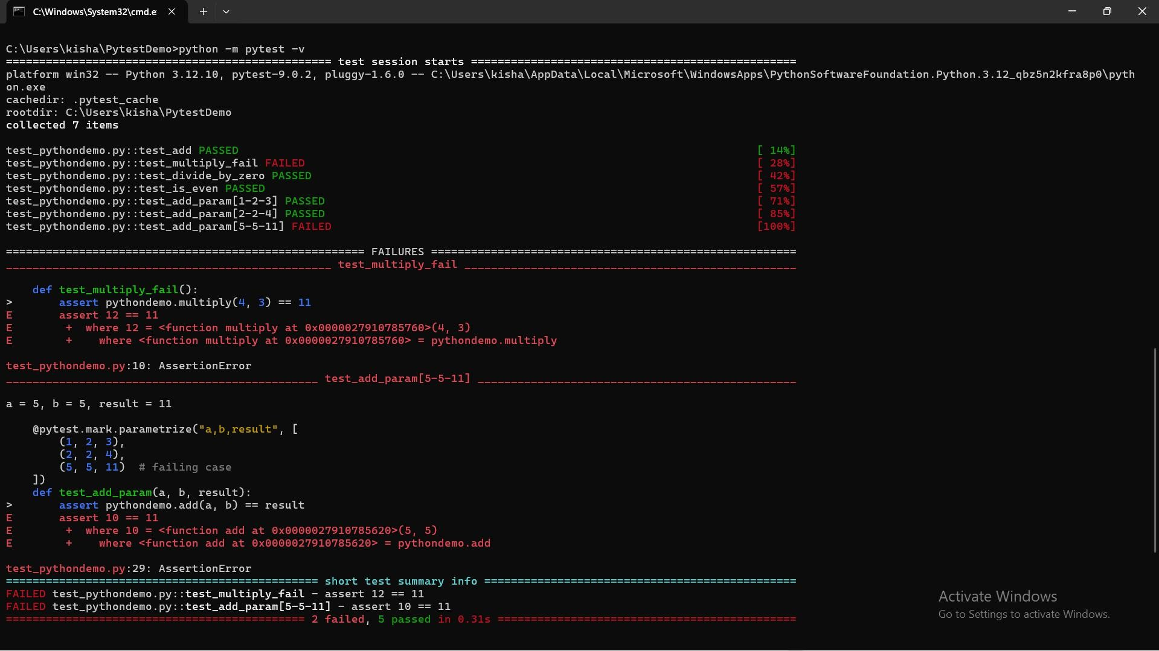

Task for you: Task 1:
Add a function:
def factorial(n): Write test cases.

pythondemo.py
def add(a, b): return a + b
def subtract(a, b): return a - b
def multiply(a, b): return a * b
def divide(a, b): if b == 0:

raise ValueError("Cannot divide by zero") return a / b
def is_even(num): return num % 2 == 0
def factorial(n): if n < 0:
raise ValueError("Factorial is not defined for negative numbers") if n == 0 or n == 1:
return 1
result = 1
for i in range(2, n + 1): result *= i
return result

Task 2:
Write test cases for: Negative numbers Large inputs test_pythondemo.py import pytest
import pythondemo def test_add():
assert pythondemo.add(2, 3) == 5

def test_divide_by_zero():
with pytest.raises(ValueError): pythondemo.divide(10, 0)

def test_is_even():
assert pythondemo.is_even(4) is True assert pythondemo.is_even(5) is False @pytest.mark.parametrize("n, expected", [
(0, 1),
(1, 1),
(5, 120),
])
def test_factorial_standard(n, expected): assert pythondemo.factorial(n) == expected

def test_factorial_negative(): with pytest.raises(ValueError):
pythondemo.factorial(-5)

def test_factorial_large_input():
assert pythondemo.factorial(20) == 2432902008176640000

def test_multiply_fail():
assert pythondemo.multiply(4, 3) == 11

def test_add_fail():
assert pythondemo.add(2, 2) == 5

def test_factorial_fail():
assert pythondemo.factorial(4) == 20

