Experiment 4
AIM: Use npm / yarn / pip to install and manage packages

Step 1: Check Installation
C:\Users\kisha>node -v
v22.13.1
C:\Users\kisha>npm -v
10.9.2
Step 2: Create New npm Project
C:\Users\kisha>mkdir npm-lab
C:\Users\kisha>cd npm-lab
C:\Users\kisha\npm-lab>npm init -y
Wrote to C:\Users\kisha\npm-lab\package.json:
{
"name": "npm-lab",
"version": "1.0.0",
"main": "index.js",
"scripts": {
"test": "echo \"Error: no test specified\" && exit 1"
},
"keywords": [],
"author": "",
"license": "ISC",
"description": ""
}

Step 3: Install Required Packages
C:\Users\kisha\npm-lab>npm install express
added 65 packages, and audited 66 packages in 10s
22 packages are looking for funding
run `npm fund` for details
found 0 vulnerabilities

C:\Users\kisha\npm-lab>npm install axios
added 11 packages, and audited 77 packages in 5s
24 packages are looking for funding
run `npm fund` for details
found 0 vulnerabilities

C:\Users\kisha\npm-lab>npm install nodemon --save-dev
added 27 packages, and audited 104 packages in 4s
28 packages are looking for funding
run `npm fund` for details
found 0 vulnerabilities

C:\Users\kisha\npm-lab>npm list
npm-lab@1.0.0 C:\Users\kisha\npm-lab
+-- axios@1.13.5
+-- express@5.2.1
`-- nodemon@3.1.11

Step 4: Create Web Server
Create a file named index.js and Add below content :
const express = require("express");
const axios = require("axios");
const app = express();

app.get("/", (req, res) => {
res.send("Hello Open Source Lab");
});

// JSON Route
app.get("/api/info", (req, res) => {
res.json({
name: "NPM Lab",
subject: "Open Source Technology",
semester: "BE 6th Sem" });
});

// Axios Demo Route
app.get("/api/user", async (req, res) => {
const response = await axios.get("https://jsonplaceholder.typicode.com/users/1");
res.json(response.data);
});
app.listen(3000, () => {
console.log("Server running at http://localhost:3000");
});

Step 5: Run Server (Normal Way)
C:\Users\kisha\npm-lab>node index.js
Server running at http://localhost:3000
http://localhost:3000
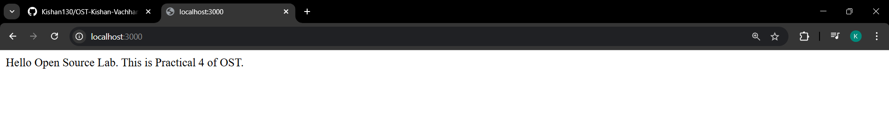
http://localhost:3000/api/info
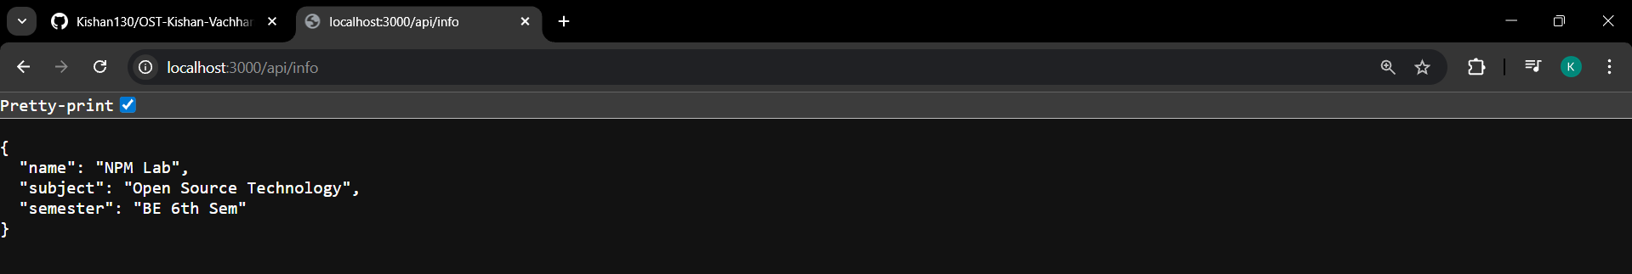
http://localhost:3000/api/user
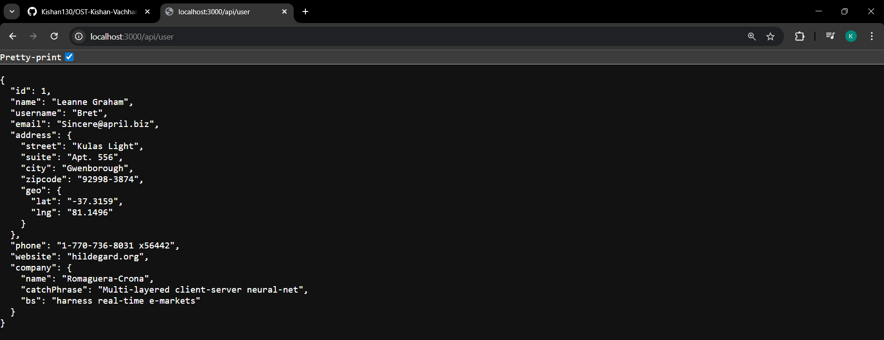

Step 6: Add npm Scripts
Open package.json and modify scripts section:

"scripts": {
"start": "node index.js",
"dev": "nodemon index.js"
}

Step 7: Run Using npm Script
1. Normal mode:
C:\Users\kisha\npm-lab>npm run start

> npm-lab@1.0.0 start
> node index.js

Server running at http://localhost:3000
Terminate batch job (Y/N)? y

2. Development mode (nodemon):
Now modify index.js text and save → Server automatically restarts (nodemon demo).
C:\Users\kisha\npm-lab>npm run dev

> npm-lab@1.0.0 dev
> nodemon index.js

[nodemon] 3.1.11
[nodemon] to restart at any time, enter `rs`
[nodemon] watching path(s): *.*
[nodemon] watching extensions: js,mjs,cjs,json
[nodemon] starting `node index.js`
Server running at http://localhost:3000
[nodemon] restarting due to changes...
[nodemon] starting `node index.js`
Server running at http://localhost:3000
[nodemon] restarting due to changes...
[nodemon] starting `node index.js`
Server running at http://localhost:3000
Terminate batch job (Y/N)? y

Step 8: Delete node_modules and Reinstall
Delete manually
Now reinstall:
C:\Users\kisha\npm-lab>npm install

added 103 packages, and audited 104 packages in 5s
28 packages are looking for funding
run `npm fund` for details
found 0 vulnerabilities

Step 9: Add .gitignore File
Create file: .gitignore
Add:
node_modules/

Step 10: Upload Project to Git (Without node_modules)
C:\Users\kisha\npm-lab>git init
Reinitialized existing Git repository in C:/Users/kisha/npm-lab/.git/

C:\Users\kisha\npm-lab>git add .

C:\Users\kisha\npm-lab>git commit -m "Practical 4 Commit"
On branch main
nothing to commit, working tree clean

C:\Users\kisha\npm-lab>git remote add origin https://github.com/Kishan130/OST-Kishan-Vachhani
error: remote origin already exists.

C:\Users\kisha\npm-lab>git branch -M main

C:\Users\kisha\npm-lab>git push -u origin main
Enumerating objects: 9, done.
Counting objects: 100% (9/9), done.
Delta compression using up to 6 threads
Compressing objects: 100% (7/7), done.
Writing objects: 100% (8/8), 12.56 KiB | 1.57 MiB/s, done.
Total 8 (delta 3), reused 0 (delta 0), pack-reused 0 (from 0)
remote: Resolving deltas: 100% (3/3), completed with 1 local object.
To https://github.com/Kishan130/OST-Kishan-Vachhani.git
e55b01e..ba37fdd main -> main
branch 'main' set up to track 'origin/main'.
