Experiment 8
AIM: Use Postman to test sample API
1. Objective
- Understand how to test REST APIs using Postman by sending different types of HTTP requests.
- Get
- Post
- Put
- Delete
2. Prerequisites
- postman
- API to be tested
  - Create a simple node.js API / use some free fake API
3. Test API
Get: URL: https://jsonplaceholder.typicode.com/posts
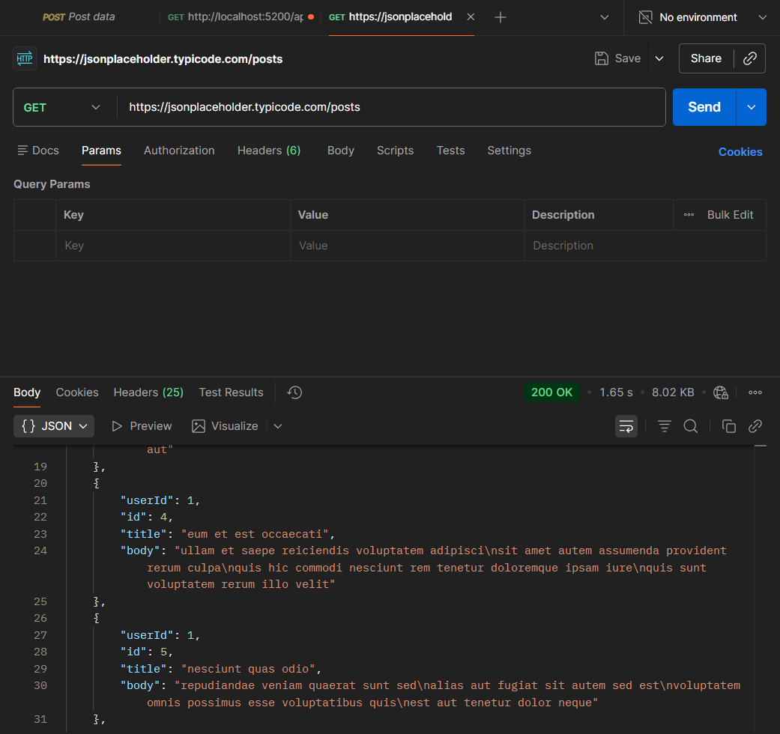
Post:
https://jsonplaceholder.typicode.com/posts

{
"title": "Test Post",
"body": "This is a sample post",
"userId": 1
}

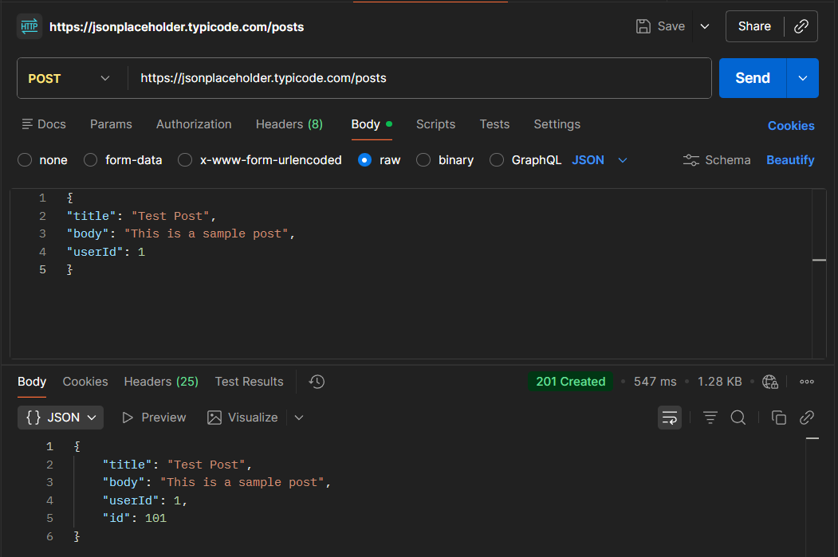

Put:
https://jsonplaceholder.typicode.com/posts/1

{
"id": 1,
"title": "Updated Title",
"body": "Updated content",
"userId": 1
}
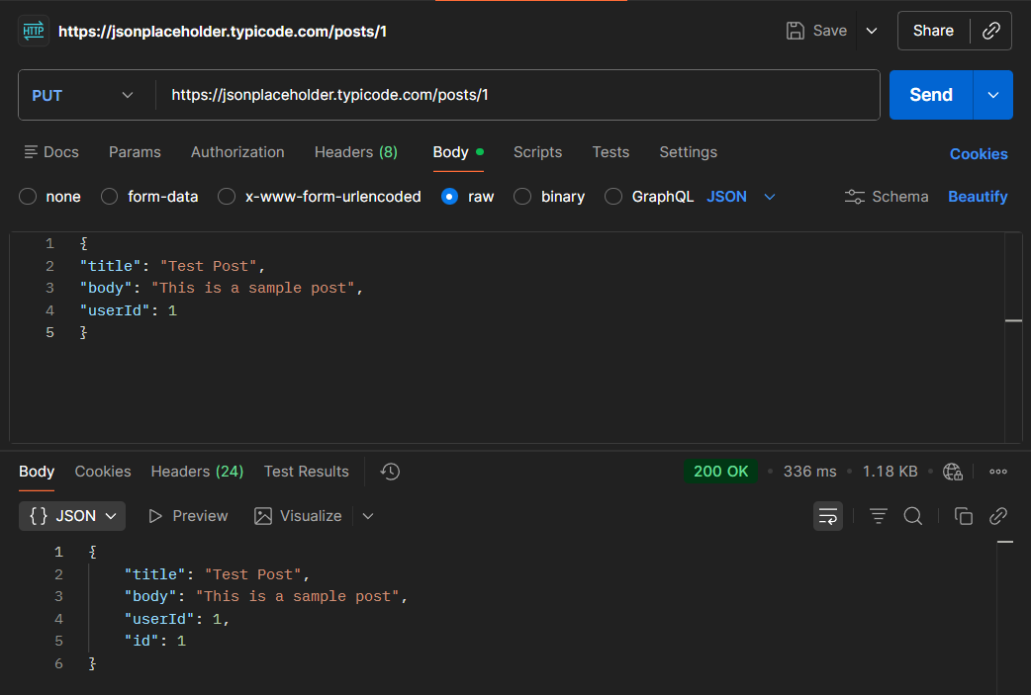

Delete:
https://jsonplaceholder.typicode.com/posts/1
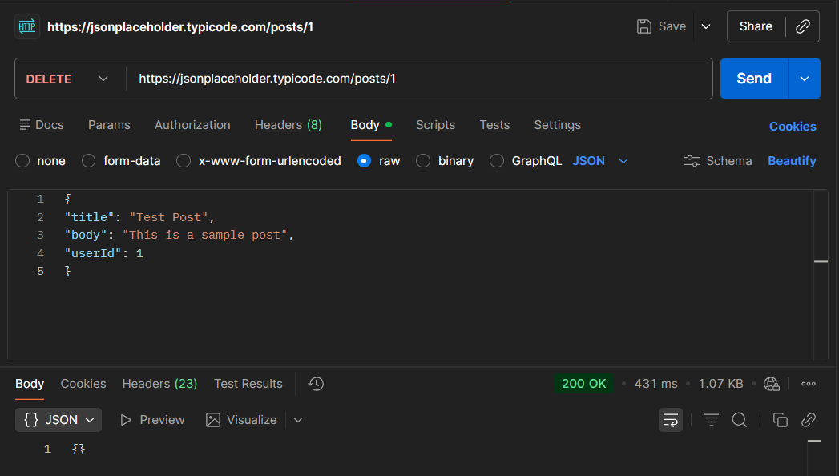

4. Create node.js API
Step 1: Create Project
mkdir simple-api
cd simple-api
npm init -y
npm install express
Step 2: Create server.js file
const express = require('express');
const app = express();
app.use(express.json());
let students = [
{ id: 1, name: "Kishan", branch: "CE" },
{ id: 2, name: "Tarak", branch: "CE" }
];
app.get('/students', (req, res) => {
res.json(students);
});
app.get('/students/:id', (req, res) => {
const student = students.find(s => s.id == req.params.id);
res.json(student);
});
app.post('/students', (req, res) => {
const newStudent = {
id: students.length + 1,
name: req.body.name,
branch: req.body.branch
};
students.push(newStudent);
res.status(201).json(newStudent);
});
app.put('/students/:id', (req, res) => {
const student = students.find(s => s.id == req.params.id);
if (student) {
student.name = req.body.name;
student.branch = req.body.branch;
res.json(student);
} else {
res.status(404).json({ message: "Student not found" });
}
});
// DELETE - Remove student
app.delete('/students/:id', (req, res) => {
students = students.filter(s => s.id != req.params.id);
res.json({ message: "Student deleted" });
});
app.listen(3000, () => {
console.log("Server running on http://localhost:3000");
});

Step 3: Run server
node server.js
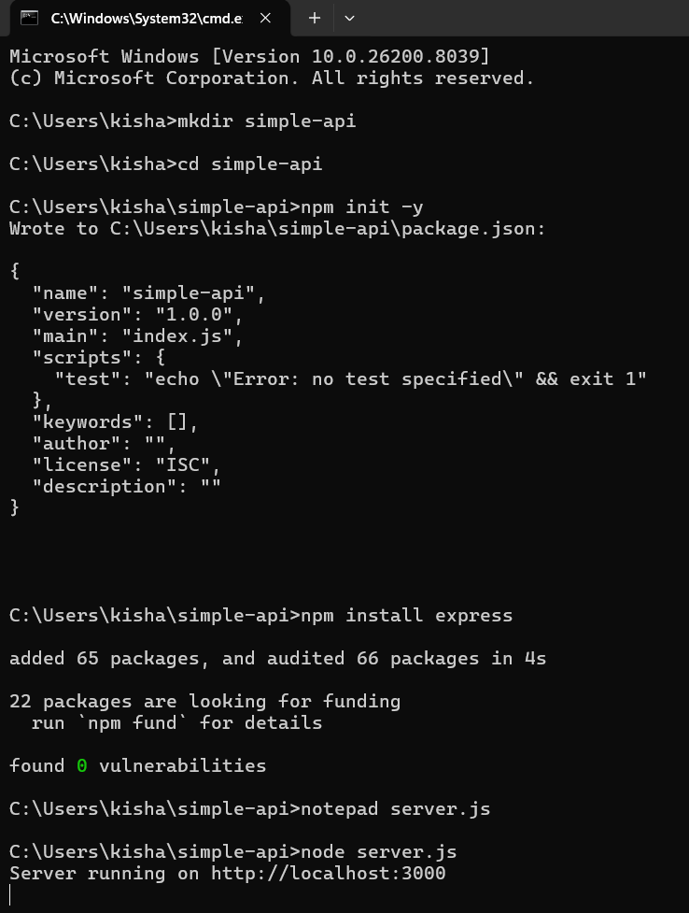
5. Procedure TEST using postman
1. GetAll:
Type: Get
URL : http://localhost:3000/students
Check response
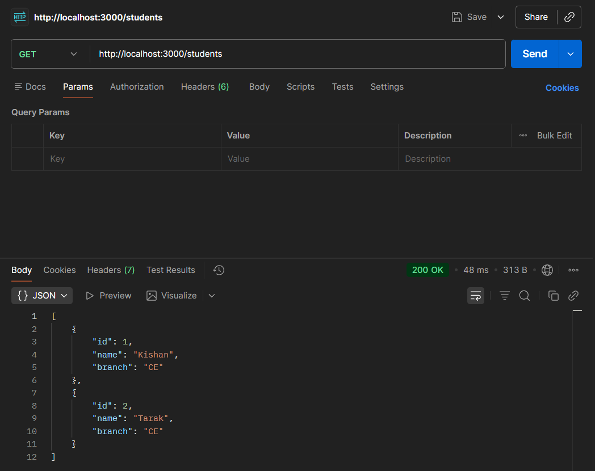

2. Post:
Type: Post
URL: http://localhost:3000/students
Body:
{
"name": "Michael",
"branch": "CE"
}
Check response and Send Get request to see new data inserted
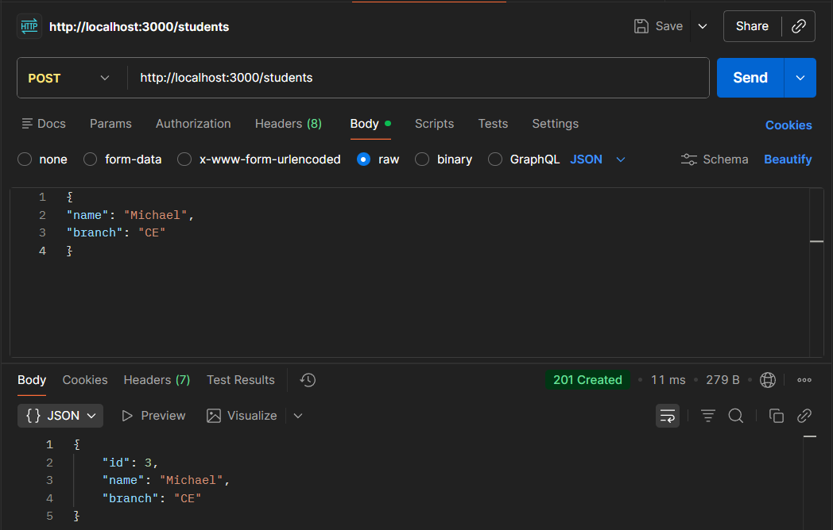
3. Put request:
Type: PUT
URL : http://localhost:3000/students/1
Body:
{
"name": "Kishan Vachhani",
"branch": "IT"
}
Check response
Send Get request to see updated data
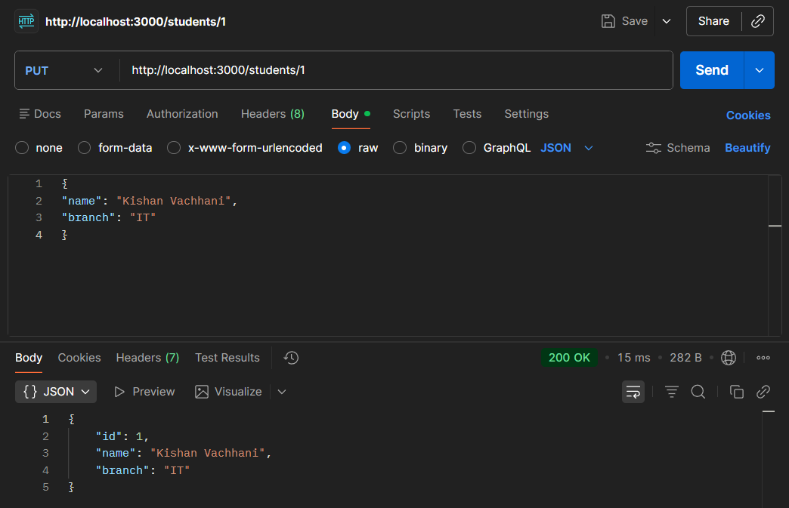
4. Delete request:
Type: DELETE
URL : http://localhost:3000/students/1
Check response
Send Get request to see updated data
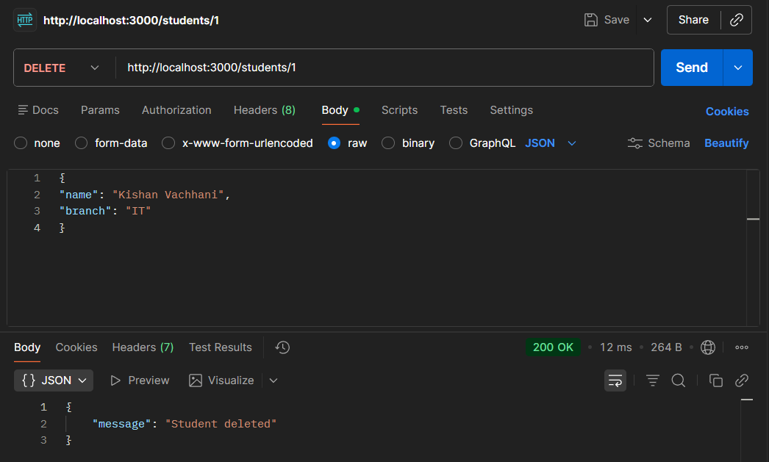

Experiment 9
AIM: Use pytest to test python application
1. Objective
- Understand unit testing concepts
- Write test cases using PyTest
- Execute and analyze test results
- Handle edge cases and exceptions
- Use parameterized testing
2. Prerequisites
- Python
- PyTest

3. Installation
Install pytest using pip:
pip install pytest
Verify it :
pytest –version

4. Create a Python module with basic mathematical operations and write PyTest test cases to
validate:
- Correct outputs
- Edge cases
- Exception handling

Step 1: Create Project PythonDemo and add file pythondemo.py
def add(a, b):
return a + b
def subtract(a, b):
return a - b
def multiply(a, b):
return a * b
def divide(a, b):
if b == 0:
raise ValueError("Cannot divide by zero")
return a / b
def is_even(num):
return num % 2 == 0

Step 2: Create a test file test_pythondemo.py
import pytest
import pythondemo
# Passing test
def test_add():
assert pythondemo.add(2, 3) == 5
# Failing test
def test_multiply_fail():
assert pythondemo.multiply(4, 3) == 11
# Exception test
def test_divide_by_zero():
with pytest.raises(ValueError):
pythondemo.divide(10, 0)
# Logical test
def test_is_even():
assert pythondemo.is_even(4) is True
assert pythondemo.is_even(5) is False

# Parametrized test
@pytest.mark.parametrize("a,b,result", [
(1,2,3),
(2,2,4),
(5,5,11) # failing case
])
def test_add_param(a,b,result):
assert pythondemo.add(a,b) == result

5. Execution
Open terminal in that folder
pytest –v
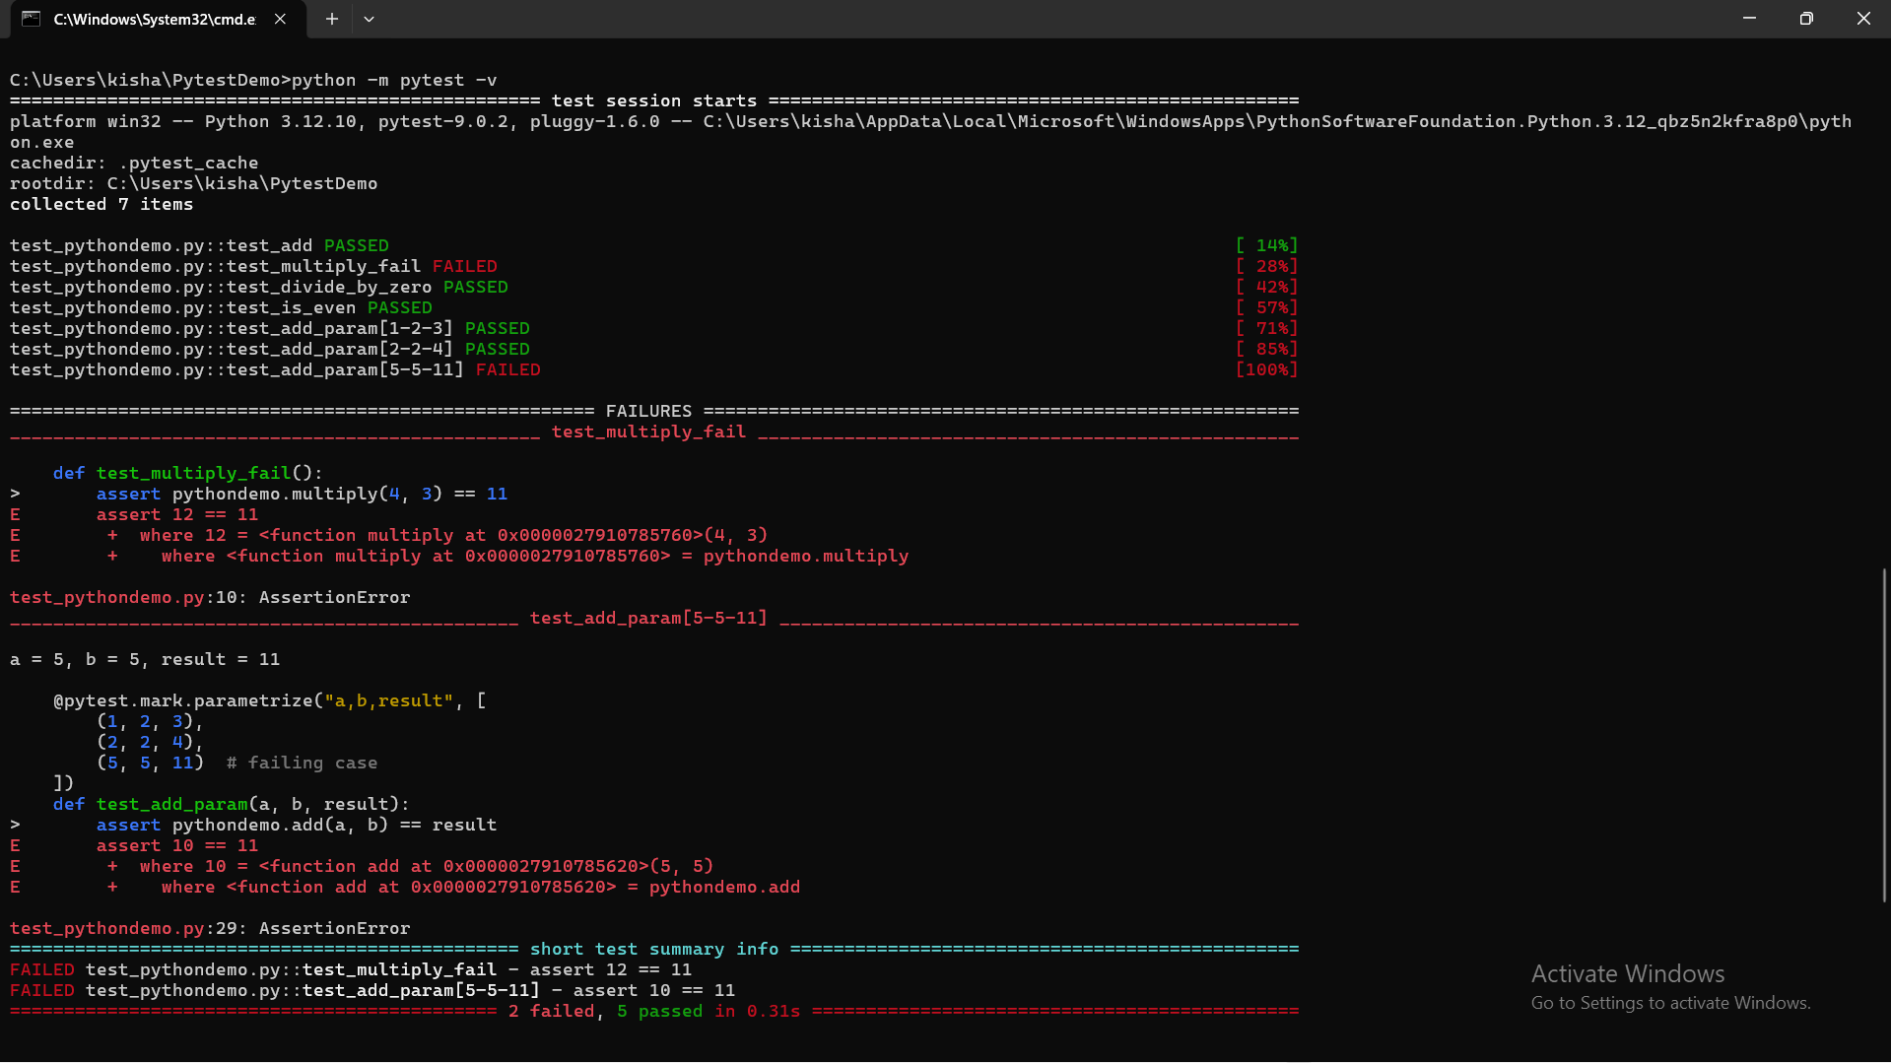
Task for you:
Task 1:
Add a function:
def factorial(n):
Write test cases.

pythondemo.py
def add(a, b):
return a + b
def subtract(a, b):
return a - b
def multiply(a, b):
return a * b
def divide(a, b):
if b == 0:
raise ValueError("Cannot divide by zero")
return a / b
def is_even(num):
return num % 2 == 0
def factorial(n):
if n < 0:
raise ValueError("Factorial is not defined for negative numbers")
if n == 0 or n == 1:
return 1
result = 1
for i in range(2, n + 1):
result *= i
return result
Task 2:
Write test cases for:
Negative numbers
Large inputs
test_pythondemo.py
import pytest
import pythondemo
def test_add():
assert pythondemo.add(2, 3) == 5

def test_divide_by_zero():
with pytest.raises(ValueError):
pythondemo.divide(10, 0)

def test_is_even():
assert pythondemo.is_even(4) is True
assert pythondemo.is_even(5) is False
@pytest.mark.parametrize("n, expected", [
(0, 1),
(1, 1),
(5, 120),
])
def test_factorial_standard(n, expected):
assert pythondemo.factorial(n) == expected

def test_factorial_negative():
with pytest.raises(ValueError):
pythondemo.factorial(-5)

def test_factorial_large_input():
assert pythondemo.factorial(20) == 2432902008176640000

def test_multiply_fail():
assert pythondemo.multiply(4, 3) == 11

def test_add_fail():
assert pythondemo.add(2, 2) == 5

def test_factorial_fail():
assert pythondemo.factorial(4) == 20 