**Major Project**

*In partial fulfilment of the requirements for the award of*

*the degree*

**Bachelors of Technology in Computer Science and Engineering**

*Submitted by*

**Jay Senjaliya - 21BT04111**

**Kishan Rupavatiya - 21BT04106**

*Submitted to*

Mentor

**Ms. Zalak Kansagra**

Semester-8

School of Technology, GSFC University

10th February 2025

**Table of Contents**

|  |  |  |
| --- | --- | --- |
| **Sr. no.** | **Title** | **Page no.** |
| 1 | Chapter 1:Introduction | 3 |
| 2 | Chapter 2:Problem Statement | 4 |
| 3 | Chapter 3:Objectives | 5 |
| 4 | Chapter 4:Need of the Solution | 6 |
| 5 | Chapter 5:Literature Review | 7 |
| 6 | Chapter 6:Figures | 9 |
| 7 | Chapter 7: implementation | 13 |
| 8 | Chapter 8:Tools and Technologies | 17 |
| 9 | Conclusion | 19 |

**CHAPTER 1: INTRODUCTION**

In the fast-paced world of modern software development, developers are constantly striving to improve productivity and efficiency. However, they often face significant challenges, such as writing repetitive code, searching for accurate documentation, and ensuring code accuracy. These tasks are not only time-consuming but also detract from the creative and problem-solving aspects of development. While existing solutions like static code snippet libraries and basic autocompletion tools offer some assistance, they lack the dynamic adaptability needed to address these challenges effectively. Static snippets often fail to account for the specific context of the code being written, and developers frequently need to switch between multiple resources to find relevant documentation, disrupting their workflow.

The rapid advancement of artificial intelligence (AI) and large language models (LLMs) has opened up new possibilities for automating and streamlining these tasks. However, there is a noticeable gap in the market for integrated tools that leverage AI to provide real-time, context-aware code generation and documentation retrieval directly within the Integrated Development Environment (IDE). This gap highlights the need for an innovative solution that can enhance developer productivity by reducing manual effort, improving coding accuracy, and providing seamless access to relevant documentation.

To address these challenges, we propose the development of a **Visual Studio Code (VS Code) extension** that leverages the power of LLMs to automate and streamline code generation and documentation retrieval. This extension aims to provide developers with real-time, context-aware code snippets and documentation summaries directly within their IDE. By integrating AI into the development workflow, the extension seeks to enhance productivity, reduce errors, and improve the overall coding experience. Key features of the extension include dynamic code generation, real-time documentation retrieval and can be developed inline suggestions, and hover documentation, all designed to make coding faster, easier, and more accurate.

**CHAPTER 2: PROBLEM STATEMENT**

In the modern software development landscape, developers face significant challenges that hinder their productivity and efficiency. Writing repetitive code, searching for accurate and relevant documentation, and ensuring code accuracy are time-consuming tasks that detract from the core creative and problem-solving aspects of development. While existing solutions, such as static code snippet libraries and basic autocompletion tools, provide some level of assistance, they often fall short in addressing these challenges effectively. Static code snippets lack the dynamic adaptability required to account for the specific context of the code being written, forcing developers to manually modify them. Additionally, developers frequently need to switch between multiple resources, such as official documentation, forums, and tutorials, to find accurate information, which disrupts their workflow and slows down progress.

To address these challenges, there is a pressing need for an AI-powered solution that integrates directly into the developer’s workflow, providing real-time, intelligent assistance. Such a solution would dynamically generate code snippets based on the context of the code being written, retrieve and summarize relevant documentation, and offer inline suggestions to improve coding efficiency. By automating these tasks, developers can focus on higher-value activities, ultimately leading to faster development cycles, improved code quality, and a more seamless coding experience.

**CHAPTER 3: OBJECTIVES**

* **Develop a VS Code Extension**
  + Create a user-friendly VS Code extension that seamlessly integrates with the IDE.
  + Provide an intuitive interface for developers to access AI-powered features.
* **Integrate Large Language Models (llama 7B instruct)**
  + Integrate state-of-the-art LLMs to enable dynamic code generation and documentation retrieval.
  + Ensure compatibility with multiple programming languages and frameworks.
* **Enable Real-Time Code Generation**
  + Develop a backend system that processes user input and generates context-aware code snippets in real-time.
  + Ensure generated code is accurate, efficient, and adheres to best practices.
* **Enhance Developer Workflow**
  + Provide features like inline suggestions and hover documentation to improve coding efficiency.
  + Minimize disruptions to the developer’s workflow by integrating features directly into the IDE.
* **Improve Coding Accuracy and Efficiency**
  + Reduce time spent on writing repetitive code and searching for documentation.
  + Improve code quality by providing intelligent, context-aware assistance.
* **Ensure Scalability and Performance**
  + Optimize the extension for performance, ensuring it can handle large codebases and complex queries.
  + Design the extension to be scalable, allowing for future support of additional features and programming languages.
* **Provide a Seamless User Experience**
  + Ensure the extension integrates smoothly with the VS Code IDE and offers a smooth, intuitive experience.

**CHAPTER 4: NEED OF THE SOLUTION**

In today’s rapidly evolving software development landscape, developers are under constant pressure to deliver high-quality code efficiently. However, several persistent challenges hinder their productivity and efficiency, creating a pressing need for innovative solutions. This chapter outlines the key problems faced by developers and explains why an AI-powered VS Code extension is essential to address these issues.

**1. Fragmented Development Workflow**

* Developers often rely on multiple tools and resources to complete their tasks, leading to a fragmented workflow. Switching between tools disrupts focus and reduces efficiency.
* The lack of an integrated solution that combines code generation, documentation retrieval, and intelligent suggestions creates unnecessary complexity.

**Need**: A unified tool that integrates seamlessly into the IDE, providing all necessary features in one place to streamline the development workflow.

2. **Time-Consuming Repetitive Tasks**

* Developers often spend a significant amount of time writing repetitive or boilerplate code, which detracts from their ability to focus on solving complex problems.
* Manual coding of repetitive patterns is not only tedious but also prone to errors, leading to inefficiencies in the development process.

**Need**: An AI-powered solution that automates repetitive tasks by generating context-aware code snippets in real-time, allowing developers to focus on higher-value activities.

**3. Improving Code Quality and Accuracy**

* Writing high-quality, error-free code is a priority for developers, but manual coding increases the risk of errors and inefficiencies.
* Without intelligent assistance, developers may overlook best practices or introduce bugs into their code.

**Need**: A tool that not only generates code but also ensures it adheres to best practices, improving overall code quality and reducing the likelihood of errors.

**CHAPTER 5:LITERATURE REVIEW**

This chapter provides a comprehensive review of the literature and technologies relevant to the Document Mining System, focusing on web scraping, natural language processing (NLP), information retrieval, and machine learning (ML). The review highlights the foundational work and advancements that have shaped the design and implementation of the system.

**5.1 Web Scraping and Data Extraction**

Web scraping is a critical component of the Document Mining System, enabling the extraction of relevant information from web pages.

* **Foundational Work**:
  + **BeautifulSoup** and **Scrapy** are widely used tools for parsing HTML and extracting structured data (Richardson, 2020). These tools allow developers to navigate the DOM tree and retrieve specific elements, such as text, links, and images.
  + **Challenges**: Web scraping faces issues like dynamic content loading (e.g., JavaScript-rendered pages) and anti-scraping mechanisms (e.g., CAPTCHAs). Tools like **Selenium** and **Puppeteer** have been developed to handle dynamic content (Mitchell, 2018).
* **Relevance to the Project**:
  + The Document Mining System uses **BeautifulSoup** and **Scrapy** to extract HTML content from URLs retrieved via Google Search. The system focuses on filtering out non-informative elements (e.g., ads, scripts) to isolate useful textual content.

**5.3 Information Retrieval and Indexing**

Efficient retrieval of relevant information is a core requirement of the Document Mining System.

* **Approximate Nearest Neighbor (ANN) Search**:
  + **FAISS** and **Annoy** are libraries designed for fast similarity search in high-dimensional spaces (Johnson et al., 2017). These tools enable efficient retrieval of documents based on vector embeddings.
  + **Relevance**: The system uses **FAISS** to index and retrieve information chunks, ensuring low-latency responses to user queries.

**5.4 Query Classification and Preprocessing**

Classifying and preprocessing user queries are essential for improving retrieval accuracy.

* **Query Preprocessing**:
  + Techniques like **stopword removal**, **lemmatization**, and **abbreviation expansion** are used to normalize queries (Manning et al., 2008).
  + **Relevance**: The system uses **Llama** to preprocess queries, ensuring that they are in a suitable format for similarity comparison.

**CHAPTER 6: FIGURES**

**Use Case Diagram**

**Activity Diagram**

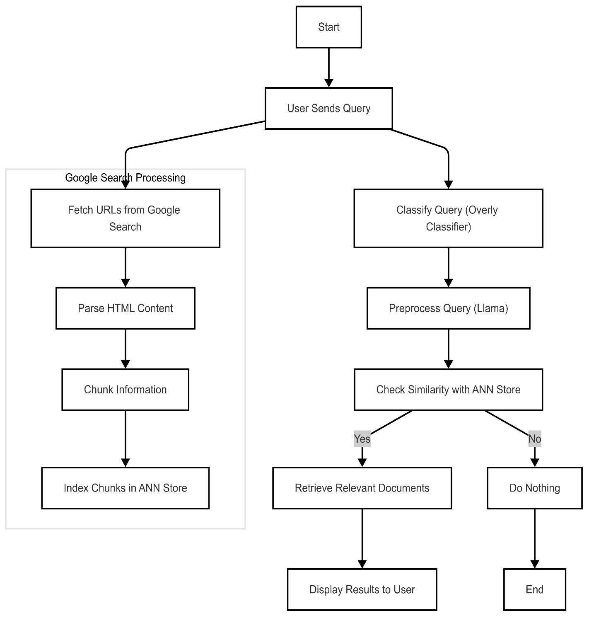

**Class Diagram**

**Sequence Diagram**

**CHAPTER 7: IMPLEMENTATION**

* **Prototype**

This chapter outlines the architecture and workflow of the Document Mining System, which integrates web scraping, natural language processing (NLP), and machine learning to retrieve, process, and match user queries with relevant information from web documents. The system comprises two primary pipelines: Google Search Result Processing and User Query Handling, as illustrated in the provided flowchart.

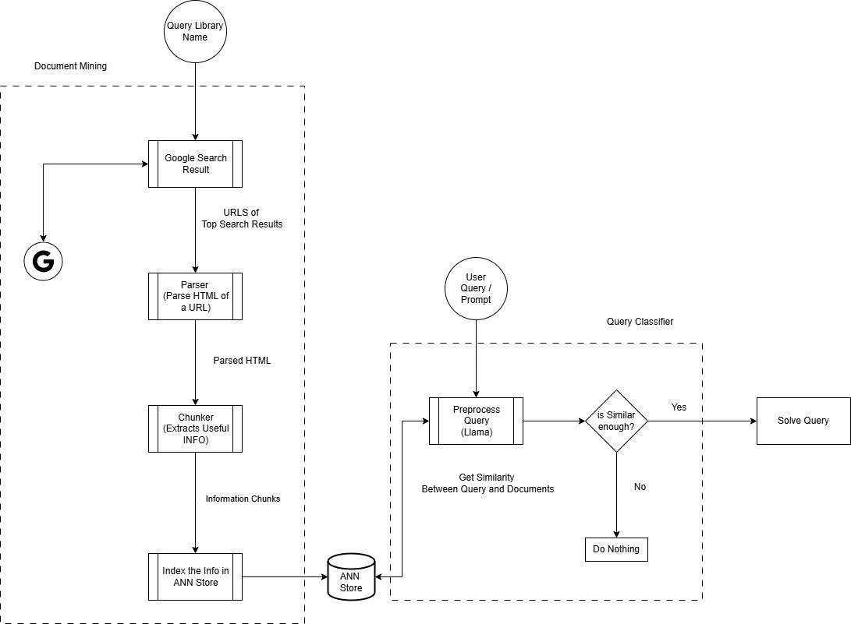

**7.1 Google Search Result Processing Pipeline**

This pipeline extracts, processes, and indexes web content to build a searchable knowledge repository.

**7.1.1 URLs of Top Search Results**

The system begins by querying Google Search APIs to retrieve URLs of top-ranked pages related to predefined keywords or topics.

Example: Searching for "machine learning trends 2025" returns URLs from authoritative domains like arXiv, Towards Data Science, and IEEE.

**7.1.2 HTML Parsing**

Parser: A web scraper (e.g., BeautifulSoup, Scrapy) extracts raw HTML content from the fetched URLs.

Parsed HTML: The parser isolates textual content while filtering out non-informative elements (ads, web scripts, navigation menus).

**7.1.3 Information Chunking**

Chunker: A rule-based or ML-driven module divides parsed text into semantically coherent chunks (e.g., paragraphs, sections).

* Chunking Criteria:
  + Sentence boundaries and topic shifts.
  + Entity density (e.g., chunks rich in keywords like "transformer models" or "AI ethics").

**7.1.4 Indexing in ANN Store**

ANN Store: Chunks are converted into vector embeddings and stored in an Approximate Nearest Neighbor (ANN) database (e.g., FAISS,).

Purpose: Enables efficient similarity searches for user queries.

**7.2 User Query/Prompt Handling Pipeline**

This pipeline processes user inputs to retrieve contextually relevant documents.

**7.2.1 Query Preprocessing with Llama**

* **Llama Integration**: The query is pre-processed using the **Llama language model** to:
  1. Normalize text (lowercasing, removing stopwords).
  2. Expand abbreviations (e.g., "NLP" → "natural language processing").
  3. Generate a vector embedding for similarity comparison.

**7.2.2 Similarity Check**

**Threshold Validation**: The system checks if the cosine similarity between the query embedding and indexed chunks exceeds a predefined threshold (e.g., 0.50-0.56 is preferred ).

* + **Yes**: Proceeds to retrieve the most relevant chunks from the ANN store.
  + **No**: Returns "No relevant documents found" or triggers a rephrasing suggestion.

**7.3 Similarity Computation Between Query and Documents**

The core of the system relies on matching user queries to indexed documents through

**7.3.1 Vector Embedding Comparison**

EmbeddingModels: Use transformer-based models to encode queries and documents into high-dimensional vectors.

ANN Search: FAISS retrieves top-k*k* nearest neighbors from the vector store in sublinear time.

**7.3.2 Ranking and Filtering**

Output: Returns ranked chunks with highlighted snippets.

**7.5 Challenges and Mitigations**

1. **Noise in Web Content**:
   * *Mitigation*: Robust HTML parsing and ML-based noise detection.
2. **Scalability of ANN Stores**:
   * *Mitigation*: Sharding and distributed indexing.
3. **Ambiguous Queries**:
   * *Mitigation*: Leveraging Llama for query disambiguation.

**CHAPTER 8: TOOLS AND TECHNIQUES USED**

The development of the AI-powered VS Code extension involves the use of a variety of tools, technologies, and techniques to ensure a robust, scalable, and user-friendly solution. This chapter outlines the key tools and techniques employed in the project, categorized into different stages of development.

* **Integrated Development Environment (IDE)**
  + Visual Studio Code (VS Code): The primary IDE used for developing the extension. VS Code provides a rich set of APIs and extensions for building custom tools.
  + VS Code Extension API: Used to create the extension’s core functionality, including commands, hover tooltips, and inline suggestions.
* **Programming Languages**
  + TypeScript/JavaScript: The primary languages used for developing the VS Code extension, leveraging the Node.js runtime.
  + Python: Used for backend development, particularly for integrating with large language models (LLMs) and handling complex data processing tasks.
  + Python: Used for backend development, particularly for integrating with large language models (LLMs) and handling complex data processing tasks.
* **Large Language Models (LLMs)**
  + Open-Source LLMs: LLAMA 7B instruct is used for code generation and documentation summarization.
  + Hugging Face Transformers: A library used to integrate and fine-tune open-source LLMs for specific tasks.
* **Backend Development**
  + Flask/FastAPI (Python): Frameworks used to build the backend server for processing user input and interacting with LLMs.
* **Data Processing and Analysis**
  + Natural Language Processing (NLP): Techniques used for analyzing and summarizing documentation.
  + Regex (Regular Expressions): For pattern matching and text processing tasks.
* **Documentation Retrieval**
  + Web Scraping Tools: Libraries like BeautifulSoup (Python) or Cheerio (Node.js) for extracting documentation from web pages.
  + Documentation APIs: Integration with official documentation sources (e.g., MDN, Python Docs) to fetch accurate and up-to-date information.
* **Version Control and Collaboration**
  + Git: For version control and collaborative development.
  + GitHub/GitLab: Platforms used for hosting the repository, managing issues, and facilitating team collaboration**.**
* **Visualization and Diagramming**
  + Mermaid AI: Used for generating visual diagrams, such as use case diagrams, to better understand and document system workflows.
  + Mermaid.js: A JavaScript-based tool for creating diagrams and flowcharts directly within the documentation or codebase.

**CONCLUSION**

The development of the **AI-Powered VS Code Extension** represents a significant advancement in enhancing developer productivity by integrating cutting-edge technologies such as **Large Language Models (LLMs)**, **Natural Language Processing (NLP)**, and **Document Mining Systems**. This project addresses critical challenges faced by developers, including repetitive coding tasks, inefficient documentation retrieval, and fragmented workflows, by providing a unified, context-aware solution directly within the Visual Studio Code IDE.

This project demonstrates the transformative potential of AI in software development. By combining cutting-edge technologies with a user-centric design, the AI-Powered VS Code Extension addresses critical pain points faced by developers and sets a new standard for intelligent development tools. As the project evolves, it will continue to empower developers, enabling them to work more efficiently, creatively, and collaboratively.