In jump tool go to requests > open new request

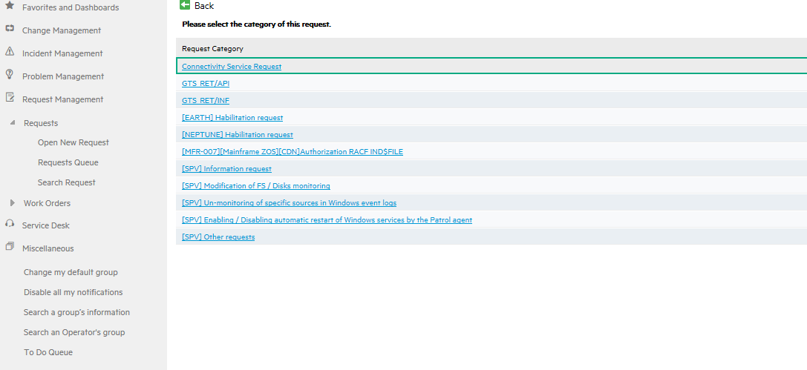

Click on open new request, select GTS_FR_RET.SBA_DBABACKUP

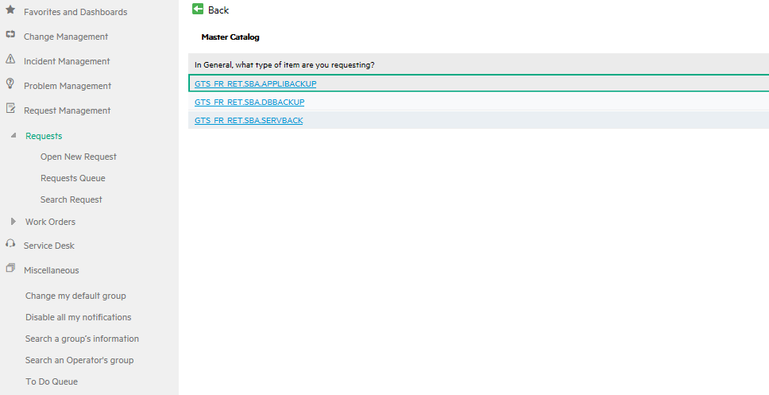

If your request is for dev, select DEV Database backup.

If your request is for hom/prd , select HOMO or PROD Database backup.

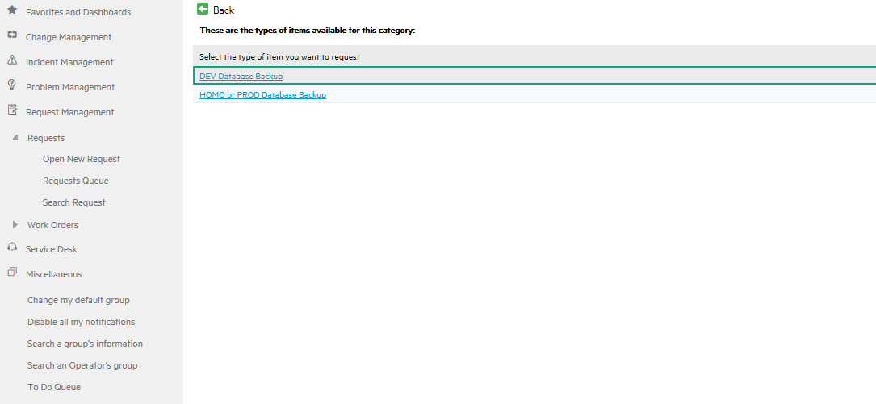

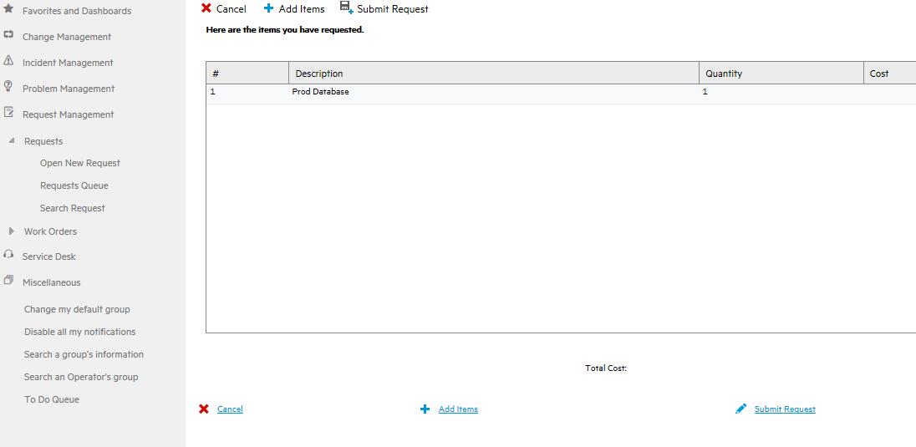

Submit the request , you will see following template.

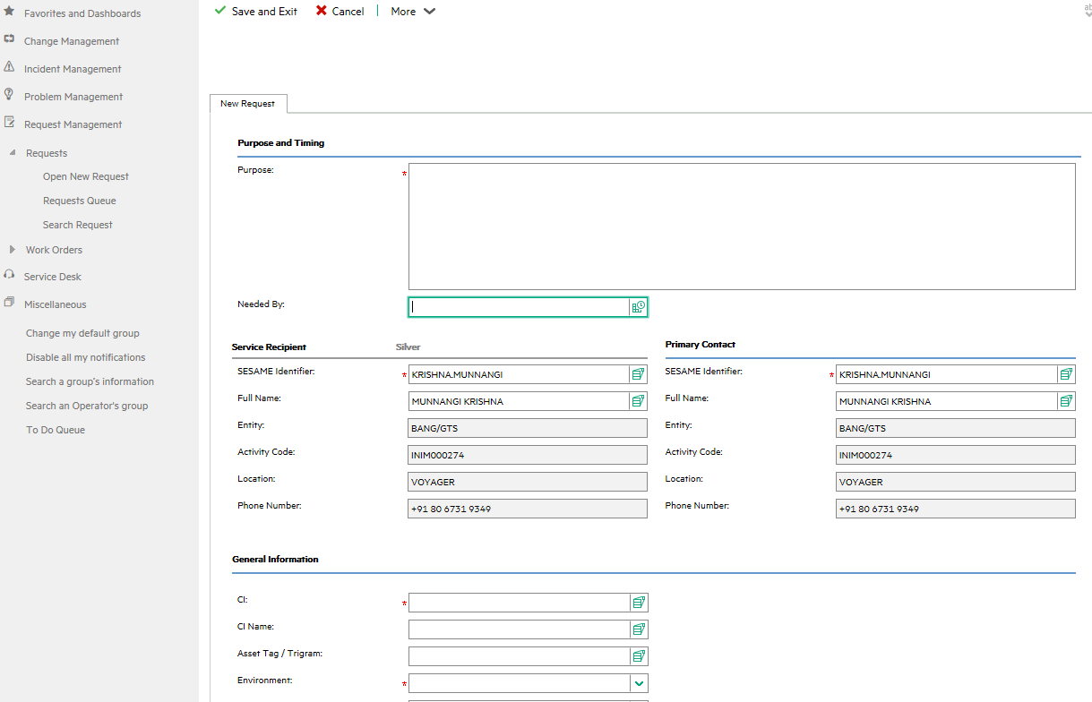

Fill the template with all the details like below and submit the request.

