# Project: Stroop Test

# What is our independent variable? What is our dependent variable?

Ans:

**Independent variable:** The condition chosen i.e. Congruent condition or the Incongruent condition.

**Dependent variable:** Time it takes to name the ink colors.

1. **What is an appropriate set of hypotheses for this task? What kind of statistical test do you expect to perform? Justify your choices.**

Ans:

To start the experiment, I propose the following alternative hypothesis

Alternative Hypothesis:

The time taken to read the sentence in Congruent condition is less than the Incongruent Condition

The null hypothesis, which reflects the current common view prior to this experiment is performed, is as under

Null hypothesis:

The time taken to read the sentences in congruent or incongruent conditions is same i.e.

The condition has no effect on the response time of the person.

In our experiment, we will try to disprove or reject the null hypothesis.

Tests to be performed:

We select a group of people and expose each of them to congruent and non-congruent condition. Now, it is important to understand that, under a particular condition, say, congruent condition, the response time of different individuals may differ. So, comparing

the response time amongst individuals may introduce various lurking variables to the experiment. Instead, we expose each person to both conditions and note the difference in their response time (or rather, **Incongruent response time-Congruent response time**). Then , we find the mean of the “**Congruent Response Time-Incongruent Response Time**” for the entire population. If the mean is significantly greater than zero, we can reject the null hypothesis and accept the alternative hypothesis as the new truth.

1. **Report some descriptive statistics regarding this dataset. Include at least one measure of central tendency and at least one measure of variability.**

Ans:

I found the Incongruent Responce Time-Congruent Response Time for each of the individuals.

|  |  |  |  |
| --- | --- | --- | --- |
| Congruent | Incongruent | Difference | Mean |
| 12.079 | 19.278 | 7.199 | 7.964792 |
| 16.791 | 18.741 | 1.95 |  |
| 9.564 | 21.214 | 11.65 |  |
| 8.63 | 15.687 | 7.057 |  |
| 14.669 | 22.803 | 8.134 |  |
| 12.238 | 20.878 | 8.64 |  |
| 14.692 | 24.572 | 9.88 |  |
| 8.987 | 17.394 | 8.407 |  |
| 9.401 | 20.762 | 11.361 |  |
| 14.48 | 26.282 | 11.802 |  |
| 22.328 | 24.524 | 2.196 |  |
| 15.298 | 18.644 | 3.346 |  |
| 15.073 | 17.51 | 2.437 |  |
| 16.929 | 20.33 | 3.401 |  |
| 18.2 | 35.255 | 17.055 |  |
| 12.13 | 22.158 | 10.028 |  |
| 18.495 | 25.139 | 6.644 |  |
| 10.639 | 20.429 | 9.79 |  |
| 11.344 | 17.425 | 6.081 |  |
| 12.369 | 34.288 | 21.919 |  |
| 12.944 | 23.894 | 10.95 |  |
| 14.233 | 17.96 | 3.727 |  |
| 19.71 | 22.058 | 2.348 |  |
| 16.004 | 21.157 | 5.153 |  |

Mean: 7.964792

Standard Deviation: 4.76239803022216

1. Provide one or two visualizations that show the distribution of the sample data. Write one or two sentences noting what you observe about the plot or plots.

Ans: I created histograms with various bin sizes.

Histogram :

With Bin Size 2

|  |  |
| --- | --- |
| *Bin* | *Frequency* |
| 0 | 0 |
| 2 | 1 |
| 4 | 6 |
| 6 | 1 |
| 8 | 4 |
| 10 | 5 |
| 12 | 5 |
| 14 | 0 |
| 16 | 0 |
| 18 | 1 |
| 20 | 0 |
| 22 | 1 |
| 24 | 0 |
| 26 | 0 |

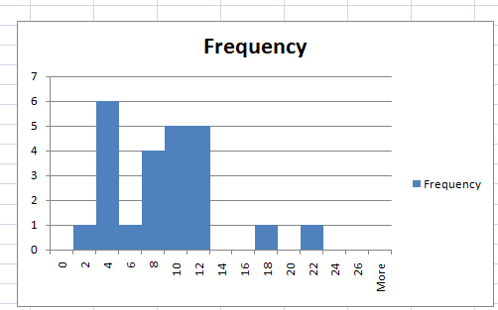

With Bin Size 3:

|  |  |
| --- | --- |
| *Bin* | *Frequency* |
| 0 | 0 |
| 3 | 4 |
| 6 | 4 |
| 9 | 7 |
| 12 | 7 |
| 15 | 0 |
| 18 | 1 |
| 21 | 0 |
| 24 | 1 |
| 27 | 0 |

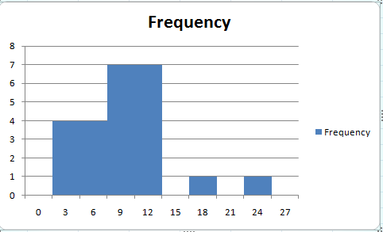

Inference:

The histograms show a positively skewed distribution with the mode occurring at somewhere between 10-12

1. Now, perform the statistical test and report your results. What is your confidence level and your critical statistic value? Do you reject the null hypothesis or fail to reject it? Come to a conclusion in terms of the experiment task. Did the results match up with your expectations?

Ans:

1. 6. Optional: What do you think is responsible for the effects observed? Can you think of an alternative or similar task that would result in a similar effect? Some research about the problem will be helpful for thinking about these two questions!

# 

<https://en.wikipedia.org/wiki/Stroop_effect>

<https://explorable.com/hypothesis-testing>

<https://explorable.com/null-hypothesis>

<https://explorable.com/how-to-write-a-hypothesis>