**Queries on the Database**

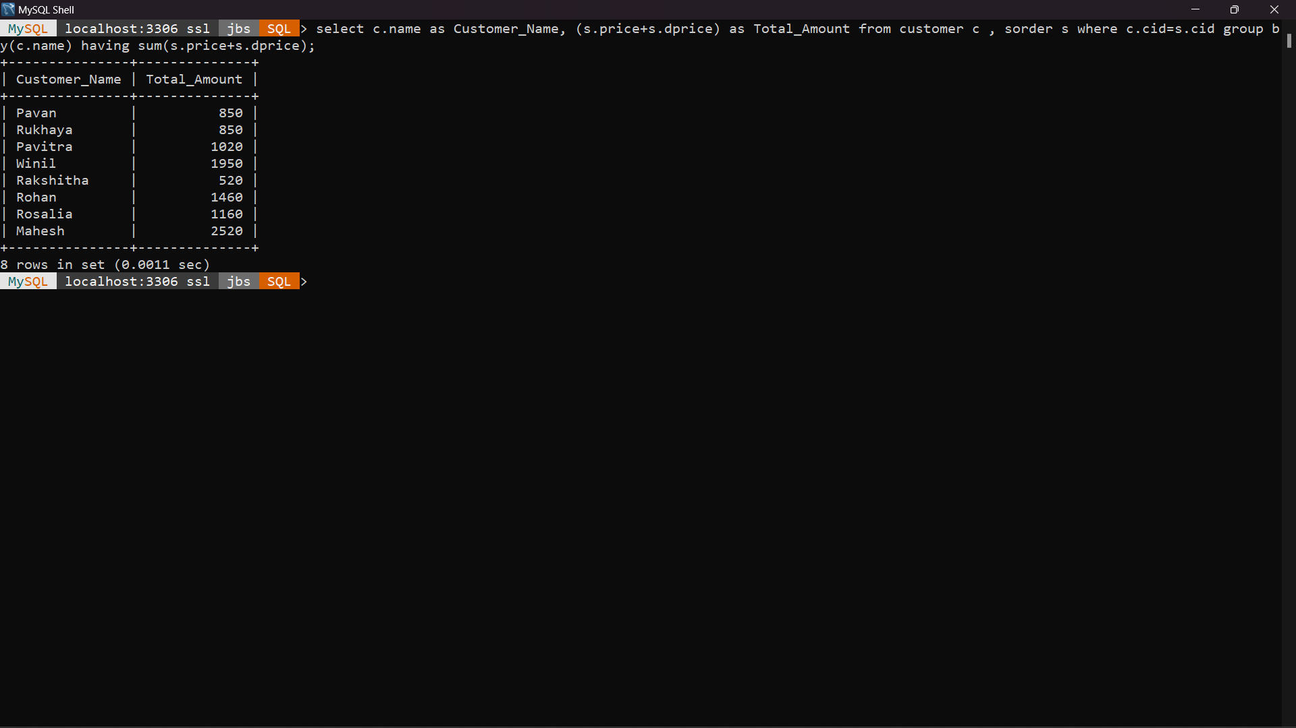**1)List the total amount of the all the special orders given by the loyal customers over the time and names of customer.**

select c.name as Customer_Name, (s.price+s.dprice) as Total_Amount from customer c , sorder s where c.cid=s.cid group by(c.name) having sum(s.price+s.dprice);

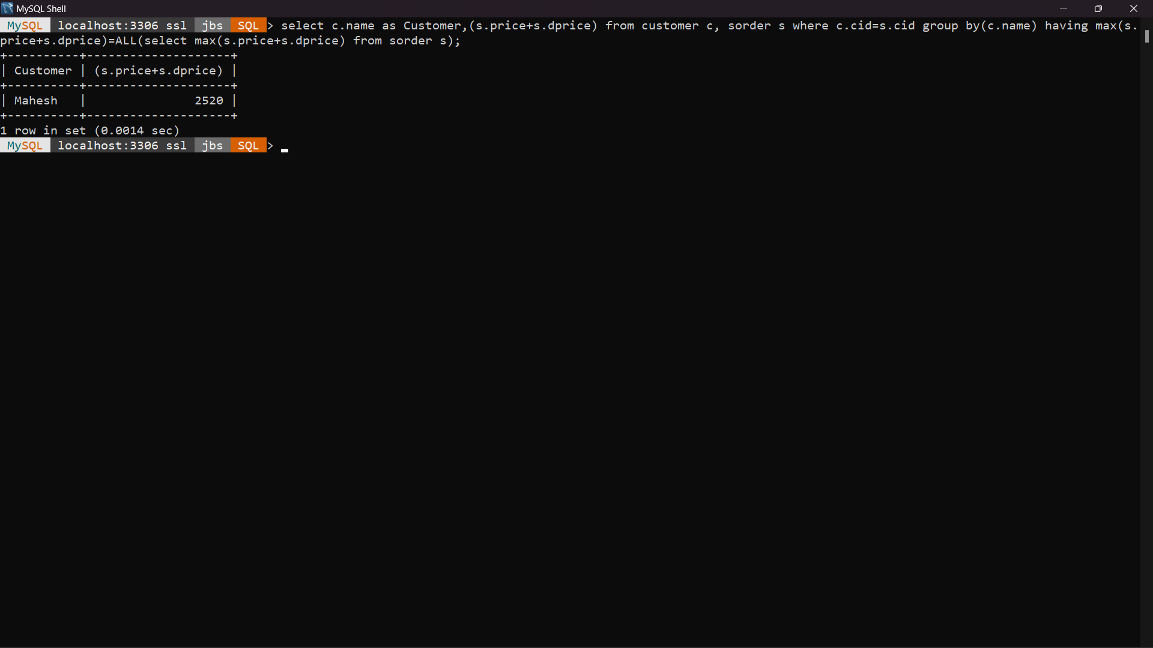**2)Display the loyal customer who has given the maximum amount of order in term of money during overall period of time.**

select c.name as Customer,(s.price+s.dprice) from customer c, sorder s where c.cid=s.cid group by(c.name) having max(s.price+s.dprice)=ALL(select max(s.price+s.dprice) from sorder s);

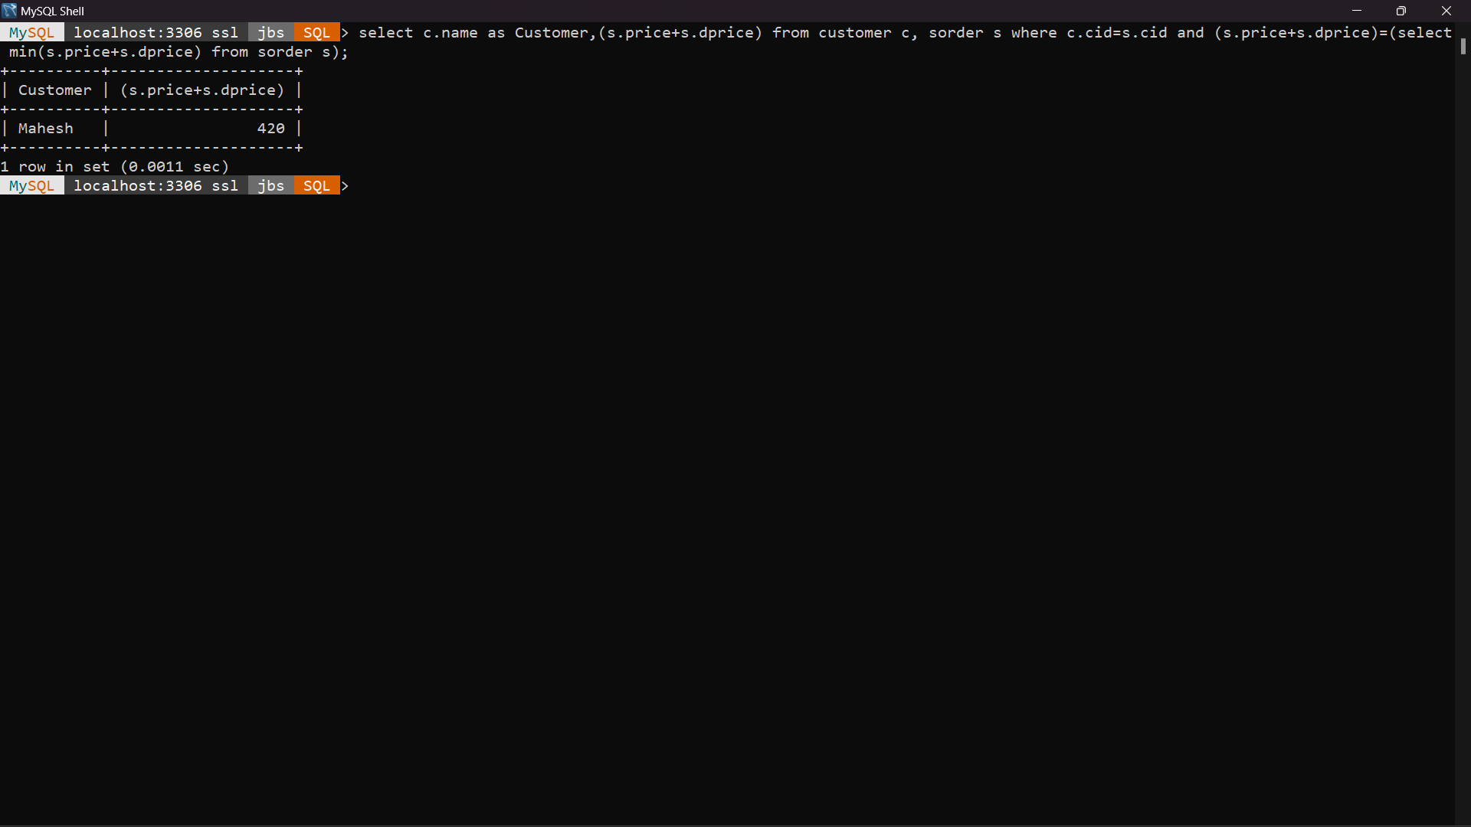**3)Display the loyal customer who has given the minimum amount of order in term of money during overall period of time.**

select c.name as Customer,(s.price+s.dprice) from customer c, sorder s where c.cid=s.cid and (s.price+s.dprice)=(select min(s.price+s.dprice) from sorder s);

**4)List the total number of special orders placed by loyal customers.**

select c.name as Customer_Name, count(s.price+s.dprice) as Total_Amount from customer c , sorder s where c.cid=s.cid group by(c.name) having count(s.price+s.dprice);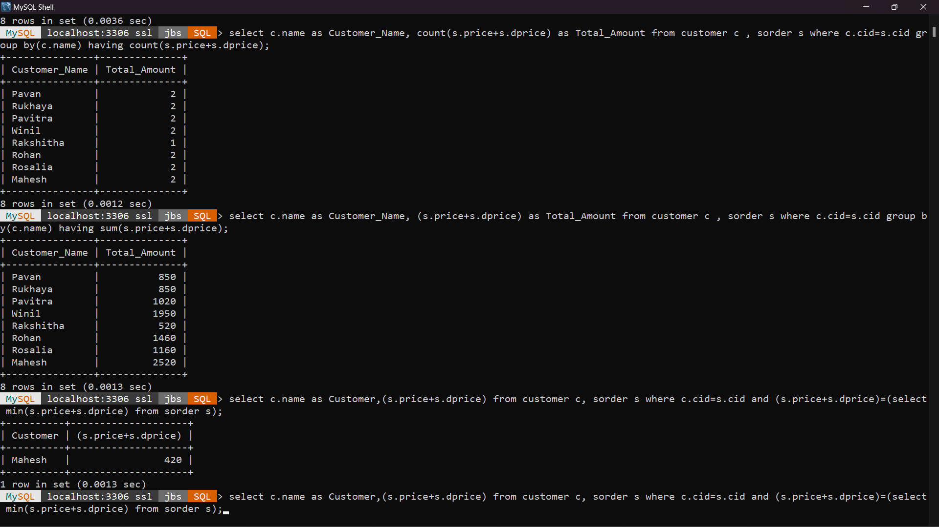

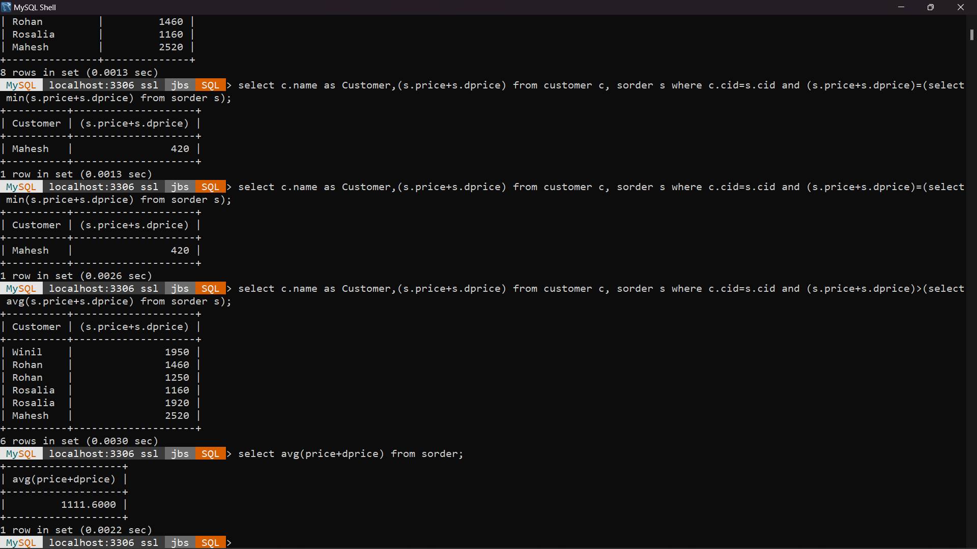**5)List the customers who have given special order of amount more than average special order amount**

select c.name as Customer,(s.price+s.dprice) from customer c, sorder s where c.cid=s.cid and (s.price+s.dprice)>(select avg(s.price+s.dprice) from sorder s);

**6)Display the total amount of sales made by each employee for the overall time**

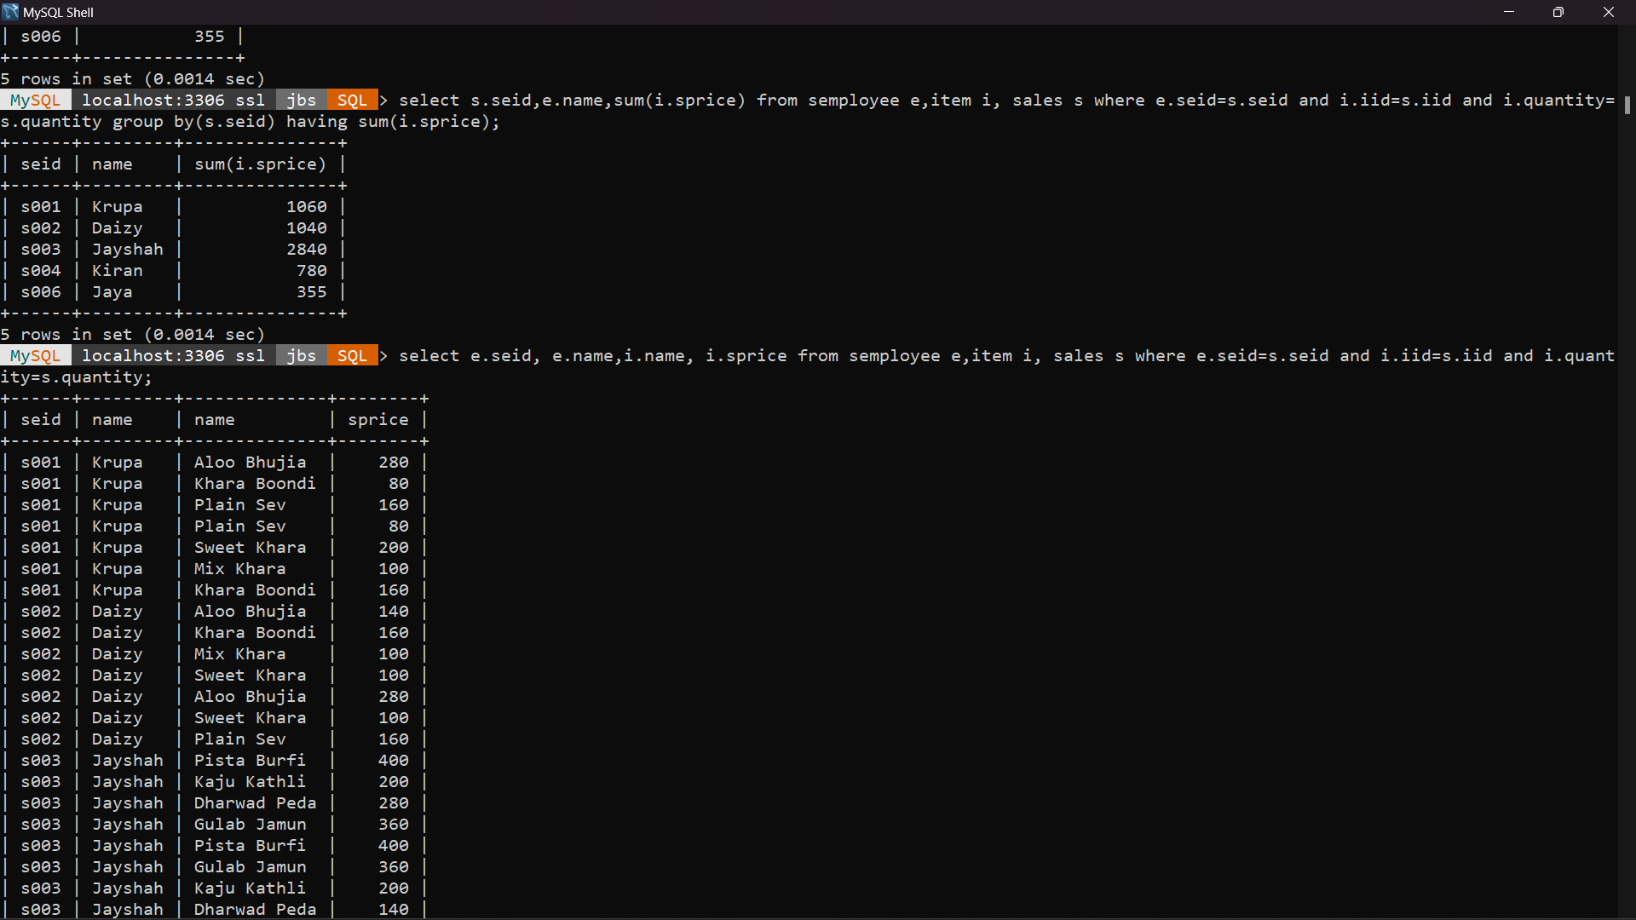

select s.seid,e.name,sum(i.sprice) from semployee e,item i, sales s where e.seid=s.seid and i.iid=s.iid and i.quantity=s.quantity group by(s.seid) having sum(i.sprice);

**7)Display employee details of employee with max sales**

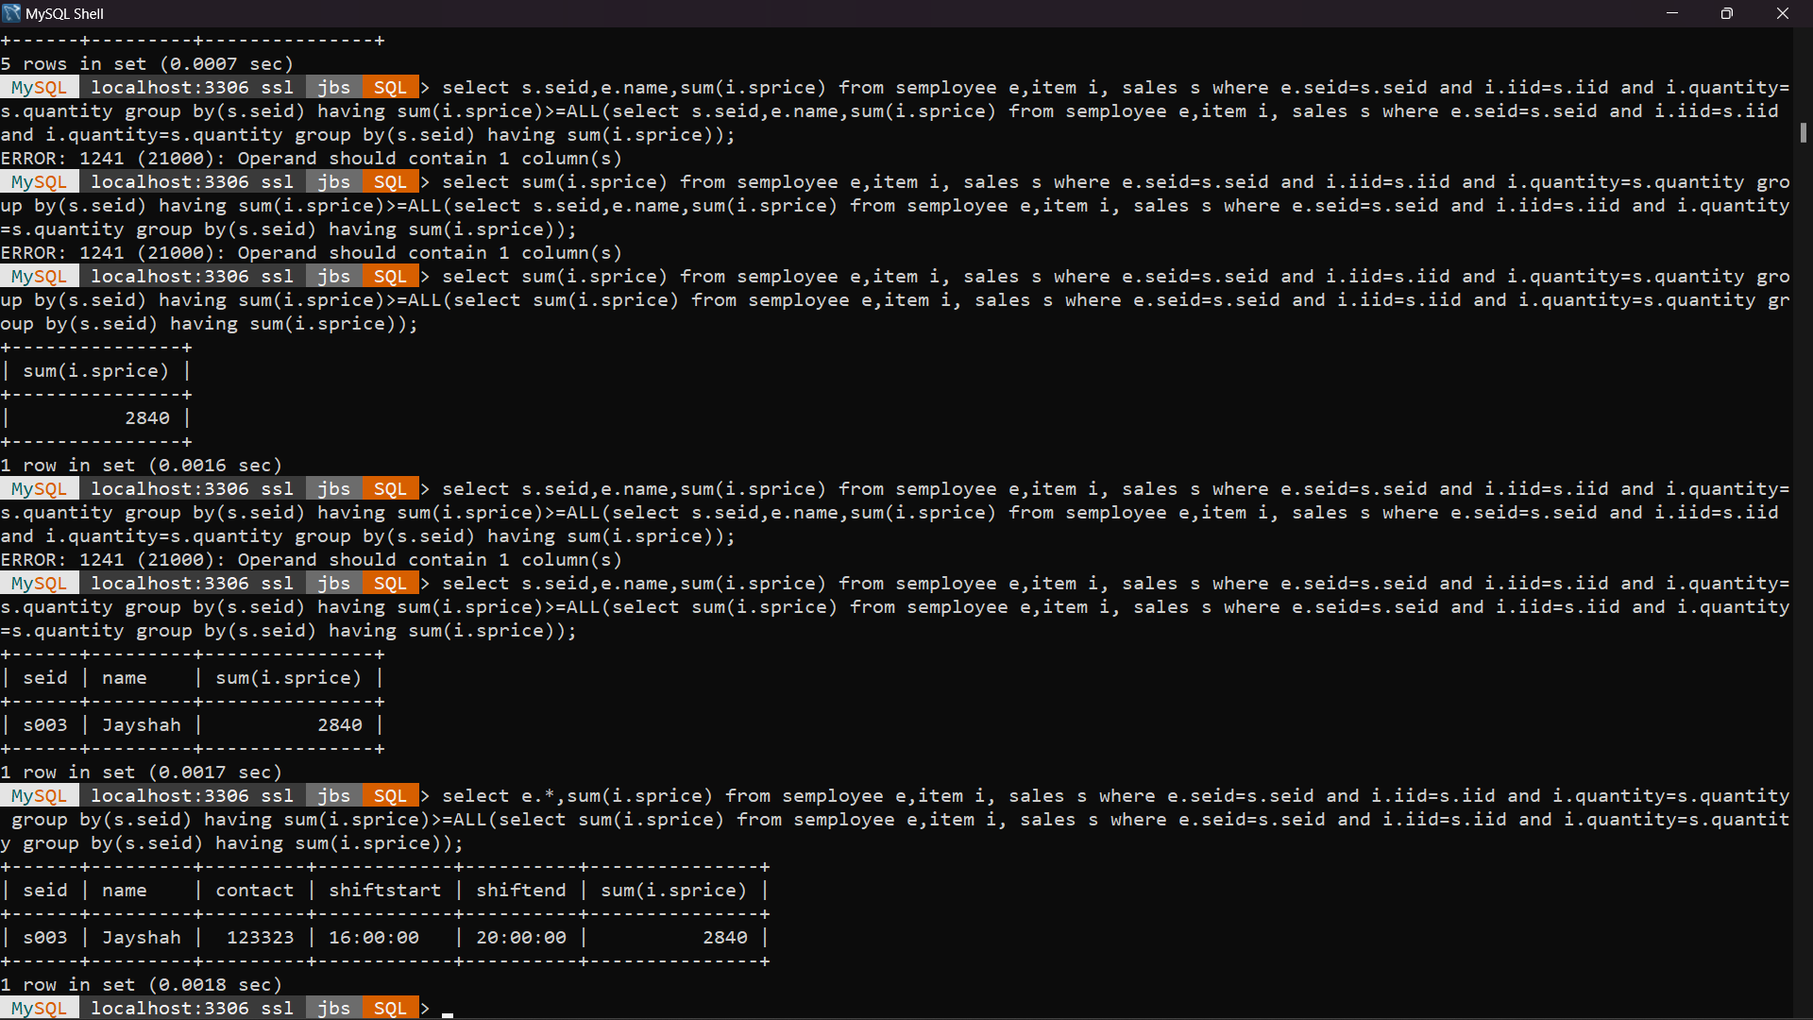select e.*,sum(i.sprice) from semployee e,item i, sales s where e.seid=s.seid and i.iid=s.iid and i.quantity=s.quantity group by(s.seid) having sum(i.sprice)>=ALL(select sum(i.sprice) from semployee e,item i, sales s where e.seid=s.seid and i.iid=s.iid and i.quantity=s.quantity group by(s.seid) having sum(i.sprice));

**8)Display employee details of employee with least sales**

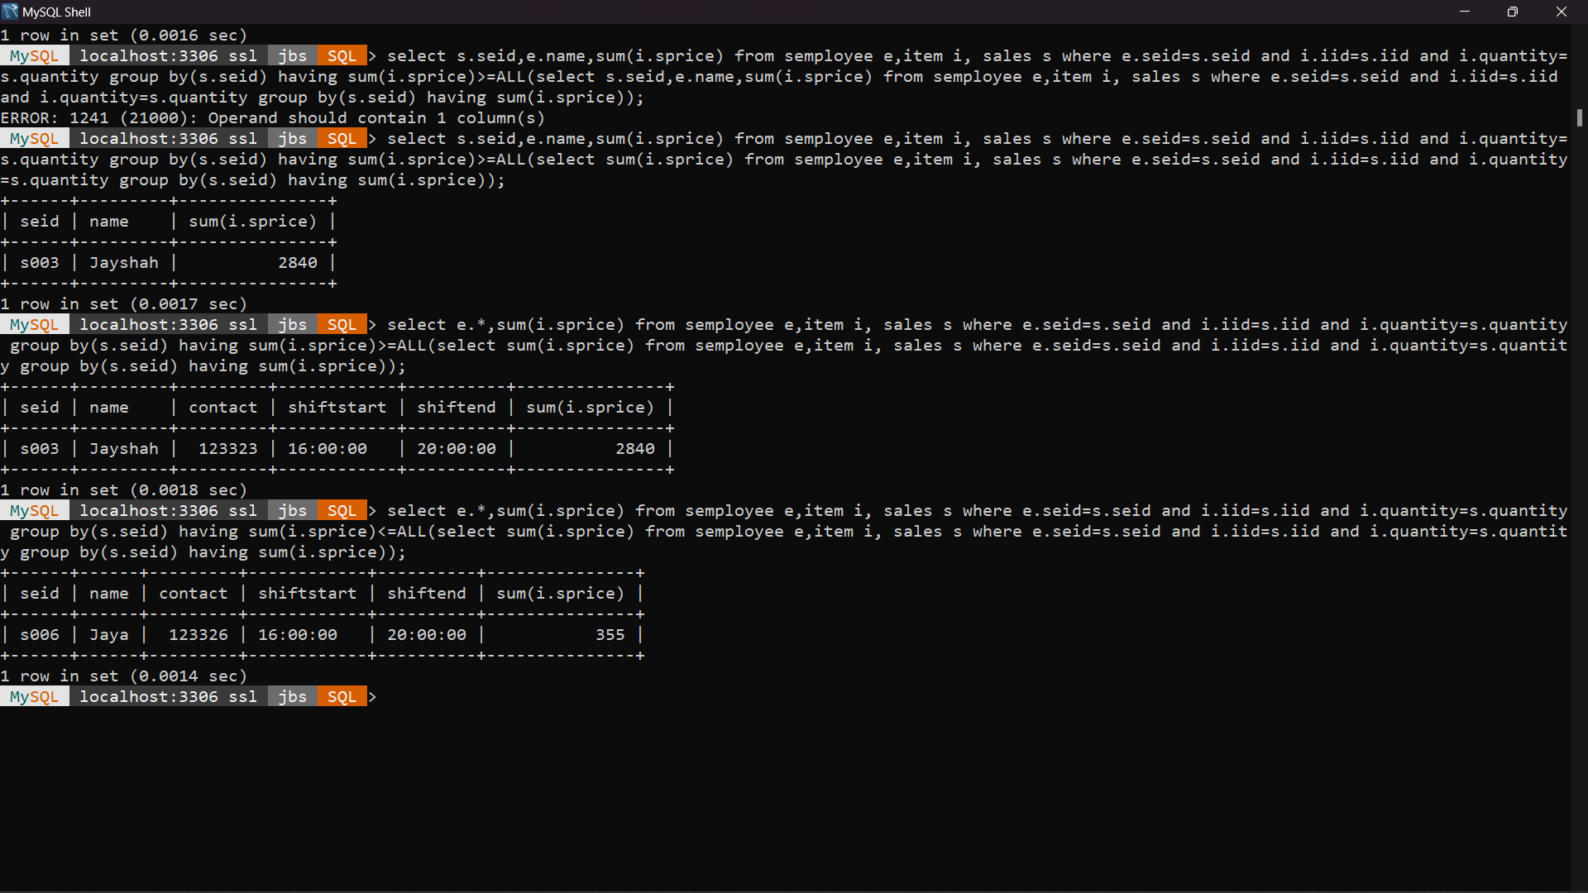select e.*,sum(i.sprice) from semployee e,item i, sales s where e.seid=s.seid and i.iid=s.iid and i.quantity=s.quantity group by(s.seid) having sum(i.sprice)<=ALL(select sum(i.sprice) from semployee e,item i, sales s where e.seid=s.seid and i.iid=s.iid and i.quantity=s.quantity group by(s.seid) having sum(i.sprice));

**9)Display total sales at each shift throughout the day**

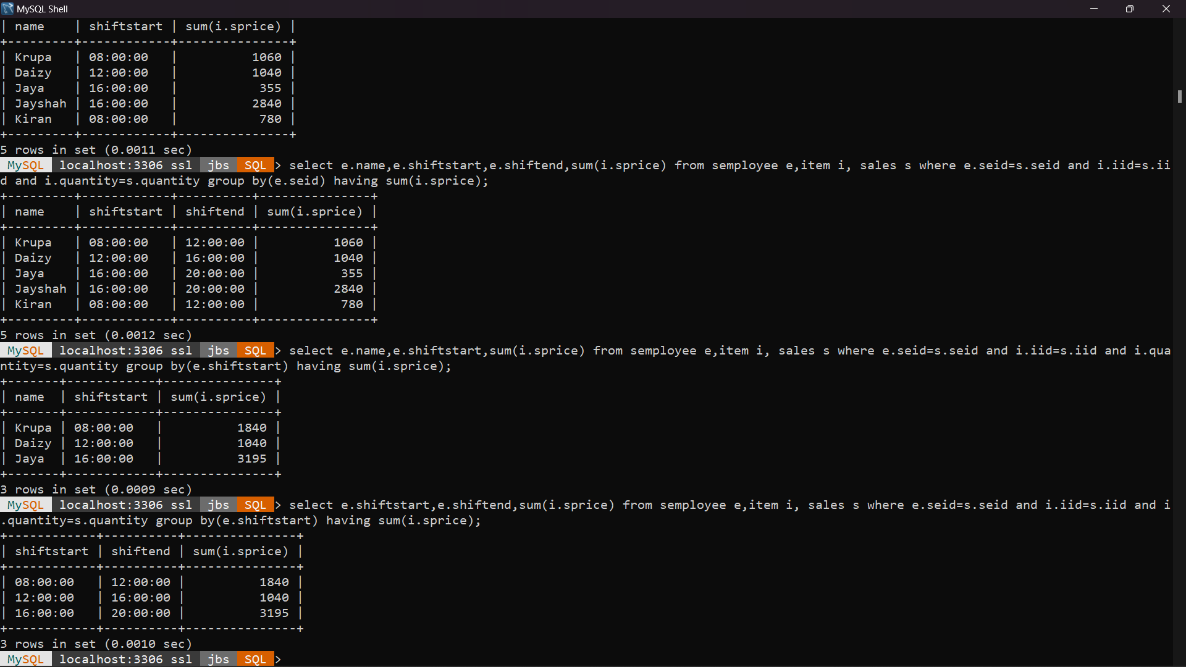select e.shiftstart,e.shiftend,sum(i.sprice) from semployee e,item i, sales s where e.seid=s.seid and i.iid=s.iid and i.quantity=s.quantity group by(e.shiftstart) having sum(i.sprice);

**10) Display total sales of employee by shift, must include all employee and their shift time**

select e.name,e.shiftstart,e.shiftend, sum(i.sprice) from semployee e,item i, sales s where e.seid=s.seid and i.iid=s.iid and i.quantity=s.quantity group by(e.seid) having sum(i.sprice);

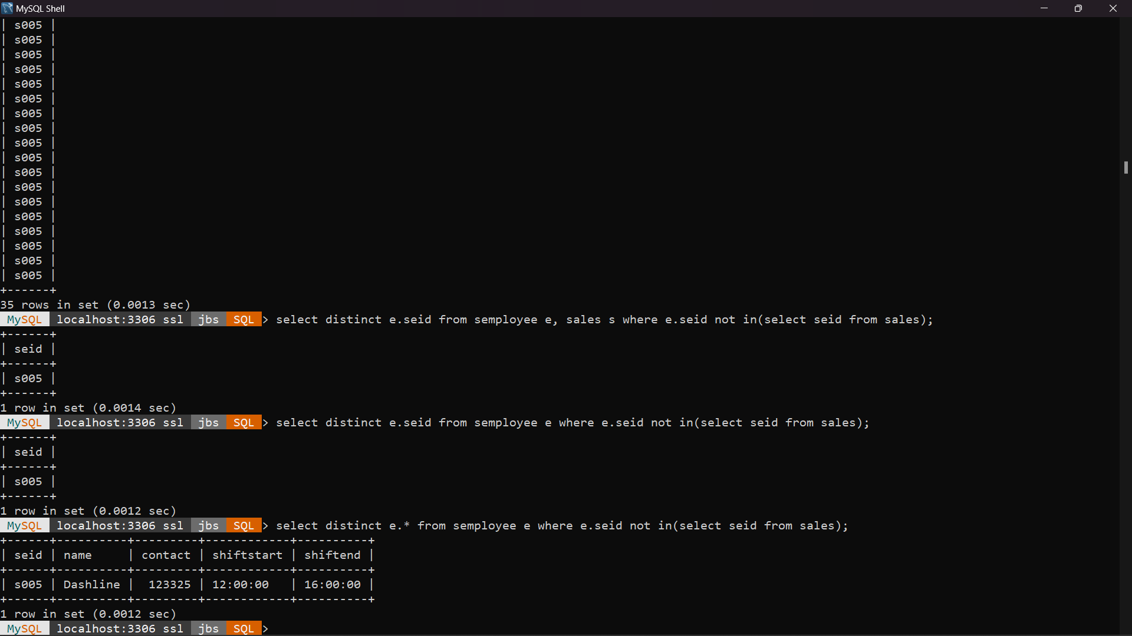**11)Display Employee details who has not done any sales**

select distinct e.* from semployee e where e.seid not in(select seid from sales);

**12)Display how much profit will generated by items purchased from each distributor on the sales overall**

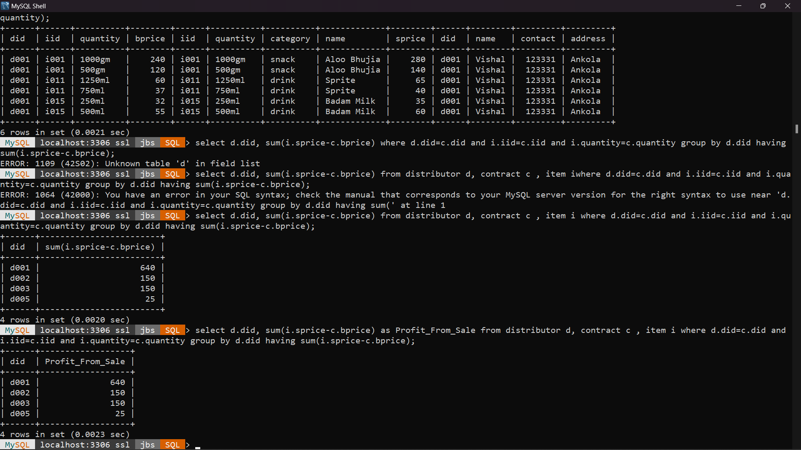

select d.did, sum(i.sprice-c.bprice) as Profit_From_Sale from distributor d, contract c , item i where d.did=c.did and i.iid=c.iid and i.quantity=c.quantity group by d.did having sum(i.sprice-c.bprice);

**13)Display the Total Sales by day**

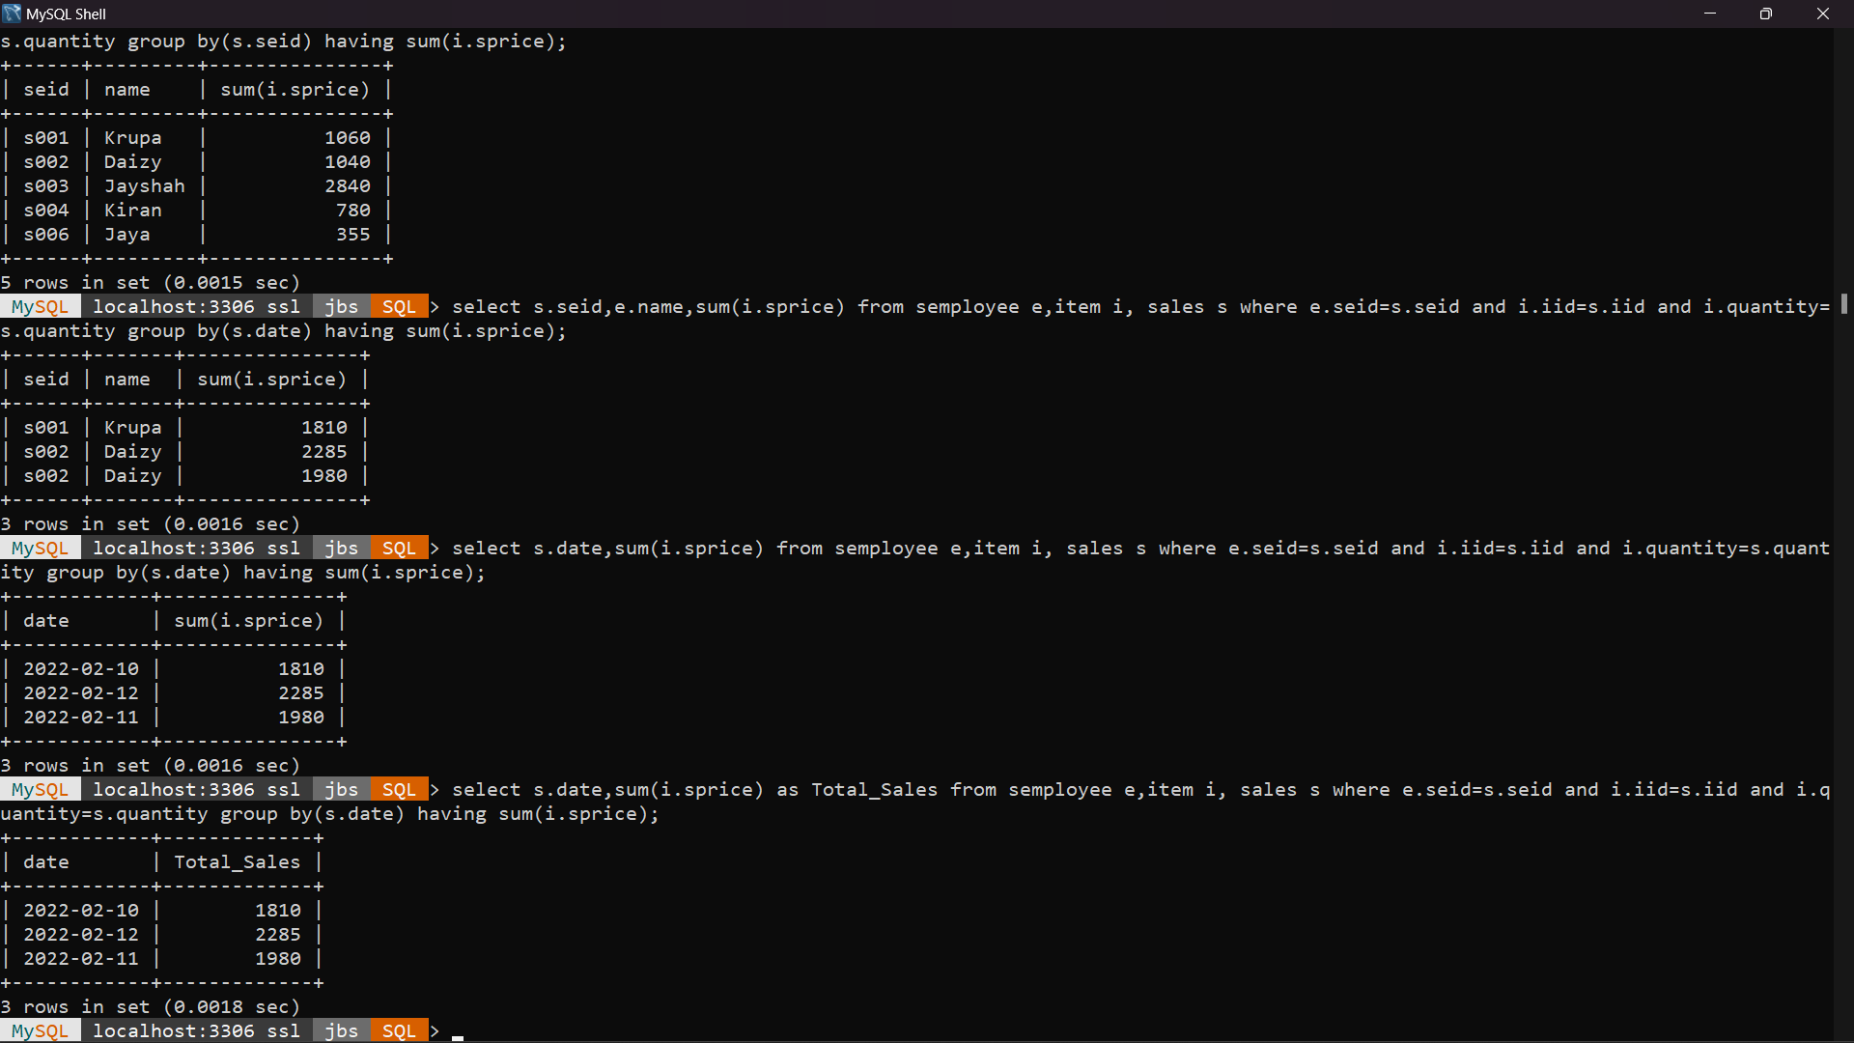

select s.date,sum(i.sprice) as Total_Sales from semployee e,item i, sales s where e.seid=s.seid and i.iid=s.iid and i.quantity=s.quantity group by(s.date) having sum(i.sprice);

**14)Display overall sales of each item by each quantity**

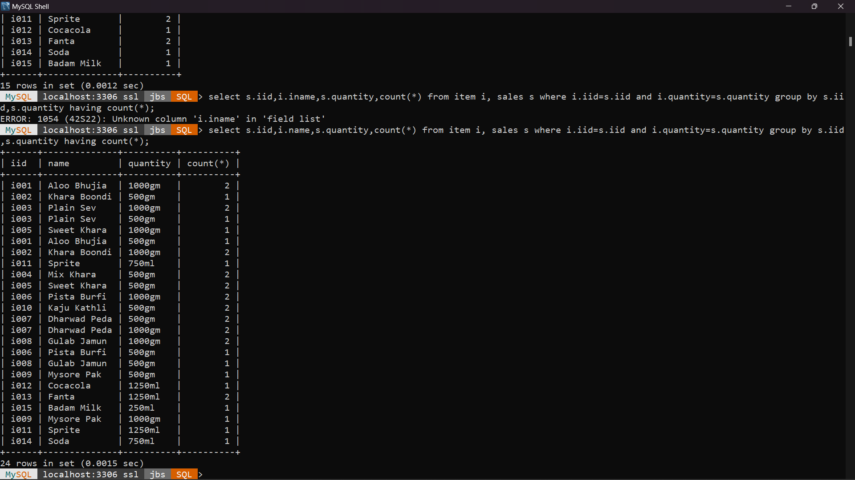

select s.iid,i.name,s.quantity,count(*) from item i, sales s where i.iid=s.iid and i.quantity=s.quantity group by s.iid,s.quantity having count(*);

**15)Which item is most popular(sold most)**

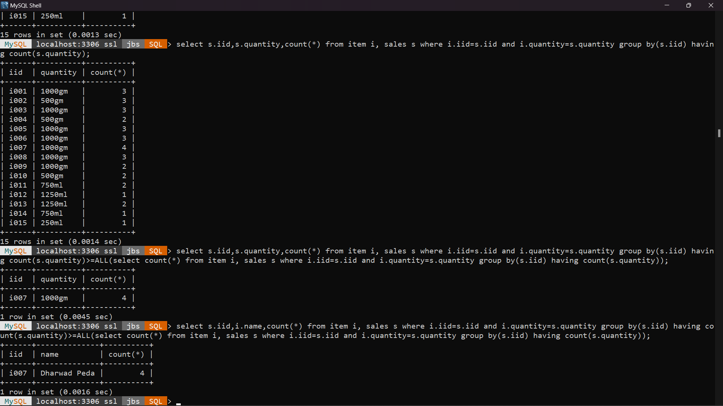

select s.iid,i.name,count(*) from item i, sales s where i.iid=s.iid and i.quantity=s.quantity group by(s.iid) having count(s.quantity)>=ALL(select count(*) from item i, sales s where i.iid=s.iid and i.quantity=s.quantity group by(s.iid) having count(s.quantity));

**16)Give the average sale of each item sold.**

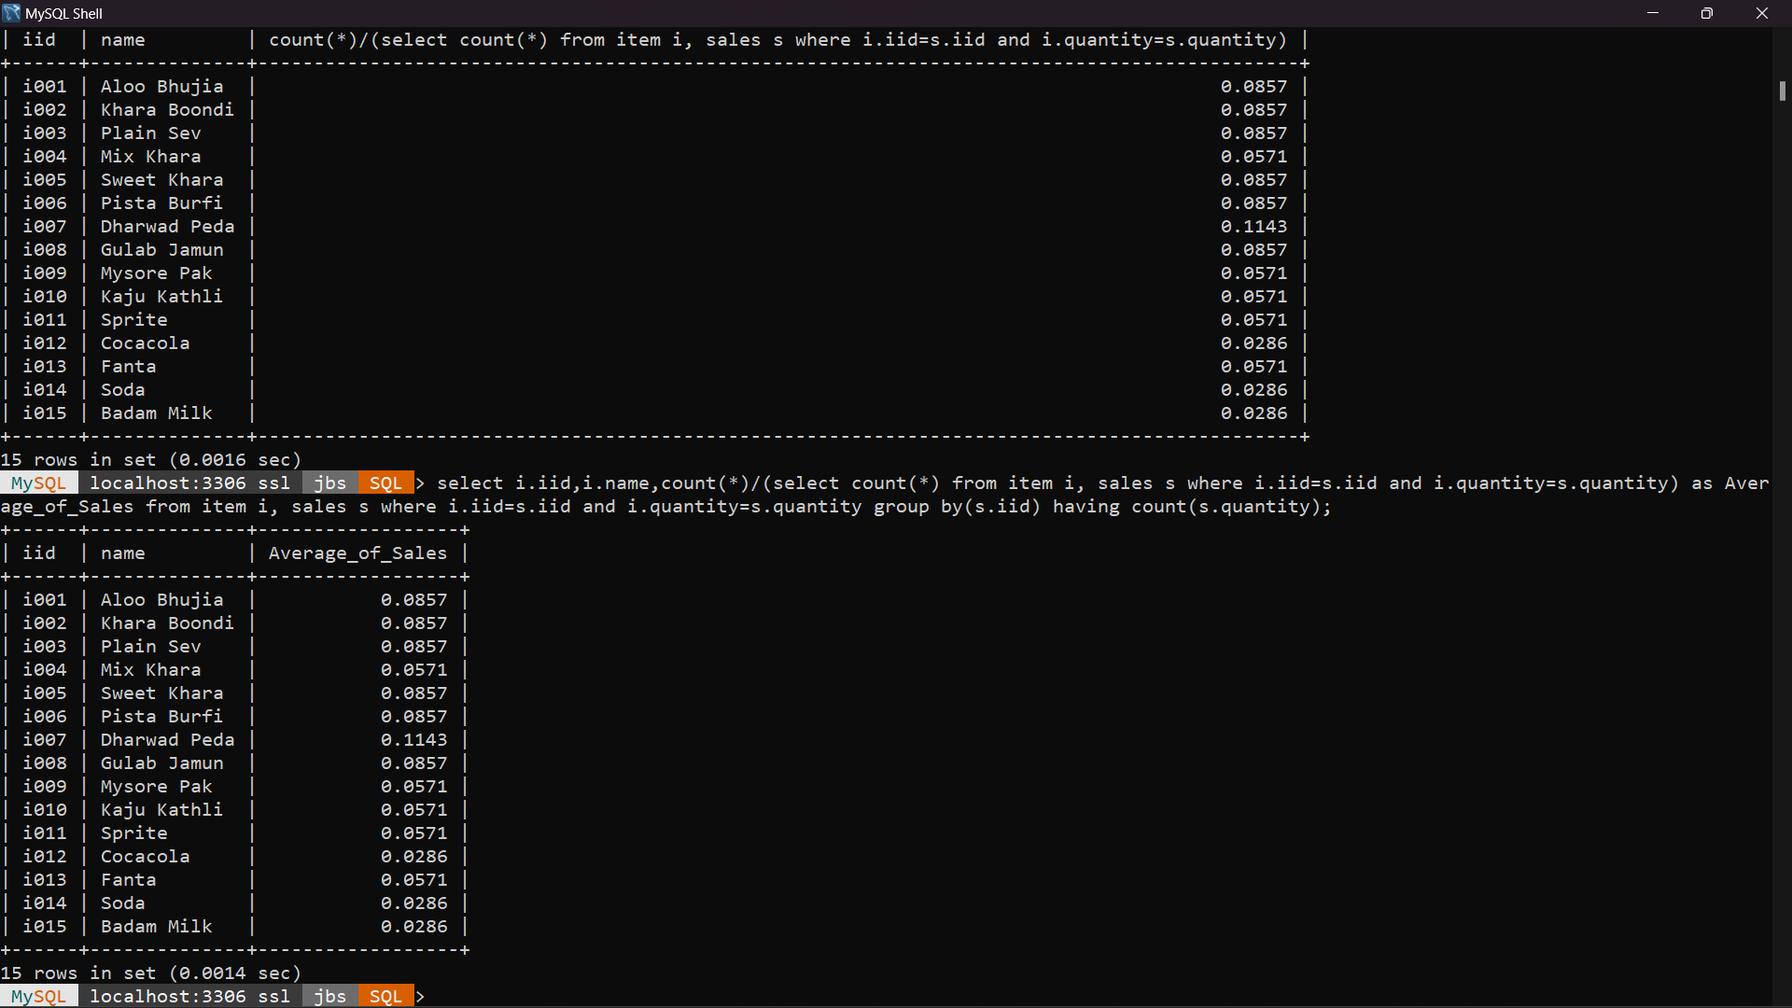

select i.iid,i.name,count(*)/(select count(*) from item i, sales s where i.iid=s.iid and i.quantity=s.quantity) as Average_of_Sales from item i, sales s where i.iid=s.iid and i.quantity=s.quantity group by(s.iid) having count(s.quantity);