LogIn Page
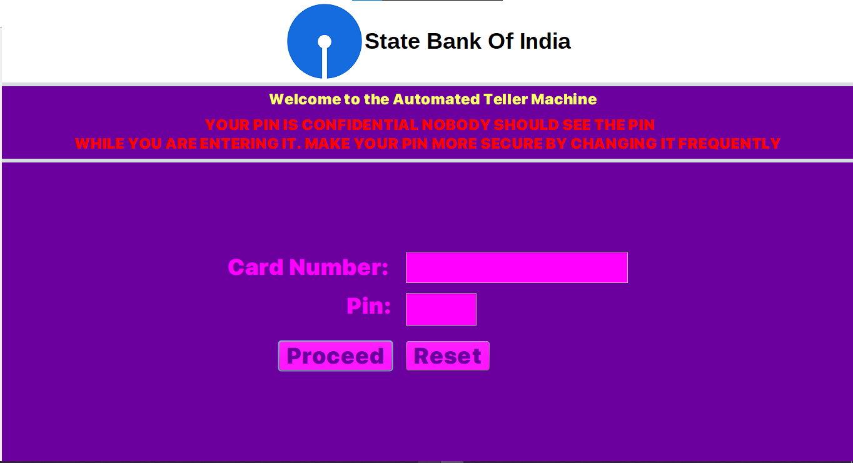
When the user enters an incorrect card number
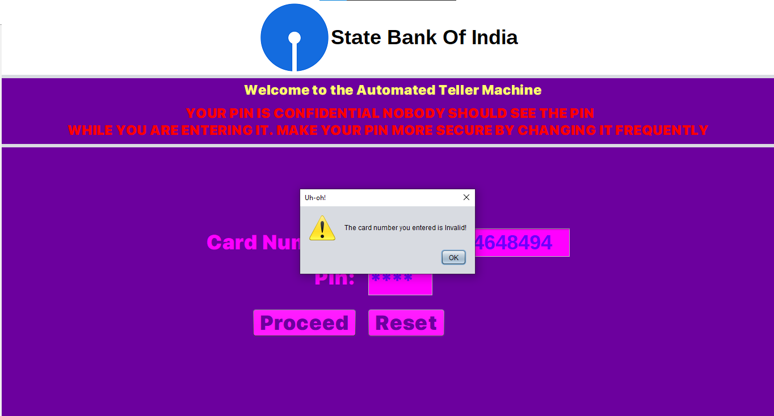

When the user Enters incorrct Pin number
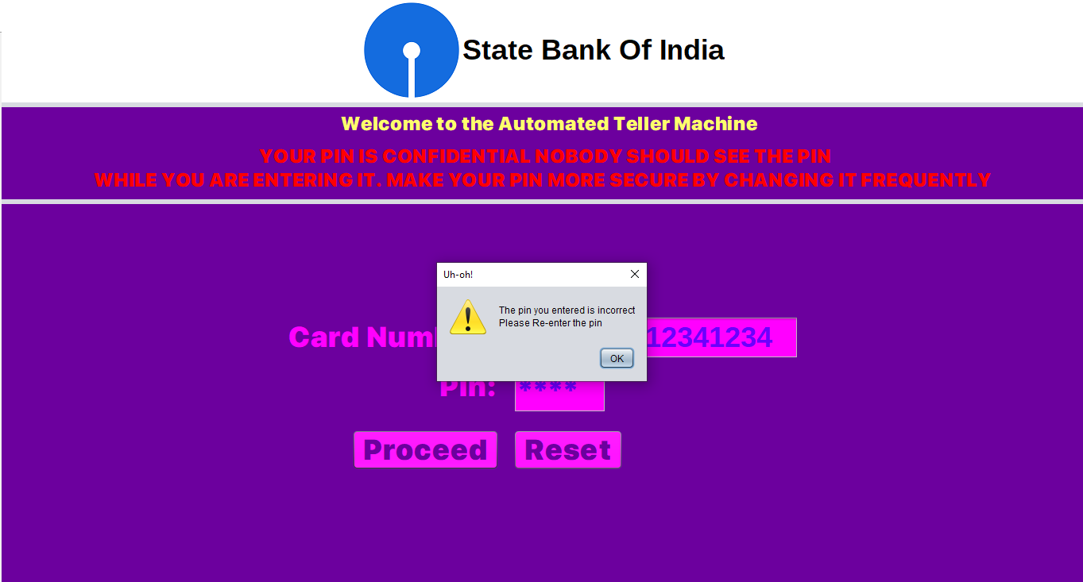
The user will be again asked to enter the Pin
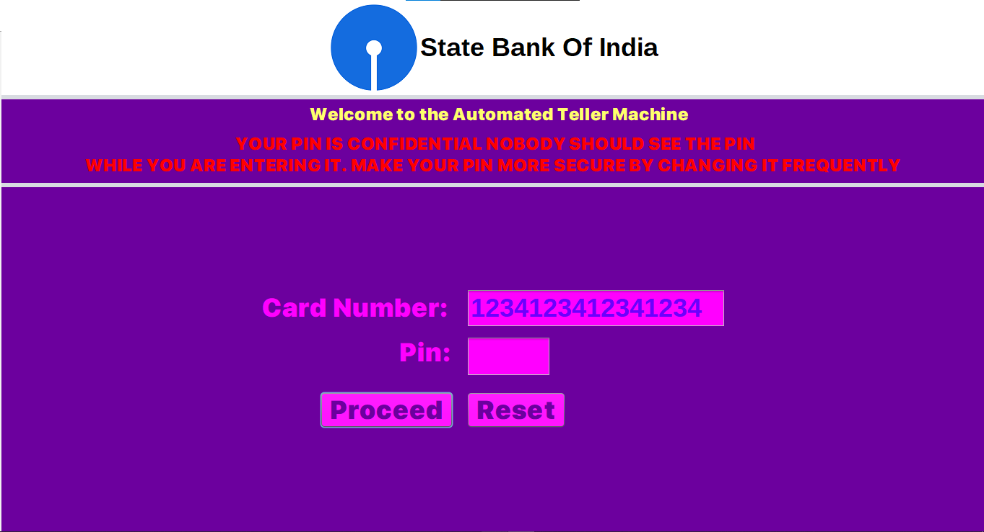

When the user enters a valid database
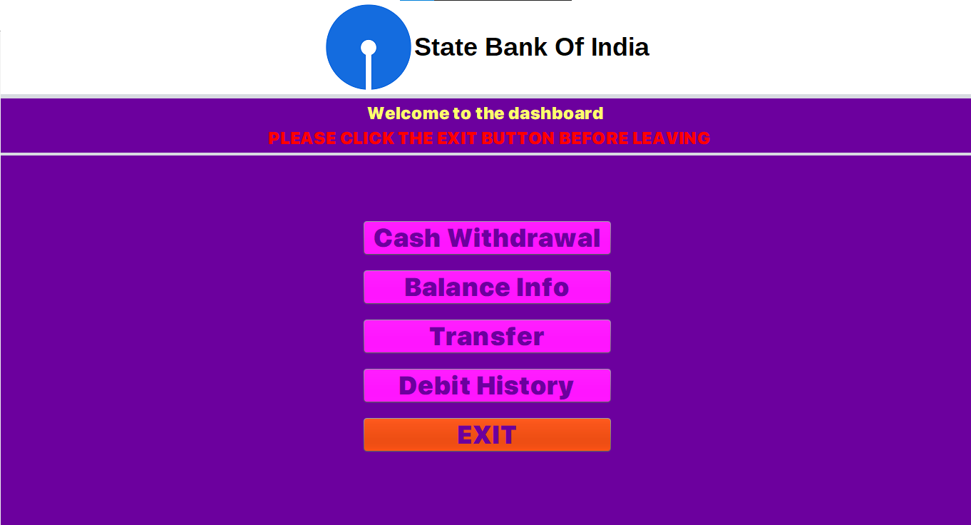
When the user Clicks Cash Withdrawal
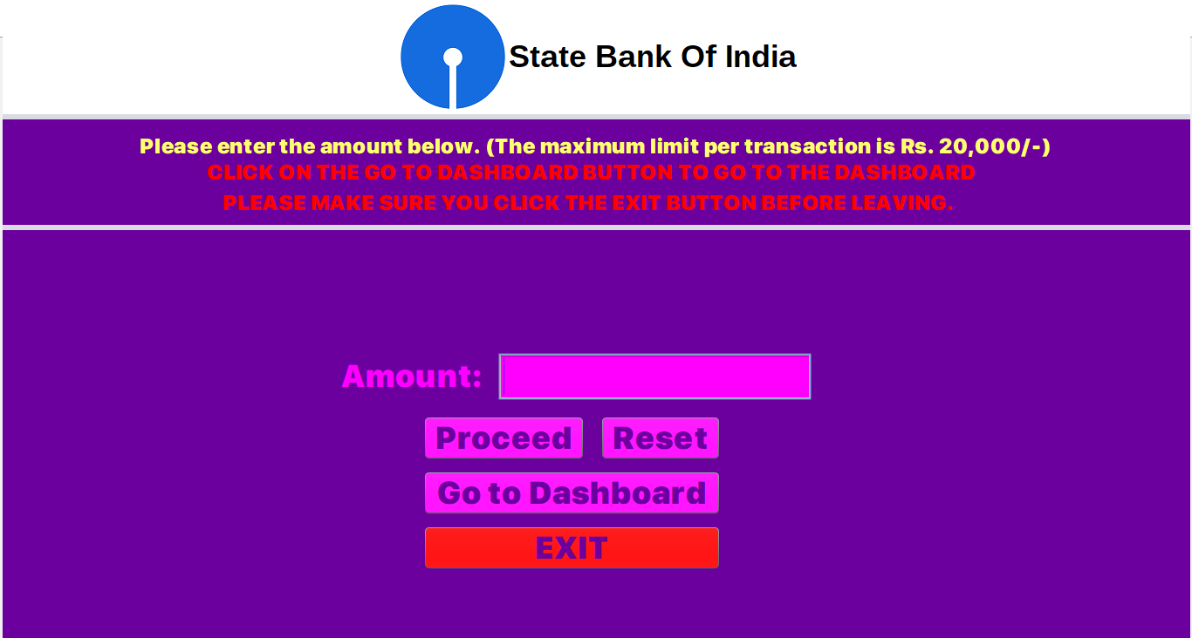

When the user enters the amount and clicks Proceed button
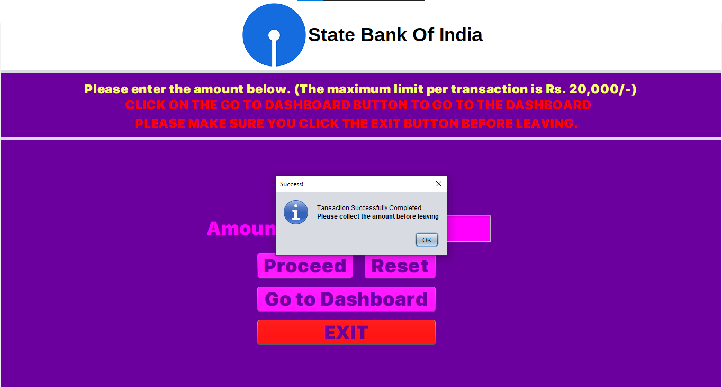
The user will now be logged out of the session

After logging in, If the user clicks Balance Info
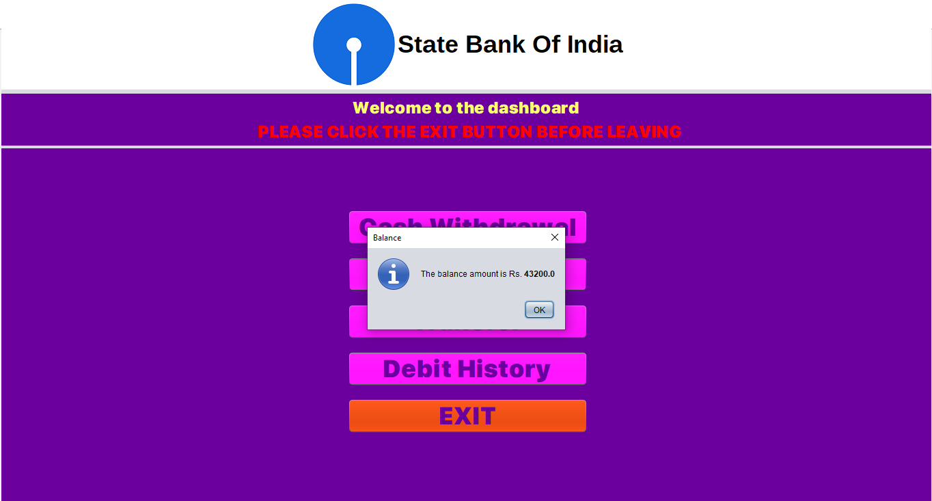
After clicking OK, if the user clicks the Transfer button (the user will now have to enter the Receiver’s username and amount)
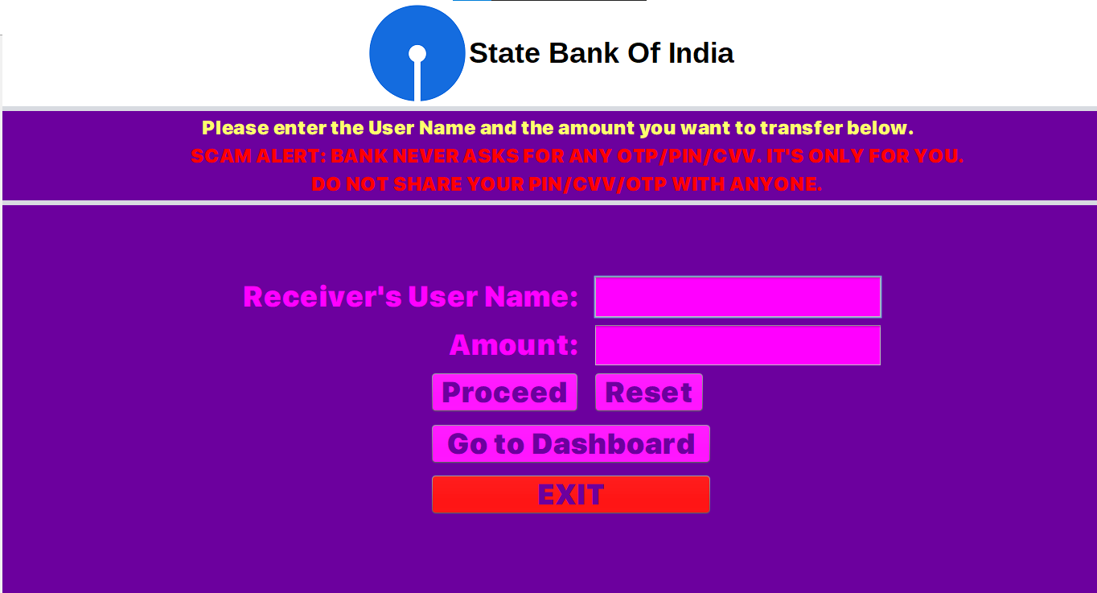

When the user clicks Proceed Button
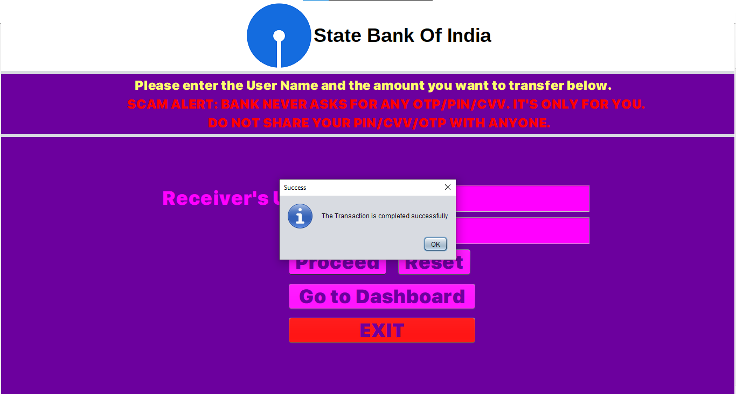
The user will now have to either click Go to dashboard button to go the dashboard or click exit to exit the session (In this case, the user clicks Go to dashboard)
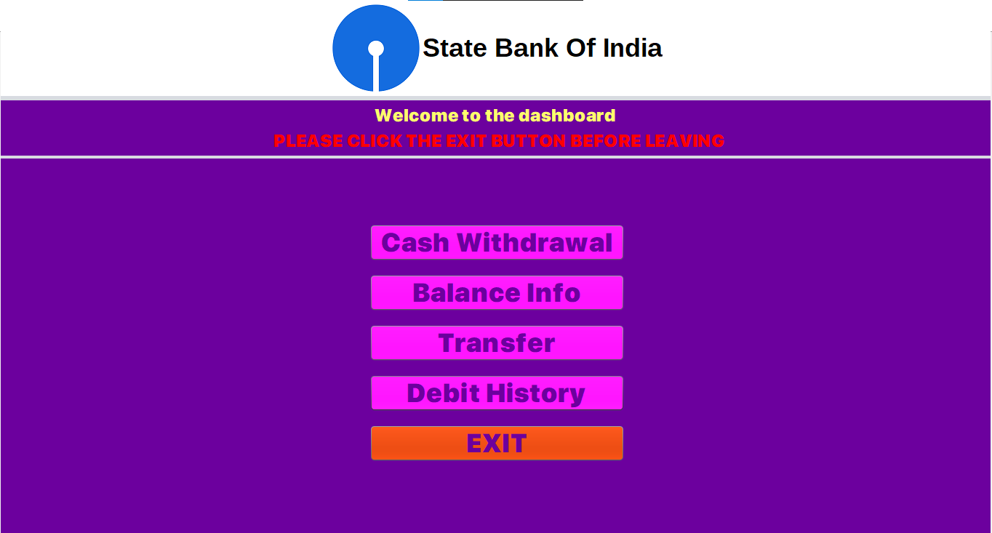

When the user clicks Debit History
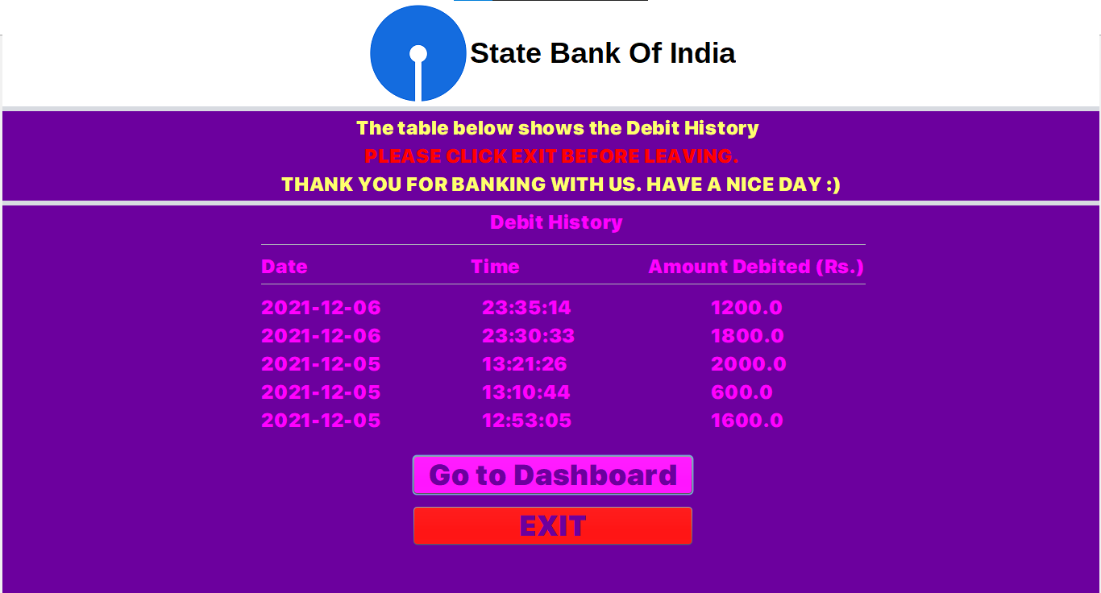
If the user clicks Exit (Will be prompted to confirm if wanna exit or not)
