# ASSIGNMENT 01 Date : 10-03-2022

1. Write a python program to input two numbers and do all basic arithmetic operations on them.

*#Author Details*print("Name: KISHAN MISHRA SIC: 190310106")  
  
*#Taking user input*a=int(input("Enter the first number:"))  
b=int(input("Enter the second number:"))  
  
print("Arithmetic Operations :-")  
print("Addition :",a+b)  
print("Subtraction:",a-b)  
print("Multiplication:",a*b)  
print("Division:",a//b)  
print("Modulus:",a%b)

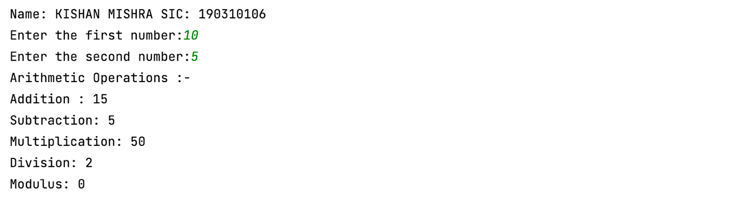Output :

1. Write a python program to input two number and swap their values without using any third variable.

*#Author Details*print("Name: KISHAN MISHRA SIC: 190310106")  
  
*#Taking user input*a=int(input("Enter the first number:"))  
b=int(input("Enter the second number:"))  
print("Before swapping")  
print("a={} b={}".format(a,b))  
  
*# temp is the third variable*temp=a  
a=b  
b=temp  
  
print("After swapping")  
print("a={} b={}".format(a,b))

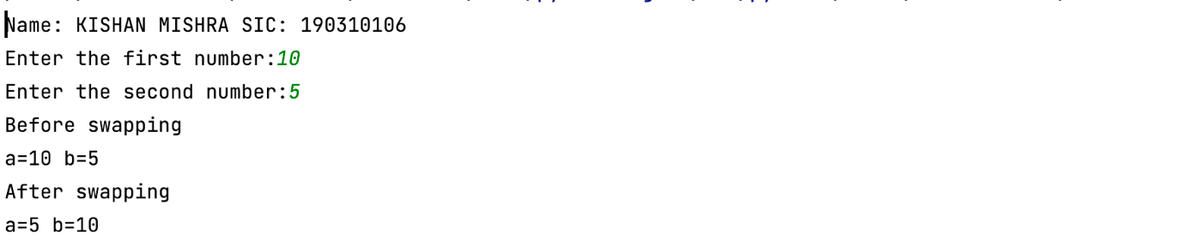 Output :

1. Write a python program to input the temperature in Fahrenheit and change it to Celsius.

*#Author Details*print("Name: KISHAN MISHRA SIC: 190310106")  
  
*#Taking user input*f=float(input("Enter the temperature in Fahrenheit :"))  
print("Temperature in Celsius:",5/9*(f-32))

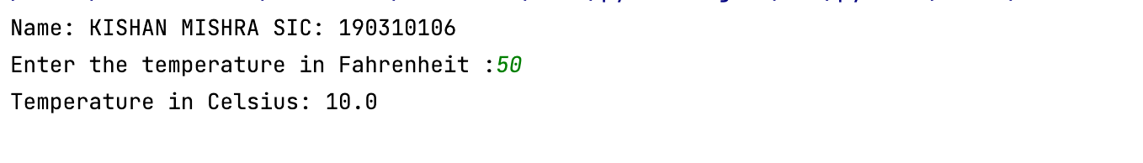Output :

1. Write a python program to input the basic salary of a person and compute its TA (20% of basic), DA (120% of basic), HRA (30% of basic), Gross (basic + ta + da +hra).

*#Author Details*print("Name: KISHAN MISHRA SIC: 190310106")  
  
*#Taking user input*sal=float(input("Enter Salary:"))  
print("TA:",ta:=0.2*sal)  
print("DA:",da:=1.2*sal)  
print("HRA:",hra:=0.3*sal)  
print('Gross Salary:',ta+hra+da+sal)

Output :

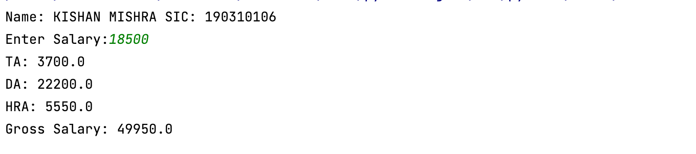

1. Write a python program to swap three variables.

*#Author Details*print("Name: KISHAN MISHRA SIC: 190310106")  
  
a,b,c=map(eval,input("Enter the values of a,b,c :").split())  
print("Values before swapping\na={} b={} c={}".format(a,b,c))  
a,b,c=b,c,a  
print("Values after swapping\na={} b={} c={}".format(a,b,c))

Output :

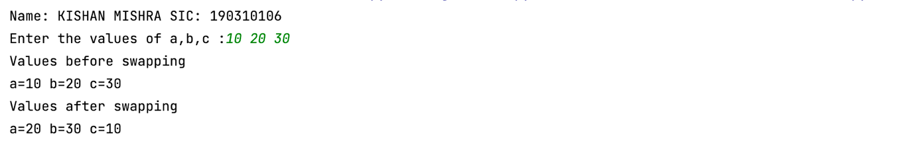

1. Write a python program to evaluate the expression 4x^4 + 3y^3 -9z + 6.

*#Author Details*print("Name: KISHAN MISHRA SIC: 190310106")  
  
x,y,z=map(eval,input("Enter the values of x,y and z:").split())  
print("Answer:",4*(x**4)+3*(y**3)-9*z+6)

Output :

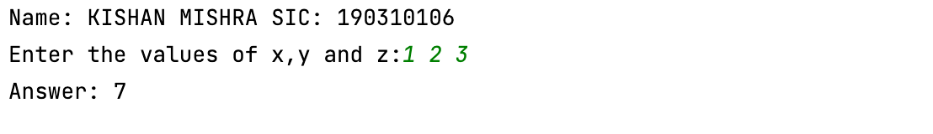

1. Write a python program to take a input in uppercase and change it to lower case.

*#Author Details*print("Name: KISHAN MISHRA SIC: 190310106")  
  
s=input("Enter the string in UPPER CASE:")  
t=""  
for i in s:  
 t+=chr(ord(i) | 1<<5)  
print("String in lowercase:",t)

Output :

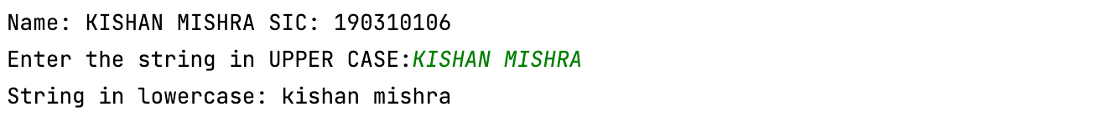

1. Write a python program to input the radius of a circle and print its area and perimeter.