

Affiliated To: Veer Narmad South Gujarat University, Surat
Project Report
AS A PARTIAL REQUIREMENT FOR THE DEGREE OF
BACHELOR OF COMPUTER APPLICATIONS (BCA)

BCA Sem V
A.Y. 2025-26

Project Title: Smart Hire Job Portal
by
Exam No. | Roll No. | Name of Student
7581 | 681 | Mistry Kishan Jayeshkumar
7545 | 698 | Maisuriya Monil Sharadkumar
 | 886 | Jariwala Vishal Bipinkumar
 | 394 | Vasava Meetkumar Ravidasbhai

Project Guide by:
Prof.Jaimini Patel

Acknowledgement

The success and outcome of this project required a lot of guidance and assistance from many people, and we are extremely fortunate to have received this throughout the completion of our project work. Whatever we have done is only due to their guidance and assistance.

We would not forget to thank Principal Dr. Aditi Bhatt, IQAC coordinator and trust representative Dr. Vaibhav Desai, In-charge of PG Courses Dr. Vimal Vaiwala, In-charge of UG and Head of the UG Department Prof. Nainesh Gathiyawala and my project guide Prof.Jaimini Patel and all other Assistant professors of SDJ International College Vesu, who took keen interest in our project work and guided us all along, till the completion of our project work by providing all the necessary information for developing a good system.

We are extremely grateful to her/him for providing such nice support and guidance, though she/he had a busy schedule managing the college affairs.

We are thankful and fortunate enough to get support and guidance from all the Teaching staff of the IT Department, which helped us in completing our project work. Also, we would like to extend our sincere regards to all the non-teaching staff of the IT Department for their timely support.

Mistry Kishan Jayeshkumar(7581)
Maisuriya Monil Sharadkumar(7545)
Jariwala Vishal Bipinkumar()
Vasava Meetkumar Ravidasbhai()

I N D E X

Sr. No | Description | Page No.
1 | Introduction
 | 1.1 Project description
 | 1.2 Project Profile
2 | Environment Description
 | 2.1 Hardware and Software Requirements
 | 2.2 Technologies Used
3 | System Analysis and Planning
 | 3.1 Existing System and its Drawbacks
 | 3.2 Feasibility Study
 | 3.3 Requirement Gathering and Analysis
4 | Proposed System
 | 4.1 Scope
 | 4.2 Project modules
 | 4.3 Module-wise objectives/functionalities Constraints
5 | Detail Planning
 | 5.1 DFD / UML – Use Case & Activity Flow Diagram
 | 5.2 Process Specification
 | 5.3 Entity-Relationship Diagram
6 | System Design
 | 6.1 Database Design
 | 6.2 User interface
7 | Software Testing & Test Cases
8 | Future Scope of Enhancements
9 | References

1.Introduction
The Smart Hire Job Portal is a robust and scalable web-based application designed to streamline and automate the entire recruitment life cycle for an organization. The platform integrates essential functionalities such as job posting and management, applicant tracking, secure candidate registration, interview scheduling, and employer relationship management. It provides an intuitive interface for both administrators/recruiters and job applicants, ensuring a smooth application experience and efficient backend operations.
The system is developed using HTML, CSS, JavaScript, Bootstrap 5, Tailwind CSS, PHP with the CodeIgniter 4 framework, and MySQL. The frontend uses HTML, CSS, and JavaScript to create dynamic and interactive user interfaces, styled with Bootstrap 5 for responsive layouts and Tailwind CSS for utility-based styling. The backend is built with PHP using CodeIgniter 4, offering a structured MVC architecture for scalable and maintainable code. MySQL serves as the relational database for secure and efficient data storage and retrieval.
To enhance functionality and user experience, the system incorporates several libraries and tools: jQuery for DOM manipulation and AJAX requests, SweetAlert2 for engaging alerts and notifications, and PHP libraries for file uploads and validation to manage candidate resumes and secure form handling. Strong authentication and session management mechanisms are implemented to safeguard sensitive information and restrict access to authorized users only.
Key Features & Modules:
- Admin/Recruiter Panel: Provides full control over job postings, applicant management, interview schedules, and user accounts, making the recruitment process simple and efficient.
- Candidate Panel: Offers a smooth application experience with job browsing, personalized profile creation, application submission, and application status tracking features.
- Job & Vacancy Management: Recruiters can post, update, and manage job details, and monitor application intake to ensure timely filling of open positions.
- Applicant Tracking System (ATS): Ensures secure handling of applications and resumes, seamless processing, and automated communication with candidates regarding their application status.
- User Management & Feedback: Maintains candidate and recruiter security, while feedback mechanisms (e.g., post-interview surveys) help improve the overall recruitment service quality.

1.1 Project Description:-
Smart Hire Job Portal is a robust web application that enables employers and recruiters to post job openings and manage the entire hiring process conveniently from their devices. It serves as a vital platform connecting organizations and job applicants, streamlining the recruitment process, and enhancing the overall talent acquisition experience.
In this system, employers/recruiters can input job details, set application requirements, manage candidate shortlists, and confirm interview schedules, while applicants can browse relevant openings, submit applications, and track their progress. The application features user authentication for both parties, real-time application status tracking, and secure communication integration, making it safe and user-friendly.
Most organizations rely on an effective recruitment system for their talent acquisition needs. The company developing or using the system must be registered and comply with employment and data privacy regulations. An Online Job Recruitment System is a web-based platform that allows companies to post their vacancies and manage the hiring workflow entirely online from the comfort of their office. The platform provides an Administration/Recruiter interface, enabling the HR department or recruitment agency to manage job postings, monitor candidate submissions, and access all application and user information.
More companies are looking for integrated recruitment systems because they simplify life for:
- The Job Applicant: Applicants can find and apply for jobs online without relying on paper applications or in-person visits.
- The Employer/Recruiter: Candidate applications, screening, and interview scheduling are managed via an automated system, providing electronic records of current vacancies, pipeline status, and historic hiring data.
Job Recruitment/Hiring is a system that can be used to fill temporary, contract, or permanent positions with the best-fit talent. Recruiting the right staff helps organizations achieve their goals, even when facing high turnover or rapid expansion.
Applicants must first register on the platform for the desired role, submitting information such as educational background, work experience, and preferred role/salary. Depending on the process, they may also provide valid identification and relevant certifications during interviews. Job roles are typically categorized into levels like entry-level, mid-senior, and executive.
[Company Name] is a leading platform that provides a dependable online (web-based) job posting and application system for users across various industries. The system acts as a bridge between employers/recruiters and candidates, delivering core recruitment services efficiently.
Developing an online job recruitment system with HTML, CSS, JavaScript, Bootstrap, Tailwind CSS, PHP (CodeIgniter 4), and MySQL provides an excellent opportunity to explore modular design, server-side MVC architecture, secure database handling, and responsive UI development, resulting in a comprehensive solution for modern talent acquisition needs.

1.2 Project Profile:-

Project Title: | Smart Hire Job Portal
Definition : | A Smart Hire Job portal is a web-based platform that connects Admin/recruiters with job seekers.
Developed For : | SDJ International College, Vesu, Surat
Project Guide(s): | Prof.Jaimini Patel
Front End: | HTML, CSS, JavaScript, Bootstrap 5, Tailwind CSS
Back End: | PHP (CodeIgniter 4), MySQL
Other (Third party tools): | Swiper.js
Operating System: | Microsoft Windows 11
Tools used for ERD & DFD | MS Word

2. Environment Description
2.1 Hardware and Software Requirements
1. Hardware Requirements:
Server Specifications
- Processor: Multi-core processor (e.g., Intel Xeon or AMD Ryzen) for handling concurrent PHP/CodeIgniter requests.
- RAM: Minimum 16 GB (32 GB or more recommended) for high concurrency and MySQL performance.
- Storage: SSD storage with at least 500 GB for fast database I/O and logs.
- Network: High-speed internet connection with redundancy.
Client Machine Specifications (Development & Testing)
- Processor: Dual-core processor (Intel i5 or equivalent).
- RAM: Minimum 8 GB (16 GB recommended) for running IDEs and testing.
- Storage: At least 256 GB SSD.
- Screen Resolution: Minimum 1920 x 1080.
Mobile Devices
- Multiple devices (smartphones/tablets) with varying operating systems (iOS, Android) for testing responsive design.

2. Software Requirements:
Core Technology Stack
- Frontend: HTML, CSS, JavaScript, Bootstrap 5, Tailwind CSS
- Backend: PHP (CodeIgniter 4)
- Database: MySQL
Operating System & Server
- Server OS: Linux (e.g., Ubuntu, CentOS) preferred for production.
- Client OS: Windows, macOS, or Linux.
- Web Server: Apache or Nginx (used as the primary web server for PHP applications).
Development & Version Control
- Code Editor/IDE: VS Code, PHPStorm, or similar.
- Version Control: Git (GitHub, GitLab, or Bitbucket).
Testing Tools
- Unit Testing: PHPUnit (for PHP backend).
- Integration/E2E Testing: Selenium or Cypress (for frontend workflow testing).
- Performance Testing: Apache JMeter.
- API Testing: Postman.
- Bug Tracking: JIRA, Trello, or Bugzilla.
CI/CD & Collaboration
- CI/CD Tools: Jenkins, GitLab CI, or CircleCI for automated deployment and testing.
- Collaboration Tools: Slack, Microsoft Teams, or similar.

2.2 Technologies Used
1. Frontend Technologies (Client-Side)
These technologies handle the user interface, interaction, and responsive design for both candidates and recruiters.
- HTML & CSS: Core building blocks of the web interface.
- JavaScript: Adds interactivity, client-side validation, and dynamic behavior.
- Bootstrap 5: Provides a responsive grid system, pre-built components, and a consistent UI.
- Tailwind CSS: Utility-first CSS framework for faster styling and customization.
- jQuery: Simplifies DOM manipulation, AJAX requests, and event handling.
- SweetAlert2: For interactive alert dialogs and notifications.
2. Backend Technologies (Server-Side)
Handles business logic, data processing, authentication, and database management.
- PHP (CodeIgniter 4): MVC framework for structured backend development and routing.
- MySQL: Relational database to store all application data (users, jobs, applications).
- PHP Libraries for File Uploads: To handle resumes and other documents.
- Session Management & Authentication: Secure login, session handling, and role-based access control.
- AJAX (via jQuery or Vanilla JS): For asynchronous communication between client and server without page reloads.

3.System Analysis and Planning
3.1 Existing System and Its Drawbacks
Existing job portal systems often suffer from limited features, inefficient workflows, and poor user experience for both candidates and employers/admins. Many platforms rely on outdated interfaces or fragmented processes, making recruitment and job-seeking cumbersome. Users frequently face the following challenges:
- Difficulty in Job Discovery: Candidates often need to browse multiple websites or filter through irrelevant job postings to find positions matching their skills and preferences.
- Lack of Personalization: Most portals provide generic job recommendations and rarely suggest opportunities tailored to a candidate’s profile, experience, or preferences.
- Poor Application Tracking: Candidates struggle to track their application status, interview schedules, or feedback from employers. Admins face difficulties monitoring ongoing recruitment processes.
- Complex Job Posting and Management: Admins/employers often encounter multi-step and manual job posting processes, increasing the chance of errors and delays.
- Inefficient Data Handling: Many portals rely on semi-automated processes, causing redundancy, delayed updates, and inaccurate candidate or job data.
- Limited Scalability: Existing systems struggle to handle increasing users, job postings, or resume data efficiently.
- Slow Communication: Lack of real-time notifications for new job postings, application updates, or interview scheduling reduces engagement.
Because of these drawbacks, there is a strong need for a modern, dynamic, and intelligent job portal designed for both candidates and admins.
The Smart Hire Job Portal addresses these limitations by leveraging a PHP (CodeIgniter 4) backend with MySQL database and HTML/CSS/JavaScript frontend, providing:
- Personalized job recommendations for candidates.
- Efficient application tracking and status updates.
- Easy job posting and management for admins.
- Fast, secure, and scalable system capable of handling large volumes of data.
- Automated notifications and updates to improve engagement.
This ensures a streamlined recruitment process, enhances the user experience, and boosts overall operational efficiency for both candidates and administrators.

3.2 Feasibility Study
Since the system is designed as a PHP (CodeIgniter 4) backend with HTML/CSS/JS frontend, feasibility is evaluated as follows:
1. Technical Feasibility:
- Frontend: HTML, CSS, JavaScript, Bootstrap 5, Tailwind CSS for responsive, dynamic, and interactive UI.
- Backend: PHP with CodeIgniter 4 framework, MySQL for database management.
- Advantages: MVC-based modular architecture, reusable components, scalable, easy to maintain, and simple integration with AJAX and APIs.
- Challenges: Ensuring smooth data flow between frontend and backend using AJAX, PHP sessions, and secure file uploads.
2. Economic Feasibility:
- All technologies used are open-source, minimizing software costs.
- Faster development due to reusable frontend templates and backend modules.
- Lower maintenance costs because of structured CodeIgniter architecture and modular database design.
3. Operational Feasibility:
- Admins can efficiently manage jobs, candidates, and application workflows.
- Candidates can browse jobs, apply online, and receive timely notifications.
- The system improves recruitment efficiency and reduces manual effort.

3.3 Requirement Gathering and Analysis
Functional Requirements:
- Frontend (HTML/CSS/JS + Bootstrap/Tailwind):
  - User-friendly dashboard for admins to post and manage jobs.
  - Candidate interface for browsing jobs and applying online.
  - Form validation using JavaScript and optional client-side libraries (e.g., jQuery Validation).
- Backend (PHP/CodeIgniter 4):
  - Secure API endpoints for job posting, fetching jobs, and user management.
  - Authentication and session management for admins and candidates.
  - Database operations using MySQL to store job and candidate data.
  - File handling for resumes or documents using PHP file upload functions.
Non-Functional Requirements:
- Performance: Fast rendering and optimized server responses.
- Scalability: Able to handle growing numbers of jobs and candidates.
- Security: Secure login, session handling, and protected file uploads.
- Usability: Intuitive and responsive UI for both admins and candidates.
- Maintainability: Modular architecture allowing easy updates and feature additions.
Requirement Analysis:
- Identify reusable frontend components (job cards, dashboards, notifications).
- Define routes and data flow between frontend and PHP backend.
- Implement proper validation and error handling on both client and server sides.
- Design a secure and scalable MySQL database schema for jobs, candidates, and applications.

4.Proposed System
The proposed system, Smart Hire Job Portal, is a modern web-based application designed to streamline the recruitment process for both candidates and administrators (admins). It moves beyond traditional job boards by focusing on personalized job discovery, efficient job management, and secure communication channels. The system is architected using the MERN stack principles: React for the highly responsive frontend, Node.js/Express.js for the scalable backend server, and MongoDB as the flexible, high-performance database.

4.1 Scope
The scope of the Smart Hire Job Portal defines the boundaries of the project—detailing what the system will do (Functional), how it will perform (Non-Functional), which external systems it will connect with (Integration), the underlying technology (Technical), and the project constraints (Management).
1. Functional Scope (What the System Does)
The system functionalities are organized into two primary user modules:

👤 Candidate/User Module
Feature Area | Key Functionality
Profile | User registration, creation of a detailed profile, and secure upload/management of the candidate's professional resume.
Jobs & Apply | Ability to search for jobs using multiple criteria (e.g., location, salary, skills, category) and to submit/. And wait for Company Email
Career Guidance | Assist candidates with building resumes, linking professional profiles, and improving communication skills.

👤 Recruiter/Admin Module
Sub-Module | Functionality
Job Management | Admins can Create new job postings, Edit existing listings, Publish them instantly, and Archive (or delete) jobs that are filled or obsolete.
Candidate Tools | Admins can Screen and Filter applications based on criteria, Shortlist candidates, and manage communication logs related to interviews, offers, or rejections.
Reporting | The system allows Admins to Generate Reports on critical hiring metrics, such as application rates, source of applicants, and time-to-hire.

2. Non-Functional Scope (How the System Performs)
The system must meet specific quality criteria to ensure a reliable and effective user experience.
Criterion | Requirement
Performance | The system must achieve acceptable and fast response times for all major operations, including job searches, page loads, and application submissions.
Security | Implement secure user authentication using JSON Web Tokens (JWT), ensure data encryption (both in transit and at rest), and maintain compliance with relevant data protection regulations (e.g., GDPR/CCPA, if applicable to the operating region).
Usability | The interface must be intuitive, require minimal training, and feature a fully responsive design that functions flawlessly across desktop, tablet, and mobile devices.
Scalability | The architecture must be designed to guarantee the system can handle a defined maximum number of concurrent users and accommodate anticipated database growth over the first two years of operation.

3. Integration Scope 🔗
The system requires integration with specific external services to enhance its core functionality.
- Communication: Mandatory integration with Email Services (e.g., SendGrid, AWS SES) for reliable transactional emails (notifications, alerts, password resets) and mass communication to users.
- SSO: Integration capabilities for Social Media/Single Sign-On (SSO) via popular platforms like Google or LinkedIn to facilitate quick and easy candidate registration/login.

4. Technical Scope
- Technology Stack: The core development utilizes PHP (CodeIgniter 4) for the backend, MySQL for the database, and HTML, CSS, JavaScript, Bootstrap 5, and Tailwind CSS for the frontend.
- Architecture: The system follows an MVC (Model-View-Controller) architecture provided by CodeIgniter 4, separating the business logic, user interface, and data layers. This ensures modularity, maintainability, and scalability. The specific architecture details (e.g., monolithic or layered design) will be formally defined and documented during the design phase.

5. Project Management Scope (Deliverables & Exclusions)
Category | Item/Constraint
Deliverables | A fully developed and tested system deployed to a production environment, complete source code, comprehensive technical documentation (including the E-R Diagram), and detailed user manuals for both Admin and Candidate roles.
Exclusions | Long-term maintenance after the contracted warranty period expires; Integration with external payroll systems (e.g., SAP, QuickBooks); Integration with internal legacy HRIS (Human Resource Information Systems).
Timeline | Key Milestones (e.g., Alpha/Beta Launch, UAT Completion) and the overall project schedule will be defined and tracked using standard project management methodologies.

4.2 Project Modules
The Smart Hire Job Portal is architecturally divided into two highly distinct environments: the Client-Side, dedicated to the job seeker's experience, and the Admin-Side, focused on recruitment workflow management and system oversight.

A. Client-Side Modules (Candidate Interface)
These modules ensure that the candidate journey—from first visit to application submission—is intuitive, personalized, and fully trackable.
Module | Detailed Description | Core Functional Responsibilities
Register / Login | This is the crucial authentication gateway. It facilitates the secure onboarding of new users and manages session continuity for returning candidates, ensuring data privacy and access control. | User Registration: Collection and validation of minimum required data (email, password). Secure Login: Verification against stored credentials and generation of authentication tokens (JWT). Password Management: Provision for password reset and recovery mechanisms.
Home Page | Acts as the primary landing page, designed for engagement and rapid orientation. It summarizes key site features and prioritizes content relevant to immediate user action. | Feature Highlights: Showcasing new or premium services. Featured Jobs: Displaying high-priority or recently posted job listings. Quick Search: Providing immediate access to the core job search utility.
Job Page | The comprehensive repository of all available job opportunities. This module provides robust tools necessary for candidates to efficiently narrow down thousands of listings to highly relevant options. | Job Listing Display: Presentation of jobs in a clear, paginated list format. Advanced Filtering: Allowing filtering by multiple criteria (industry, salary range, job type, location). Keyword Search: High-performance full-text search across job titles and descriptions.
Job Details | Dedicated module that presents the exhaustive information needed for a candidate to qualify a job. It is the final step before the application decision. | Complete Description: Full job summary, duties, and required qualifications. Company Profile: Information about the recruiting organization. Application Function: Direct 'Apply Now' button linked to the application process. Contextual Recommendations: Listing similar jobs based on metadata.
User Dashboard | The personalized control center providing a holistic view of the candidate’s engagement with the portal and the current state of their job hunt. | Personalized Recommendations: Algorithmic suggestions based on profile data and search history. Application Tracker: Detailed list of all submitted applications and their current status updates. Profile Management: Quick access to update personal information and preferences.
Resume Upload Section | A secure and dedicated utility for managing critical application documents. Ensures that the application process is quick and uses the most current document version. | File Management: Ability to upload, replace, or delete resume files. Security & Validation: Enforcing file type (PDF/DOCX) and size limits. Preview Function: Allowing candidates to review the uploaded document before submission.
About Page | Provides transparency and context regarding the portal’s purpose and organizational structure. | Displaying static content detailing the company mission, values, and team structure.
Contact Page | The primary channel for user support and external inquiries. | Provides a validated form for submitting questions or feedback, ensuring prompt routing to the appropriate administrative team.
Service Page | Designed to highlight the value-added features that differentiate the portal from standard job boards, including potential monetization streams. | Detailing services like premium profile visibility, career advice workshops, or paid resume critique services.

B. Admin-Side Modules (Recruiter Interface)
These modules are protected and focused entirely on administrative control, candidate management, and data consistency, serving as the core of the Applicant Tracking System (ATS) functionality.
Module | Detailed Description | Core Functional Responsibilities
Admin Login | A highly restricted and secure authentication module designed to prevent unauthorized access to sensitive applicant data and system control functions. | Credential Validation: Secure login using unique administrative usernames and strong passwords. Authorization Check: Verifying the user's role/permissions level upon successful login.
Admin Controller (CRUD) | This is the command center for all content and user data, underpinning the smooth operation of the recruitment pipeline. | Job Post Management: Comprehensive interface for Creating detailed job postings, Updating content (salary, location, requirements), and Archiving/Deleting filled or expired jobs.

4.3 Module-wise Objectives / Functionalities & Constraints 🎯
This section systematically lists the specific objectives and key functionalities for each module, alongside the constraints that govern their operation for both the Client-Side (Candidate) and Admin-Side interfaces.
  - Client-Side Modules (Candidate Interface)
Module | Objective | Key Functionalities | Client-Side Constraints
Register / Login | Secure registration and authentication for new and returning candidates. | User profile creation; secure login with email/password; password recovery process. | Mandatory registration required to access job details or apply.
Home Page | Provide a quick overview of the portal's content and latest job features. | Display latest/featured job postings; quick search bar integration; portal statistics highlights. | Content refresh requires a stable internet connection.
Job Page | Enable efficient discovery and filtering of all available job listings. | Display paginated job list; advanced filtering (location, category, type); high-performance keyword search. | Filtering accuracy relies on complete job data provided by the Admin.
Job Details | Show complete information necessary for a candidate to assess the job and apply. | Full job description; company overview; 'Apply Now' button; similar job recommendations. | Application requires a valid, uploaded resume.
User Dashboard | Offer a personalized, centralized control center for the candidate’s application journey. | View personalized job recommendations; track application status; manage profile settings. | Dashboard data accuracy is dependent on real-time backend updates.
Resume Upload | Facilitate easy and secure submission and management of application documents. | Upload/update resume file; file type/size validation; secure storage integration. | File uploads must adhere to size and format restrictions (e.g., max 5MB, PDF/DOCX).
About Page | Inform users about the portal's purpose, mission, and services. | Display static content about the organization and its goals. | N/A (Static Content).
Contact Page | Provide a direct communication channel between users and portal admins. | Submission form for inquiries/feedback; display support contact information. | Form submission requires a valid email address for a reply.
Service Page | Highlight specialized services or additional features offered by the portal. | Detail premium features (if any); link to external resources (career guidance). | Access to premium services may be restricted to paid subscribers.

  - Admin-Side Modules (Recruiter Interface)

Module | Objective | Key Functionalities | Admin-Side Constraints
Admin Login | Securely restrict access exclusively to authorized system administrators. | Unique admin email/password authentication; session management. | Only registered admins can successfully log in and access the panel.
Admin Controller (CRUD) | Provide full control over the creation, management, and deletion of core system data. | Jobs: Create, update, delete, and archive job postings. Candidates: View, filter, update application status, and manage user records. | Job and candidate updates must comply with data validation rules (e.g., required fields).

C. General System Constraints
These constraints apply universally to the entire Smart Hire Job Portal system:

- Security & Compliance: The system must maintain secure authentication and authorization protocols (e.g., JWT). All data handling must comply with relevant data privacy laws.
- Performance: High traffic periods will require necessary backend scaling (Node.js/Express) and database optimization (MongoDB indexing) to maintain acceptable response times.
- Technical Environment: The system operation is strictly dependent on the MERN stack infrastructure. Any feature requiring non-MERN technologies must be integrated as a separate service.
- API Usage: Integration modules (e.g., Payments, SSO) are constrained by the rate limits and terms of service of the external third-party providers (e.g., Stripe, Google)

5.1 DFD / UML – Use Case & Activity Flow Diagram

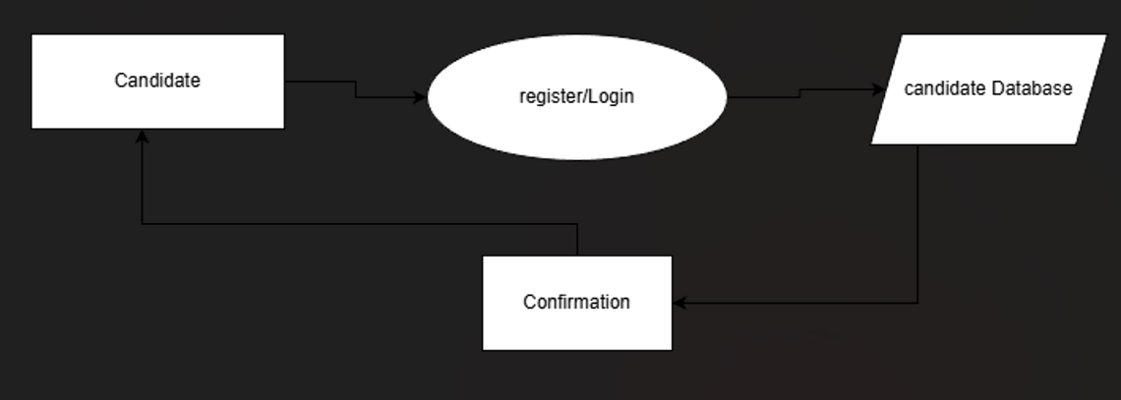

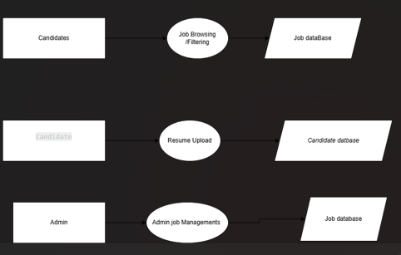

2. UML Use Case Diagram

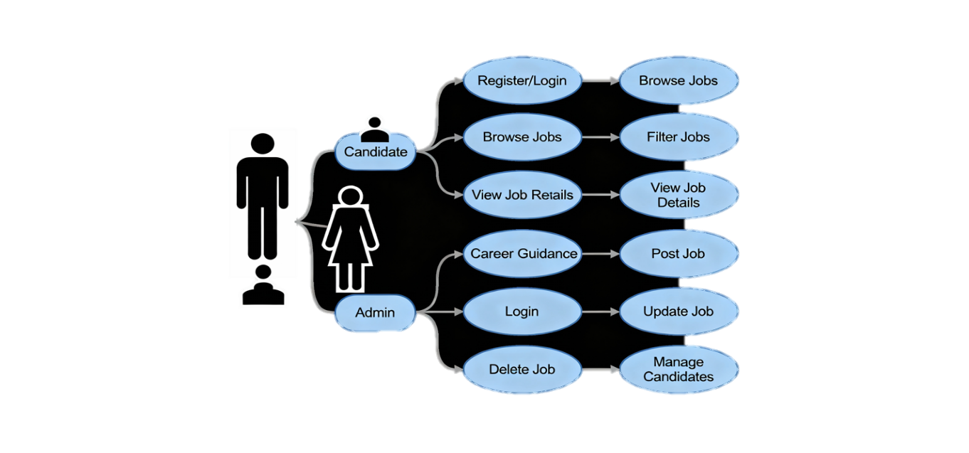

3. Activity Flow Diagram

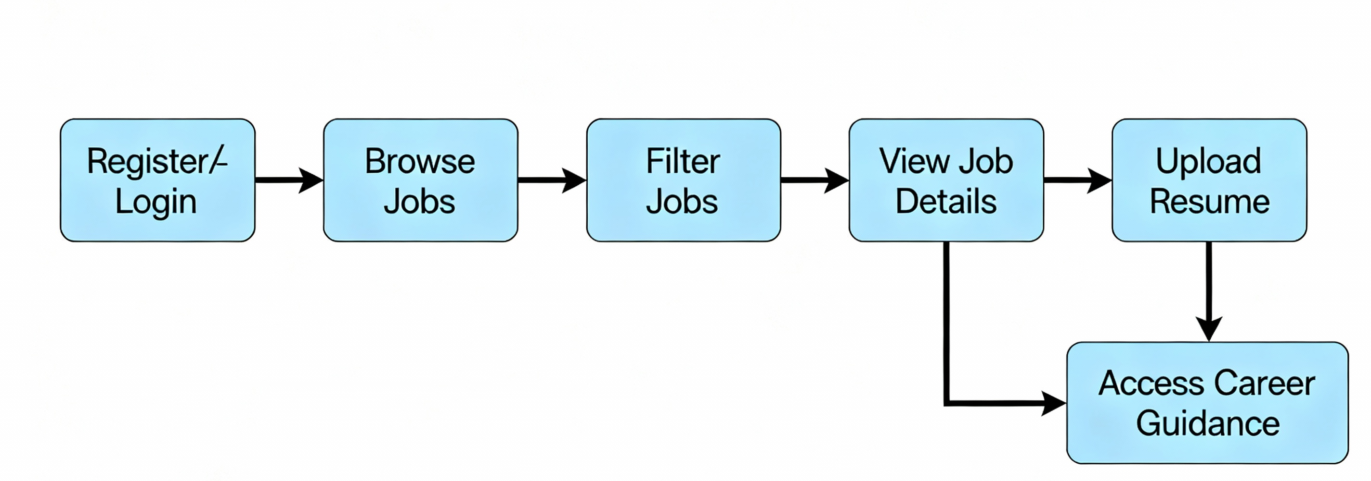

4. Entity-Relationship Diagram (ERD)

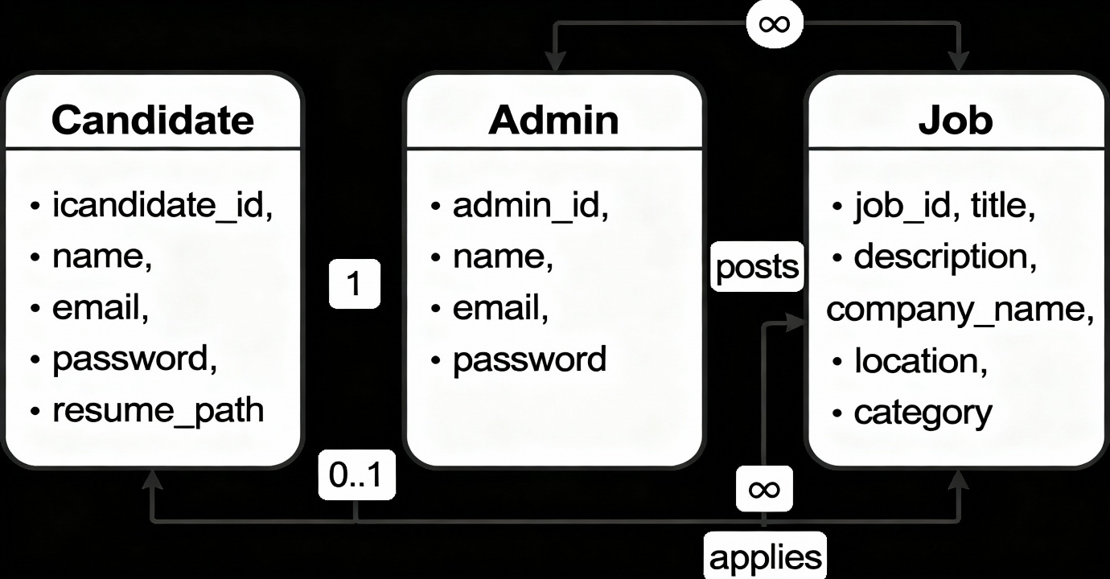

5.2 Process Specification
This section documents the detailed, non-visual logic for the most critical data operations. Since the backend is Node.js/Express, this defines the server-side controller logic.

5.3 Entity-Relationship Diagram (MongoDB)
For a MongoDB database, this model is specifically a Document Model Diagram that emphasizes data Embedding (denormalization) for faster reads and Referencing (using ObjectIDs) for large or frequently changing data.
Collection (Entity) | Primary Use | Key Relationship Strategy
User | Stores all candidate profile data. | Embedding: Small data like contact info is embedded. Referencing: Array of ObjectIDs links to all related Application documents.
Job | Stores all job posting details. | Embedding: Job requirements (skills) are embedded. Referencing: A single ObjectId links to the posting Admin. Array of ObjectIDs for all Applications.
Application | Stores the link between a Candidate and a Job, plus status history. | Referencing: Critical references to one User and one Job (many-to-one relationship).
Admin | Stores the credentials and roles for administrators. | Referencing: Referenced by the Job collection to show the creator.

6. System Design
Database design:
Jobs table :

Field Name | Type | Description | Relationship/Indexing Notes
_id | ObjectId | Unique identifier for the job. | Primary Key.
jobCode | String | Unique identifier for internal tracking. | Unique Index.
title | String | Job title. | Indexed for search.
company | Object | Embedded details about the hiring company. | Embedded Document.
locations | Array | Geographical work location(s). | Array of Strings/Objects.
experienceLevel | String | Required experience level (e.g., "Senior-Level"). | Indexed for filtering.
category | String | Job category (e.g., "Administration"). | Indexed for filtering.
description | String | Detailed job description. | Indexed for full-text search.
requirements, responsibilities, education, skills, perks, benefits | Array | Lists of required attributes and offerings. | Embedded Arrays (Denormalization for fast read).
isFeatured | Boolean | Flag to mark jobs for homepage promotion. | Indexed for quick retrieval.
postedAt, deadline | Date | Timestamps for posting and application cutoff. | Indexed for sorting/filtering.
status | String | Current status (e.g., "active"). | Indexed for filtering.
hiringTeam | Array | List of IDs or objects representing the hiring personnel. | Potential Reference to Admin/User documents.
saveBy, likedBy, savedBy | Array | Lists of User IDs who saved/liked the job. | Referencing: Array of User ObjectIDs (Many-to-Many).

User table :
Field Name | Type | Description | Relationship/Indexing Notes
_id | ObjectId | Unique user identifier. | Primary Key.
fullName | String | Candidate's full name. | Indexed for Admin search.
email | String | User's primary email address. | Unique Index (Used for Login).
password | String | Hashed password (e.g., "$2b$10..."). | Secured field.
workStatus | String | Candidate's professional status (e.g., "experienced"). | Indexed for matching/filtering.
role | String | User's system role ("candidate"). | Indexed for access control.
createdAt, updatedAt | Date | Timestamps for document creation and updates.

Skill table:
Field Name | Type | Description | Relationship/Indexing Notes
_id | ObjectId | Unique skill entry identifier. | Primary Key.
name | String | The name of the skill (e.g., "React.js"). | Indexed for fast retrieval.
userId | String/ObjectId | The ID of the user who possesses this skill. | Referencing: Links back to the Users Collection. (Crucial for profile retrieval).

Contact table :

Field Name | Type | Description | Purpose/Usage
_id | ObjectId | The unique identifier for this inquiry document. | Primary Key.
name | String | The name provided by the sender. | For Admin reference and personalization when replying.
email | String | The sender's email address. | Crucial for the Admin to respond to the inquiry.
phone | String | Optional contact phone number provided by the sender. | Alternative contact method.
message | String | The body content of the inquiry or feedback. | Stores the core message content.
date | Date | The exact timestamp when the message was submitted. | Used for sorting, tracking, and prioritizing responses by the Admin.

7. Software Testing
6.1 Introduction
Software testing is a crucial process in the development of the Online Job Recruitment System. It ensures that the platform meets Recruiter (Admin) and Candidate (User) requirements, functions accurately, and remains free from critical errors. Since the system involves candidate profile management, application tracking, and secure data handling, testing guarantees the platform's reliability, performance, and data security before deployment.
Objectives of Software Testing
- Detect and fix defects early in the development lifecycle to reduce the cost and effort of correction.
- Ensure the system meets all Recruiter and Candidate requirements, verifying that workflows like job posting and application submission function correctly.
- Verify the reliability, performance, and security of the platform, particularly concerning data privacy (e.g., resume storage) and high-volume application handling.
- Deliver a quality product that improves the efficiency of the hiring team and provides a seamless, trustworthy experience for job seekers.
Types of Software Testing
- Manual Testing
  - Conducted by testers without automation tools.
  - Useful for checking UI/UX of the Candidate portal, navigation, and the logical flow of key workflows (e.g., the complete application submission process or the Admin's candidate filtering process).
- Automated Testing
  - Tools like Selenium or Cypress for UI tests, or Postman for API tests, automate repetitive tasks.
  - Helps validate API endpoints for profile CRUD (Create, Read, Update, Delete) operations, application submission, and load tests to simulate high volumes of concurrent job applicants.
Levels of Software Testing
- Unit Testing: Focuses on verifying that individual functions or modules (like the password encryption or a specific calculation) work correctly in isolation.
- Integration Testing: Verifies that different modules work together correctly when integrated (e.g., ensuring candidate registration successfully passes data to the profile module).
- System Testing: Tests the complete, fully integrated system to verify that it meets both the functional and non-functional (e.g., security, performance) requirements from end-to-end.
- Acceptance Testing: The final phase where the system is validated against the original business requirements to ensure it's ready for deployment and satisfies the needs of the end-users (Recruiters and Candidates).

7. Limitation and System Enhancement
7.1 Limitations
The system's reliance on digital infrastructure and complex features introduces several challenges.
- Internet Dependency: Requires a stable internet connection. Users with poor connectivity will face delays in uploading large files (resumes) or navigating the system.
- Digital Literacy Issues: Users unfamiliar with digital tools may struggle with complex ATS features or profile management, leading to usability challenges and incomplete data.
- Security Concerns: Highly vulnerable to threats like data breaches, hacking, and phishing, given the sensitive nature of stored PII (Personally Identifiable Information, like resumes and contact details).
- Integration Challenges: API failures or technical errors can disrupt crucial links with internal HRIS (for hire hand-off) or external email/calendar services, causing workflow disruptions.
- High Maintenance Cost: Significant operational costs are incurred for secure cloud hosting, regular software updates, and specialized tools needed for compliance (GDPR/CCPA).
- Scalability Limitations: Risk of system slowdowns or crashes during high-volume events (e.g., peak application periods) if the cloud resources are not configured to scale immediately.
- Trust Issues: New users (candidates) may initially hesitate to share sensitive data. Recruiters may also doubt the system's ability to accurately filter and rank candidates.
- Dependency on Third-Party Services: Operations can be impacted by the downtime or policy changes of external tools relied upon, such as AI resume parsers or SSO authentication providers.

7.2 System Enhancements
1. Intelligence & Automation
- AI-Powered Matching and Scoring: Implement AI/ML to automatically score and rank candidates against job requirements, significantly reducing manual screening time for recruiters.
- Automated Interview Scheduling: Integrate with calendar services (Google/Outlook) to allow candidates to self-schedule slots, eliminating manual coordination efforts.
- Candidate Support Chatbot: Introduce an AI chatbot for instant answers to FAQs (application process, password resets), freeing up human recruiter time.
2. Security & Compliance
- Multi-Factor Authentication (MFA): Strengthen security via two-factor methods (e.g., OTPs) for both users and recruiters, crucial for protecting stored PII (Personally Identifiable Information).
- End-to-End Encryption with Audit Trails: Encrypt all sensitive data and maintain tamper-proof logs of file access/modification, ensuring compliance and data transparency.
- Enhanced Profile Verification: Integrate with third parties to securely verify certifications/degrees and conduct background checks earlier for better candidate vetting.
3. Scalability & Reach
- Cloud-Based Scalability: Deploy on a robust cloud platform (AWS, Azure, or GCP) to ensure seamless scaling and high performance during heavy traffic (mass hiring events).
- Multi-Language Support: Provide the interface and key content in multiple languages to improve accessibility and attract a wider, international talent pool.
4. User Experience & Reporting
- Dedicated Mobile Application: Develop a native app (iOS/Android) for candidates to easily search jobs and track status, and for recruiters to manage basic approvals on the go.
- Advanced Analytics Dashboard: Offer the Admin/HR team a detailed dashboard with real-time reports on critical metrics like Time-to-Hire and candidate funnel drop-off rates for strategic optimization.

8.Bibliography
A bibliography is an essential part of any research or software project documentation. It provides a list of sources that were referred to during the development of the project. These sources may include books, research papers, websites, online articles, technical documentation, software manuals, and industry reports. A well-structured bibliography not only enhances the credibility of the project but also allows future researchers and developers to explore relevant references.
Importance of Bibliography
1.Online Articles and Websites
• GeeksforGeeks (www.geeksforgeeks.org)
• Used for learning database normalization, ER diagrams, and CRUD operations in PHP and MySQL.
• W3Schools (www.w3schools.com)
• Provided tutorials for HTML, CSS, JavaScript, Bootstrap, Tailwind CSS, and PHP.
• Stack Overflow (www.stackoverflow.com)
• Helped in troubleshooting errors and understanding best coding practices.
• Mozilla Developer Network (developer.mozilla.org)
• Used for learning JavaScript, APIs, and web development fundamentals.
• PHP Official Documentation (www.php.net/docs.php)
• Served as a reference for PHP functions, MySQL integration, and security best practices.

2.Software Tools and Documentation
• XAMPP (Apache Friends - www.apachefriends.org)
•Used for setting up the local development environment with Apache, MySQL, and PHP.
• MySQL Documentation (dev.mysql.com/doc/)
• Provided guidance on database design, indexing, and performance optimization.
• Bootstrap (getbootstrap.com/docs/5.0/)
• Used for implementing a responsive design in the project.
• Tailwind CSS (tailwindcss.com/docs/)
• Helped in creating utility-first CSS components.

