Migration Approach & Suggestions
aftermarketdbx — For Discussion / Showcase (companion to the DE Standards document, not itself a standard)
Version 1.0 | 2026-09-17

1. Purpose
This is a separate, non-binding companion to the DE Standards & Governance Framework. It captures suggested planning tools — a migration methodology, a wave sequencing approach, and a worked Azure Boards example — for team discussion and stakeholder showcase. Nothing here needs sign-off; it's a starting point to react to.

2. Recommended 5-Phase Migration Methodology
Based on Databricks' published migration methodology ("Databricks Migration Strategy: Lessons Learned", Databricks Blog, Oct 2024), which reflects patterns from their Professional Services team across many customer migrations.
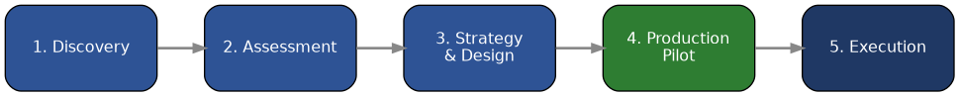
Phase | What happens
1. Discovery | Understand why we're migrating and the constraints of the current system; stakeholder Q&A and architecture discussions; profile the legacy workload to estimate scope and cost.
2. Assessment | Evaluate complexity of existing code/pipelines in depth; refine scope; identify what can be retired outright rather than migrated.
3. Strategy & Design | Finalize target architecture and detailed design for data migration, transformation logic, and reporting; map source-to-target; agree tooling and delivery approach.
4. Production Pilot | Migrate one clearly defined, valuable end-to-end use case first (data, code, and reports) to prove the pattern and surface real issues early; capture lessons in a retro before scaling.
5. Execution | Repeat the pilot pattern at scale across remaining sources/tables, applying lessons learned, typically in parallel agile sprints.

Key lessons worth carrying into this project
- Think big, start small: pick one meaningful, end-to-end use case for the pilot rather than a trivial one — a real reporting dashboard end-to-end tells you more than a toy table.
- Automate discovery where possible: use profiling/metadata scans rather than relying only on interviews, to get an honest picture of usage and complexity.
- Data migration is separate work from code/pipeline migration — plan historic/catch-up loads and ongoing ingestion as their own workstream, not an afterthought.
- Don't skip governance: Unity Catalog access control, auditing, and lineage should be part of the design from the start, not retrofitted.
- Validate with business SMEs: real user-acceptance testing and data reconciliation against the old system builds the trust needed to decommission it.
- Operationalize before declaring done: quality checks, exception handling, reprocessing, and pipeline observability are what make a migration "real" in production, not just a one-time load.
Source: Komninos, Shah, Bhatt, Sharma & Léturgez, "Databricks Migration Strategy: Lessons Learned," Databricks Blog, Oct 23, 2024 — databricks.com/blog/databricks-migration-strategy-lessons-learned.

3. Wave-Based Rollout Strategy
Rather than migrating all ~100+ tables/pipelines at once, group them into waves by business criticality and complexity. This keeps the Production Pilot (Phase 4 above) contained, and lets Wave 1 double as the pilot.
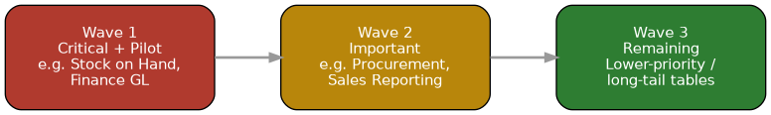
Wave | Criteria | Suggested candidates
Wave 1 — Critical | High business criticality, relatively well-understood source, clear consuming team ready for UAT. Doubles as the pilot. | Stock on Hand, Finance GL summary — anything with a well-known BIS source and an eager analyst partner.
Wave 2 — Important | Meaningful business value, moderate complexity; benefits directly from Wave 1's lessons/framework reuse. | Procurement, sales reporting variants.
Wave 3 — Remaining | Lower urgency, long-tail or low-usage tables; good fit once the framework and standards are stable. | Everything else, including newly onboarded Excel/API sources.
Wave assignment should be a short workshop with business stakeholders, not a purely technical call — criticality is a business judgment.

4. Azure Boards — Worked Example
Illustrates the hierarchy set in the Standards document (Section 7.6): Epic = the migration project itself, Feature = per source system, User Story = per table, Task = per delivery step.
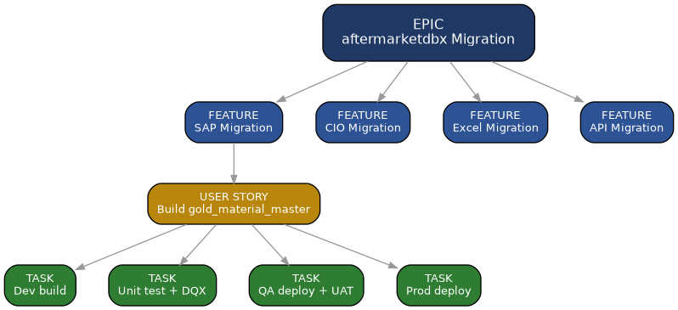

Example board (Sprint view)
To Do | In Progress | In PR Review | In QA
Build gold_vendor_master (SAP) | Build gold_material_master (SAP) | Build gold_gl_summary (SAP) | Build gold_stock_on_hand (SAP)
Onboard Excel: pricing file | DQX rules: gold_customer | Contract review: gold_sales | UAT: gold_finance_gl
"Done" column omitted here for space — in practice it lists items deployed to Prod with sign-off recorded per the Release Checklist.

This document is a discussion aid — update freely without going through the standards change-control process.

