Data Engineering Standards & Governance Framework
aftermarketdbx — Synapse to Databricks Migration
Version 3.1 | Draft | 2026-10-13

Table of Contents

1. Purpose & Scope
This document defines the minimum standards the Data Engineering (DE) team follows to migrate the existing Synapse pipelines and views to Databricks. It is the single reference for design, build, and release.
- In scope: migrating Synapse items (pipelines and views) to Databricks, and the standards those migrated items must follow.
- Out of scope: Azure AD / group and workspace access setup, and compute (SQL warehouse) provisioning — owned by BIS / Central IT.

2. Current vs. Proposed Architecture

2.1 Current State — Synapse
SAP GUI exports land on a network drive, an Auto Loader job moves them into Azure Storage, Synapse pipelines transform them into Silver parquet files, and analysts query views built on those files.

2.2 Proposed State — Databricks
BIS extracts the source systems into its own prod_silver tables, which DE treats as raw input. If the BIS table is in good shape, DE builds Gold as a materialized view directly on it; if not, DE builds its own Silver first and then Gold. Analysts consume Gold only.
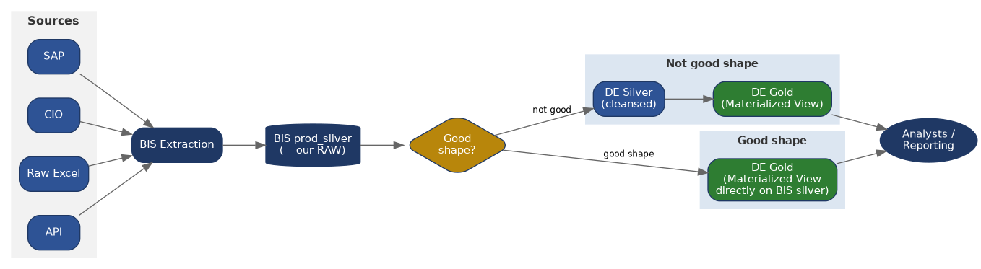

3. Layer & Design Standards

3.1 Raw (BIS prod_silver)
- Treated as read-only input. DE does not write to BIS tables.

3.2 Silver (DE-owned, only when needed)
- Built only when the BIS table is not in good shape (dirty keys, unreliable schema, unclear delete behavior).
- Holds cleansing, standard data types, deduplication, and conformed keys. DQX checks run on write (Section 10).

3.3 Gold (DE-owned, analyst-facing)
- Materialized views are the default for Gold. Build on BIS silver directly when it is in good shape, otherwise on DE Silver.
- Every Gold object has a data contract (Section 4) before go-live.
Standard materialized view pattern, using automatic liquid clustering by default, or explicit columns when the query pattern is known:
CREATE OR REPLACE MATERIALIZED VIEW <catalog>.<schema>.mv_<business_entity>
CLUSTER BY AUTO -- or: CLUSTER BY (<column_1>, <column_2>)
AS
SELECT ...
FROM <source_table>;
Hard partitioning is not used by default; revisit per table only if a real need appears.

3.4 Soft-Deleted Records
- Where the source marks deletes with a flag instead of removing rows, deletes are carried through as state (is_deleted), never hard-deleted on ingestion.
- Gold hides deleted rows by default (is_deleted = false) unless the contract states otherwise.

3.5 Date & Time
- All dates and datetimes are stored in UTC, unless BIS specifies otherwise for a given source (confirmed by BIS).
- Any non-UTC value must be declared in that table's data contract.

4. Data Contract (Mandatory)
Every Gold table must have a data contract before it is released. No contract, no release. The contract is a YAML file that states what the table promises its consumers: owner, grain, schema, refresh timing, quality rules and thresholds, and change policy.
- Location: contracts/<catalog>.<schema>.<table>/contract.yaml, at the root of the bundle repo (Section 8), so it is versioned and reviewed with the code.
- Created in the feature branch and reviewed in the same PR as the table it describes.
- A breaking change to a contract requires a version bump and notice to its consumers.
- Template: download the mandatory contract template (v1) from SharePoint — [SharePoint link to be added]. Do not create contracts from scratch.

5. Environment & Catalog
Catalogs and schemas are created and named by BIS; DE does not control them. Values are left blank to be filled in.
Environment | BIS Catalog ID | Catalog Name | Schema(s) | Volume Name
Dev | name-601 | __________ | __________ | __________
QA | name-301 | __________ | __________ | __________
Prod | name-101 | __________ | __________ | __________
If a new schema or volume is needed, DE raises a request to BIS.
Compute: queries and materialized views run on a SQL warehouse. Warehouse setup and sizing are BIS responsibility; a DE compute standard may be defined in future.

6. Naming Conventions

6.1 Principles
Standard | Rule
Native Terminology | Use the platform's official object name.
Consistency | Same prefix pattern across all projects.
Business Meaning | Name should describe the business process or data domain.
Lowercase | Use lowercase with underscores.
No Personal Names | Do not include employee or team names.
No Versions | Do not use _v1, _v2, _final, etc.
No Environment Names | Do not include _dev, _uat, _prod.
Avoid Unnecessary Abbreviations | Use abbreviations only if widely understood (SAP, SOH, SKU).
One Object, One Purpose | Object name should clearly indicate its purpose.

6.2 Object Naming
Object Type | Prefix | Naming Pattern | Example
Job | job_ | job_<domain>_<action> | job_inventory_refresh
Notebook | nb_ | nb_<domain>_<action> | nb_inventory_transform
Pipeline | pl_ | pl_<domain>_<layer> | pl_inventory_silver
Table | tbl_ | tbl_<business_entity> | tbl_sales_order
View | vw_ | vw_<business_entity> | vw_sales_order
Materialized View | mv_ | mv_<business_entity> | mv_inventory_snapshot
Function | fn_ | fn_<action> | fn_convert_uom
Procedure | sp_ | sp_<action> | sp_load_sales_order
Volume | vol_ | vol_<purpose> | vol_source_files
Dashboard | dash_ | dash_<business_area> | dash_inventory_health
Alert | alt_ | alt_<event> | alt_pipeline_failure

7. Git, Branching & CI/CD

7.1 Branching Strategy
- main is the only long-lived branch, and is protected. No one commits directly to main.
- Create a feature branch from main for every change: feature/<ticket-id>_<desc> (for example feature/DE-102_stock_on_hand).
- Develop and test in the dev target. When dev work is done, push to QA (deploy to the qa target) and test there.
- Once QA passes, raise a PR to main. The PR needs approval from Kishan or Chenna.
- Merging to main deploys to prod, using the service principal.
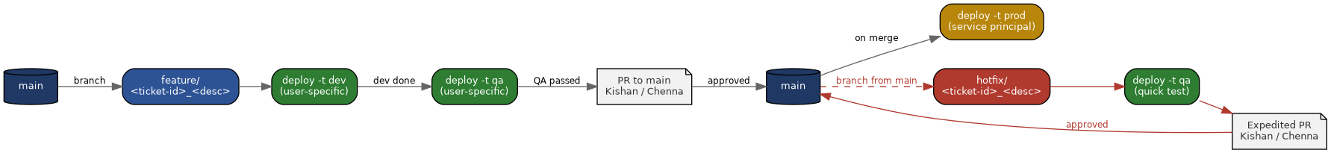
Figure 2 — Feature branch flow (top) and hotfix flow (red) from main.

7.2 PR Rules
- PR must link a work item and include its data contract (Section 4).
- Approval by Kishan or Chenna is required before merge.
- Squash-merge; no force-push to main.

7.3 Hotfix Procedure
For urgent production fixes that cannot wait for the normal feature flow. main stays the only long-lived branch.
- Create hotfix/<ticket-id>_<desc> from main.
- Make the minimal fix only, with a linked ticket. Update the data contract if the fix changes the table's shape.
- Deploy to the qa target for a quick test.
- Raise an expedited PR to main. Approval by Kishan or Chenna is still required, and no checks are skipped.
- On merge, prod is deployed by the service principal.
- Open feature branches pull in the latest main so the fix is not lost or overwritten.
- Record the root cause on the ticket.

8. Databricks Asset Bundle (DAB) Standards

8.1 Source of Truth
The DAB root folder is the source of truth for all code. Everything deployed to Databricks (pipelines, jobs, materialized view SQL, contracts, tests) lives in the bundle and is deployed from it, never edited directly in a workspace.
<repo-root>/
databricks.yml # bundle config, targets, permissions
resources/ # jobs, pipelines
src/ # SQL and Python code
contracts/ # data contracts (Section 4)
tests/ # unit and data tests

8.2 Targets
Target | Root path | Run as | Notes
dev | Per user: /Workspace/Users/<user>/.bundle/<bundle_name>/dev | Deploying user | Personal development and testing
qa | Per user: /Workspace/Users/<user>/.bundle/<bundle_name>/qa | Deploying user | Pre-release testing from the feature branch
prod | Service principal root path (not a personal folder) | Service principal only | Deployed only on merge to main; never a personal identity

8.3 Global Permissions
Bundle-level permissions grant CAN_MANAGE to a group across all bundle resources. Prod runs and deploys as a service principal.
bundle:
name: <bundle_name>

permissions:
- group_name: <to be specified>
level: CAN_MANAGE

targets:
dev:
mode: development
workspace:
host: <dev workspace url>
root_path: /Workspace/Users/<user>/.bundle/${bundle.name}/${bundle.target}
qa:
workspace:
host: <qa workspace url>
root_path: /Workspace/Users/<user>/.bundle/${bundle.name}/${bundle.target}
# run_as: deploying user (default)
prod:
mode: production
workspace:
host: <prod workspace url>
root_path: /Workspace/Users/<service principal application id>/.bundle/${bundle.name}/${bundle.target}
run_as:
service_principal_name: <service principal application id>

9. DE vs. Analyst Access
Persona | Can access | Cannot access
Data Engineer | Silver and Gold (read/write); dev and qa freely; prod via pipeline only | BIS tables (write); manual writes to prod
Analyst | Gold only (read), plus a dedicated sandbox folder if needed | Raw, Silver, and DE job/repo folders
Group and permission setup is owned by BIS / Central IT.

10. Quality, Audit & Reuse
- DQX rules are defined per table and referenced in its data contract, including warn / quarantine / fail thresholds and who is notified when records are quarantined.
- Every pipeline run writes an audit record: pipeline name, run ID, source and target tables, start/end time, status, and row counts (read, written, quarantined).
- Lineage comes from Unity Catalog's built-in lineage.
- Reuse shared helper code (DQX wrapper, audit logger, config reader) instead of copying notebooks per table.

11. Repo Naming Standards
Object | Pattern | Example
Project umbrella | aftermarketdbx | aftermarketdbx
Source repo | aftermarketdbx-<source/project> | aftermarketdbx-sap, aftermarketdbx-sio
Shared framework repo | aftermarketdbx-framework | aftermarketdbx-framework
Contract path (inside a source repo) | contracts/<catalog>.<schema>.<table>/contract.yaml | contracts/name-101.gold.gold_finance_gl_summary/contract.yaml

12. Appendix — Diagram Source (Mermaid)

A.1 Proposed Architecture
flowchart LR
SAP --> BIS[BIS Extraction]
CIO --> BIS
Excel[Raw Excel] --> BIS
API --> BIS
BIS --> RAW[(BIS prod_silver = our RAW)]
RAW --> CHECK{Good shape?}
CHECK -->|good shape| MV[DE Gold - Materialized View on BIS silver]
CHECK -->|not good| SILVER[DE Silver - cleansed]
SILVER --> GOLD[DE Gold - Materialized View]
MV --> ANALYSTS[Analysts / Reporting]
GOLD --> ANALYSTS

A.2 CI/CD Flow
flowchart LR
MAIN0[(main)] -->|branch| FEAT[feature/ticket-id_desc]
FEAT -->|dev work| DEV[bundle deploy -t dev]
DEV -->|dev done, push to QA| QA[bundle deploy -t qa]
QA -->|QA passed| PR[PR to main - approval Kishan / Chenna]
PR -->|approved| MAIN1[(main)]
MAIN1 -->|on merge| PROD[bundle deploy -t prod - service principal]
MAIN1 -.branch from main.-> HOT[hotfix/ticket-id_desc]
HOT --> HQA[bundle deploy -t qa - quick test]
HQA --> HPR[Expedited PR - approval Kishan / Chenna]
HPR --> MAIN1

