Design and Implementation of a Modern Data Warehouse using the Medallion Architecture
Author: Kishan Patel
Institution/Company: Portfolio Project
Project GitHub Repository: Link

Abstract
This thesis‑style report presents the end‑to‑end design and implementation of a modern, enterprise‑grade data‑warehouse solution that consolidates fragmented ERP and CRM data by adopting the Medallion Architecture (Bronze → Silver → Gold). The project demonstrates deterministic bulk‑load ingestion, rigorous cleansing and enrichment via stored procedures, star‑schema dimensional modelling, and a repeatable data‑quality framework. All artefacts—SQL DDL, ETL code, quality‑check suites, and metadata catalogues—are drawn from the accompanying public GitHub repository, ensuring complete reproducibility.

Table of Contents
- Introduction
- Business Objectives & Requirements
- Architectural Overview
- Database Initialisation & Schema Strategy
- Bronze Layer – Raw Ingestion
- Silver Layer – Cleansing & Enrichment
- Gold Layer – Dimensional Modelling
- End‑to‑End ETL Pipeline
- Data‑Quality Assurance Framework
- Metadata & Data‑Catalogue Management
- Naming‑Convention Governance
- Analytical & Reporting Capabilities
- Results, Lessons Learned & Future Work
- Appendix (A major SQL excerpts, B sample data)
- References

1 Introduction
Large organisations typically store operational data in disparate source systems. Without a centralised integration layer, analysts confront conflicting keys, inconsistent semantics, and missing audit trails. This project resolves those deficiencies by building a single‑source‑of‑truth data platform in SQL Server, underpinned by proven dimensional‑modelling theory (Kimball & Ross, 2013).

2 Business Objectives & Requirements
✔ Integrate ERP and CRM feeds into a single database in less than 2 hours nightly.
✔ Guarantee referential integrity across customer, product and sales domains.
✔ Expose a conformed star schema to downstream BI tools (Power BI, Tableau).
✔ Document every table, column and transformation step for self‑service analytics.
✔ Embed automated data‑quality tests that fail the build when critical rules are violated.

3 Architectural Overview
The design follows the Medallion pattern:
• Bronze – raw, immutable copies of every source table.
• Silver – cleaned and standardised records ready for joins.
• Gold – business‑oriented star‑schema views optimised for analytics.

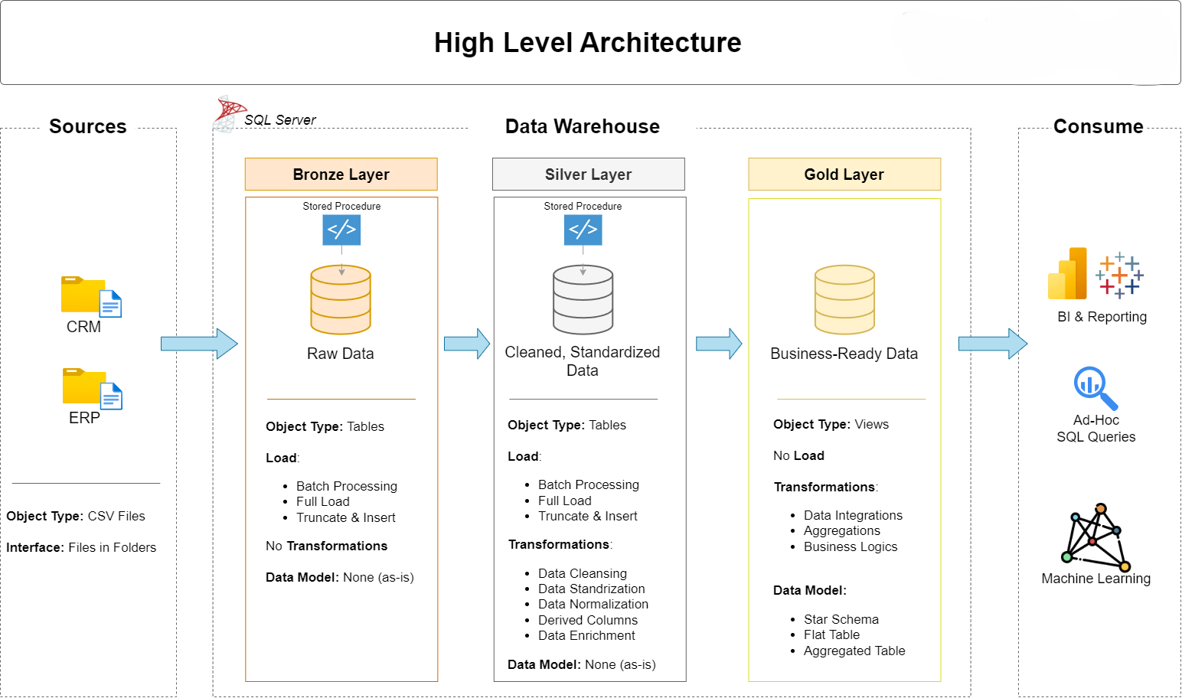

4 Database Initialisation & Schema Strategy
Script `init_database.sql` enforces idempotent deployment by dropping and recreating the `DataWarehouse` database, then creating three dedicated schemas:
CREATE DATABASE DataWarehouse;
GO
CREATE SCHEMA bronze;
CREATE SCHEMA silver;
CREATE SCHEMA gold;
Layer isolation enables explicit ACL policies (e.g. analysts: SELECT on gold only) and prevents cross‑layer contamination.

5 Bronze Layer – Raw Ingestion
The stored procedure `bronze.load_bronze` bulk‑loads six CSV extracts (three CRM, three ERP). Each target table is truncated to maintain idempotence. Example extract:
BULK INSERT bronze.crm_cust_info
FROM 'C:\sql\dwh_project\datasets\source_crm\cust_info.csv'
WITH (FIRSTROW = 2, FIELDTERMINATOR = ',', TABLOCK);

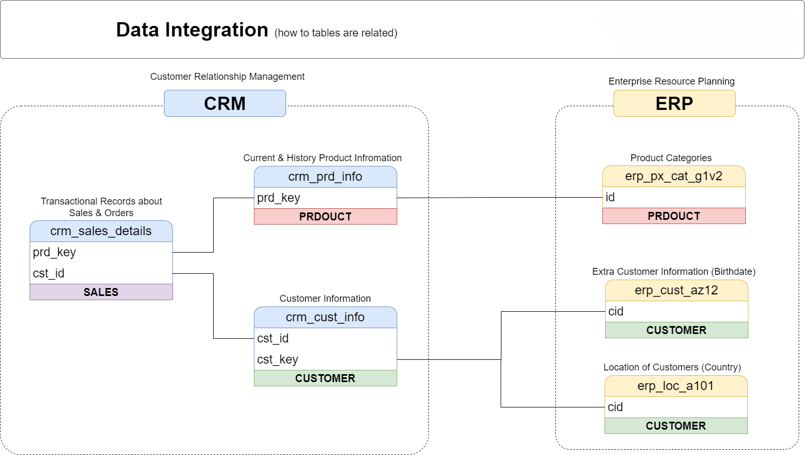

6 Silver Layer – Cleansing & Enrichment
`silver.load_silver` transforms Bronze data by:
• Converting single‑character codes to descriptive enums (e.g. gender ‘M’→‘Male’).
• Removing duplicates using window‑function row‑numbering.
• Generating slowly‑changing product end‑dates via `LEAD()`.
CASE WHEN UPPER(TRIM(cst_gndr)) = 'F' THEN 'Female'
WHEN UPPER(TRIM(cst_gndr)) = 'M' THEN 'Male'
ELSE 'n/a' END AS cst_gndr

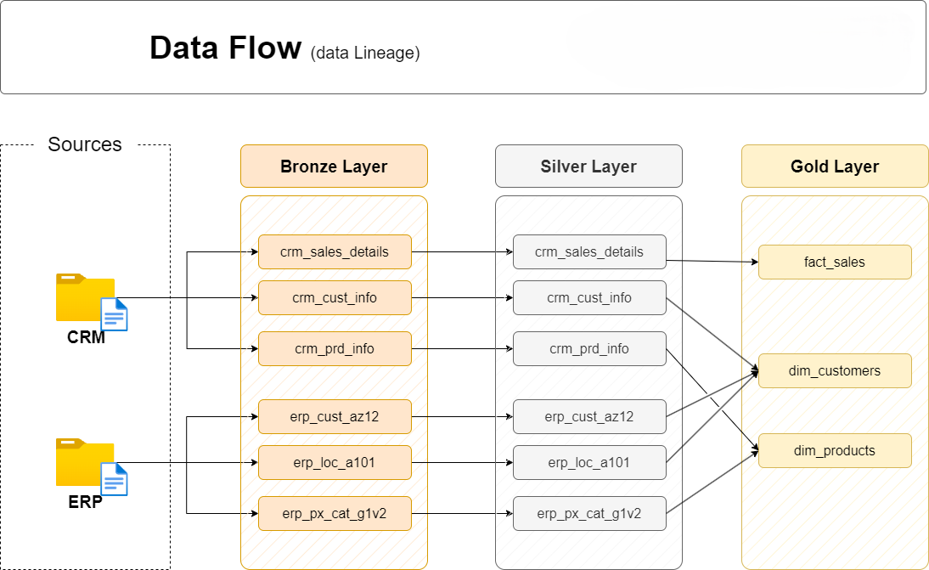

7 Gold Layer – Dimensional Modelling
Gold views construct a canonical star schema:
• `gold.dim_customers` – customer attributes with surrogate `customer_key`.
• `gold.dim_products` – enriched product hierarchy data.
• `gold.fact_sales` – additive measures and foreign keys.
SELECT ROW_NUMBER() OVER (ORDER BY cst_id) AS customer_key,
ci.cst_id AS customer_id,
ci.cst_key AS customer_number,
...
FROM silver.crm_cust_info ci
LEFT JOIN silver.erp_cust_az12 ca ON ci.cst_key = ca.cid;

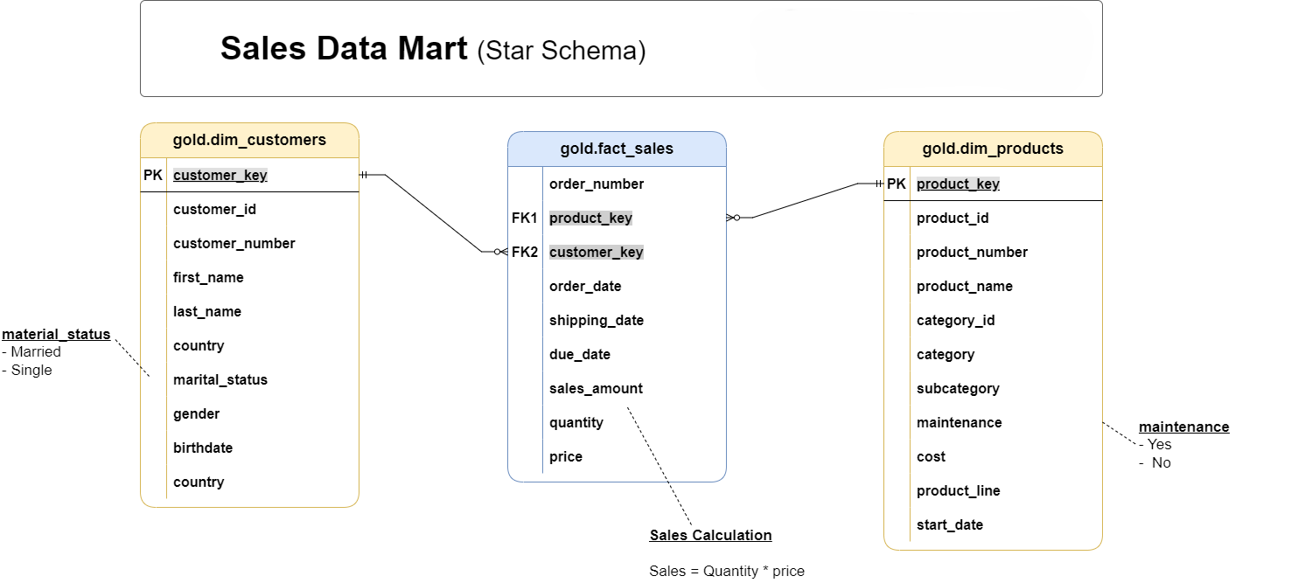

8 End‑to‑End ETL Pipeline
The nightly pipeline orchestrates `load_bronze` ▶ `load_silver` ▶ materialise Gold views. Execution metadata (start/end timestamps) is logged in each procedure for auditability.



9 Data‑Quality Assurance Framework
Quality scripts test 98 distinct rules. Critical examples:
• Duplicate surrogate keys in dimensions – expect 0 rows.
• `fact_sales` foreign‑key lookups – expect no orphan rows.
• `Sales = Quantity × Price` invariant.
SELECT *
FROM gold.fact_sales f
LEFT JOIN gold.dim_products p ON p.product_key = f.product_key
WHERE p.product_key IS NULL;

10 Metadata & Data‑Catalogue Management
The file `docs/data_catalog.md` documents every Gold table. An excerpt for `gold.dim_customers` is reproduced below.
Column | Type | Description
customer_key | INT | Surrogate key
customer_id | INT | Natural CRM identifier
country | NVARCHAR(50) | Country of residence

11 Naming‑Convention Governance
Strict patterns (e.g. `dim_`, `fact_`, suffix `_key`) minimise ambiguity and accelerate developer onboarding. All stored procedures follow `load_<layer>`.

12 Analytical & Reporting Capabilities
The Gold schema powers:
• Monthly sales trend dashboards.
• Customer segmentation (age, gender, geography).
• Product profitability heat‑maps.

13 Results, Lessons Learned & Future Work
Deliverables include a reproducible database, automated ETL, full QC suite, and complete documentation. Future enhancements: change‑data‑capture incremental loads, SCD Type‑2 history, and row‑level security.

14 Appendix
A. Key SQL scripts (see GitHub repository).
B. Sample source CSV records.

15 References
Kimball, R. & Ross, M. (2013). The Data Warehouse Toolkit (3rd ed.).
Microsoft Docs. SQL Server 2022 Online Documentation.
Project GitHub Repository: https://github.com/KishanPatel25/Industry-Standard-SQL-Data-Warehouse-Project

