Structure
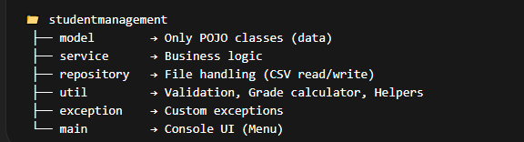

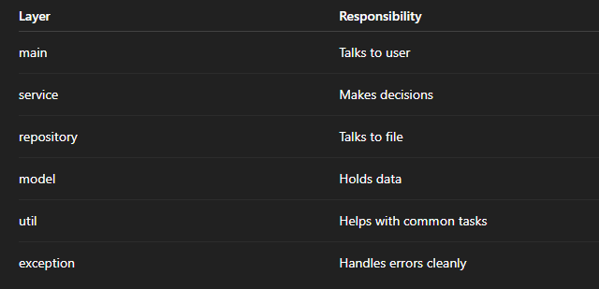

1 model → Only POJO Classes (DATA ONLY)
POJO = Plain Old Java Object
Means:
- Only variables
- Getters/Setters
- Constructors
- No heavy logic
Example:
public class Student {
private String studentId;
private String name;
private String mobile;
private String email;
private int semester;
// Constructor
// Getters and Setters
}
What this layer does:
- Represents real-world entities
- Stores data in object form
- Nothing else
Important Rule:
No file reading
No business logic
No printing
Only data.

2 service → Business Logic Layer
This is the brain of your system.
It decides:
- Can student be added?
- Are marks valid?
- What is total?
- What is grade?
- Can faculty login?
Example:
public class StudentService {
public void addStudent(Student student) {
// validate data
// call repository to save
}
public List<Student> getAllStudents() {
// call repository
}
}
This layer:
- Talks to repository
- Applies rules
- Performs calculations
- Controls system behavior
If tomorrow you change from CSV → Database,
only repository changes.
Service remains same.
This is professional architecture.

3 repository → File Handling Layer
This layer talks to CSV files.
Example:
public class StudentRepository {
public void save(Student student) {
// open students.csv
// write student data
}
public List<Student> findAll() {
// read students.csv
// convert each row into Student object
}
}
This layer:
- Reads CSV
- Writes CSV
- Converts text → Objects
- Converts objects → text
It does NOT:
calculate grades
validate business rules
print UI
Only data storage.

4 util → Helpers & Reusable Logic
Utility classes that can be reused anywhere.
Example:

GradeUtil
public class GradeUtil {
public static String calculateGrade(double percentage) {
if (percentage >= 90) return "A+";
if (percentage >= 80) return "A";
if (percentage >= 70) return "B";
if (percentage >= 60) return "C";
if (percentage >= 50) return "D";
return "Fail";
}
}

ValidationUtil
public class ValidationUtil {
public static boolean isValidEmail(String email) {
return email.contains("@");
}
public static boolean isValidMobile(String mobile) {
return mobile.length() == 10;
}
}
Why separate?
Because utility logic:
- Can be used by many services
- Keeps service clean
- Improves modularity

5 exception → Custom Exceptions
Instead of writing:
throw new Exception("Invalid marks");
We create:
public class InvalidMarksException extends Exception {
public InvalidMarksException(String message) {
super(message);
}
}
Why?
Because:
- Code becomes clean
- Errors become meaningful
- Professional practice
- Improves OOP understanding

6 main → Console UI (Menu Layer)
This layer only:
- Shows menu
- Takes input
- Calls service
- Prints result
Example:
public class Main {
public static void main(String[] args) {
System.out.println("1. Add Student");
System.out.println("2. Add Marks");
// Take input
// Call StudentService
}
}
Important Rule:
No file writing here
No business calculations here
Only interaction.

How Everything Connects (Example Flow)
Let’s say faculty adds a student.
Step 1:
Main takes input.
Step 2:
Main calls:
studentService.addStudent(student);
Step 3:
StudentService:
- Validates data
- Calls repository
Step 4:
Repository:
- Writes to students.csv
Done.
Each layer has one job only.
That’s called:
Separation of Concerns
Clean Architecture

In Model:
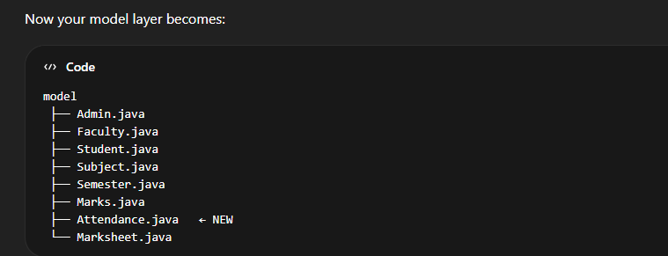

2 How Roles Will Work (Architecture)

Admin Responsibilities
Admin will:
- Create Semester
- Add Students to Semester
- Add Subjects to Semester
- Assign Faculty to Subject (optional now)
- View full reports
Admin does structural work.

Faculty Responsibilities
Faculty will:
- Login
- Select semester
- Select subject
- Enter marks
- Mark attendance
- Generate marksheet
Faculty does operational work.

3 How We Handle Attendance
Now think carefully.
Attendance belongs to:
👉 Student
👉 Subject
👉 Semester
👉 Date
So Attendance must be a separate class.

Attendance.java
Fields:
studentId
subjectCode
date
status (Present / Absent)
Why separate class?
Because:
- One student has many attendance records
- Attendance is not permanent data inside Student
- It changes daily
Very important design principle:
Repeating records = separate entity

