**HALLODOC -PLATFORM**

**BE-CE Semester- VIII**

Prepared at

TATVASOFT

**Tatvasoft House, Near Shivalik Business Center, Sarkhej - Gandhinagar Highway Rajpath Rangoli Road Ahmedabad**

**Prepared By**

**Gelani Naimish Sanjaybhai.**

**Guided By: External Guide**

**Ms. Stephy Patel Ms. Sweety Patel**

**Department of CE TatvaSoft**

**LJIET, Ahmedabad Ahmedabad, Gujarat.**

**SUBMITTED TO**



**L.J. Institute of Engineering & Technology Gujarat Technological University**

 

**L. J. Institute of Engineering & Technology**

**Ahmedabad**

**CERTIFICATE**

This is to certify that the project report submitted along with the project entitled **HalloDoc** has been carried out by **Gelani Naimish Sanjaybhai** under my guidance in partial fulfillment for the degree of

Bachelor of Engineering in Computer Engineering, 8th Semester of Gujarat Technological University, Ahmadabad during the academic year 2023-24.

|  |  |
| --- | --- |
| Ms. Stephy Patel | Prof. Shruti Raval |
| **Internal Guide** | **Head of the Department** |

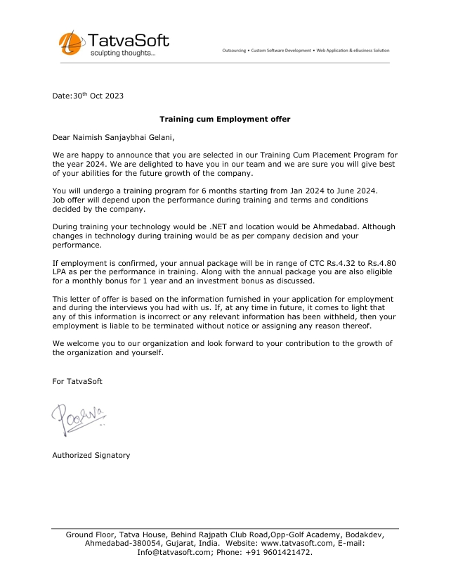



**L. J. Institute of Engineering & Technology****Ahmedabad**

**DECLARATION**

We hereby declare that the Internship report submitted along with the Internship entitled **HalloDoc** submitted in partial fulfillment for the degree of Bachelor of Engineering in **Computer Engineering** to Gujarat Technological University, Ahmedabad, is a bonafide record of original project work carried out by me at TatvaSoft under the supervision of Ms. Sweety Patel and that no part of this report has been directly copied from any students’ reports or taken from any other source, without providing due reference.

Name of the Student Sign of Student

Gelani Naimish Sanjaybhai

**ACKNOWLEDGEMENT**

I would like to express my sincere gratitude to several individuals for supporting me throughout my internship project. First, I wish to express my sincere gratitude to my Internal Guide, **Ms. Stephy Patel**, for his enthusiasm, patience, insightful comments, helpful information, practical advice and unceasing ideas that have helped me tremendously at all times in my project. Without his support and guidance, this project would not have been possible.

I would like to express my endless thanks to my external guide **Ms. Sweety S. Patel** at **HALLODOC- PLATFORM** their sincere and dedicated guidance throughout the project development.

Also, our hearty gratitude to our Head of Department, **prof. Shruti Raval** and our internal guide **Ms. Stephy Patel**  for giving us encouragement and technical support on the project.

**Gelani Naimish Sanjaybhai**

**200320107020**

**ABSTRACT**

HalloDoc is a cutting-edge platform poised to revolutionize healthcare delivery by seamlessly integrating online doctor consultations and diagnostic services. With a user-friendly interface catering to both physicians and patients, HalloDoc streamlines medical processes, enhancing patient care and optimizing workflow for healthcare providers.

The platform offers a comprehensive suite of features, facilitating efficient access to patient records, appointment management, and secure communication channels between doctors and patients. Patients can conveniently request care for themselves or on behalf of others, fostering accessibility and convenience in healthcare delivery.

Admin functionalities empower comprehensive oversight, enabling the review of patient and physician records, case management, and the ability to manage requests effectively.

HalloDoc represents a significant advancement in healthcare technology, bridging the gap between healthcare providers and patients, thereby promoting accessibility, efficiency, and improved patient outcomes in the digital age.

**LIST OF FIGURES**

**Figure No. Figure Description Page No.**

Fig 1.1 Company Logo ………………………………… 2

Fig 2.1 Production Stages………...................................... 6

Fig 3.1 Scrum Methodology…………………………….. 12

Fig 3.2 Gantt Chart……………………………………… 1

Fig 4.1 Activity of Proposed System……………………. 17

Fig 4.2 Use Case Diagram – User ………………………. 19

Fig 4.3 Use Case Diagram – Provider ………………….. 19

Fig 4.4 Use Case Diagram – Admin …………………….. 20

Fig 4.5 Data Flow Diagram (Level 0)…………………… 21

Fig 4.6 Data Flow Diagram (Level 1)………………. 21

Fig 4.5 Data Flow Diagram (Level 2)……………………. 22

Fig 5.1 Scrum Methodology……………………………... 27

Fig 5.2 Different Roles in Scrum………………………... 29

Fig 5.3 Landing Page…………………………………….. 41

Fig 5.4 Login Page………………………………………. 41

Fig 5.5 Reset Password Page…………………………….. 42

Fig 5.6 Select Role Page .………………………………. 43

Fig 5.7 Submit Request Page……………………………... 43

Fig 5.8 Info Alert Page…………………………………. 44

Fig 5.9 Family / Friend Request Page……………………... 45

Fig 5.10 Concierge Request Page………………………. 45

Fig 5.11 Business Request Page…………………………… 46

Fig 5.12 Patient Dashboard Page……………………………… 46

Fig 5.13 View Document Page……………………………....... 47

Fig 5.14 Patient Profile Page………………………………….. 47

Fig 5.15 Patient Request Page………………………………… 48

Fig 5.16 Patient Request For Me Page ……………………….. 48

Fig 5.17 Patient Request For Someone else Page ……………. 49

Fig 5.18 Admin Dashboard New State ……………………….. 50

Fig 5.19 Assign Case …………………………………………. 50

Fig 5.20 Pending State Dashboard …………………………… 51

Fig 5.21 Active State Dashboard …………………………….. 51

Fig 5.22 Conclude State Dashboard ………………………….. 52

Fig 5.23 ToClose State Dashboard …………………………… 52

Fig 5.24 Unpaid State Dashboard …………………………… 53

Fig 5.25 SendMail ……………………………………………. 53

Fig 5.26 View Case …………………………………………... 54

Fig 5.27 View Notes ………………………………………….. 54

Fig 5.28 Cancel Case …………………………………………. 55

Fig 5.29 Block Case ………………………………………….. 55

Fig 5.30 View Uploads – Admin …………………………….. 56

Fig 5.31 Transfer Case ……………………………………….. 56

Fig 5.32 Clear Case …………………………………………... 57

Fig 5.33 Send Order ………………………………………….. 57

Fig 5.34 Encounter – Admin …………………………………. 58

Fig 5.35 Profile – Admin ……………………………………... 59

Fig 5.36 Provider Information – Admin ……………………… 59

**LIST OF TABLES**

**Table Table Name Page**

**No. No**

Table 3.1 Project/Internship Summary……........................ 8

Table 3.2 Technologies Used to Develop Project………… 10

Table 4.1 Activity of Proposed System ………………….. 17

Table 5.1 Admin………………………………………...... 29

Table 5.2 AdminRegion……………………………..…… 30

Table 5.3 AspNetRoles………………………….………. 30

Table 5.4 AspNetUserRoles……………….…………….. 30

Table 5.5 AspNetUsers………………………..…………. 30

Table 5.6 BlockRequest…………………………...……… 30

Table 5.7 Business………………………………………... 31

Table 5.8 CaseTag………………………………………… 31

Table 5.9 Concierges……………………………………… 31

Table 5.10 EmailLogs……………………………………… 32

Table 5.11 HealthProfessionals…………………………….. 32

Table 5.12 OrderDetails……………………………………. 32

Table 5.13 HealthProfessionalTypes………………………. 33

Table 5.14 Menu…………………………………………… 33

Table 5.15 Physicians……………………………………… 33

Table 5.16 PhysicianLocations…………………………….. 34

Table 5.17 PhysicianNotifications…………………………. 34

Table 5.18 PhysicianRegions………………………………. 35

Table 5.19 Regions………………………………………… 35

Table 5.20 Requests ………………………………………. 35

Table 5.21 RequestBusiness ………………………………. 36

Table 5.22 RequestClient …………………………………. 36

Table 5.23 RequestClosed ………………………………… 37

Table 5.24 RequestConcierge …………………………….. 37

Table 5.25 RequestNotes ………………………………….. 37

Table 5.26 RequestStatusLog ……………………………... 37

Table 5.27 RequestTypes …………………………………. 38

Table 5.28 RequestWiseFile ………………………………. 38

Table 5.29 Roles …………………………………………... 38

Table 5.30 RoleMenu ……………………………………… 39

Table 5.31 Shifts …………………………………………... 39

Table 5.32 ShiftDetail ……………………………………... 39

Table 5.33 ShiftDetailRegion ……………………………... 39

Table 5.34 SMSLog ……………………………………….. 40

Table 5.35 User ……………………………………………. 40

Table 7.1 TestCase-01(Registration) …………………….. 66

Table 7.2 TestCase-02(Login) …………………………… 67

Table 7.3 TestCase-03(RequestForm) …………………... 67

Table 7.4 TestCase-04(PopupForm) ……………………... 68

Table 8.1 Summary of Intership Project …………………. 72

**LIST OF SYMBOLS**

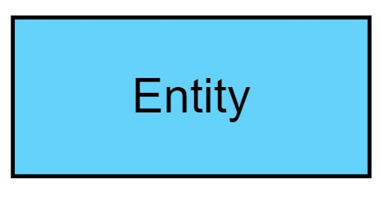

**Entity**

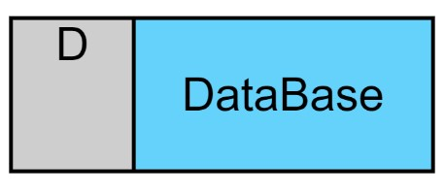

**Database Table**

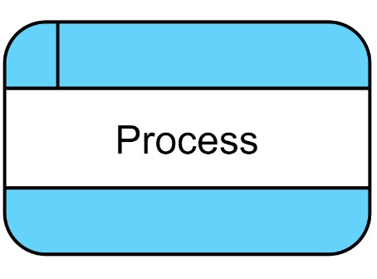

**Process**



|  |  |
| --- | --- |
| **Dataflow** |  |

**Actor** 

**LIST OF ABBREVIATIONS**

* Docs Documents
* IDE Integrated Development Environment
* SQL Structured Query Language
* JS JavaScript
* HTML Hyper Text Markup Language
* CSS Cascading Style Sheet
* CSHTML C Sharp Hyper Text Markup Language
* CS C Sharp
* DBA Database Administrator
* DBMS Database Management System
* HR Human resources
* QA Quality Assurance
* SMS Short Message Service
* UI User Interface
* UX User Experience

**TABLE OF CONTENTS**

**Acknowledgement…………………………………………………………….. I**

**Abstract………………………………………………………………………... II**

**List of Figures…………………………………………………………………. III**

**List of Tables………………………………………………………………….. IV**

**List of Symbols ………………………………………………………………… V**

**List of Abbreviation…………………………………………………………… VI**

**Table of Contents……………………………………………………………... VII**

**Chapter 1 1.0 Overview of the Company……………………………….. 1**

* 1. History………………………………………………. **2**
  2. Different Services…………………………………… **2**

**Chapter 2 2.0 Overview of Company Department ……………………. 3**

* 1. All Departments……………………………………… **4**
  2. Technical Specifications in Department……………… **4**
  3. Sequence of Operators……………………………….. **5**
  4. Product Stages………………………………………… **6**

**Chapter 3 3.0 Introduction to Internship………………………………. 7**

3.1Internship Project Summary ……………………….. **8**

* 1. Purpose……………………………………………... **9**

**9**

* 1. Scope………………………………………………..
  2. Objective…………………………………………… **9**
  3. Technology and Literature Review………………… **10**
  4. Planning……………………………………………. **11**
  5. Scheduling…………………………………………. **14**

**Chapter 4 4.0 System Analysis………………………………………….. 15**

* 1. Study of Current System…………………………… **16**
  2. Weaknesses of Current System…………………….. **16**
  3. Requirements of New System……………………… **16**
  4. Feasibility Study…………………………………… **17**
  5. Use Case Diagram………………………………….. **19**
  6. Data Flow Diagrams………………………………… **21**
  7. List of Main Modules …………….………………… **22**
  8. Features of New System…………………………….. **22**
  9. Selection of Hardware and Software ……………….. **24**

**Chapter 5 5.0 System Design……………………………………………... 26**

* 1. System Design & Methodology………………………. **27**
  2. Database Design………………………………………. **29**
  3. Interface Design………………………………………. **41**

**Chapter 6 6.0 Implementation……………………………………………. 61**

* 1. Implementation platform……………………………… **62**
  2. Module Specifications………………………………… **63**

**Chapter 7 7.0 Testing……………………………………………………… 65**

* 1. Testing Plan ………………………………………….. **66**
  2. Testing Strategy………………………………………. **66**
  3. Testing Method……………………………………... **67**
  4. Testing Cases……………………………………….. **68**

**Chapter 8 8.0 Conclusion and Discussion……………………………….. 59**

* 1. Overall Analysis of Internship………………………. **60**
  2. Problem Encountered and Possible Solutions………. **60**
  3. Summary of Internship……………………………… **61**
  4. Limitation and Future Work………………………… **61**

**References …………………………………………………………………….. 62**

**Appendix... …………………………………………………………………….. 63**

Chapter

1

===============================================================

**1. OVERVIEW OF THE COMPANY**

===============================================================

**History**

**Different Products**

**OVERVIEW OF THE COMPANY**



**Tatvasoft**

TatvaSoft, founded in 2001 and headquartered in Ahmedabad, is a distinguished software product development company known for its expertise in designing and implementing mobile apps, advanced software solutions, and websites. Specializing in crafting comprehensive digital solutions, TatvaSoft assists businesses across various sectors in overcoming their challenges and achieving their goals effectively.

With a skilled team proficient in a multitude of technologies, TatvaSoft offers bespoke website development services tailored to the unique needs of each client. Whether it's creating dynamic e-commerce platforms, interactive corporate websites, or engaging web applications, TatvaSoft leverages its expertise to deliver high-quality, visually appealing, and user-friendly websites.

In addition to website development, TatvaSoft excels in mobile app development and software implementation. By conceptualizing and strategizing the entire development process, the company ensures that projects are executed with precision, reducing risks, managing costs, and delivering solutions that meet and exceed client expectations.

Through its commitment to excellence and innovation, TatvaSoft has earned a reputation as a trusted partner for businesses seeking to leverage technology to drive growth and success in today's digital landscape.

**DIFFERENT SERVICES**

* Custom Software Development
* Web Development
* Mobile App Development
* UI/UX Design
* Product Development & Maintenance
* Cloud Services
* Big Data & Analytics Solutions
* IT Services & IT Consulting

Chapter

2

===============================================================

**2. OVERVIEW OF THE COMPANY DEPARTMENT**

===============================================================

**All Departments**

**Technical Specifications in department**

**Sequence of operators**

**Product stages**

===============================================================

**OVERVIEW OF THE COMPANY DEPARTMENT**

**TatvaSoft: Your One-Stop Shop for Software Development**

TatvaSoft is a reputed CMMI level 3 software and mobile app development company with a focus on providing exceptional customer service. We offer a full range of development services to ensure your project's success, from initial concept to final product.

**All departments**

* HR Department
* Sales Marketing Department
* Development Department
* Testing Department

**Technical Specifications in department**

* **HR Department**

Our HR team is committed to finding the best talent and fostering a positive work environment that maximizes employee productivity. They handle everything from recruitment and compensation to training and development.

* **Sales Marketing Department**

Our sales and marketing team works diligently to understand your target market and develop strategies to reach them effectively. They help you determine the best pricing and positioning for your product or service.

* **Development Department**

Our development department is comprised of skilled professionals across various specialties, including web development, Android development, and iOS development. We use the latest technologies to create high-quality, user-friendly applications.

* **Testing Department**

Our testing department plays a vital role in ensuring the quality of your software. They rigorously test all aspects of your application to identify and fix any bugs before it reaches the market.

**Sequence of operators**

1. **Requirement Gathering & Analysis:** Our research team gathers your requirements, analyzes them, and defines the features to be developed. They also estimate the project's cost and timeline.
2. **Development & Team Allocation:** We leverage expert teams like ASP.NET MVC for backend and a modern UI framework for frontend, ensuring a tailored approach for each project.
3. **Testing & Quality Assurance:** Once development is complete, our testing team meticulously tests the software to ensure it meets all requirements and functions flawlessly.

**Product stages**

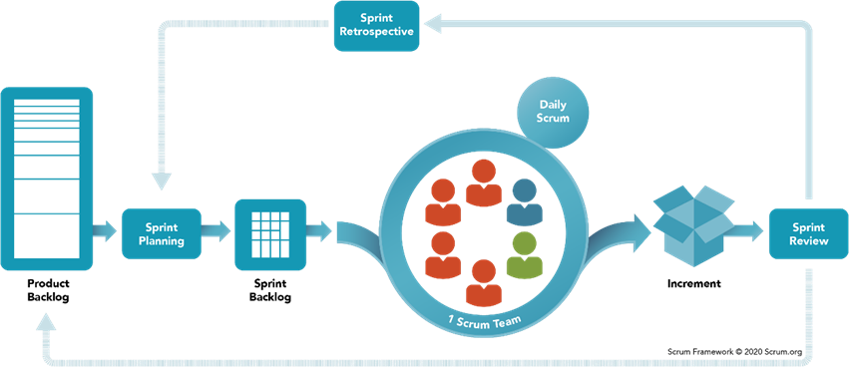

Fig 2.1 Production Stage

Chapter

3

===============================================================

**3. INTRODUCTION TO INTERNSHIP**

===============================================================

**Project Summary**

**Purpose**

**Objective**

**Scope**

**Technology and Literature Review**

**Planning**

**Scheduling**

===============================================================

**INTRODUCTION TO INTERNSHIP**

**Project Summary**

Table 3.1: Project Summary

|  |  |  |
| --- | --- | --- |
| **Project Title** | HalloDoc | |
| **Aim** | HalloDoc is a cutting-edge healthcare platform aimed at revolutionizing patient-doctor interactions. Our mission is to remove barriers to healthcare by offering virtual consultations and diagnostic services, eliminating the need for physical visits. Like effective marketing relies on understanding ideal customers, HalloDoc tailors healthcare solutions by considering individual needs and preferences. With a user-friendly interface, we empower patients to take control of their health conveniently. HalloDoc is committed to transforming healthcare delivery, ensuring accessible and personalized care anytime, anywhere. | |
| **Developed At** | Tatvasoft | |
| **Project Category** | Web site | |
| **Tools** | IDE | Visual Studio |
| Languages/Frameworks | ASP .NET  (MVC),  PostgreSQL,  Bootstrap |
| Database | PostgreSQL |
| **Duration** | 3 Months (January 2024 to April 2024) | |

**Purpose**

HalloDoc aims to break down barriers in healthcare by fostering trust and accessibility. Just as understanding the ideal customer is crucial in effective marketing, we believe in understanding patients deeply. Our platform facilitates virtual consultations and diagnostics, eliminating physical barriers to care. Through personalized interactions, we address individual needs, habits, and aspirations, ensuring tailored healthcare solutions. HalloDoc empowers patients to engage with their health, making informed decisions. By leveraging technology and understanding patients comprehensively, we strive to revolutionize healthcare delivery, providing accessible and trustworthy care to all.

**Objective**

HalloDoc's core goal is to enhance healthcare accessibility and trust, our platform empowers patients with virtual consultations and diagnostics. Through this innovative approach, HalloDoc aims to revolutionize healthcare, bridging the gap between patients and providers while ensuring accurate representation of patient needs.

**Scope**

The scope of the HalloDoc project includes facilitating virtual consultations and offering diagnostic services for remote monitoring and analysis. Efficient patient management tools will be developed, along with telemedicine features for remote healthcare delivery. A user-friendly interface and dedicated mobile application will enhance accessibility. Integration with existing healthcare systems will enable seamless data exchange, while features for patient feedback and ratings will promote transparency and accountability. Continuous improvement mechanisms will ensure HalloDoc remains innovative in healthcare technology.

**Technology and Literature Review**

# Table 3.2 Technologies Used to Develop Project

|  |  |
| --- | --- |
| Front End | Bootstrap, HTML, CSS |
| Back End | ASP .NET |
| Database | Postgres |

**Planning**

**Project / Internship Development Approach and Justification**

The software development models are the various processes or methodologies that are being selected for the development of the project depending on the project’s aims and goals. There are many development life cycle models that have been developed in order to achieve different required objectives. The models specify the various stages of the process and the order in which they are carried out.

The selection of model has very high impact on the testing that is carried out. It will define the what, where and when of our planned testing, influence regression testing and largely determines which test techniques to use.

According to our project requirements we chose scrum methodology to accomplish project in effective and timely manner.

Scrum Methodology

Scrum is an agile development methodology used in the development of Software based on an iterative and incremental processes. Scrum is adaptable, fast, flexible and effective agile framework that is designed to deliver value to the customer throughout the development of the project.

The primary objective of Scrum is to satisfy the customer’s need through an environment of transparency in communication, collective responsibility and continuous progress. The development starts from a general idea of what needs to be built, elaborating a list of characteristics ordered by priority (product backlog) that the owner of the product wants to obtain.

Scrum Methodology & Process

Scrum is precisely an evolution of Agile Management. Scrum methodology is based on a set of very defined practices and roles that must be involved during the software development process. It is a flexible methodology that rewards the application of the 12 agile principles in a context agreed by all the team members of the product.



Fig 3.1 Scrum Methodology

(“Courtesy of Scrum.org”)

Scrum is executed in temporary blocks that are short and periodic, called Sprints, which usually range from 2 to 4 weeks, which is the term for feedback and reflection. Each Sprint is an entity in itself, that is, it provides a complete result, a variation of the final product that must be able to be delivered to the client with the least possible effort when requested.

The process has as a starting point, a list of objectives/ requirements that make up the project plan. It is the client of the project that prioritizes these objectives considering a balance of the value and the cost thereof, that is how the iterations and consequent deliveries are determined.

On the one hand the market demands quality, fast delivery at lower costs, for which a company must be very agile and flexible in the development of products, to achieve short development cycles that can meet the demand of customers without undermining the quality of the result. It is a very easy methodology to implement and very popular for the quick results it gets.

Scrum methodology is used mainly for software development, but other sectors are also taking advantage of its benefits by implementing this methodology in their organizational models such as sales, marketing, & HR teams etc.

**Roles and Responsibilities**

* Scrum Master

The person who leads the team guiding them to comply with the rules and processes of the methodology. Scrum master manages the reduction of impediments of the project and works with the Product Owner to maximize the ROI. The Scrum Master is in charge of keeping Scrum up to date, providing coaching, mentoring and training to the teams in case it needs it.

* Product Owner

Product is the representative of the stakeholders and customers who use the software. They focus on the business part and is responsible for the ROI of the project. They translate the vision of the project to the team, validate the benefits in stories to be incorporated into the Product Backlog and prioritize them on a regular basis.

* Team

A group of professionals with the necessary technical knowledge who develop the project jointly carrying out the stories they commit to at the start of each sprint.

**Group Dependencies**

* Java Development Team

Java Team develops back-end of web application. The API developed by Java team is then used by other teams to develop front-end and database.

* .Net Development Team

.Net works in both back-end as well as front-end development. It uses API developed by Java team. It processes documents and make it processable by Java team.

* DBA Team is responsible for entire database related work. It provides database service to Java as well as .Net team.

**Scheduling**

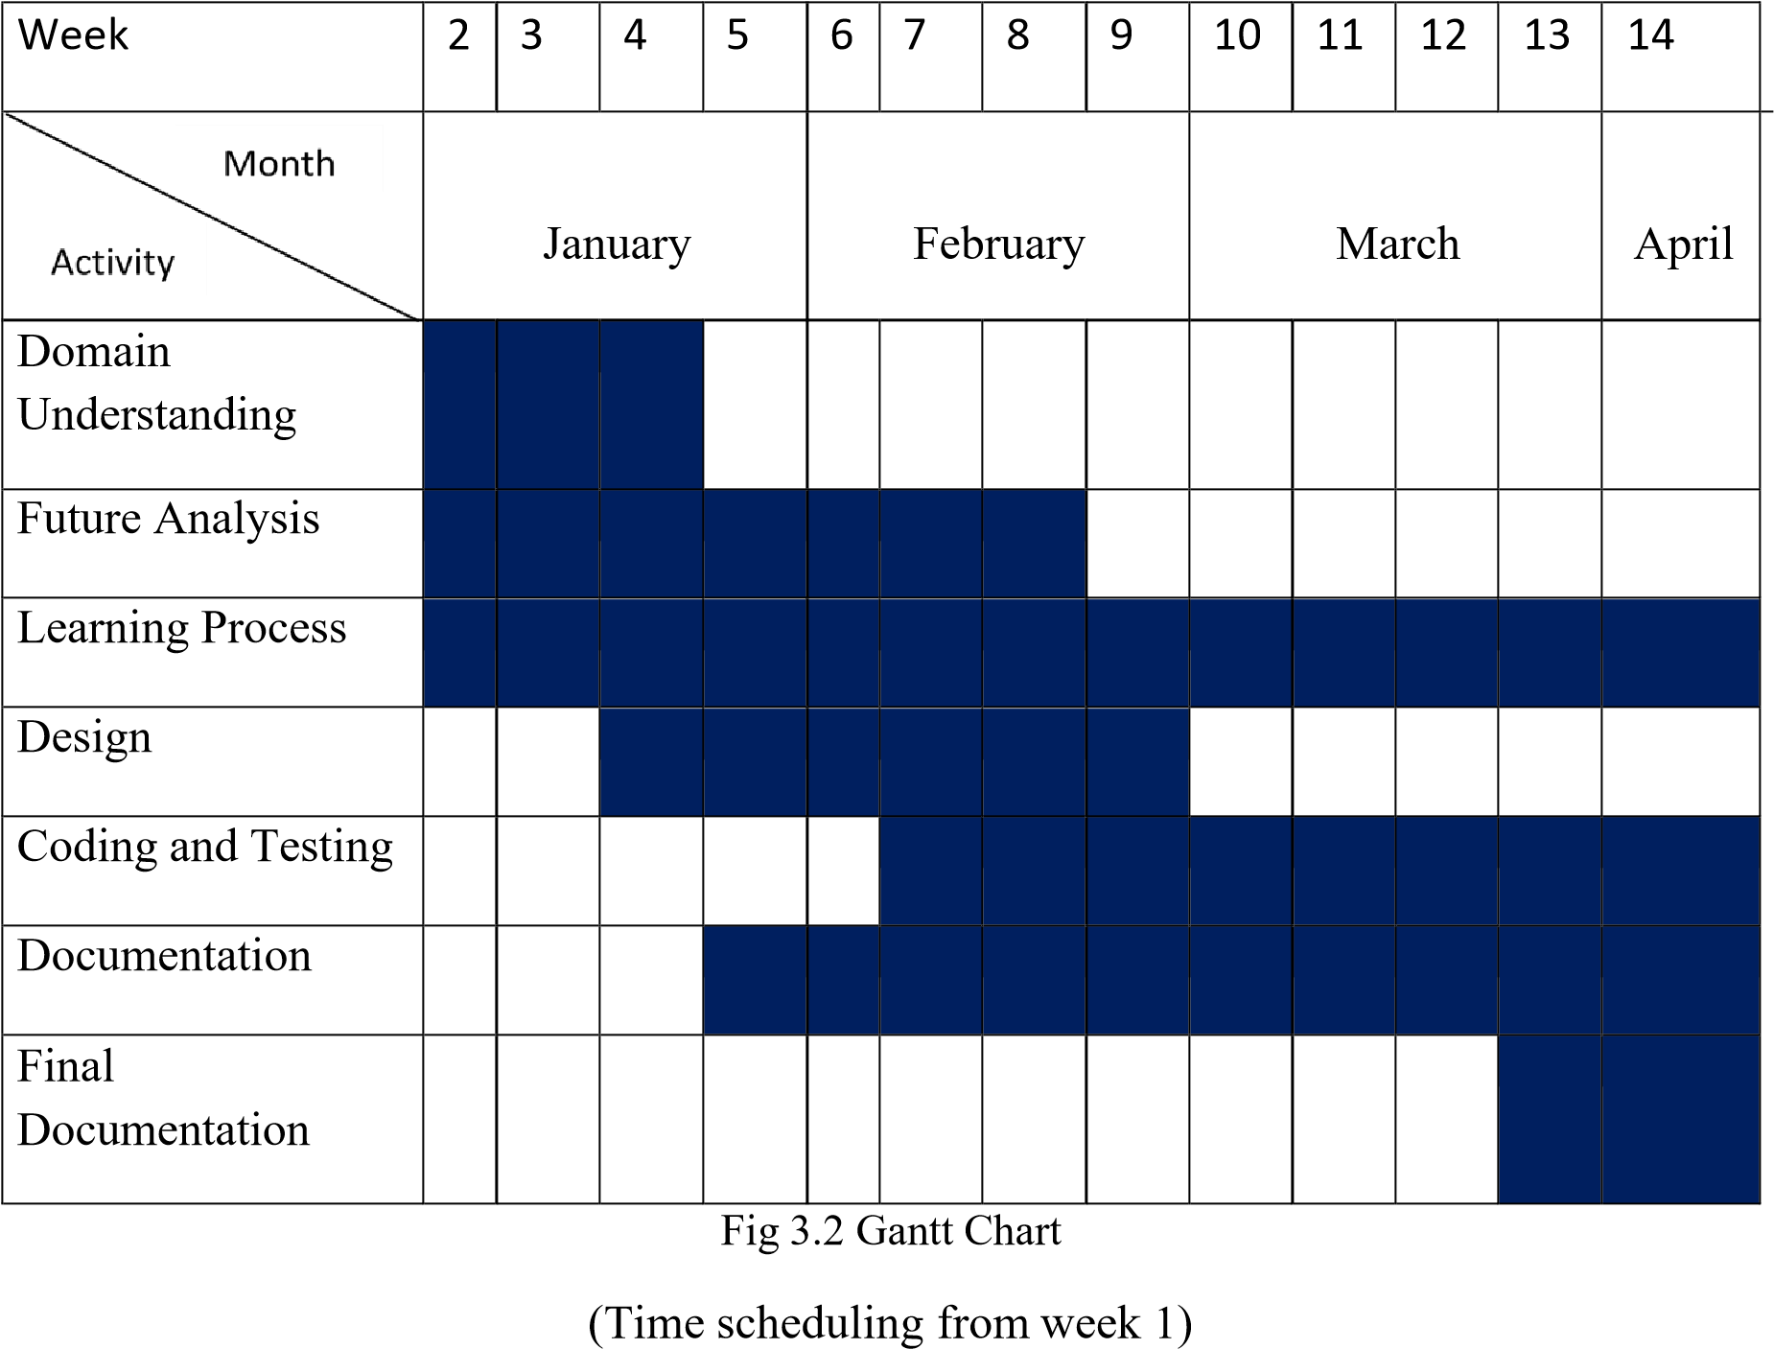

Chapter

4

===============================================================

**4. SYSTEM ANALYSIS**

===============================================================

**Study of Current System**

**Weakness of Current System**

**Requirement of New System**

**Feasibility Study**

**Use case Diagram**

**Data flow Diagram**

**List of main Modules**

**Features of New System**

**Selection of Hardware and Software**

===============================================================

**SYSTEM ANALYSIS**

**Study of Current System**

1. **Teladoc:** 
   * Limited Physical Examination: Teladoc consultations may lack the ability for healthcare providers to conduct physical examinations, which can be crucial for certain medical conditions or diagnoses.
   * Lack of Continuity of Care: Since Teladoc connects users with different healthcare providers for each consultation, there may be a lack of continuity of care and familiarity with the patient's medical history.
   * Technical Limitations: Users in areas with poor internet connectivity or limited access to technology may face challenges in accessing Teladoc's virtual healthcare services.

1. **ZocDoc:** 
   * Limited Provider Availability: Zocdoc's availability of healthcare providers may vary depending on location and specialty, leading to potential difficulties in finding appointments with preferred providers.
   * Reliance on User Reviews: While user reviews can provide valuable insights, they may not always accurately reflect the quality of care provided by healthcare providers listed on Zocdoc.
   * Appointment Scheduling Issues: Users may encounter scheduling conflicts or difficulties in booking appointments due to limited availability or discrepancies between Zocdoc's listings and actual provider schedules.

1. **Amwell:** 
   * Diagnosis Limitations: Remote consultations through Amwell may have limitations in diagnosing certain medical conditions that require in-person evaluations or diagnostic tests.
   * Privacy Concerns: Users may have concerns about the privacy and security of their personal health information when using Amwell's virtual healthcare services, especially with regards to data breaches or unauthorized access.
   * Insurance Coverage: While Amwell accepts various insurance plans, not all services or consultations may be covered by insurance, potentially leading to out-of-pocket expenses for users.

**Weakness of Current System**

* Lack of Physical Examination
* Continuity of Care Issues
* Technical Limitations
* Limited Provider Availability
* Reliance on User Reviews
* Appointment Scheduling Issues
* Diagnosis Limitations
* Privacy Concerns

**Requirement of New System**

* Comprehensive Virtual Care
* Integrated Patient Management
* User-Friendly Interface
* Multi-Platform Accessibility
* Secure Communication
* Remote Monitoring Capabilities
* Interoperability with Existing Systems
* Personalization and Customization
* Scalability and Flexibility
* Regulatory Compliance
* Feedback and Improvement Mechanisms

**Feasibility Study**

**Scheduling for the Project**

# Table: 4.1 Activity of Proposed System

|  |  |  |
| --- | --- | --- |
| **Title** | **Date** | **Status** |
| Study Time | 15/01/2024 to 22/01/2024 | **Completed** |
| Introduction of languages | 22/01/2024 to 24/01/2024 | **Completed** |
| Data Gathering and  Requirements Analysis | 24/01/2024 to 26/01/2024 | **Completed** |
| Design Diagrams | 26/01/2024 to 29/01/2024 | **Completed** |
| Data Dictionary | 29/01/2024 to 30/01/2024 | **Completed** |
| Database, Stored Procedure | 30/01/2024 to 01/02/2024 | **Completed** |

|  |  |  |
| --- | --- | --- |
| Template Design, Reports | 02/02/2024 to 17/02/2022 | **Completed** |
| Coding/Implementation | 17/03/2024 to 04/04/2024 | **Completed** |
| Change Detection | 05/04/2024 to 10/04/2024 | **Completed** |
| Testing | 11/04/2024 to 12/04/2024 | **Completed** |
| Referencing the change | 13/04/2024 to 15/04/2024 | **Completed** |

**Use Case Diagram**

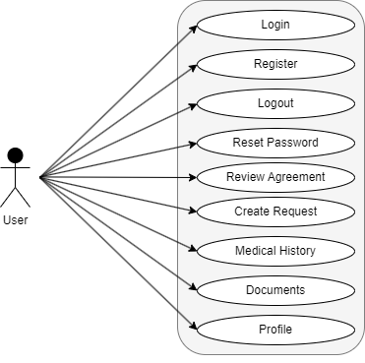

Fig 4.2 User - Use case diagram

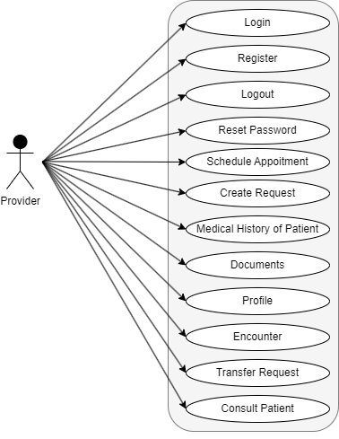

Fig 4.3 Provider - Use case diagram

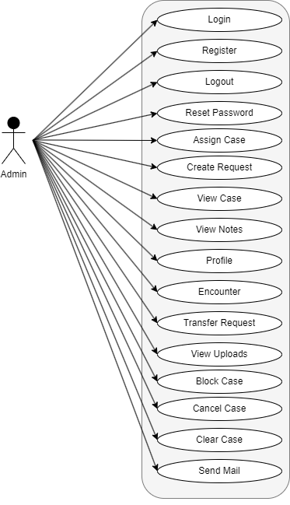

Fig 4.4 Admin - Use case diagram

**Data Flow Diagram**

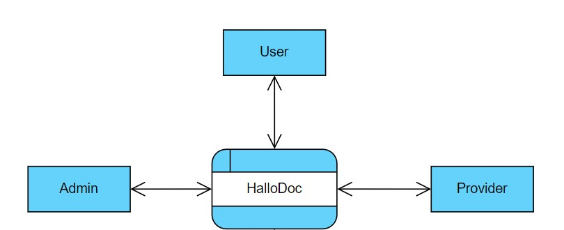

Fig. 4.5 Data Flow Diagram (Level 0)

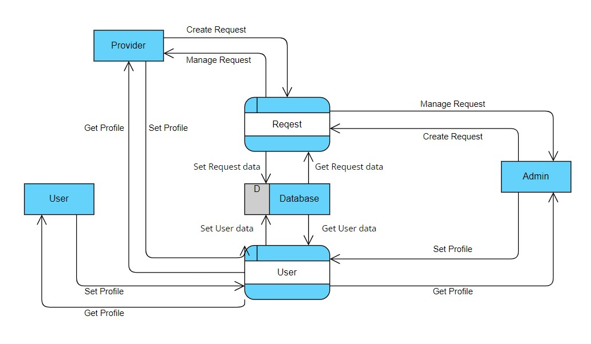

Fig 4.6 Data Flow Diagram (Level 1 Admin)

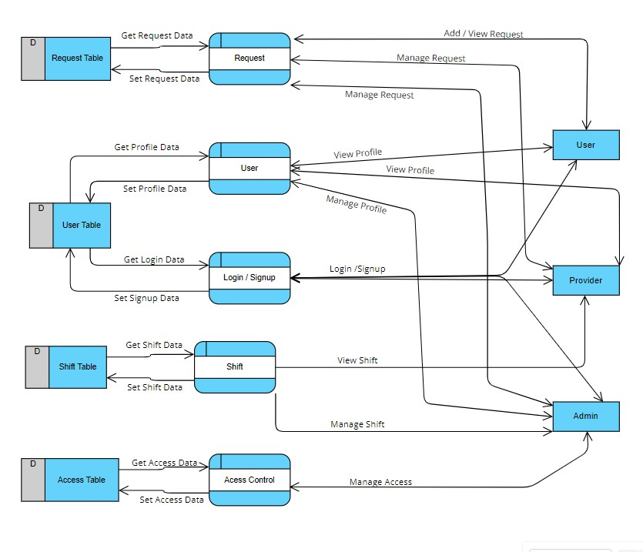

Fig 4.4 Data Flow Diagram (Level 1 Client/User)

**List of Modules**

● System consists mainly two main modules:

1. Admin
2. Provider iii. Patient (User)

**Features of New System**

This website is going to be used by mainly 3 kinds of user that deals with this application:

1. **Admin**
2. **Provider**
3. **Patient (User)**

1. Admin:

* Role: The admin user has overarching control and management responsibilities within the healthcare system.
* Responsibilities:
* Manage user accounts and permissions, including creating, modifying, and deleting accounts as needed.
* Configure system settings and preferences, such as appointment scheduling rules and billing parameters.
* Monitor system performance and resolve technical issues or security concerns.
* Generate reports and analytics to track key performance indicators and assess system usage.
* Ensure compliance with regulatory requirements and standards for healthcare data privacy and security.
* Collaborate with providers and patients to gather feedback and implement system improvements.

2. Provider:

* Role: The provider user includes healthcare professionals who deliver medical services within the system.
* Responsibilities:
* Conduct virtual consultations with patients, including diagnosing medical conditions, prescribing medications, and developing treatment plans.
* Review patient medical records and history to provide personalized care and recommendations.
* Document patient encounters accurately and comprehensively, ensuring all relevant information is captured for continuity of care.
* Collaborate with other healthcare providers and specialists as needed for multidisciplinary care.
* Communicate with patients effectively and compassionately, addressing their concerns and providing education on health management.
* Stay updated on medical best practices and guidelines to deliver high-quality care and improve patient outcomes.

3. Patient:

* Role: The patient user represents individuals seeking healthcare services and managing their health within the system.
* Responsibilities:
* Schedule appointments with healthcare providers, including selecting preferred dates and times for consultations.
* Provide accurate and complete medical history information during consultations to facilitate diagnosis and treatment.
* Participate actively in virtual consultations, asking questions, expressing concerns, and following provider recommendations.
* Adhere to prescribed treatment plans, including taking medications as directed and attending follow-up appointments.
* Communicate openly and honestly with healthcare providers about symptoms, changes in health status, or treatment adherence issues.
* Access educational resources and tools within the system to learn about health conditions, preventive care measures, and lifestyle management strategies.

**Selection of Hardware and Software**

● Hardware

o Development Machine Requirement (Average performance)

▪ 8 GB RAM

▪ 50 GB HDD

▪ Internet o Client Machine Requirement

▪ 4 GB RAM

▪ 5 GB of HDD space

▪ Network related tools o Host Machine Requirement

▪ 32 GB RAM

▪ 500 GB of HDD space

▪ Network related tools

* Software o Development Machine Requirements

▪ Visual Studio

▪ PostgreSQL

▪ PgAdmin

▪ Browser o Client Machine Requirements

▪ Browser o Host Machine Requirements ( Linux )

Chapter

5

===============================================================

**5. SYSTEM DESIGN**

===============================================================

**System Design and Methodology Database Design Interface Design**

===============================================================

**SYSTEM DESIGN**

**System Design and Methodology**

* We are using Scrum Methodology in development process.

Scrum is an agile development methodology used in the development of Software based on iterative and incremental processes. Scrum is adaptable, fast, flexible and effective agile framework that is designed to deliver value to the customer throughout the development of the project. The primary objective of Scrum is to satisfy the customer’s need through an environment of transparency in communication, collective responsibility and continuous progress. The development starts from a general idea of what needs to be built, elaborating a list of characteristics ordered by priority (product backlog) that the owner of the product wants to obtain.

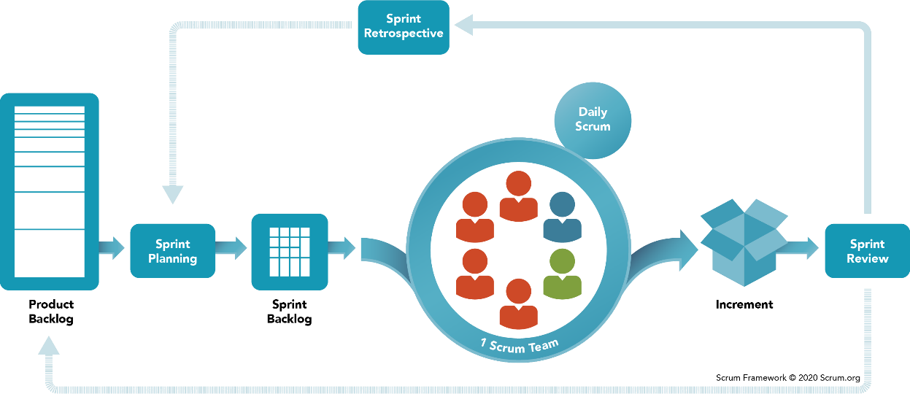

Fig 5.1 Scrum Methodology

**Scrum Methodology & Process**

Scrum is precisely an evolution of Agile Management. Scrum methodology is based on a set of very defined practices and roles that must be involved during the software development process. It is a flexible methodology that rewards the application of the 12 agile principles in a context agreed by all the team members of the product.

Scrum is executed in temporary blocks that are short and periodic, called Sprints, which usually range from 2 to 4 weeks, which is the term for feedback and reflection. Each Sprint is an entity in itself, that is, it provides a complete result, a variation of the final product that must be able to be delivered to the client with the least possible effort when requested.

The process has as a starting point, a list of objectives/ requirements that make up the project plan. It is the client of the project that prioritizes these objectives considering a balance of the value and the cost thereof, that is how the iterations and consequent deliveries are determined.

On the one hand the market demands quality, fast delivery at lower costs, for which a company must be very agile and flexible in the development of products, to achieve short development cycles that can meet the demand of customers without undermining the quality of the result. It is a very easy methodology to implement and very popular for the quick results it gets.

Scrum methodology is used mainly for software development, but other sectors are also taking advantage of its benefits by implementing this methodology in their organizational models such as sales, marketing, & HR teams etc.

**Different Roles in Scrum**

Fig 5.2 Different Roles in Scrum

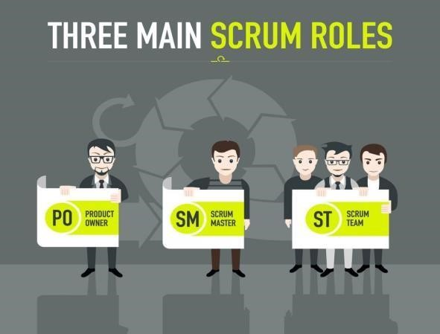

**Database Design**

# Table 5.1 Admin

|  |  |  |  |  |
| --- | --- | --- | --- | --- |
| **Table Name** | **Admin** |  |  |  |
| **Field Name** | **Data Type** | **Length** | **Nullable** | **Comments** |
| **AdminId** | **int** |  | **No** | **Its Primary Key.** |
| **AspNetUserId** | **nvarchar** | **128** | **No** | **Its Foreign key of AspNetUsers Table.** |
| **FirstName** | **nvarchar** | **100** | **No** |  |
| **LastName** | **nvarchar** | **100** | **Yes** |  |
| **Email** | **nvarchar** | **50** | **No** |  |
| **Mobile** | **nvarchar** | **20** | **Yes** |  |
| **Address1** | **nvarchar** | **500** | **Yes** |  |
| **Address2** |  | **500** | **Yes** |  |
| **City** | **nvarchar** | **100** | **Yes** |  |
| **RegionId** | **int** |  | **Yes** |  |
| **Zip** | **nvarchar** | **10** | **Yes** |  |
| **AltPhone** | **nvarchar** | **20** | **Yes** |  |
| **CreatedBy** | **nvarchar** | **128** | **No** |  |
| **CreatedDate** | **datetime** |  | **No** |  |
| **ModifiedBy** | **nvarchar** | **128** | **Yes** | **Its Foreign key of AspNetUsers Table.** |
| **ModifiedDate** | **datetime** |  | **Yes** |  |
| **Status** | **tinyint** |  | **Yes** |  |
| **IsDeleted** | **bit** |  | **Yes** |  |
| **RoleId** | **int** |  | **Yes** |  |

# Table 5.2 AdminRegion

|  |  |  |  |  |
| --- | --- | --- | --- | --- |
| **Table Name** | **AdminRegion** | |  |  |
| **Field Name** | **Data Type** | **Length** | **Nullable** | **Comments** |
| **AdminRegionId** | **int** |  | **No** | **Its Primary Key.** |
| **AdminId** | **int** |  | **No** | **Its Foreign key of Admin Table.** |
| **RegionId** | **int** |  | **No** | **Its Foreign key of Region Table.** |

# Table 5.3 AspNetRoles

|  |  |  |  |  |
| --- | --- | --- | --- | --- |
| **Table Name** | **AspNetRoles** | |  |  |
| **Field Name** | **Data Type** | **Length** | **Nullable** | **Comments** |
| **Id** | **nvarchar** | **128** | **No** | **Its Primary Key.** |
| **Name** | **nvarchar** | **256** | **No** |  |

# Table 5.4 AspNetUserRoles

|  |  |  |  |  |
| --- | --- | --- | --- | --- |
| **Table Name** | **AspNetUserRoles** | |  |  |
| **Field Name** | **Data Type** | **Length** | **Nullable** | **Comments** |
| **UserId** | **nvarchar** | **128** | **No** | **Its Primary Key.Its Foreign key of AspNetUsers Table.** |
| **RoleId** | **nvarchar** | **128** | **No** | **Its Primary Key.** |

# Table 5.5 AspNetUsers

|  |  |  |  |  |
| --- | --- | --- | --- | --- |
| **Table Name** | **AspNetUsers** | |  |  |
| **Field Name** | **Data Type** | **Length** | **Nullable** | **Comments** |
| **Id** | **nvarchar** | **128** | **No** | **Its Primary Key.** |
| **UserName** | **nvarchar** | **256** | **No** |  |
| **PasswordHash** | **nvarchar** | **MAX** | **Yes** |  |
| **Email** | **nvarchar** | **256** | **Yes** |  |
| **PhoneNumber** | **nvarchar** | **20** | **Yes** |  |
| **IP** | **nvarchar** | **20** | **Yes** |  |
| **CreatedDate** | **datetime** |  | **No** |  |
| **CreatedDate** | **datetime** |  | **Yes** |  |

Table 5.6 BlockRequests

|  |  |  |  |  |
| --- | --- | --- | --- | --- |
| **Table Name** | **BlockRequests** | |  |  |
| **Field Name** | **Data Type** | **Length** | **Nullable** | **Comments** |
| **BlockRequestId** | **int** |  | **No** | **Its Primary Key.** |
| **PhoneNumber** | **nvarchar** | **50** | **Yes** |  |
| **Email** | **nvarchar** | **50** | **Yes** |  |
| **IsActive** | **bit** |  | **Yes** |  |
| **Reason** | **nvarchar** | **MAX** | **Yes** |  |
| **RequestId** | **nvarchar** | **50** | **No** |  |
| **IP** | **nvarchar** | **20** | **Yes** |  |
| **CreatedDate** | **datetime** |  | **Yes** |  |
| **ModifiedDate** | **datetime** |  | **Yes** |  |

# Table 5.7 Business

|  |  |  |  |  |
| --- | --- | --- | --- | --- |
| **Table Name** | **Business** |  |  |  |
| **Field Name** | **Data Type** | **Length** | **Nullable** | **Comments** |
| **BusinessId** | **int** | **100** | **No** | **Its Primary Key.** |
| **Name** | **nvarchar** |  | **No** |  |
| **Address1** | **nvarchar** | **500** | **Yes** |  |
| **Address2** | **nvarchar** | **500** | **Yes** |  |
| **City** | **nvarchar** | **50** | **Yes** |  |
| **RegionId** | **int** |  | **Yes** | **Its Foreign key of Region Table.** |
| **ZipCode** | **nvarchar** | **10** | **Yes** |  |
| **PhoneNumber** | **nvarchar** | **20** | **Yes** |  |
| **FaxNumber** | **nvarchar** | **20** | **Yes** |  |
| **IsRegistered** | **bit** |  | **Yes** |  |
| **CreatedBy** | **nvarchar** | **128** | **Yes** | **Its Foreign key of AspNetUsers Table.** |
| **CreatedDate** | **datetime** |  | **No** |  |
| **ModifiedBy** | **nvarchar** | **128** | **Yes** | **Its Foreign key of AspNetUsers Table.** |
| **ModifiedDate** | **datetime** |  | **Yes** |  |
| **Status** | **tinyint** |  | **Yes** |  |
| **IsDeleted** | **bit** |  | **Yes** |  |
| **IP** | **nvarchar** | **20** | **Yes** |  |

# Table 5.8 CaseTag

|  |  |  |  |  |
| --- | --- | --- | --- | --- |
| **Table Name** | **CaseTag** |  |  |  |
| **Field Name** | **Data Type** | **Length** | **Nullable** | **Comments** |
| **CaseTagId** | **int** |  | **No** |  |
| **Name** | **nvarchar** | **50** | **No** |  |

Table 5.9 Concierge

|  |  |  |  |  |
| --- | --- | --- | --- | --- |
| **Table Name** | **Concierge** | | | |
| **Field Name** | **Data Type** | **Length** | **Nullable** | **Comments** |
| **ConciergeId** | **int** |  | **No** | **Its Primary Key.** |
| **ConciergeName** | **nvarchar** | **100** | **No** |  |
| **Address** | **nvarchar** | **150** | **Yes** |  |
| **Street** | **nvarchar** | **50** | **No** |  |
| **City** | **nvarchar** | **50** | **No** |  |
| **State** | **nvarchar** | **50** | **No** |  |
| **ZipCode** | **nvarchar** | **50** | **No** |  |
| **CreatedDate** | **datetime** |  | **No** |  |
| **RegionId** | **int** |  | **No** | **Its Foreign key of Region Table.** |
| **RoleId** | **nvarchar** | **20** | **Yes** |  |

Table 5.10 EmailLog

|  |  |  |  |  |
| --- | --- | --- | --- | --- |
| **Table Name** | **EmailLog** | |  |  |
| **Field Name** | **Data Type** | **Length** | **Nullable** | **Comments** |
| **EmailLogID** | **decimal** | **9** | **No** | **Its Primary Key.** |
| **EmailTemplate** | **nvarchar** | **MAX** | **No** |  |
| **SubjectName** | **nvarchar** | **200** | **No** |  |
| **EmailID** | **nvarchar** | **200** | **No** |  |
| **ConfirmationNumber** | **nvarchar** | **200** | **Yes** |  |
| **FilePath** | **nvarchar** | **MAX** | **Yes** |  |
| **RoleId** | **int** |  | **Yes** |  |
| **RequestId** | **int** |  | **Yes** |  |
| **AdminId** | **int** |  | **Yes** |  |
| **PhysicianId** | **int** |  | **Yes** |  |
| **CreateDate** | **datetime** |  | **No** |  |
| **SentDate** | **datetime** |  | **Yes** |  |
| **IsEmailSent** | **bit** |  | **Yes** |  |
| **SentTries** | **int** |  | **Yes** |  |
| **Action** | **int** |  | **Yes** |  |

# Table 5.11 HealthProfessionals

|  |  |  |  |  |
| --- | --- | --- | --- | --- |
| **Table Name** | **HealthProfessionals** | | |  |
| **Field Name** | **Data Type** | **Length** | **Nullable** | **Comments** |
| **VendorId** | **int** |  | **No** | **Its Primary Key.** |
| **VendorName** | **nvarchar** | **100** | **No** |  |
| **Profession** | **int** |  | **Yes** | **Its Foreign key of HealthProfessionalType Table.** |
| **FaxNumber** | **nvarchar** | **50** | **No** |  |
| **Address** | **nvarchar** | **150** | **Yes** |  |
| **City** | **nvarchar** | **100** | **Yes** |  |
| **State** | **nvarchar** | **50** | **Yes** |  |
| **Zip** | **nvarchar** | **50** | **Yes** |  |
| **RegionId** | **int** |  | **Yes** |  |
| **CreatedDate** | **datetime** |  | **No** |  |
| **ModifiedDate** | **datetime** |  | **Yes** |  |
| **PhoneNumber** | **nvarchar** | **100** | **Yes** |  |
| **IsDeleted** | **bit** |  | **Yes** |  |
| **IP** | **nvarchar** | **20** | **Yes** |  |
| **Email** | **nvarchar** | **50** | **Yes** |  |
| **BusinessContact** | **nvarchar** | **100** | **Yes** |  |

# Table 5.12 OrderDetails

|  |  |  |  |  |
| --- | --- | --- | --- | --- |
| **Table Name** | **OrderDetails** | |  |  |
| **Field Name** | **Data Type** | **Length** | **Nullable** | **Comments** |
| **Id** | **int** |  | **No** | **Its Primary Key.** |
| **VendorId** | **int** |  | **Yes** |  |
| **RequestId** | **int** |  | **Yes** |  |
| **FaxNumber** | **nvarchar** | **50** | **Yes** |  |
| **Email** | **nvarchar** | **50** | **Yes** |  |
| **BusinessContact** | **nvarchar** | **100** | **Yes** |  |
| **Prescription** | **nvarchar** | **max** | **Yes** |  |
| **NoOfRefill** | **int** |  | **Yes** |  |
| **CreatedDate** | **datetime** |  | **Yes** |  |
| **CreatedBy** | **nvarchar** | **100** | **Yes** |  |

Table 5.13 HealthProfessionalType

|  |  |  |  |  |
| --- | --- | --- | --- | --- |
| **Table Name** | **HealthProfessionalType** | | |  |
| **Field Name** | **Data Type** | **Length** | **Nullable** | **Comments** |
| **HealthProfessionalId** | **int** |  | **No** | **Its Primary Key.** |
| **ProfessionName** | **nvarchar** | **50** | **No** |  |
| **CreatedDate** | **datetime** |  | **No** |  |
| **IsActive** | **bit** |  | **Yes** |  |
| **IsDeleted** | **bit** |  | **Yes** |  |

# Table 5.14 Menu

|  |  |  |  |  |
| --- | --- | --- | --- | --- |
| **Table Name** | **Menu** |  |  |  |
| **Field Name** | **Data Type** | **Length** | **Nullable** | **Comments** |
| **MenuId** | **int** |  | **No** | **Its Primary Key.** |
| **Name** | **nvarchar** | **50** | **No** |  |
| **AccountType** | **tinyint** |  | **No** | **1 - Admin, 2 - Physician** |
| **SortOrder** | **int** |  | **Yes** |  |

Table 5.15 Physician

|  |  |  |  |  |
| --- | --- | --- | --- | --- |
| **Table Name** | **Physician** |  | | |
| **Field Name** | **Data Type** | **Length** | **Nullable** | **Comments** |
| **PhysicianId** | **int** |  | **No** | **Its Primary Key.** |
| **AspNetUserId** | **nvarchar** | **128** | **Yes** | **Its Foreign key of AspNetUsers Table.** |
| **FirstName** | **nvarchar** | **100** | **No** |  |
| **LastName** | **nvarchar** | **100** | **Yes** |  |
| **Email** | **nvarchar** | **50** | **No** |  |
| **Mobile** | **nvarchar** | **20** | **Yes** |  |
| **MedicalLicense** | **nvarchar** | **500** | **Yes** |  |
| **Photo** | **nvarchar** | **100** | **Yes** |  |
| **AdminNotes** | **nvarchar** | **500** | **Yes** |  |
| **IsAgreementDoc** | **bit** |  | **Yes** |  |
| **IsBackgroundDoc** | **bit** |  | **Yes** |  |
| **IsTrainingDoc** | **bit** |  | **Yes** |  |
| **IsNonDisclosureDoc** | **bit** |  | **Yes** |  |
| **Address1** | **nvarchar** | **500** | **Yes** |  |
| **Address2** | **nvarchar** | **500** | **Yes** |  |
| **City** | **nvarchar** | **100** | **Yes** |  |
| **RegionId** | **int** |  | **Yes** |  |
| **Zip** | **nvarchar** | **10** | **Yes** |  |
| **AltPhone** | **nvarchar** | **20** | **Yes** |  |
| **CreatedBy** | **nvarchar** | **128** | **No** | **Its Foreign key of AspNetUsers Table.** |
| **CreatedDate** | **datetime** |  | **No** |  |
| **ModifiedBy** | **nvarchar** | **128** | **Yes** | **Its Foreign key of AspNetUsers Table.** |
| **ModifiedDate** | **datetime** |  | **Yes** |  |
| **Status** | **tinyint** |  | **Yes** |  |
| **BusinessName** | **nvarchar** | **100** | **No** |  |
| **BusinessWebsite** | **nvarchar** | **200** | **No** |  |
| **IsDeleted** | **bit** |  | **Yes** |  |
| **RoleId** | **int** |  | **Yes** |  |
| **NPINumber** | **nvarchar** | **500** | **Yes** |  |
| **IsLicenseDoc** | **bit** |  | **Yes** |  |
| **Signature** | **nvarchar** | **100** | **Yes** |  |
| **IsCredentialDoc** | **bit** |  | **Yes** |  |
| **IsTokenGenerate** | **bit** |  | **Yes** |  |
| **SyncEmailAddress** | **nvarchar** | **50** | **Yes** |  |

Table 5.16 PhysicianLocation

|  |  |  |  |  |
| --- | --- | --- | --- | --- |
| **Table Name** | **PhysicianLocation** | |  |  |
| **Field Name** | **Data Type** | **Length** | **Nullable** | **Comments** |
| **LocationId** | **int** |  | **No** |  |
| **PhysicianId** | **int** |  | **No** | **Its Foreign key of Physician Table.** |
| **Latitude** | **decimal** | **9** | **Yes** |  |
| **Longitude** | **decimal** | **9** | **Yes** |  |
| **CreatedDate** | **datetime** |  | **Yes** |  |
| **PhysicianName** | **nvarchar** | **50** | **Yes** |  |
| **Address** | **nvarchar** | **500** | **Yes** |  |

Table 5.17 PhysicianNotification

|  |  |  |  |  |
| --- | --- | --- | --- | --- |
| **Table Name** | **PhysicianNotification** | | |  |
| **Field Name** | **Data Type** | **Length** | **Nullable** | **Comments** |
| **id** | **int** |  | **No** | **Its Primary Key.** |
| **PhysicianId** | **int** |  | **No** | **Its Foreign key of Physician Table.** |
| **IsNotificationStopped** | **bit** |  | **No** |  |
|  |  |  |  |  |

Table 5.18 PhysicianRegion

|  |  |  |  |  |
| --- | --- | --- | --- | --- |
| **Table Name** | **PhysicianRegion** | |  |  |
| **Field Name** | **Data Type** | **Length** | **Nullable** | **Comments** |
| **PhysicianRegionId** | **int** |  | **No** | **Its Primary Key.** |
| **PhysicianId** | **int** |  | **No** | **Its Foreign key of Physician Table.** |
| **RegionId** | **int** |  | **No** | **Its Foreign key of Region Table.** |

# Table 5.19 Region

|  |  |  |  |  |
| --- | --- | --- | --- | --- |
| **Table Name** | **Region** |  |  |  |
| **Field Name** | **Data Type** | **Length** | **Nullable** | **Comments** |
| **RegionId** | **int** |  | **No** | **Its Primary Key.** |
| **Name** | **nvarchar** | **50** | **No** |  |
| **Abbreviation** | **nvarchar** | **50** | **Yes** |  |

Table 5.20 Request

|  |  |  |  |  |
| --- | --- | --- | --- | --- |
| **Table Name** | **Request** |  | | |
| **Field Name** | **Data Type** | **Length** | **Nullable** | **Comments** |
| **RequestId** | **int** |  | **No** | **Its Primary Key.** |
| **RequestTypeId** | **int** |  | **No** | **1- Business, 2- Patient, 3- Family & 4-**  **Concierge** |
| **UserId** | **int** |  | **Yes** | **Its Foreign key of User Table.** |
| **FirstName** | **nvarchar** | **100** | **Yes** |  |
| **LastName** | **nvarchar** | **100** | **Yes** |  |
| **PhoneNumber** | **nvarchar** | **23** | **Yes** |  |
| **Email** | **nvarchar** | **50** | **Yes** |  |
| **Status** | **tinyint** |  | **No** | **1-Unassigned,2-Accepted,3-Cancelled,4Reserving,5-MDEnRoute,6-MDOnSite,7-**  **FollowUp,8-Closed,9-Locked,10-Declined,11Consult,12-Clear,13-CancelledByProvider,14CCUploadedByClient,15-**  **CCApprovedByAdmin** |
| **PhysicianId** | **int** |  | **Yes** | **Its Foreign key of Physician Table.** |
| **ConfirmationNumber** | **nvarchar** | **20** | **Yes** |  |
| **CreatedDate** | **datetime** |  | **No** |  |
| **IsDeleted** | **bit** |  | **Yes** |  |
| **ModifiedDate** | **datetime** |  | **Yes** |  |
| **DeclinedBy** | **varchar** | **250** | **Yes** |  |
| **IsUrgentEmailSent** | **bit** |  | **No** |  |
| **LastWellnessDate** | **datetime** |  | **Yes** |  |
| **IsMobile** | **bit** |  | **Yes** |  |
| **CallType** | **tinyint** |  | **Yes** |  |
| **CompletedByPhysician** | **bit** |  | **Yes** |  |
| **LastReservationDate** | **datetime** |  | **Yes** |  |
| **AcceptedDate** | **datetime** |  | **Yes** |  |
| **RelationName** | **nvarchar** | **100** | **Yes** |  |
| **CaseNumber** | **nvarchar** | **50** | **Yes** |  |
| **IP** | **nvarchar** | **20** | **Yes** |  |
| **CaseTag** | **nvarchar** | **50** | **Yes** |  |
| **CaseTagPhysician** | **nvarchar** | **50** | **Yes** |  |
| **PatientAccountId** | **nvarchar** | **128** | **Yes** |  |
| **CreatedUserId** | **int** |  | **Yes** |  |

# Table 5.21 RequestBusiness

|  |  |  |  |  |
| --- | --- | --- | --- | --- |
| **Table Name** | **RequestBusiness** | |  |  |
| **Field Name** | **Data Type** | **Length** | **Nullable** | **Comments** |
| **RequestBusinessId** | **int** |  | **No** | **Its Primary Key.** |
| **RequestId** | **int** |  | **No** | **Its Foreign key of Request Table.** |
| **BusinessId** | **int** |  | **No** | **Its Foreign key of Business Table.** |
| **IP** | **nvarchar** | **20** | **Yes** |  |

# Table 5.22 RequestClient

|  |  |  |  |  |
| --- | --- | --- | --- | --- |
| **Table Name** | **RequestClient** | | | |
| **Field Name** | **Data Type** | **Length** | **Nullable** | **Comments** |
| **RequestClientId** | **int** |  | **No** | **Its Primary Key.** |
| **RequestId** | **int** |  | **No** | **Its Foreign key of Request Table.** |
| **FirstName** | **nvarchar** | **100** | **No** |  |
| **LastName** | **nvarchar** | **100** | **Yes** |  |
| **PhoneNumber** | **nvarchar** | **23** | **Yes** |  |
| **Location** | **nvarchar** | **100** | **Yes** |  |
| **Address** | **nvarchar** | **500** | **Yes** |  |
| **RegionId** | **int** |  | **Yes** | **Its Foreign key of Region Table.** |
| **NotiMobile** | **nvarchar** | **20** | **Yes** |  |
| **NotiEmail** | **nvarchar** | **50** | **Yes** |  |
| **Notes** | **nvarchar** | **500** | **Yes** |  |
| **Email** | **nvarchar** | **50** | **Yes** |  |
| **strMonth** | **nvarchar** | **20** | **Yes** |  |
| **intYear** | **int** |  | **Yes** |  |
| **intDate** | **int** |  | **Yes** |  |
| **IsMobile** | **bit** |  | **Yes** |  |
| **Street** | **nvarchar** | **100** | **Yes** |  |
| **City** | **nvarchar** | **100** | **Yes** |  |
| **State** | **nvarchar** | **100** | **Yes** |  |
| **ZipCode** | **nvarchar** | **10** | **Yes** |  |
| **CommunicationType** | **tinyint** |  | **Yes** |  |
| **RemindReservationCount** | **tinyint** |  | **Yes** |  |
| **RemindHouseCallCount** | **tinyint** |  | **Yes** |  |
| **IsSetFollowupSent** | **tinyint** |  | **Yes** |  |
| **IP** | **nvarchar** | **20** | **Yes** |  |
| **IsReservationReminderSen** | **tinyint** |  | **Yes** |  |
| **t** |  |  |  |  |
| **Latitude** | **decimal** | **9** | **Yes** |  |
| **Longitude** | **decimal** | **9** | **Yes** |  |

# Table 5.23 RequestClosed

|  |  |  |  |  |
| --- | --- | --- | --- | --- |
| **Table Name** | **RequestClosed** | |  |  |
| **Field Name** | **Data Type** | **Length** | **Nullable** | **Comments** |
| **RequestClosedId** | **int** |  | **No** | **Its Primary Key.** |
| **RequestId** | **int** |  | **No** | **Its Foreign key of Request Table.** |
| **RequestStatusLogId** | **int** |  | **No** | **Its Foreign key of RequestStatusLog Table.** |
| **PhyNotes** | **nvarchar** | **500** | **Yes** |  |
| **ClientNotes** | **nvarchar** | **500** | **Yes** |  |
| **IP** | **nvarchar** | **20** | **Yes** |  |

# Table 5.24 RequestConcierge

|  |  |  |  |  |
| --- | --- | --- | --- | --- |
| **Table Name** | **RequestConcierge** | |  |  |
| **Field Name** | **Data Type** | **Length** | **Nullable** | **Comments** |
| **Id** | **int** |  | **No** | **Its Primary Key.** |
| **RequestId** | **int** |  | **No** | **Its Foreign key of Request Table.** |
| **ConciergeId** | **int** |  | **No** | **Its Foreign key of Concierge Table.** |
| **IP** | **nvarchar** | **20** | **Yes** |  |

# Table 5.25 RequestNotes

|  |  |  |  |  |
| --- | --- | --- | --- | --- |
| **Table Name** | **RequestNotes** | |  |  |
| **Field Name** | **Data Type** | **Lengt h** | **Nullabl**  **e** | **Comments** |
| **RequestNotesId** | **Int** |  | **No** | **Its Primary Key.** |
| **RequestId** | **Int** |  | **No** | **Its Foreign key of Request Table.** |
| **strMonth** | **Nvarchar** | **20** | **Yes** |  |
| **intYear** | **Int** |  | **Yes** |  |
| **intDate** | **Int** |  | **Yes** |  |
| **PhysicianNotes** | **Nvarchar** | **500** | **Yes** |  |
| **AdminNotes** | **Nvarchar** | **500** | **Yes** |  |
| **CreatedBy** | **Nvarchar** | **128** | **No** |  |
| **CreatedDate** | **Datetime** |  | **No** |  |
| **ModifiedBy** | **Nvarchar** | **128** | **Yes** |  |
| **ModifiedDate** | **Datetime** |  | **Yes** |  |
| **IP** | **Nvarchar** | **20** | **Yes** |  |
| **AdministrativeNotes** | **Nvarchar** | **500** | **Yes** |  |

# Table 5.26 RequestStatusLog

|  |  |  |  |  |
| --- | --- | --- | --- | --- |
| **Table Name** | **RequestStatusLog** | |  |  |
| **Field Name** | **Data Type** | **Length** | **Nullable** | **Comments** |
| **RequestStatusLogId** | **int** |  | **No** | **Its Primary Key.** |
| **RequestId** | **int** |  | **No** | **Its Foreign key of Request Table.** |
| **Status** | **tinyint** |  | **No** |  |
| **PhysicianId** | **int** |  | **Yes** | **Its Foreign key of Physician Table.** |
| **AdminId** | **int** |  | **Yes** | **Its Foreign key of Admin Table.** |
| **TransToPhysicianId** | **int** |  | **Yes** | **Its Foreign key of Physician Table.** |
| **Notes** | **nvarchar** | **500** | **Yes** |  |
| **CreatedDate** | **datetime** |  | **No** |  |
| **IP** | **nvarchar** | **20** | **Yes** |  |
| **TransToAdmin** | **bit** |  | **Yes** |  |

Table 5.27 RequestType

|  |  |  |  |  |
| --- | --- | --- | --- | --- |
| **Table Name** | **RequestType** | |  |  |
| **Field Name** | **Data Type** | **Length** | **Nullable** | **Comments** |
| **RequestTypeId** | **int** |  | **No** | **Its Primary Key.** |
| **Name** | **nvarchar** | **50** | **No** |  |

# Table 5.28 RequestWiseFile

|  |  |  |  |  |
| --- | --- | --- | --- | --- |
| **Table Name** | **RequestWiseFile** | |  |  |
| **Field Name** | **Data Type** | **Length** | **Nullable** | **Comments** |
| **RequestWiseFileID** | **int** |  | **No** | **Its Primary Key.** |
| **RequestId** | **int** |  | **No** | **Its Foreign key of Request Table.** |
| **FileName** | **nvarchar** | **500** | **No** |  |
| **CreatedDate** | **datetime** |  | **No** |  |
| **PhysicianId** | **int** |  | **Yes** | **Its Foreign key of Physician Table.** |
| **AdminId** | **int** |  | **Yes** | **Its Foreign key of Admin Table.** |
| **DocType** | **tinyint** |  | **Yes** | **1-TestOne,2-MedicalReport,3-CostReceipt** |
| **IsFrontSide** | **bit** |  | **Yes** |  |
| **IsCompensation** | **bit** |  | **Yes** |  |
| **IP** | **nvarchar** | **20** | **Yes** |  |
| **IsFinalize** | **bit** |  | **Yes** |  |
| **IsDeleted** | **bit** |  | **Yes** |  |
| **IsPatientRecords** | **bit** |  | **Yes** |  |

# Table 5.29 Role

|  |  |  |  |  |
| --- | --- | --- | --- | --- |
| **Table Name** | **Role** |  |  |  |
| **Field Name** | **Data Type** | **Length** | **Nullable** | **Comments** |
| **RoleId** | **int** |  | **No** | **Its Primary Key.** |
| **Name** | **nvarchar** | **50** | **No** |  |
| **AccountType** | **tinyint** |  | **No** | **1 - Admin, 2 - Physician** |
| **CreatedBy** | **nvarchar** | **128** | **No** |  |
| **CreatedDate** | **datetime** |  | **No** |  |
| **ModifiedBy** | **nvarchar** | **128** | **Yes** |  |
| **ModifiedDate** | **datetime** |  | **Yes** |  |
| **IsDeleted** | **bit** |  | **No** |  |
| **IP** | **nvarchar** | **20** | **Yes** |  |

# Table 5.30 RoleMenu

|  |  |  |  |  |
| --- | --- | --- | --- | --- |
| **Table Name** | **RoleMenu** | |  |  |
| **Field Name** | **Data Type** | **Length** | **Nullable** | **Comments** |
| **RoleMenuId** | **int** |  | **No** | **Its Primary Key.** |
| **RoleId** | **int** |  | **No** | **Its Foreign key of Role Table.** |
| **MenuId** | **int** |  | **No** | **Its Foreign key of Menu Table.** |

# Table 5.31 Shift

|  |  |  |  |  |
| --- | --- | --- | --- | --- |
| **Table Name** | **Shift** |  |  |  |
| **Field Name** | **Data Type** | **Length** | **Nullable** | **Comments** |
| **ShiftId** | **int** |  | **No** | **Its Primary Key.** |
| **PhysicianId** | **int** |  | **No** | **Its Foreign key of Physician Table.** |
| **StartDate** | **date** |  | **No** |  |
| **IsRepeat** | **bit** |  | **No** |  |
| **WeekDays** | **char** | **7** | **Yes** |  |
| **RepeatUpto** | **int** |  | **Yes** |  |
| **CreatedBy** | **nvarchar** | **128** | **No** | **Its Foreign key of AspNetUsers Table.** |
| **CreatedDate** | **datetime** |  | **No** |  |
| **IP** | **nvarchar** | **20** | **Yes** |  |

# Table 5.32 ShiftDetail

|  |  |  |  |  |
| --- | --- | --- | --- | --- |
| **Table Name** | **ShiftDetail** | | | |
| **Field Name** | **Data Type** | **Length** | **Nullable** | **Comments** |
| **ShiftDetailId** | **int** |  | **No** | **Its Primary Key.** |
| **ShiftId** | **int** |  | **No** | **Its Foreign key of Shift Table.** |
| **ShiftDate** | **datetime** |  | **No** |  |
| **RegionId** | **int** |  | **Yes** |  |
| **StartTime** | **time** |  | **No** |  |
| **EndTime** | **time** |  | **No** |  |
| **Status** | **tinyint** |  | **No** |  |
| **IsDeleted** | **bit** |  | **No** |  |
| **ModifiedBy** | **nvarchar** | **128** | **Yes** | **Its Foreign key of AspNetUsers Table.** |
| **ModifiedDate** | **datetime** |  | **Yes** |  |
| **LastRunningDate** | **datetime** |  | **Yes** |  |
| **EventId** | **nvarchar** | **100** | **Yes** |  |

# Table 5.33 ShiftDetailRegion

|  |  |  |  |  |
| --- | --- | --- | --- | --- |
| **Table Name** | **ShiftDetailRegion** | |  |  |
| **Field Name** | **Data Type** | **Length** | **Nullable** | **Comments** |
| **ShiftDetailRegionId** | **int** |  | **No** | **Its Primary Key.** |
| **ShiftDetailId** | **int** |  | **No** | **Its Foreign key of ShiftDetail Table.** |
| **RegionId** | **int** |  | **No** | **Its Foreign key of Region Table.** |
| **IsDeleted** | **bit** |  | **Yes** |  |

# Table 5.34 SMSLog

|  |  |  |  |  |
| --- | --- | --- | --- | --- |
| **Table Name** | **SMSLog** |  |  |  |
| **Field Name** | **Data Type** | **Length** | **Nullable** | **Comments** |
| **SMSLogID** | **decimal** | **9** | **No** | **Its Primary Key.** |
| **SMSTemplate** | **nvarchar** | **MAX** | **No** |  |
| **MobileNumber** | **nvarchar** | **50** | **No** |  |
| **ConfirmationNumber** | **nvarchar** | **200** | **Yes** |  |
| **RoleId** | **int** |  | **Yes** |  |
| **AdminId** | **int** |  | **Yes** |  |
| **RequestId** | **int** |  | **Yes** |  |
| **PhysicianId** | **int** |  | **Yes** |  |
| **CreateDate** | **datetime** |  | **No** |  |
| **SentDate** | **datetime** |  | **Yes** |  |
| **IsSMSSent** | **bit** |  | **Yes** |  |
| **SentTries** | **int** |  | **No** |  |
| **Action** | **int** |  | **Yes** |  |

# Table 5.35 User

|  |  |  |  |  |
| --- | --- | --- | --- | --- |
| **Table Name** | **User** |  | | |
| **Field Name** | **Data Type** | **Length** | **Nullable** | **Comments** |
| **UserId** | **int** |  | **No** | **Its Primary Key.** |
| **AspNetUserId** | **nvarchar** | **128** | **Yes** | **Its Foreign key of AspNetUsers Table.** |
| **FirstName** | **nvarchar** | **100** | **No** |  |
| **LastName** | **nvarchar** | **100** | **Yes** |  |
| **Email** | **nvarchar** | **50** | **No** |  |
| **Mobile** | **nvarchar** | **20** | **Yes** |  |
| **IsMobile** | **bit** |  | **Yes** |  |
| **Street** | **nvarchar** | **100** | **Yes** |  |
| **City** | **nvarchar** | **100** | **Yes** |  |
| **State** | **nvarchar** | **100** | **Yes** |  |
| **RegionId** | **int** |  | **Yes** |  |
| **ZipCode** | **nvarchar** | **10** | **Yes** |  |
| **strMonth** | **nvarchar** | **20** | **Yes** |  |
| **intYear** | **int** |  | **Yes** |  |
| **intDate** | **int** |  | **Yes** |  |
| **CreatedBy** | **nvarchar** | **128** | **No** |  |
| **CreatedDate** | **datetime** |  | **No** |  |
| **ModifiedBy** | **nvarchar** | **128** | **Yes** |  |
| **ModifiedDate** | **datetime** |  | **Yes** |  |
| **Status** | **tinyint** |  | **Yes** |  |
| **IsDeleted** | **bit** |  | **Yes** |  |
| **IP** | **nvarchar** | **20** | **Yes** |  |
| **IsRequestWithEmail** | **bit** |  |  |  |

**Interface Design**

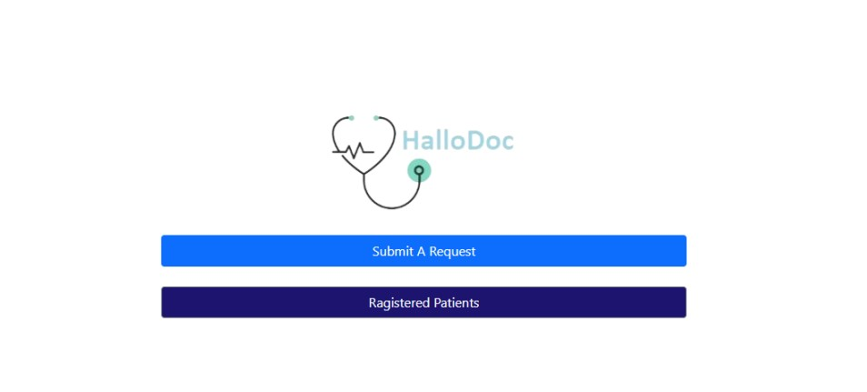

Fig 5.3 Landing Page

**Description**: Landing page will shown when website url is searched

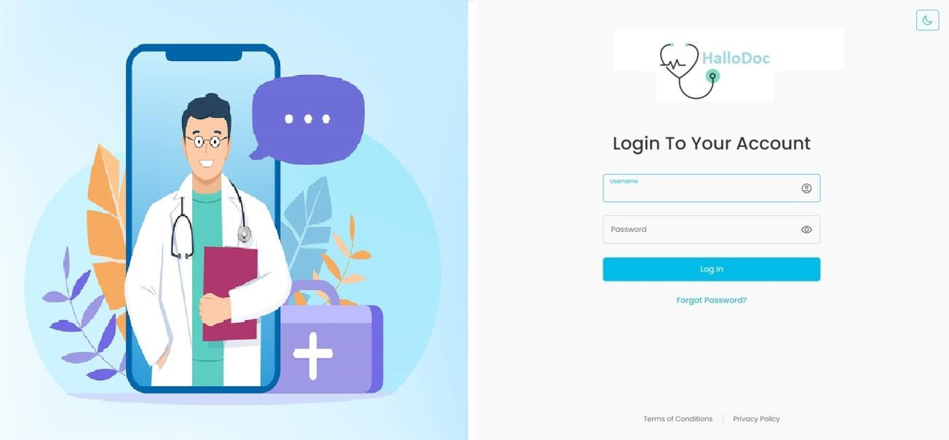

Fig 5.4 Login Page

**Description:** Login page with personal details such as email address and password after successfully submitted all the details and then clicking on log in button user can successfully enter in the system and there is also option for forgot password.

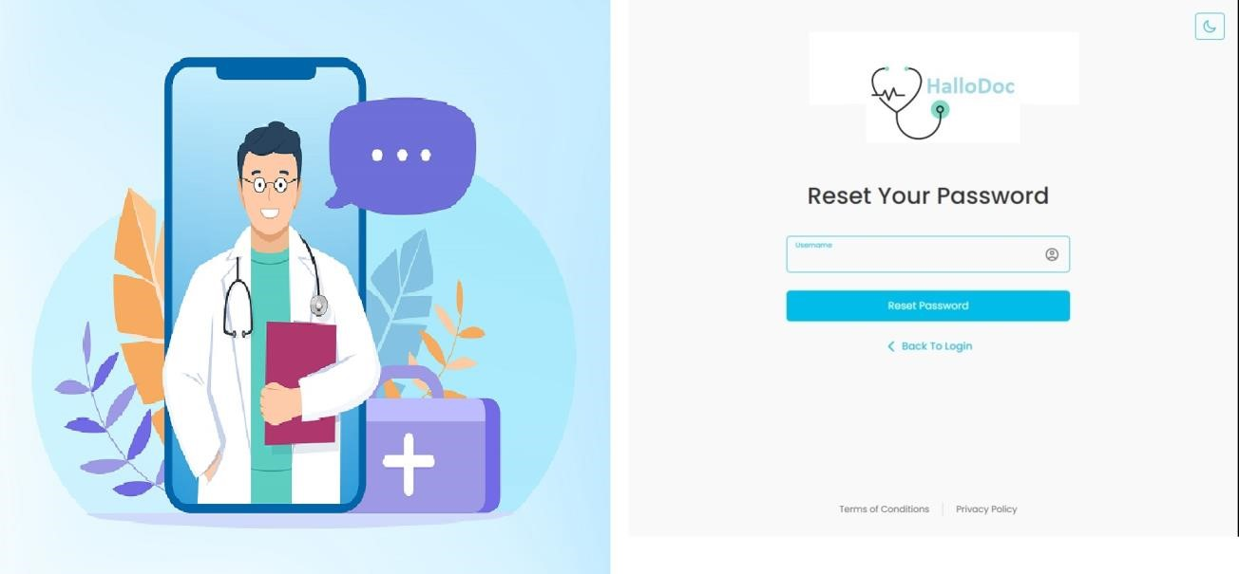

Fig 5.5 Reset Password Page

**Description:** The reset password page prompts users to enter their email address. Upon submission, a password reset link is sent to the email. Users click the link, set a new password, and gain access to their account.

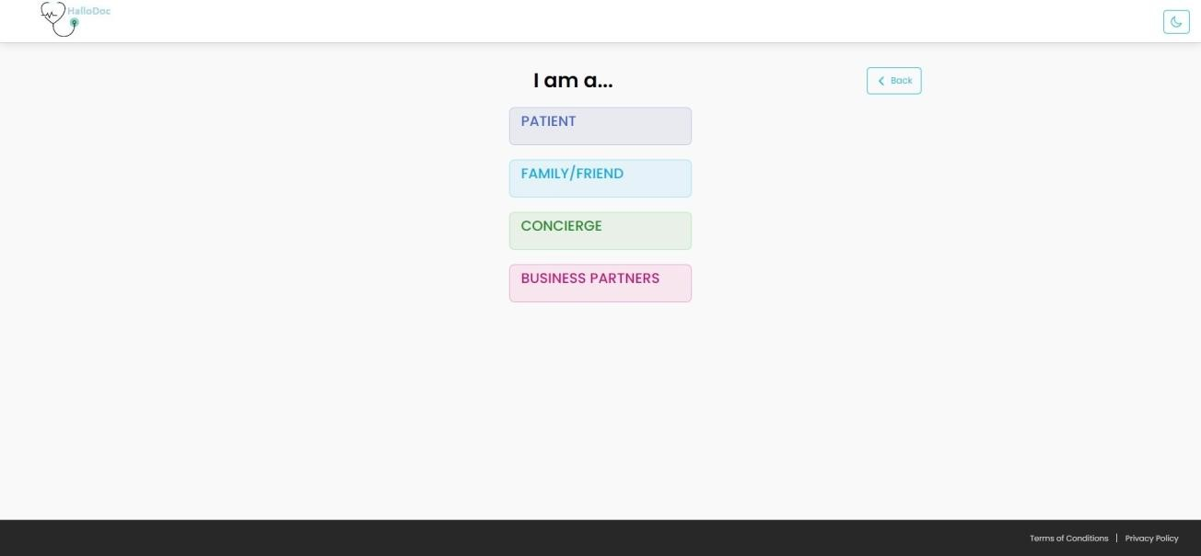

Fig 5.6 Select Role Page

**Description**: This is Screenshot of submit request screen it shows four different types of request Patient,Family/Friend,Concierge and Business Partners

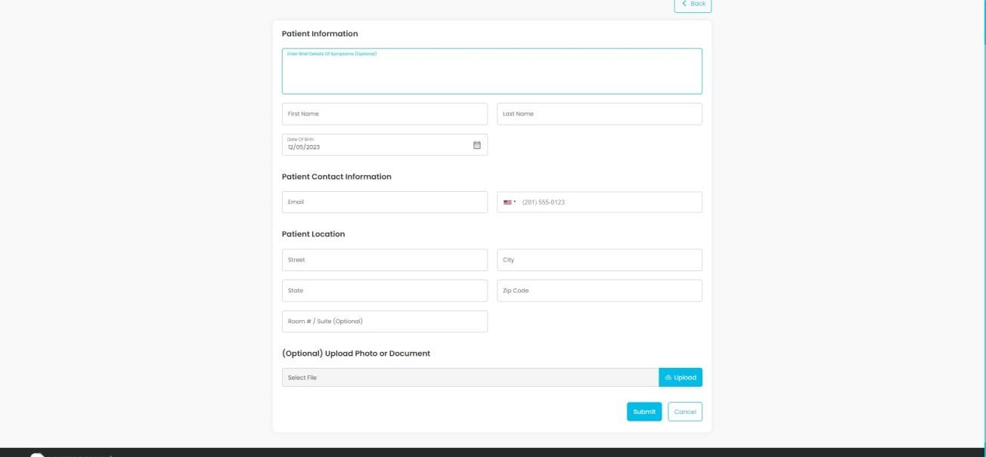

Fig 5.7 Submit Request Page

**Description**: This is Screenshot of form for submit request patient. Patient can upload any medical documents here .

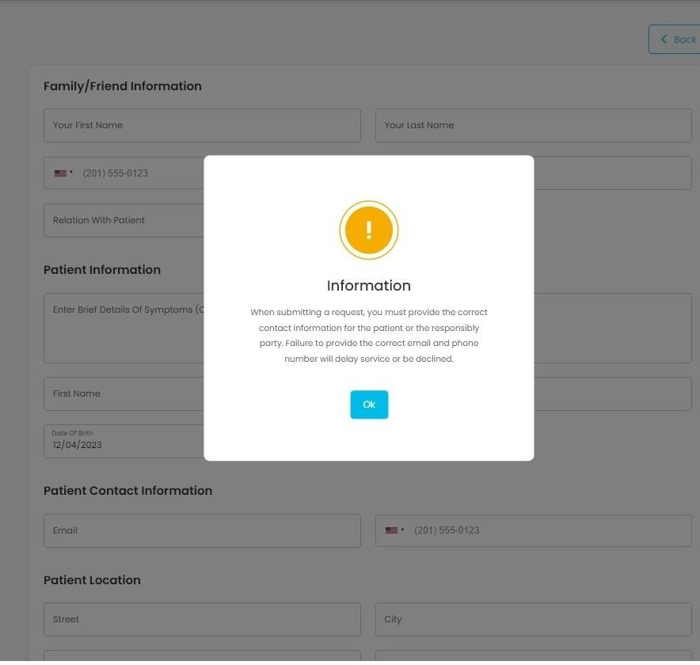

Fig 5.8 Info Alert Page

**Description**: This is Screenshot Of popup that warns user to give correct data while submitting request as any of these 3 request types same pop up will shown when forms are loaded excluding Patient type.

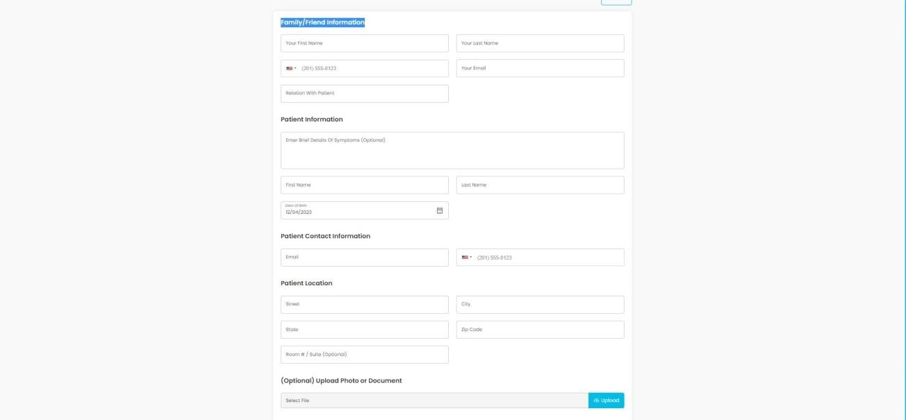

Fig 5.9 Family/Friend Request Page

**Description**: This screenshort shows family friend request form.

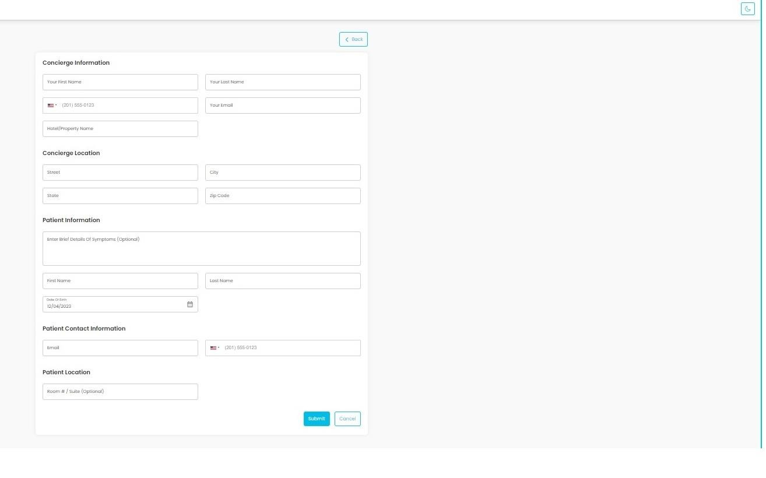

Fig 5.10 Concierge Request Page

**Description**: This screenshort shows concierge request form.

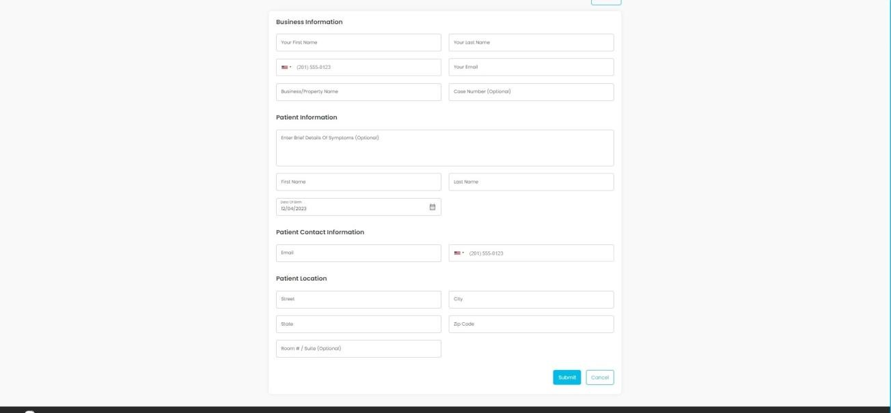

Fig 5.11 Business Request Page

**Description**: This is screenshort shows submit request as business partners.

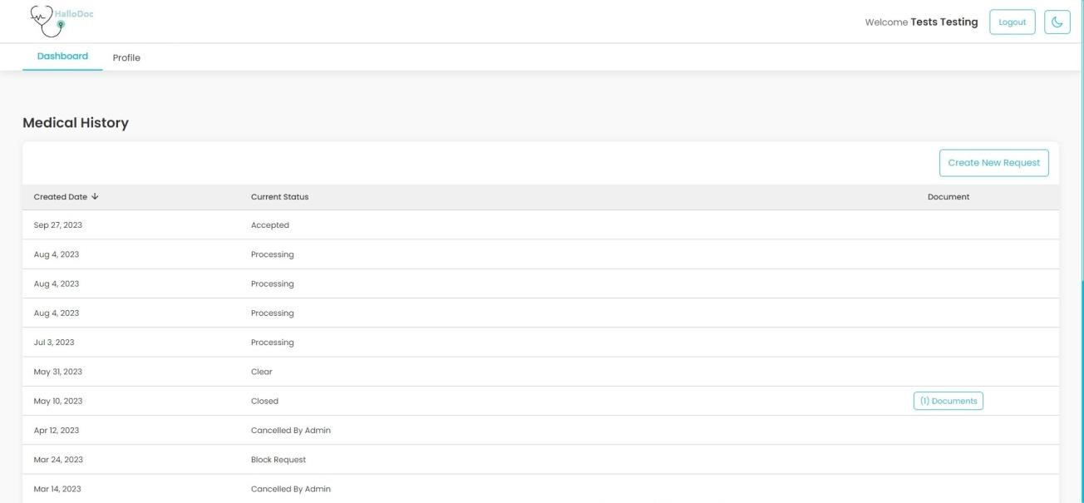

Fig 5.12 Patient Dashboard Page

**Description**: After successful log in this is dashboard page of patient site.

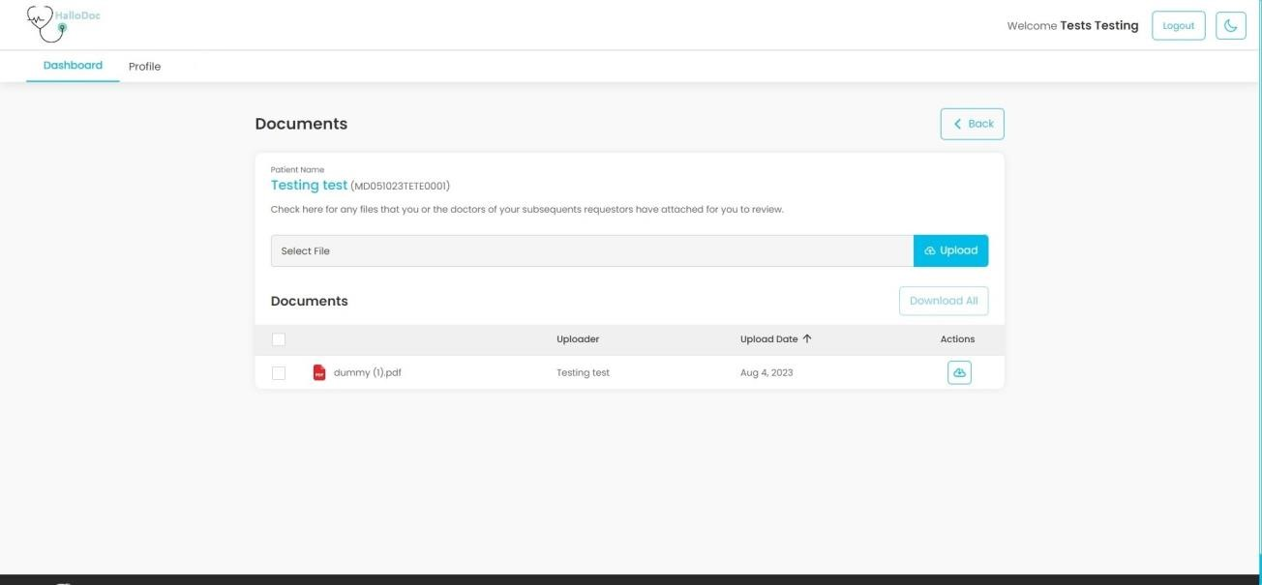

Fig 5.13 View Documents Page

**Description**: This is Screenshot View document page which shows all documents of particular request and shows uploader name with uploaded date. Also user can download the documents one by one or selected by checkboxs.user can upload documents also.

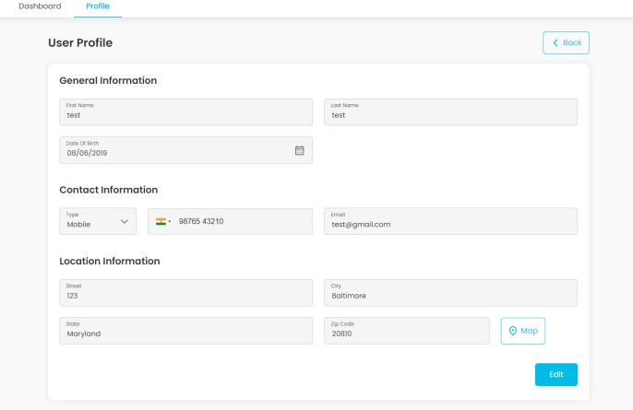

Fig 5.14 Patient Profile Page

**Description**: This is Patient Profile page user can edit the fields except email.

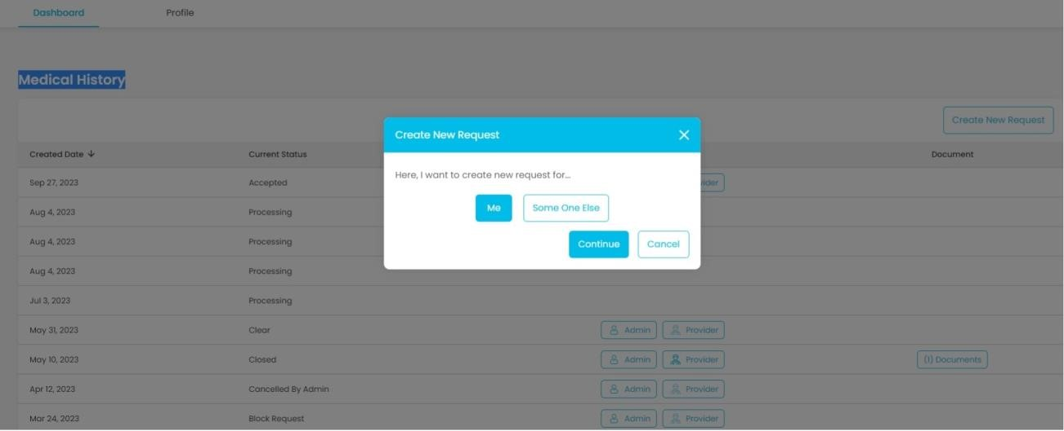

Fig 5.15 Patient Request Page

**Description**: This is Patient request option page user can request for him or her self or for others.

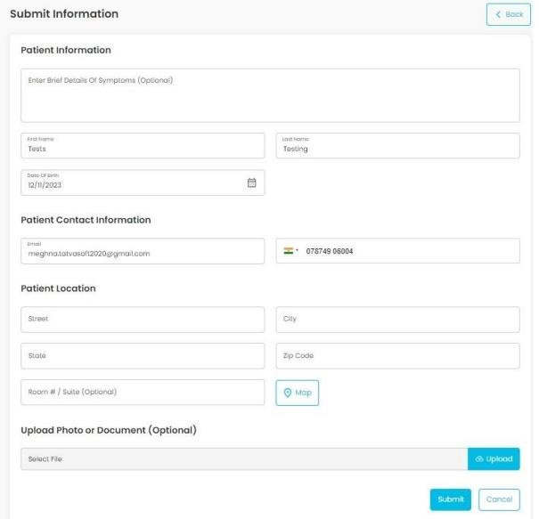

Fig 5.16 Patient Request for Me Page

**Description**: This is Screenshot of create new request for me when user clicks me button and submits this screen will show with user data filled and user can change also while submitting information for himself.

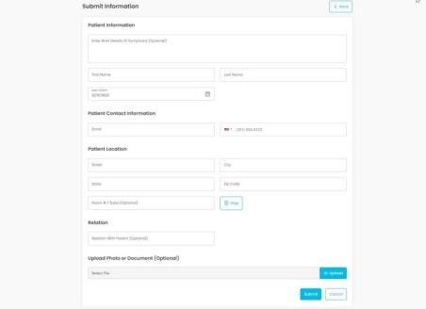

Fig 5.17 Patient Request for someone else Page

**Description**: This is Screenshot of submit request for some one else user can submit request by filling up the data and also can upload the document.

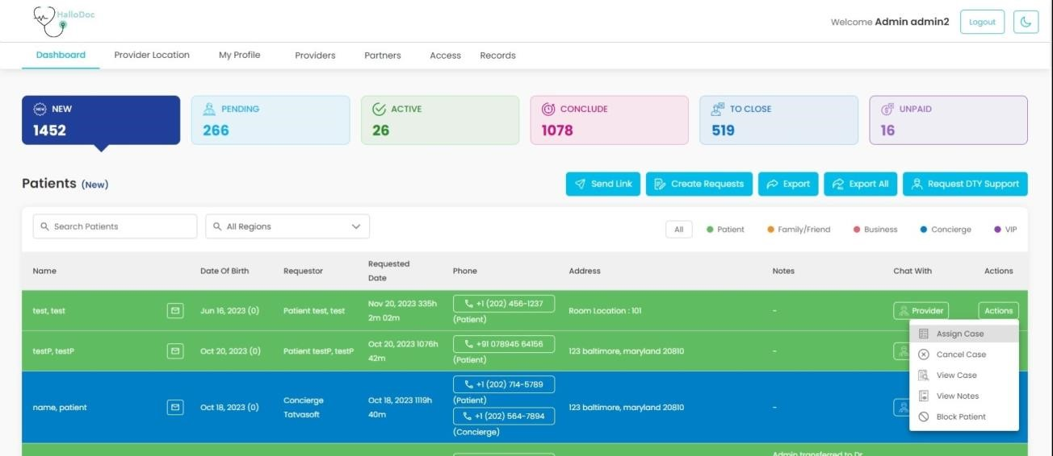

Fig 5.18 Admin Dashboard - New State Dashboard

**Description:** This is Screenshot of admin dashboard . admin dashboard will be shown if logged in email belongs to admin table.

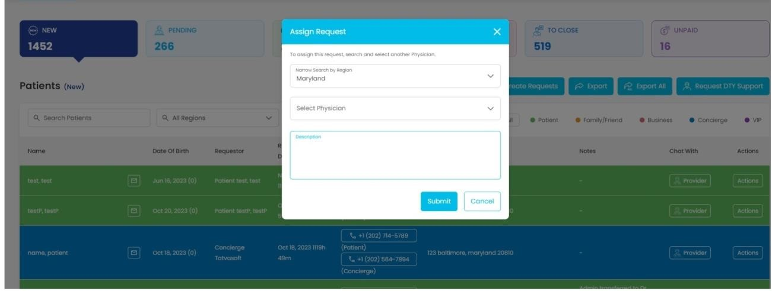

Fig 5.19 Assign Case

**Description:** This is Screenshot of assign case popup admin can assign case to the provider when the request is in new state.

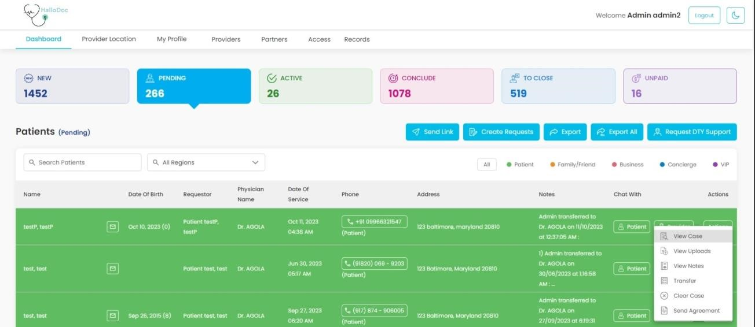

Fig 5.20 Pending State Dashboard

**Description:** This is Screenshot of admin dashboard in pending state from here admin can send link for agreement to the patient . it will sent on registered email.

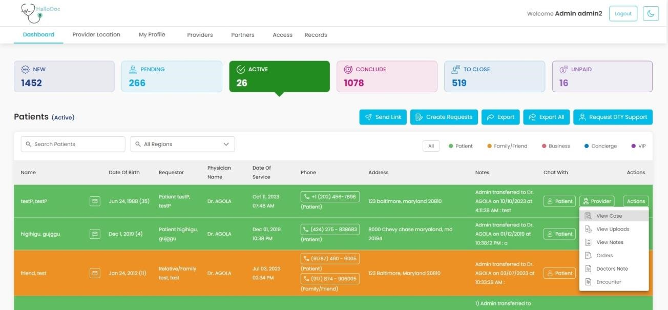

Fig 5.21 Active State Dashboard

**Description:** This is Screenshot of admin dashboard in active state and following six operations can be performed on request view case , view uploads , view notes,orders,doctors note,encounter.

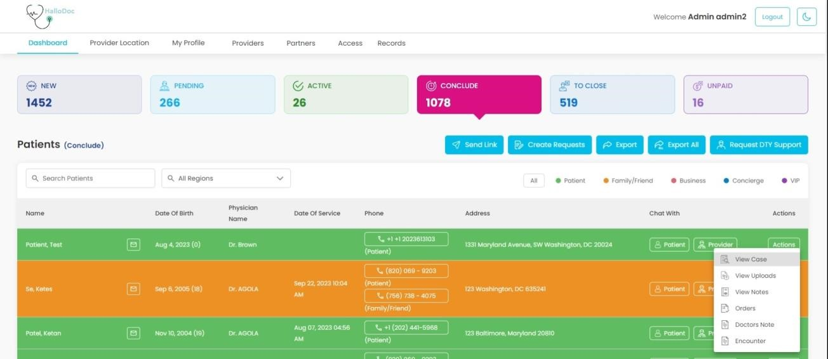

Fig 5.22 Conclude State Dashboard

**Description:** This is Screenshot of admin dashboard in conclude state and following six operations can be performed on request view case , view uploads , view notes,orders,doctors note,encounter.

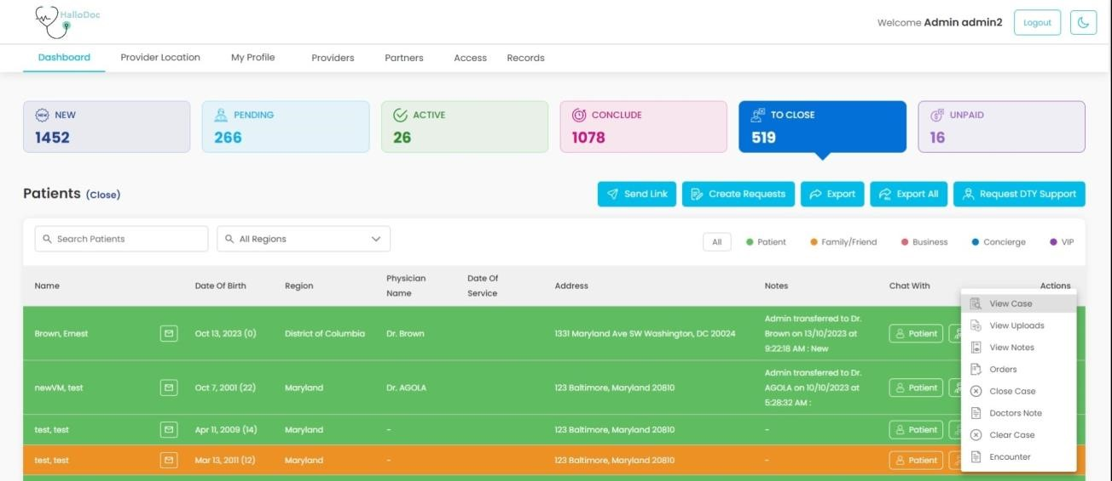

Fig 5.23 To Close State Dashboard

**Description:** This is Screenshot of admin dashboard in to close state in which requests are ready to close .

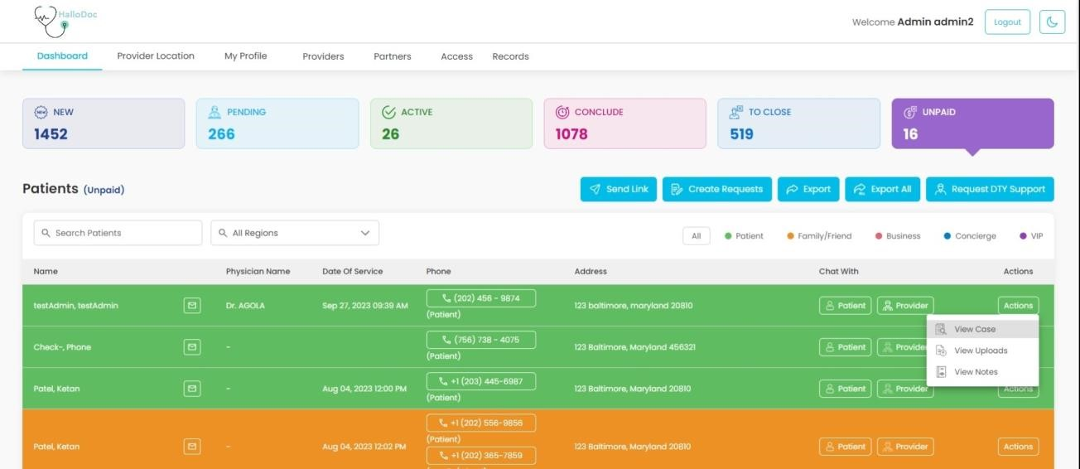

Fig 5.24 Unpaid State Dashboard

**Description:** This is Screenshot of admin dashboard in unpaid state.

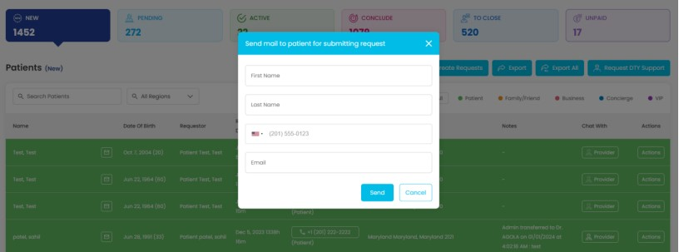

Fig 5.25 Send Mail

**Description:** This popup is opened when clicked on Send link button in dashboard, it will be used to send link of Submit Request Screen page to the patient via email and SMS.

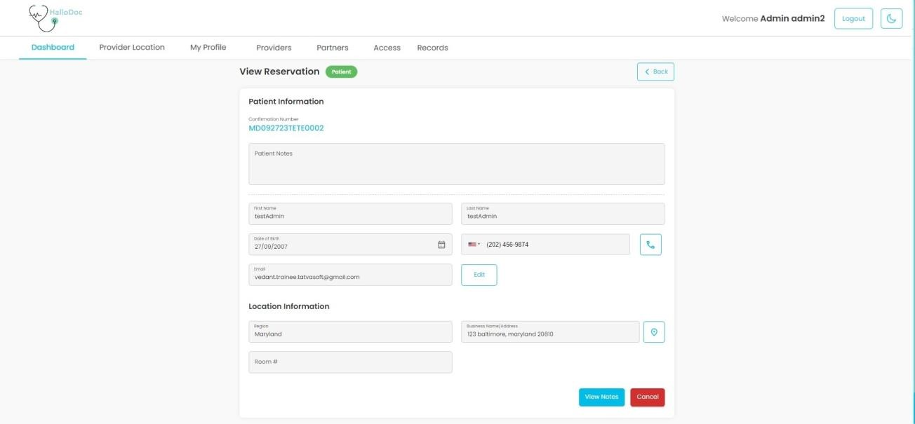

Fig 5.26 View Case

**Description:** This screen will appear when admin clicks on view case button from any state.it show description of the request.

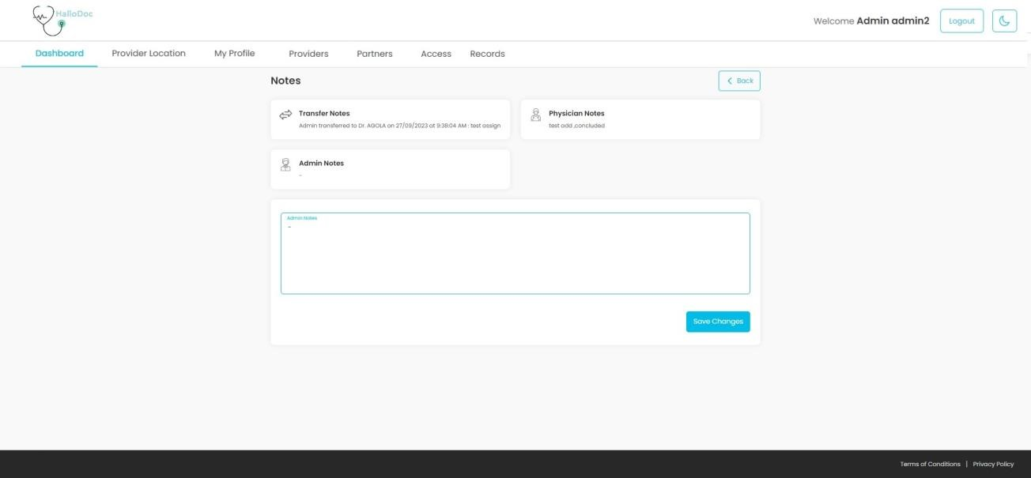

Fig 5.27 View Notes

**Description:** This screen will appear when admin clicks on view notes button .it shows notes like admin notes ,physician notes , transfer notes , other notes are patient cancellations notes it will appear if patient have not accept the agreement.

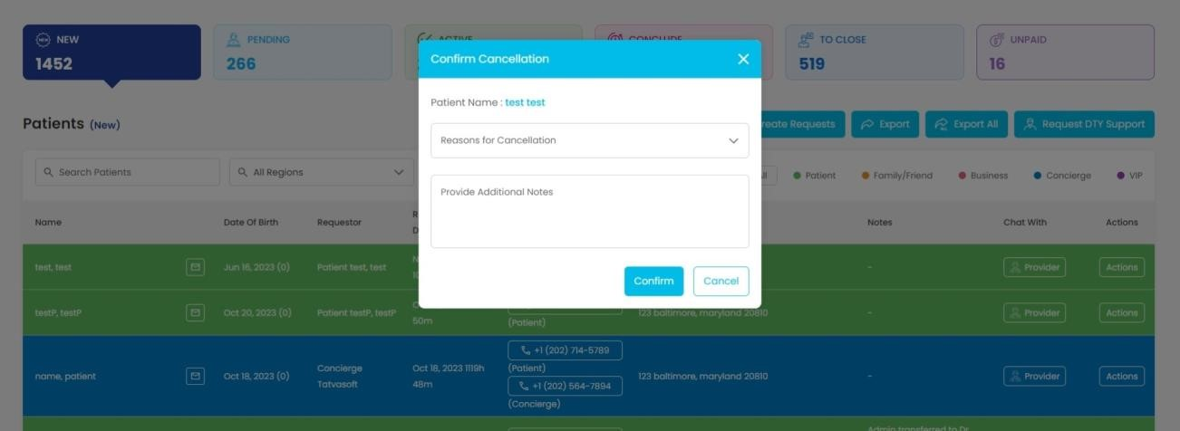

Fig 5.28 Cancel Case

**Description:** This screen will appear when admin clicks on cancel case button .it shows the drop down for reason for cancelling the case it also have text area for addition description. After cancellation request will move to ToClose state.

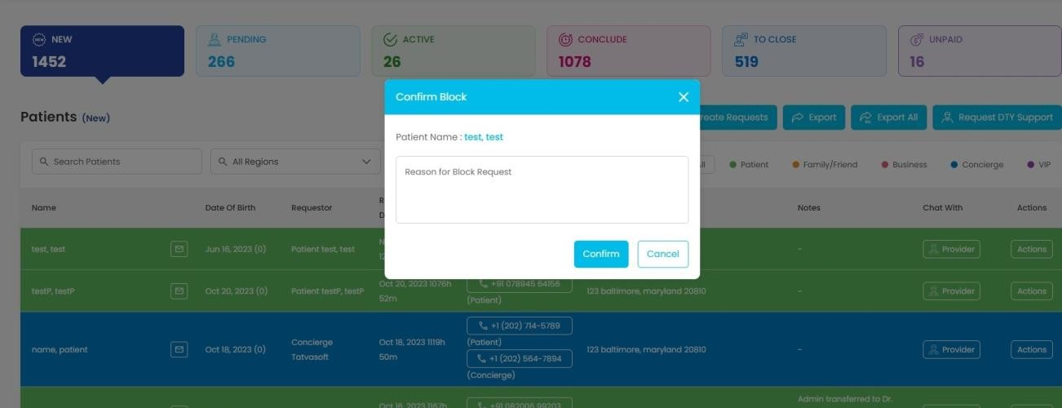

Fig 5.29 Block Case

**Description:** This screen will appear when admin clicks on block case button .it shows the text area for reason for blocking patient.

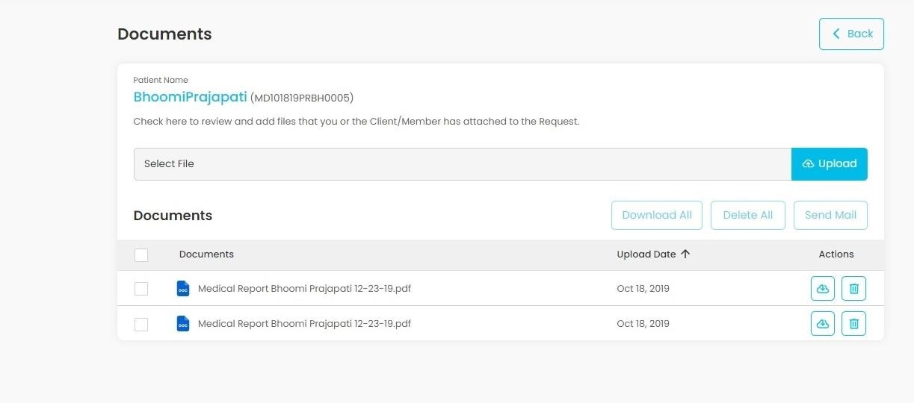

Fig 5.30 View Uploads Admin

**Description:** This screen will appear when admin clicks on view uploads button .it shows all the documents related to the request and admin can download , delete the document. Admin can also send documents on email of the client to which request belongs to . and admin can also upload the document.

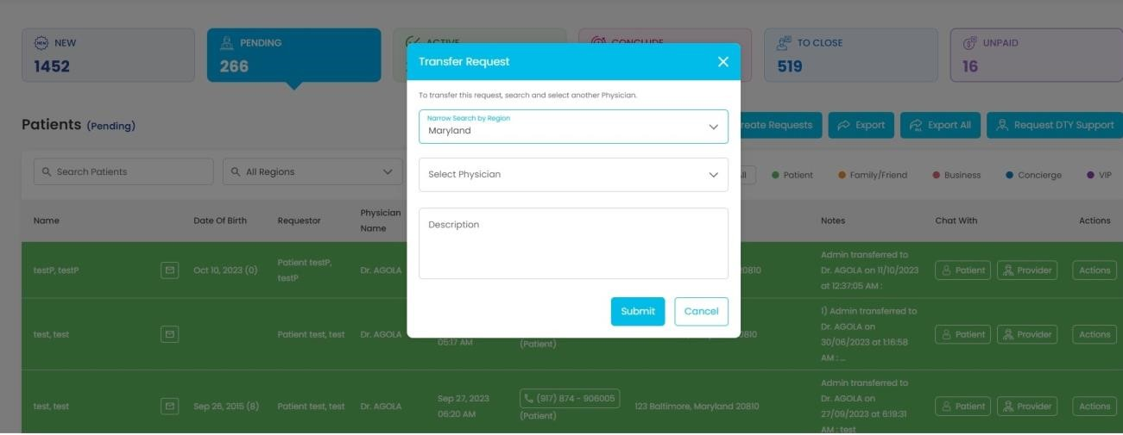

Fig 5.31 Transfer Case

**Description:** This screen will appear when admin clicks on transfer case button .it will transfer request to one physician to another physician.

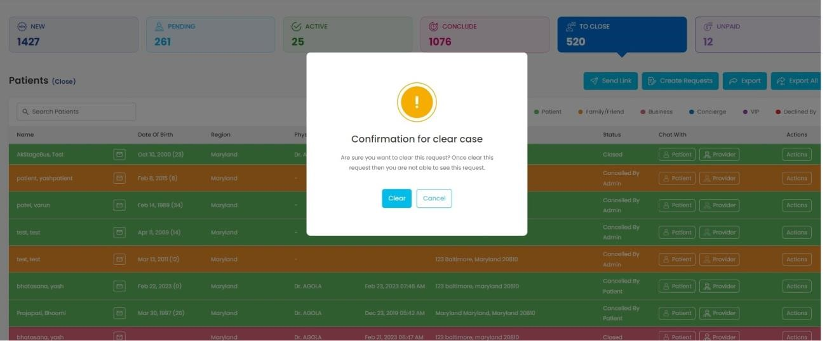

Fig 5.32 Clear Case

**Description:** This screen will appear when admin clicks on clear case button .it will remove the request from the dashboard .

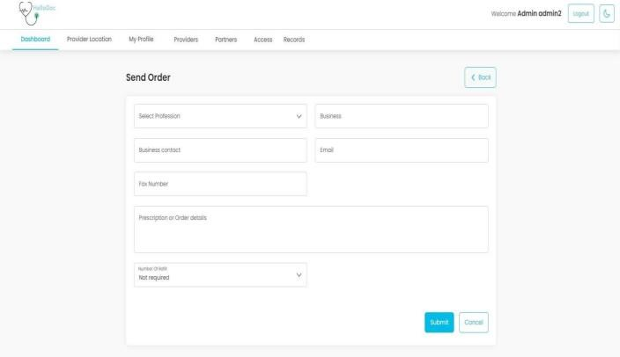

Fig 5.33 Send Orders

**Description:** This page will open when admin/provider will click on “Orders” link from Actions menu. From the active, conclude and close state, admin/providers can send order to a registered business.

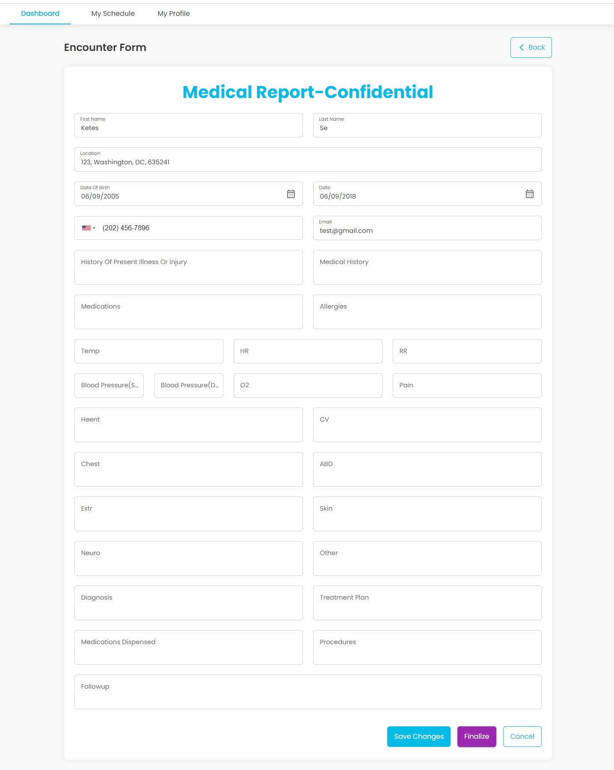

Fig 5.34 Encounter - Admin

**Description:** This form will appear when admin clicks on encounter button .it will show details of the consultation filled by provider.admin can edit this also.

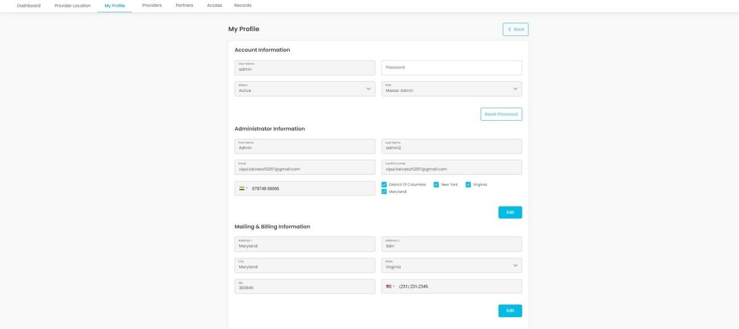

Fig 5.35 Profile - Admin

**Description:** This form will appear when admin clicks on my profile tab.

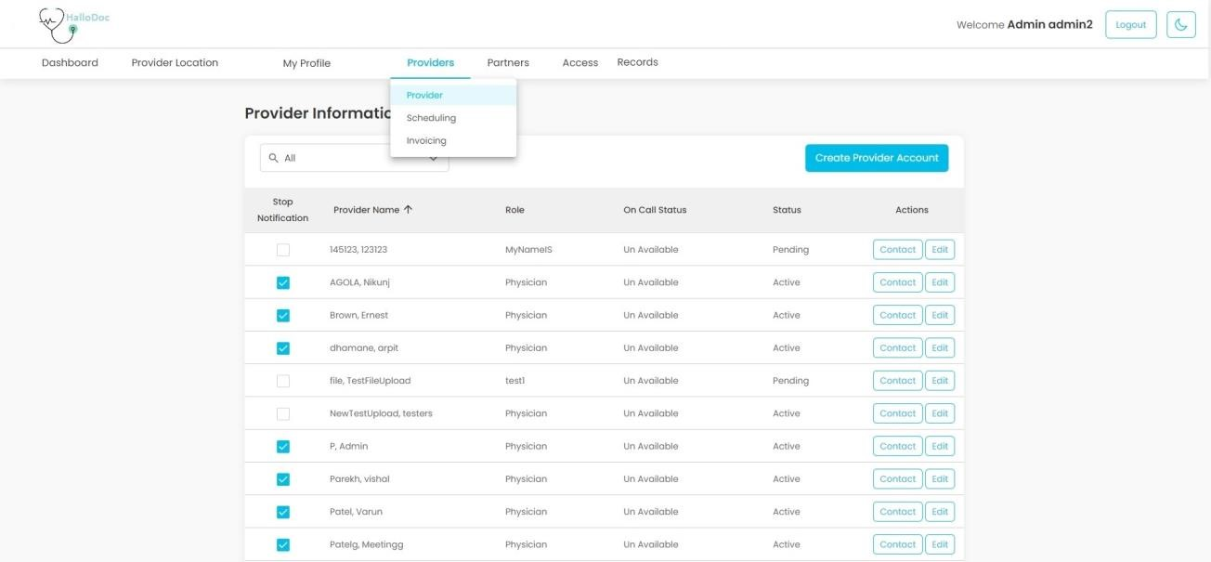

Fig 5.36 Provider Information - Admin **Description:** This form will appear when admin clicks on my profile tab.

Chapter

6

===============================================================

**6. IMPLEMENTATION**

===============================================================

**Implementation Platform Module Specification**

=============================================================== Gujarat Technological University 60 LJIET, Ahmedabad

Project ID: 399549 Testing

**IMPLEMENTATION**

**Implementation Platform**

* Visual Studio

Visual Studio is a comprehensive integrated development environment (IDE) developed by Microsoft. It offers advanced features for code editing, debugging, project management, version control integration, testing, and performance profiling. Visual Studio is available in different editions, including Community, Professional, and Enterprise, catering to various developer needs. It supports development for multiple platforms and seamlessly integrates with other Microsoft development tools and services, facilitating end-to-end application development and deployment workflows.

* Meet IntelliSense.

Go beyond syntax highlighting and auto complete with IntelliSense, which provides smart completions based on variable types, function definitions, and imported modules.

* Print statement debugging is a thing of the past

Debug code right from the editor. Launch or attach to your running apps and debug with break points, call stacks, and an interactive console.

* Git commands built-in

Working with Git and other SCM providers has never been easier. Review different, stage files, and make commits right from the editor. Push and pull from any hosted SCM service.

* Deploy with confidence and ease

With [Microsoft Azure y](https://azure.microsoft.com/)ou can deploy and host your React, Angular, Node, Python (and more!) sites, store and query relational and document based data, and scale with server less computing, all with ease, [all from within VS.](https://code.visualstudio.com/docs/azure/extensions)

Gujarat Technological University 61 LJIET, Ahmedabad

**Module Specification**

This website is going to be used by mainly 3 kinds of user that deals with this application:

* 1. **Admin**
  2. **Provider**
  3. **Patient (User)**

1. Admin:

* Role: The admin user has overarching control and management responsibilities within the healthcare system.
* Responsibilities:
* Manage user accounts and permissions, including creating, modifying, and deleting accounts as needed.
* Configure system settings and preferences, such as appointment scheduling rules and billing parameters.
* Monitor system performance and resolve technical issues or security concerns.
* Generate reports and analytics to track key performance indicators and assess system usage.
* Ensure compliance with regulatory requirements and standards for healthcare data privacy and security.
* Collaborate with providers and patients to gather feedback and implement system improvements.

2. Provider:

* Role: The provider user includes healthcare professionals who deliver medical services within the system.
* Responsibilities:
* Conduct virtual consultations with patients, including diagnosing medical conditions, prescribing medications, and developing treatment plans.
* Review patient medical records and history to provide personalized care and recommendations.
* Document patient encounters accurately and comprehensively, ensuring all relevant information is captured for continuity of care.
* Collaborate with other healthcare providers and specialists as needed for multidisciplinary care.
* Communicate with patients effectively and compassionately, addressing their concerns and providing education on health management.
* Stay updated on medical best practices and guidelines to deliver high-quality care and improve patient outcomes.

3. Patient:

* Role: The patient user represents individuals seeking healthcare services and managing their health within the system.
* Responsibilities:
* Schedule appointments with healthcare providers, including selecting preferred dates and times for consultations.
* Provide accurate and complete medical history information during consultations to facilitate diagnosis and treatment.
* Participate actively in virtual consultations, asking questions, expressing concerns, and following provider recommendations.
* Adhere to prescribed treatment plans, including taking medications as directed and attending follow-up appointments.
* Communicate openly and honestly with healthcare providers about symptoms, changes in health status, or treatment adherence issues.
* Access educational resources and tools within the system to learn about health conditions, preventive care measures, and lifestyle management strategies.

Chapter

7

===============================================================

**7. TESTING**

===============================================================

**Testing Plan Testing Strategy Testing Methods Testing Cases**

===============================================================

**TESTING**

**Testing Plan**

A test plan is the cornerstone of a successful testing implementation. The testing plan represents the overall approach to the test. In many ways, the test plan serves as a summary of the test activities that will be performed. It shows how the tests will be organized, and outlines all of the tester’s needs that must be met in order to properly carry out the test.

The goal of test planning is to establish the list of tasks that, if performed, will identify all of the requirements that have not been met in the software. There are many standards that can be used for developing test plans. Early in the deployment planning phase, the testing effort, and identifies the methodology that your team will use to conduct tests. It also identifies the hardware, software, and tools required for testing and the features and functions that will be tested. A well- rounded test plan notes any risk factors that jeopardize testing and includes a testing schedule. So, I can say that Test Planning details the activities, dependencies and effort required to conducting the system test.

**Testing Strategy**

The test strategy is a formal description of how a software product will be tested. A test strategy is developed for all levels of testing, as required. The test team analyzes the requirements, writes the test strategy and reviews the plan with the project team. The test plan may include test cases, conditions, and the test environment, a list of related tasks, pass/fail criteria and risk assessment.

The purpose of the testing strategy is to define the overall context for the entire testing process. The process is different depending on the specific characteristics of your solution. In many respects, this is the most important part of the testing process, since all future testing decisions will be made within the context of the strategy. As a programmer, we have to just do a unit testing which is a part of White Box testing. Other type of the testing in each phase of the software is done by testing department. Unit testing begins at the vortex of the spiral and concentrates on each unit (i.e. component) of the software as implemented in source code.

**Testing Methods**

**Unit Testing**

Unit testing involves the testing of each unit or an individual component of the software application. It is the first level of functional testing. The aim behind unit testing is to validate unit components with its performance.

A unit is a single testable part of a software system and tested during the development phase of the application software.

The purpose of unit testing is to test the correctness of isolated code. A unit component is an individual function or code of the application. White box testing approach used for unit testing and usually done by the developers.

Whenever the application is ready and given to the Test engineer, he/she will start checking every component of the module or module of the application independently or one by one, and this process is known as Unit testing or components testing.

**Testing Cases**

**Testing: -** Software testing is a critical element of software quality assurance and represents the ultimate review or specification, design and code generation.

Table 7.1 Test Cases 01 - Registration

|  |  |  |  |  |  |
| --- | --- | --- | --- | --- | --- |
| Step | Test Steps | Test Data | Expected Result | Actual Result | Status (Pass/Fail) |
| 1 | Click  Register  Button | Blank Fields | Give the message of mandatory field | Give Validation message to enter mandatory field | PASS |

|  |  |  |  |  |  |
| --- | --- | --- | --- | --- | --- |
| 2 | All Data would be entered | Enter All Data    Name : ABC, email : ABC@gmail.com , password : 123456 | Give the message of Register  Successfully | Register Successfully | PASS |

Table 7.2 Test Cases 02 - Login

|  |  |  |  |  |  |
| --- | --- | --- | --- | --- | --- |
| Step | Test Steps | Test Data | Expected  Result | Actual Result | Status (Pass/Fail) |
| 1 | Click  Login  Button | Blank Fields | Give the message of  mandatory field | Give Validation message to enter mandatory field | PASS |
| 2 | All Data would be entered | Enter All Data email:ABC@gmail.com, password : 123456 | Give the message of Login  Successfully | Login Successfully | PASS |

Table 7.3 Test Case 03 – Request Form

|  |  |  |  |  |  |
| --- | --- | --- | --- | --- | --- |
| Step | Test Steps | Test Data | Expected  Result | Actual Result | Status (Pass/Fail) |
| 1 | Add Address | Blank Fields | Give the message of  mandatory field | Give  Validation message to enter  mandatory field | PASS |

|  |  |  |  |  |  |
| --- | --- | --- | --- | --- | --- |
| 2 | All Data would be entered | Enter All Data email:ABC@gmail.com,  Name : Delvadiya Shyam,    Address : “Shyam” ,  Krishna Park, Jamjodhpur zip code: 360530 , state :  Gujarat , country : India , mobile no : 9879879870 | Give the message of Add  Successfully | Add  Successfully | PASS |

Table 7.4 Test Cases 04 – PopUp Form

|  |  |  |  |  |  |
| --- | --- | --- | --- | --- | --- |
| Step | Test Steps | Test Data | Expected  Result | Actual Result | Status (Pass/Fail) |
| 1 | Pay | Blank Fields | Give the message of  mandatory field | Give  Validation message to enter  mandatory field | PASS |
| 2 | All Data would be entered | Enter All Data | Give the message of  Success | *Success* | PASS |

Chapter

8

===============================================================

**8. CONCLUSION AND DISCUSSION**

===============================================================

**Overall Analysis of Internship Problem Encountered and possible solutions Summary of Internship Limitation and future Work**

===============================================================

**CONCLUSION AND DISCUSSION**

**Overall Analysis of Internship**

1. Since the very first day of internship, I learned a lot of new things from the respected industry guides and fellow interns.
2. First of all, started from basics of C#.
3. Then learned Scrum methodology.
4. Overview of MVC – Entitity Frame Work is given.
5. SQL is covered.
6. HTML and CSS overview is also given.
7. Project work is assigned.
8. Project work is completed and report is prepared.

**Problem Encountered and Possible Solutions**

Problem Encountered:

* + The website interface might not be intuitive or userfriendly.
  + Users may require separate installations for body measurement functionalities.

Possible Solutions:

* + Revamp the website interface to prioritize user-friendliness and responsiveness.

* + Integrate body measurement features seamlessly within the platform, eliminating the need for separate installations.

**Summary of Internship**

Table 8.1 Summary of Internship/Project

|  |  |  |
| --- | --- | --- |
| **Project Title** | **HalloDoc** | |
| **Aim** | Our main Aim is to remove the barrier that is generated due to lack of consumer trust as they are not physically touching or can watch the product but by showing it on avatar they can at least look and decide that how it will suit on them as per body measurement. When you understand who your ideal customer is, what they look like, their habits, interests, challenges, aspirations, in fact everything about them, you'll be much more effective in marketing to them. | |
| **Developed At** | **Tatvasoft** | |
| **Project Category** | **Web site** | |
| **Tools** | **IDE** | **Visual Studio** |
| **Languages**  **/Framewor ks** | **PostgreSQL,**  **Bootstrap,**  **CSHTML,CSS,**  **JS,C#,ASP**  **DOTNET** |
| **Database** | **PostgreSQL** |
| **Duration** | 3 **Months (January 2024 to April 2024)** | |

**Limitation**

1. Limited physical examination capabilities.
2. Potential challenges with connectivity in remote areas.
3. Dependence on user's technological proficiency for effective use.

**Future Enhancement**

1. Integration of AI for enhanced diagnostics.
2. Expansion of services to include specialist consultations.
3. Implementation of wearable technology for remote patient monitoring.

**REFERENCE**

**Websites**

1. [*https://online.visual-paradigm.com*](https://online.visual-paradigm.com/)
2. [*https://learn.microsoft.com/en-us/aspnet/mvc/*](https://learn.microsoft.com/en-us/aspnet/mvc/)
3. [*https://getbootstrap.com/docs/5.0/getting-started/introduction/*](https://getbootstrap.com/docs/5.0/getting-started/introduction/)
4. [*https://stackoverflow.com/*](https://stackoverflow.com/)
5. [*https://www.w3schools.com/*](https://www.w3schools.com/)
6. [*https://www.c-sharpcorner.com/*](https://www.c-sharpcorner.com/)