Q-1 What is software? What is software engineering?
- Software is set of institutions that helps a computer to do particular task.
- Calculator is best example of software when user input 2 numbers and click on "+" Symbol it does addition
- When user input 2 numbers and click on "-" Symbol it does subtraction.
- Additiona, subtraction, multiplication, division and module these all are instructions. When you combine all instructions on one flie that is called calculator software.
- Software engineering is technical career
- That provide software solutions to clients for thier business.
- Software engineers use different programming languages for designing, development, testing and maintenance of software.
- Java, python, php, c# are well known programing languages in software engineering.

Q-2 Explain types ofsoftware
- There are mainly two types of software
1.SYSTEM SOFTWARE
2. APPLICATION SOFTWARE

1.SYSTEM SOFTWARE
- System software is a software that helps user to interact with device for basic functionality.
- It is an moderator between user and device's hardware.
- Basic example of system software is operating system in every device.
- For example:- ios Android windows linux
- Its runs independently. It starts running when system turns on and stops after system turns off.
- Other example of system software os, device drivers, firmwate.

2.application software
- Application software help user in performing various tasks like surfing on internet, making notes, setting alarm/remindeds and also playing games.
- Application software uses for particular task for example browser used for surfing on internet, ms power point is used for creating presentation and paint is used for drawing.
- For development of application system software engineer uses high level programming languages
- It is intermediate between user and computer.
- It is starts and stops based on user requirement.
- It requires system software to run in device.
- Example of application software browser, games, paint, graphics software etc

Q-3. What is SDLC? Explain each phase of SDLC.
- Sdlc stands for system development life cycle, also known as application development life cycle.
- It is cost effective and time efficient process that developers use to design and build high quality software.
- Purpose of sdlc is to minimize the project risks by advance planning.

- There are 6 phase in sdlc
1.Requirement
2. Design
3. Development
4. Testing
5. Deployment
6. Maintenance
1.requirement:-
This phase involves gathering information about the software requirements from customers.
2.design:-
In this phase developer creates design of software which includes overall architecture of software, data structures and interfaces.
It has 2 types:-
1.high level design:-it gives the architecture of software products.
2.low level design:- it describe how each amd every feature in the software should work.
3.developmet:-
- In these phase develper turn the software requirement into code that make the product.
- They implement the code , create database and connect both front end and back end in this product/software.Also developer check for bugs.
4.testing:-
- In this phase developer test the software if there are any bugs or features of software are working well.
- For example:-login page checking for authority of user, search button showing appropriate result or not. Also theh check that software meets the client needs.
5.deployment:-
- This is final step in the sdlc. In this phase ownership of the software/ product given to client.
- This phase includes training and documentation to help the user /client.
6.maintenance:-
- After released the software, developer Continuesly ensuring that software is working as clients requirements.
- Also this phase includes upgrading product, adding new features and also solving bugs reported by client.

- Some popular models of sdlc:--
1.waterfall model
2.agile model
3.spiral model
4.V-shaped model
5.big bang model

Q-4. What is DFD? Create a DFD diagramon Flipkart
- Dfd stands for data flow diagram.
- It represent how data will flow in software /system.
- It is used in system analysis and design.
- Dfd level 0 is called a context diagram. in dfd level 1 we refers main functions of system. In dfd level 1 we divide main processes of dfd level 0 into sub processes.
- In dfd level 2 you can go one step deeper from dfd level 1 and divide / add more sub processes.
- Dfd level 0,1,2, chart

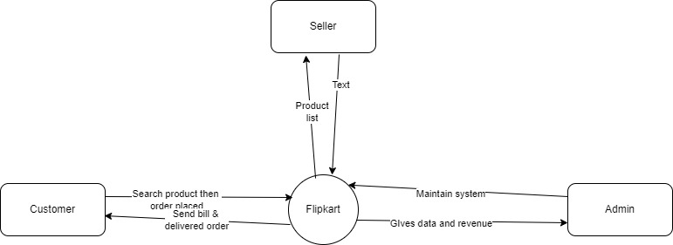

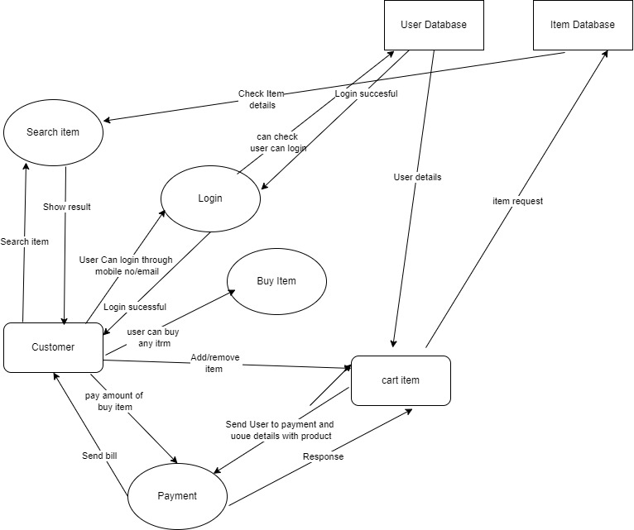

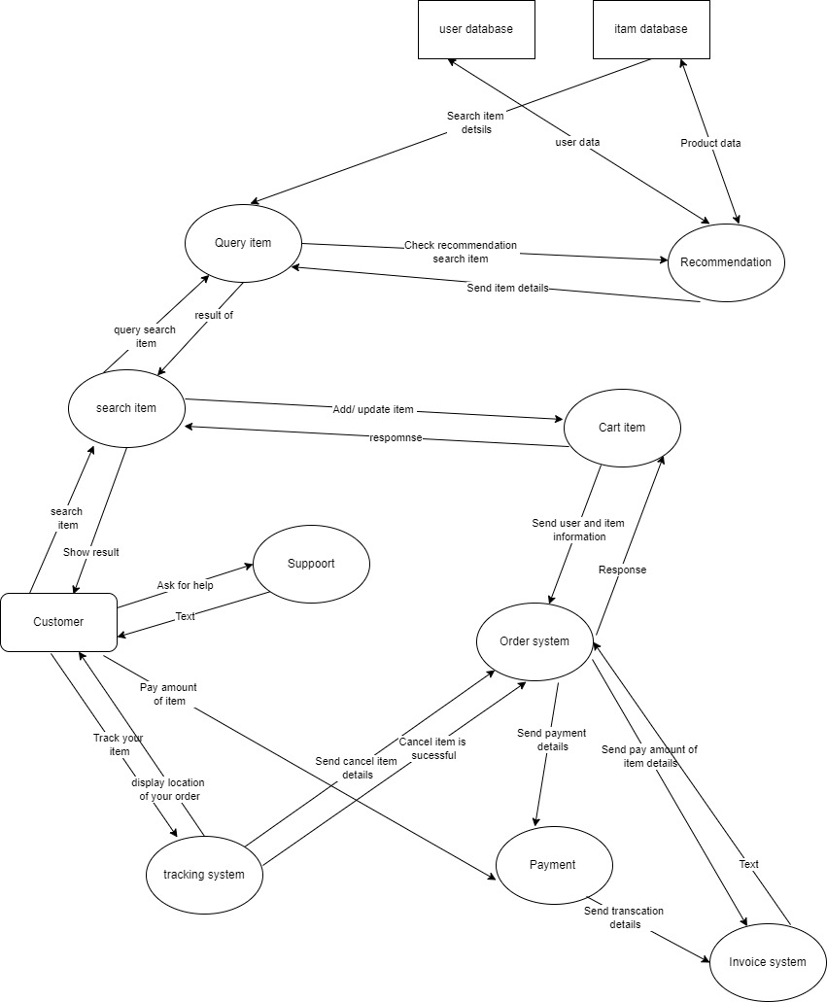

Q-5. What is Flow chart? Create a flowchart to make addition of two numbers
- Flowchart is diagram that show in which direction work will flow.
- It is used to divide whole problem into small step to solve the problem.

- Some popular type of flow chart
1.process flow chart
2.workflow diagram
3.dataflow chart
4.swimlane diagram
- To create flow chart it has some symbols:-
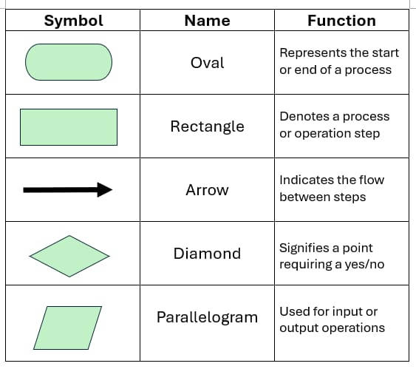

- Flowchart addition of two number:-
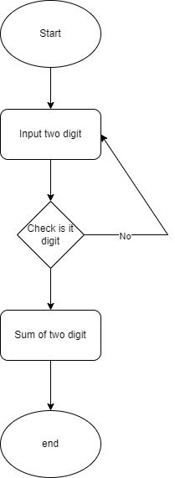

Q-6. What is Use case Diagram? Create a use-case on bill payment on paytm.
Use case diagram represent different direction in which user communicate with software or system.

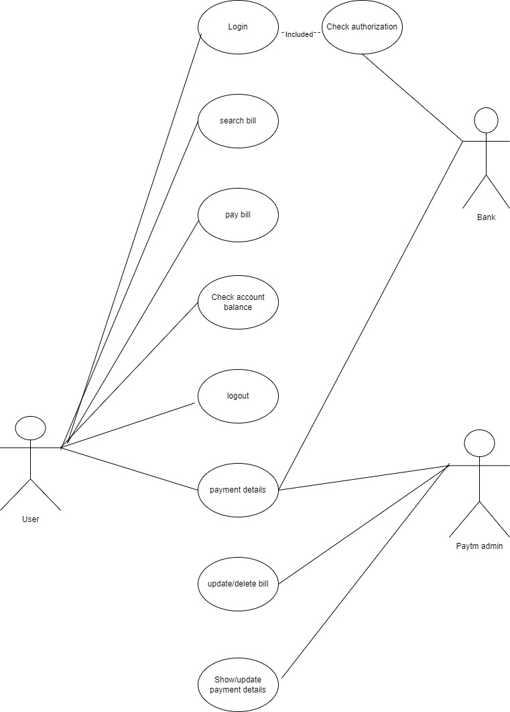
There are two types of use case diagram.
1.behavioral diagram
2.uml diagram

There are four main components of use case diagram
1.actor
2.system
3.relationship
4.use cases.

