Sales Forecasting & Demand Intelligence
Executive Summary — Prepared for Head of Supply Chain & CFO

Executive Summary
Over the last four years our sales have grown steadily at roughly 14% per year, but that growth is highly seasonal: November and December alone regularly account for as much sales as three or four average months combined. Using three different forecasting techniques, we project total sales of approximately $130,000 over the next three months (January–March), which is a normal seasonal low following the holiday peak, not a sign of slowing business. Two independent detection methods flagged about a dozen unusually high or low sales weeks in the historical data, most of them tracing back to expected holiday spikes. Finally, we grouped our 17 product sub-categories into four demand patterns to guide stocking decisions — from steady, reliable sellers like Phones and Chairs to volatile, small-volume items like Fasteners and Labels that need a different inventory approach. The East region stands out as both our most dependable growth market historically and our strongest growth forecast for the next quarter.

Key Findings from Exploratory Analysis
- Technology is our top-revenue category ($827K over 4 years), narrowly ahead of Furniture ($729K) and Office Supplies ($705K), even though Office Supplies has the most individual orders — its items are simply lower-priced.
- East is our most dependable region: its year-over-year growth rate has stayed within a few points of ~18% every year, while South has swung from -32% to +33% year to year.
- Average shipping time is about 4 days company-wide and barely differs by region (under a couple of hours' difference between the fastest and slowest region).
- November, December, and September are consistently our three strongest months, every single year — a reliable, repeatable seasonal pattern rather than a one-off.
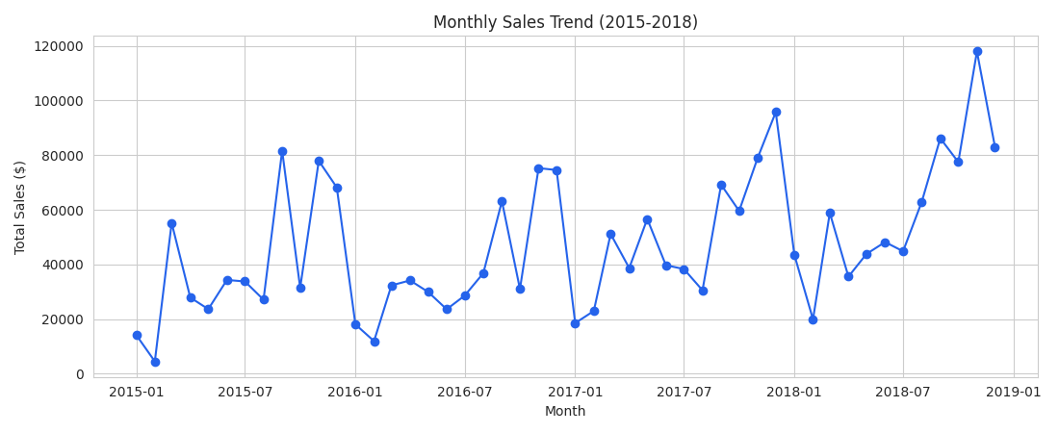

3-Month Sales Forecast
We built and compared three different forecasting approaches — a classical statistical model (SARIMA), an industry-standard tool (Facebook Prophet), and a machine-learning model (XGBoost). All three agree on the general shape (a seasonal dip after the December peak), and XGBoost was the most accurate on a held-out test period, so it is our recommended forecast:
Month | Forecasted Sales (XGBoost) | Plain-language range*
January 2019 | $43,900 | roughly $38,000 – $50,000
February 2019 | $34,400 | roughly $29,000 – $40,000
March 2019 | $52,100 | roughly $46,000 – $72,000 (widest uncertainty — see note)

*Ranges are derived from how far apart our three models' forecasts land for each month, giving a practical sense of the uncertainty rather than a single falsely-precise number. March has the widest spread because it is furthest from today and the models disagree the most about how quickly the post-holiday dip recovers.
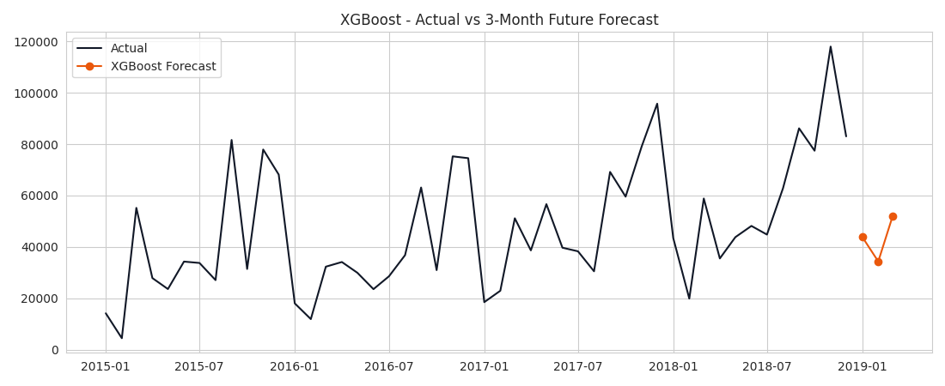

Top 3 Anomalies Detected & Likely Cause
Week | Sales | Likely Cause
March 22, 2015 | $37,700 (extreme spike) | No obvious US retail holiday this week — likely a large bulk/corporate order or a one-off promotion; worth checking against that week's promotions calendar.
December 2, 2018 | $36,000 (spike) | Cyber Monday / early holiday shopping period — expected seasonal spike.
September 13, 2015 | $30,000 (spike) | Falls in our recurring September back-to-office/school sales bump identified in the seasonality analysis.
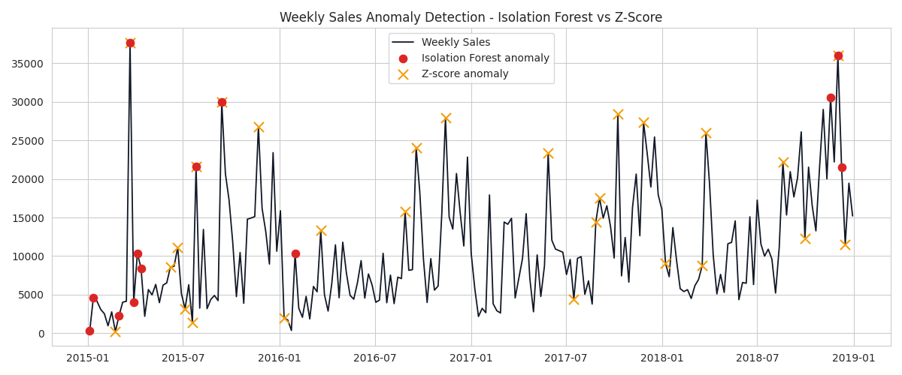

Product Demand Segmentation & Stocking Strategy
We grouped our 17 product sub-categories into four demand patterns based on how much they sell, how fast they're growing, and how volatile (unpredictable) their month-to-month sales are:
Segment | Example Products | Recommended Stocking Approach
High Volume, Stable Demand | Phones, Chairs, Tables, Storage, Binders, Accessories | Standard reorder points; safe to automate replenishment.
Growing Demand | Copiers | Increase safety stock ahead of season; revisit reorder levels quarterly.
Declining Demand | Machines | Avoid large forward purchase commitments; clear excess via promotion.
Low Volume, High Volatility | Bookcases, Envelopes, Supplies, Furnishings, Labels, Paper, Art, Appliances, Fasteners | Smaller, more frequent reorders; consider vendor-managed inventory.
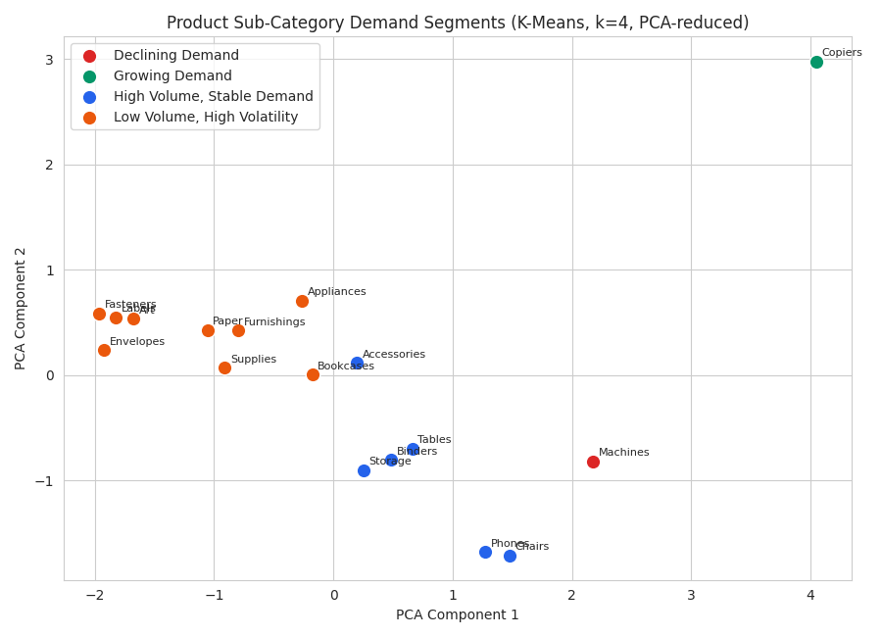

Business Recommendations
- Lean into the East region for the next quarter's growth push — it is both our historically most consistent grower and our strongest forecasted grower next quarter (+25.7% year over year), while West is forecast to soften (-14.7%).
- Begin building holiday inventory for Technology and Furniture no later than September, since our seasonality analysis shows demand consistently jumps in September and peaks in November/December — waiting until October risks stockouts during the highest-revenue weeks of the year.
- Move Fasteners, Labels, Art, and Envelopes (our 'Low Volume, High Volatility' cluster) to smaller, more frequent purchase orders rather than large batches, freeing up working capital currently tied up in unpredictable, slow-moving stock.

Risk & Limitation
Our forecast comparison used only three months of held-out data to judge model accuracy. That is a small enough sample that one unusually good or bad month can meaningfully shift which model looks 'best.' We recommend re-checking model accuracy every month as new actual sales come in, rather than treating this one-time comparison as final. We also could not access the original supplementary Kaggle dataset from this environment due to network restrictions, so the multi-source merge exercise in the notebook uses a placeholder dataset with the same structure — this does not affect the Superstore sales forecasts themselves, which are built entirely on the real, provided sales data.

