**PG LIFE**

**A PROJECT REPORT**

***Submitted by***

## Amarendra Sahoo

## REGD NO- 210720100023

## Debashree Jena

## REGD NO- 210720100113

## Kishan Das

## REGD NO- 210720100021

***in partial fulfillment for the award of the degree***

***of***

**MASTER IN COMPUTER APPLICATION**

**

# **DEPARTMENT OF APPLIED SCIENCE**

**CENTURION UNIVERSITY OF TECHNOLOGY AND MANAGEMENT**

**BHUBANESWAR, ODISHA**

**NOV, 2022**

## **BONAFIDE CERTIFICATE**

Certified that this project report “**PG LIFE**” is the bonafide work of “**Amarendra Sahoo, Debashree Jena,Kishan Das**” who carried out the project work under my supervision. This is to further certify to the best of my knowledge that this project has not been carried out earlier in this institute and the University.

Signature of the supervisor

Prof. Anil Kumar Meher

(Asst. Prof., Dept. of CSE)

*Certified that the above mentioned project has been duly carried out as per the norm of the college statutes of the university*

**SIGNATURE**

**(Prof. Mamata Garanayak)**

**PROFESSOR & HOD**

**DEPT. OF CSE, CUTM**

DEPARMENTAL SEAL

**ACKNOWLEDGEMENT**

It is our pleasure to be indebted to various people, who directly or indirectly contributed in the development of this work and who influenced my thinking, behavior and acts during the course of study.

I am thankful to **Prof. Anil Kumar Meher -, Asst. Prof., Dept. of CSE** for his support, cooperation, and motivation, valuable presence that helped me in completing this project.

I also extend my sincere appreciation to **Prof. Mamata Garanayak**, **HOD, Dept. of CSE** who provided her valuable suggestions and precious time in accomplishing my project.

**Name: Amarendra Sahoo**

**Regd. No:210720100023**

**Name: Debashree Jena**

**Regd. No:210720100113**

**Name: Kishan Das**

**Regd. No:210720100021**

**Contents**

**Certificate**

**Acknowledgement**

1. Introduction
   1. Purpose
   2. Scope
   3. Definitions, Acronyms, and Abbreviations
   4. References
   5. Overview
2. General Description
   1. Product Perspective
   2. Product Functions
   3. User Characteristics
   4. Assumptions and Dependencies
3. Specific Requirements
   1. External Interface Requirements
   2. Functional Requirements
   3. Use Cases
   4. Classes / Objects
   5. Non-Functional Requirements
   6. Design Constraints
   7. Other Requirements
4. Analysis Models
   1. Sequence Diagrams
   2. State-Transition Diagrams (STD)
   3. Deployment Diagram
   4. Activity Diagram
   5. Componate
   6. ER Digram
5. User Interface
   1. Login
   2. Admin Dashboard
   3. Pg-owner Dashboard
   4. User Dashboard
6. Conclusion
7. **Introduction**

PG Life has become important factors in modern paying guest accomdation field. This system should help to streamline the administrative task and provide real-time access to the data. Building this system in web based interface will further help the ease of accessibility through any web browser. The stay findings enable the definition of the project problem statement, its objectives, scopes and advantages of the PG Life.

* 1. **Purpose**

The purpose this documents is to present a detailed description of the PG Life. It will explain the purpose and features of the software, the interfaces of the software, what the software will do, the constraints under which it must operates and how the software will react to external stimuli. This document is intended for both the end users and the developers of the software.

* 1. **Scope**

This document covers the requirements for the PG Life. This software will provide a graphical environment in which the users of the system will be able to perform various operations that are associated with storing, marinating, updating and retrieving user information. The purpose of this is to guide developers in selecting a design that will be able to accommodate the full-scale application.The system will capture information about user’s personal details lectures and the courses. Storing updating and retrieving in a fast and accurate way.

* 1. **Definitions, Acronyms, and Abbreviations**

The PG Life has to handle records for many number of users and maintenance was difficult. Though it has used an information system, it was totally manual. Hence there is a need to upgrade the system with a computer based information system.

* 1. **References**

An Integrated Approach to Software Engineering Approach - Pankaj Jalote Software Engineering

A Practitioner’s Approach - Roger S Pressman

* 1. **Overview**

The purpose this documents is to present a detailed description of the PG Life. It will explain the purpose and features of the software, the interfaces of the software, what the software will do, the constraints under which it must operates and how the software will react to external stimuli. This document is intended for both the end users and the developers of the software.

1. **General Description**
   1. **Product Perspective**

The product PG Life, is an independent product and does not depend on any other product or system. The product will automate various tasks associated with handling user details and better organizing the stored information and optimum performance, thus helping to ensure smooth working of these processes.

**2.2 Product Functions**

Our system has three types of accessing modes,

1. Admin

2. Pg Owner

3.User

**i) Admin:**

PG Life is managed by Admin. Admin has to update and monitor the registered user details, add a new user, provide pg for all users, distribute each user etc., Admin can update his profile, and also can give help to the pg owners and users.

**ii) Pg Owner:**

Pg owner view their Booking-log, pg list, and add the pg in pglist and can view their property.

**iii)User:**

User can add them onto the portal and view their booking, view on pg, also can view the pg details in graphical order.user also view in pg properties .

**2.4 Assumptions and Dependencies**

We assume that the Office personnel do all the data entry based and the correct values obtained from forms and registers.

We assume that the computers that will use the software will be part of the college LAN.

Users with administrator access should be careful in deleting or modifying any information knowingly or unknowingly which will lead to inconsistency of the database.

The end users of this software are assumed to have basic level of computer knowledge i.e. point and click.

1. **Specific Requirements**
   1. **External Interface Requirements** 
      1. **User Interfaces**

• GUI along with meaningful Frames and buttons

• Reports are generated as per the requirement

• Refer Appendices 2.

* + 1. **Hardware Interfaces**

|  |  |
| --- | --- |
| **Hardware Environment** | **Intel I5 Laptop** |
| **System Configuration** | **Ram 16GB, HDD 512GB** |
| **Operating System** | **Windows 11** |

* + 1. **Software Interfaces**

|  |  |
| --- | --- |
| **Web** | **Apache Webserver** |
| **Frontend** | **Java, J2EE** |
| **Backend** | **MySQL** |

When invalid inputs are given to the modules then the error messages will be popped up in order to inform the user that the input provided is not taken by the database. When incomplete information is provided by the user and the user tries to submit the form in order to store the details in the database the system will pop up a message box asking the user to enter all the details required.

* + 1. **Communications Interfaces**

The machine will have to be part of the pg in Local area Network to access the central database.

* 1. **Functional Requirements**

PG Life involves the following functions

**3.2.1 Registration**

Function: signup user and pg owner, enroll User.

Priority:

Requirements:User & Pg owner 1st registration .

**3.2.2Add PG**

Function : Pg owner add pg.

Priority:

Requirements: Pg details.

**3.2.3 Booking**

Function: user view pg and booking.

Priority:

Requirements:In this case,user first signup then come to index page.as per his/her requirement they can choose city and view the pg and make booking.

**3.2.4 View PG**

Function: Check the Overall Pg details.

Priority:

Requirements: Admin,pg owner & user view the pg.

**3.2.5 City wise PG**

Function: Check city wise Pg .

Priority:

Requirements:User check the city wise pg.

* 1. **Use Cases**

The main purpose of a use case diagram is to portray the dynamic aspect of a system. It accumulates the system's requirement, which includes both internal as well as external influences. It invokes persons, use cases, and several things that invoke the actors and elements accountable for the implementation of use case diagrams.

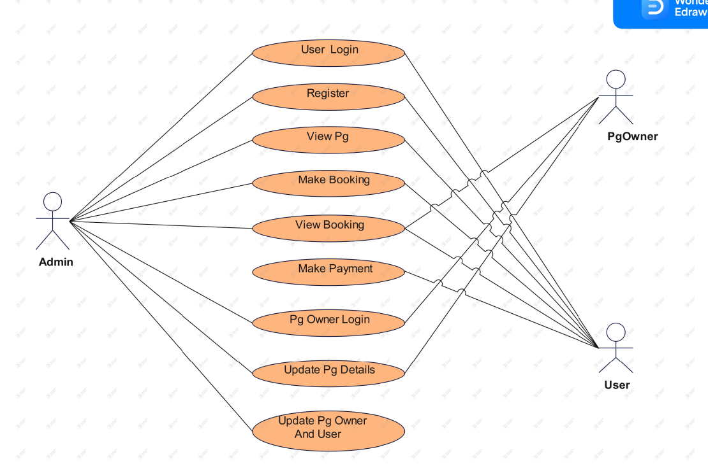

* 1. **Classes / Objects**

The purpose of class diagram is to model the static view of an application. Class diagrams are the only diagrams which can be directly mapped with object-oriented languages and thus widely used at the time of construction.

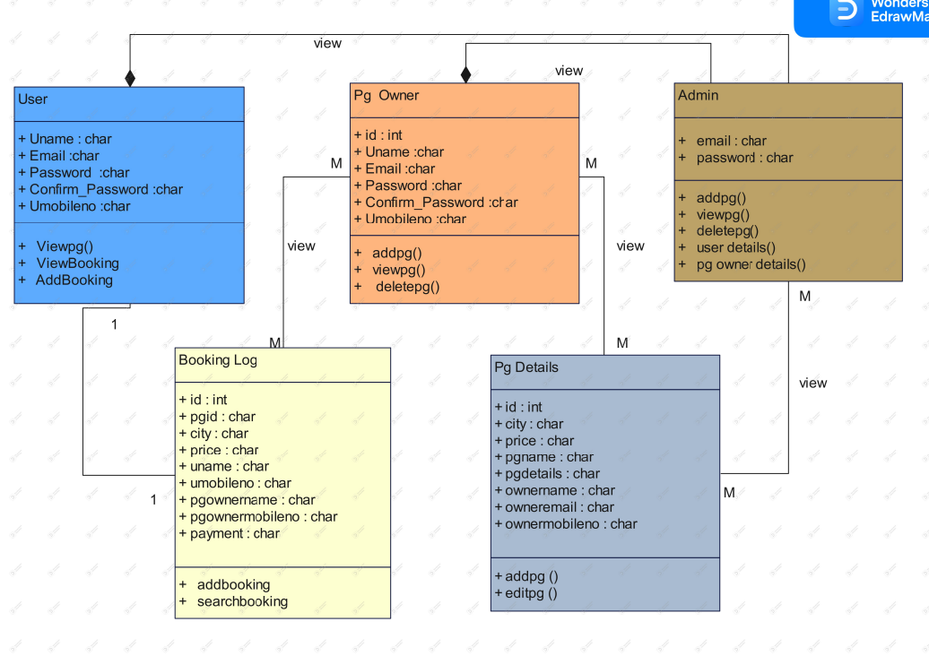

* 1. **Non-Functional Requirements**
     1. **Performance**

Easy tracking of records and updating can be done. All the requirements relating to performance characteristics of the system are specified in the section below. There are two types of requirements.

1. **Static Requirements**

These requirements do not impose any constraints on the execution characteristics of the system. They are:

**1) Number of Terminals:** The software makes use of an underlying database that will reside at the server, while the front end will be available online to the administrative and departmental computers as well as students and teachers.

**2) Number of Users:** The number of users may vary, as this software finds applications in almost all department of the organization.

1. **Dynamic Requirements**

These specify constraints on the execution characteristics of the system. They typically include response time and throughout of the system. Since these factors are not applicable to the proposed software, it will suffice if the response tine is high and the transactions are carried out precisely and quickly.

* + 1. **Reliability**

The software will not be able to connect to the centralized database in the event that the college LAN fails or in the event of the server being down due to a hardware or software failure

* + 1. **Availability**

The software will be available only to authorized users of the colleges like teachers to mark the students attendance, student to view their enrolled course, admin to add an update students records

* + 1. **Security**

The security requirements deal with the primary security. The software should be handled only by the administrator and authorized users. Only the administrator has right to assign permission like creating new accounts and generating password. Only authorized users can access the system with username and password.

* + 1. **Maintainability**

Backups for database are available.

* + 1. **Portability**

The Software is a web-based application and is built in PHP and MYSQL so it is platform independent and is independent of operating system.

* 1. **Design Constraints**

This software provides security. The login form prevents the system from being misused by unauthorized users. Only an authorized operator will be granted rights to modify as per requirements. This software is also reliable and fault tolerant. The system developed is designed to handle invalid inputs. Since reliability is major area of concern the system has a backup to avoid data loss. The user should know the programming language very well that is used to develop a software

* 1. **Other Requirements**

**Database**

All the data will be stored in a relational database

1. **Analysis Models**
   1. **Sequence Diagrams**

A sequence diagram is a type of interaction diagram because it describes how and in what order a group of objects works together. These diagrams are used by software developers and business professionals to understand requirements for a new system or to document an existing process.

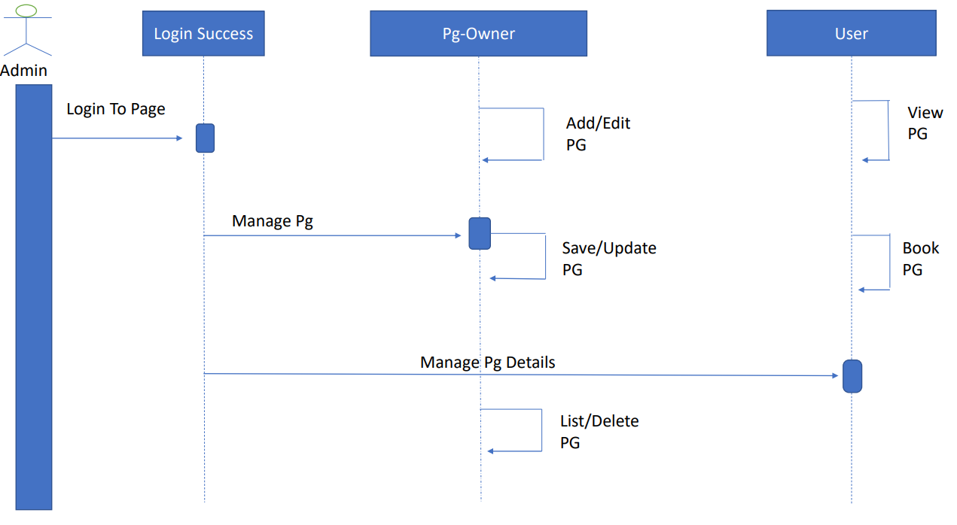

* 1. **State-Transition Diagrams (STD)**

State-chart diagram is one of the five UML diagrams used to model the dynamic nature of a system. They define different states of an object during its lifetime and these states are changed by events. State-chart diagrams are useful to model the reactive systems. Reactive systems can be defined as a system that responds to external or internal events.

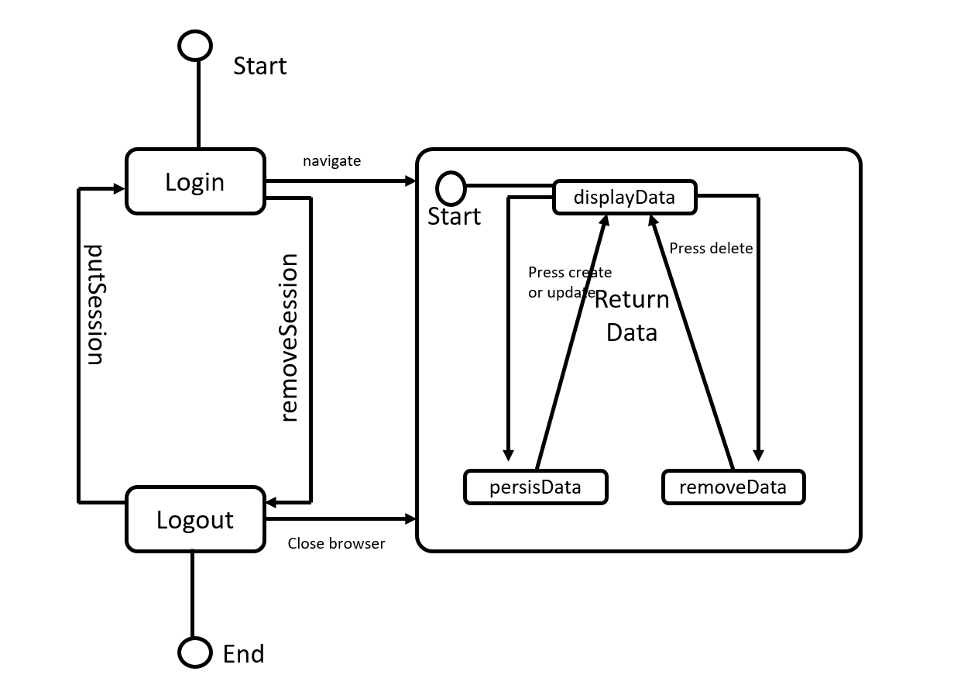

* 1. **Deployment Diagram**

A deployment diagram that shows the execution architecture of a system, including nodes such as hardware or software execution environments, and the middleware connecting them. Deployment diagrams are typically used to visualize the physical hardware and software of a system.

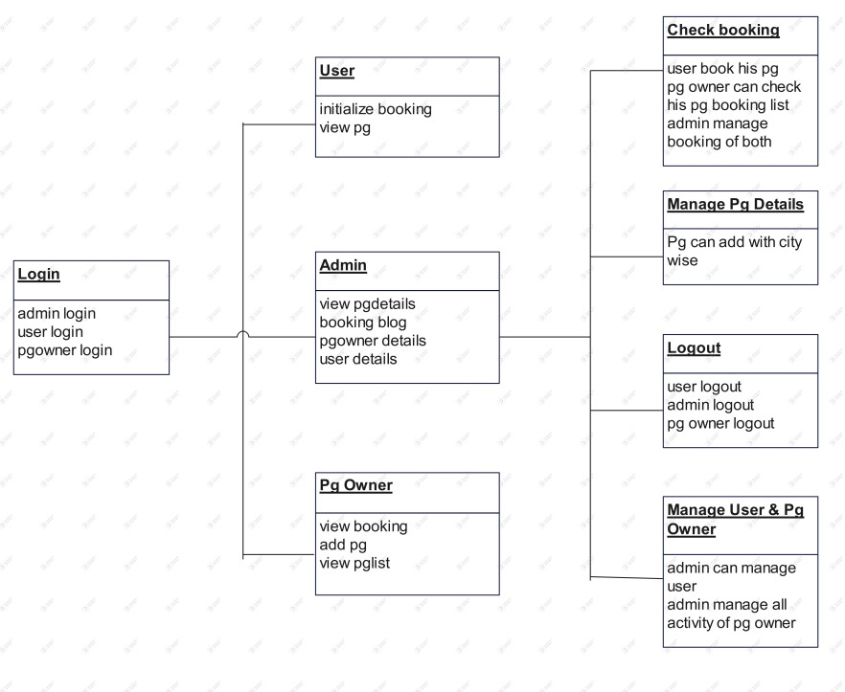

* 1. **Activity Digram**

We use **Activity Diagrams** to illustrate the flow of control in a system and refer to the steps involved in the execution of a use case. We model sequential and concurrent activities using activity diagrams. So, we basically depict workflows visually using an activity diagram.

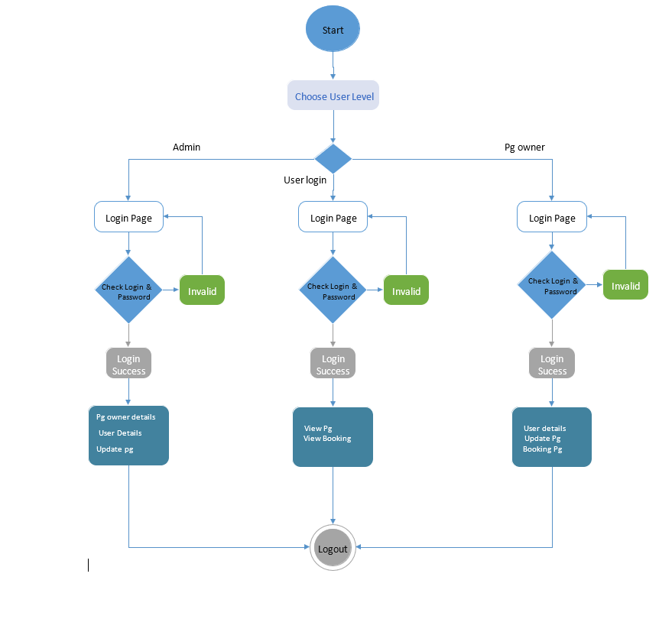

* 1. **Component**

Component diagram is a special kind of diagram in UML. The purpose is also different from all other diagrams discussed so far. It does not describe the functionality of the system but it describes the components used to make those functionalities.

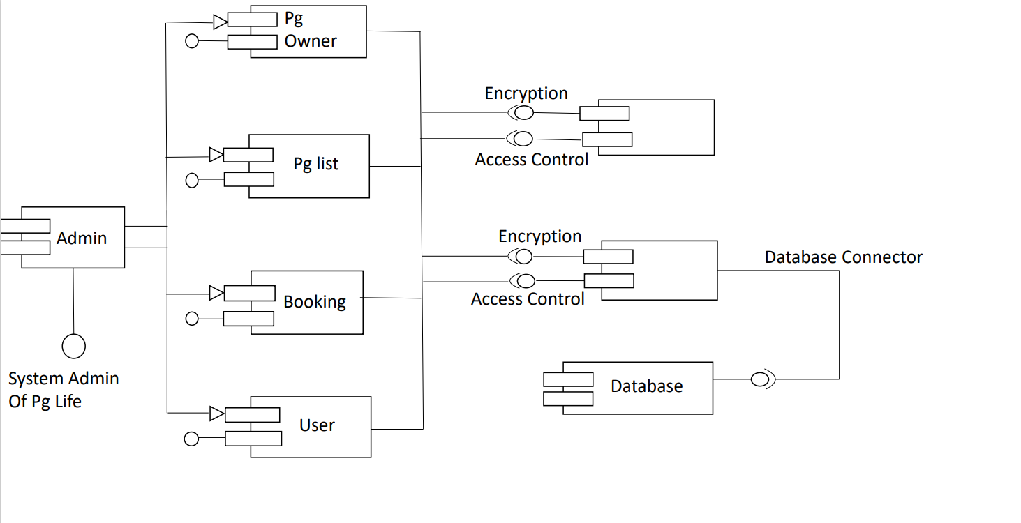

* 1. **ER Diagram**

**ER Diagram** stands for Entity Relationship Diagram, also known as ERD is a diagram that displays the relationship of entity sets stored in a database. In other words, ER diagrams help to explain the logical structure of databases. ER diagrams are created based on three basic concepts: entities, attributes and relationships.

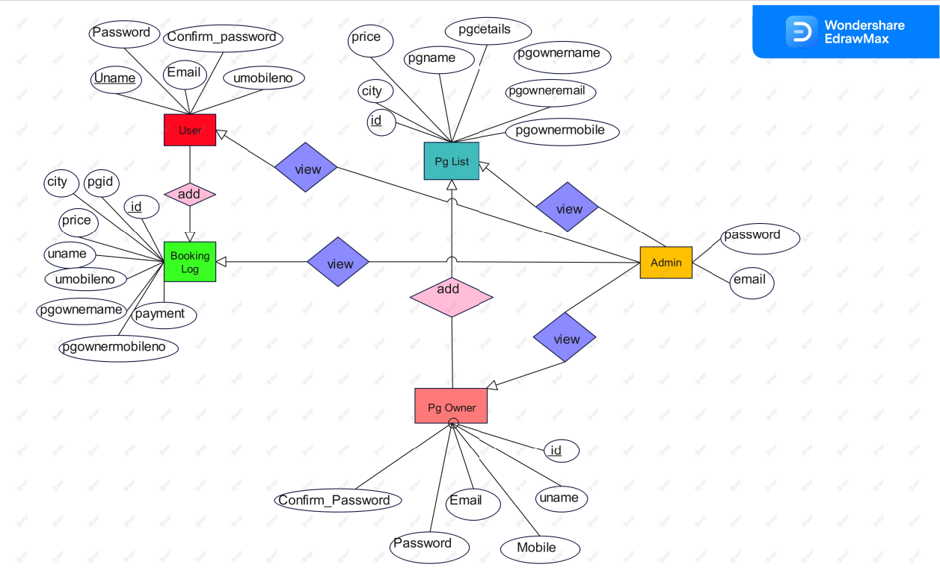

1. **User Interface**
2. **Login**

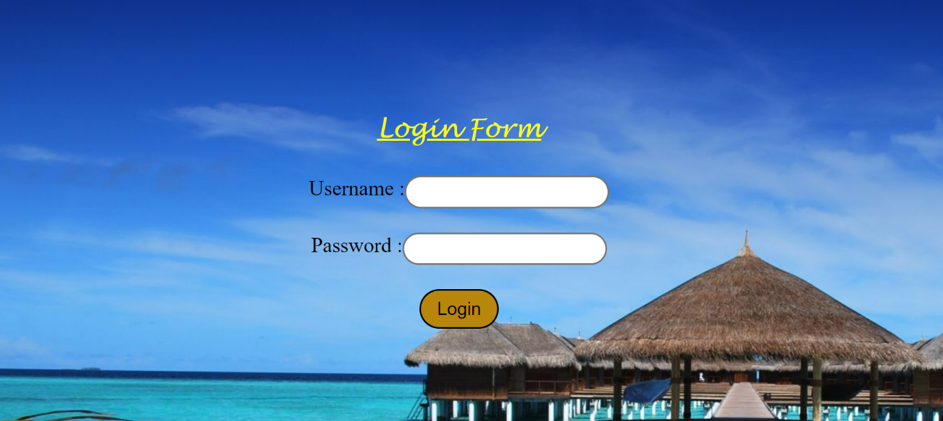

1. **Admin Dashboard**

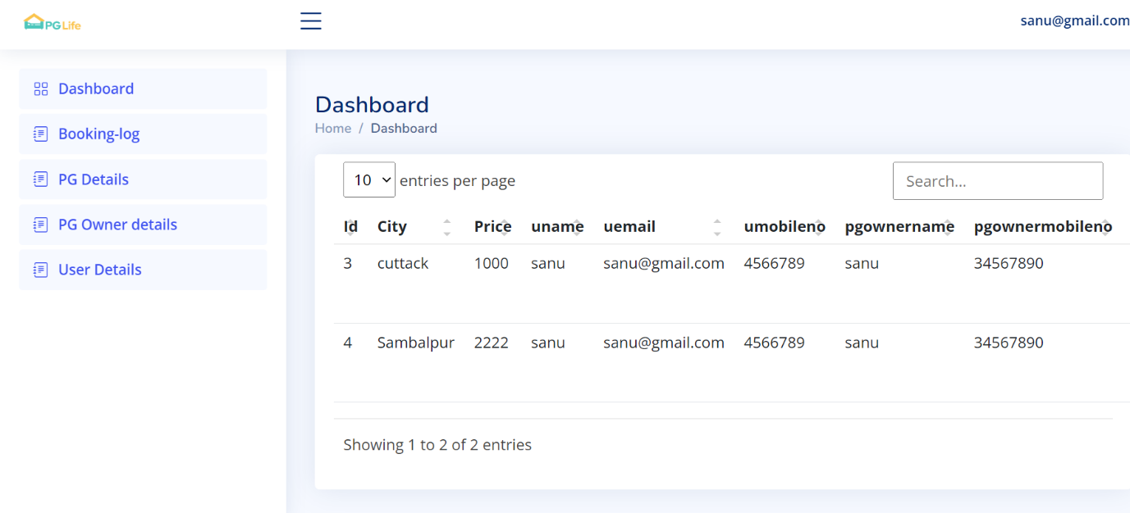

1. **Booking-log**
2. **PG Details**
3. **PG Owner Details**
4. **User Details**
5. **PG Owner Dashboard**

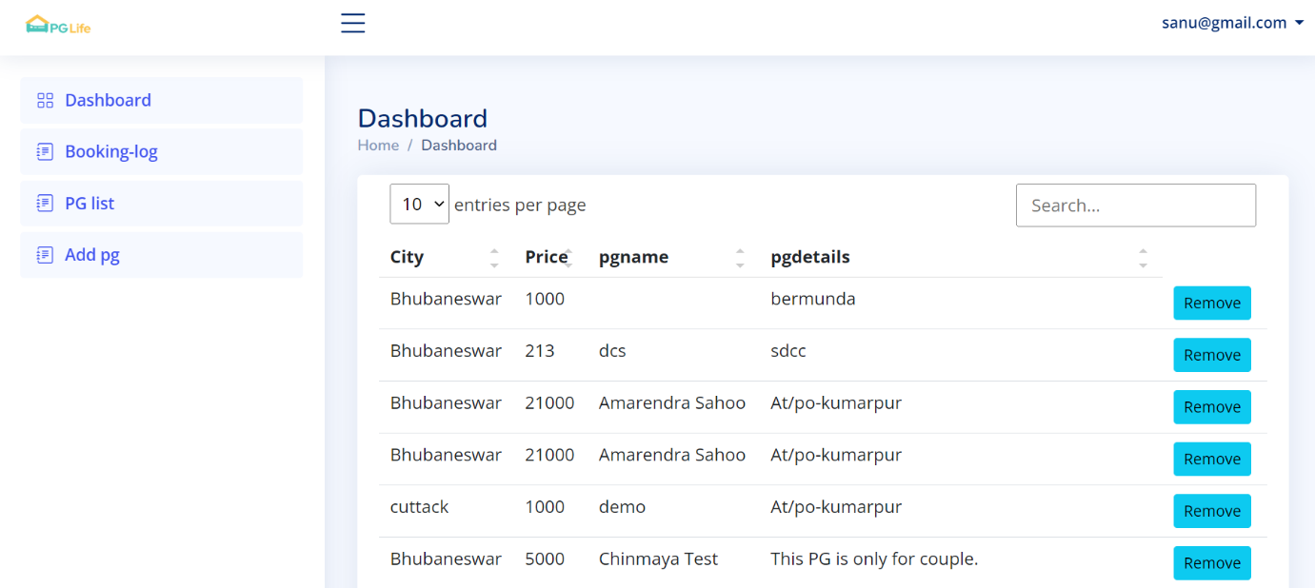

1. **Booking-log**
2. **PG list**
3. **Add pg**
4. **User Dashboard**

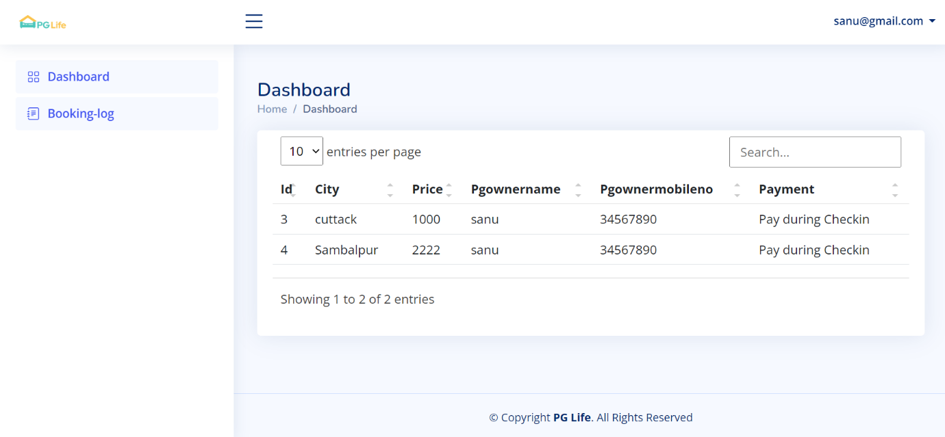

1. **View pg**
2. **Booking-log**

**Conclusion:**

Our project is only a humble venture to satisfy the needs to manage their project work. Several user friendly coding have also adopted. This package shall prove to be a powerful package in satisfying all the requirements of the school. The objective of software planning is to provide a frame work that enables the manger to make reasonable estimates made within a limited time frame at the beginning of the software project and should be updated regularly as the project progresses.

At the end it is concluded that we have made effort on following points:

* A description of the background and context of the project and its relation to work already done in the area.
* Made statement of the aims and objectives of the project.
* The description of Purpose, Scope, and applicability.
* We define the problem on which we are working in the project.
* We describe the requirement Specifications of the system and the actions that can be done on these things.
* We understand the problem domain and produce a model of the system,

Which describes operations that can be performed on the system.

* We included features and operations in detail, including screen layouts.
* We designed user interface and security issues related to system.
* Finally the system is implemented and tested according to test cases.