SQL TASK -1

To create Database
- create database task_user;

To create Table -1 (Employee)
- create table employee
(
EM_ID int primary key AUTO_INCREMENT,
FIRST_NAME varchar(255),
LAST_NAME varchar(255),
SALARY INT,
JOINING_DATE date,
DEPARTMENT varchar(255)
)
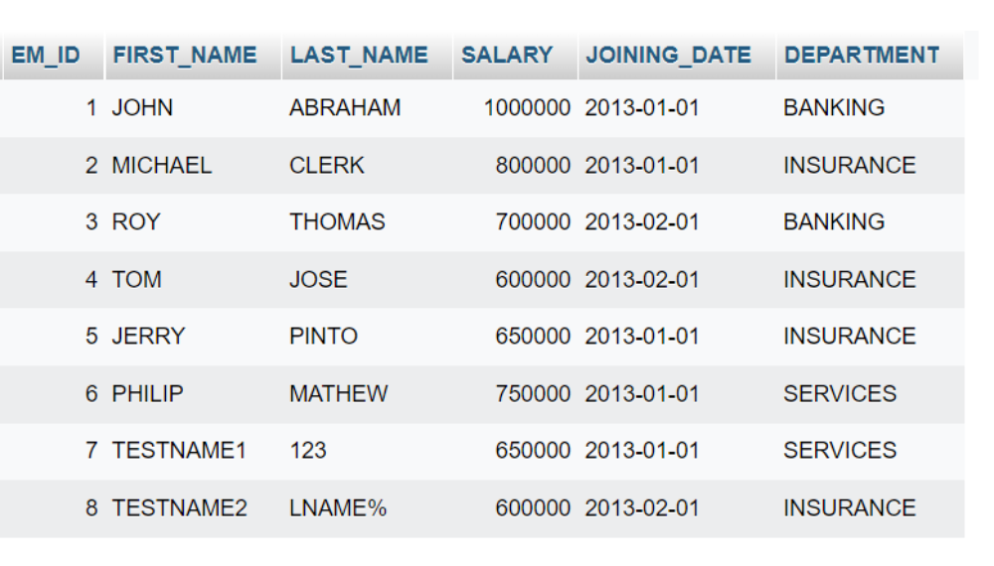

To create Table -2 (Incentives)
- create table incentives
(
insentive_id int primary key AUTO_INCREMENT,
EMPLOYEE_REF_ID INT,
INCENTIVE_DATE date,
INCENTIVE_AMT varchar(255)
)
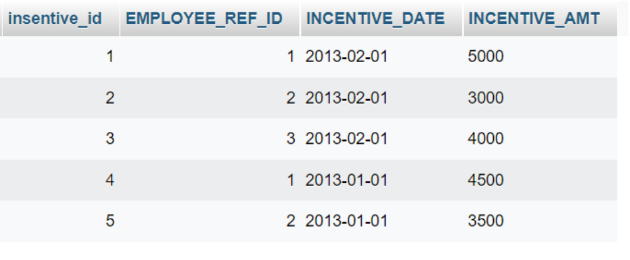

- select FIRST_NAME as Employee_name from employee;
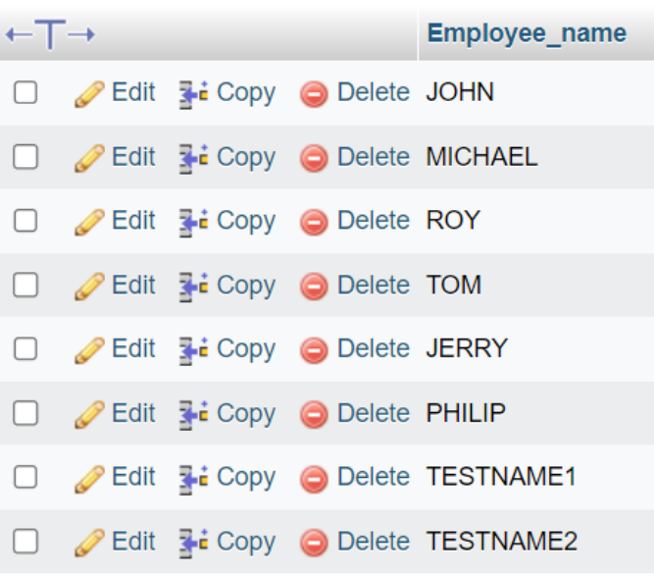
- select FIRST_NAME,joining_date from employee;

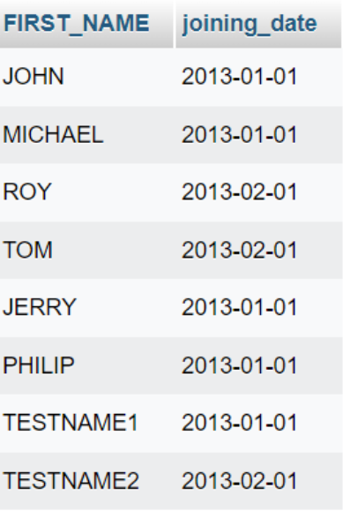

- select * from employee order by FIRST_NAME asc, SALARY desc;

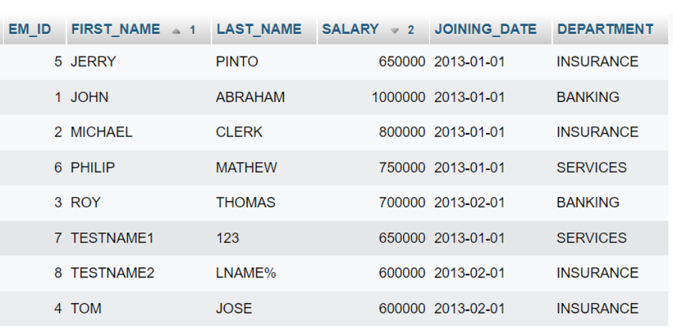
- select * from employee where FIRST_NAME like '%o%';

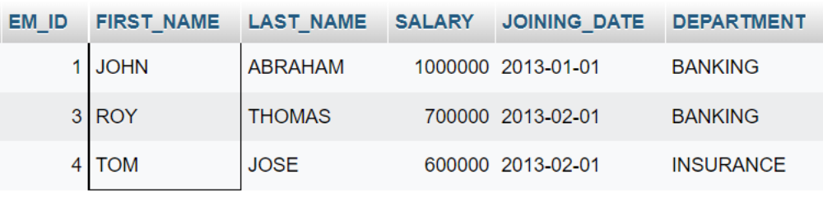

- select * from employee where JOINING_DATE like '%2013-01%';
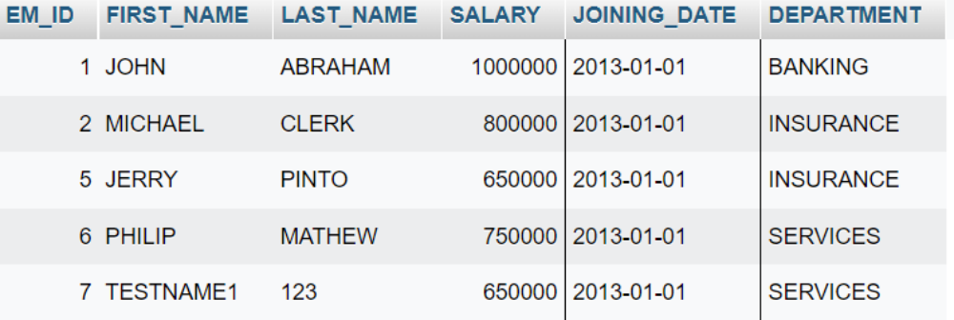

- select DEPARTMENT,sum(salary) total_salary from employee group by DEPARTMENT order by total_salary desc;
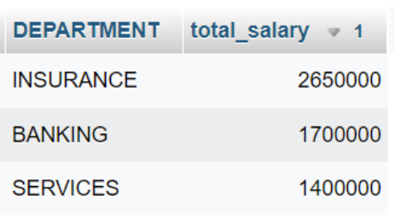

- select DEPARTMENT,max(salary) from employee group by department order by salary asc;
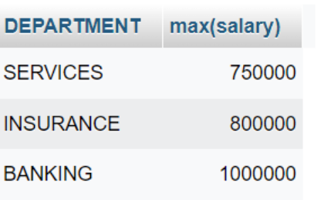

- select FIRST_NAME,incentive_amt from employee inner join incentives on employee.EM_ID=incentives.EMPLOYEE_REF_ID and incentive_amt > 3000;
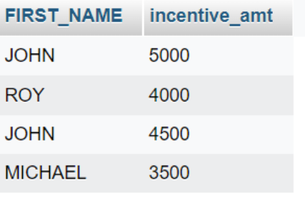
- select max(SALARY) from employee where SALARY < (select max(SALARY) from employee);
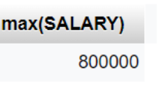
- select FIRST_NAME,INCENTIVE_AMT from employee left join incentives on employee.EM_id=incentives.EMPLOYEE_REF_ID;
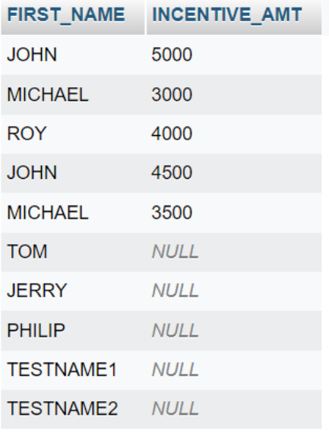
- create view multiview as select FIRST_NAME,LAST_NAME,SALARY from employee;
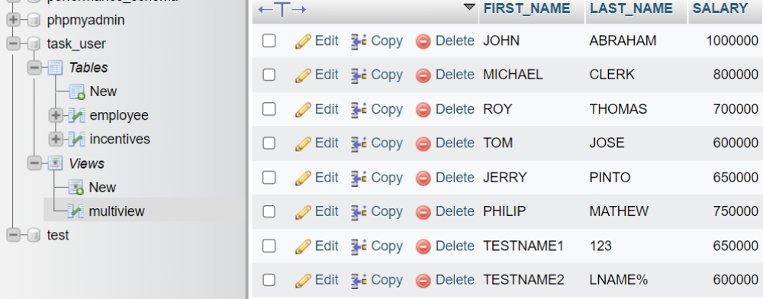

- select max(salary),DEPARTMENT from employee group by department order by max(salary) desc;
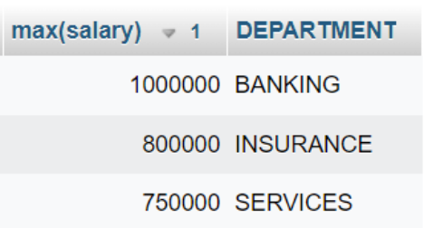

SQL TASK -2
- To Create Table - 1 SALES_PERSON
create table CUSTOMER
(
SNO int,
SNAME varchar(255),
CITY varchar(255),
COMM int,
)
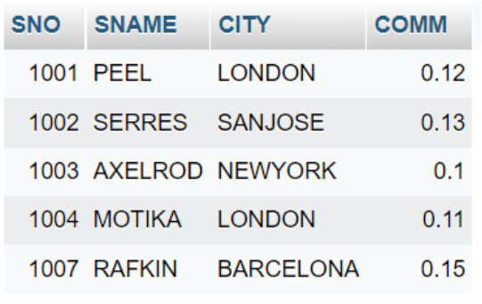

- To Create Table – 2 CUSTOMER
create table CUSTOMER
(
CNM int,
CNAME varchar(255),
CITY varchar(255),
RATING int,
SNO int
)

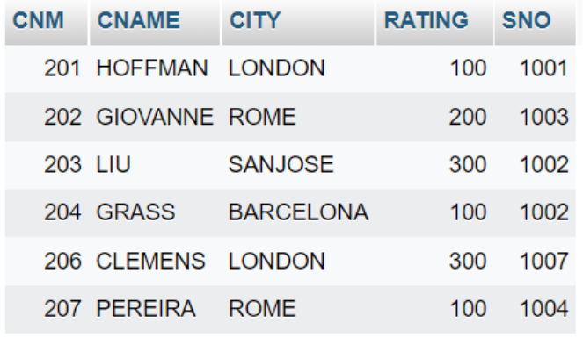

- To Create Table – 3 Order_1
create table ORDER_1
(
ONM int,
AMT float,
ODE date,
CNM int,
SNO int
)
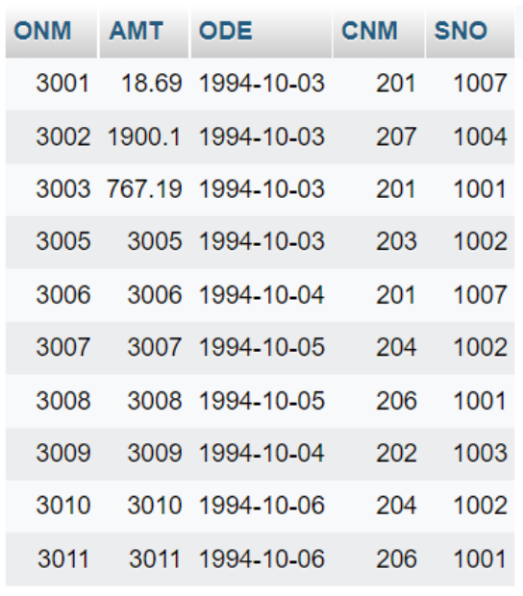

- select * from order_1 where amt > 1000;

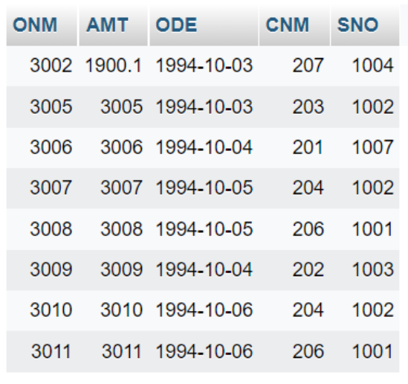
- select SNAME,CITY from sales_person where COMM > 0.10 and CITY='london';

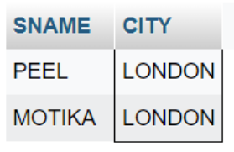
- select SNAME from sales_person WHERE CITY in ('london','barcelona');
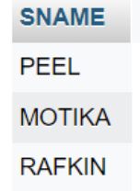
- select SNAME from sales_person WHERE COMM BETWEEN 0.10 and 0.12 order by SNAME ASC;

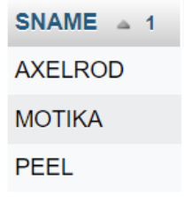
- select CNAME from customer where CITY is null;

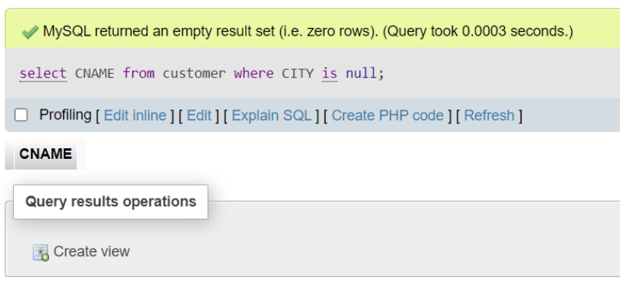

- select * from order_1 where ODE in ('1994-10-03','1994-10-04');

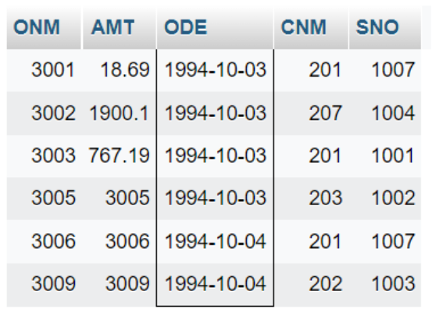

- SELECT cname FROM customer WHERE cname like 'A%' or cname like 'B%';

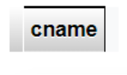
- select cname from customer where rating <=100 and city='rome';

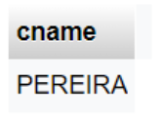

- select onm from order_1 where AMT!=0 or amt='null';

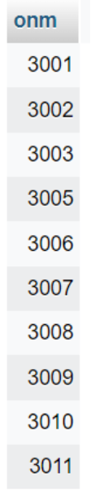

- select COUNT(DISTINCT sno) from order_1;

