Software Requirements Specification (SRS)

Project: Web-Based Code Merge Simulator
Team No: 13
Version: 1.0
Authors: KISHAN KABADI S, MADAN P, SAURAV SHASHIDHARA
Date: 03-10-2026

Revision history
Version | Date | Author | Change summary | Approval
1.0 | 03-10-2026 | Team 13 | First complete draft of the SRS with use-case diagrams and traceability matrix

Approvals
Role | Name | Signature / Email | Date
Course Coordinator | Prof Arpitha K

Table of Contents
1. Introduction
2. Overall description
3. External interface requirements
4. System features (detailed)
5. Non-functional requirements (detailed)
5.1 Security
6. Quality attributes and acceptance tests
7. System models and diagrams
8. Requirements Traceability Matrix (RTM)

1. Introduction

1.1 Purpose
Anyone who has opened a file full of <<<<<<< and >>>>>>> lines after a Git merge knows how easy it is to lose track of which side said what. This document describes a small web tool that makes that moment less painful: two versions of a piece of code sit side by side, the differences are highlighted, and the user settles each disagreement by hand in an editor.
This Software Requirements Specification (SRS) sets out what the Web-Based Code Merge Simulator must do, how well it must do it, and how we will check that it does. It is written for the development team to build from, for the testers to verify against, and for the course evaluators to assess the project.

1.2 Scope
The simulator is a browser application. It covers loading two versions of a text or source file, finding the line-level differences with a diff algorithm, showing the versions in side-by-side editable panes, letting the user resolve each conflict by choosing a side or typing their own text, and applying the decisions to produce one merged file that can be downloaded or copied.
It does not talk to Git or any other version-control system, does not manage branches, commits or repositories, does not merge binary files, and has no user accounts or server-side storage. It is a simulator and learning aid, not a replacement for a full merge tool.

1.3 Audience
Developers building the tool, QA engineers writing and running the tests, course instructors and evaluators, and students or junior developers who will use the finished simulator to practise resolving merge conflicts.

1.4 Definitions
Term | Meaning
Diff | The list of lines that were added, removed or changed between two versions of a file.
Hunk | A block of neighbouring lines that differ between the two versions. In this tool every hunk is presented as one conflict.
Conflict | A hunk where the user has to decide what the final text should be.
Version A / Version B | The two inputs being compared. Informally, "ours" and "theirs".
Merged Result | The editable pane that holds the file being assembled from the user's decisions.
Three-way merge | A merge that also looks at a common ancestor version, so that one-sided changes can be merged automatically.
Myers' algorithm / LCS | Standard methods for finding the shortest set of edits between two sequences of lines. LCS stands for longest common subsequence.
UI, API | User Interface, Application Programming Interface.
XSS | Cross-site scripting: an attack where untrusted text is run as code in the browser.
CSP | Content Security Policy: a browser rule that limits where scripts may come from.
TLS / HTTPS | The encryption protocol and the secure web protocol built on it.
WCAG | Web Content Accessibility Guidelines.
RTM | Requirements Traceability Matrix.

2. Overall description

2.1 Product perspective
The simulator is a self-contained single-page web application. Everything runs in the user's browser: there is no backend that receives code, and nothing needs to be installed. It is a standalone product, though its conflict markers and workflow deliberately follow what developers see in Git, so the skills carry over to real projects.
Internally we expect a few clear parts: an input module, a diff engine, a conflict manager, the editor and resolution interface, a merge engine, and an export module. The detailed design will be covered in the Software Architecture and Design document.

2.2 Major product functions
- Load two code versions by typing, pasting, uploading, or choosing a sample scenario
- Compute a line-based diff and display both versions side by side with highlights
- Detect and list conflicts, with a live count of how many remain
- Resolve each conflict by accepting A, B or both, or by editing the text directly
- Navigate between conflicts, and undo, redo or revert decisions
- Apply the merge once every conflict is settled, and show a summary of the decisions
- Download or copy the merged file
- Reset the session and keep a readable log of what was done

2.3 User roles and characteristics
- Student / junior developer: knows basic programming and has seen version control, but is not yet comfortable with merge conflicts. Wants clear visuals and the freedom to undo mistakes.
- Experienced developer: wants a quick, keyboard-friendly way to compare two snippets and combine them. Cares about speed and about the output being exactly right.
- Instructor / evaluator: uses the sample scenarios to demonstrate merging, and may read the resolution log to see how a student approached a conflict.
There is only one level of access. All users have the same abilities, and no one has to sign in.

2.4 Operating environment
A current desktop browser (Chrome, Firefox, Edge or Safari) with JavaScript enabled, on any operating system. The application is delivered as static files from a web host over HTTPS. A keyboard and mouse or trackpad are expected. Tablets are supported on a best-effort basis.

2.5 Constraints
- Must run entirely client-side, so that user code is never transmitted (see CMS-SR-003).
- Built with standard web technologies (HTML, CSS and JavaScript or TypeScript). Any editor or diff library must be open source and pinned to a fixed version.
- Line-level comparison is the baseline. Character-level highlighting is a bonus, not a requirement.
- Only text files in UTF-8 are supported, up to 2 MB each.
- The project must be delivered within the course timeline by a small student team.

2.6 Assumptions and dependencies
- Users have a modern browser that supports the File, Clipboard and Blob APIs.
- Users supply text that is meant to be merged. Two completely unrelated files will simply show as one large conflict.
- The sample scenarios and test fixtures will be prepared by the team before testing begins.

3. External interface requirements

3.1 User interfaces
The main screen is a three-pane workspace. Version A is on the left, Version B on the right, and the Merged Result sits below or in the centre depending on screen width. Above the panes is a toolbar with Load, Sample, Compare, Undo, Redo, Apply Merge and Reset. A conflict navigator on the side lists every conflict with its status (Open, A, B, Both, Manual). A status bar at the bottom shows the live count of resolved and remaining conflicts.
Accessibility matters here. All actions must be reachable by keyboard, text and marker symbols must back up every colour cue, and contrast must meet WCAG 2.1 AA. A light and a dark theme are welcome but optional.

3.2 Hardware interfaces
No special hardware is needed. The tool uses the standard keyboard, mouse or trackpad, and touch where available.

3.3 Software interfaces
- Browser File API: reading uploaded and dropped files.
- Browser Clipboard API: copying the final output and the resolution log.
- Blob and download support: saving the merged file without a server.
- Diff and editor components: an in-house implementation of Myers' algorithm, with an open-source code editor component for the panes if the team decides to use one.

3.4 Communications
The only network traffic is the one-time download of the application files over HTTPS (TLS 1.2 or higher). Once the page has loaded, the tool makes no network requests that involve user code. The tool also works offline if the files have already been cached by the browser.

4. System features (detailed)
Each requirement below comes with acceptance criteria and a reference test case. Functional IDs follow the pattern CMS-F-###, where the hundreds-and-tens digits tell you which feature group the requirement belongs to. Priority is High, Medium or Low, where High means the project is not complete without it.

4.1 Version Input and Loading
Description: Everything starts with getting two versions of some code into the tool. This feature group covers typing, pasting, uploading, and the built-in practice scenarios that make the tool easy to try without hunting for files.
Req ID | Requirement (shall...) | Type | Priority | Source / Stakeholder | Acceptance criteria / Test case ref | Comments / Dependencies
CMS-F-001 | The system shall provide two editable code panes, labelled Version A and Version B, where the user can type or paste code. | Functional | High | End user | AC-CMS-F-001: Text entered in either pane is kept exactly as typed, including tabs, blank lines and trailing spaces. Test: TC-Load-01 | Runs fully in the browser. No login needed.
CMS-F-002 | The system shall let the user load either version from a local text or source file, using a file picker or drag-and-drop. | Functional | Medium | End user | AC-CMS-F-002: Dropping a 500-line .py file fills the pane in under 1 s. A binary or oversized file is rejected with a clear message and the pane is left untouched. Test: TC-Load-02 | Uses the browser File API. Limits are set in CMS-SR-005.
CMS-F-003 | The system shall offer at least three built-in sample scenarios: non-overlapping edits, a same-line conflict, and a deleted-versus-modified block. | Functional | Medium | Instructor | AC-CMS-F-003: Choosing a sample fills both panes, and Compare reports the documented number of conflicts for that sample. Test: TC-Load-03 | Handy for demos and first-time users.
CMS-F-004 | The system shall optionally accept a third, common-ancestor version to enable a three-way comparison, and fall back to a two-way comparison when none is given. | Functional | Low | Instructor | AC-CMS-F-004: With an ancestor, a hunk changed on only one side is merged automatically. Without one, every differing hunk is treated as a conflict. Test: TC-Load-04 | Stretch goal. Can slip to a later iteration.

4.2 Diff and Conflict Detection
Description: Once the code is loaded, the tool has to work out what is actually different and present it in a way a person can read at a glance. A hunk here means a block of neighbouring lines that differ between the two versions.
Req ID | Requirement (shall...) | Type | Priority | Source / Stakeholder | Acceptance criteria / Test case ref | Comments / Dependencies
CMS-F-010 | The system shall compute a line-based diff of the two versions using Myers' algorithm (or an equivalent LCS-based method) when the user clicks Compare, and again after either pane is edited. | Functional | High | Course brief | AC-CMS-F-010: For the fixture files in the test suite, the output matches the expected list of added, removed and unchanged lines. Test: TC-Diff-01 | Core of the DiffEngine module.
CMS-F-011 | The system shall show the two versions side by side with aligned line numbers. Added, removed and changed lines shall carry distinct highlights and a text marker (+, −, ~), so meaning does not depend on colour alone. | Functional | High | End user / Accessibility | AC-CMS-F-011: Every changed line has both a highlight and a marker. Unchanged lines are not highlighted. Test: TC-Diff-02 | See CMS-NF-005.
CMS-F-012 | The system shall group neighbouring differing lines into hunks and list each hunk as a conflict with its start and end line in both versions. | Functional | High | End user | AC-CMS-F-012: A fixture with three separate differing regions produces exactly three conflicts with the correct line ranges. Test: TC-Diff-03 | Hunk boundaries must be deterministic.
CMS-F-013 | The system shall display a live conflict counter showing total, resolved and remaining conflicts. | Functional | Medium | End user | AC-CMS-F-013: The counter updates within 200 ms of any change in resolution state. Test: TC-Diff-04 | Depends on CMS-F-012.
CMS-F-014 | The system shall keep the two version panes scrolled together, with a toggle to turn this off. | Functional | Medium | End user | AC-CMS-F-014: With sync on, scrolling one pane moves the other to the same line range. With sync off, the panes scroll independently. Test: TC-Diff-05
CMS-F-015 | The system shall highlight the exact words or characters that differ inside a changed line. | Functional | Low | End user | AC-CMS-F-015: For "total = a + b" against "total = a - b", only the operator is highlighted. Test: TC-Diff-06 | Nice to have.
CMS-F-016 | The system shall provide an option to ignore whitespace-only differences when comparing. | Functional | Low | End user | AC-CMS-F-016: Two versions that differ only in trailing spaces show zero conflicts with the option on, and the expected conflicts with it off. Test: TC-Diff-07

4.3 Interactive Conflict Resolution
Description: This is the heart of the project. The user should be able to look at a conflict, make a call, and see the result straight away, without ever having to read raw conflict markers in a text file.
Req ID | Requirement (shall...) | Type | Priority | Source / Stakeholder | Acceptance criteria / Test case ref | Comments / Dependencies
CMS-F-020 | The system shall show controls beside each conflict to Accept A, Accept B, or Accept Both (A first, then B). | Functional | High | End user | AC-CMS-F-020: Clicking each control puts exactly the matching lines into the merged result for that conflict and marks it resolved. Test: TC-Res-01
CMS-F-021 | The system shall provide a third editable pane, Merged Result, that starts with all non-conflicting lines in place and lets the user edit any text, including text inserted by an Accept action. | Functional | High | Course brief | AC-CMS-F-021: Typing in the Merged Result pane changes only that pane. Version A and Version B stay untouched. Test: TC-Res-02 | Satisfies the editable-panes goal of the project.
CMS-F-022 | The system shall mark a conflict as "resolved (manual)" when the user edits its region in the Merged Result pane, and keep that distinct from conflicts resolved with a button. | Functional | Medium | End user | AC-CMS-F-022: After a manual edit, the conflict shows a Manual badge and the remaining count goes down by one. Test: TC-Res-03 | Needs a mapping between each hunk and its region in the merged text.
CMS-F-023 | The system shall let the user jump to the next or previous conflict using buttons and keyboard shortcuts, scrolling all panes to it. | Functional | Medium | End user | AC-CMS-F-023: Pressing Next on conflict 1 brings conflict 2 into view in all three panes. After the last conflict, Next wraps to the first. Test: TC-Res-04 | Shortcut keys are listed in the Help panel.
CMS-F-024 | The system shall support undo and redo of resolution actions and edits for at least the last 50 steps. | Functional | High | End user | AC-CMS-F-024: Accept A, then Accept B, then Undo restores the Accept A result. Redo reapplies Accept B. Test: TC-Res-05
CMS-F-025 | The system shall let the user revert a single resolved conflict back to unresolved without affecting any other conflict. | Functional | Medium | End user | AC-CMS-F-025: Reverting conflict 2 restores its markers and leaves conflicts 1 and 3 resolved. Test: TC-Res-06

4.4 Merge Application and Export
Description: After the decisions are made, the tool has to turn them into one clean file, refuse to do so if something is still undecided, and let the user take the result away.
Req ID | Requirement (shall...) | Type | Priority | Source / Stakeholder | Acceptance criteria / Test case ref | Comments / Dependencies
CMS-F-030 | The system shall show unresolved conflicts in the Merged Result pane with conventional markers (<<<<<<<, =======, >>>>>>>) and show resolved conflicts as plain final text. | Functional | High | Course brief | AC-CMS-F-030: With two of three conflicts resolved, the pane contains exactly one marker block. Test: TC-Mrg-01 | Mirrors what developers see in Git, so it is a useful teaching aid.
CMS-F-031 | The system shall enable Apply Merge only when no unresolved conflicts remain. If the user tries anyway, the system shall list the unresolved conflicts and produce no output. | Functional | High | End user | AC-CMS-F-031: With one conflict unresolved the button is disabled and its tooltip names the conflict. With none unresolved it is enabled. Leftover marker lines in the text trigger a warning. Test: TC-Mrg-02
CMS-F-032 | The system shall, on Apply Merge, produce the final merged text and show it in a read-only Final Output view together with a short summary of how each conflict was resolved. | Functional | High | Course brief | AC-CMS-F-032: Final Output equals the Merged Result text. The summary lists each conflict with A, B, Both or Manual. Test: TC-Mrg-03
CMS-F-033 | The system shall let the user download the final output as a text file (default name merged.<ext>) and copy it to the clipboard. | Functional | Medium | End user | AC-CMS-F-033: The downloaded file is byte-identical to Final Output. Copying shows a short confirmation. Test: TC-Mrg-04 | Uses Blob download and the Clipboard API.
CMS-F-034 | The system shall preserve the line endings (LF or CRLF) and indentation of the chosen lines in the output, and warn the user if the two inputs use different line endings. | Functional | Medium | Developer | AC-CMS-F-034: Merging two CRLF files exports CRLF. Mixed input shows a notice naming the style that was used. Test: TC-Mrg-05

4.5 Session Management and Learning Support
Description: A few small features that make the tool forgiving to use and easier to learn from.
Req ID | Requirement (shall...) | Type | Priority | Source / Stakeholder | Acceptance criteria / Test case ref | Comments / Dependencies
CMS-F-040 | The system shall provide a Reset action that clears the panes, conflicts and history after the user confirms. | Functional | Medium | End user | AC-CMS-F-040: After confirming, all panes are empty and the counter shows 0. If the user cancels, nothing changes. Test: TC-Sess-01
CMS-F-041 | The system shall keep an on-screen resolution log listing each action in order (conflict number, action, time) and let the user copy it as text. | Functional | Low | Instructor | AC-CMS-F-041: After three resolutions, the log shows three entries in the order performed. Test: TC-Sess-02 | Useful for instructors reviewing how a student worked.
CMS-F-042 | The system shall warn the user before the tab is closed or refreshed while there is unsaved or unresolved work. | Functional | Low | End user | AC-CMS-F-042: Closing the tab with unresolved conflicts shows the browser's leave-page prompt. With a clean session it does not. Test: TC-Sess-03

5. Non-functional requirements (detailed)
These describe how well the system must behave, not what it does. Each one is measurable so that it can be tested. IDs follow CMS-NF-###.
Req ID | Requirement | Category | Priority | Acceptance criteria / Measurement
CMS-NF-001 | Comparing two files of up to 2,000 lines each shall take no more than 2 seconds, and everyday actions (accept, navigate, undo) shall respond within 200 ms, on a mid-range laptop (4 cores, 8 GB RAM) running a current browser. | Performance | High | Measured over 10 runs on the benchmark fixtures: 95% of runs meet both limits. Test: TC-Perf-01
CMS-NF-002 | A first-time user shall be able to resolve the built-in three-conflict sample without any instructions. | Usability | High | At least 4 of 5 test users finish within 5 minutes, and the average ease-of-use rating is 4 out of 5 or better. Test: TC-UX-01
CMS-NF-003 | The tool shall work on the latest two releases of Chrome, Firefox, Edge and Safari on desktop, at a minimum window size of 1280 x 720. Narrower screens shall fall back to a stacked layout. | Compatibility | High | The smoke test suite passes on every listed browser. Test: TC-Compat-01
CMS-NF-004 | The tool shall never lose or alter the user's text except through an explicit user action. | Reliability / Data integrity | High | Loading text and exporting it unchanged gives a byte-identical result. Zero data-loss defects open at release. Test: TC-Rel-01
CMS-NF-005 | The tool shall meet WCAG 2.1 AA for colour contrast, be fully usable by keyboard, and never use colour alone to show a change. | Accessibility | Medium | Automated audit (axe or Lighthouse) shows no AA failures, and a manual keyboard-only run completes the sample scenario. Test: TC-UX-02
CMS-NF-006 | The diff and merge logic shall live in its own module, separate from the user interface, and be covered by automated unit tests. | Maintainability | Medium | At least 80% line coverage on the DiffEngine, ConflictManager and MergeEngine modules in the CI report. Test: TC-Mnt-01

5.1 Security

5.1.1 Security objectives
Because people may paste real work code into the tool, three goals shape every security decision:
- SO-1 Keep the user's code private. Code that is typed, pasted or uploaded stays in the browser and is gone when the session ends. It is never sent anywhere or stored.
- SO-2 Protect the page and the output. Text from the user must never be able to run as script, and the merged file must contain exactly what the user decided and nothing else.
- SO-3 Handle untrusted input safely. Unexpected files or very large inputs should be turned away politely, not crash or freeze the tool.

5.1.2 Security requirements
Req ID | Requirement (shall...) | Type | Priority | Acceptance criteria / Test case ref
CMS-SR-001 | The application shall be served only over HTTPS (TLS 1.2 or higher), and plain HTTP requests shall be redirected. | Security | High | A TLS scan reports no protocol below 1.2, and an HTTP request returns a redirect to HTTPS. Test: TC-Sec-01
CMS-SR-002 | All user-supplied code shall be rendered as plain text and never interpreted as HTML or executed. | Security | High | Pasting <script>alert(1)</script> and <img src=x onerror=alert(1)> into either pane runs nothing and shows the text literally. Test: TC-Sec-02
CMS-SR-003 | The application shall not send user code to any server, and shall not store it in cookies, localStorage, IndexedDB or analytics. | Privacy | High | With the browser network tab open during a full session, no request contains user code, and storage is empty after the session. Test: TC-Sec-03
CMS-SR-004 | The application shall set a Content Security Policy that blocks inline scripts and any script loaded from outside the site's own origin. | Security | High | The response headers include the policy, and an injected external script is blocked by the browser. Test: TC-Sec-04
CMS-SR-005 | The application shall reject uploaded files larger than 2 MB, or that are binary or not valid UTF-8, and tell the user why. | Security | Medium | A 3 MB file and a .png renamed to .txt are both rejected with a message, and the panes are unchanged. Test: TC-Sec-05
CMS-SR-006 | Third-party libraries shall be pinned to exact versions and checked for known vulnerabilities before each release. | Security | Medium | The dependency audit report shows no high or critical issues at release. Test: TC-Sec-06
CMS-SR-007 | Exported files shall be created in the browser as plain-text downloads with a sanitised file name. | Security | Medium | A file name containing ../ or special characters is cleaned before download, and the file opens as plain text. Test: TC-Sec-07
Mapping to objectives: CMS-SR-003 supports SO-1. CMS-SR-001, 002, 004 and 007 support SO-2. CMS-SR-005 and 006 support SO-3.

6. Quality attributes and acceptance tests
- Exit criteria for acceptance: every High-priority functional requirement is implemented and verified, no critical non-functional requirement fails, no data-loss or security defect is open, and the RTM shows all planned test cases passed.
- Acceptance test suites: Input and Loading, Diff and Conflict Detection, Resolution, Merge and Export, Session, Performance, Security, Compatibility, and Accessibility.
- Quality attributes in focus: correctness of the merged output (most important), usability for first-time users, responsiveness on typical files, and privacy of user code.

7. System models and diagrams

7.1 UML Use-Case diagram: Load and Compare
This diagram covers how a user gets two versions into the tool and sees the differences. Running the diff always includes highlighting the changed lines, and viewing the conflict summary always includes detecting the conflicting hunks.
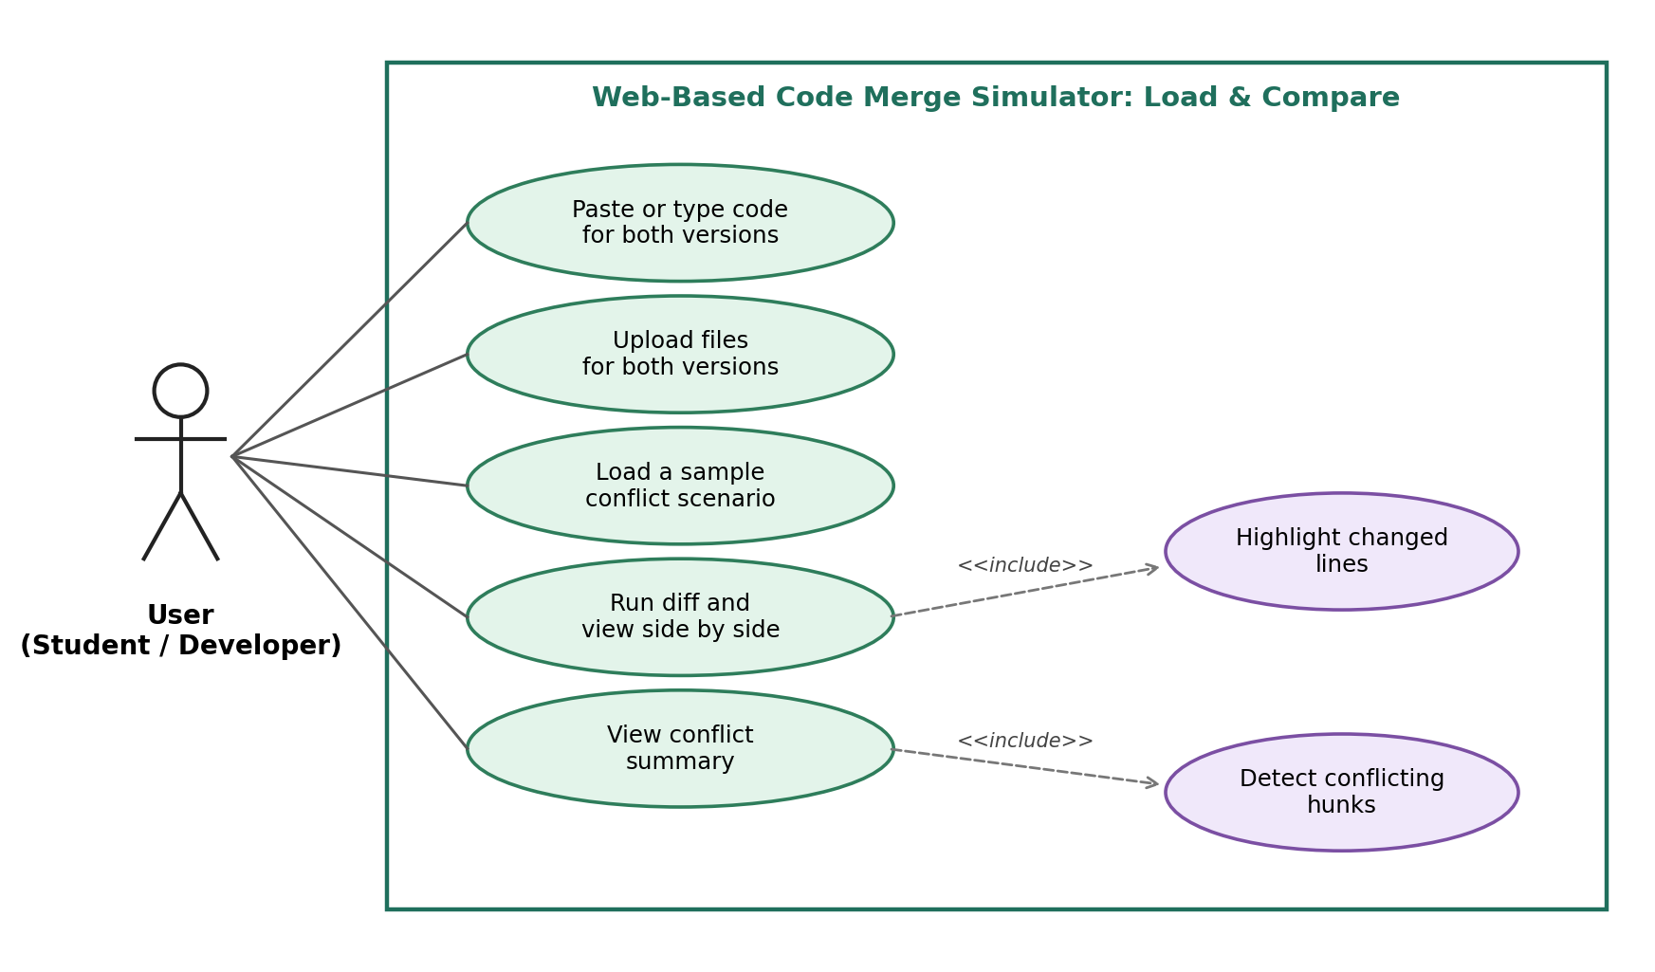
Figure 1: Use cases for loading and comparing versions

7.2 UML Use-Case diagram: Resolve and Merge
This diagram covers what happens after the comparison. Accepting a side or editing the merged text always updates the merged preview, and applying the merge always includes a check that no conflicts are left open.
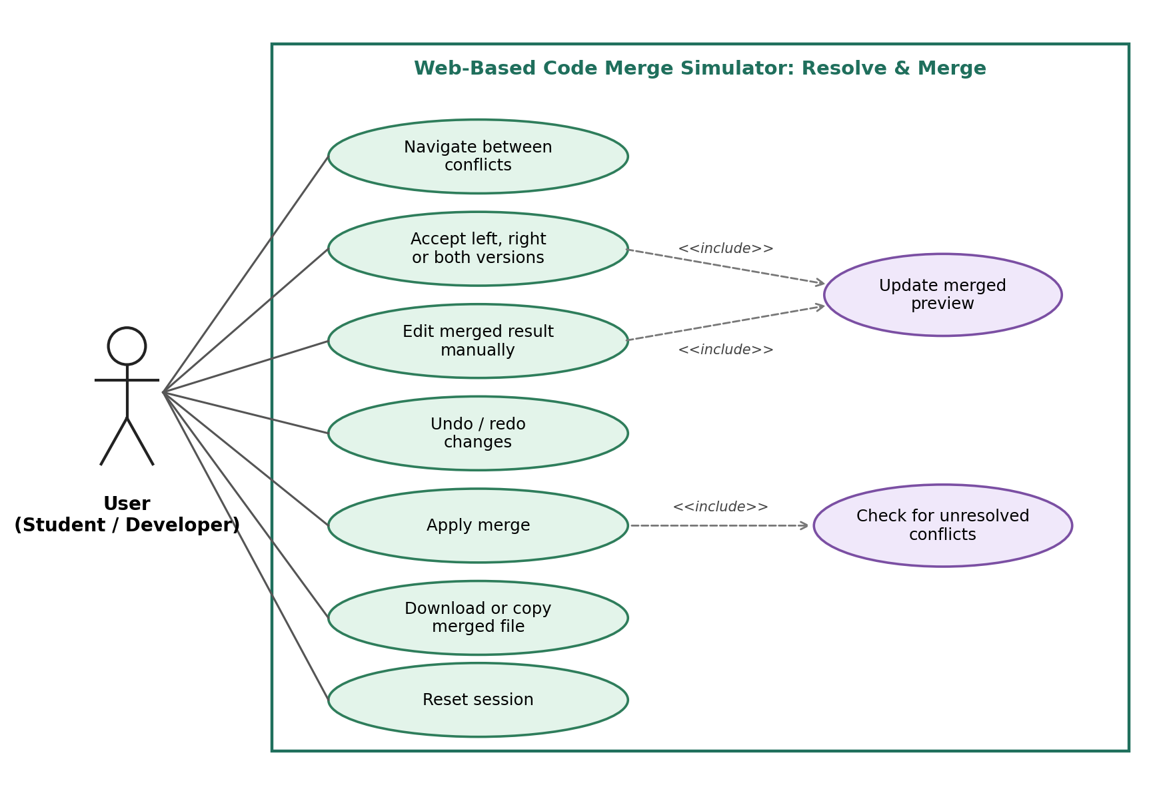
Figure 2: Use cases for resolving conflicts and applying the merge

8. Requirements Traceability Matrix (RTM)
Status key: N = not yet implemented, P = partially implemented, A = achieved and verified. Design specification IDs (DS-...) are placeholders that will be matched to the Software Architecture and Design document.
Req ID | Requirement (short) | Section ref / Design Spec | Module | Test case(s) | Status (N/P/A) | Comments
CMS-F-001 | Editable A/B input panes | 4.1 / DS-Input-01 | InputModule | TC-Load-01 | N
CMS-F-002 | Load version from file | 4.1 / DS-Input-02 | InputModule | TC-Load-02 | N
CMS-F-003 | Built-in sample scenarios | 4.1 / DS-Input-03 | InputModule | TC-Load-03 | N
CMS-F-004 | Optional common ancestor | 4.1 / DS-Input-04 | InputModule | TC-Load-04 | N
CMS-F-010 | Compute line diff | 4.2 / DS-Diff-01 | DiffEngine | TC-Diff-01 | N
CMS-F-011 | Side-by-side highlighted view | 4.2 / DS-Diff-02 | DiffView | TC-Diff-02 | N
CMS-F-012 | Group lines into conflicts | 4.2 / DS-Diff-03 | ConflictManager | TC-Diff-03 | N
CMS-F-013 | Live conflict counter | 4.2 / DS-Diff-04 | ConflictManager | TC-Diff-04 | N
CMS-F-014 | Synchronised scrolling | 4.2 / DS-Diff-05 | DiffView | TC-Diff-05 | N
CMS-F-015 | Word-level highlighting | 4.2 / DS-Diff-06 | DiffEngine | TC-Diff-06 | N
CMS-F-016 | Ignore-whitespace option | 4.2 / DS-Diff-07 | DiffEngine | TC-Diff-07 | N
CMS-F-020 | Accept A / B / Both controls | 4.3 / DS-Resolve-01 | ResolutionUI | TC-Res-01 | N
CMS-F-021 | Editable merged result pane | 4.3 / DS-Resolve-02 | ResolutionUI | TC-Res-02 | N
CMS-F-022 | Manual-resolution status | 4.3 / DS-Resolve-03 | ConflictManager | TC-Res-03 | N
CMS-F-023 | Next / previous conflict | 4.3 / DS-Resolve-04 | ResolutionUI | TC-Res-04 | N
CMS-F-024 | Undo / redo history | 4.3 / DS-Resolve-05 | SessionManager | TC-Res-05 | N
CMS-F-025 | Revert one conflict | 4.3 / DS-Resolve-06 | ConflictManager | TC-Res-06 | N
CMS-F-030 | Git-style markers for open conflicts | 4.4 / DS-Merge-01 | MergeEngine | TC-Mrg-01 | N
CMS-F-031 | Guard on Apply Merge | 4.4 / DS-Merge-02 | MergeEngine | TC-Mrg-02 | N
CMS-F-032 | Apply merge and summary | 4.4 / DS-Merge-03 | MergeEngine | TC-Mrg-03 | N
CMS-F-033 | Download and copy output | 4.4 / DS-Merge-04 | ExportModule | TC-Mrg-04 | N
CMS-F-034 | Preserve line endings | 4.4 / DS-Merge-05 | ExportModule | TC-Mrg-05 | N
CMS-F-040 | Reset session | 4.5 / DS-Session-01 | SessionManager | TC-Sess-01 | N
CMS-F-041 | Resolution log | 4.5 / DS-Session-02 | SessionManager | TC-Sess-02 | N
CMS-F-042 | Leave-page warning | 4.5 / DS-Session-03 | SessionManager | TC-Sess-03 | N
CMS-NF-001 | Performance | 5 / DS-Perf-01 | DiffEngine / WebUI | TC-Perf-01 | N
CMS-NF-002 | Usability | 5 / DS-UX-01 | WebUI | TC-UX-01 | N
CMS-NF-003 | Compatibility | 5 / DS-Compat-01 | WebUI | TC-Compat-01 | N
CMS-NF-004 | Reliability / Data integrity | 5 / DS-Rel-01 | MergeEngine / ExportModule | TC-Rel-01 | N
CMS-NF-005 | Accessibility | 5 / DS-Access-01 | WebUI | TC-UX-02 | N
CMS-NF-006 | Maintainability | 5 / DS-Maint-01 | DiffEngine / MergeEngine | TC-Mnt-01 | N
CMS-SR-001 | Transport security (HTTPS only) | 5.1.2 / DS-Sec-01 | SecurityLayer | TC-Sec-01 | N
CMS-SR-002 | Render user code as text (anti-XSS) | 5.1.2 / DS-Sec-02 | SecurityLayer | TC-Sec-02 | N
CMS-SR-003 | No transmission or storage of user code | 5.1.2 / DS-Sec-03 | SecurityLayer | TC-Sec-03 | N
CMS-SR-004 | Content Security Policy | 5.1.2 / DS-Sec-04 | SecurityLayer | TC-Sec-04 | N
CMS-SR-005 | Upload size and type limits | 5.1.2 / DS-Sec-05 | SecurityLayer | TC-Sec-05 | N
CMS-SR-006 | Dependency pinning and audit | 5.1.2 / DS-Sec-06 | SecurityLayer | TC-Sec-06 | N
CMS-SR-007 | Safe export file names | 5.1.2 / DS-Sec-07 | SecurityLayer | TC-Sec-07 | N

