Answer1:

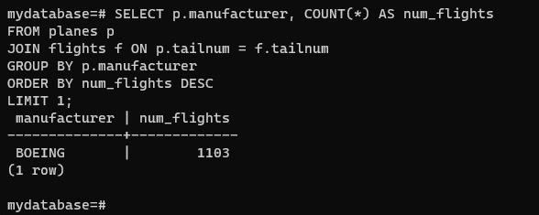

Answer 2:

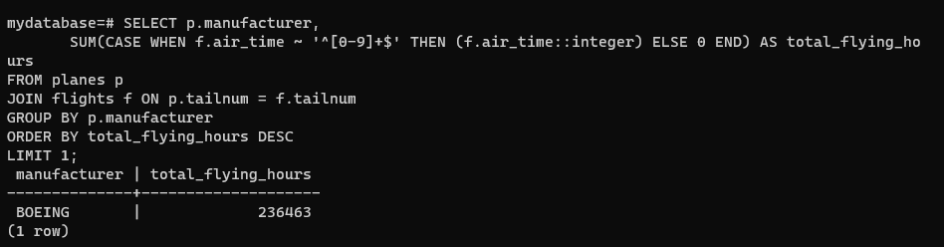

Answer 3:

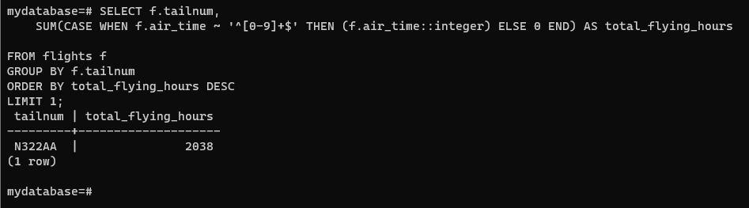

Answer 4:

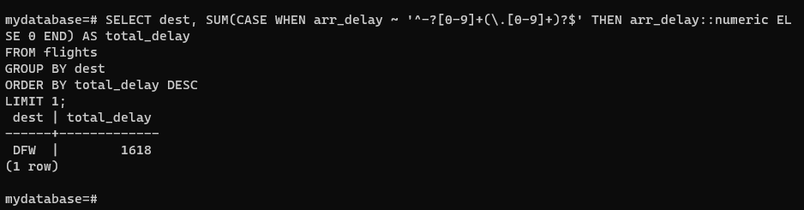

Answer 5:

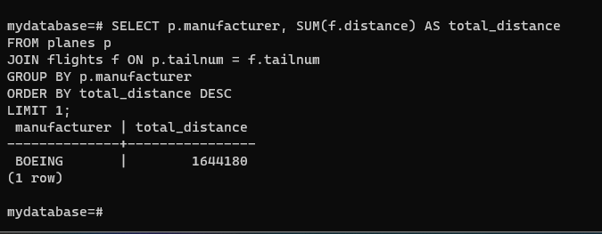

Answer 6:

