**Analyzing Personal Expenses**

**1. Introduction**

**Managing personal finances is essential for maintaining financial stability and making informed spending decisions. This project, "Analyzing Personal Expenses," is designed to track and analyze monthly expenses using Python, MySQL, and Streamlit. The project provides users with insights into their spending habits by categorizing expenses, identifying patterns, and visualizing key metrics.**

**2. Project Workflow**

**The project consists of four key components:**

1. **Synthetic Expense Data Generation:**
   * **A Python script (expense_project.py) creates realistic synthetic expense data using the Faker library.**
   * **Each transaction is assigned a category, description, payment mode, and amount and stored in a CSV file (expenses_data.csv).**
2. **Database and Table Creation**

* **Before inserting expense data, a MySQL database and table were created using MySQL Workbench. The following SQL commands were executed to set up the database and table.**

**Step 1: Create Database:  
CREATE DATABASE expense_tracker;**

**Step 2: Create Table:**

**USE expense_tracker;**

**CREATE TABLE expenses (**

**id INT AUTO_INCREMENT PRIMARY KEY,**

**date DATE,**

**category VARCHAR(255),**

**payment_mode VARCHAR(255),**

**description TEXT,**

**amount FLOAT,**

**cashback FLOAT**

**);**

* **This table is designed to store detailed expense records, including:  
  Date – When the expense occurred.  
  Category – Classification (e.g., Food, Rent, Shopping).  
  Payment Mode – How the expense was paid (Cash, Credit Card, UPI, etc.).  
  Description – Additional details about the transaction.  
  Amount – The total transaction amount.  
  Cashback – Any cashback received from the transaction.**

**The AUTO_INCREMENT primary key ensures each transaction has a unique ID.**

1. **Database Integration:**
   * **A second Python script (mysqlconnector.py) reads the CSV file and inserts the data into a MySQL database (expense_tracker).**
2. **Streamlit Dashboard for Analysis:**
   * **A Streamlit-based interactive dashboard fetches data from MySQL and presents it in visual form using Plotly and Streamlit widgets.**
   * **Users can analyze spending trends, category-wise expenses, payment methods, cashback insights, and recurring expenses.**

**3. Technologies Used**

* **Python (for data generation, database handling, and dashboard development)**
* **Faker (for generating synthetic expense data)**
* **MySQL (for storing and retrieving expense records)**
* **Streamlit (for interactive data visualization)**
* **Plotly (for creating dynamic charts and graphs)**

**4. Using the Streamlit Dashboard**

**Step 1: Install Required Dependencies**

**Ensure you have all necessary Python libraries installed:**

**pip install streamlit pandas mysql-connector-python plotly faker  
  
Step 2: Run the Streamlit Dashboard**

**Run the dashboard script using:**

**python -m streamlit run expense_streamlit.py  
  
Step 3: Explore the Insights**

**The dashboard provides the following insights:**

* **Overall Spending Trend – A monthly expense overview with total spending.**
* **Category-wise Spending – Breakdown of expenses by category.**
* **Payment Methods Analysis – Usage patterns of cash, credit cards, and other payment modes.**
* **Cashback Insights – Identification of transactions eligible for cashback.  
   Recurring Expenses – Recognition of fixed expenses like rent or subscriptions.**

**5. Streamlit Web Application Sample Screenshots**

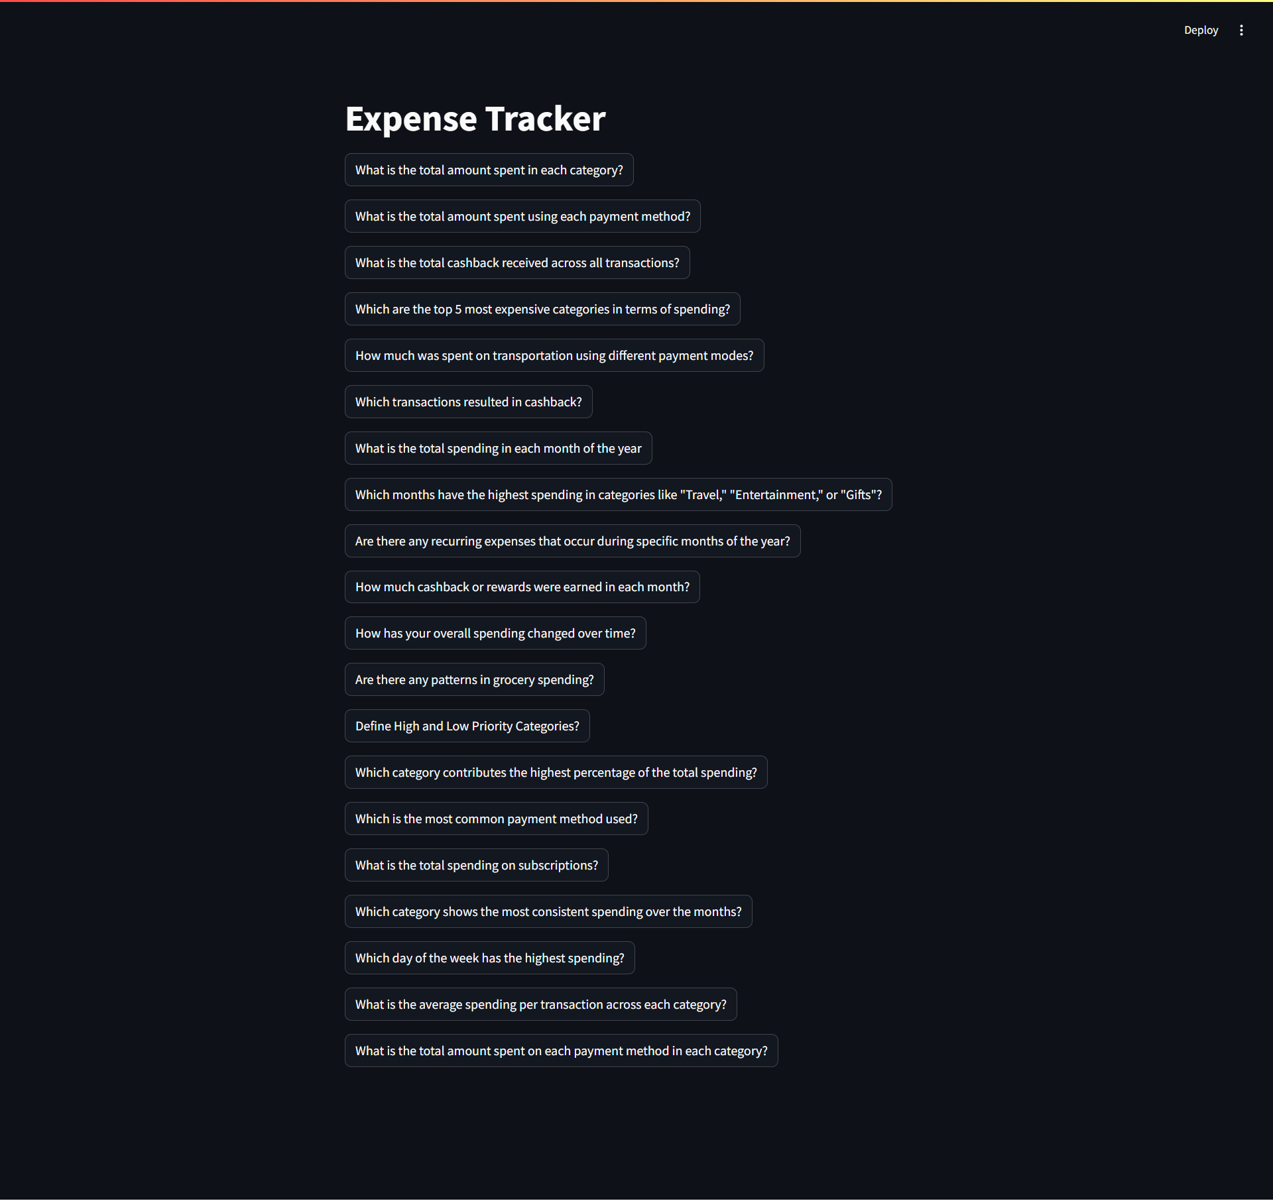

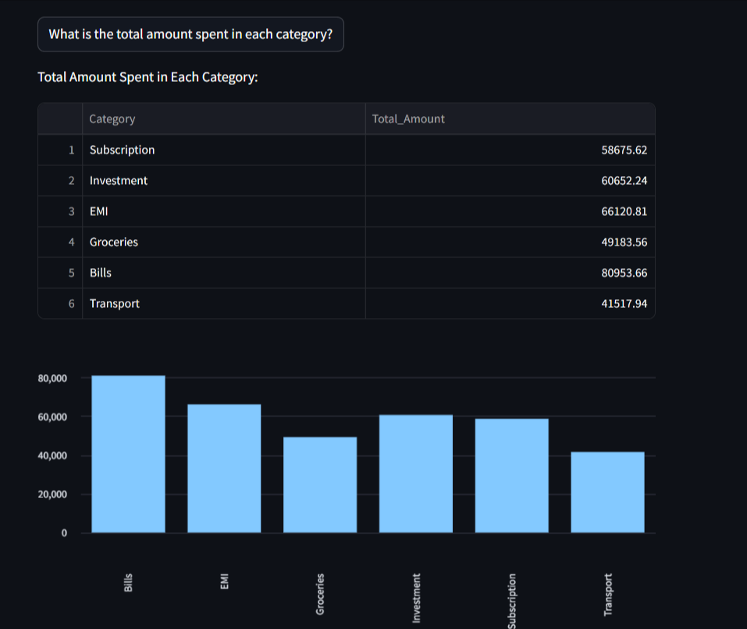

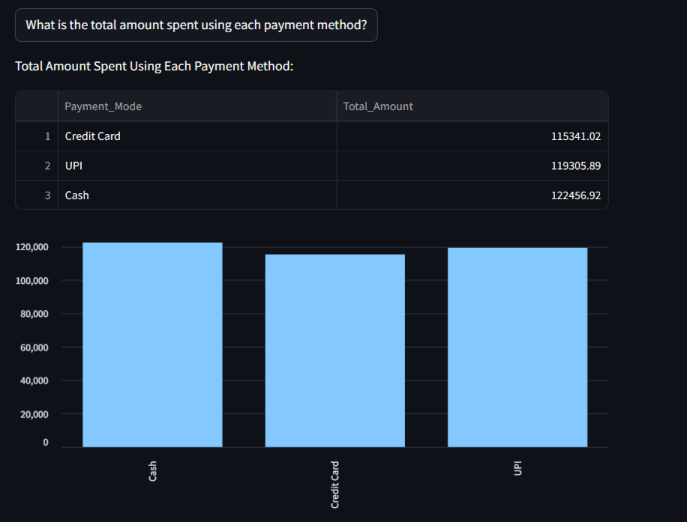

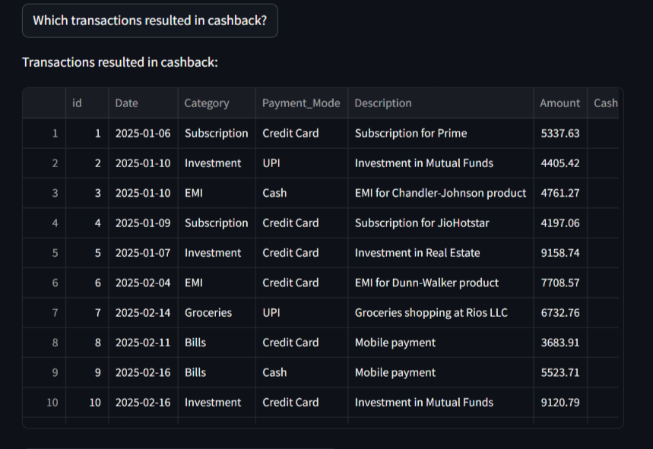

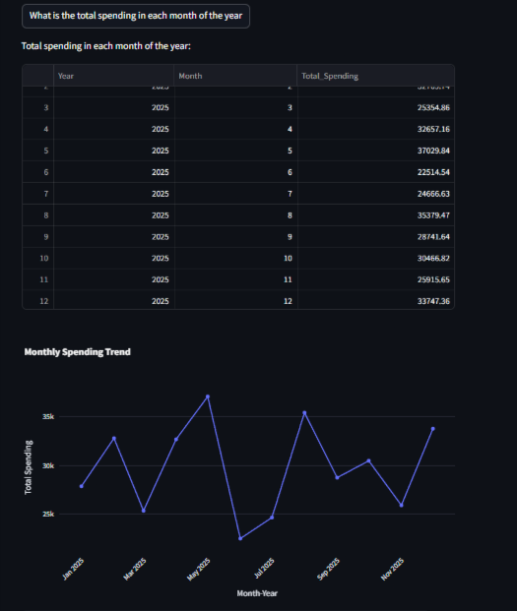

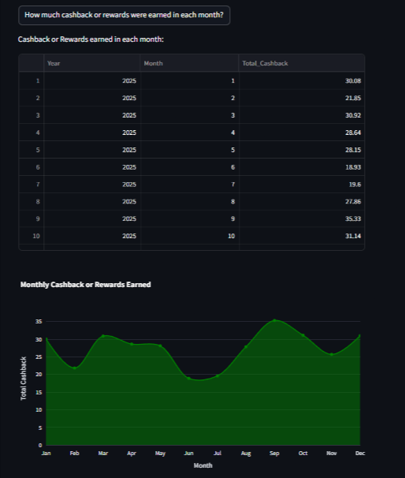

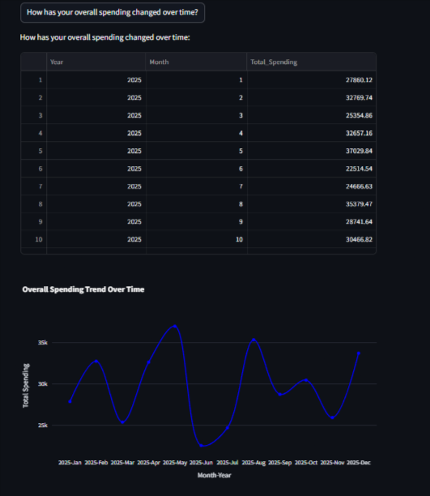

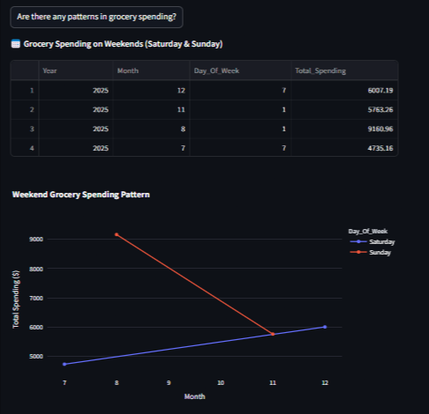

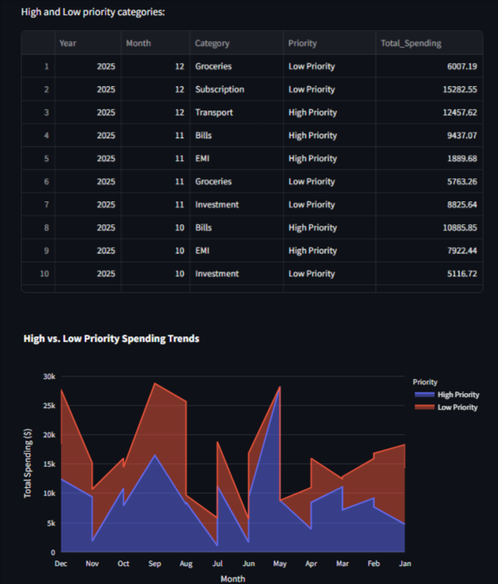

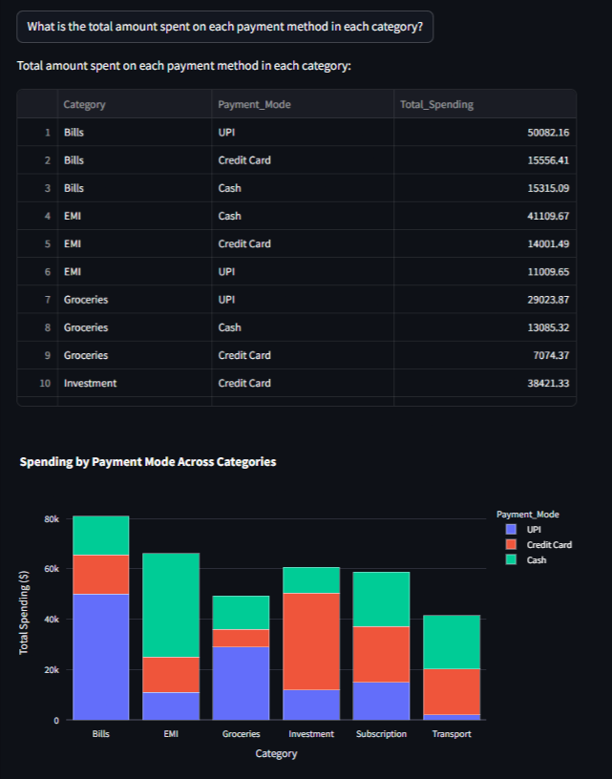

**6. Future Enhancements**

**User Authentication: Secure login to store and track individual user expenses.  
Expense Forecasting: Predict future expenses using machine learning.  
Budgeting Feature: Set monthly limits and receive alerts for overspending.**

**7. Conclusion**

**This project provides a data-driven approach to personal finance management. By using MySQL queries and visual analytics, users can gain meaningful insights into their spending behavior and make informed financial decisions.**