**FLOWCHART FOR DATASTORING**

Prepared by: Sharveena Padmaraj (1191101614)

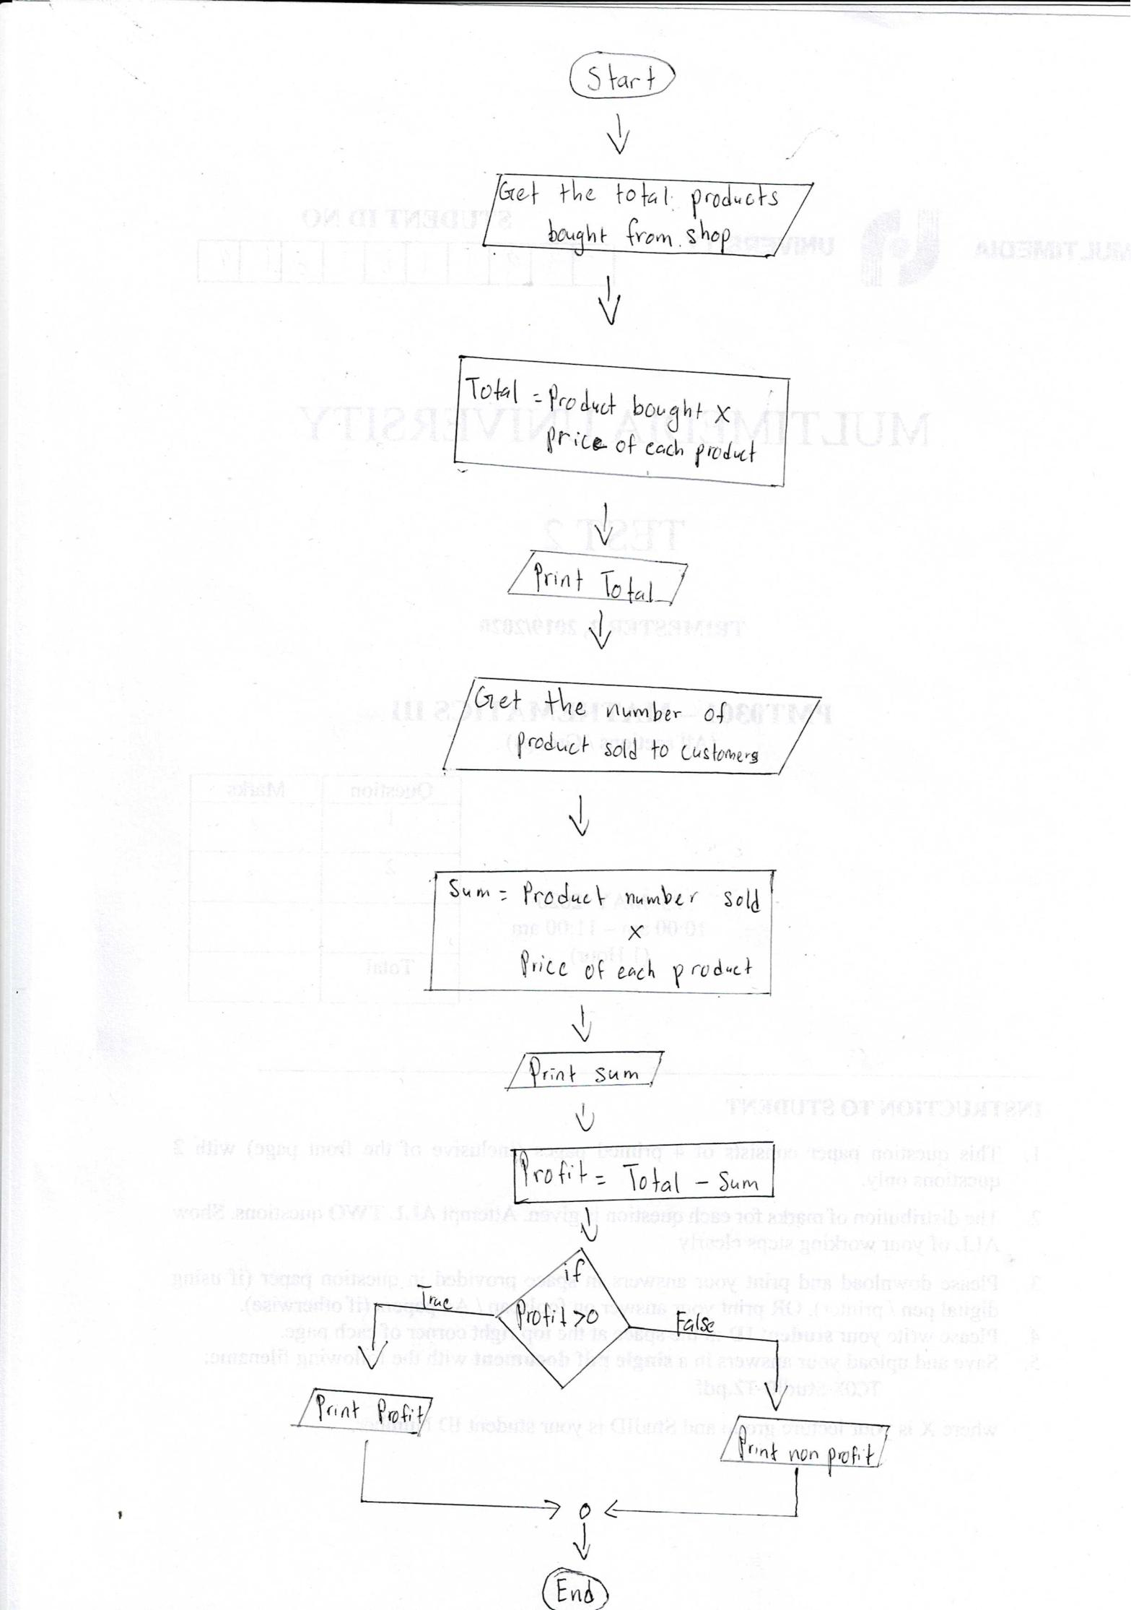

**FLOWCHART FOR PAYMENT SERVICES**

Prepared by: Kishen Kumar A/L Sivalingam (1191101423)

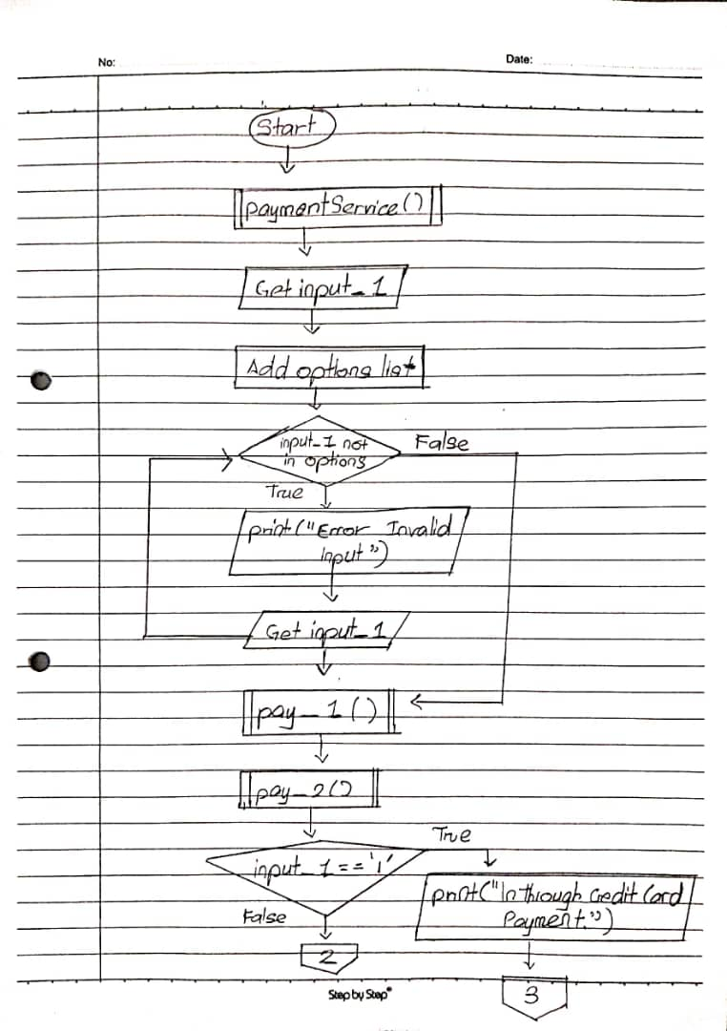

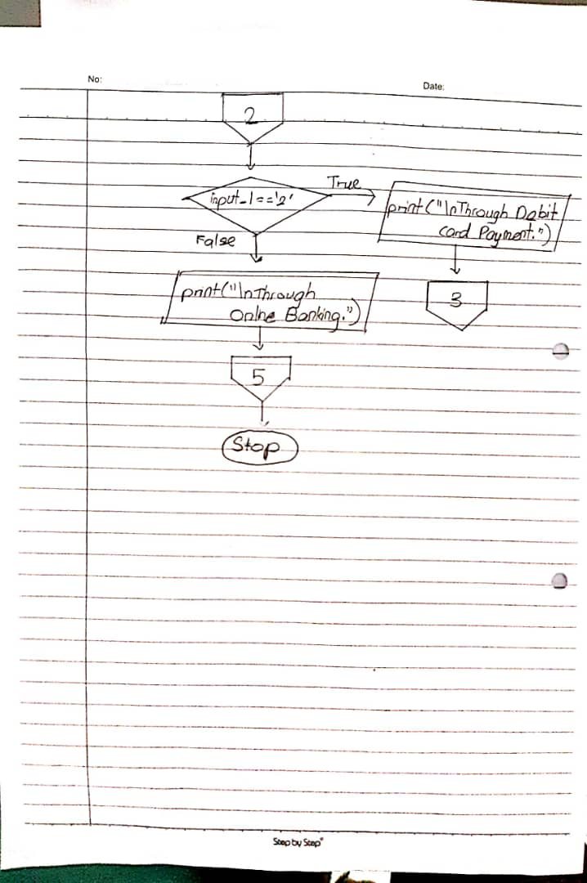

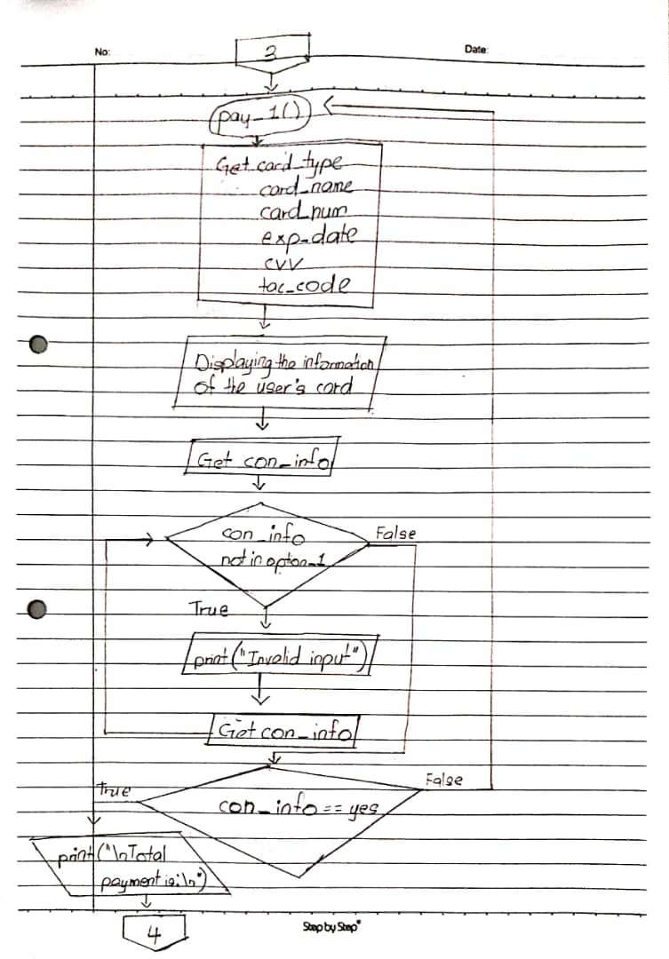

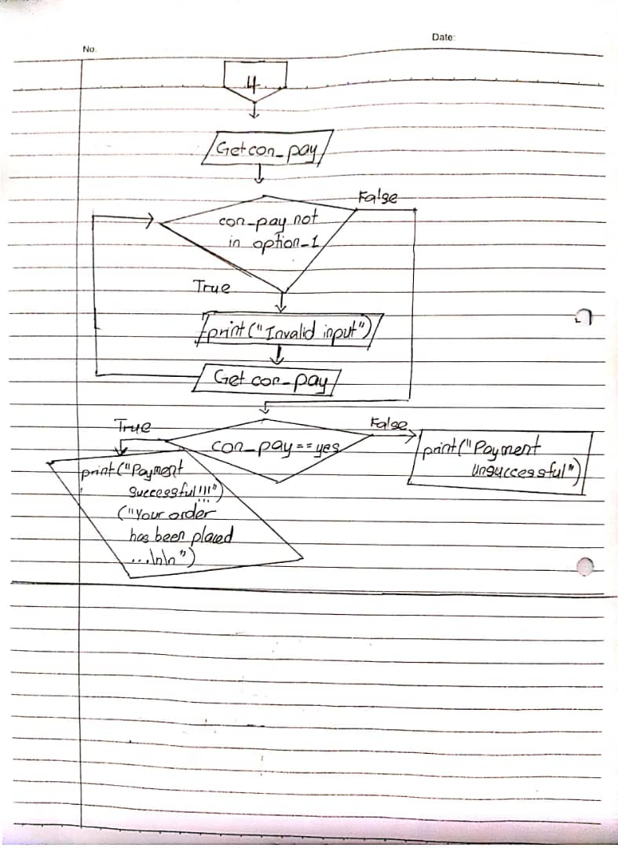

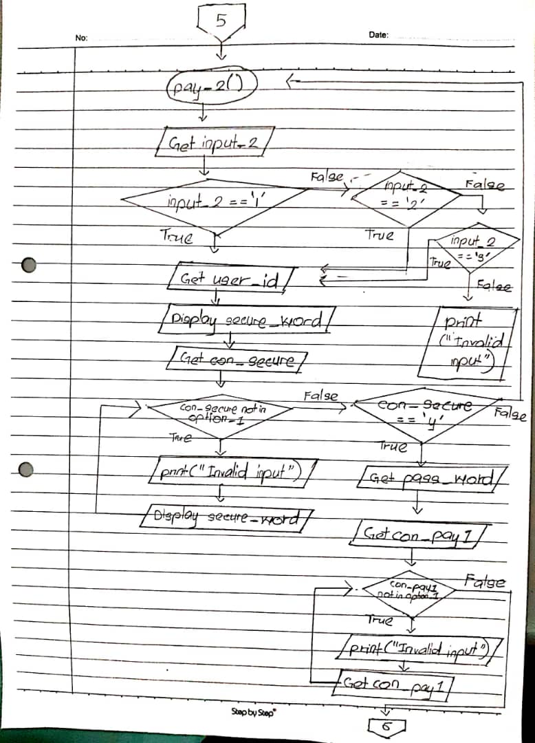

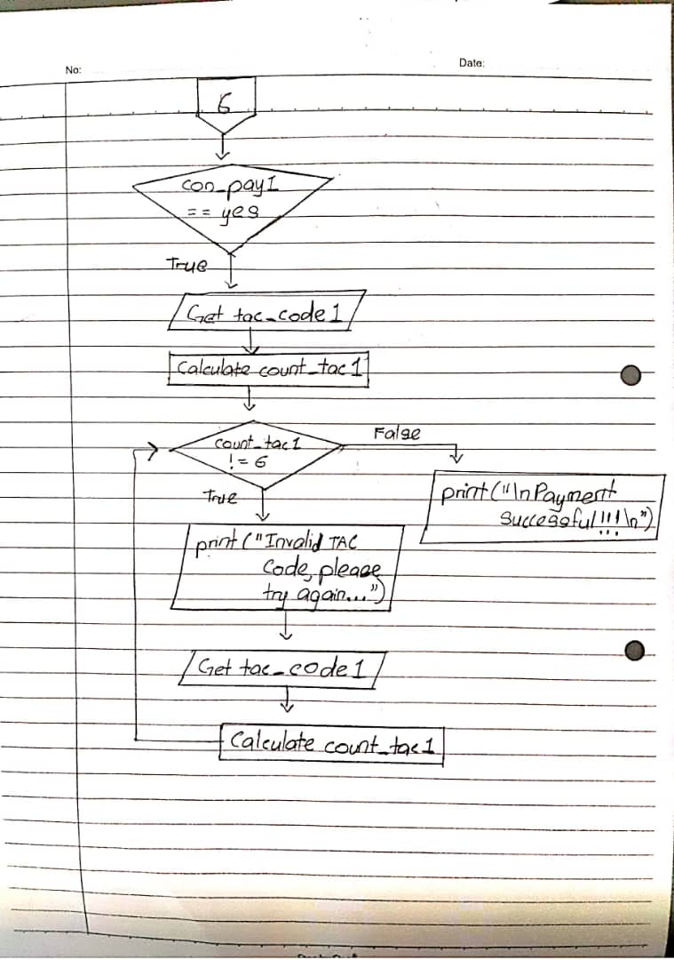

**FLOWCHART FOR SHOPPING CART**

Prepared by: Nurul Syaqeera Binti Ismail (1191101189)

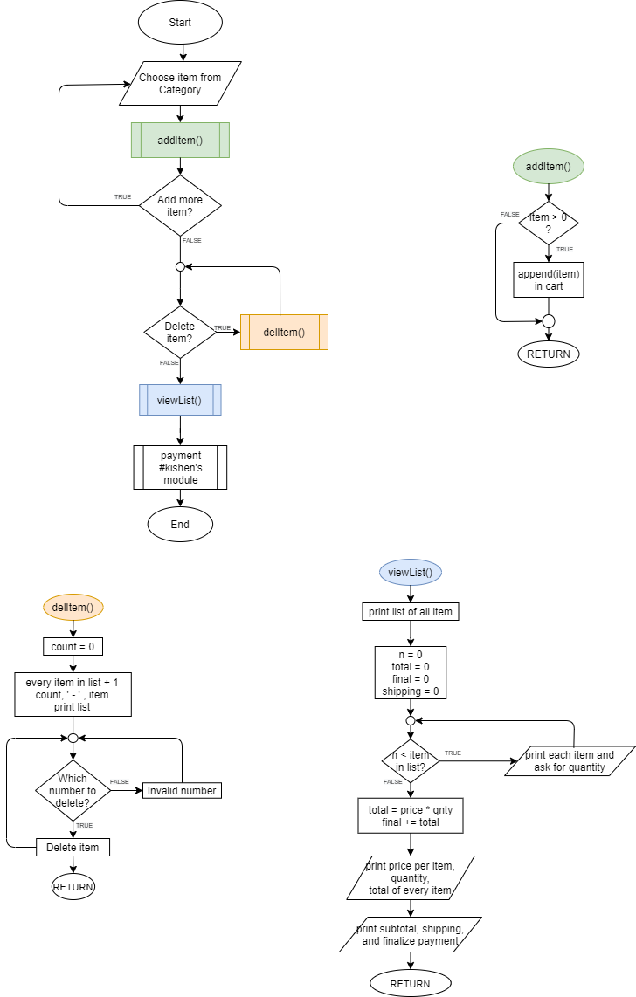

**FLOWCHART FOR CUSTOMER SERVICES**

Prepared by: HARRI GANESH A/L G CHANDRA BOSE (1191100277)

