Lab 2: Agile Backlog Creation & Sprint Simulation in Jira
Problem Statement #52 - Community Tool & Equipment Library
Name: Kshitij G Shettigar | SRN: PES1UG24CS240

The five functional requirements and two non-functional requirements identified in Lab 1 were grouped into five Epics and decomposed into seventeen User Stories, totalling 73 story points. Every FR and both NFRs from Lab 1 are traced to at least one story. The backlog was prioritised, estimated on the Fibonacci scale, and executed as two one-week sprints in a company-managed Jira Scrum project.
Deliverable 1: Epics
Lab 1's requirements were grouped into major functional themes. Each Epic is a body of work that delivers one coherent capability of the library and can be broken into User Stories.
Epic ID | Epic Name | Description | Lab 1 Reqs | Stories | Points
EPIC-1 | Tool Catalogue & Availability | Enables Community Members to find equipment and see its true, real-time physical availability across every neighbourhood depot locker before they travel to collect it. | FR-002, NFR-001 | 3 | 13
EPIC-2 | Reservations & Pickup Windows | Enables a Community Member to hold an available item for a bounded pickup window, and returns uncollected items to circulation automatically so that scarce tools are never blocked by a no-show. | FR-003 | 3 | 10
EPIC-3 | Borrowing & Member Eligibility | Enforces borrowing eligibility at checkout so that members with overdue items or unpaid fees cannot take further equipment, protecting the high-value tools the rest of the neighbourhood is waiting on. | FR-004 | 3 | 13
EPIC-4 | Deposits, Fees & Payments | Calculates security deposits from tool category, enforces loan duration limits, accrues late fees, and processes every hold and charge through the external payment gateway as tokenised references with no card data stored. | FR-001, NFR-002 | 4 | 21
EPIC-5 | Returns & Damage Settlement | Records item condition on return, lets the Library Custodian log a damage assessment with repair cost, and settles the held deposit with an itemised, auditable breakdown of every deduction. | FR-005, NFR-002 | 4 | 16
TOTAL |  |  |  | 17 | 73
Deliverable 2: User Stories, Priority and Story Points
Each story follows the Agile 'As a / I want / So that' convention so that the end-user goal, not the implementation, defines the work. Priority reflects dependency and user impact; story points use the Fibonacci scale (2, 3, 5, 8) to express effort, complexity and uncertainty relative to one another rather than in hours.
ID | User Story | Epic | Traces to | Priority | Pts
1.1 | Search the tool catalogue  As a Community Member, I want to search the catalogue by category, keyword or date, so that I can find the tool I need without travelling to the depot. | EPIC-1 | FR-002 | High | 5
1.2 | See real-time item status  As a Community Member, I want every search result to show its status (Available, Reserved, On Loan or Under Repair), so that I never travel for a tool that somebody else already has. | EPIC-1 | FR-002, NFR-001 | High | 5
1.3 | Show depot locker location  As a authenticated Community Member, I want each available item to show its depot locker ID, so that I can collect it from the right locker. | EPIC-1 | FR-002, NFR-001 | Medium | 3
2.1 | Reserve an available item  As a Community Member, I want to reserve an available item for a pickup window of up to 24 hours, so that it is held for me while I make my way to the depot. | EPIC-2 | FR-003 | High | 5
2.2 | Auto-release uncollected reservations  As a Library Custodian, I want an uncollected reservation to return to Available automatically when its pickup window closes, so that scarce tools are not blocked by members who never turn up. | EPIC-2 | FR-003 | Medium | 3
2.3 | Prevent double reservation  As a Community Member, I want a reserved item to be blocked from other members, so that two of us never arrive at the depot for the same tool. | EPIC-2 | FR-003 | Medium | 2
3.1 | Verify borrowing eligibility at checkout  As a Library Custodian, I want the system to verify that a member has no overdue item and no unpaid damage or late fee before any checkout is confirmed, so that equipment is never lent to a member already in default. | EPIC-3 | FR-004 | High | 8
3.2 | Block high-value items on a failed check  As a Library Custodian, I want high-value equipment blocked whenever the eligibility check fails, so that the most costly tools stay protected from repeat defaulters. | EPIC-3 | FR-004 | High | 3
3.3 | Show the refusal reason  As a Community Member, I want to be told exactly why my checkout was refused, so that I know what to settle before I try to borrow again. | EPIC-3 | FR-004 | Low | 2
4.1 | Calculate deposit from tool category  As a Library Custodian, I want each item's security deposit set automatically from its tool category, so that the deposit held always matches the value at risk. | EPIC-4 | FR-001 | High | 5
4.2 | Enforce category loan duration limits  As a Library Custodian, I want the maximum loan duration enforced per tool category, so that high-demand equipment keeps circulating through the neighbourhood. | EPIC-4 | FR-001 | High | 3
4.3 | Accrue late return fees  As a Library Custodian, I want a late fee charged for every day an item is held past its due date, so that members have a real reason to return equipment on time. | EPIC-4 | FR-001 | Medium | 5
4.4 | Hold deposits via tokenised payment  As a Community Member, I want my deposit held through the external payment gateway as a tokenised reference with no card data stored, so that my card details are never at risk from the library's systems. | EPIC-4 | NFR-002 | High | 8
5.1 | Record item condition on return  As a Library Custodian, I want to record each item's condition at the moment it is returned, so that any damage is attributed to the correct loan and member. | EPIC-5 | FR-005 | High | 3
5.2 | Log a damage assessment with repair cost  As a Library Custodian, I want to log a damage assessment against a returned item with its repair cost, so that the cost of repair can be recovered from the held deposit. | EPIC-5 | FR-005 | High | 5
5.3 | Settle the deposit with an itemised breakdown  As a Community Member, I want an itemised breakdown of every deduction when my deposit is released, so that I can see exactly what I was charged for and why. | EPIC-5 | FR-005 | High | 5
5.4 | Keep an immutable settlement audit record  As a Library Custodian, I want every deposit hold, deduction and release written to an immutable 12-month audit record, so that the library can always prove what it charged a member. | EPIC-5 | NFR-002 | Medium | 3

Deliverable 3: Sprint Plan
The backlog was split on the Epic boundary rather than at an arbitrary point, so that each sprint delivers a capability that can be demonstrated end to end. The two sprints are near-identical in size, 36 and 37 points, which keeps the planned velocity flat across the release.
Sprint 1 - Discovery & Access (1 week)
Sprint goal: A member can find a tool, trust the availability shown, hold it for pickup, and be correctly allowed or refused at checkout.
Order | Story | Epic | Priority | Pts
1 | Story 1.1 Search the tool catalogue | EPIC-1 | High | 5
2 | Story 1.2 See real-time item status | EPIC-1 | High | 5
3 | Story 2.1 Reserve an available item | EPIC-2 | High | 5
4 | Story 3.1 Verify borrowing eligibility at checkout | EPIC-3 | High | 8
5 | Story 3.2 Block high-value items on a failed check | EPIC-3 | High | 3
6 | Story 1.3 Show depot locker location | EPIC-1 | Medium | 3
7 | Story 2.2 Auto-release uncollected reservations | EPIC-2 | Medium | 3
8 | Story 2.3 Prevent double reservation | EPIC-2 | Medium | 2
9 | Story 3.3 Show the refusal reason | EPIC-3 | Low | 2
 | Sprint total |  |  | 36
Sprint 2 - Deposits & Settlement (1 week)
Sprint goal: Every loan is backed by a correctly calculated deposit taken through the payment gateway, and every return is settled with an itemised, auditable breakdown.
Order | Story | Epic | Priority | Pts
1 | Story 4.1 Calculate deposit from tool category | EPIC-4 | High | 5
2 | Story 4.4 Hold deposits via tokenised payment | EPIC-4 | High | 8
3 | Story 4.2 Enforce category loan duration limits | EPIC-4 | High | 3
4 | Story 5.2 Log a damage assessment with repair cost | EPIC-5 | High | 5
5 | Story 5.3 Settle the deposit with an itemised breakdown | EPIC-5 | High | 5
6 | Story 5.1 Record item condition on return | EPIC-5 | High | 3
7 | Story 4.3 Accrue late return fees | EPIC-4 | Medium | 5
8 | Story 5.4 Keep an immutable settlement audit record | EPIC-5 | Medium | 3
 | Sprint total |  |  | 37

Both sprints were run in Jira: stories were dragged into the sprint, the sprint was started with a one-week duration, and each story was moved To Do -> In Progress -> Done before the sprint was completed.

Deliverable 4: Jira Workspace Evidence
Evidence is captured at each step of the lab procedure. Click inside a box and paste the screenshot (Ctrl+V); the box grows to fit the image. Delete the grey prompt text after pasting. Captions are already written and do not need editing.
Step 1 - Set up the Jira project
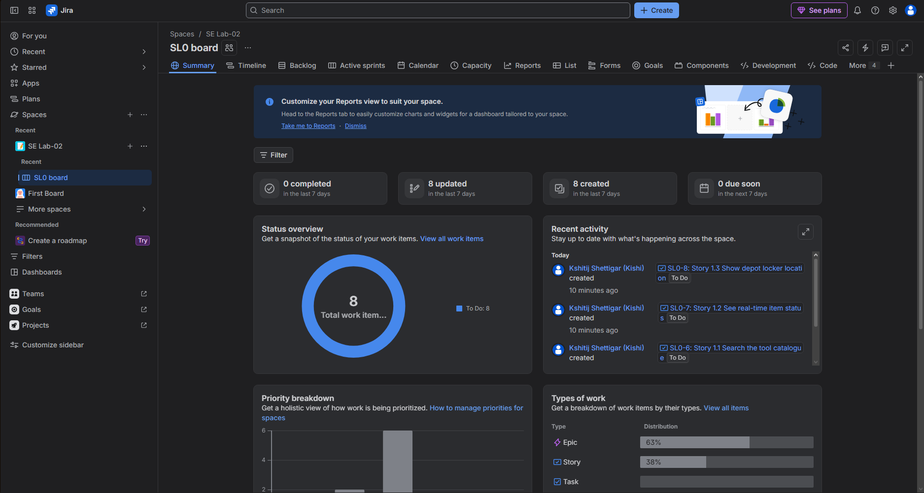
Figure 1: Company-managed Scrum project and board created.
Step 2 - Create Epics
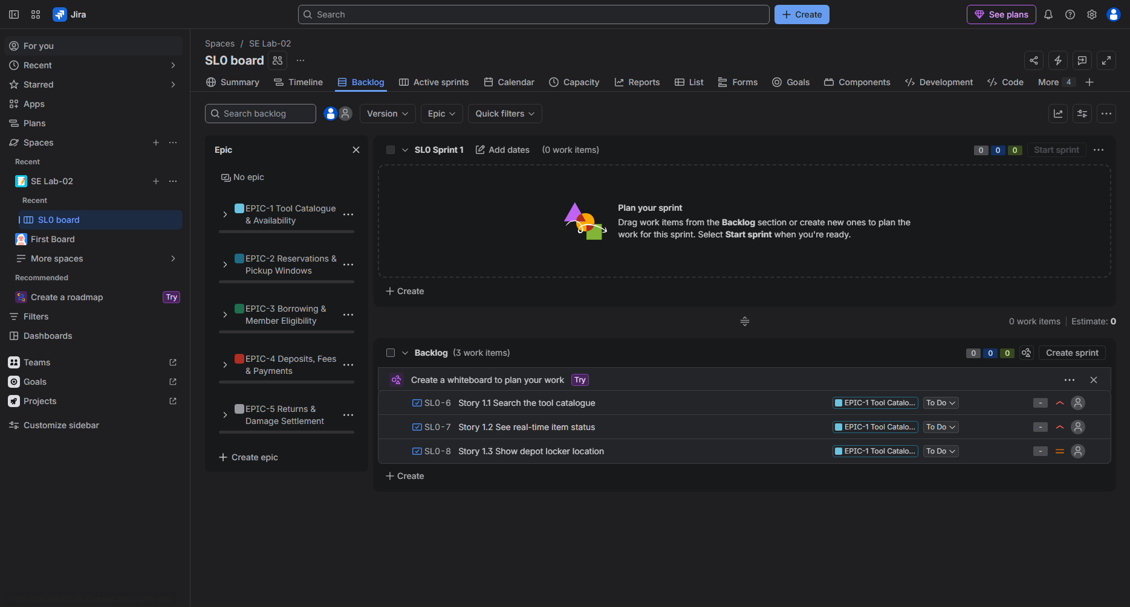
Figure 2: All five Epics created from the Lab 1 functional requirements.

Step 3 - Write User Stories
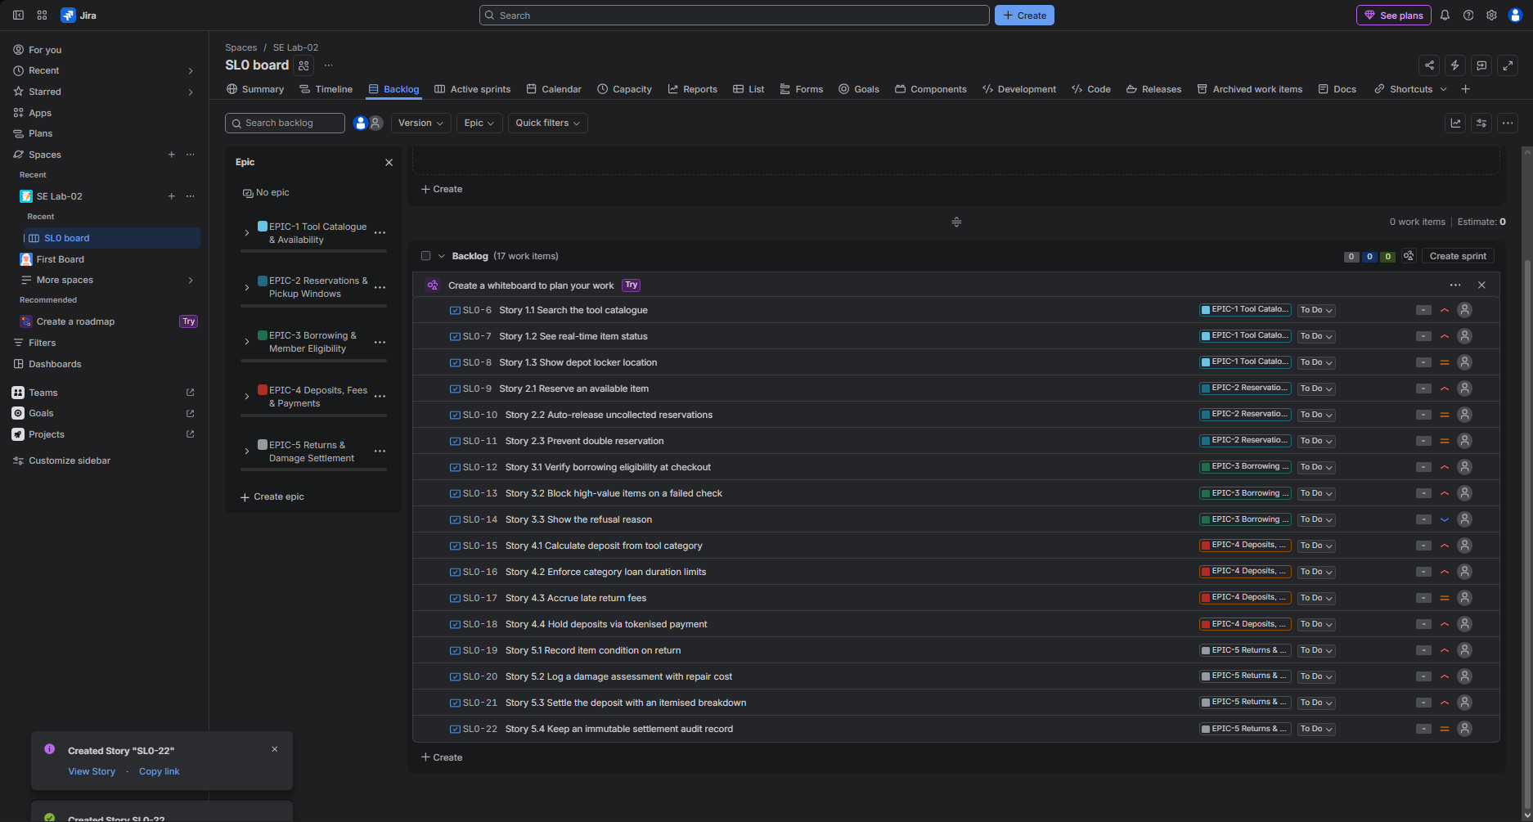
Figure 3: Backlog populated with all seventeen User Stories under their Epics.
Step 4 & 5 - Prioritise and estimate
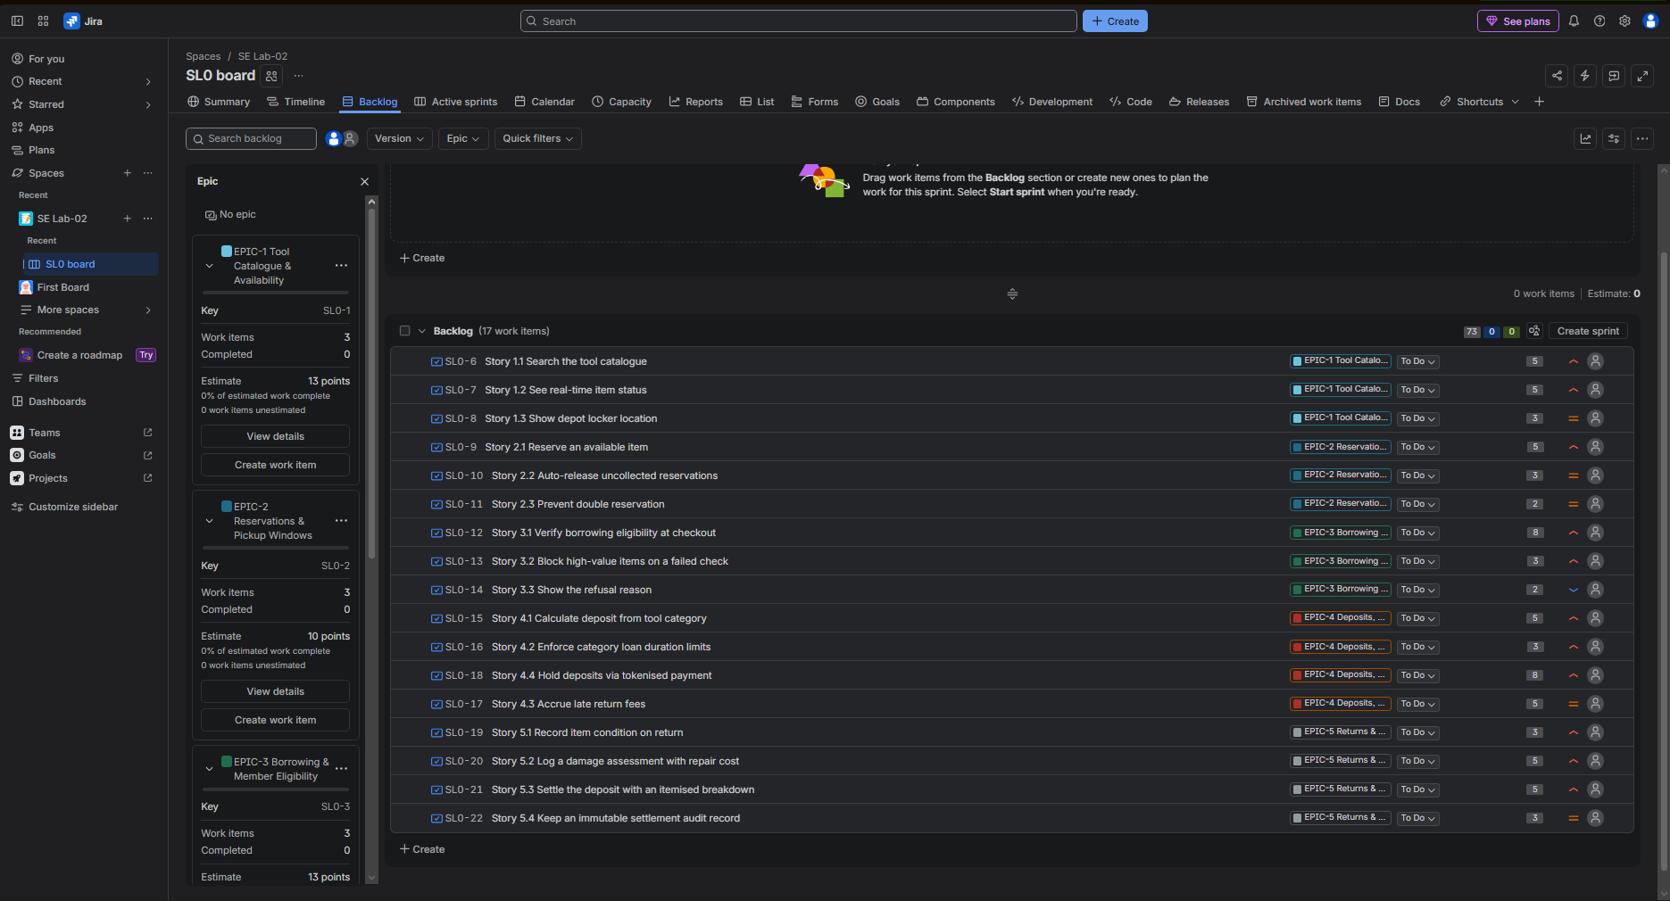
Figure 4: Priorities assigned and story points estimated on the Fibonacci scale.

Step 6a - Sprint 1 planned
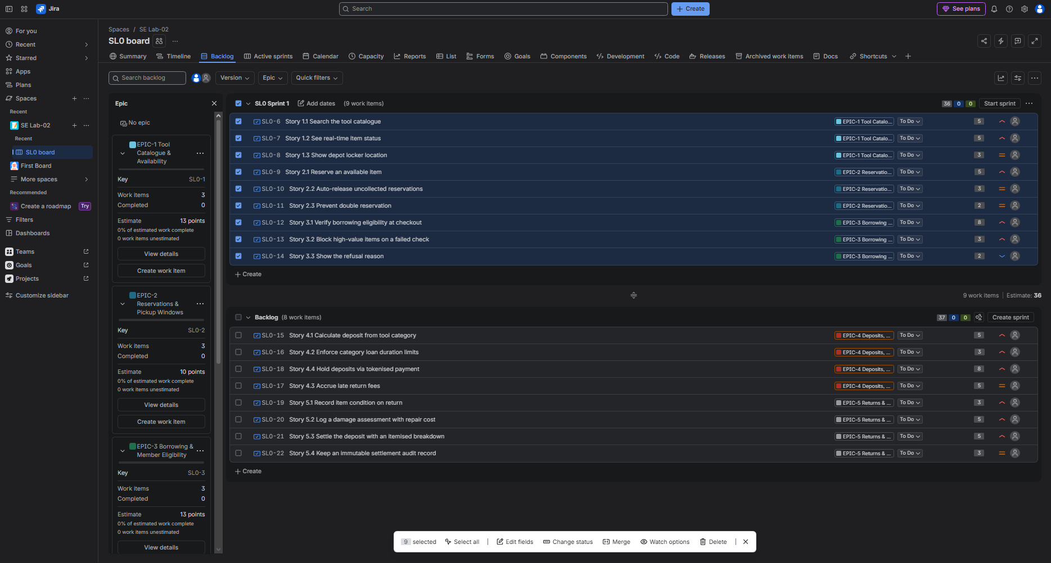
Figure 5: Sprint 1 populated with nine Stories totalling 36 points, before starting.
Step 6b - Sprint 1 in progress
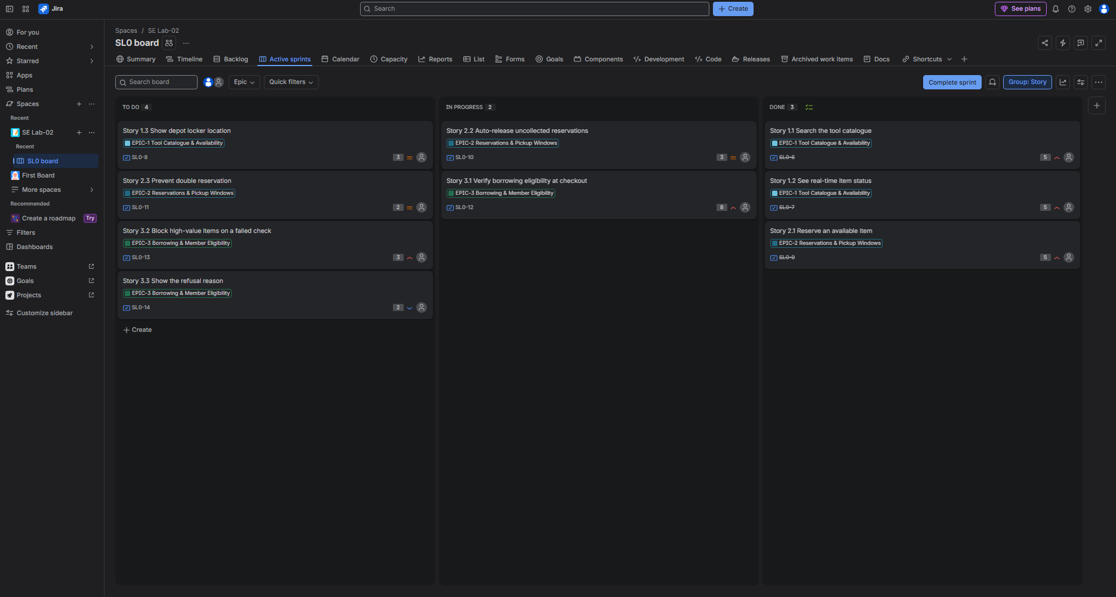
Figure 6: Sprint 1 active board with work distributed across the three columns.
Step 6c - Sprint 2 run
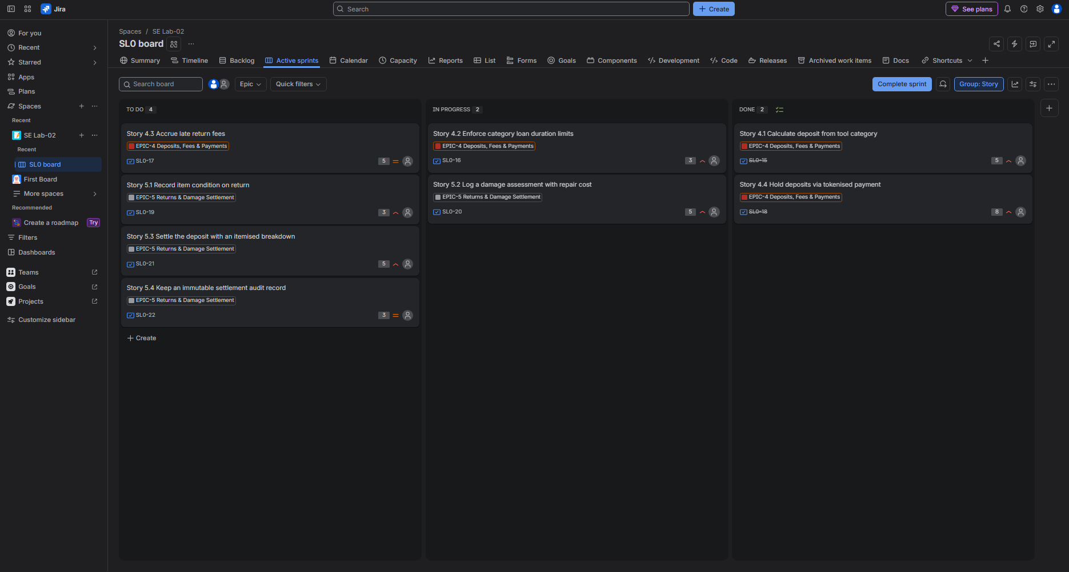
Figure 7: Sprint 2 active board with its eight Stories totalling 37 points.
Step 6d - Epic completion
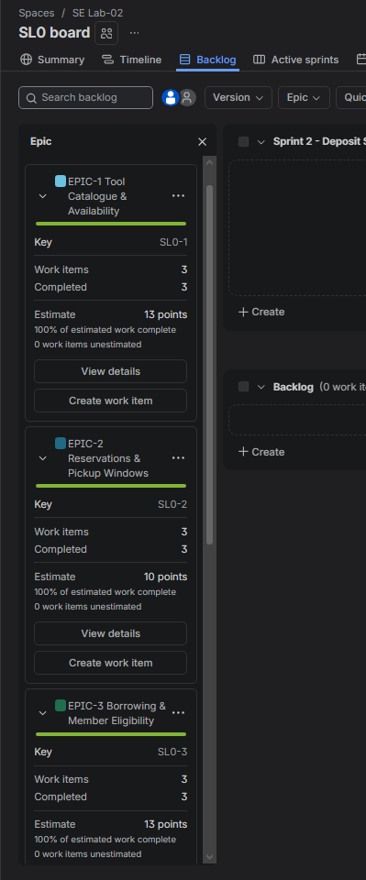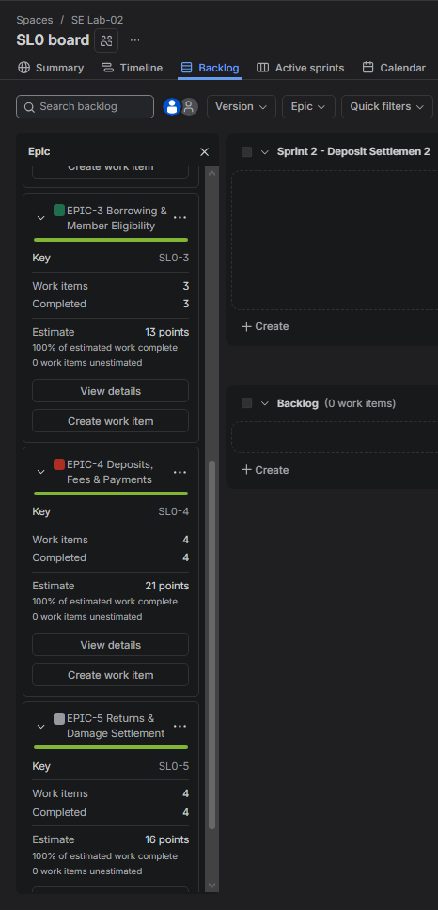
Figure 8: Epic progress after both sprints closed, showing completed points per Epic.

Step 7a - Burndown, Sprint 1
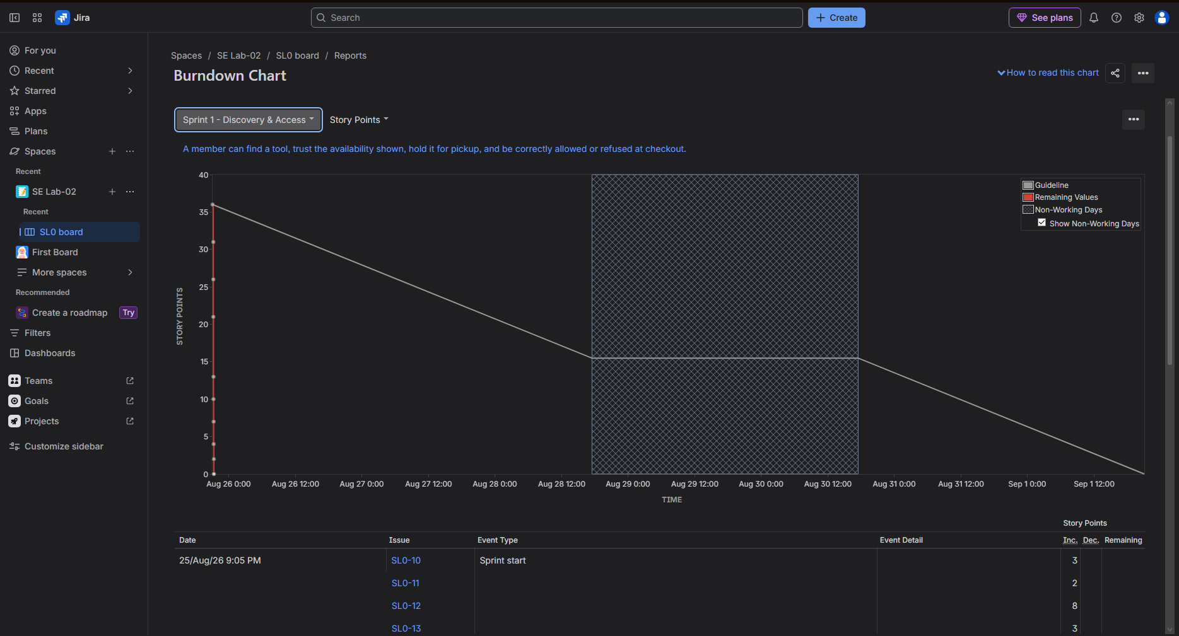
Figure 9: Burndown Chart for Sprint 1 (Discovery & Access).
Step 7b - Burndown, Sprint 2
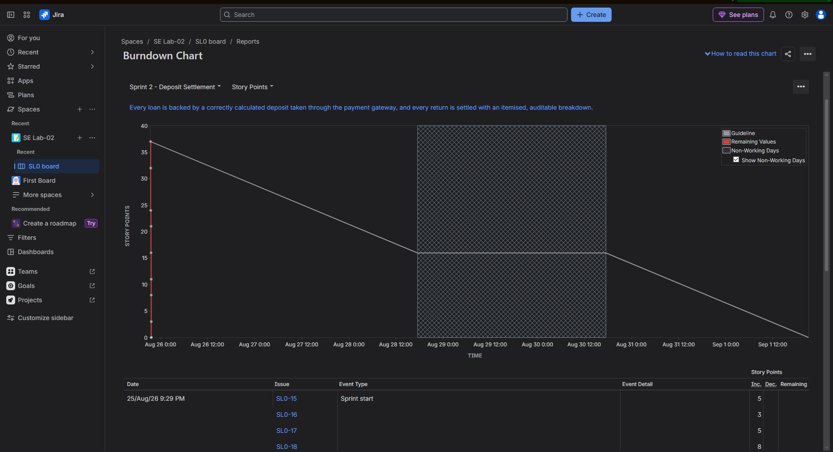
Figure 10: Burndown Chart for Sprint 2 (Deposits & Settlement).

Deliverable 5: Reflection
1. Did your estimations reflect the actual effort?
Only partly, and the simulation was too short to test them honestly. The two 8-point stories, 3.1 (verify borrowing eligibility) and 4.4 (tokenised deposit holds), were sized high because neither is self-contained: 3.1 has to read overdue and unpaid-fee state that other stories own, and 4.4 depends on an external payment gateway outside our control. That dependency risk is exactly what the non-linear Fibonacci scale exists to capture, and in real work those two are the most likely to overrun. The 2-point stories, 2.3 and 3.3, were sized on genuinely narrow scope and would probably hold. What the simulation cannot tell us is whether a 5 is really a 5 - relative estimates only become trustworthy once several sprints of measured velocity exist to calibrate them against, and we have none.
2. Was your backlog well-prioritized?
Yes, and the test is that priority follows dependency rather than preference. Every High story is one that other stories sit on top of: an item cannot be reserved (2.1) before it can be found and its status trusted (1.1, 1.2), and a deposit cannot be settled (5.3) before it can be calculated and held (4.1, 4.4). The single Low, story 3.3 (show the refusal reason), is genuinely deferrable - a refused checkout is still correctly refused without an explanation, so the system is safe without it and merely unhelpful. The one debatable placement is 4.3 (late fee accrual) at Medium; it is the library's main deterrent against late returns, and a real product owner would likely raise it to High.
3. How did your simulated sprint align with your plan?
Both sprints closed at one hundred per cent - 36 of 36 points, then 37 of 37 - and that perfect alignment is itself the finding rather than a success. The 'work' was a drag between board columns, so no story could turn out harder than estimated, nothing was blocked, and no scope was discovered mid-sprint. A real sprint aligns with its plan far less cleanly, and carry-over is normal. What the exercise did genuinely validate is the shape of the plan: splitting on the Epic boundary rather than at an arbitrary point meant each sprint had a goal statable in one sentence and demonstrable end to end, instead of leaving half a capability stranded across the boundary.
4. What insights did the burndown chart give about your team's capacity?
The most useful insight is what the chart could not show. Because both sprints were executed in minutes rather than across a week, the remaining-work line stays flat and then falls in a few steps at the end instead of tracking the grey guideline steadily downward. Flat-then-cliff is the classic signature of work that was not actually spread across the sprint, and on a real team it is a warning: either stories are only being finished at the deadline, or they are not broken down finely enough to be completed incrementally. On capacity itself, two sprints at 36 and 37 points imply a velocity of roughly 36 points per sprint, but a velocity derived from simulated completions is not evidence of anything. Three or four genuinely timeboxed sprints would be needed before that number could be used to forecast.

