Lab-1 Software Engineering
Name: Kshitij G Shettigar
SRN: PES1UG24CS240

Problem Statement: Community Tool & Equipment Library

Overview: A neighbourhood resource-sharing library where members check out power tools, camping gear, and lawnmowers, track deposit calculations, manage return dates, and log damage assessments.
Target Stakeholders / Actors: Community Member, Library Custodian ( Payment Gateway is also an Actor)
Deliverable 1 : FRs and NFRs

Req ID | Type | Description | Priority | Acceptance Criteria | Rationale (short) | Comments
FR-001 | Functional | The system shall set each item's security deposit and maximum loan duration from its tool category, and charge a late fee for every day an item is held past its due date. | High | Pass: A Category-C item (Rs.2000 deposit, 3-day limit) holds Rs.2000 at checkout and charges 2 days' late fee on a 2-day-late return. Fail: No deposit held, a loan over the category limit, or a late return with no fee. | Deposits and duration caps are the library's only protection against loss.
FR-002 | Functional | The system shall let a member search the catalogue by category, keyword or date, showing each result's status (Available / Reserved / On Loan / Under Repair) and its depot locker. | High | Pass: A 'lawnmower' search returns only lawnmowers, each with a status and locker ID, and an item checked out 5 s earlier already shows On Loan. Fail: A result shows no locker, or an item on loan is listed Available. | Members collect in person, so a wrong status or locker sends them to the wrong place.
FR-003 | Functional | The system shall let a member reserve an available item for a pickup window of at most 24 hours, and release the reservation automatically if the item is not collected in time. | Medium | Pass: A reservation marks the item Reserved and blocks other members; an uncollected one returns to Available within 5 minutes of the window closing. Fail: Two members hold one item, or an expired reservation still blocks it. | Holds prevent wasted trips, but holds that never expire hide scarce tools.
FR-004 | Functional | Before confirming any checkout the system shall verify that the member has no overdue item and no unpaid damage or late fee, and shall block high-value items if either check fails. | High | Pass: A member holding one overdue drill is refused a chainsaw and shown the reason. Fail: A member with overdue tools borrows further high-value equipment. | Unenforced eligibility lets one member hoard what the neighbourhood is waiting on.
FR-005 | Functional | The system shall record each item's condition on return, let the Library Custodian log a damage assessment with repair cost, deduct that cost and any late fee from the held deposit, and release the balance. | High | Pass: A return with Rs.500 damage and Rs.120 late fee against a Rs.2000 deposit releases Rs.1380 with an itemised breakdown. Fail: The deposit is released in full despite logged damage. | Settlement is the step members dispute; an itemised breakdown makes the charge defensible.
NFR-001 | Nonfunc. | Inventory search shall return real-time availability across all depot lockers within 2 s at the 95th percentile under 200 concurrent sessions, and expose locker contents only to authenticated members. | High | Pass: At 200 concurrent users, p95 search latency is at most 2 s, locker status at most 10 s stale, and an unauthenticated locker request returns HTTP 401. Fail: p95 above 2 s, staler data, or unauthenticated access succeeds. | Stale data sends members to empty lockers, and locker contents reveal where valuable tools sit.
NFR-002 | Nonfunc. | All deposit holds and fee charges shall be processed through the external payment gateway as tokenised references, with no card data stored and an immutable 12-month audit record of every hold, deduction and release. | High | Pass: A scan after 100 transactions finds only gateway tokens and no card data, and every transaction has a timestamped audit entry the application cannot alter. Fail: Card data is recoverable, or a deduction has no matching audit entry. | The library must be able to prove what it charged, and has no reason to store card data.

Deliverable 2 : UML Use-Case Diagram
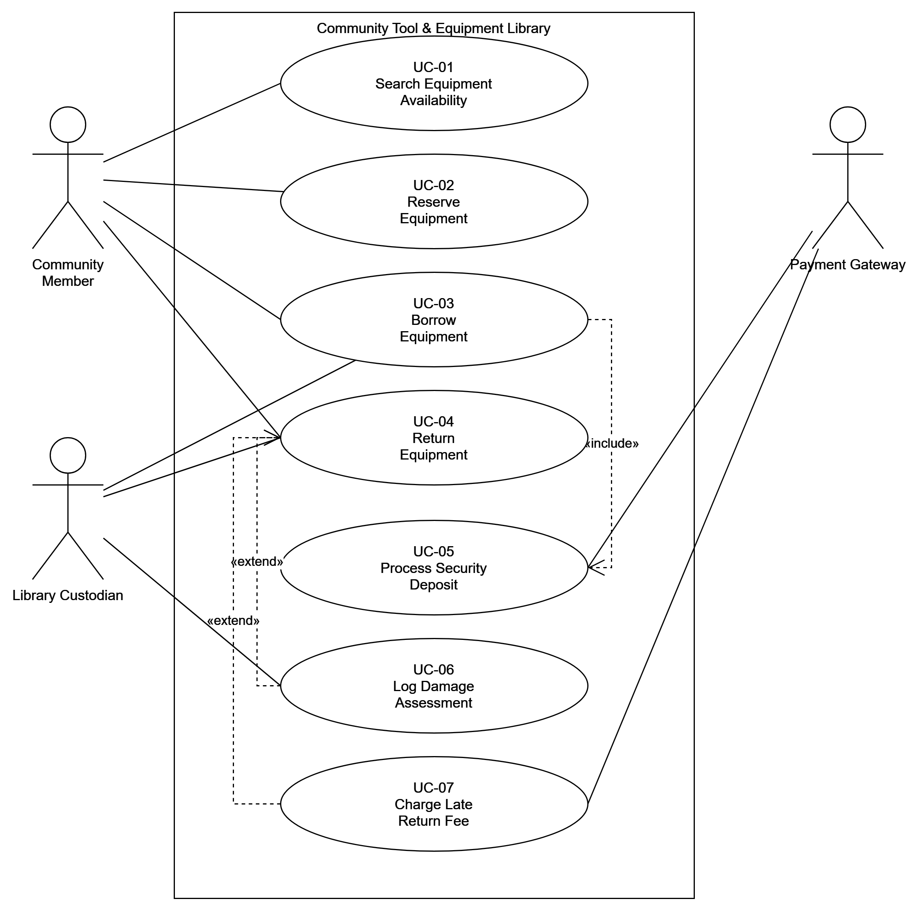

Deliverable 3 : Use-Case Specification

Use Case ID | UC-03
Use Case Name | Borrow Equipment
Primary Actor | Community Member
Secondary Actors | Library Custodian, Payment Gateway
Related Requirements | FR-001, FR-002, FR-004, NFR-002
Description | A Community Member borrows an item of equipment from the library. The system checks the member's eligibility, calculates and holds a security deposit, and records the loan against a due date.
Preconditions | 1. The Community Member is registered and authenticated on the system.  2. The member has no overdue item and no unpaid damage or late fee (FR-004).  3. The requested item's status is Available, or Reserved by that same member.  4. The member has a valid deposit payment method registered with the Payment Gateway.
Postconditions | 1. The item is marked On Loan against the member, with a due date set from its tool category's maximum loan duration.  2. A security deposit for that category is held against the member's payment method.  3. The depot locker inventory is updated so the item no longer appears as available.  4. A timestamped audit entry records both the loan and the deposit hold (NFR-002).
Main Success Scenario | 1. The Community Member searches the catalogue for the required equipment.  2. The system displays matching items with their current status and depot locker (FR-002).  3. The member selects an available item and requests to borrow it.  4. The system verifies the member's eligibility - no overdue items and no unpaid fees (FR-004).  5. The system calculates the security deposit and the loan duration limit for the item's tool category (FR-001).  6. The system requests a deposit hold from the Payment Gateway. [includes UC-05 Process Security Deposit]  7. The Payment Gateway authorises the hold and returns a tokenised reference.  8. The system records the loan, sets the due date, and marks the item On Loan.  9. The Library Custodian releases the item from the depot locker to the member.  10. The system issues a confirmation showing the due date and the deposit amount held. The use case ends successfully.
Alternate Flow | 6a. Deposit authorisation declined  6a1. The Payment Gateway rejects the deposit hold and returns a decline reason.  6a2. The system notifies the member and prompts for an alternative payment method.  6a3. The member selects a different method and the flow resumes at step 6.  6a4. If authorisation fails again after 2 attempts, the system cancels the borrow request, returns the item to Available, and notifies the member. The use case ends in failure.

