Software Architecture Document — Online Examination Portal
Course: UE24CS341A — Software Engineering, PES University, Dept. of CSE
Project: Online Examination System with Multiple-Choice Questions and Evaluation
Team: Kshitij G Shettigar (Backend & Data) · Kartik Basavaraj Meti (Frontend & UX) · Komal S Sajja (QA & Docs)
Version: 1.0 · Date: 2026-10-15

1. Purpose
This document records the architecture chosen for the Online Examination Portal: the architectural style, the components and the interfaces between them, the technology each layer is built with, and why. Every component traces to requirements in Documents/markdown/SRS.md.

2. Architecture selection
We chose a Layered architecture for the Online Examination Portal.

2.1 Styles compared
Style | Fit for this system | Verdict
Layered (Presentation / Business / Data) | One deployable on one server; every rule (timer, eligibility, scoring) sits in one Business layer over one consistent database | Chosen
Microservices | Independent scaling is not needed at 200 concurrent attempts (NFR-001), and splitting attempts and scoring across services breaks the single transaction that submission needs (FR-020, FR-022) | Rejected — operational cost with no requirement that pays for it
Client-Server | Topologically true — browsers are the clients of one server — but says nothing about how the server is organised | Absorbed — the layered server is the server

2.2 Reasons for the choice
- One consistent record for each attempt. Starting an attempt, saving responses, submitting and scoring all read and write the same attempt row (FR-016, FR-019, FR-020, FR-022). In one Business layer over one database this is a single database transaction; across services it would need distributed coordination.
- The rules live on the server, behind one layer. The timer is computed from the server clock (FR-017), eligibility from server time and enrollment (FR-015), and the answer key never leaves the server (FR-029). Layering puts all of these in the Business layer, where the browser cannot reach or alter them.

2.3 Security advantage
The Presentation layer has no path to the database. It can only call Business-layer interfaces, and every Business-layer view checks the caller's session and role before acting (FR-003). The Attempt Session Manager builds the question payload for the Student and leaves out the correct option; the Presentation layer has no other route to it, so the key cannot leak through the page (FR-029, verified by IT_035).

2.4 Performance benefit
Evaluation runs inside the server, on data already in the same database, as soon as the attempt is submitted — no network hop between services. Scoring a 100-question attempt is one query for the responses and one for the key, well within the 5-second target (NFR-002). Every page reads through one repository with indexed foreign keys, which is what NFR-001 (95% of requests within 2 s at 200 concurrent attempts) is load-tested against.

3. Component diagram
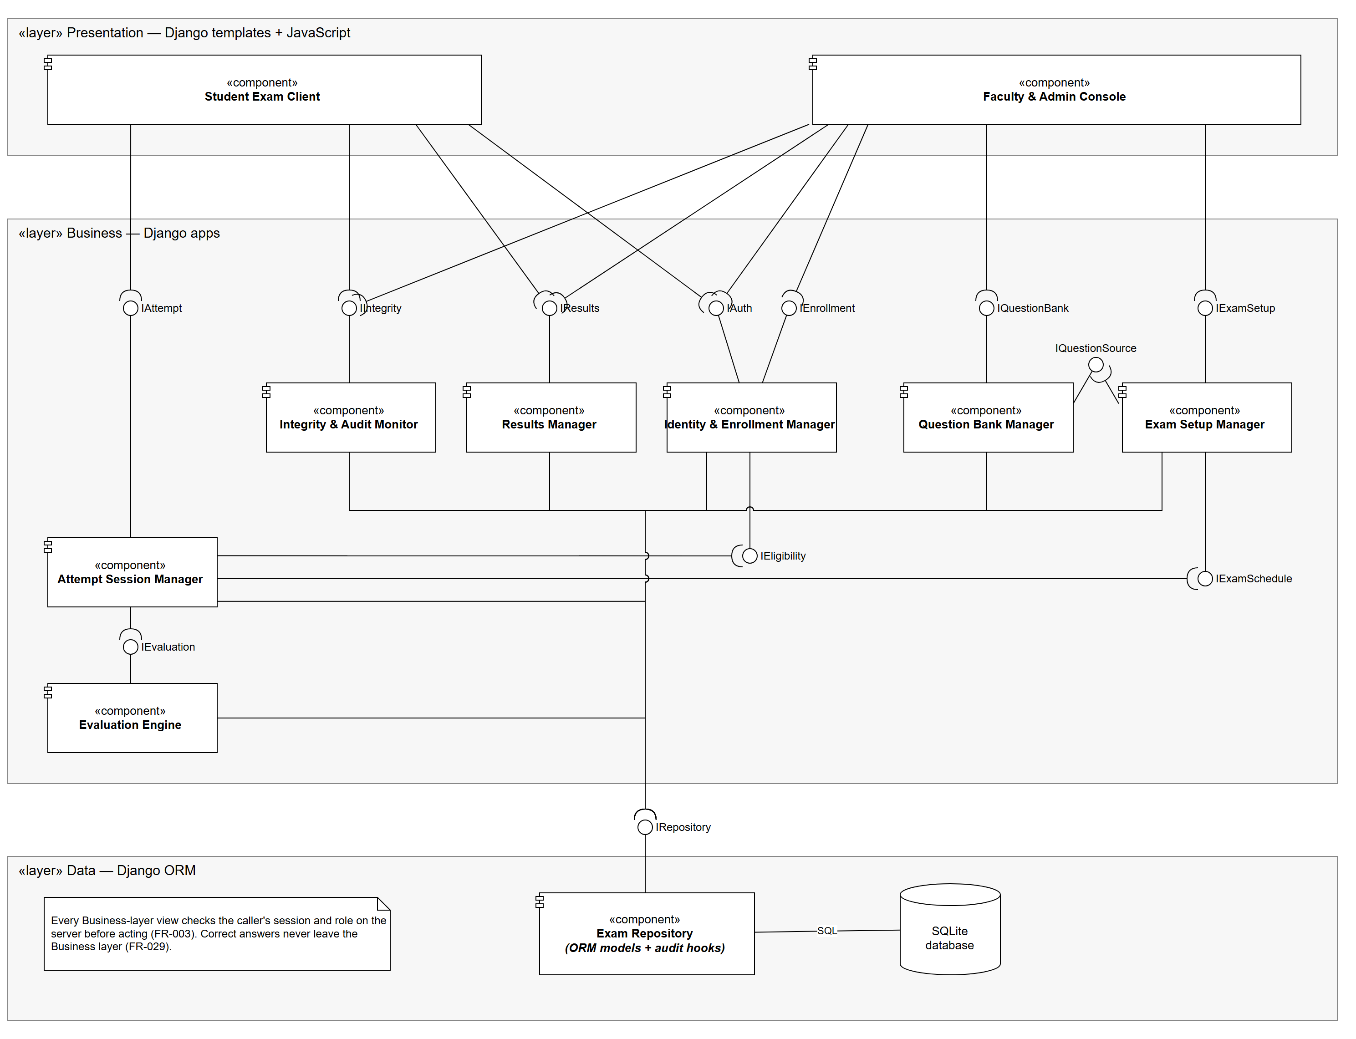
Source: Documents/diagrams/component_diagram.drawio (open in draw.io). Notation: a ball is a provided interface on the component that implements it; a socket is a required interface on the component that calls it; a ball in a socket is an assembly connector.

3.1 Components
Layer | Component | Responsibility | Requirements
Presentation | Student Exam Client | Dashboard, exam screen, server-driven countdown, question palette, autosave and focus-loss listeners, scorecard | FR-014, FR-017, FR-018, FR-019, FR-027, FR-028
Presentation | Faculty & Admin Console | Course and enrollment screens, question editor, exam setup and scheduling, results publishing, integrity and audit views | FR-004, FR-005, FR-007–FR-013, FR-026
Business | Identity & Enrollment Manager | Registration, sign-in, roles, account lockout, course enrollment, eligibility checks | FR-001–FR-006, FR-015, NFR-011, NFR-012
Business | Question Bank Manager | Questions, options, tags, versioning of questions in use | FR-007, FR-008, FR-009
Business | Exam Setup Manager | Examination details and policy, question selection, Draft/Published state, schedule window | FR-010–FR-013, NFR-010
Business | Attempt Session Manager | Start attempt, server timer, answer-free paper payload, autosave, resume, submit and auto-submit | FR-015–FR-021, FR-029
Business | Evaluation Engine | Scores a submitted attempt: positive and negative marks, total, percentage, pass/fail | FR-022, FR-023, FR-024
Business | Results Manager | Withholds results until published; publish and unpublish; scorecards | FR-025, FR-026, FR-027
Business | Integrity & Audit Monitor | Records focus-loss events; shows events and the audit trail to Faculty and Administrators | FR-028, FR-030
Data | Exam Repository | Django ORM models over the database; writes the append-only audit entry on every change | FR-030, NFR-013

3.2 Interfaces
Interface | Provided by | Required by | Kind
IAuth | Identity & Enrollment Mgr | Student Exam Client, Faculty & Admin Console | HTTP view
IEnrollment | Identity & Enrollment Mgr | Faculty & Admin Console | HTTP view
IQuestionBank | Question Bank Mgr | Faculty & Admin Console | HTTP view
IExamSetup | Exam Setup Mgr | Faculty & Admin Console | HTTP view
IAttempt | Attempt Session Mgr | Student Exam Client | HTTP view + JSON endpoints (autosave, timer)
IIntegrity | Integrity & Audit Monitor | Student Exam Client (report events), Faculty & Admin Console (view) | HTTP view + JSON endpoint
IResults | Results Mgr | Student Exam Client, Faculty & Admin Console | HTTP view
IEligibility | Identity & Enrollment Mgr | Attempt Session Mgr | In-process call
IExamSchedule | Exam Setup Mgr | Attempt Session Mgr | In-process call
IQuestionSource | Question Bank Mgr | Exam Setup Mgr | In-process call
IEvaluation | Evaluation Engine | Attempt Session Mgr | In-process call, same transaction as submission
IRepository | Exam Repository | all seven Business components | Django ORM

Count: 7 Presentation→Business, 4 Business→Business, 1 Business→Data. Nothing in the Presentation layer requires IRepository.

4. Technology stack
Layer | Technology | Why
Presentation | Django templates, HTML/CSS, plain JavaScript (timer display, autosave every ≤ 5 s, visibilitychange listener) | Server-rendered pages keep the answer key server-side by default; no separate front-end build
Business | Django 5 (Python 3.12) — one Django app per Business component | Built-in authentication, password hashing (NFR-011), CSRF protection and ORM (NFR-013), and the admin site for course setup
Data | Django ORM over SQLite | Relational data — enrollment, attempts and scores — in one file database; the ORM keeps a later move to PostgreSQL a settings change
Automation | GitHub Actions — runs python manage.py test on every push and pull request | Course requirement (Sprint 1); a failing test blocks the merge

Auto-submission without a background worker. An expired attempt is submitted and evaluated the first time any request touches it, and a close_expired_attempts management command, run every minute by cron, catches attempts that nobody touches (FR-020, FR-022). This avoids a task queue the system does not otherwise need.

5. Deployment
One Linux virtual machine runs the Django application under Gunicorn behind Nginx (HTTPS), with the SQLite database file on the same machine and its clock synchronised by NTP. Secrets such as SECRET_KEY come from environment variables, never from the repository (NFR-014). After a restart the service is back within 60 seconds and every attempt resumes from its stored start time and saved responses (NFR-004).

6. Known limits
Limit | Accepted because | Upgrade path
Single server — a single point of failure | The requirement is recovery (NFR-004), not zero downtime; autosave and server-held start times make every attempt resumable | Run two app servers behind the load balancer once the database moves to PostgreSQL
SQLite allows one writer at a time | 200 students autosaving every 5 s is about 40 short writes per second, which SQLite in WAL mode handles; NFR-001's load test confirms it | Switch the DATABASES setting to PostgreSQL; no code changes

