An Expert System for Diagnosing Dog and Cat

Diseases for PetBetter

A Thesis Proposal

presented to the faculty of the

College of Computer Studies

De La Salle University

in partial fulfillment

of the requirements of the degree of

Bachelor of Science in Computer Science

by

Ramon Teodoro R. Arca

Christine Gendrano

Adviser

August 23, 2016

Date

**Table of Contents**

Chapter 1 - Research Background 2

1.1 Introduction 2

1.2 Background of the Problem 2

1.3 Statement of the Problem 2

1.4 Research Objectives 3

1.4.1 General Objective: 3

1.4.2 Specific Objective: 3

1.5 Significance of the Study 3

1.6 Scope and Limitations of the Study 3

Chapter 2 - Review of Related Literature 4

2.1 Review of Related Expert Systems 4

2.1.1 Pig-Vet 4

2.1.2 Fish-Expert 4

2.2 Review of Methodology 5

2.2.1 Certainty Factor 5

Chapter 3 - Theoretical Framework 7

Chapter 4 - Methodology 8

4.1 Description 8

4.2 Steps 8

4.3 Gantt Chart 9

Bibliography 10

# Chapter 1 - Research Background

## 1.1 Introduction

Telemedicine is formally defined as the use of telecommunication equipment and information technology to provide clinical care to individuals at distant sites and the transmission of medical and surgical information and images needed to provide that care. Telemedicine is a growing technology being used in today’s world, and it has expanded into different medical fields, like televeterinary. Televeterinary involves animals into the telemedicine process, whether household animals like dogs or cats, or livestock like chicken and pigs. In this study, an expert system will be developed and be implemented into PetBetter, a televeterinary system in its proposal stages, to be used in the Philippines as a cost-efficient alternative to veterinary clinics for animal welfare groups and far-away locations.

## 1.2 Background of the Problem

The main idea of a televeterinary system for dogs and cats is that a veterinarian would be able to diagnose and monitor the dog or cat’s health without being physically present. In order to do this, one solution is to use an expert system.

An expert system is a software programmed with artificial intelligence technologies in order to make decisions based on facts and heuristics. It is connected to a database filled with expert knowledge on the field it is made for. The software asks the patients questions regarding their health, exploring deeper into the knowledge base until it arrives at a diagnosis. In the case of televeterinary, the owners’ of the dog or cat are expected to describe the animal’s well-being.

The Philippine Animal Welfare Society (PAWS) is a volunteer-based non-government organization whose goal is to prevent animal cruelty through education, animal sheltering and advocacy. Since the organization is volunteer-based, the need for a cost-efficient veterinary system arises. Animal health is also a major concern, especially in rural areas. If animal health is neglected, diseases may also pass to humans.

## 1.3 Statement of the Problem

Animal welfare groups in the Philippines, like PAWS, are mostly volunteer-based, non-government organizations, meaning their budgets are not funded by the government. The budget the organizations have might not be enough to fully support the health of the animals they are taking care of. Also, far-away places might not have nearby access to veterinary clinics. Thus, the aim of this study is to develop an expert system to be implemented into PetBetter. The system will serve as a cost-efficient alternative to veterinary clinics for animal welfare groups whose advocacy is to save the animals, and far-away locations that have little to no access to veterinary clinics.

## 1.4 Research Objectives

### 1.4.1 General Objective:

To create an expert system for diagnosing dog and cat related diseases, to be used for the PetBetter system.

### 1.4.2 Specific Objective:

1. To develop an expert system shell that can be used for dog and cat disease diagnosis
2. To develop a knowledge base for diagnosing dog and cat diseases for the use of the expert system
3. To implement the developed expert system into PetBetter as its core diagnosis system.

## 1.5 Significance of the Study

The study matters most for pet owners who are too far away from veterinary clinics, therefore unable to treat their pet’s diseases. The study is also significant to the animal welfare groups residing in the country, as a cost-efficient televeterinary system will be helpful to their cause in saving the mistreated animals.

## 1.6 Scope and Limitations of the Study

The expert system to be developed only covers dog and cat illnesses and diseases. It will not include livestock animals like pig, or chicken. The expert system to be developed will be implemented as the expert system for PetBetter. The expert system will be developed for a mobile environment, in line with PetBetter’s requirements.

# Chapter 2 - Review of Related Literature

## 2.1 Review of Related Expert System

Developed by Feng, et al.(2005), Pig-Vet is a web-based expert system for pig disease diagnosis. Pig-Vet can mimic human pig disease expertise and perform diagnosis on a number of pig-related diseases on a user-friendly interface. Pig-Vet’s knowledge acquisition involves 1) interviewing experts in the pig disease diagnosis field, 2) a questionnaire, 3) designing a web-based knowledge elicitation system and 4) conducting literature review. For the representation of the knowledge acquired into a knowledge-based system(KBS) usable format, a production rule is adopted. Each production rule has two sections - a symptom pattern section and an action section, in the form of “IF symptom pattern A, THEN the disease B”. The symptoms are given weights, which are classified into {0.1, 0.2, 0.3, 0.4, …, 0.9, 1.0}, wherein if a symptom has a weight of 1, then a disease can be inferred from this symptom. In addition, there are two rules incorporated into the knowledge base: 1) diseases are divided into categories according to the occurrence, and 2) symptoms have a state of strength i.e conditional probability.

Research by Li, et al.(2002), Fish-Expert is a web-based expert system for fish disease diagnosis. Fish-Expert can mimic human fish disease expertise and perform diagnosis on a number of fish-related diseases on a user-friendly interface. Fish-Expert’s knowledge acquisition involves 1) surveying and interviewing farmers to understand and identify problems, 2) interviewing human experts, and 3) knowledge elicitation by computers. Fish-Expert’s knowledge base contains all the rules for diagnosing fish diseases, with each rule having two sections - a symptom pattern section and an action section, in the form of “IF symptom pattern A, THEN the disease H”.

## 2.2 Review of Inference Techniques

According to Setyarani, et al.(2013), the certainty factor model can be used as a methodology for diagnosing dog related diseases. The certainty factor shows the measurement of certainty to a fact or rule.

The certainty factor is defined below:

CF [h, e] = MB[h, e]-MD[h, e]

Where:

CF [h, e] = Certainty Factor

MB[h, e] = Measurement of Belief to hypothesis *h*, if given evidence *e*(between 0 and 1)

MD[h, e] = Measurement of Disbelief to hypothesis *h*, if given evidence between *e*(between 0 and 1)

An example for a Certainty Value for the user is shown below:

|  |  |
| --- | --- |
| No | 0 |
| Quite Sure | 0.4 |
| Pretty Sure | 0.6 |
| Sure | 0.8 |
| Definitely Sure | 1.0 |

If a patient chooses “No”, then the value for that symptom is 0. This means that the patient is sure that he/she is not experiencing the symptom. The certainty factor can be used to determine dog and cat diseases because the animals are unable to answer for themselves. The owner of the pet is responsible for determining which symptoms are correct and which are not, and since the owner might not be sure if the animal is really experiencing this symptom, the certainty factor can be used so that it can provide a more accurate diagnosis.

|  |  |  |
| --- | --- | --- |
|  | KA used | KB rules |
| Feng, et al. | interviewing experts, questionnaire, web-based knowledge elicitation system, literature review | symptom pattern section and action section, symptoms are given weights, diseases are divided into categories and symptoms have a state of strength |
| Li, et al. | surveying, interviewing experts, knowledge elicitation by computers | symptom pattern section and action section |

Summary of Review of Expert Systems

|  |  |  |
| --- | --- | --- |
|  | Methodology | Techniques used |
| Setyarani, et al. | Certainty factor model | belief/disbelief system, certainty factor shows the measurement of certainty to a fact or rule |

Summary of Review of Methodologies

# 

# Chapter 3 - Theoretical Framework

Knowledge base representation

Researches by Feng, et al. (2005) and Li, et al. (2002) both use the same knowledge base representation: a symptom pattern section and an action section, through the form of “IF symptom A, THEN disease B”. The research by Feng, et al. uses additional factors to represent the knowledge: the diseases are divided into categories according to occurrence, and that the symptoms have a state of strength. Also, the symptoms have weights in them, which are classified into {0.1, 0.2, 0.3, 0.4, …, 0.9, 1.0}, wherein if a symptom has a weight of 1, then a disease can be inferred from this symptom.

Knowledge acquisition

Researches by Feng, et al. (2005) and Li, et al. (2002 use the same methods to acquire the knowledge for the knowledge base: interviewing the experts in the pig disease diagnosis field, a questionnaire or survey, a web-based knowledge elicitation system for farmers, and a literature review.

Inference Method

Research by Setyarani, et al. (2013), the certainty factor model will be used for dog and cat disease diagnosis. The CF model can be used as a supplement to the production rule. It introduces a belief and disbelief variable to the answers of the owners of the animal, wherein the owner can be “not sure” or “pretty sure” if the animal is experiencing a certain symptom.

# Chapter 4 - Methodology

The software development cycle to be used for developing this expert system is the Agile Software Development Cycle because it is iterative in nature and the development can be done in a fast but efficient way. The first iteration will be developing the expert system shell, as this is the primary requirement in developing an expert system. The next iteration will be creating the knowledge base for the system, and the third iteration will be implementing the inference engine.

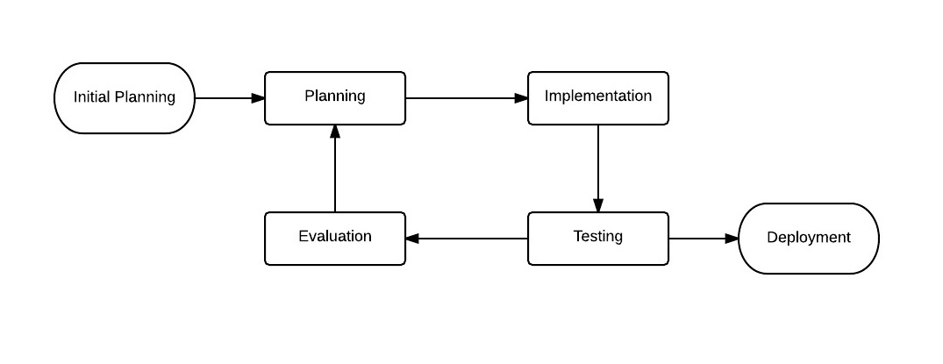

Agile Software Development Cycle

## 4.1 Description

The methodology to acquire knowledge for the knowledge base will involve interviewing with animal health experts and veterinarians. Next, literature review for animal diseases will be done, with the help of the animal health experts and veterinarians. The knowledge gathered will be used for the knowledge base of the expert system. There will be constant communication with the animal health experts and veterinarians in order to improve the knowledge base rules.

## 4.2 Steps



The owner of the pet chooses whether the pet is a dog or cat. This is to determine which knowledge base the expert system is using. Next, ask preliminary questions about the animal, like gender, breed, height and weight, etc. Next, ask symptoms related to common diseases for the animal. Continue to ask questions based on the responses given by the owner until the expert system finds a probable diagnosis. Present the diagnosis to the owner and the veterinary for immediate action

## 4.3 Gantt Chart

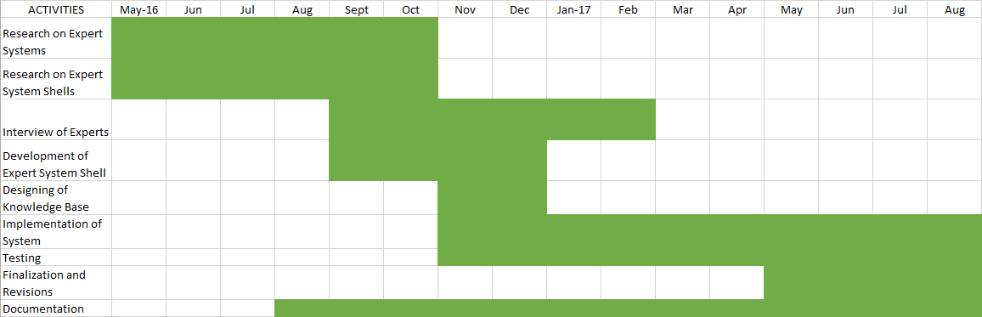

# Bibliography

Feng, X., Xiaoshuan, Z., Zetian, F., & Yun, Z. (2005, February 15). Pig-Vet: Web-Based Expert System For Pig Disease Diagnosis. *Livestock Environment VII, 18-20 May 2005, Beijing, China*. doi:10.13031/2013.18420

Li, D., Fu, Z., & Duan, Y. (2002, September 6). Fish-Expert: A web-based expert system for fish disease diagnosis. *Expert Systems with Applications,* *23*(3). doi:10.1016/s0957-4174(02)00050-7

Setyarini, E., Putra, D., & Purnawan, A. (2013, January). The Analysis of Comparison of Expert System of Diagnosing Dog Disease by Certainty Factor Method and Dempster-Shafer Method. *IJCSI International Journal of Computer Science Issues, Vol. 10, Issue 1, No 2, January 2013,* 576-584.

telemedicine. (n.d.) Mosby's Medical Dictionary, 8th edition. (2009). Retrieved August 26 2016 from <http://medical-dictionary.thefreedictionary.com/telemedicine>