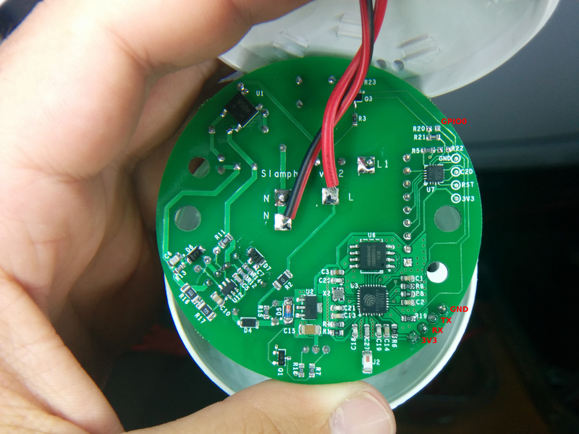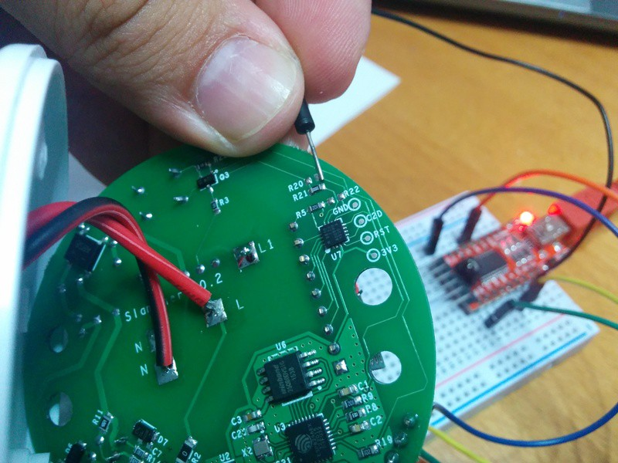

CLARIFICATION – the square pin is NOT ground – the square hole is 3v3.

If you wire your FTDI as per the wiring diagram below it should work.

The relay is controlled by GPIO12.

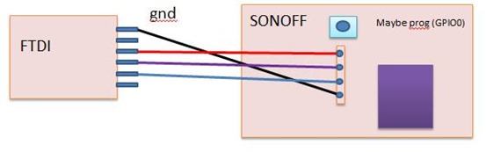

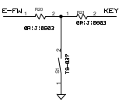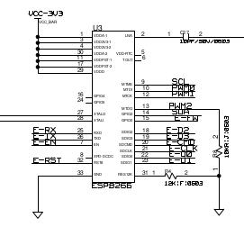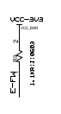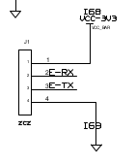

There is R20 that connects the GPIO0 to GND through switch S1 (See section A8 of the schematics), but R20 is missing in the board. That is why we can not boot the ESP8266 into programming mode. I assume R20 is a 0 ohms resistor (0R|J|0603), so I just soldered a small cable on the terminals where R20 is supposed to go, and that is it. Now you can flash the Slampher the same way as the Sonoff.

Relay = GPIO12;  
Led = GPIO13;  
Button = GPIO00;

**Hardware Preparation**

You need to make the serial programming interface of the Sonoff module / the ESP8266 microchip available. Examples are shown in in [Peter Scargill's blog](http://tech.scargill.net/itead-slampher-and-sonoff) or by [captain-slow.dk](http://captain-slow.dk/2016/05/22/replacing-the-itead-sonoff-firmware/). In most cases the pins are available on the PCB but connectors need to be soldered to allow interfacing. You'll furthermore need a **3.3V FTDI**

Relay is on GPIO12

**USB-to-Serial Converter/Programmer**.

The following table shows the connection for most Sonoff modules:

| **Sonoff** | **Programmer** |
| --- | --- |
| 1 (VCC) | 3V3 |
| 2 (RX) | TX |
| 3 (TX) | RX |
| 4 (GND) | GND |

### **Bringing the Module in Flash Mode**

The "brain" of the Sonoff Module (normally the ESP8266) needs to be put into Flash Mode. This is done, by pulling the GPIO0 pin to GND while the chip is booting. On most modules the installed control button is connected to GPIO0 and GND, making entering Flash Mode very easy. On other modules you will need to connect pins on the PCB.

To bring a Sonoff module into Flash Mode:

1. Disconnect serial programmer and power)
2. Connect GPIO0 and GND (e.g. Press the button)
3. Connect serial programmer
4. Release GPIO0 (after one-two seconds)

**Basic wiring**

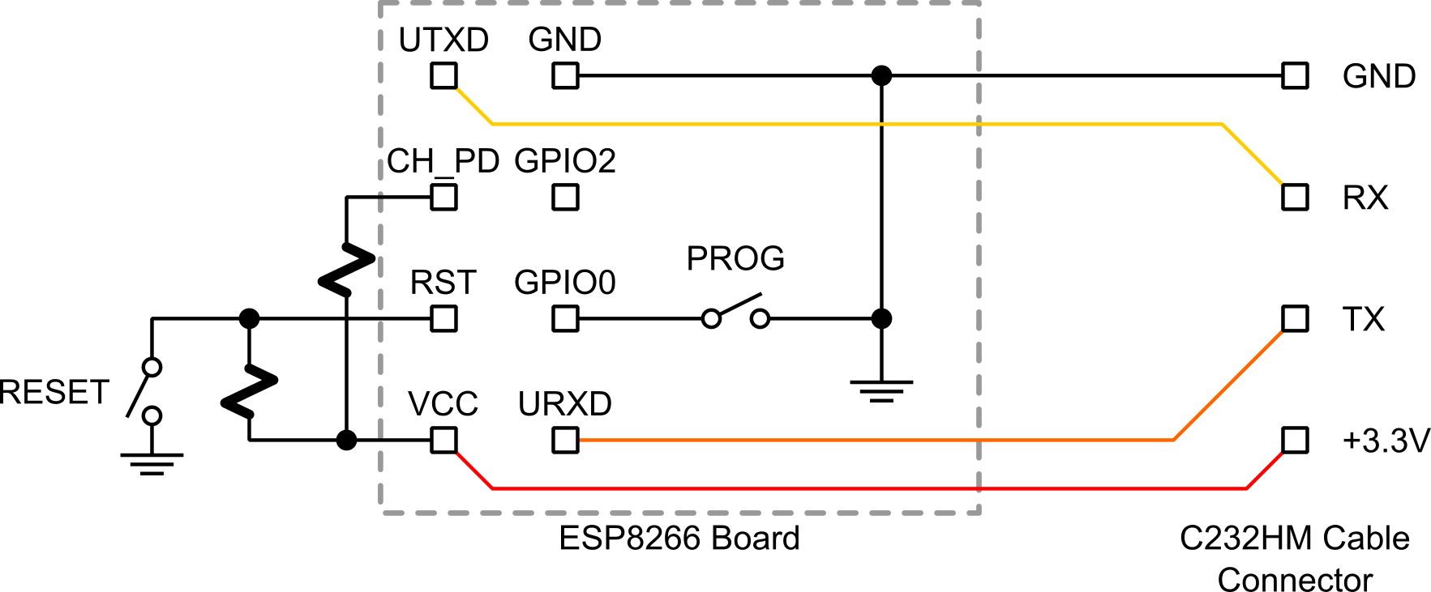

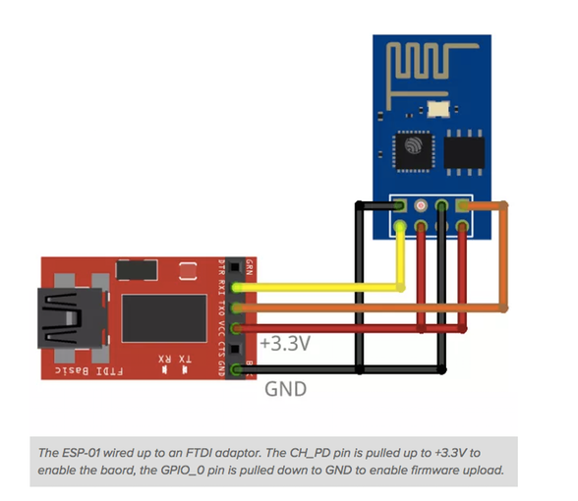

ESP01-USB converter

This module is an USB adapter / programmer for ESP8266 modules of type ESP-01. It is conveniently fitted with a 2x4P 2.54mm female header to plug the ESP01 (according to illustration picture 2) and configure or run it right away. A large 1000μF cap will help getting a steady 5.0V VCC from the USB bus and jumper (on the right of the 2x4P header) will help configuring the GPIO0 line according needs. The module is based on the USB-UART bridge CH340 from WCH which is compatible with all platforms.

