Basic Queries: SELECT, WHERE, ORDER BY, LIMIT

Q. What products do we sell and at what price?

SELECT product_name,
list_price AS selling_price,
standard_cost AS cost_price,
(list_price - standard_cost) AS profit,
category
FROM products
ORDER BY profit DESC;

Outcome:
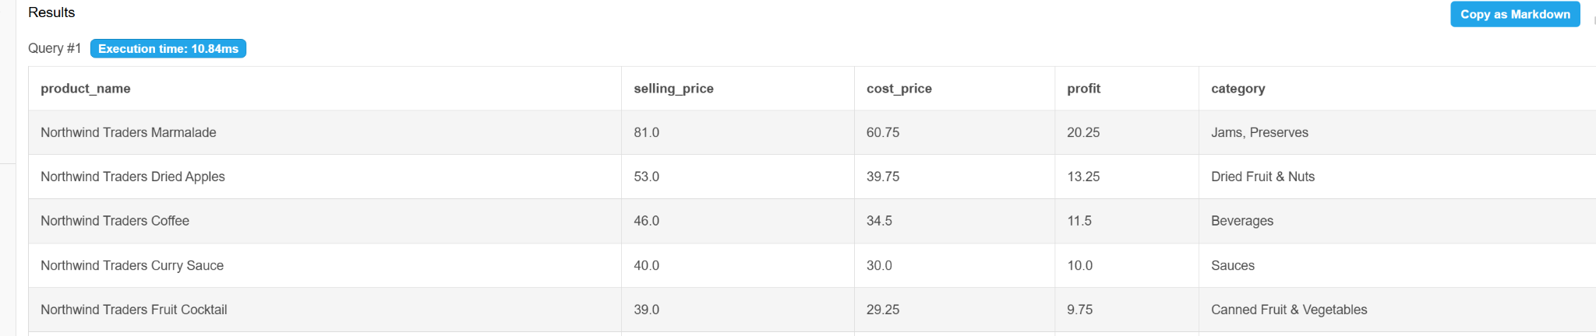

Overview:- Marmalade is our highest profit product followed by Dried Apples and Coffee

Q. Which products cost more than $50?

SELECT product_name,
list_price,
category
FROM products
WHERE list_price > 50
ORDER BY list_price DESC;

Outcome:
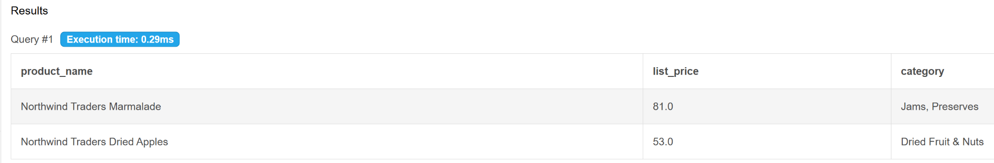
Overview:Products costing more than 50 dollars are also our highest profit products.

Q. Show all customers from the USA:
SELECT CONCAT(first_name, ' ' , last_name) AS customer_name,
company,
city,
state_province
FROM customers
WHERE country_region ='USA';

Outcome:
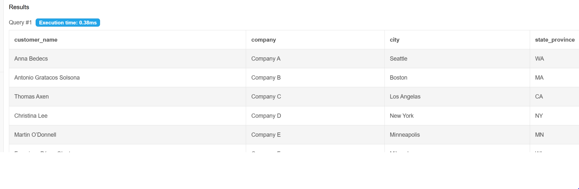
Overview: This outcome shows all customers from the USA.

Q. Show all orders placed in 2006.

SELECT *
FROM orders
WHERE YEAR(order_date) = 2006
ORDER BY order_date DESC;

Outcome:
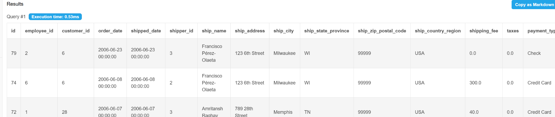
Overview: All 2006 order have been order by DESC order

Additional Q. Count total orders, compare sales with other years

SELECT COUNT(*) AS Total_Orders,
YEAR(order_date) AS order_year
FROM orders
GROUP BY YEAR(order_date)
ORDER BY order_year;

Outcome:
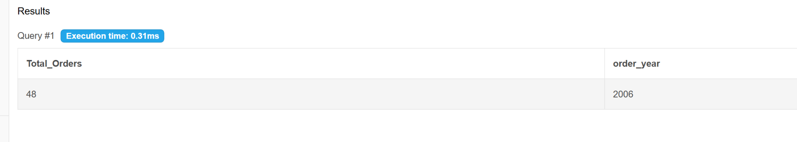
Overview: In dataset only 2006 year sell is available so we only get 1 year sell by total orders

Q. Find orders that have not been shipped yet (shipped_date is NULL).

SELECT *
from orders
WHERE shipped_date IS NULL
ORDER BY order_date DESC;

Outcome:
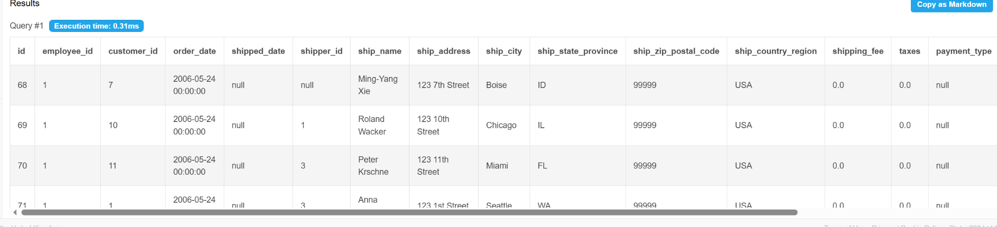

Overview: Shipped_date is set by null with DESC on order date

Q. Find discontinued products:

SELECT *
from products
WHERE discontinued = 1;

Outcome:
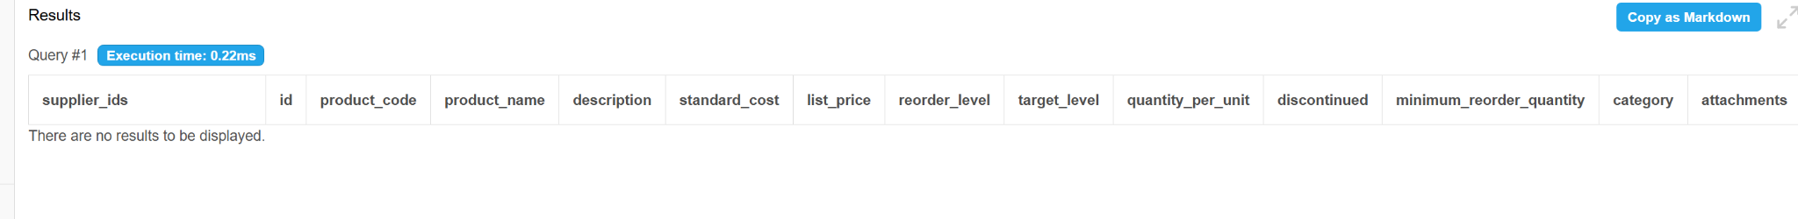
Overview: No products are discounted. This is a positive sign for business but can also indicate that nobody is looking at which products should be discontinued!

Aggregations: GROUP BY, HAVING, COUNT, SUM, AVG

Q. How many orders has each customer placed?

SELECT customer_id,
COUNT(*) as total_orders
FROM orders
GROUP BY customer_id
ORDER BY total_orders DESC;

Outcome:
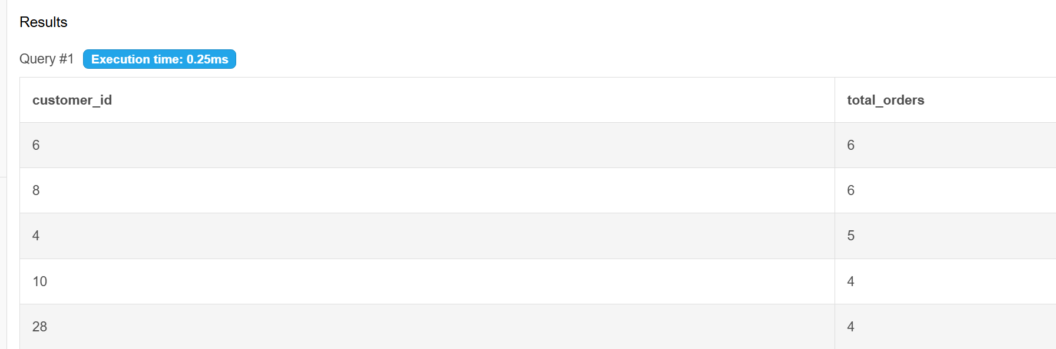

Overview: customer_id 6 and 8 have a highest total order

Q. How many products are in each category?
SELECT category,
COUNT(*) as num_products,
AVG(list_price) as avg_price,
MIN(list_price) as min_price,
MAX(list_price) as max_price
FROM products
GROUP BY category
ORDER BY num_products DESC;
Outcome:
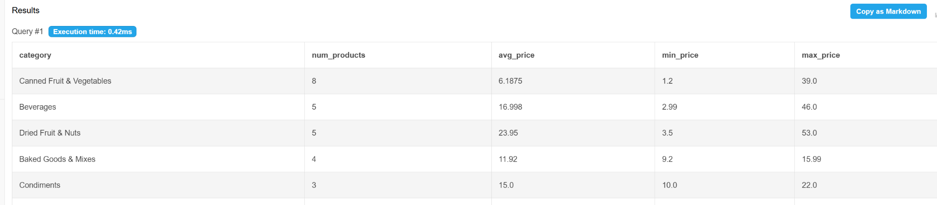
Overview: Canned fruit and vegetables are the highest number in category followed by Beverages

Q. Which countries do our customers come from, and how many per country?

SELECT country_region,
COUNT(*) AS num_customers
FROM customers
GROUP BY country_region
ORDER BY num_customers DESC;

Outcome:
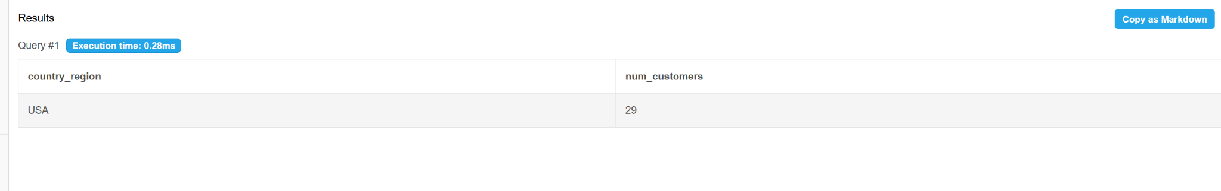
Overview: We have only USA customers so its display only this country’s customers with total Numbers.

Q. What is the average and total value of line items per product?

SELECT product_id,
COUNT(*),
SUM(quantity),
AVG(unit_price)
FROM order_details
GROUP BY product_id
ORDER BY AVG(unit_price) DESC;

Outcome:
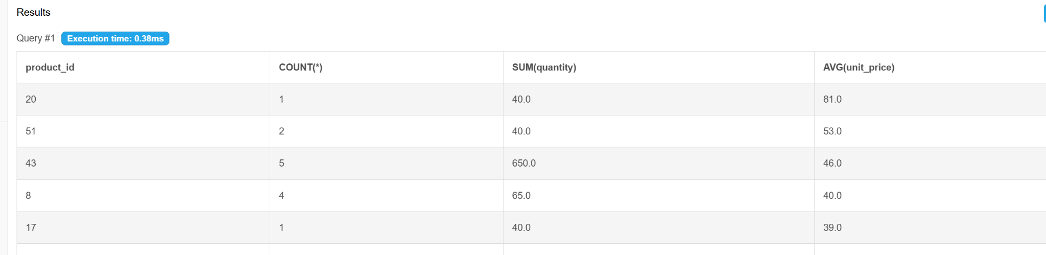

Overview: Product_id 20 and 51 have highest average price

JOINS: Multi-Table Analysis

Q. Show each order with the customer's name and company.

SELECT o.id as order_id,
CONCAT(c.first_name, ' ', c.last_name) AS customer_name,
c.company,
c.country_region,
o.order_date,
o.shipping_fee
FROM orders o
JOIN customers c
ON o.customer_id = c.id;

Outcome:

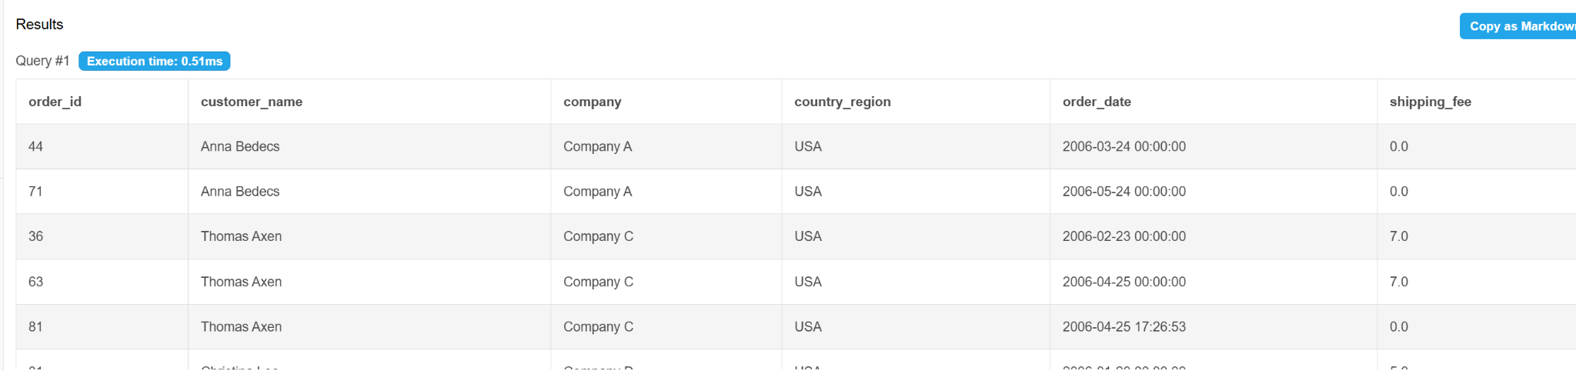
Overview: Tables shows the customer name and company

Q. Which products have never been ordered?
HINT: Left Join
SELECT products.product_name,
products.category,
products.discontinued
FROM products
LEFT JOIN order_details
ON products.id = order_details.product_id
WHERE order_details.product_id IS NULL;

Outcome:
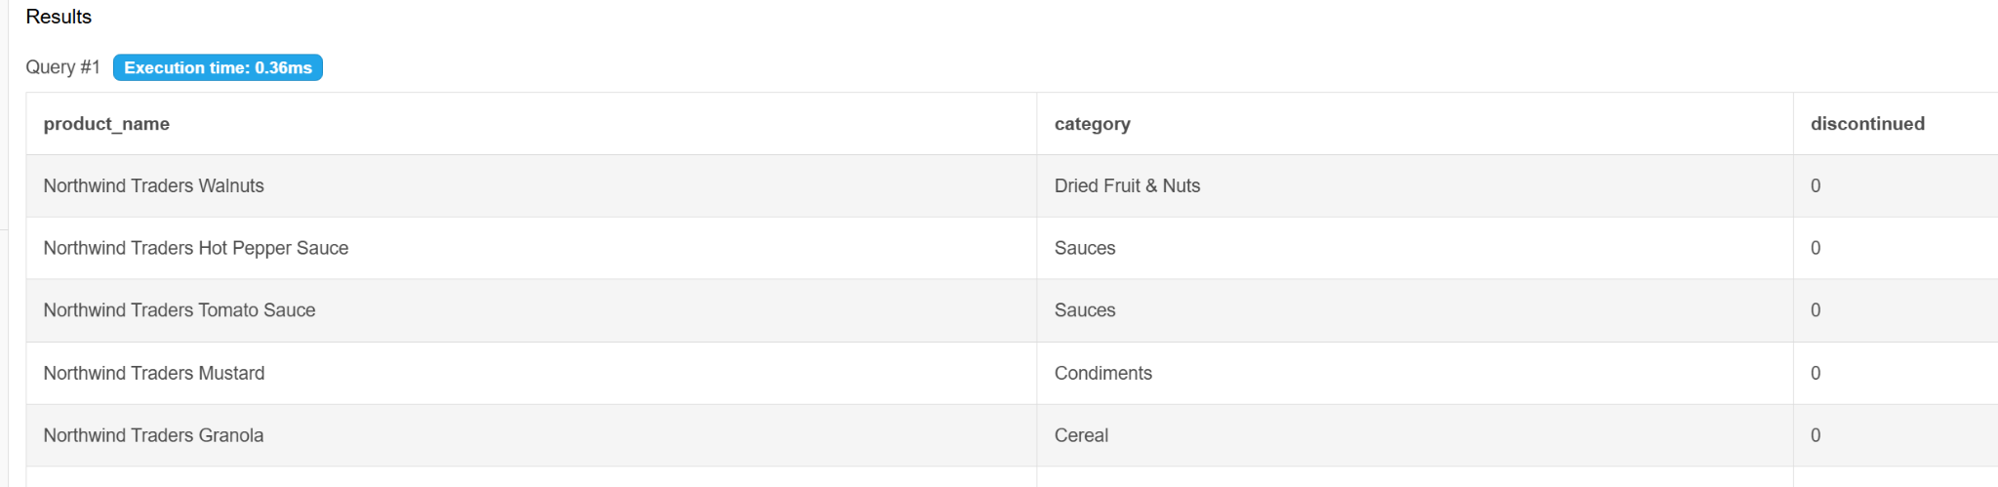
Overview: Northwind Traders Walnuts, Northwind Traders Hot Pepper Sauce are never been ordered

Q. Which suppliers provide the most products?

SELECT suppliers.id, COUNT(products.id)
FROM suppliers LEFT JOIN products
ON suppliers.id = products.supplier_ids
GROUP BY suppliers.id
ORDER BY COUNT(products.id) DESC;

Outcome:
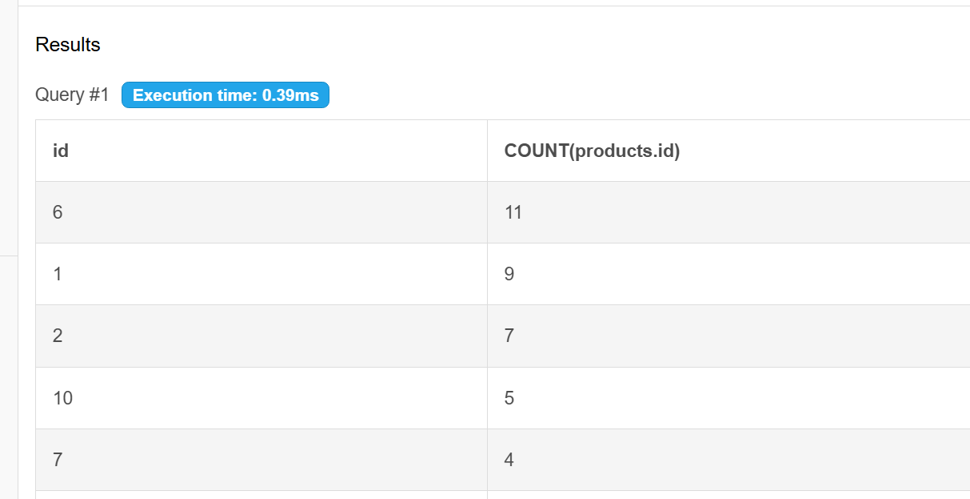

Overview: Customer_id 6 provides the most of goods

Q. Which products are the best sellers by revenue?

SELECT p.product_name,
p.category,
COUNT(od.id) AS times_ordered,
SUM(od.quantity) AS units_sold,
ROUND(SUM(od.unit_price * od.quantity * (1 - od.discount)), 2) AS revenue
FROM products p
JOIN order_details od ON p.id = od.product_id
GROUP BY p.id
ORDER BY revenue DESC
LIMIT 15;

Outcome:
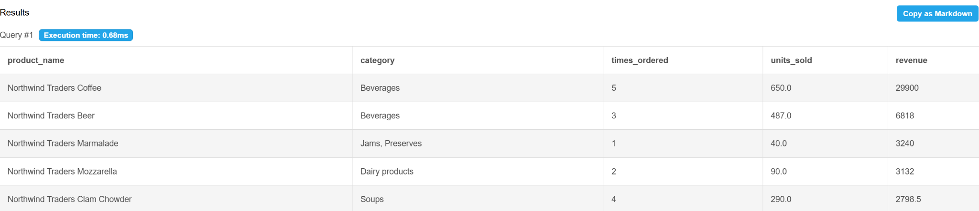
Overview: Northwind traders Coffee and Beer have a highest revenue.

Subqueries

Q. Find products priced above the average price in their category:

SELECT product_name, list_price,
(SELECT AVG(list_price)
FROM products) AS avg_price
FROM products
WHERE list_price > (SELECT AVG(list_price) FROM products)
ORDER by list_price DESC;

Outcome:
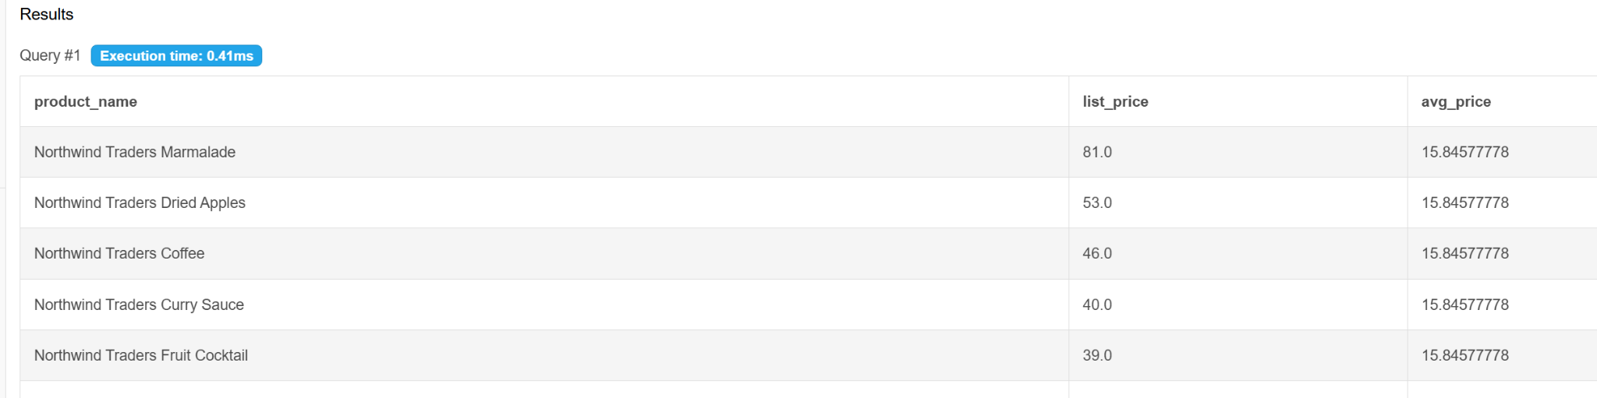
Overview: Northwind Traders Marmalade has a priced in their average price

