**Loading the Dataset**

import pandas as pd

# Load the dataset

df = pd.read_csv('ecommerce_data.csv')

# Print the first few rows to verify the data has been loaded correctly

print(df.head())

**Dataset**

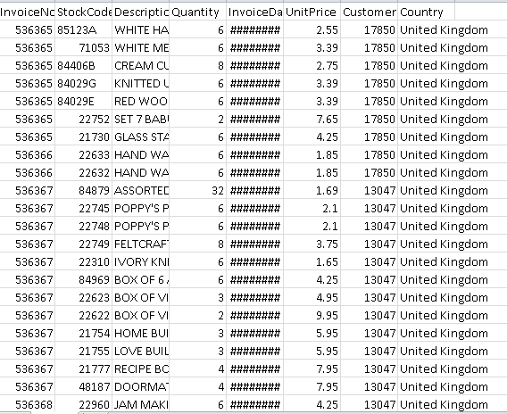

**Preprocessing**

import pandas as pd

from sklearn.preprocessing import StandardScaler

from sklearn.model_selection import train_test_split

# Assuming 'df' is your DataFrame

# Step 1: Handling Missing Values

df.fillna(df.mean(), inplace=True)

# Step 2: Handling Categorical Data (One-Hot Encoding)

df = pd.get_dummies(df, columns=['categorical_column'])

# Step 3: Feature Scaling

scaler = StandardScaler()

df[['numerical_column1', 'numerical_column2']] = scaler.fit_transform(df[['numerical_column1', 'numerical_column2']])

# Step 8: Splitting Data

X = df.drop('target_variable', axis=1)

y = df['target_variable']

X_train, X_test, y_train, y_test = train_test_split(X, y, test_size=0.2, random_state=42)

**Challenges faced by IBM e-commerce**

**Platform Complexity:**

Understanding the intricacies of the cloud platform, including deployment, services, and configurations, can be challenging for those new to the environment.

**Service Integration:**

Integrating various services (e.g., databases, caching, authentication) with the application and ensuring they work seamlessly can be complex.

**Scalability and Performance:**

Designing the application to handle high traffic loads and ensuring it scales efficiently can be challenging, especially during peak times.

**Security Concerns:**

Ensuring the application is secure and protected against common web vulnerabilities like SQL injection, cross-site scripting, and others is crucial.

**Data Management:**

Handling data effectively, including storage, retrieval, and management of user information, products, orders, etc., can be a significant challenge.

**User Authentication and Authorization:**

Implementing secure and user-friendly authentication and authorization mechanisms is crucial to protect user accounts and sensitive information.

**Payment Processing:**

Integrating a secure and reliable payment gateway while ensuring compliance with payment industry standards can be complex.

**User Experience (UX) and Interface Design:**

Designing an intuitive and visually appealing user interface that offers a smooth user experience can be a significant challenge.

**Cross-Browser Compatibility:**

Ensuring the application functions correctly across different web browsers and devices can be challenging due to varying levels of compatibility.

**Regulatory Compliance:**

Adhering to legal and regulatory requirements, especially concerning data privacy and security (e.g., GDPR, HIPAA), can be complex and time-consuming.

**Testing and Quality Assurance:**

Rigorous testing for functionality, security, and performance is essential, and setting up automated testing suites can be challenging.

**Documentation and Knowledge Transfer:**

Maintaining comprehensive documentation for the application's architecture, deployment process, and codebase can be overlooked but is crucial for future development and maintenance.