Dev Ops

Dev Ops is neither a technology nor a tools, it is a concept which helps development team and Operation team (production team) to communicate to develop & deploy the applications, these teams would use some tools to develop & deploy

* Git: Version controlling
* Jenkins/Bamboo: CI - CD pipeline
* Docker: It is a container that can ship your application to any environment
* AWS: Cloud system where you deploy the application

Git:

It is centralized version controlling system, used to share and collaborate other people work, Git provides a Repository where you can have all your work, the repository will track all the changes each person does with some unique id i.e., called as snapshot will have hash number.

If you use GIT you can get updates done on any time, i.e., if developers had written some code and updated the GIT later they write more lines of code & feel that the old code is required, then they can get that old code back if its committed.

Git has many commands

git init: To create local repository

git pull: To pull the changes to local repo from the remote repo

git push: To push the local changes to the remove repo

git branch branchName: To create a new branch

git checkout branchName: To get inside the branch

git merge destinationBranchName: To merge the destinationBranch with the currently checked in branch

git add: to add the changes that needs to be committed

git commit: to commit the changes

git log: To see history of commits

git clone: To clone the remote repository

Ground Rules when you are working in GIT

1. Create a custom branch if you want to update your repository, even a small modification also you have to do in custom branch not in the master branch
2. From local repository push the custom branch to the remote repository not the master branch
3. In Remote repository merge the master with the custom branch, if git doesn’t give conflict error you are free to merge, if you get a conflict close the merge request and update the local repository with the remote repository through pull request
4. Merge the remote repository changes with local repository changes if there’s a conflict using pull command and then push the changes to the remote.

There are two ways you can create local repository in GIT

1. git clone: Creates local repository from remote repository, it will have link to the remote by default
2. git init: Creates local repository manually, but will not have link to the remote repository by default, you must link it through some git command.

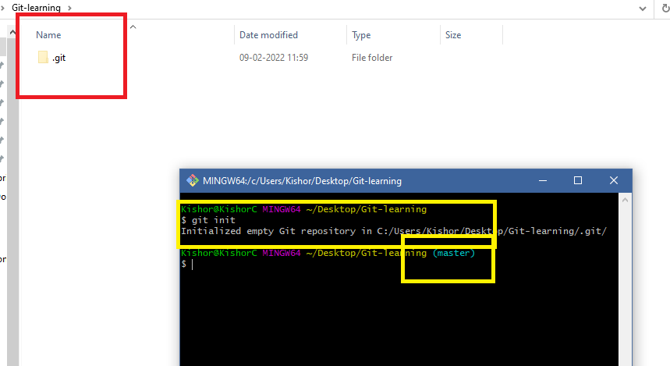

By default you have a branch called master branch.

Important commands

git branch branchName

git checkout branchName

git merge branchName

git pull

git push -u origin branchName

git branch -d branchName: Deletes the branch

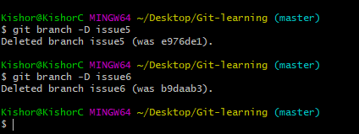

When conflicts to occur

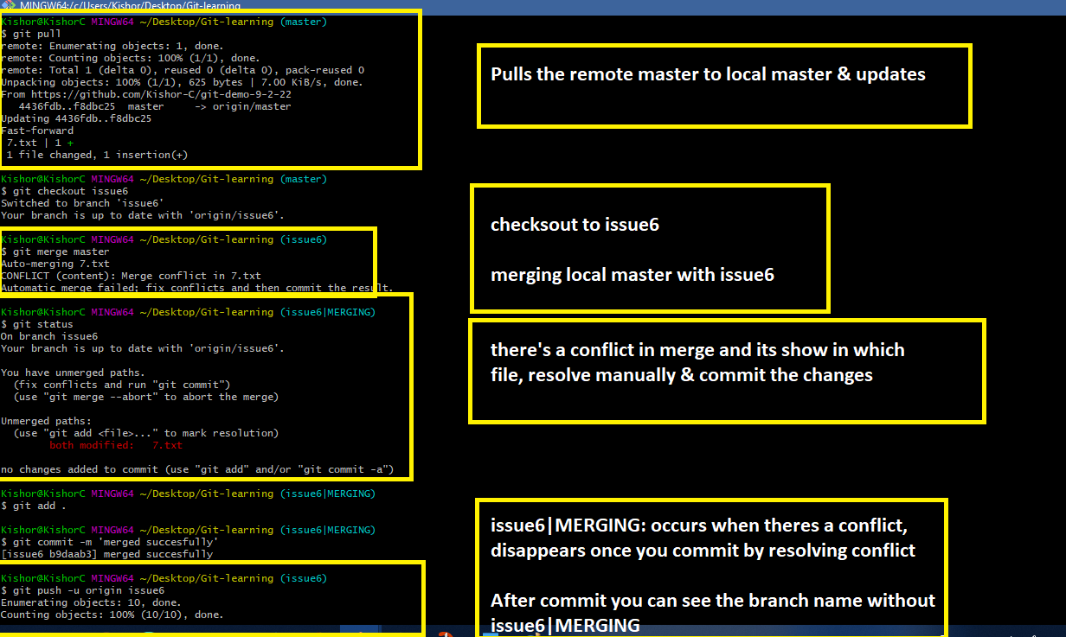

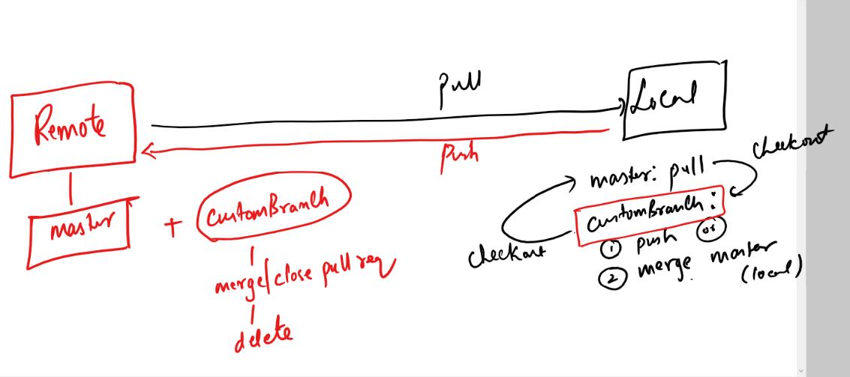

Git Organization:

Here you can create a repository where multiple members can collaborate to the project

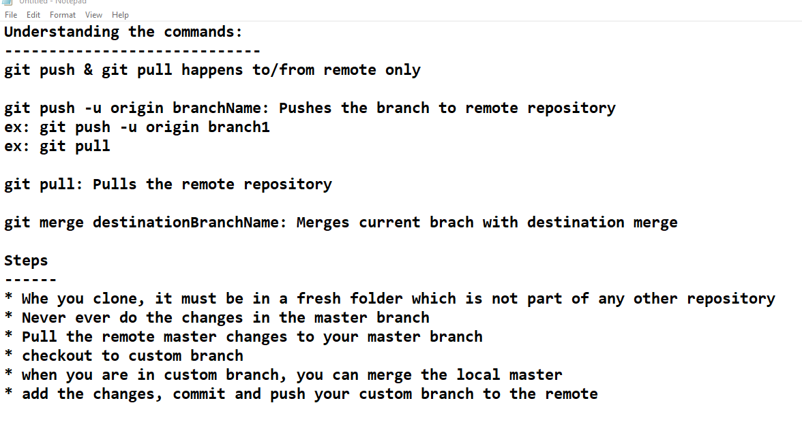

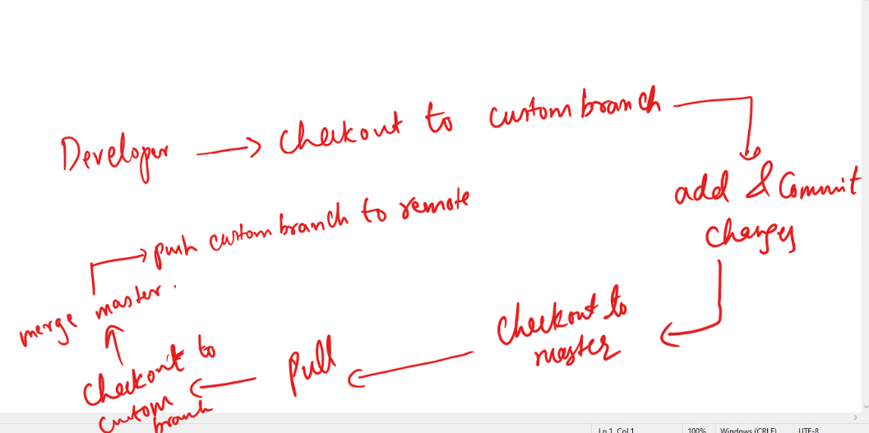

AWS

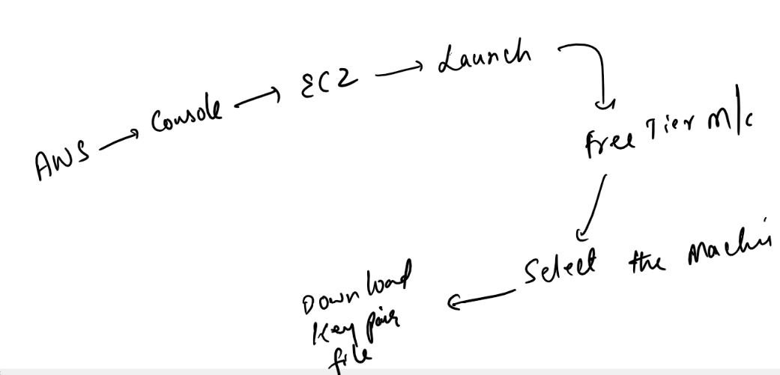

How to install git in AWS EC2 linux

>> sudo yum install git -y

How to install java in AWS EC2 linux

>> sudo yum install java-1.8.0-devel -y

You can create an executable jar and run on your aws ec2, firstly you must push the jar to the git from your local machine, then you need to pull the jar from git from the cloud machine

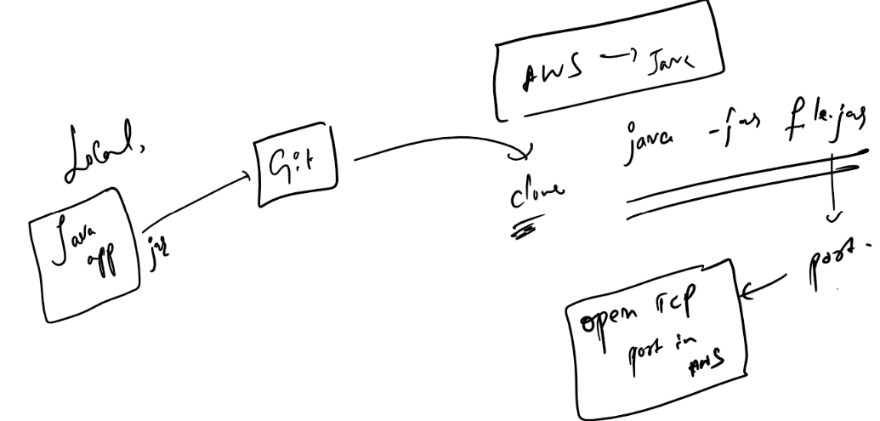

Note: AWS machines port are not available to public by default, hence you must configure TCP port in the security of the AWS instance to access that port.

