Write a JDBC program to retrieve all the data from the contacts table.

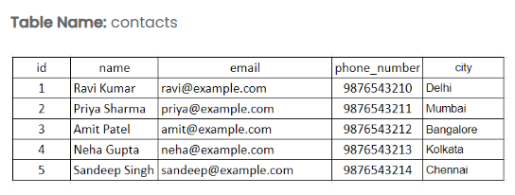

Note: All Records are Prepopulated.
Input format :
No console input
Output format :
The output should display the contact details as shown in the sample output.
Sample test cases :
Input 1 :
Output 1 :
ID: 1, Name: Ravi Kumar, Email: ravi@example.com, Phone Number: 9876543210, City: Delhi
ID: 2, Name: Priya Sharma, Email: priya@example.com, Phone Number: 9876543211, City: Mumbai
ID: 3, Name: Amit Patel, Email: amit@example.com, Phone Number: 9876543212, City: Bangalore
ID: 4, Name: Neha Gupta, Email: neha@example.com, Phone Number: 9876543213, City: Kolkata
ID: 5, Name: Sandeep Singh, Email: sandeep@example.com, Phone Number: 9876543214, City: Chennai
Note :
The program will be evaluated only after the “Submit Code” is clicked.
Extra spaces and new line characters in the program output will result in the failure of the test case.

