Single File Programming Question
Write a JDBC Program to get the 2nd row from the "contacts" table using ResultSet interface methods.

Table Name: contacts
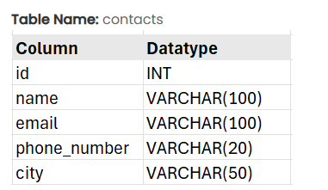
Note: All records are prepopulated.
Input format :
No console input
Output format :
The output should display the second row from the table.
Sample test cases :
Input 1 :
Output 1 :
ID: 2, Name: Priya Sharma, Email: priya@example.com, Phone Number: 9876543211, City: Mumbai
Note :
The program will be evaluated only after the “Submit Code” is clicked.
Extra spaces and new line characters in the program output will result in the failure of the test case.

