Single File Programming Question
Write a Java (JDBC) program to connect with the MySQL database, insert the given data in the table, and display the employee details.
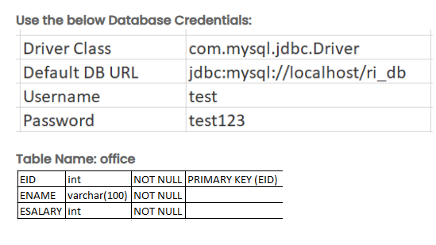
Note:
Utilize try/catch and finally block to handle the SQLException.
The table name is case-sensitive and must match the one specified above.
Input format :
The first line of the input consists of a number of employees in the first line.
EID, ENAME, ESALARY in the next consecutive lines.
Refer to the sample input.
Output format :
Displays office table details.
Refer to the sample output for reference.
Sample test cases :
Input 1 :
3
101
Ashwin
10000
102
Kumar
20000
103
amore
30000
Output 1 :
Database connected successfully.
101 Ashwin 10000
102 Kumar 20000
103 amore 30000
Connection closed successfully.
Note :
The program will be evaluated only after the “Submit Code” is clicked.
Extra spaces and new line characters in the program output will result in the failure of the test case.

