Write a Java (JDBC) program to insert student details into a table and display the inserted details and the total number of rows affected.

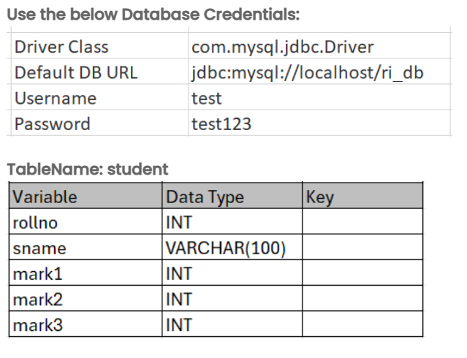

Note:
Utilize try/catch and finally block to handle the SQLException.
The table name is case-sensitive and must match the one specified above.
Input format :
The number of students (integer) on the first line.
For each student:
- Roll number (integer)
- Name (string)
- Marks of three subjects (three integers, one for each line)
Output format :
"Database connected successfully."
For each student inserted:
- "Roll No: [roll number]"
- "Name: [name]"
- "Marks1: [marks of subject 1]"
- "Marks2: [marks of subject 2]"
- "Marks3: [marks of subject 3]"
Total number of rows inserted (an integer).
"Connection closed successfully."
Sample test cases :
Input 1 :
2
1234567
Babu
37
89
98
1001
Moni
90
87
44
Output 1 :
Database connected successfully.
Roll No: 1234567
Name: Babu
Marks1: 37
Marks2: 89
Marks3: 98
Roll No: 1001
Name: Moni
Marks1: 90
Marks2: 87
Marks3: 44
2
Connection closed successfully.
Input 2 :
3
7840534
Babu
37
89
98
6849906
Moni
90
87
44
179596
Mona
60
47
94
Output 2 :
Database connected successfully.
Roll No: 7840534
Name: Babu
Marks1: 37
Marks2: 89
Marks3: 98
Roll No: 6849906
Name: Moni
Marks1: 90
Marks2: 87
Marks3: 44
Roll No: 179596
Name: Mona
Marks1: 60
Marks2: 47
Marks3: 94
3
Connection closed successfully.
Note :
The program will be evaluated only after the “Submit Code” is clicked.
Extra spaces and new line characters in the program output will result in the failure of the test case.

