Write a Java (JDBC) program to connect to a MySQL database and print all the employee details who have salaries greater than or equal to a given input.

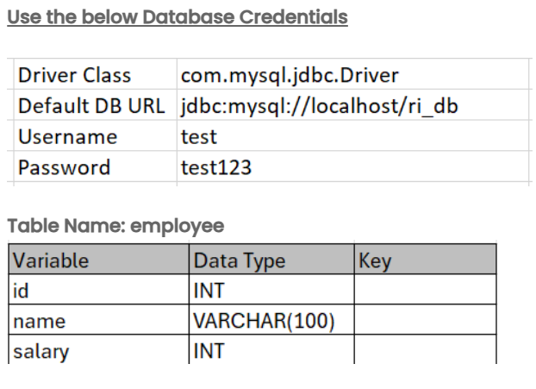

Note:
- Utilize try/catch and finally blocks to handle SQLException.
- The table name is case-sensitive and must match the one specified above.
- All records in the table are prepopulated.
Input format :
- The input consists of a double value that represents the salary.
Output format :
- The output prints the respective employee details.
- If no employee meets the criteria, print "No records found for the given salary threshold."

Refer to the sample output for formatting specifications.
Sample test cases :
Input 1 :
25000
Output 1 :
Database connected successfully.
1 Alice 40000.0
2 Bob 35000.0
4 Darvin 28000.0
5 Embella 25000.0
Connection closed successfully.
Input 2 :
55000
Output 2 :
Database connected successfully.
No records found for the given salary threshold.
Connection closed successfully.
Note :
The program will be evaluated only after the “Submit Code” is clicked.
Extra spaces and new line characters in the program output will result in the failure of the test case.

