Loan data Management
You are tasked with developing a Java application to manage loan data using JDBC and MySQL. The application should allow users to perform CRUD (Create, Read, Update, Delete) operations on the loan data stored in the database.

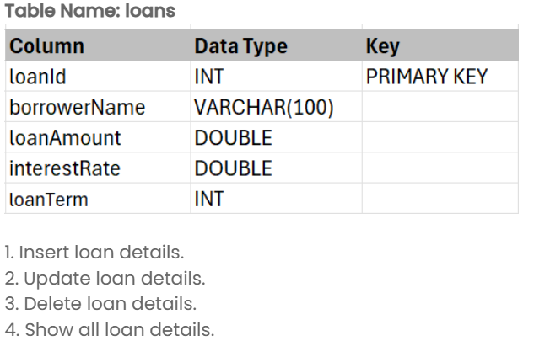
NOTE:
Utilize try/catch and finally block to handle the SQLException.
﻿The table name is case-sensitive and must match the one specified above.
The Table is created and some tuples have been already inserted into the table.
id range is between 1001 to 1005.
Input format :
The input consists of a number representing the CRUD operation like
1 - Inserting (the input should be of all attributes)
2 - Update (update the interestrate based on loanId)
3 - Delete
4 - Show all details
Output format :
The output should perform all the crud operations based on Menu driven.
Sample test cases :
Input 1 :
1
1006
Frank Taylor
80000.00
4.1
12
Output 1 :
Loan added successfully.
Loan ID: 1001, Borrower Name: Alice Johnson, Loan Amount: 50000.0, Interest Rate: 3.5%, Loan Term: 5 years
Loan ID: 1002, Borrower Name: Bob Smith, Loan Amount: 75000.0, Interest Rate: 4.0%, Loan Term: 10 years
Loan ID: 1003, Borrower Name: Catherine Brown, Loan Amount: 120000.0, Interest Rate: 3.75%, Loan Term: 15 years
Loan ID: 1004, Borrower Name: David Wilson, Loan Amount: 90000.0, Interest Rate: 4.25%, Loan Term: 20 years
Loan ID: 1005, Borrower Name: Evelyn Clark, Loan Amount: 65000.0, Interest Rate: 3.9%, Loan Term: 7 years
Loan ID: 1006, Borrower Name: Frank Taylor, Loan Amount: 80000.0, Interest Rate: 4.1%, Loan Term: 12 years
Input 2 :
2
1001
4.1
Output 2 :
Loan updated successfully.
Loan ID: 1001, Borrower Name: Alice Johnson, Loan Amount: 50000.0, Interest Rate: 4.1%, Loan Term: 5 years
Loan ID: 1002, Borrower Name: Bob Smith, Loan Amount: 75000.0, Interest Rate: 4.0%, Loan Term: 10 years
Loan ID: 1003, Borrower Name: Catherine Brown, Loan Amount: 120000.0, Interest Rate: 3.75%, Loan Term: 15 years
Loan ID: 1004, Borrower Name: David Wilson, Loan Amount: 90000.0, Interest Rate: 4.25%, Loan Term: 20 years
Loan ID: 1005, Borrower Name: Evelyn Clark, Loan Amount: 65000.0, Interest Rate: 3.9%, Loan Term: 7 years
Input 3 :
3
1001
Output 3 :
Loan deleted successfully.
Loan ID: 1002, Borrower Name: Bob Smith, Loan Amount: 75000.0, Interest Rate: 4.0%, Loan Term: 10 years
Loan ID: 1003, Borrower Name: Catherine Brown, Loan Amount: 120000.0, Interest Rate: 3.75%, Loan Term: 15 years
Loan ID: 1004, Borrower Name: David Wilson, Loan Amount: 90000.0, Interest Rate: 4.25%, Loan Term: 20 years
Loan ID: 1005, Borrower Name: Evelyn Clark, Loan Amount: 65000.0, Interest Rate: 3.9%, Loan Term: 7 years
Input 4 :
4
Output 4 :
Loan ID: 1001, Borrower Name: Alice Johnson, Loan Amount: 50000.0, Interest Rate: 3.5%, Loan Term: 5 years
Loan ID: 1002, Borrower Name: Bob Smith, Loan Amount: 75000.0, Interest Rate: 4.0%, Loan Term: 10 years
Loan ID: 1003, Borrower Name: Catherine Brown, Loan Amount: 120000.0, Interest Rate: 3.75%, Loan Term: 15 years
Loan ID: 1004, Borrower Name: David Wilson, Loan Amount: 90000.0, Interest Rate: 4.25%, Loan Term: 20 years
Loan ID: 1005, Borrower Name: Evelyn Clark, Loan Amount: 65000.0, Interest Rate: 3.9%, Loan Term: 7 years
Note :
The program will be evaluated only after the “Submit Code” is clicked.
Extra spaces and new line characters in the program output will result in the failure of the test case.

