REST - JAXRS & Jersey
UI - OJET, Javascript, Typescript, React
Unix
Devops
Docker & Kubernetes
+ Project

Rest webservices using JAXRS & Jersey
REST Webservices
- Spring REST - Ecosystem - heavy weight - jar/war (250-300) -> AWS - 10$
- JAX-RS - Java EE / JakartaEE - Apache, Weblogic, Websphere - lightweight - (50 - 80) -> AWS - 5$
REST principles
Protocol - HTTP
Datatstructure - JSON / XML / TEXT
URI - name the resource
Implementing REST Webservices using JAX-RS (Specification) & Jersey is an implementation of JAX-RS
Spring REST | Jax-RS
@RestController, @RequestMapping(“path”) | @Path(“path”)
@GetMapping  @PostMapping  @PutMapping  @DeleteMapping  @PostMapping(consumes=MediaType.JSON)  @RequestBody  @PathVariable : {id} | @POST  @GET  @PUT  @DELETE  @Consumes(MediaType.JSON)  @Produces(MedaType.JSON)  @PathParam : {id}
JAX-RS Project Structure
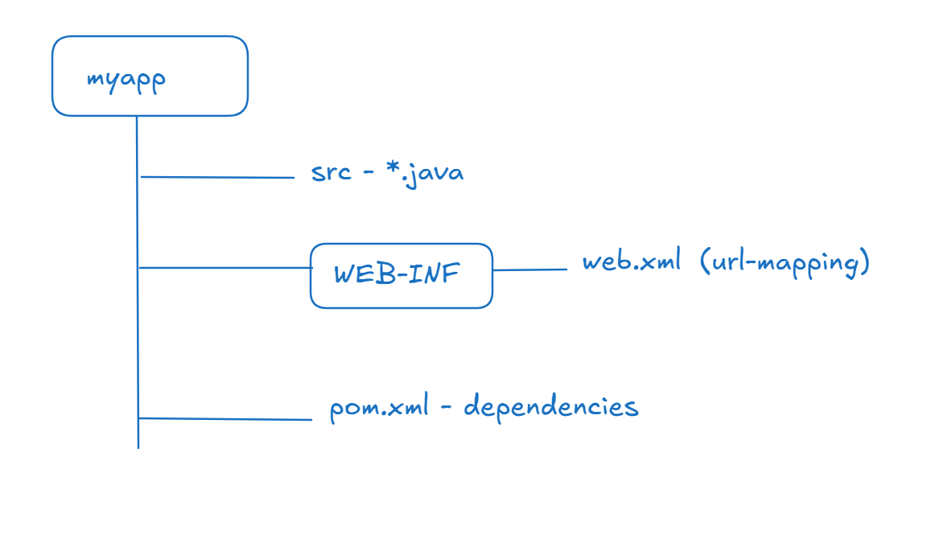
Setup
- JDK - 21/24/25
- Eclipse IDE
- Tomcat Server
Project Setup
File -> Dynamic Web Project -> Select web.xml -> Convert to Maven Project

How to share JSON data in JAX-RS
You must create a Java Class and use its object

Creating a service layer which will have business logics, since we are not using DB right now, we will maintain the business logic to handle the data in Collection - ArrayList

REST: Representational State Transfer
SOAP: Simple Object Access Protocol - it completely relies on XML based datastructure
Controller -> Service -> DAO -> Database
Steps to interact with the database
- Add ojdbc dependency if you are using oracle
- Create DAO layer and access it using service layer / Controller layer

New Features in Javascript / ES6 Features
ES stands for Ecma Script which is a specification for the Javascript, these new features has improved the syntax of the Javascript and has simplified how we write Javascript code.
- let, const, class, super, extends - keywords
- Template Strings - back tick character to create string
- Arrow functions - to simplify writing callback functions
- Rest & Spread parameters
- Destructuring
- Promises
- Generators
#Activity: Understand What is a promise and invoke the json place holder /users resource using fetch() function provided by Javascript that returns Promise, and display those data in the browser

What is a promise
It is an object that represents the data of the asynchronous operation, it may succeed or fail sometimes, to handle promise you need to use .then(callbackFn) for success and .catch(callbackFn) for errors.
fetch(URL): it is a built in function that returns promise

React.js - It is mainly used to create Single Page Applications with a reusable UI component
Single Page Applications - It will have only one page where you can do all the task, ex: Git Hub, Gmail, Facebook, Instagram
React.js allows you to only create Client side application not server side application, to access backend services, react uses HTTP API’s to call those backend services
Component: It is a reusable UI
ex: Profile pic in Instagram / facebook
How to create react application
There are 2 ways to create react application
npx create-react-app app-name: Toolkit provided by react community
npm create vite@latest app-name: Toolkit provided by vite community
State in components: These are component data which are like props but it is writable i.e., you can modify it, you must use this state whenever the data comes from the user or from the backend or if the component state changes
In react you get a built in function called as hook function i.e., useState();
let [name, setName] = useState(); or useState(“”) // the parameter is initial value
let [phone, setPhone] = useState();

