Kubernetes (K8S)
It is a container orchestration tool, it completely automates the container life cycle - scheduling the container, starting the container, stopping the container, scaling up and scaling down the container.
There are orchestration tools
- Docker Swarm -> You will get this when you install docker desktop
K8S architecture
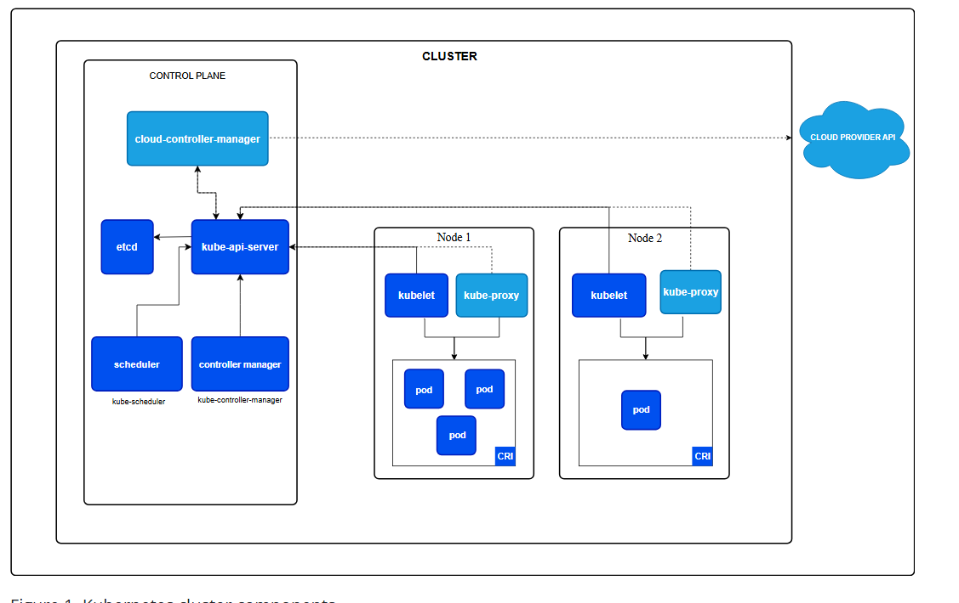
K8S architecture has
- Control Plane - Manages the Data Plane
- Data Plane - Worker Node - This is where VMs will be available where containers will be running
Control Plane you have components like
- Api - server -> Whenever operations team deploy any application, the request goes through API Server
- etcd -> It is a database that logs everything about the cluster, like when you deploy the application its meta data will be stored in etcd
- Scheduler -> It takes care of scheduling the containers -> when to start the container
- Controller Manager -> It constantly checks the worker node, if any pods crash then it immediately commands to start a new pod
Data Plane or Worker Node - Here the VMs will be running
- kubelet - it is an agent that commands the Container Runtime Environment to start the Pod
- kube-proxy - manages network between the pods -> communication between the pods
- Container Runtime Environment - Here the pods will be running
Kubernetes building blocks/Resources
- Pod
- ReplicaSet
- Service
  - ClusterIP
  - NodePort
  - Load Balancer
- Rolling updates and Rollback (These are not K8s resources)
Industries provide kubernetes cluster as a service provider
- AWS - EKS
- Google - GKE
- Microsoft - AKS
- Oracle - OKE
Note: We don’t need to manage the cluster, because it will be managed by the providers, as a DevOps engineer we must use kubectl which is a k8s client interface to deploy the application

