Market Place Hackathon

DAY 3 - API INTEGRATION AND DATA MIGRATION

17 | January | 2025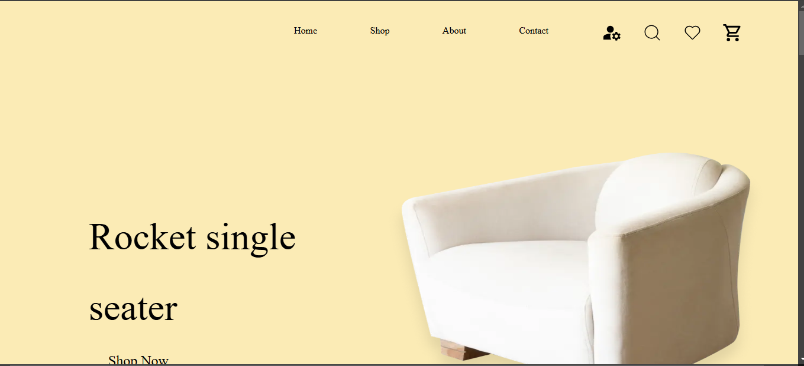

**Data fetching from API into Sanity dashboard**

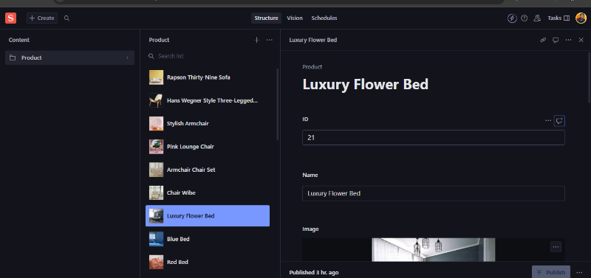

# How I fetched data in sanity from API

I have Tamplate 0 here is step by step in blow,

* Install sanity in my Next.JS project by commend
* Create schema for my products fields this is that schema blow,
* export default {
* name: 'product',
* title: 'Product',
* type: 'document',
* fields: [
* {
* name: 'id',
* title: 'ID',
* type: 'string',
* },
* {
* name: 'name',
* title: 'Name',
* type: 'string',
* },
* {
* name: 'image',
* title: 'Image',
* type: 'image',
* },
* {
* name: 'imagePath',
* title: 'Image Path',
* type: 'url',
* },
* {
* name: 'price',
* title: 'Price',
* type: 'number',
* },
* {
* name: 'description',
* title: 'Description',
* type: 'text',
* },
* {
* name: 'discountPercentage',
* title: 'Discount Percentage',
* type: 'number',
* },
* {
* name: 'isFeaturedProduct',
* title: 'Is Featured Product',
* type: 'boolean',
* },
* {
* name: 'stockLevel',
* title: 'Stock Level',
* type: 'number',
* },
* {
* name: 'category',
* title: 'Category',
* type: 'string',
* },
* ],
* };
* Then I fetch data by on specific file and its data fetching script code.

# How I fetched data for sanity to my Next.JS project

In Sanity studio I write query in vision section .

*[_type == 'product']

Then I write my fetching code in page

Then I apply tailwind CSS and manage my data .

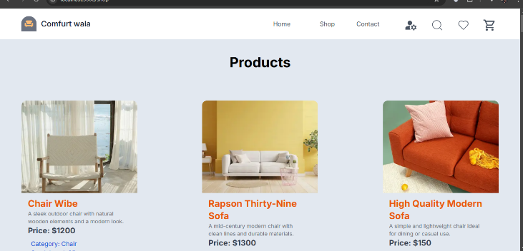

**Github: Repository link: https://github.com/Kishor-Kumar47/Marketplace-Technical-Foundation-General-E-Commerce.git**

Day 3 have been done Successfully

Kishor Kumar

GIAIC Id #: 00496110