DAY 4 - BUILDING DYNAMIC FRONTEND COMPONENTS FOR YOUR MARKETPLACE

Project Overview:

I have choose E-commerce website of furniture for my Market Place website that is template number 0.

* I have build responsive UI design . and also make it easy and clear.
* I want to help those people who want to buy furniture for home , wedding , offices , schools, hospitals, and other .
* My website is totally user friendly , and easy to handle.
* I also add Category section which shows everywhere at website so that user easily select their products.
* When user go to checkout page he is to sign in so that he prosed their order.
* I will use Authorization that user will access whole website with checkout.
* I have team for my business of furniture . they are fully skilled in physical furniture business.

1. Product Listing Component:

I have all components in my website that I need shown in screenshots,

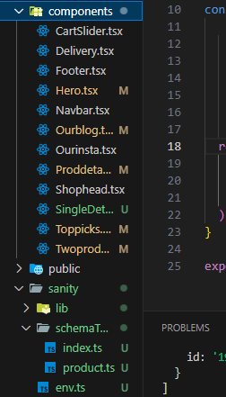

# There are Dynamic products,

In my all product section my all products are dynamic that is comes from sanity database.

I added field of all that I need just like,

* Name
* Image
* Description
* Category
* Stock
* Discount
* Id
* Price

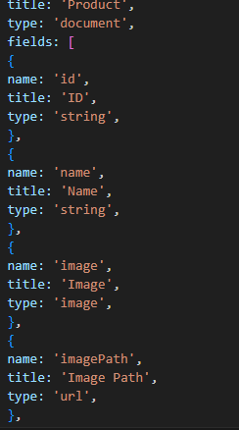

## 2. Product Detail Component:

I used dynamic product routing. When I click on specific product its open it details page where everything is defined in detailed .

Flieds:

* Name
* Image
* Description
* Category
* Stock
* Discount
* Id
* Price

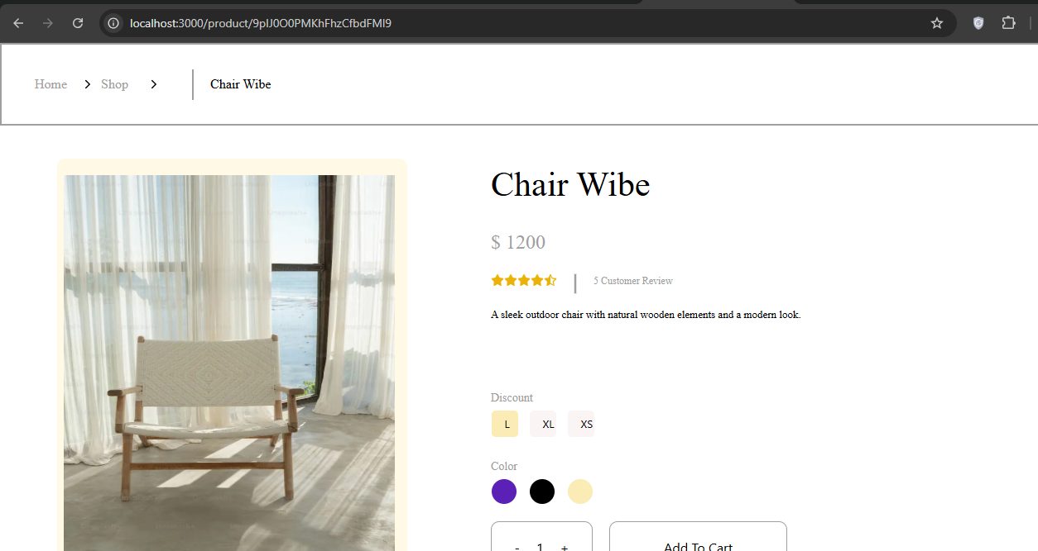

# Category Component:,

1. Now I am focusing on category section that is similar to navbar but change by functionality .
2. Their will some links of category that’s comes from sanity and when we will click on specific category it will show category related product.

Just like Bed, Chairs, etc.

# Search Bar:

I have use **Shadcn** to get search bar functionality just like when user like on search bar icon it will appears input their user enter product name or category.

# 6.Some other functionality:

I am use Cart functionality when user click add to cart button his product will added in cart section.

And I am also create whish list section their user can add his product favorite that he plan to buy in future.

I am creating user profile section their user can see his profile and purchases.

# 7.Review and Rating:

I am also adding review functionality their user rat product and add reviews

# 8.Footer and Header:

I also add header for user to navigate easily to any pages.

And footer for brand , and term and services and also for check policeis.

# 9.Notification:

I also use notify functionality when use add product to cart here appear notification added to cart.

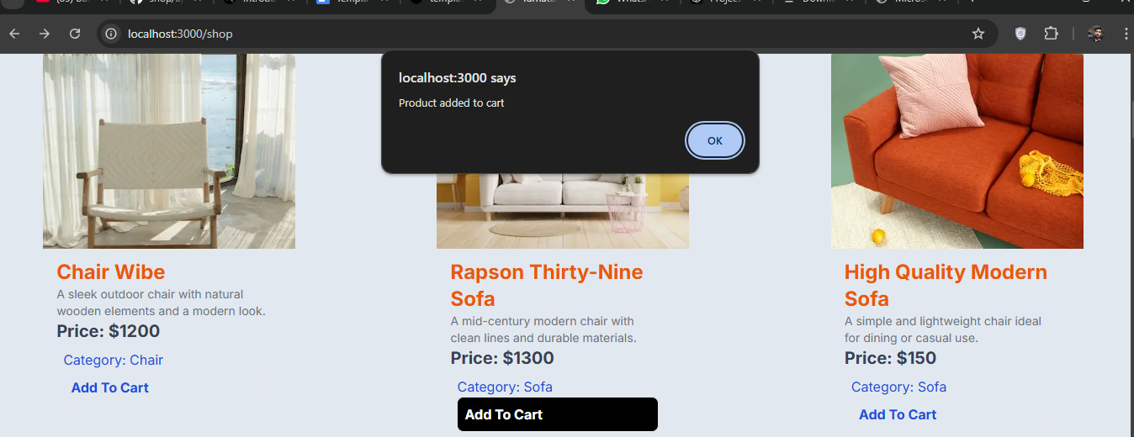

# 10. Analytics Dashboard Component:

I will analytics dashboard but I was not dynamic first slowly I make it dynamic.

Thire I will show product progress and it sales , order, and reaches.

# Some Screen shots of website parts:

Cart:

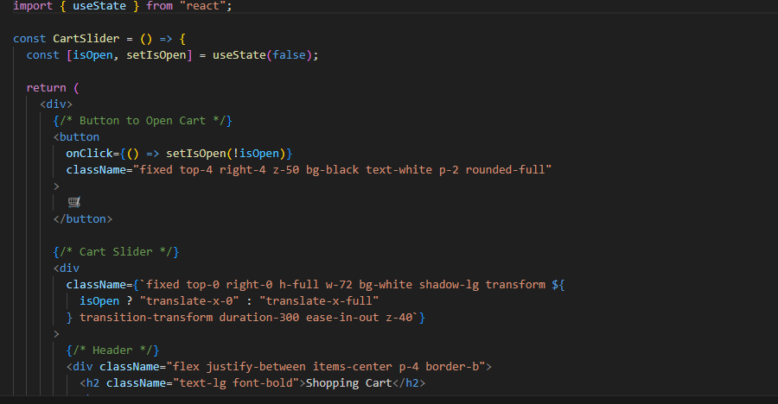

Product detailed page

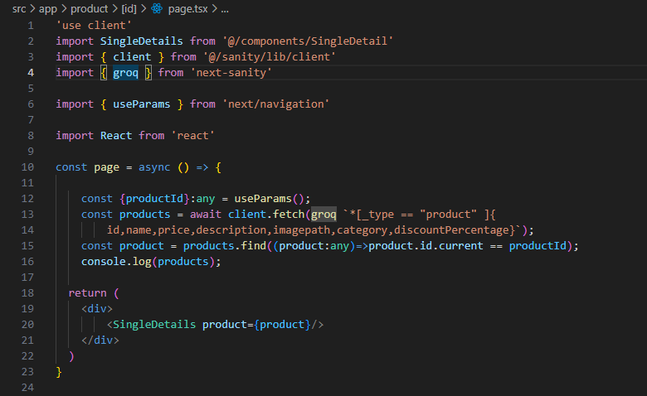

My pages :

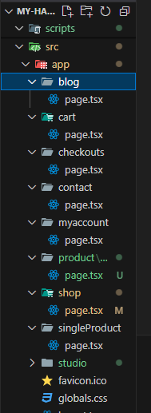 Kishor Kumar