# I completely done my website fully functional and easy to user.

# ***DAY 6 - DEPLOYMENT PREPARATION AND STAGING ENVIRONMENT SETUP***

# There are some feature that I implement in my website:

# Add to cart:-

All products add to cart totally functional .

# User Dashboard:-

Every single user will have their own dashboard if user is no loged in so dashboard told them to login first totally functional and simple .

# View Cart :-

All product have also added to view cart page here we can see subtotal price , it’s VAT and also total price totally functional .

# User Authentication:-

All users should authenticated if they want to process order. I use Clerk fo that, totally functional .

# Payment method:-

I use Stripe for payment method , if user is loged in then he can go to payment page, fully functional .

***Screen shots :***

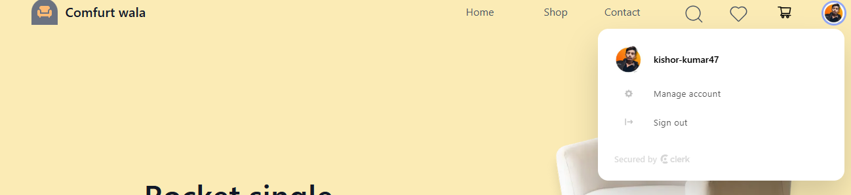

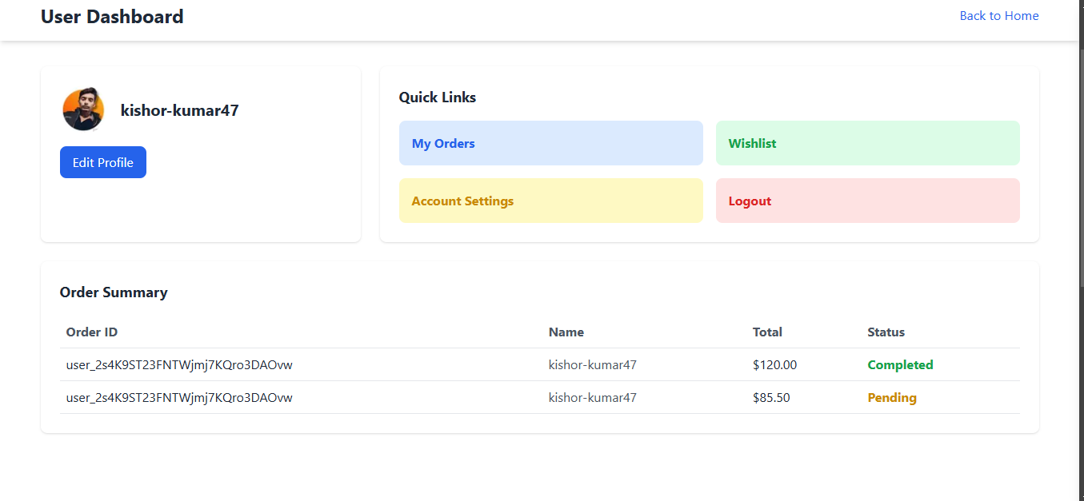

https:

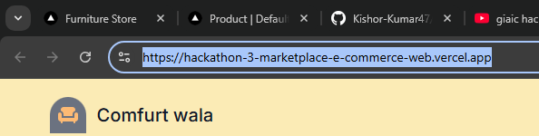

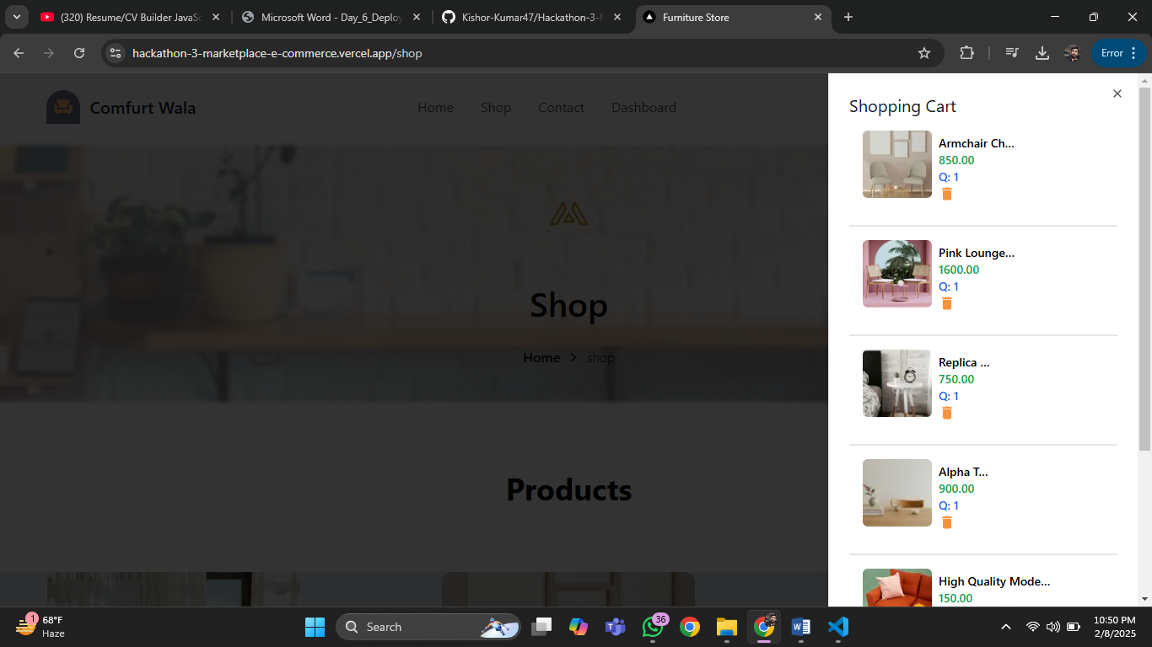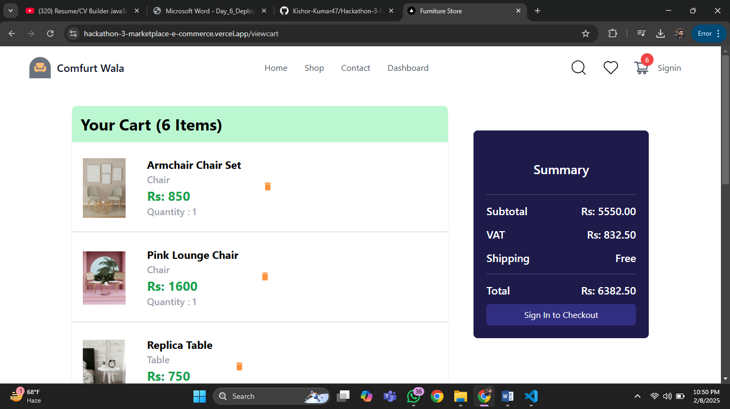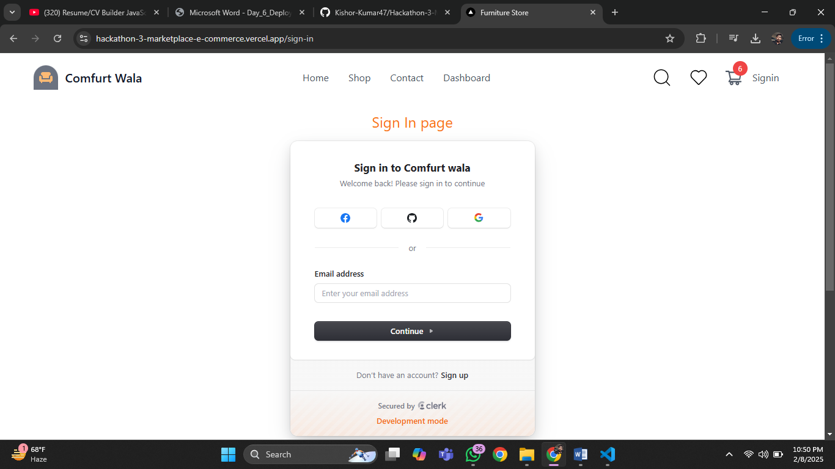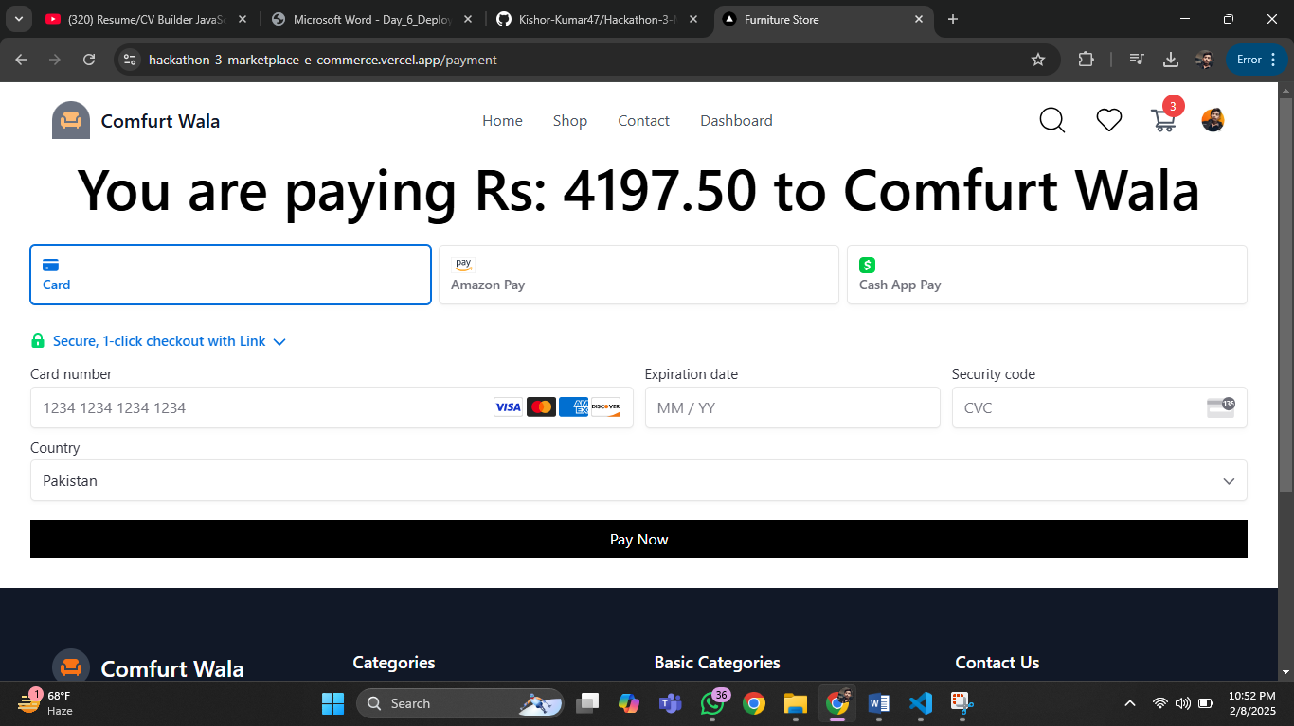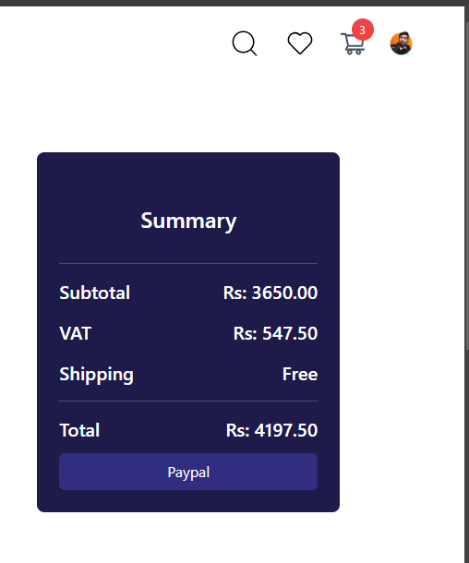

# This is all about my website I also create physical workplace for product produce product . I have one wood designer, 2 painters and other as a need. I will run It as a real business Insha Allah.

Kishor Kumar

496110