A SYNOPSIS OF MINI PROJECT ON

WEATHER WEB

Submitted In Partial
Fulfillment of the Requirements for the Award of the Degree of

BACHELOR OF TECHNOLOGY IN
COMPUTER SCIENCE & ENGINEERING
By

NAME Roll No.
Mr. Rohan Vijay Rendale B55
Mr. Yash Dilip Kumbhar B56
Mr. Kishor Krishnat Shahapure B58

GUIDED BY
Miss. S. S. Malame



Department of Computer Science & Engineering

Sharad Institute of Technology College of Engineering, Yadrav

ABSTRACT

Weather is the state of the atmosphere at a given place and time in regards to heat, cloudiness, dryness, sunshine, wind, and rain. Of all the geophysical phenomena weather is the most significant one that influences us. Weather can vary greatly and largely depends on climate, seasons and various other factors. The chief goal of this work is to get the weather forecast of any city throughout the world through an application. This paper aims at creating a web application using javascript .

Literature Survey: (If Applicable)

Problem Statement:

Changes in the atmosphere are continuous in time and space, but computer models cannot fully simulate this situation. The main reason is that in a computer model, the atmosphere is divided into many grids to simulate the changes in air pressure, temperature, humidity, etc.

Objective:

Weather is what is happening in the atmosphere at any time or short period of time. Weather conditions can change suddenly. Today may be warm and sunny, tomorrow may be cool and cloudy. Weather conditions include clouds, rain, snow, sleet, hail,fog, mist, sunshine, wind, temperature and thunderstorm.

Weather web application is a web based application through which you will able to get all the reports related to weather forecasting of any locations.

It shows the whole world’s weather including their states and city .

Existing system:

Previously built Weather Report project web based application was compatible with system and every time users start this application, they have to set their default location to get weather reports on it. Due to complex coding, system responding time was high and require more memory to get start up. The concept of graphics for geographical region was not implemented in older version. Dynamic concept was not implemented under the existing system, thus theme and color of web page was not changing as per the weather report

Proposed system:

Under web based Weather Report project application, some exciting features has been added such as managing and handling exception error directly by the system which will be not visible by the user to make it bug free. Multiple choice provided to the user by which they can even select different weather channel as per their requirement and interest in it. Its pattern recognition system will able to notify abut bad weather condition previously before it begins with digital graphics is another added advantage of this system. Once location selected by the user for its system use, it will make it default location and remembered by the system so that users do not have to change every time they use this system.

Flowchart

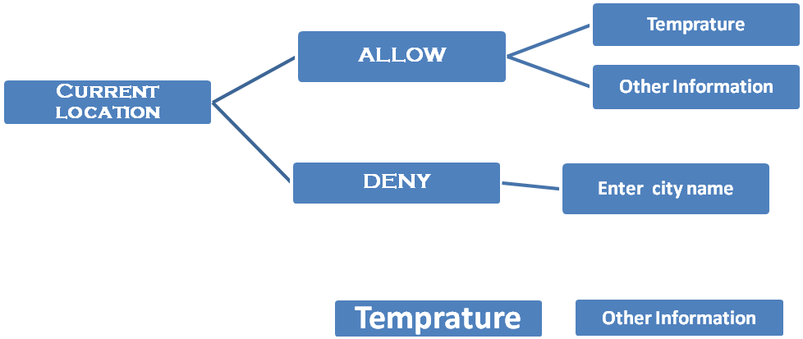

Requirements:

Hardware requirements:
1) Operating System
2) Compiler
3) RAM and ROM

Software platforms:

Visual Studio Code,Firefox,etc.

Schedule of Project Work Completion:
Gantt chart:

Result

HTML

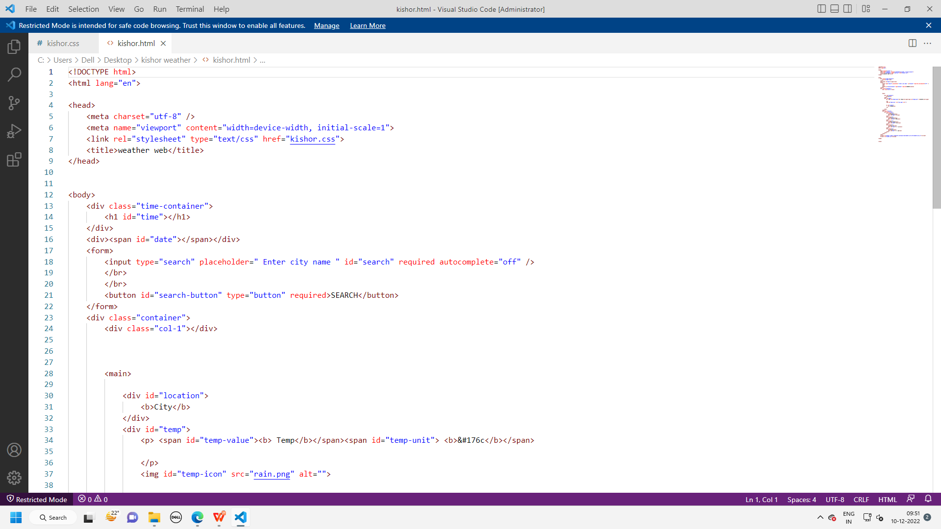

CSS

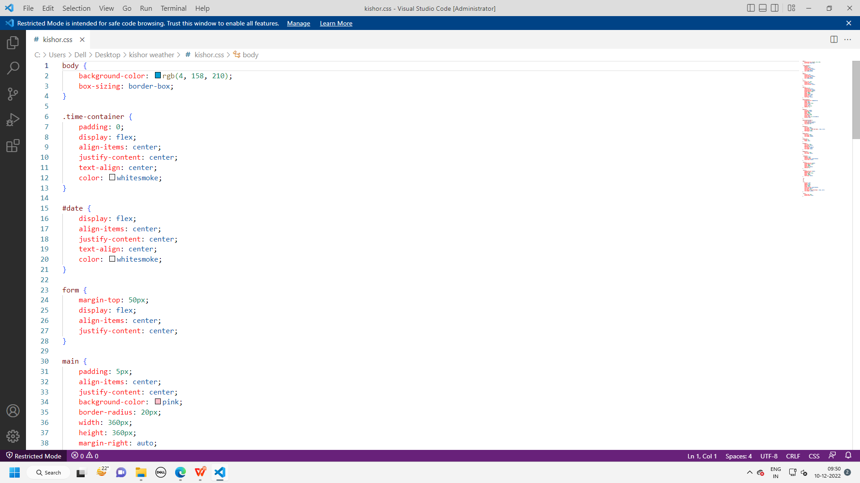

JS

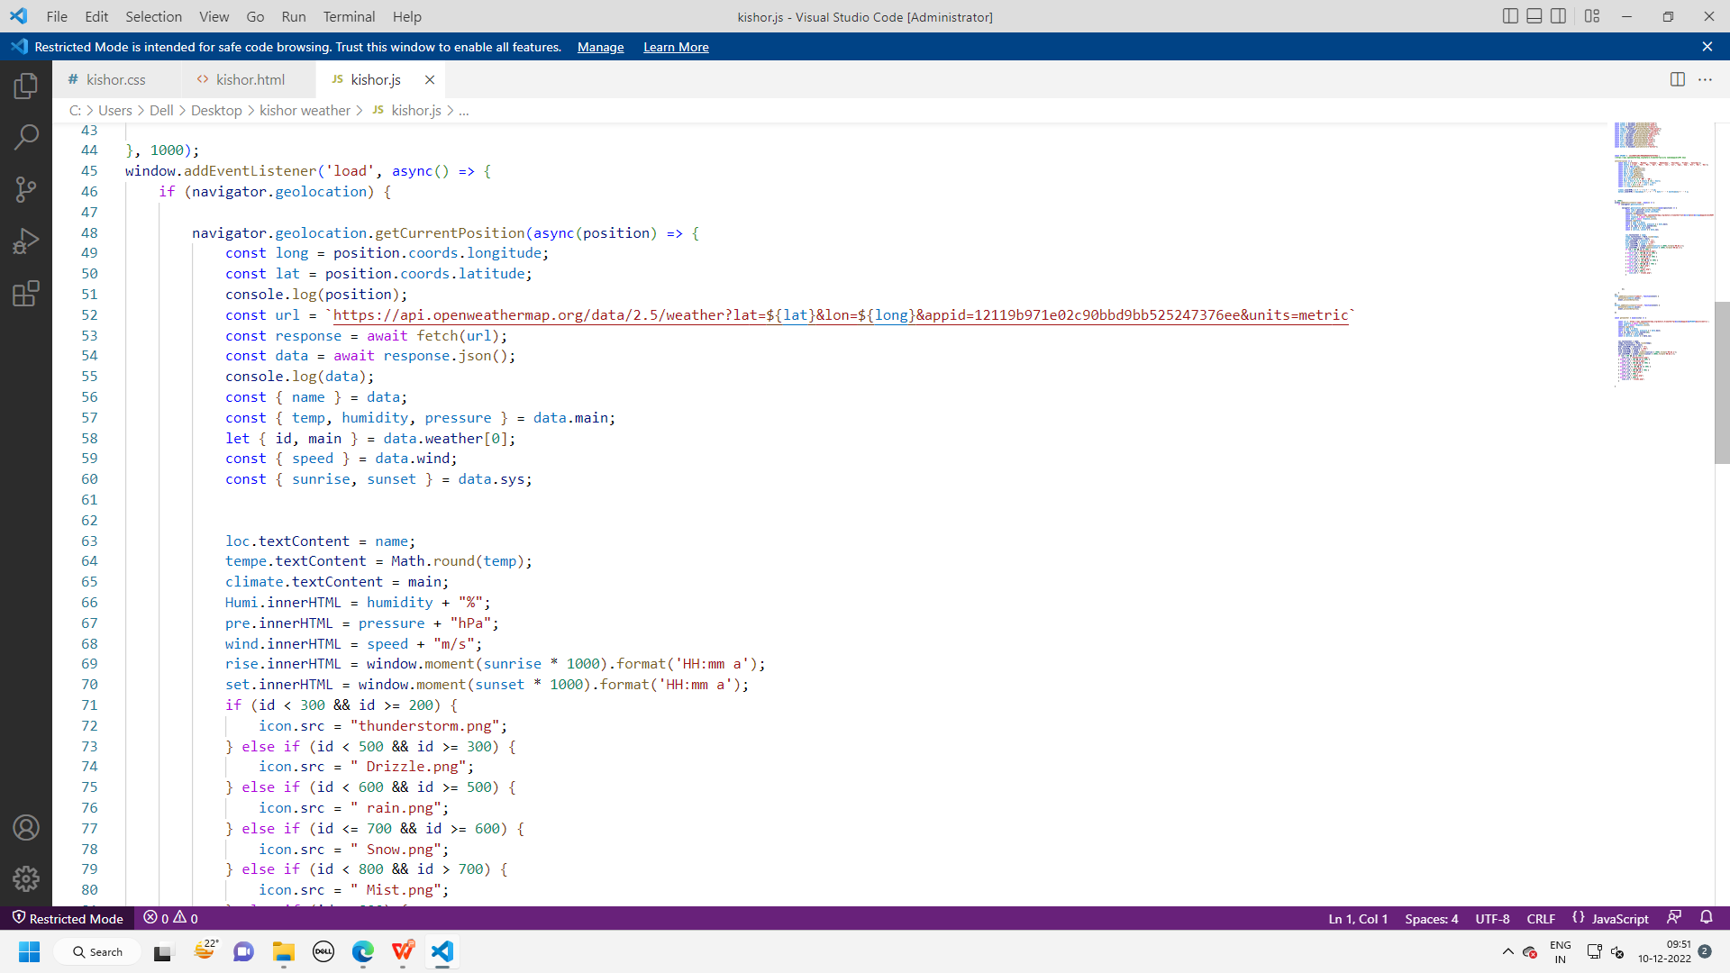

OUTPUT

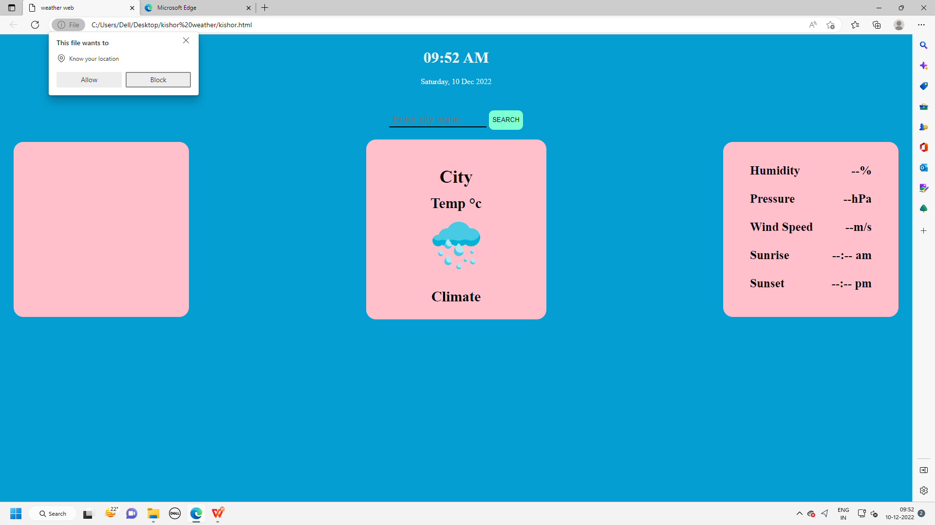

Advantages:

Farmers can known when to plant or harvest their crops

People can choose where and when to take their holidays to take advantages of good weather

Aircraft and shipping rely heavily on accurate weather forecasting

Applications:

This project has enormous and useful applications:
A weather web is a way to use your computer to check current temperature .
Help user to access Weather of different place all over the world on the screen .

Future Scope:
The demand for weather and climate forecast information in support of critical decision-making has grown rapidly during the last decade and will grow even faster in the coming years. Great advances have been made in the utilization of predictions in many areas of human activities.

References:
- https://www.youtube.com/watch?v=ICE0qyyi0ow&feature=youtu.be
- https://openweathermap.org/api

Name of student | Signature(s) of student
Mr. Rohan Vijay Rendale
Mr. Yash Dilip Kumbhar
Mr. Kishor Krishnat Shahapure

Miss. S. S. Malame Dr. Pushpender Sarrao
Guide Associate Professor and Head
Dept. of CSE Dept. of CSE
SITCOE SITCOE

