**EAST WEST UNIVERSITY**

**Project Report**

**Title: Design a full-fledged network for an organization with multiple subnets.**

**Course Code: CSE405**

**Course Title: Computer Networks**

**Section: 03**

**Submitted to**

**Dr. Anisur Rahman**

**Assistant Professor**

**Department of Computer Science and Engineering**

**Submitted By**

**Moni Kishore Dhar**

**2016-2-60-099**

**Submission date**

**17-8-2019**

**Abstract:**

The purpose of this project is to design a suitable network system for International Apex University in such a way that represents how much efficient the interconnectivity of the system and sub networks of the whole university is. Both wired and wireless connectivity establish in this university’s network infrastructure. This university networks infrastructure consists two lab, single subnet for each server room, reception, classroom, library, admission office, administrative office, employee room, faculty room which are connected with 5 routers using wire and this network also provides wireless internet access for everyone. This complex network supports business process like admissions, results, e-Tender, advising etc.

**Introduction:**

The computer network represents a component, especially on how it enhances the functional performance in different fields and organizations, such as companies and Universities. A University’s computer network performs so many functions, such as connecting students with the university, faculty, the library, and over the internet. Most universities today use the network to provide online education by connecting widely dispersed students with their professors directly. For this reason, computer networks play a vital role in the education area by providing efficient communications for the university environment. However, the design of computer networks differs from one university to another. This is as a result of many factors which determine the differences.

In this project, the task is to create a complete model of the complex network by discovering the interconnectivity of the systems and sub networks, which will reflect the International Apex University’s structure and facilities.

**Objectives:**

The main goal of this project is to present a Local Area Network model design suitable for a University by discovering the interconnectivity of the systems and sub-networks. Many universities are searching for ways to integrate networks that have security, backup, and other features available in a university network. The universities are faced with challenges in designing a network that is equal in the standards used by developed countries. The main problem they face deals with a profound budget deficit. This project will help these universities to design a network that employs low-cost solutions without unacceptable compromises in security or quality.

**Components:**

* Router
* Server (DHCP+DNS+WEB)
* Switch
* Wireless Router
* Access Point
* PC
* Laptop
* Wireless Smart Device
* Printer
* Cloud and TV

**Connection Setup:**

The network is divided into subnets and all the subnets are connected through router and all routers are interconnected to each other. Each classroom, lab, library, employees room, faculty room, admission office, administrative office has own subnets. All the IP of end devices are provided through one DHCP server across the whole network.

**Design:**

The network that I designed looks like bellow. There is are routers through which the other sub-networks are connected like server room, classroom, Labs, Library, Employee room and other administrative and academic wings.

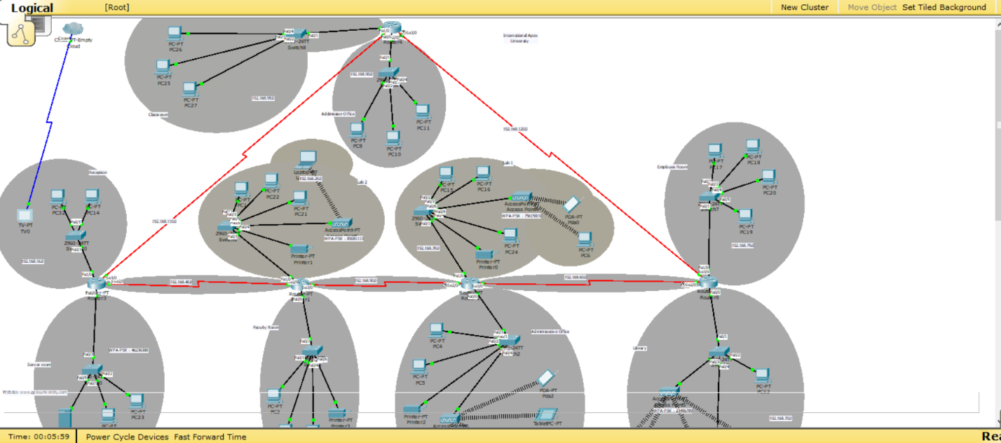

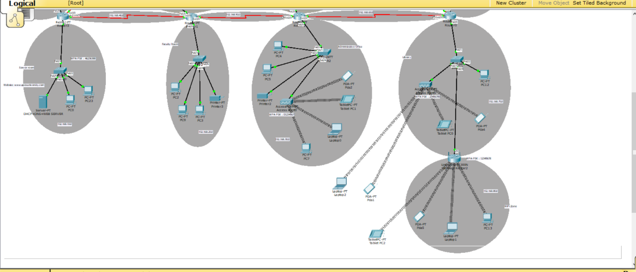

**Implementation:**

* **Router:**

In this project I used 5 routers (2811) which are interconnected with each other and every routers are connected with subnet. To expand the subnets I used switch. For configuring the routers we can use CLI command form and config. To configure the routers I used config in this network. By using config I setup fast ethernet, serial port, routing table.

The figures of below shows router configuration:

**Router 1:**

Fast Ethernet Configuration:

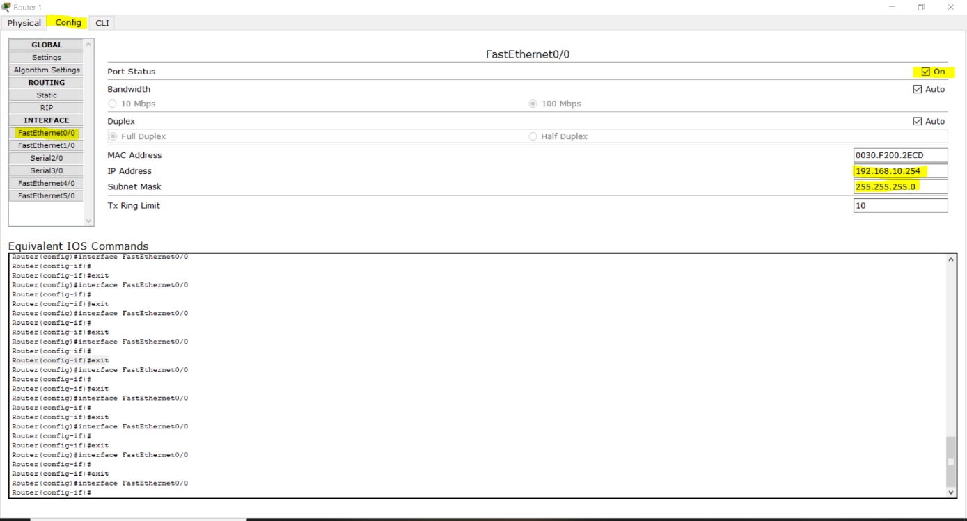

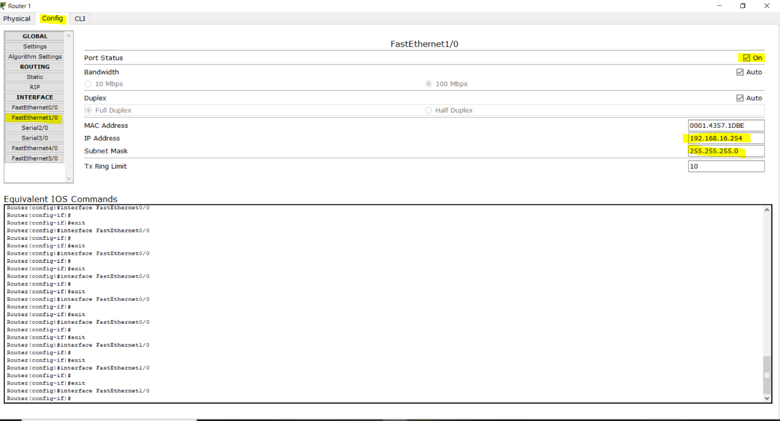

Serial Port Configuration:

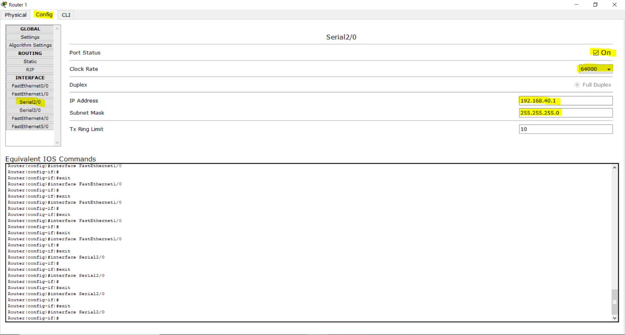

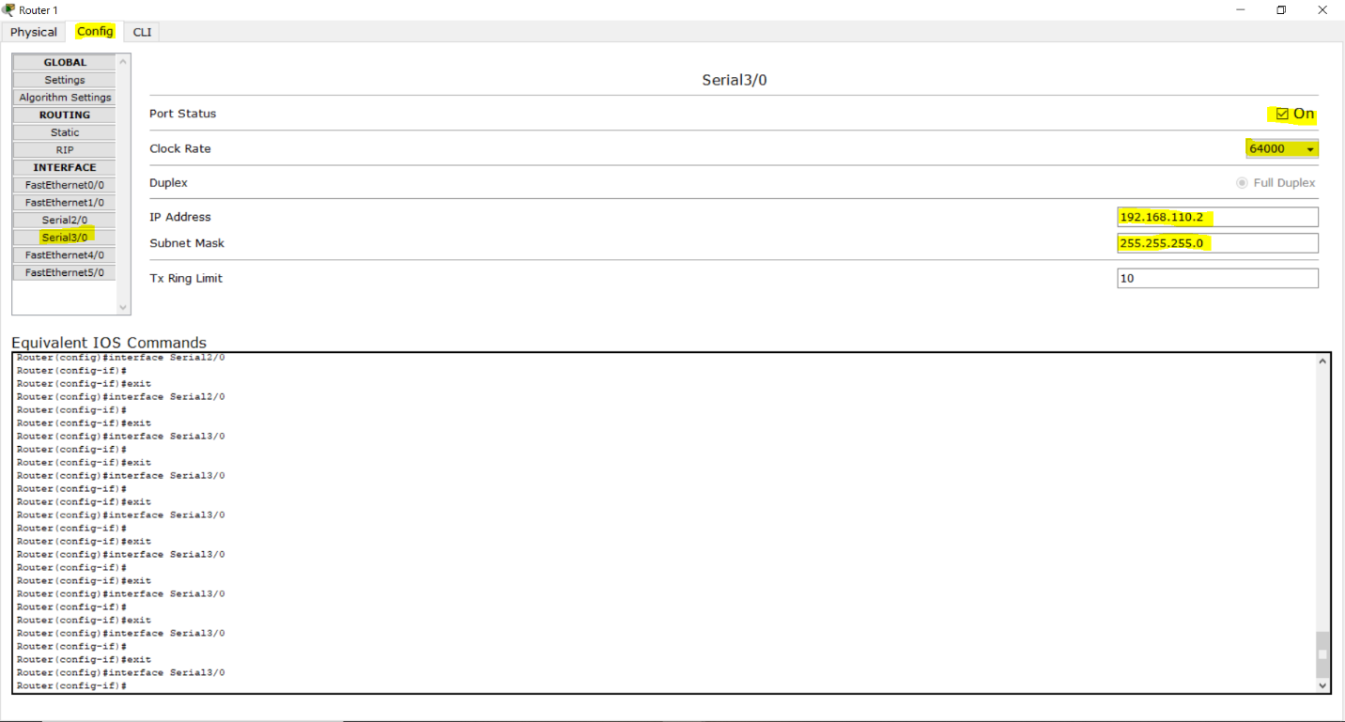

Routing Configuration:

Static (Using Next Hope) :

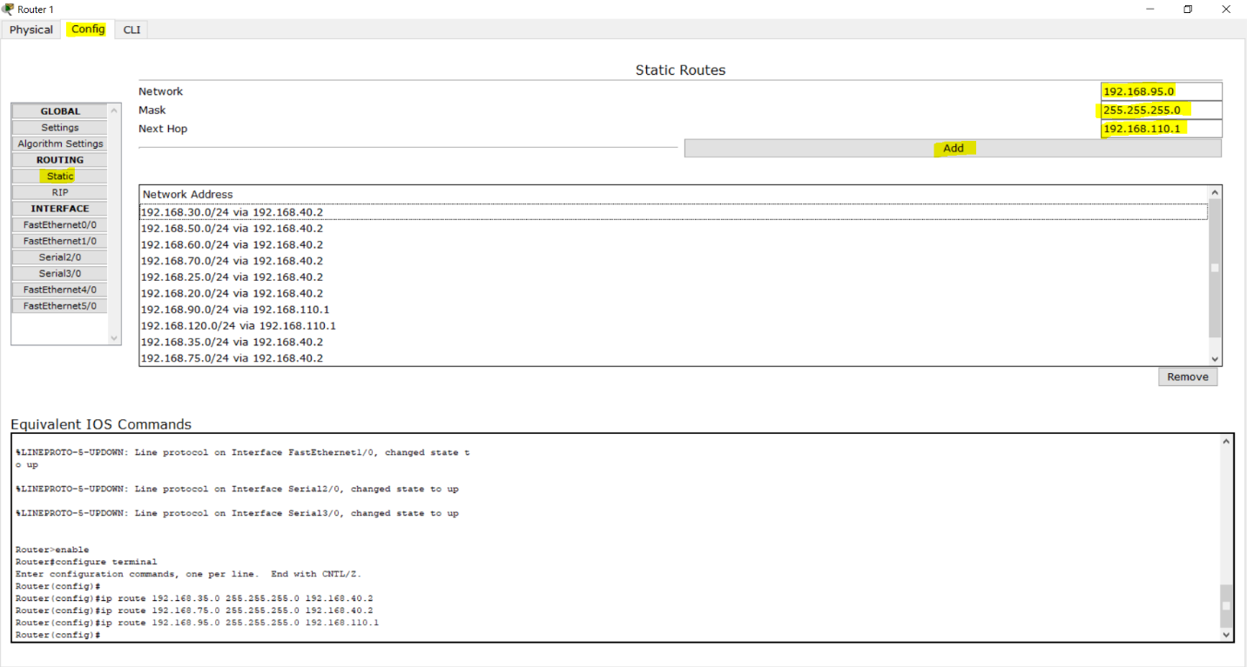

Rip (Dynamic) :

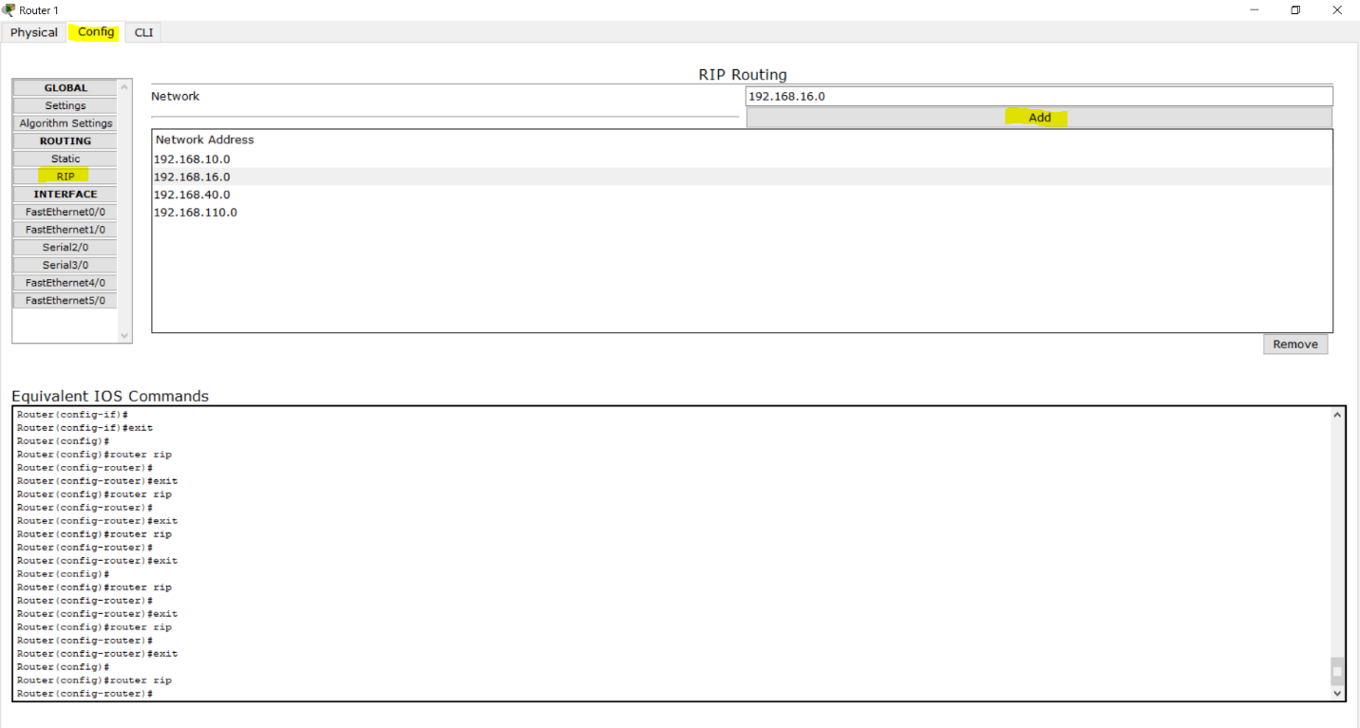

N.B. : One of them can be use for routing. I use both of them.

* **Switch:**

Switches are devices used on the network to transmit and receive data from one device to another or to many devices depending on the message intended. A switch provides the full bandwidth of the network to each port, thereby reducing collisions on the network. Switches also perform functions from the Data Link Layer. The name of each port is Fast Ethernet, and the numbering of ports begins at 0/1 and ends at 0/24.

In this project I used 2960-24TT switch to expand the subnet.

* **Server:**

The term server refers to a device or a computer program that supports other devices or programs which are called clients. This is known as the client-server model. One server can support many clients and can give different functionalities or characteristics to different clients.

In this entire network I used only one server which is work as three type of server. I fixed the IP address of that server statically and that is **192.168.10.4**

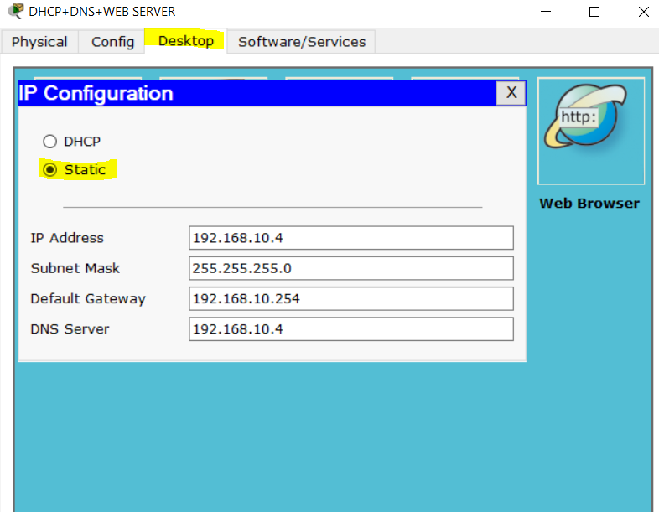

This three types of server is :

1. **DHCP:** Dynamic Host Configuration Protocol (DHCP) server is used to provide IP address to all other hosts. To provide IP address in hosts of same subnet I configured server in config by typing all necessary IPs. To distribute IP to hosts of other subnet in other network I used a command in each fast ethernet interface in each router. The command is

**#ip helper-addresss DHCP_SERVER_IP**

I also provide default gateway and DNS server IP by using DHCP server.

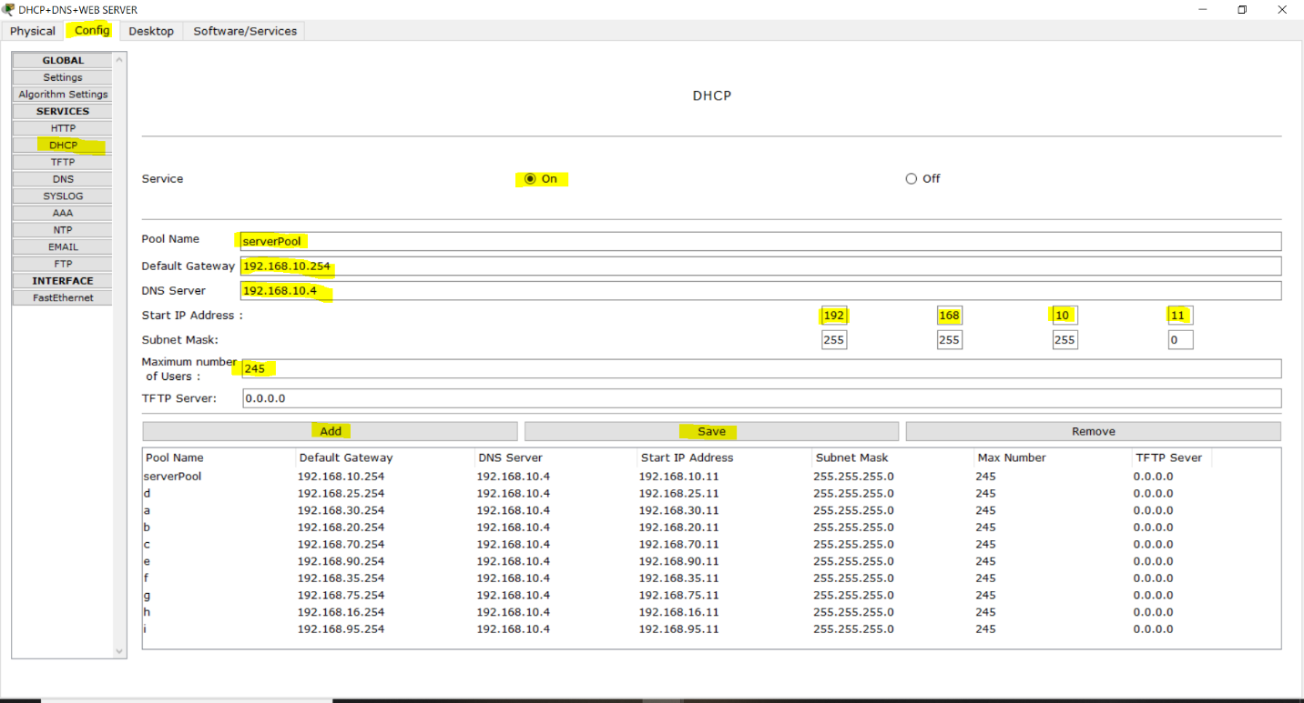

1. **DNS:** The Domain Name System (DNS) is a server service that maps a domain name to IP addresses. I configured this server like bellow:

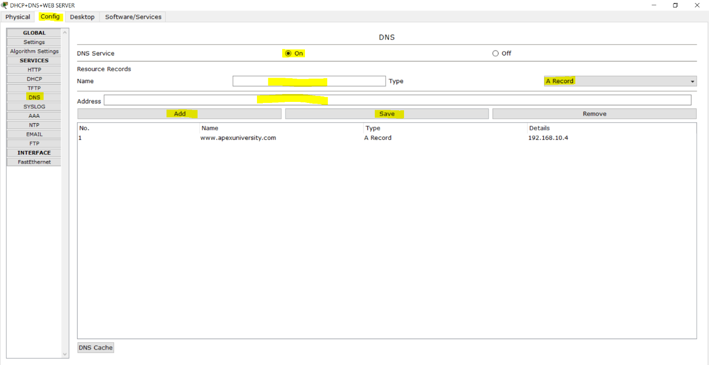

1. **HTTP Web Server:** The primary function of web server is to store, process and deliver web pages to clients. Here we had imported our university webpages to the HTTP server. I configured that server like bellow:

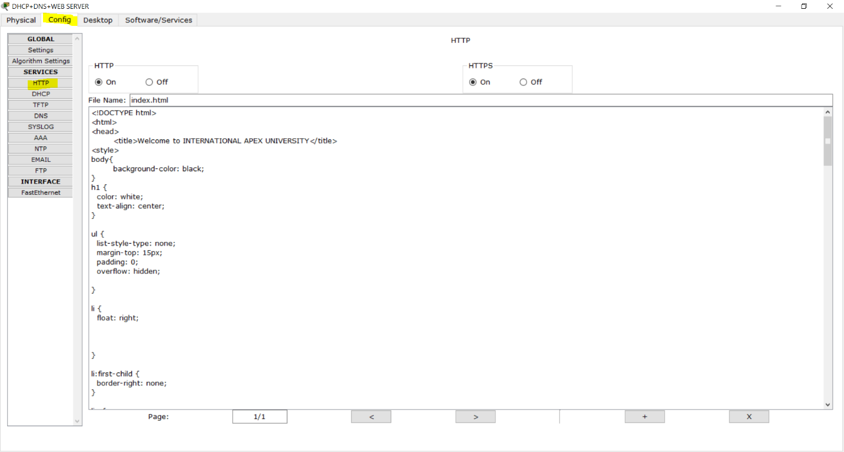

**Webpage looks like:**

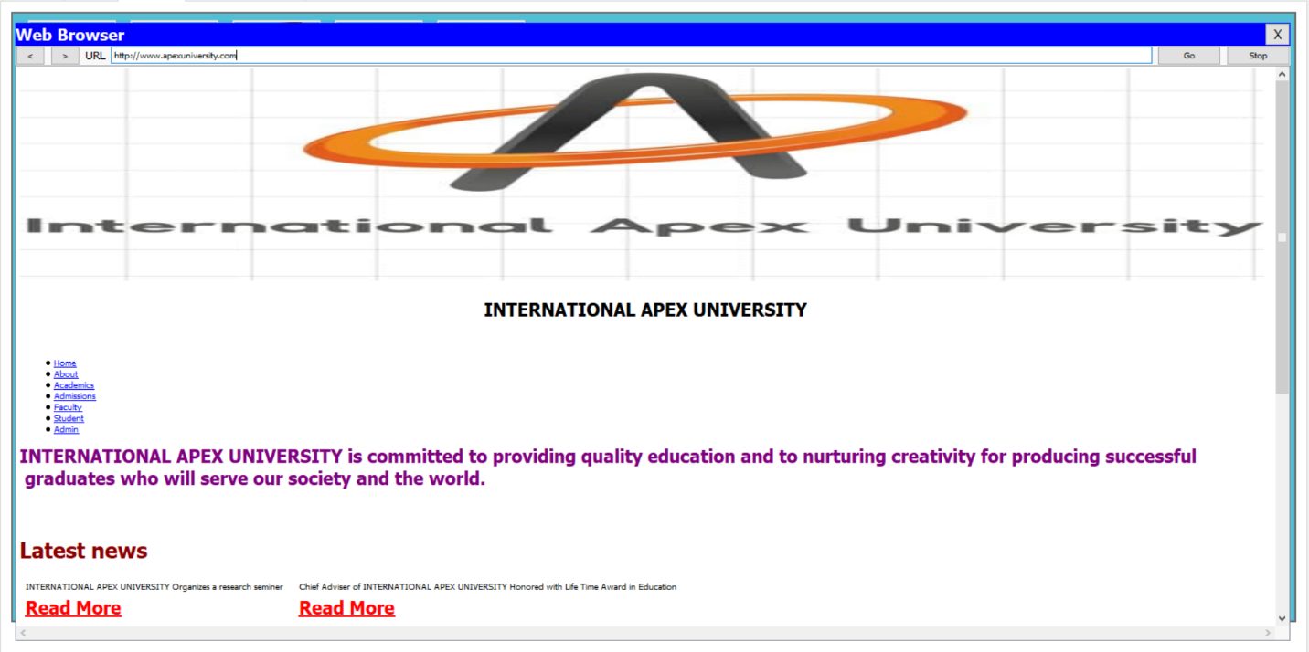

* **Wireless Router:**

This is use to provide wireless network. Which is connected to a subnet by switch. Internet is configured by DHCP and LAN is configured by statics. This LAN provide wireless devises a unique subnets IP address.

In this network I provided the LAN IP statically which is **192.168.80.1**

I also provide a password (WPA-PSK) for that router for security purpose.

Configuration of wireless router:

**Internet:**

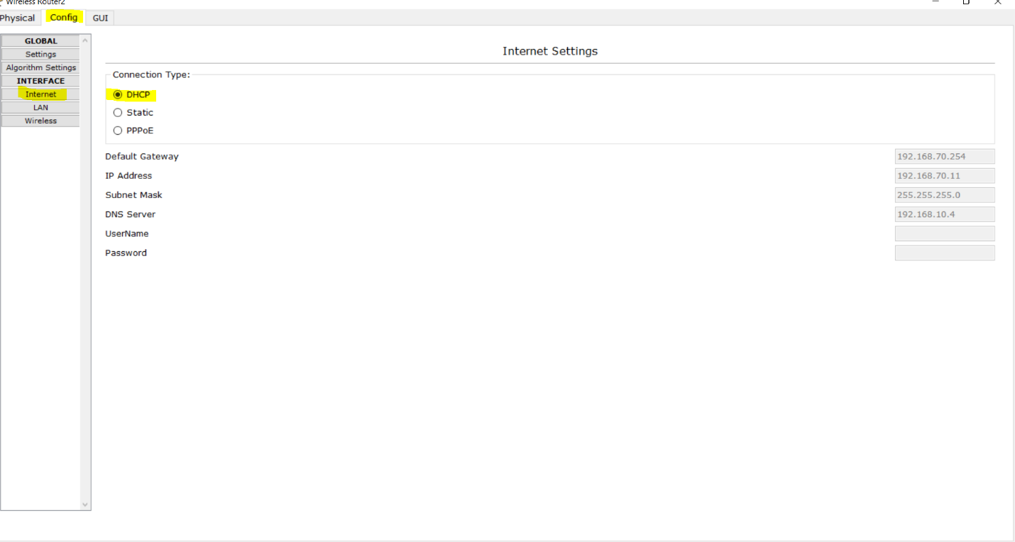

**LAN:**

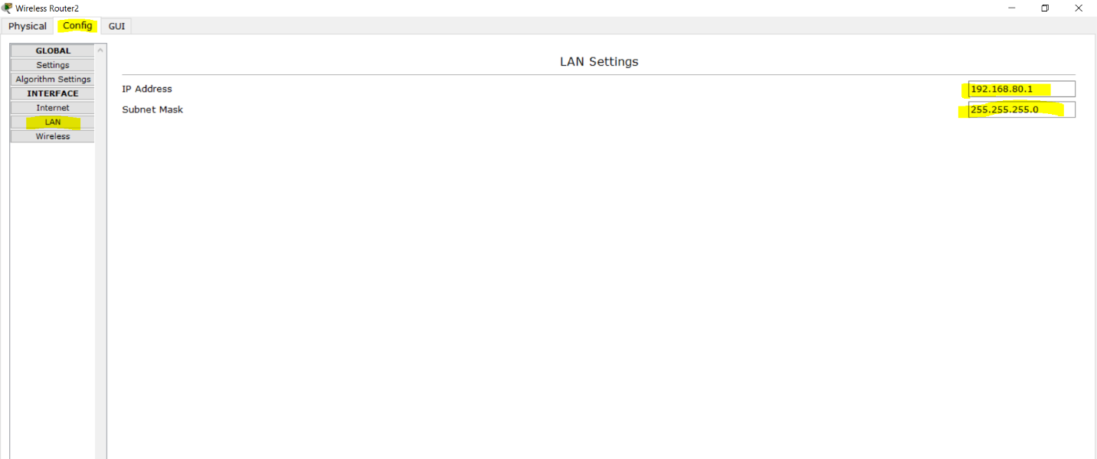

**Password:**

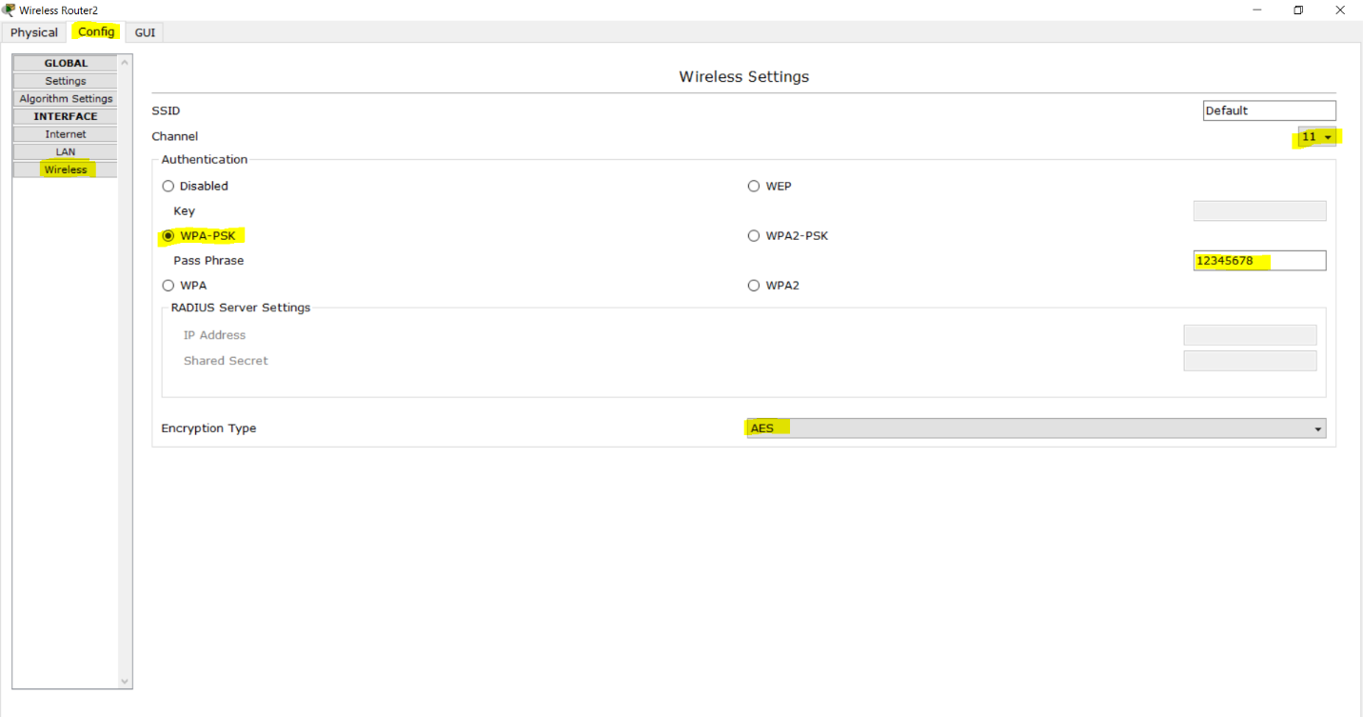

**GUI:**

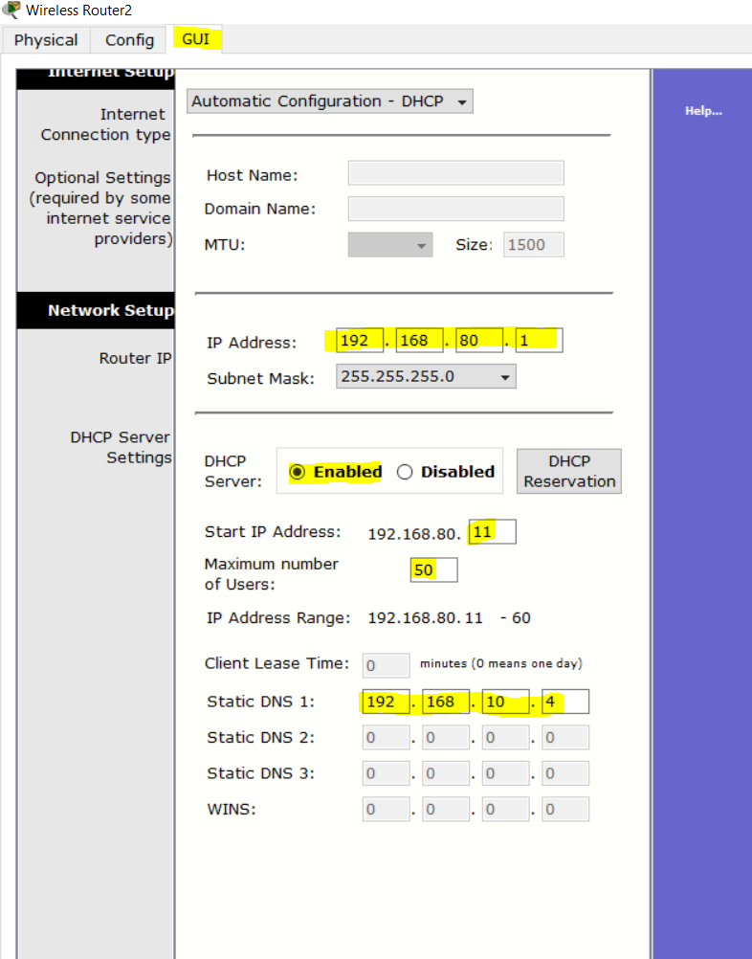

* **Access Point:**

In this network I used 4 access point which were connected with switch. I also gave them a unique password (WPA-PSK).

Configuration of access point:

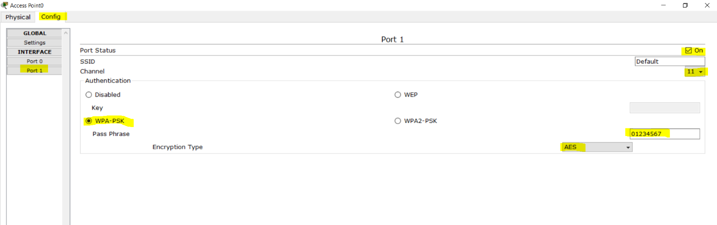

* **Laptop:**

In this network I used Laptop which is a end device. This laptop can be connected with wireless router and access point by giving their password. Laptop needs a IP address which is provided automatically by the DHCP Server when it is connected with a subnet.

Configuration of laptop:

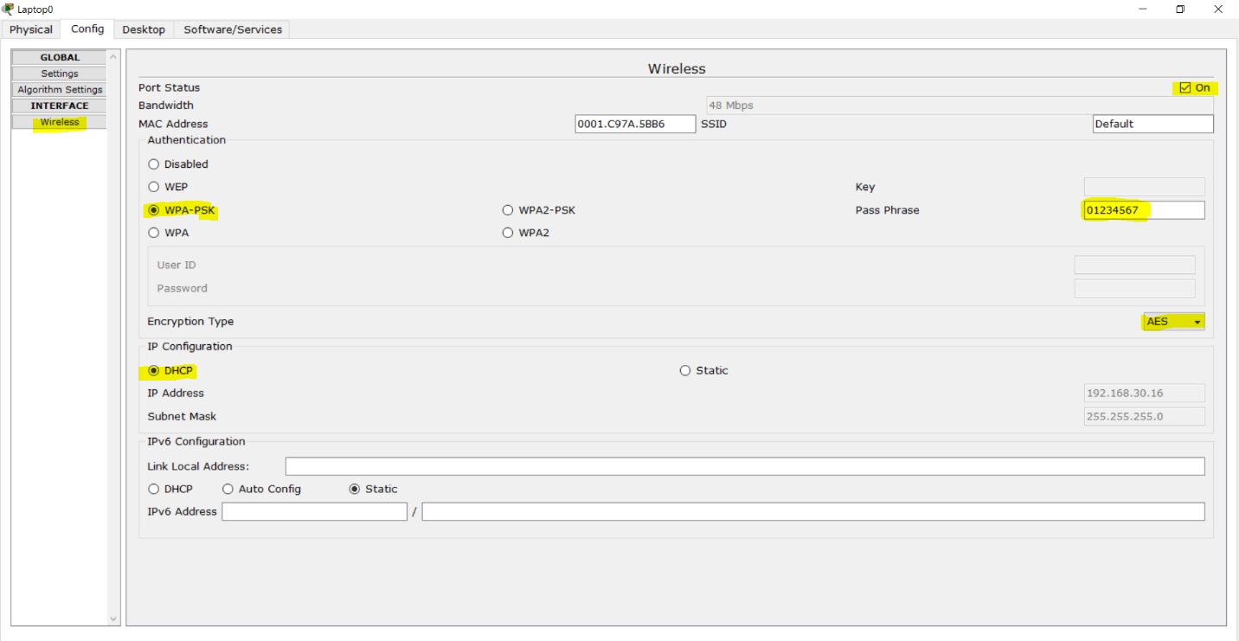

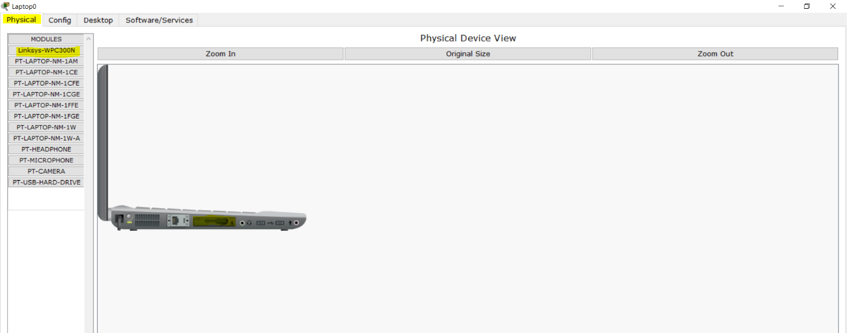

* **PC**

PC is a end device which is connected with switch using crossover cable. Each PC needs a IP address which is provided automatically by the DHCP Server when it is connected with a subnet.

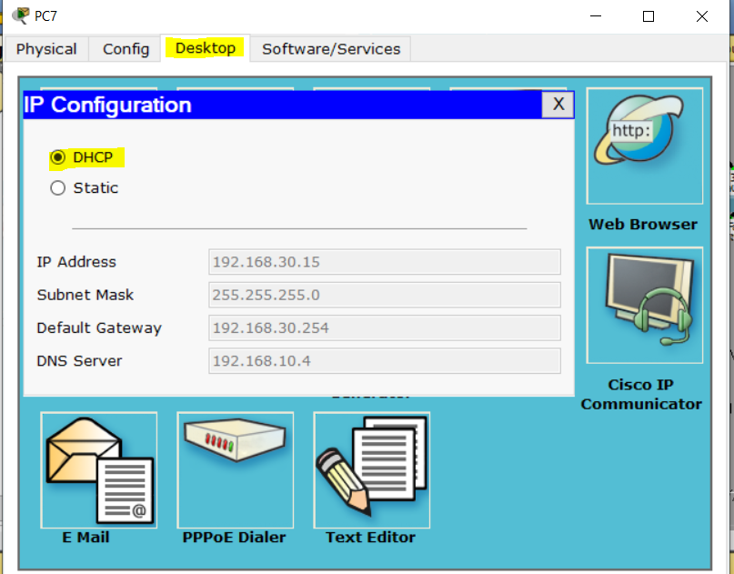

* **Wireless Smart device**

This device can connect with wireless router and access point.

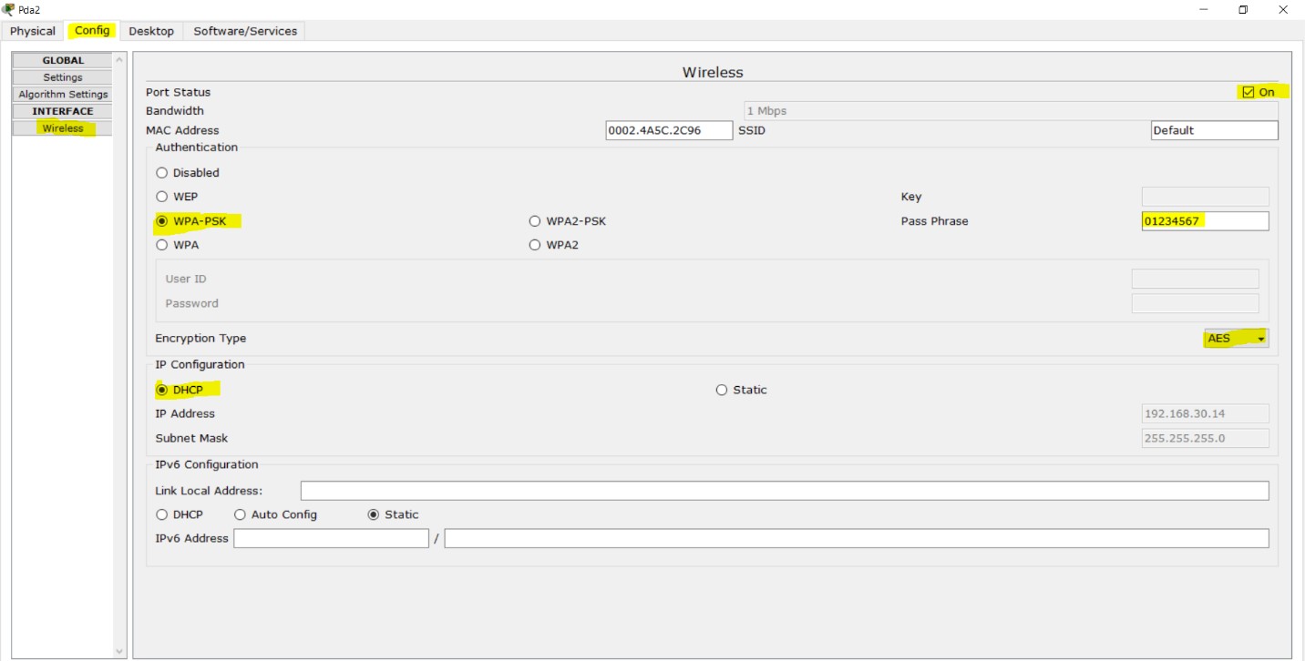

* **Printer**

In this network I used printer which is connected with a switch using straight through cable.

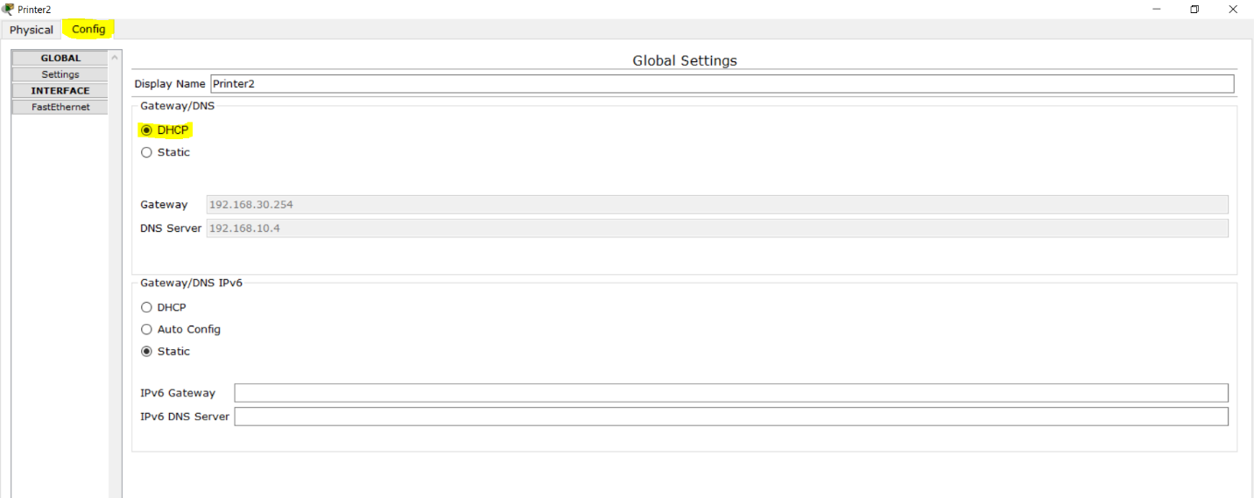

* **Cloud and TV**

In this network I used TV in reception subnet. And this TV is connected with a cloud. I configured cloud by providing some pictures in TV settings like bellow. And then I turned on the TV and this device show those desired pictures. Configuration of cloud and tv:

**Cloud:**

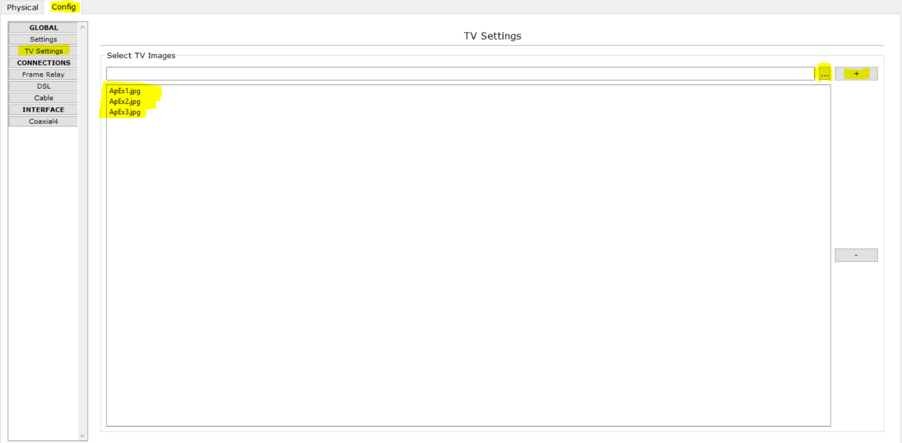

**TV:**

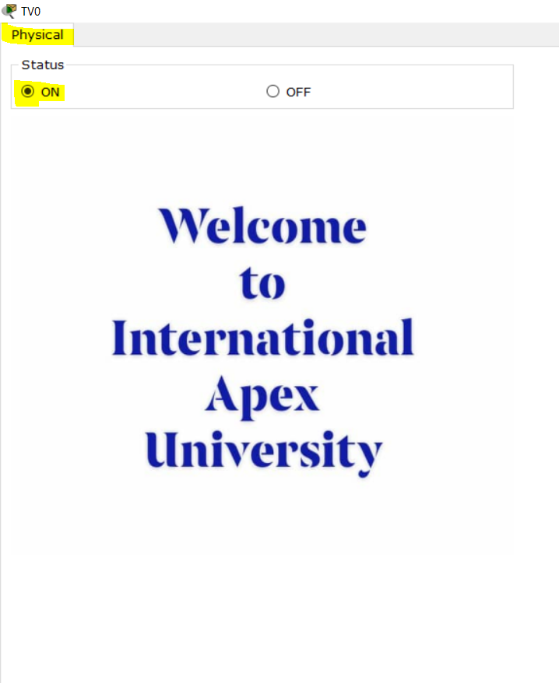

**Justifying the Design:**

My target was to create a complete model of the complex network by discovering the interconnectivity if the systems and subnetworks, which will reflect the INTERNATIONAL APEX University’s structure and facilities. I made it in my network. In this network all the classroom, labs, admission office, administrative office which are basically subnetworks are connected to router. Which are represent the whole university structure.

My second target was to create DHCP, DNS and Web server(HTTP) and also to follow IPV4 Addressing. In my network I used only one server in entire network. Which can provide IPV4 address to every hosts in network. This server also used as DNS server which is resolve the URL. Again this server also provide a web page which reflect university’s profile in http port. Here I can make fulfil of this three demand in one server so it is cost efficient.

My another target was to make wireless connection in whole network. Here I used wireless router and access point also to fill up this demand.

**Conclusion**

The network that we designed maintaining those several criteria is quite good as it will be cost efficient. There is always room for development. As network grows structure will grow as well as cost. For security issue considering safety measure is a must. Although there may have been some challenges in this project due to some constraints, at the end our aim was achieved by designing a network for International Apex University.