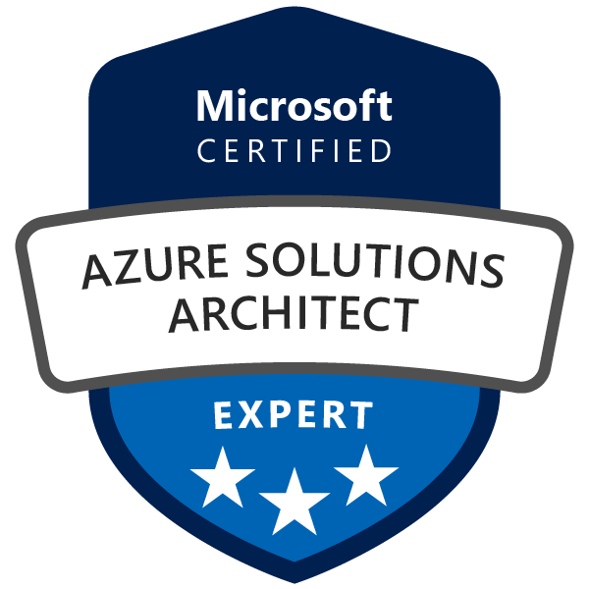
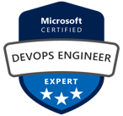
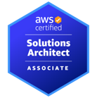
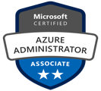
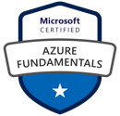
Aditya Jaiswal
Total Exp: 5 Years
Relevant: 5+ Years

Ph: +91 1234567890
Email: abc@gmail.com
Noida

PROFFESIONAL SUMMARY

- A qualified and result-oriented professional with overall 5 years of experience in IT Industry, as a DevOps Engineer with hands-on experience supporting, Automating, and optimizing mission critical deployments in production server & cloud. Building, Deploying, Source code management, leveraging configuration management, CI/CD, and DevOps processes. Strong hands on experience in IAC tools like Terraform and Ansible.

- Certified Microsoft Azure Solution Architect Expert (AZ-305), Microsoft Azure DevOps Engineer Expert
(AZ-400) & AWS Solution Architect Associate (SAA-C03)

TECHNICAL SKILLS

Version Control | Azure Repos & Git
Build Tool | Maven, NodeJS(Basics)
Continuous Integration Tool | Azure Pipelines & Jenkins
Containerization | Azure Container Registry (ACR) & Docker
Configuration Management Tool | Ansible
Container Orchestration tool | OpenShift, Azure Kubernetes Service (AKS)
Cloud Technology | Azure, Azure DevOps
Scripting/Command-Line | Shell Scripting
Infrastructure Provisioning Tools | Terraform
Security Tools | Trivy, OWASP Dependency Check
Code Quality Check Tool | SonarQube

WORK EXPERIENCE

Current Organization:
Capgemini Technology Services India Ltd
Designation: Consultant - July 2019 –Present

Role | Project | Tools Used
Azure DevOps Engineer | Cloud DevOps | Azure DevOps àAzure Pipeline, Service Connection, SelfHosted Agent, Azure Boards, Azure Artifacts  Azure Cloud à VM, VNET, Subnet, NSGs, ACR, AKS, Load  Balancer, Azure AD, Azure Functions etc IaC à Terraform & ARM templates
Key Contributions:
- Experience in creating Azure CI/CD Pipeline (Build & Release) from scratch using both Classic editor and YAML method
- Integrate various tools across Pipeline stages such as SonarQube, OWASP, Trivy as per requirement
- Used Maven & MS Build as a build tool for Java & DotNet project respectively.
- Experienced with both Azure MS Hosted Build Agent & Self-Hosted Agent configuration.
- Performed security checks for vulnerabilities on application using OWASP Dependency checks
- Artifacts management using Azure Artifacts in Azure DevOps
- Container Image Vulnerability detection using AquaSec Trivy
- Created Terraform & ARM template for provisioning Azure Infrastructure such as VM & private AKS cluster through Azure Pipeline.
- Experience on Azure PaaS Service like WebApp, Functions & Logic Apps (Serverless)
- Used Azure KeyVault to store Service Principal Client ID & Client Secret for AKS.
- Good Experience with User & Group Access Management in Azure DevOps for Organization & Project Scope.
- Experience with Azure RBAC on Subscription & Resource level
- Performed various PoCs and provided Coaching Services to the Clients as per their CI/CD Project requirements to achieve good DevSecOps approach.

Previous Organization:
XYZ Consultancy Services Limited – Bangalore
Designation: IT Analyst – Nov 201X to Apr 202X

Role | Project | Tools Used
DevOps Engineer | Q_DEVOPS | Gitlab, Jenkins, Maven, SonarQube, Selenium, Nexus, Docker, Grafana, OpenShift, Jira & Confluence
Key Contribution:
- Experience in using GIT and Jenkins to create a Maven Build jobs for continuous integration.
- Experience in automating CI & CD pipeline using Jenkins for all build and deployments.
- Configured SonarQube for source code analysis.
- Configured Nexus Repository for deploying the Artifacts.
- Experience in writing playbooks for deployment in Docker Container using Ansible.
- Experience in creating Docker Images using Docker file
- Good knowledge on Ansible Playbooks and YAML Scripting.
- High-Level knowledge about Kubernetes, since it is introduced in our environment recently.

CERTIFICATIONS

Code | Certification Name | Completion Date
AZ-305 | Microsoft Certified Azure Solution Architect Expert | Feb-2023
SAA-C03 | AWS Solution Architect Associate | Oct-2022
AZ-400 | Microsoft Certified Azure DevOps Engineer Expert | May-2022
AZ-104 | Azure Administrator Associate | Dec-2021
AZ-900 | Azure Fundamentals | Sep-2021
EX-300 | RED HAT CERTIFIED ENGINEER (RHCE) | Aug-2018
EX-200 | RED HAT CERTIFIED SYSTEM ADMINISTRATOR (RHCSA) | Apr-2017

ACHIEVEMENTS

- Customer Delight à Received for doing multiple POCs and getting good feedback & appreciation from engagements
- Europe India Awards for Q4 2021 à Value Creator from Cloud DevOps for Q4 2021
- 3 times Hero Of The Cluster à Received for good work performance in project in a Quarter

ACADEMIC QUALIFICATIONS

Year | Degree | University/Board | Percentage %
2019 | BTECH - Computer Science Engineering | AKTU | XX%
2014 | School Name | CBSE | XX%
2012 | Cambridge Public School | CBSE | XX%

PERSONAL DETAILS

- Marital Status: Unmarried
- DOB: 20th Aug 1998
- Hobbies: Badminton, Cricket, Painting & doing POCs on any Cloud DevOps topics
- Present Location: Bangalore
- Nationality: Indian

