**Q1**. Draw the circuit diagram of Buck Converter, Boost Converter and Buck Boost Converter and compare between the construction of them.

Ans:

1. **Buck Converter -**

* Definition: Buck or step down converter converts power from high voltage source to low voltage source
* Circuit Diagram

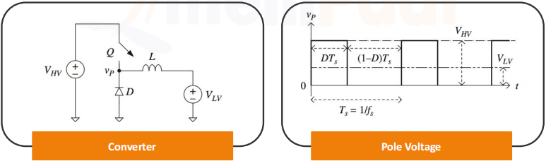

* Basic Components
  + Power Semiconductor switch(Q)
  + Inductor(L)
  + Inverse diode(D)
* Voltage Gain = D = VLV/VHV

1. **Boost Converter -**

* **Definition**: Boost or power up converter converts power from Low voltage source to high voltage source
* **Circuit Diagram**

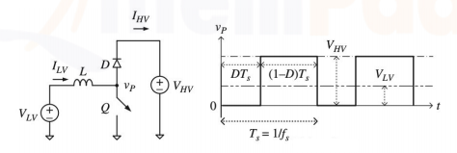

* **Basic Components**
  + Power Semiconductor switch(Q)
  + Inductor(L)
  + Inverse diode(D)
* Voltage Gain = D = VHV/VLV = 1/(1-D)
* Duty Cycle = 1-(VLV/VHV)

1. **Buck-Boost Converter -**

* **Definition**: Buck and boost converters can be integrated to create a bidirectional buck-boost converter. This converter is commonly used for hybrid electric vehicles as it enables discharge of the low-voltage battery to a higher voltage during motoring using a boost and charging of the low-voltage battery from the high-voltage link using a buck converter. This integration of a buck converter and a boost converter is often known as a half– bridge converter.
* **Circuit Diagram**

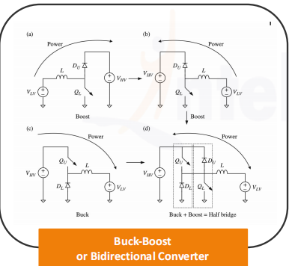

* **Basic Components**
  + Power Semiconductor switch(Q) = 2 No
  + Inductor(L)
  + Inverse diode(D) =2 No

**Q2**. Determine the power density and the efficiencies of the fuel cell and plant at full load if the balance of the plant consumes 20% of the fuel cell output power (ηbop equals 80%).



3. The parameters of a fuel cell are provided in the table. For simplicity, the effects of temperature and pressure are ignored.

4. Determine:

(i) the no-load voltage

(ii) the full-load voltage at 15,000 A/m2

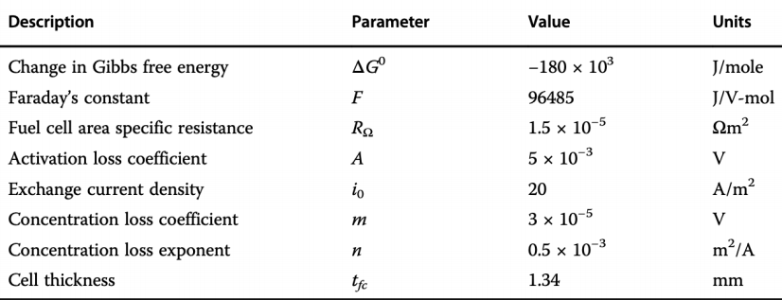

Ans:

* Power density of Fuel Cell (PsFc)= Vfc * Ifc

= 3.98 * 1.34

= 5.33

* power density of fuel cell power plant= nFcp

= nbop * nFc

= nbop/V0r

= 80/0.93

=86

* Efficiency of Fuel Cell = nfc= (Vfc/V0r) * 100
* Efficiency of fuel cell power plant(nfcp) = nbop *nfc

= nbop * (Vfc/V0r)

= 80 * (-3.98/-0.93)

=342.72

* no-load voltage(V0r) = (Delta G0)/2F

(V0r) = (-180*1000)/2*96485

(V0r)= -0.93

* full-load voltage at 15,000 A/m2(Vfc) = (V0r - (Delta Vohm) - (Delta Va) -(Delta Vc))

Vfc= (-0.93 - (Rohm *Ifc)-(A log(Ifc/i0))- (m e nifc)

Vfc = (-0.93 - 0.00015 -0.014- 3.04)

Vfc = -3.98