

Candidate Table Builder
Architecture & Developer Guide
How the application turns a recruiter tracker and a set of resumes into a client-ready Excel table, and how to run, deploy and extend it.
Document date | 19 October 2026
Applies to | Repository “Candidate-Table-Builder”, branch main
Audience | Developers who will maintain or extend the project
Sample data | All names, numbers and resumes in the screenshots are fictional

Contents
1. Overview 4
1.1 What the output contains 4
1.2 Design principles 4
2. Technology stack 5
3. Architecture 6
3.1 Responsibilities 6
4. Repository structure 7
5. End-to-end flow 8
5.1 Step by step 8
6. Frontend 10
6.1 Screens and state 10
6.2 Reading a resume in the browser 10
6.3 Batching and pacing 10
6.4 Progress display 11
6.5 Review screen 12
7. Backend API 13
7.1 Tracker parsing (tracker.py) 13
8. Gemini extraction 14
8.1 What Gemini returns 14
8.2 Reliability: retries, fallback and time budget 14
8.3 Quota counter (usage.py) 15
9. Business rules 15
9.1 Rules per column 15
9.2 Years of experience 16
9.3 Companies (Last 3) 16
10. Matching and validation 16
11. Verification tools 17
11.1 Verify panel 17
11.2 Verification sheet 19
12. Excel output format 19
13. Configuration 19
14. Running the project 20
14.1 One-click start (Windows) 20
14.2 Developer mode 20
15. Deployment 21
16. Limits and known constraints 21
17. How to extend the project 22
17.1 Add an output column that comes from the tracker 22
17.2 Add an output column that comes from the resume 22
17.3 Other common changes 23
18. Testing and troubleshooting 23
18.1 Regression check 23
18.2 Troubleshooting 24
19. Glossary 24

1. Overview
Candidate Table Builder is a web application for recruiters. A recruiter uploads two things:
- the tracker — an Excel file with one row per candidate (contact details, current and expected CTC, notice period, offers, comments);
- the candidates' resumes — 2 to 50 files, PDF or Word (.docx), including scanned PDFs.
The application reads each resume, pulls out the facts a client wants to see, pairs every resume with the right tracker row, and produces one formatted Excel table that can be sent to the client. Before downloading, the recruiter reviews the table and can check every value against its source.

1.1 What the output contains
Output column | Source | Example
Name | Resume | Arjun Mehta
No. of Years of Experience | Resume (tracker as fallback) | 6+ Years
Education (Highest) | Resume | M.Tech - Data Science, National Institute of Technology Karnataka (2019)
Companies (Last 3) | Resume | 1. Northwind Analytics – Senior Data Engineer | Mar 2024 – Present
Contact No | Resume, cross-checked with tracker | 9811200341
Email id | Resume, cross-checked with tracker | arjun.mehta.dev@example.com
Current CTC (Fixed) + Any variable | Tracker | 18 Lpa (Fixed) + 2 Lpa (Variable)
Expected CTC (Fixed) | Tracker | 26 Lpa
Notice Period/Offer status | Tracker | 60 Days (with an offer: 14 Days | Have an offer 20 Lpa; DOJ: 26th Oct'26)
Recruiter_Comments | Tracker | Open to relocate

1.2 Design principles
- The AI only extracts facts. Gemini returns raw facts (names, dates, degrees) as JSON. Every formatting rule and every calculation is plain Python code, so the output is consistent and testable.
- Never mix up candidates. Each resume is matched to a tracker row on phone, email and name. Anything uncertain is flagged instead of guessed.
- Nothing is stored on the server. Files are processed in memory for the length of one request.
- Runs on free tiers. Vercel (hosting) and Gemini (AI) free plans, with pacing and model fallback to stay inside their limits.
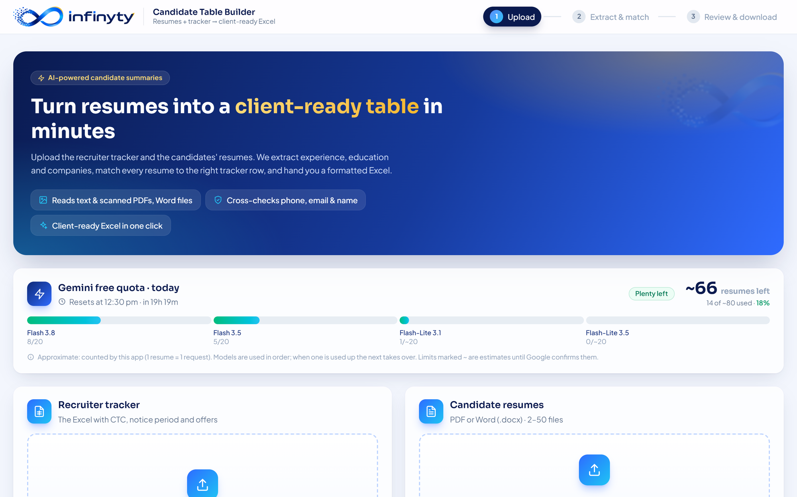
Figure 1. The home screen: banner, Gemini quota bar, and the two upload areas.

2. Technology stack
Layer | Technology | Why it is used
Frontend | React 18, TypeScript, Vite 6 | Single-page app; fast builds; type safety across the UI.
Styling | Tailwind CSS 4 (theme in index.css) | Brand colours and animations defined once as theme tokens.
PDF reading | pdf.js (pdfjs-dist 4) | Extracts text in the browser and draws pages in the Verify panel.
Word reading | mammoth | Extracts text / HTML from .docx files in the browser.
Backend | Python, FastAPI | Small HTTP API; Python has the best Excel and text-matching libraries.
Excel | openpyxl | Reads the tracker and writes the formatted output workbook.
Matching | rapidfuzz | Fast fuzzy comparison of names, companies and institutes.
AI | Google Gemini API (flash models) over HTTPS with httpx | Reads text and scanned PDFs; returns structured JSON.
Hosting | Vercel (services: web + api) | Free plan hosts the static site and the Python API together.
Usage counter | Local JSON file, or Upstash Redis when configured | Tracks the daily Gemini quota.

3. Architecture
The system has two parts that talk over HTTP: a React application that runs entirely in the user's browser, and a stateless FastAPI backend. The backend calls the Gemini API and keeps a small counter of the day's usage.
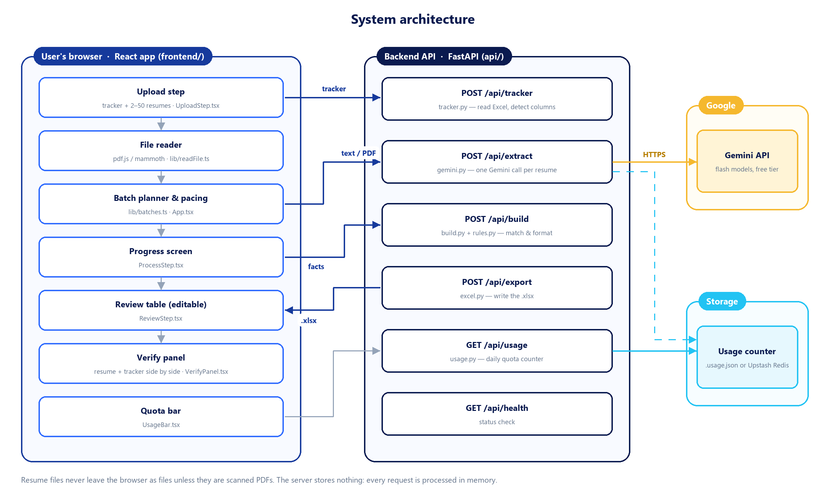
Figure 2. System architecture: browser components, backend endpoints and external services.

3.1 Responsibilities
Part | Responsible for | Not responsible for
Browser (React) | Reading files, deciding text vs. scanned, batching and pacing, showing progress, the editable review table, the Verify panel, triggering the download. | Any formatting rule or matching decision.
Backend (FastAPI) | Parsing the tracker, calling Gemini, matching resumes to tracker rows, applying every formatting rule, writing the Excel file, counting quota. | Storing files or results. Each request is independent.
Gemini | Extracting raw facts from one resume and returning JSON that follows a fixed schema. | Formatting, calculating experience, choosing which companies to show.

Why the split matters
Because rules live only in api/_core/rules.py and api/_core/build.py, a rule change is a Python change with no UI work, and the same resume always produces the same row for the same extracted facts.

4. Repository structure
Candidate-Table-Builder/
├── api/ Backend (FastAPI)
│ ├── index.py HTTP routes and request models
│ ├── requirements.txt Python dependencies
│ └── _core/
│ ├── tracker.py Read tracker Excel, detect columns by header text
│ ├── gemini.py Prompt, JSON schema, Gemini call, retries, model fallback
│ ├── rules.py Every formatting rule (experience, education, companies, CTC…)
│ ├── build.py Match resumes to tracker rows and build the table
│ ├── excel.py Write the output workbook (client sheet + Verification sheet)
│ └── usage.py Daily Gemini quota counter
├── frontend/ Frontend (React + Vite)
│ ├── index.html
│ ├── public/ logo.webp, mark.png
│ └── src/
│ ├── App.tsx Step control and the run orchestration (start → review)
│ ├── types.ts Shared TypeScript types
│ ├── index.css Tailwind theme, animations, viewer styles
│ ├── lib/
│ │ ├── api.ts Calls to the backend
│ │ ├── readFile.ts Read PDF / DOCX, decide text vs. scanned
│ │ ├── batches.ts Batch sizes and pacing constants
│ │ ├── evidence.ts Where each output value came from (Verify panel)
│ │ └── audit.ts Rows for the Verification sheet
│ └── components/
│ ├── UploadStep.tsx Tracker + resume upload, column mapping
│ ├── UsageBar.tsx Gemini quota bar
│ ├── ProcessStep.tsx Progress ring and resume queue
│ ├── ReviewStep.tsx Editable review table, download
│ ├── VerifyPanel.tsx Output vs. source, verified ticks
│ ├── ResumeViewer.tsx PDF / DOCX viewer with highlights
│ ├── TrackerViewer.tsx Tracker sheet grid with highlighted cells
│ └── ui.tsx, icons.tsx Shared building blocks
├── start.bat One-click local start on Windows
├── vercel.json Vercel services and rewrites
├── .env.example Template for the API key
└── README.md

Files that never go to git
.env (the API key), .venv/, node_modules/, frontend/dist/, every *.xlsx and .usage.json are listed in .gitignore.

5. End-to-end flow
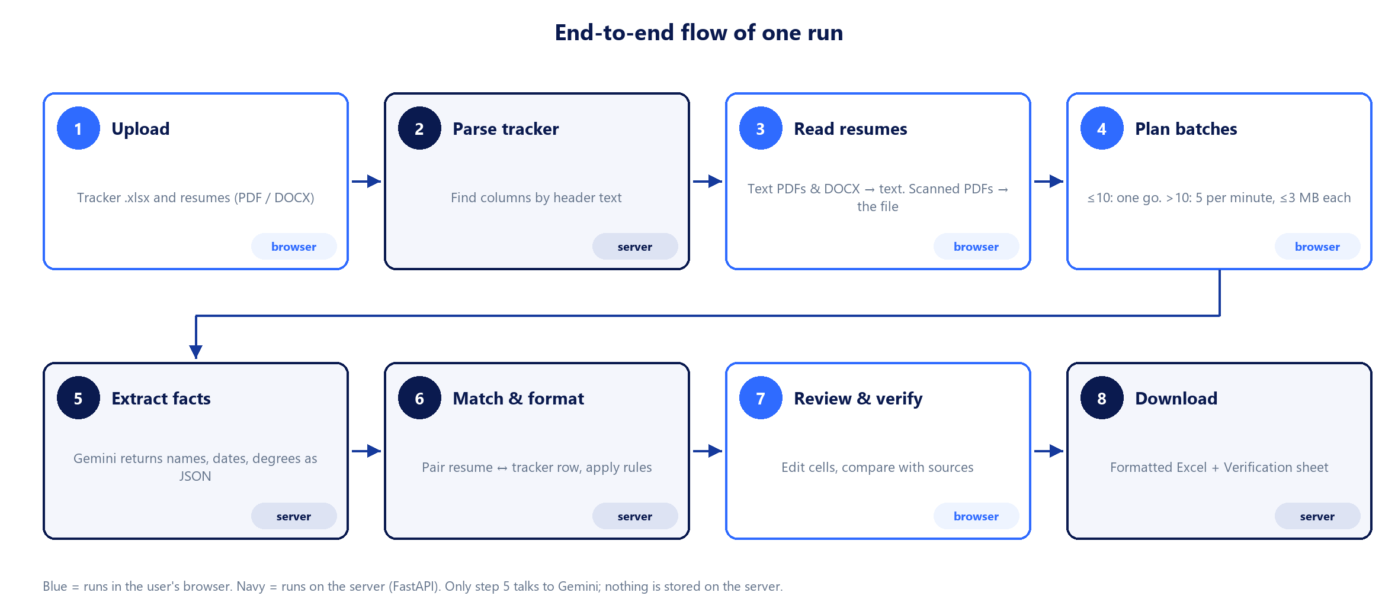
Figure 3. The eight steps of one run and where each one executes.

5.1 Step by step
# | Step | What happens | Code
1 | Upload | The user drops the tracker and the resumes (files or a whole folder). Non PDF/DOCX files are skipped with a notice. | UploadStep.tsx
2 | Parse tracker | The tracker is posted to /api/tracker. The server finds the header row and maps each needed field to a column by header text. The user can correct the mapping. | tracker.py
3 | Read resumes | Each file is opened in the browser. Text is extracted; a PDF with too little text is treated as scanned and sent as a file instead. | lib/readFile.ts
4 | Plan batches | Resumes are grouped into requests: all at once for 10 or fewer, otherwise 5 per minute; never more than about 3 MB per request. | lib/batches.ts, App.tsx
5 | Extract facts | /api/extract calls Gemini once per resume (up to 5 in parallel) and returns the facts as JSON. | gemini.py
6 | Match & format | /api/build pairs resumes with tracker rows, applies all formatting rules, and returns rows with a status and notes. | build.py, rules.py
7 | Review & verify | The user edits cells, marks rows red, and compares values with the resume and the tracker. | ReviewStep.tsx, VerifyPanel.tsx
8 | Download | /api/export writes the workbook. The browser names the file with the current date and time. | excel.py

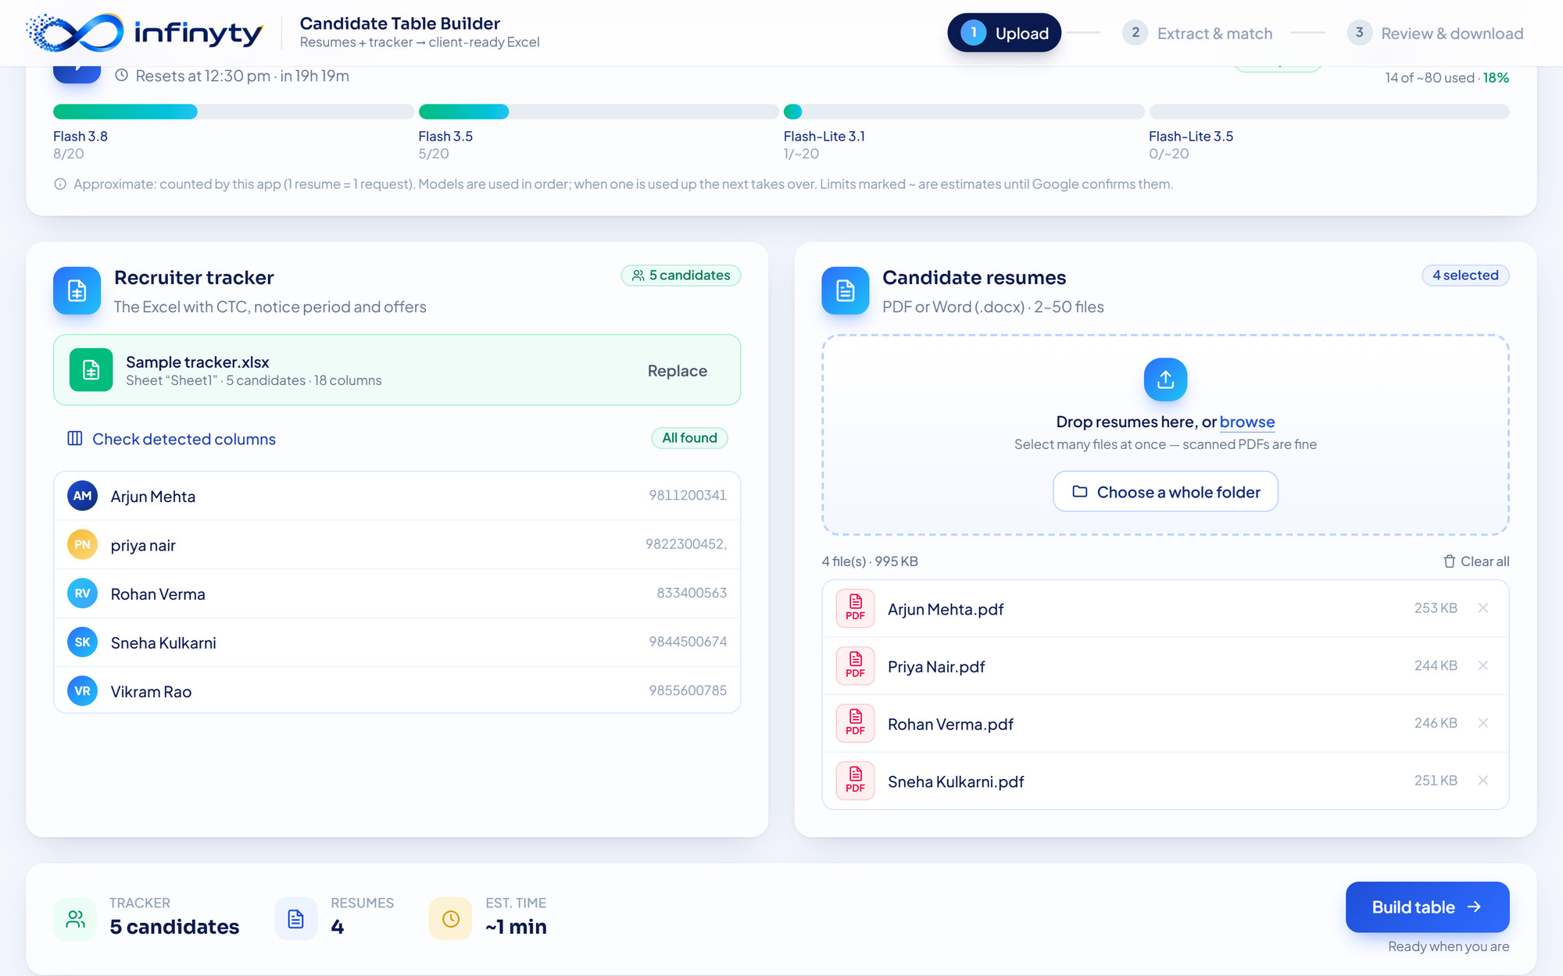
Figure 4. Upload screen with a tracker and four resumes loaded. The summary bar shows counts and the estimated time.
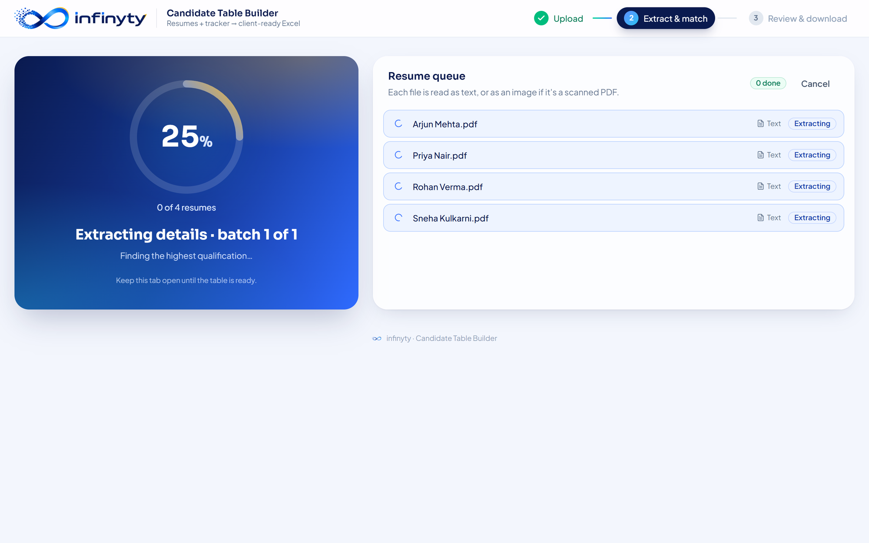
Figure 5. Processing screen: progress ring on the left, live status of each resume on the right.

6. Frontend

6.1 Screens and state
App.tsx owns the application state and switches between three steps: upload, process and review. There is no router and no global state library; state is passed to the step components as props.
State in App.tsx | Meaning
tracker, mapping | Parsed tracker (headers, rows, row numbers) and the field → column mapping.
files | The resume files the user selected.
jobs | One entry per resume during a run: file, read mode, extracted text, Gemini result, status.
run | Phase of the run (reading, extracting, waiting, building, done, error), batch number, countdown target.
table | The result: columns and rows. Each row carries values, status, notes, the tracker row index, highlight and verified.
elapsedMs | How long the run took, shown on the review screen.
usage | Gemini quota summary for the quota bar.

6.2 Reading a resume in the browser
Reading happens in the browser so that only a few kilobytes of text travel to the server, and the original file stays on the user's machine whenever possible.
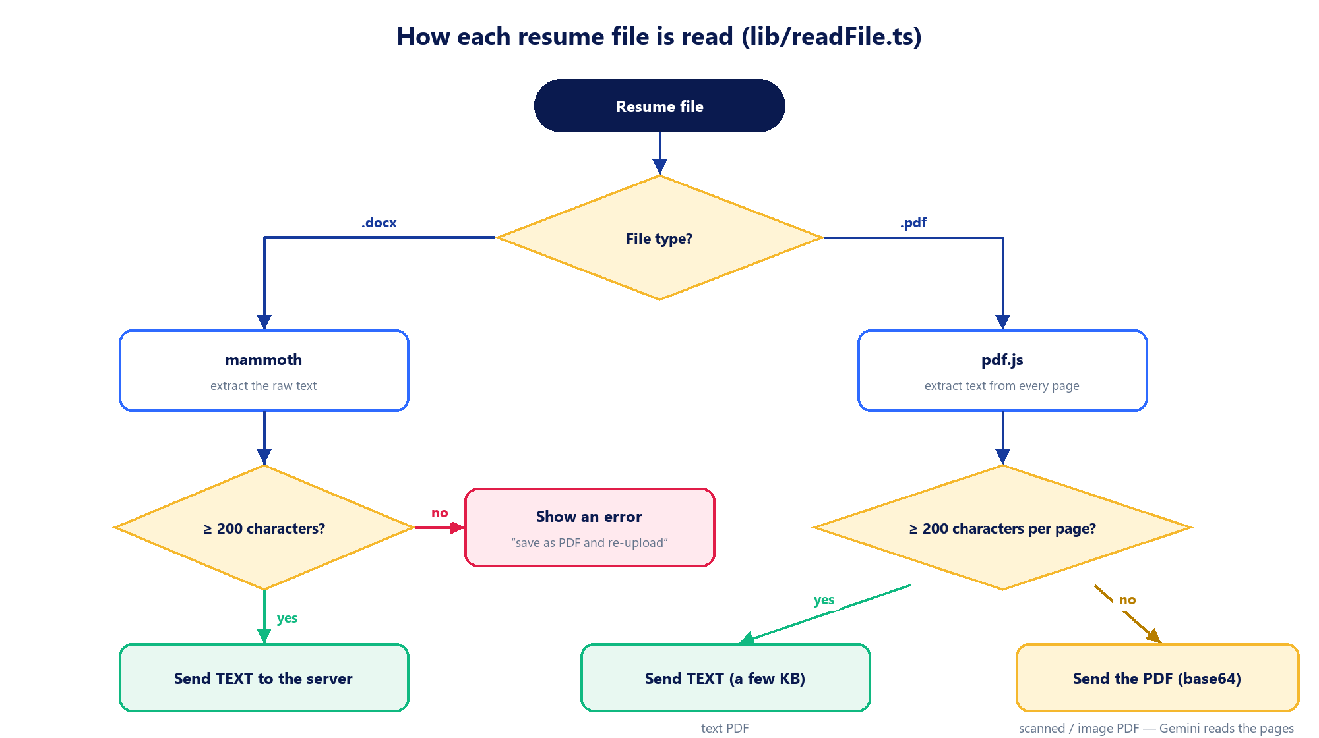
Figure 6. Decision made for every file in lib/readFile.ts.

6.3 Batching and pacing
Gemini's free tier limits requests per minute, and Vercel limits a request body to 4.5 MB. The browser therefore controls the timing. Constants are at the top of lib/batches.ts.
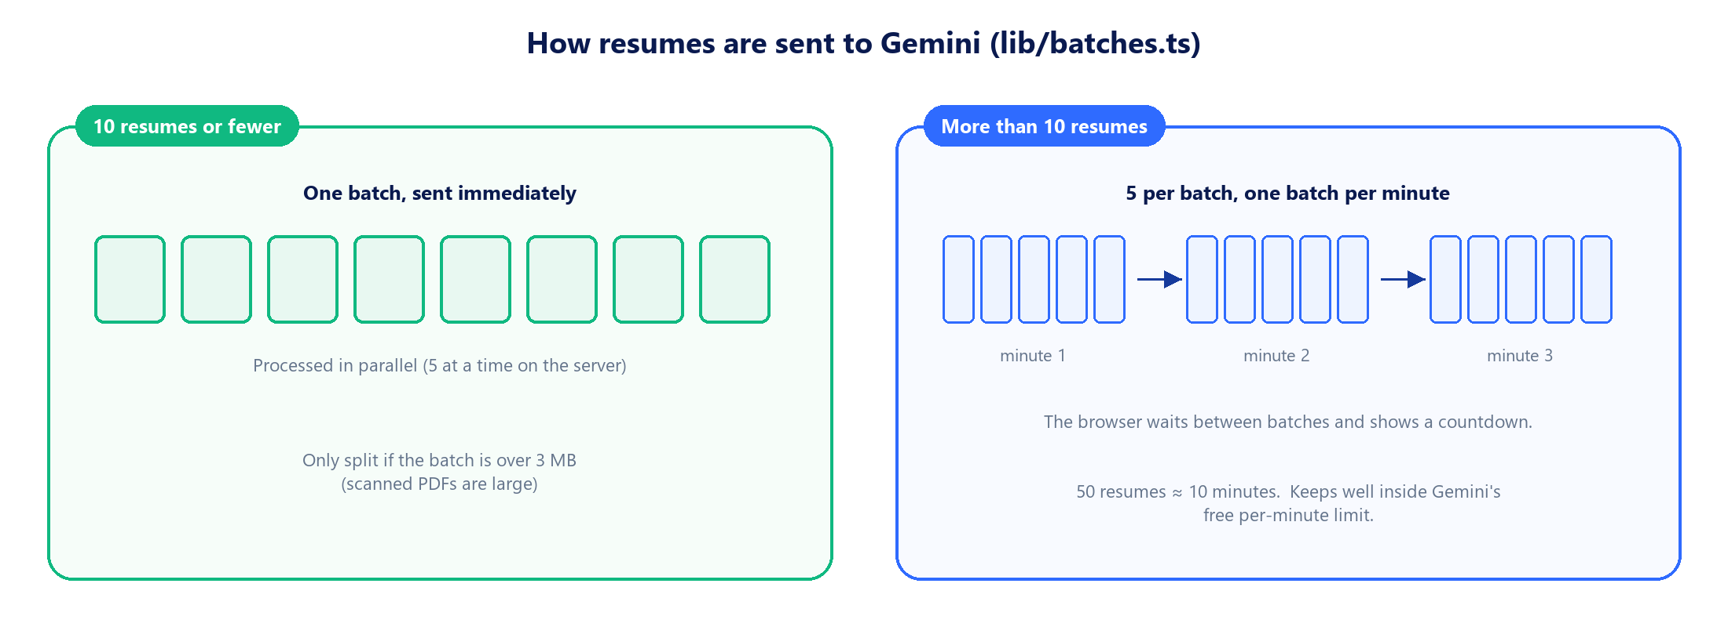
Figure 7. Small runs go at once; larger runs are paced at five resumes per minute.
Constant | Value | Meaning
SMALL_RUN_LIMIT | 10 | Up to this many resumes are sent without waiting.
PACED_BATCH_SIZE | 5 | Batch size for larger runs.
PACED_INTERVAL_MS | 60 000 | Time from the start of one batch to the start of the next.
MAX_BATCH_BYTES | 3 MB | Upper size of one request (text length or base64 length).
MIN_RESUMES / MAX_RESUMES | 2 / 50 | Allowed number of resumes per run (UploadStep.tsx).

6.4 Progress display
All resumes of a batch return together, so the true count would jump from 0% to 100%. ProcessStep.tsx shows an estimate instead: reading 5%, extraction 85%, matching 10%. While a batch is with Gemini, its share fills gradually and is capped below 100% until the results arrive. The value never moves backwards, and the animation uses timers so it keeps moving in a background tab.

6.5 Review screen
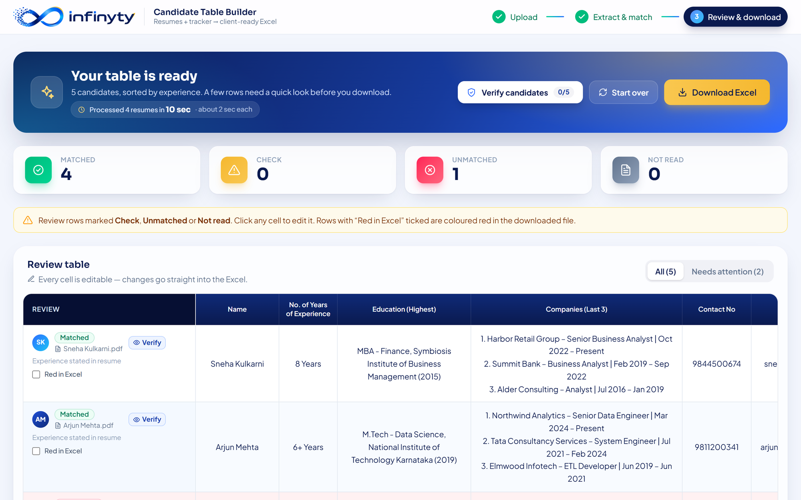
Figure 8. Review screen: processing time, status counts, and the editable table.
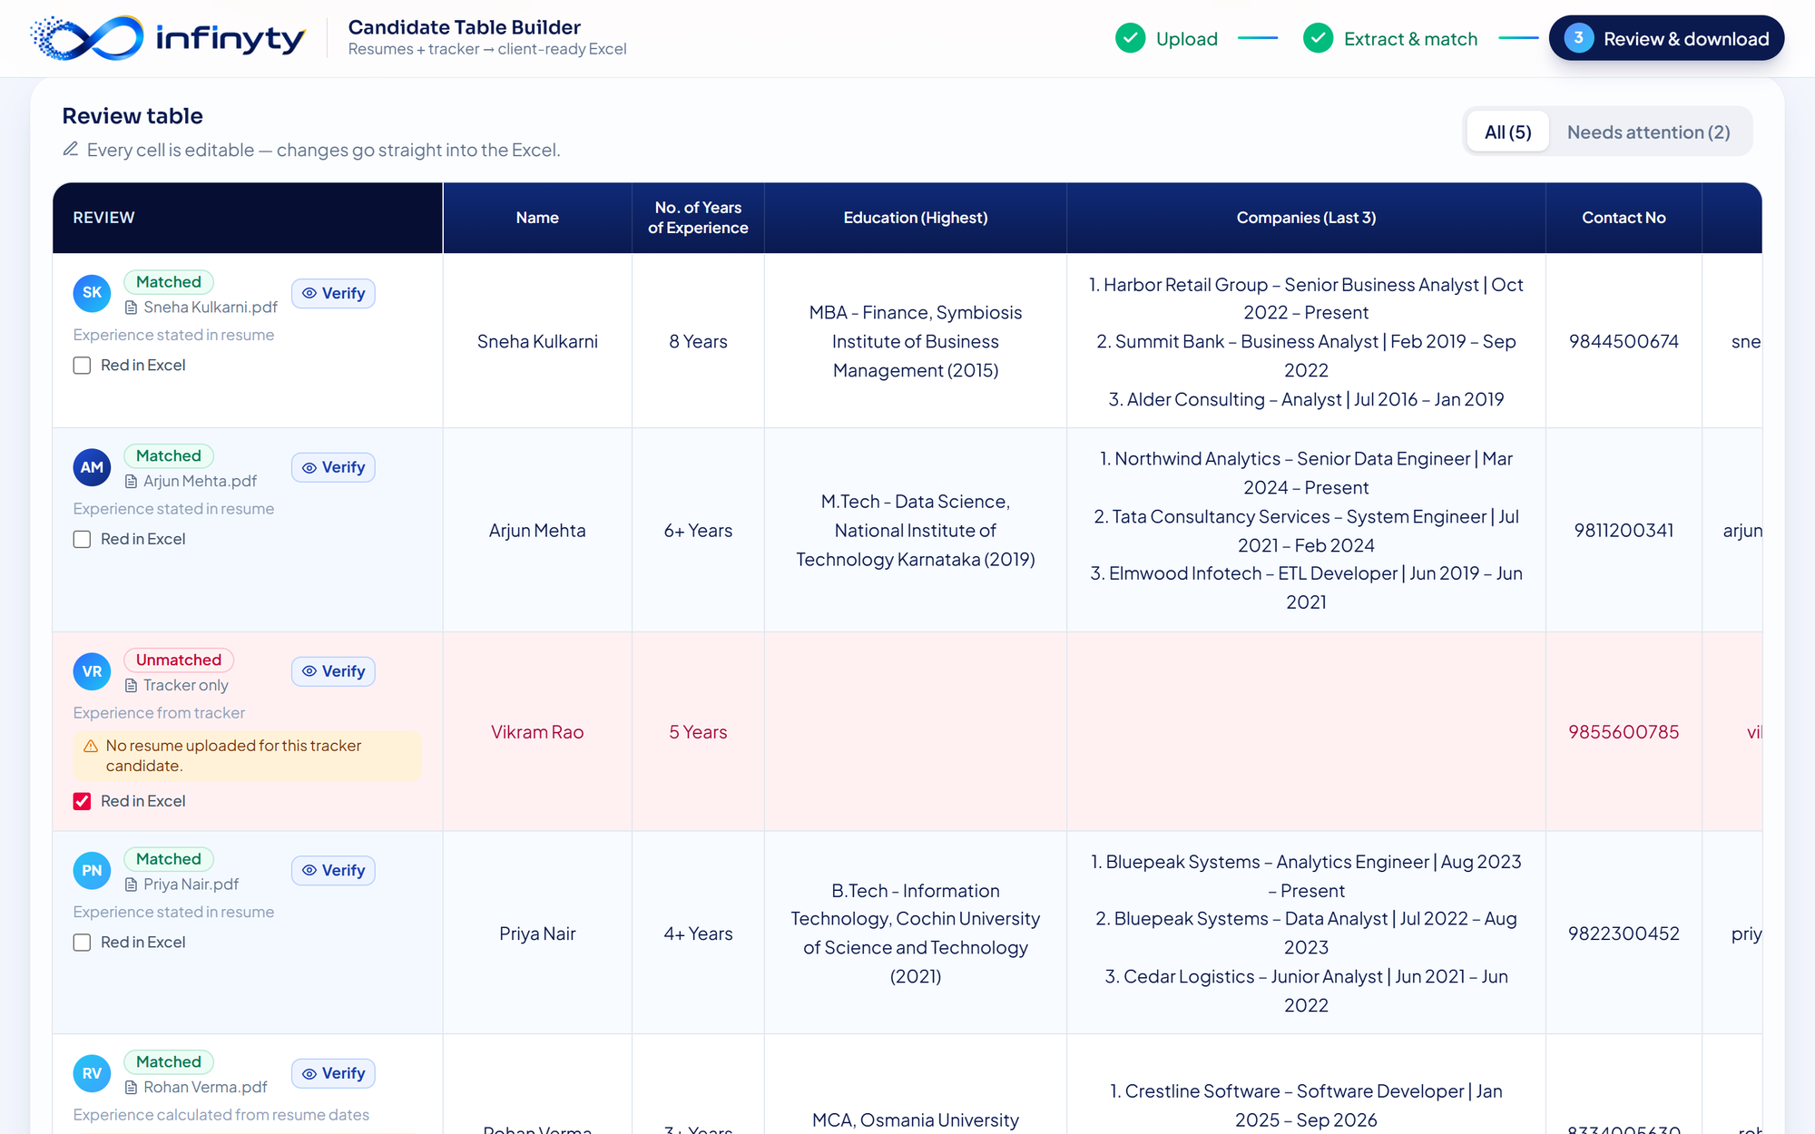
Figure 9. The review table. The red row is a tracker candidate with no resume; it will be red in the Excel as well.
- Every cell is editable (contentEditable); edits are stored in table.rows[].values and go straight into the export.
- “Red in Excel” controls the highlight flag. It is pre-ticked for Unmatched and Not read rows.
- “Needs attention” filters to rows that are not cleanly matched or that carry notes.

7. Backend API
The backend is one FastAPI application defined in api/index.py. All routes live under /api. Interactive documentation is available at /api/docs when the server is running.
Method & path | Input | Output | Module
GET /api/health | — | ok, current model, whether the API key is configured. | index.py
GET /api/usage | — | Per-model usage and limits, total remaining, reset time. | usage.py
POST /api/tracker | Multipart file (.xlsx) | headers, rows, row_numbers, detected mapping, field labels, required fields. | tracker.py
POST /api/extract | JSON: up to 20 resumes, each mode = text (with text) or file (with file_b64). | For each resume: data (facts) or error. | gemini.py
POST /api/build | JSON: resumes with their facts and text, tracker rows, mapping. | columns and rows; each row has values, status, notes, match, tracker_row, experience_source. | build.py, rules.py
POST /api/export | JSON: columns, rows (values, highlight, audit), audit column names. | The .xlsx file. | excel.py

7.1 Tracker parsing (tracker.py)
Tracker column order changes between roles, so columns are never addressed by letter. The header row is the first of the top ten rows that contains a candidate-name header. Each field is matched by keywords in the header text:
Field key | Header must contain | Required
name | “candidate name” (or exactly “name”) | Yes
phone | “contact”, “phone” or “mobile” | Yes
email | “email”, “e-mail” or “mail id” | Yes
current_ctc | “current ctc” | Yes
variable | “variable” | Yes
expected_ctc | “expected ctc” | Yes
notice | “notice” | Yes
offer | “offer” | Yes
total_exp | “total” together with “exp”, “yrs” or “year” | No
comments | “comment” or “remark” | No

Only the first sheet of the workbook is read. Rows without a candidate name are dropped. The Excel row number of each kept row is returned in row_numbers so the Verify panel can show references such as “E5”.

8. Gemini extraction
api/_core/gemini.py sends one request per resume to the Gemini REST API with temperature 0 and a response schema, so the answer is always JSON in a known shape. For a text resume the text is sent; for a scanned PDF the PDF itself is sent inline (base64) and Gemini reads the pages.

8.1 What Gemini returns
Field | Content
name | Full name as written.
phones, emails | Every phone number and email address of the candidate.
stated_total_experience | The exact phrase stating total experience (for example “6+ years of experience”), or null.
education[] | level (phd, masters, bachelors, diploma, school, other), degree, branch, institute, year. Missing parts are null.
experience[] | One entry per role: company, title, start_month, start_year, end_month, end_year, is_current, is_internship, is_client_project.

Client projects
IT-services resumes often list client assignments under the employer (for example Tata Consultancy Services → Orion Media). Gemini marks those entries with is_client_project = true and the code leaves them out of “Companies (Last 3)”. Freelance work and overlapping jobs are kept. If every entry is flagged, the flags are ignored.

8.2 Reliability: retries, fallback and time budget
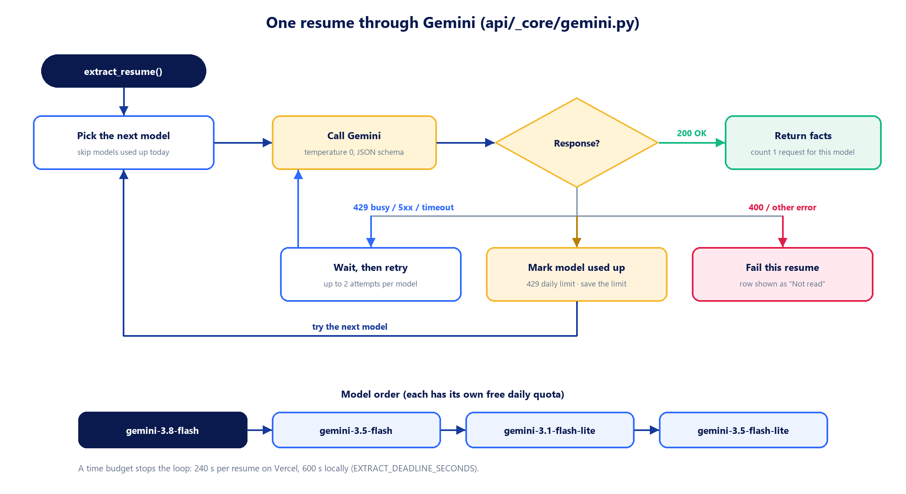
Figure 10. What happens to one resume inside extract_resume().
- Retry: busy (429 per-minute), 5xx and network errors are retried, up to 2 attempts per model, honouring the delay Gemini suggests.
- Fallback: when a model's free daily quota is used up, the next model in the chain is tried. Models already known to be used up today are skipped immediately.
- Time budget: each resume has a deadline (240 s on Vercel, 600 s locally) so a request can never exceed the hosting limit.
- Failure: if nothing works, the resume gets an error, and its row is shown as “Not read” with tracker data filled in.

8.3 Quota counter (usage.py)
Google has no API for remaining free quota, so the application counts its own successful calls per model for the current quota day (the day changes at midnight US Pacific time). When Google reports that a model's daily limit is reached, the model is marked used up and the limit Google quotes is saved, so the numbers correct themselves. The counter is stored in .usage.json locally, in /tmp on Vercel, or in Upstash Redis when UPSTASH_REDIS_REST_URL and UPSTASH_REDIS_REST_TOKEN are set.

9. Business rules
All rules are in api/_core/rules.py (formatting) and api/_core/build.py (choosing sources). This chapter is the reference for what the output must look like.

9.1 Rules per column
Column | Rule
Name | Name from the resume. Names written fully in upper or lower case are converted to title case. Falls back to the tracker name.
No. of Years of Experience | See 9.2. Shown as 4 Years or 4+ Years.
Education (Highest) | Highest level wins: PhD > Master's > Bachelor's > diploma. Format Degree - Branch, Institute (Year), using only parts the resume states. Long degree names are shortened (Bachelor of Technology → B.Tech). City and state are removed from the institute.
Companies (Last 3) | See 9.3. One line per company: 1. Company – Title | Mon YYYY – Present.
Contact No | 10 digits, without +91 or a leading 0. A valid number from the resume wins; a difference from the tracker is noted.
Email id | Lower case, spaces removed. Resume first, tracker otherwise; a difference is noted.
Current CTC (Fixed) + Any variable | Only the fixed amount, e.g. 12.3 Lpa, when variable is empty, NA, No, Nil or 0; otherwise 10 Lpa (Fixed) + 2 Lpa (Variable). A bare number gets “Lpa”.
Expected CTC (Fixed) | Copied from the tracker.
Notice Period/Offer status | The notice period as written, e.g. 60 Days. Only when there is an offer: <notice period> | <offer & DOJ>. Any “LWD …” inside the offer cell is removed; an empty, NA or “No offer” cell counts as no offer. “offer of X” becomes “offer X”.
Recruiter_Comments | Copied from the tracker's comments column.

9.2 Years of experience
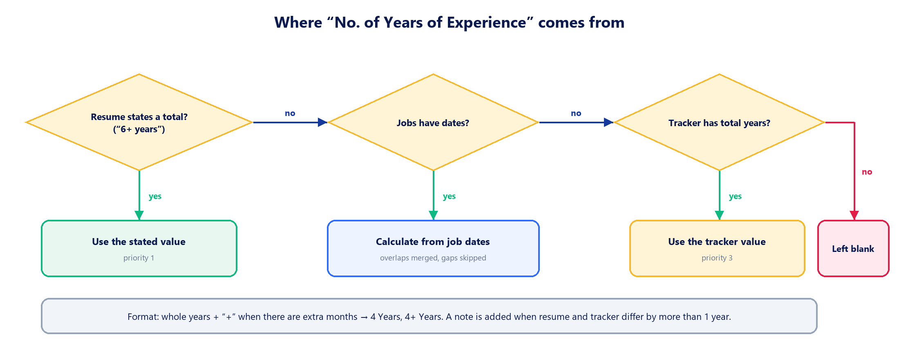
Figure 11. Priority of sources for the experience column.
When calculating from dates, every role becomes a month interval; overlapping intervals are merged and gaps between jobs are not counted. A current role runs to the current month. If the resume value and the tracker value differ by more than one year, a note is added to the row.

9.3 Companies (Last 3)
1. Client-project entries are removed (see 8.1).
2. Roles are ordered most recent first. If any role has no start year, the resume's own order is kept.
3. Consecutive roles at the same employer are grouped. Company names are compared without suffixes such as Pvt, Ltd, Technologies.
4. The three most recent companies get one line each: the latest title, and the date range of the whole stay.
5. If the candidate has fewer than three companies, the spare lines are used to list individual roles, most recent company first.
Candidate history | Output
Five companies | The three most recent companies, one line each.
One company, three roles | Three lines, one per role, all with the same company name.
Two companies, the first with two roles | Two lines for the first company's roles, one line for the second company.

10. Matching and validation
Matching is the step that prevents one candidate's CTC from landing on another candidate's row. It is implemented in match() and build_table() in api/_core/build.py.
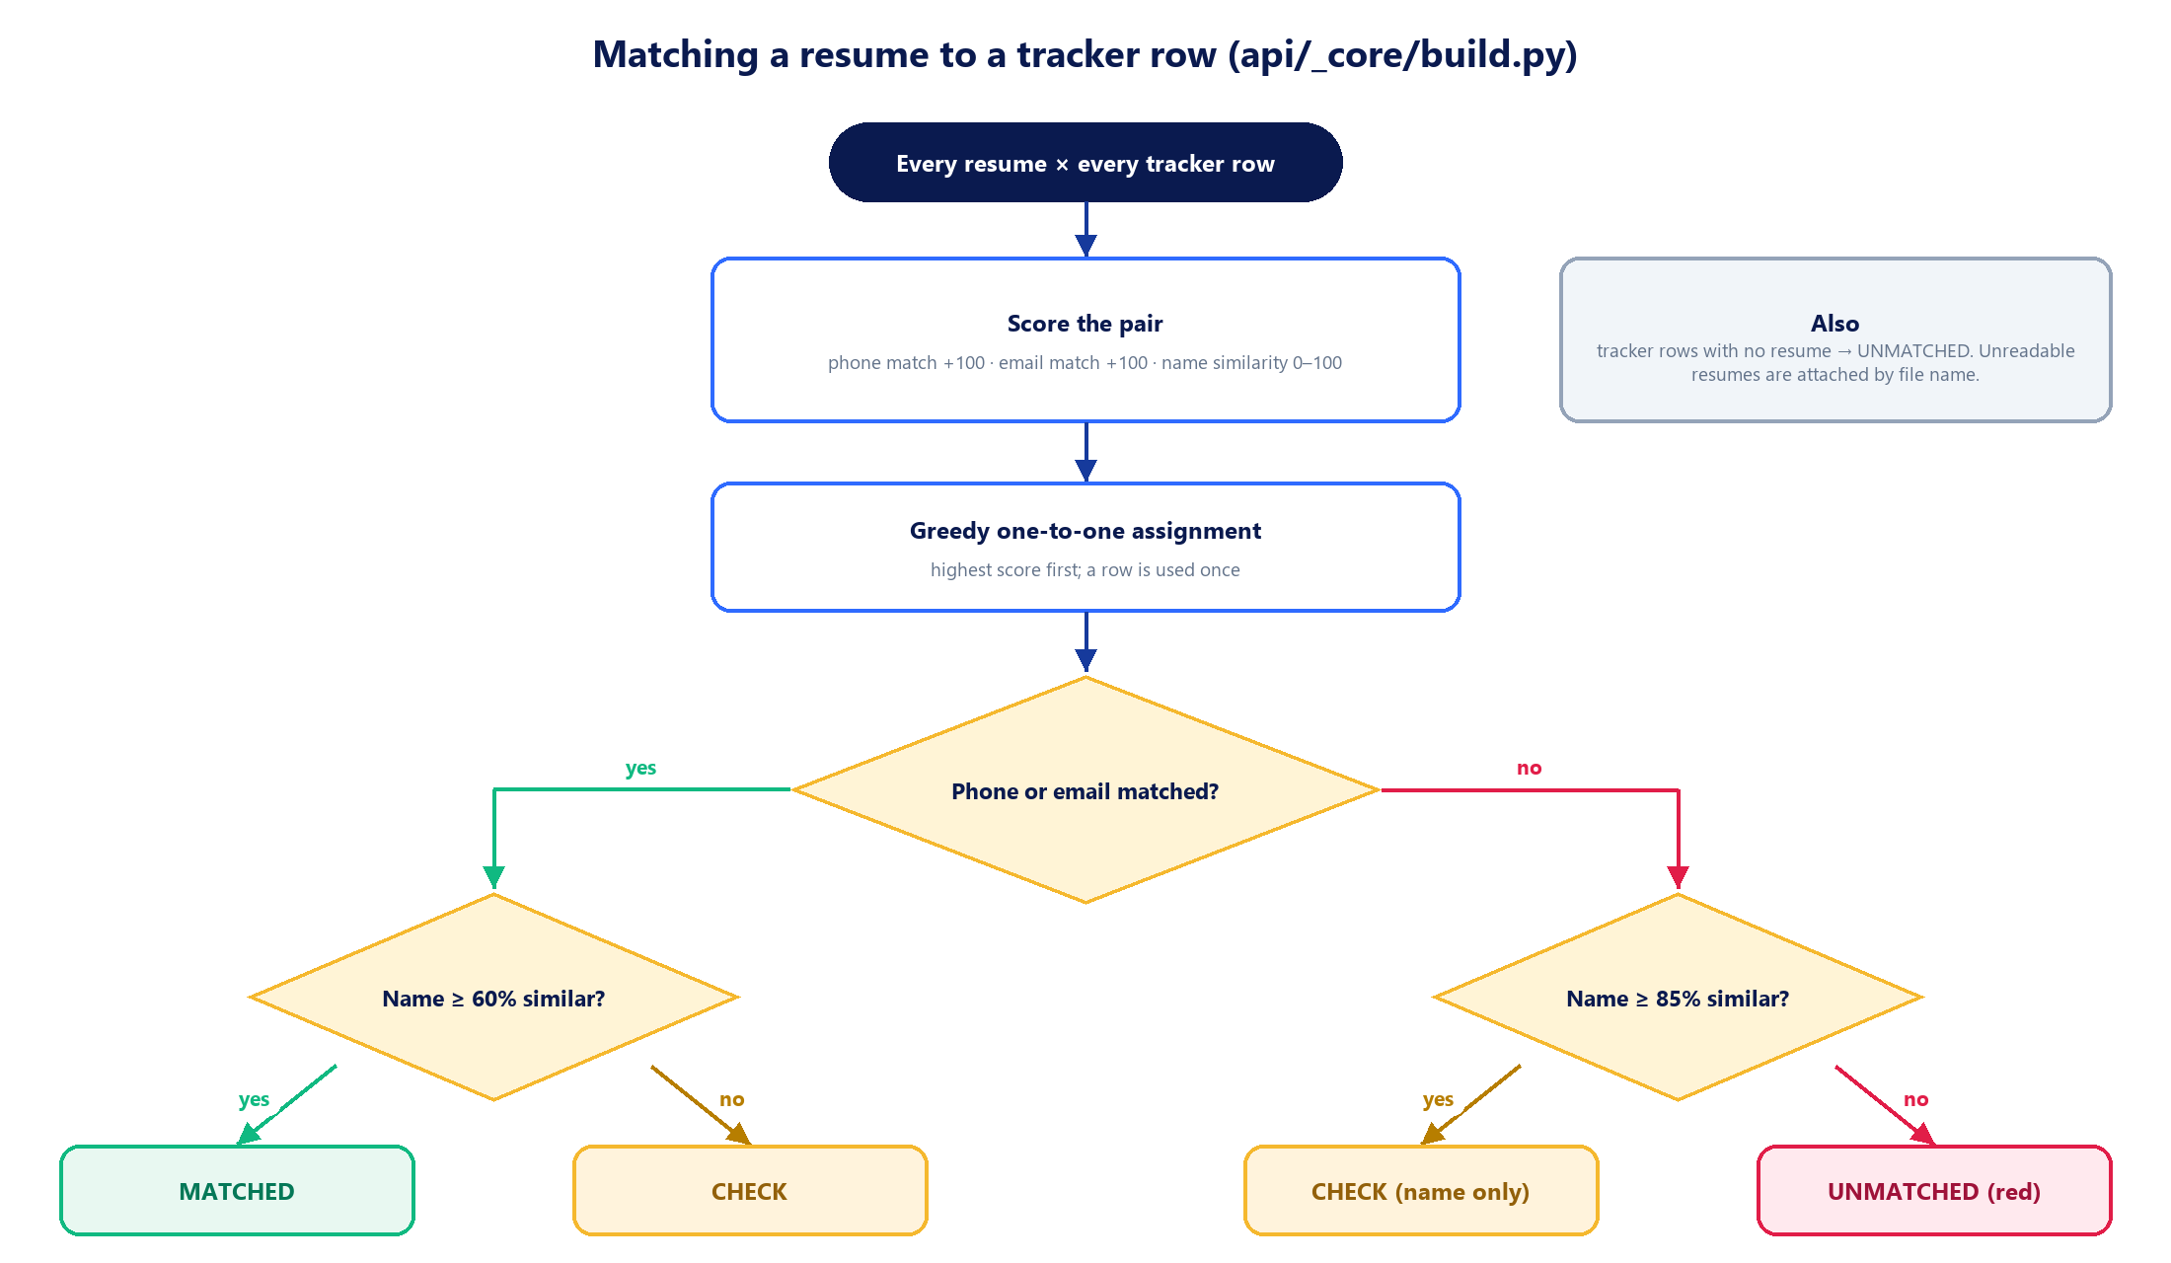
Figure 12. How a resume is paired with a tracker row and which status it receives.
Status | Meaning | In the Excel
Matched | Phone or email agrees and the names are similar. | Normal row
Check | Matched on name only, or phone/email agree but the names differ, or two resumes competed for one row. | Normal row (the user decides)
Unmatched | A resume with no tracker row, or a tracker row with no resume. | Red row
Not read | The resume could not be extracted. Tracker data is filled in if the file name matches a candidate. | Red row

- Phone comparison tolerates a tracker number with a missing or extra digit (for example 833400563 vs 8334005630).
- The file name is also compared with the tracker name, because resumes are usually saved under the candidate's name.
- For text resumes, a fact check confirms that the institute, graduation year and company names appear in the resume text; anything that does not is added to the row's notes.

11. Verification tools

11.1 Verify panel
The Verify panel puts the output next to its sources. The left side shows the resume or the tracker sheet; the right side shows one card per output column with its value, its source and a check result.
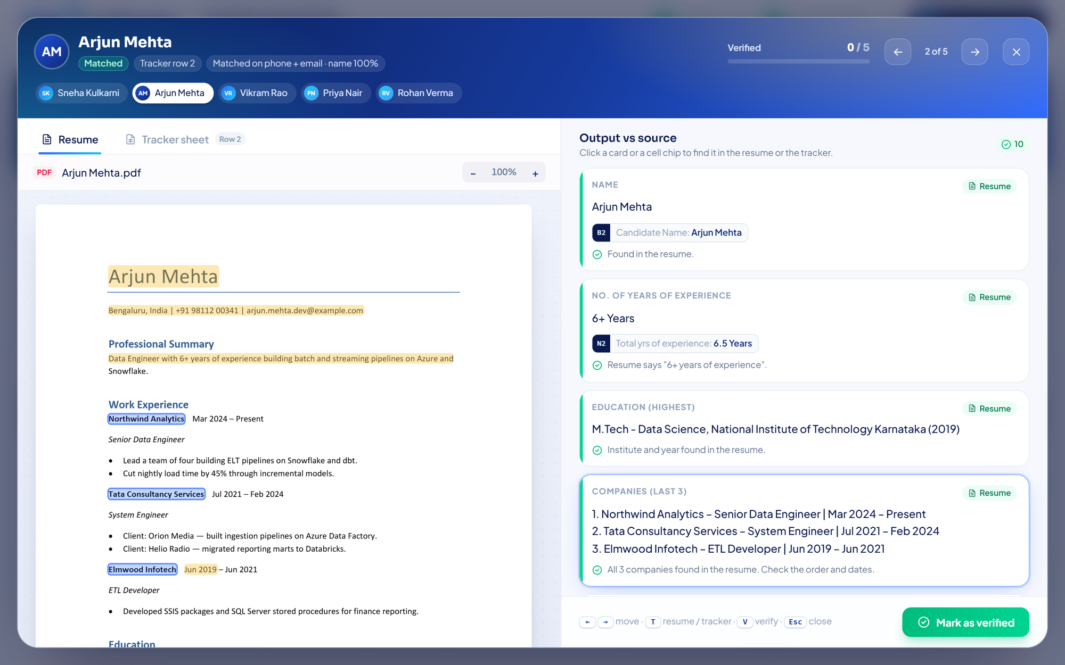
Figure 13. Verify panel, Resume tab. Extracted values are highlighted; clicking a card jumps to the value on the page.
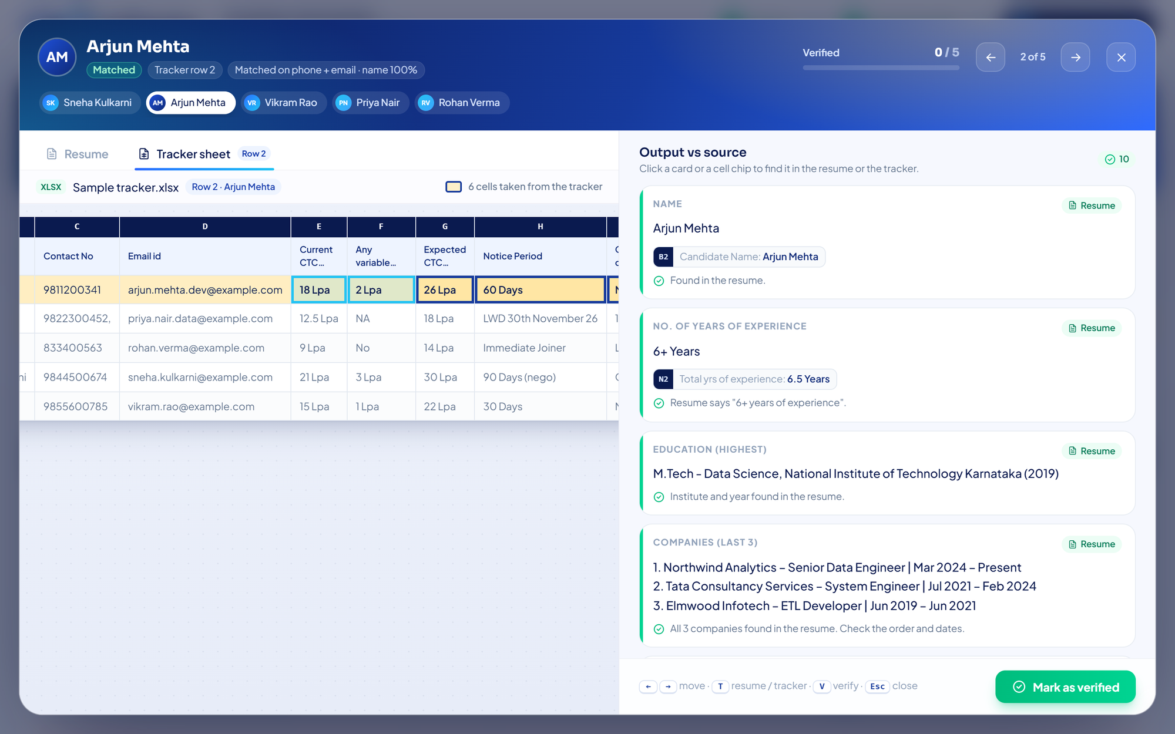
Figure 14. Verify panel, Tracker sheet tab. The candidate's row is gold; cells taken only from the tracker have a dark frame.
Piece | File | Role
Evidence | lib/evidence.ts | For each column: source (resume, tracker, calculated), status (ok, warn, info, missing), the words to highlight, and the tracker cells involved.
Resume viewer | ResumeViewer.tsx | Draws PDF pages with pdf.js and a text layer, or a .docx as HTML, and highlights matching text.
Tracker viewer | TrackerViewer.tsx | Shows the whole sheet with column letters and row numbers; highlights the row and frames tracker-only cells.
Panel | VerifyPanel.tsx | Navigation, keyboard shortcuts (← → move, T switch tab, V verify, Esc close), verified ticks.

Scanned resumes
A scanned PDF has no text layer, so nothing can be highlighted and resume values are marked for a visual check. Tracker values are still compared.

11.2 Verification sheet
The downloaded workbook has two sheets. Candidates is the client table. Verification is for the recruiter and lists, for every row: resume file, how it was read, match result and evidence, tracker row, the raw tracker values, the experience source, the Gemini model used, whether the row was marked verified, and any notes. The rows are built in lib/audit.ts and written by _audit_sheet() in excel.py.

12. Excel output format
Aspect | Setting (api/_core/excel.py)
Sheet name | Candidates (first sheet), Verification (second sheet)
Header row | Bold white text on dark blue (1F4E78), centered, frozen
Cells | Centered horizontally and vertically, wrapped text, thin black borders, stored as text so phone numbers keep their digits
Column widths | WIDTHS dictionary, in Excel character units
Row heights | Estimated from the longest wrapped cell, because Excel does not auto-fit rows written by a library
Red rows | Light red fill (FFC7CE) with dark red text when highlight is true
File name | Set in the browser: YYYY-MM-DD_HH-MM-SS.xlsx
Row order | Most experienced first

13. Configuration
Configuration is read from environment variables. Locally they come from the .env file in the project root; on Vercel they are set in the project settings.
Variable | Default | Purpose
GEMINI_API_KEY | — (required) | Google AI Studio API key.
GEMINI_MODEL | gemini-3.8-flash | Main model.
GEMINI_FALLBACK_MODELS | gemini-3.5-flash, gemini-3.1-flash-lite, gemini-3.5-flash-lite | Comma-separated models tried when the main one is busy or out of daily quota.
GEMINI_DAILY_LIMITS | 20 per model | Optional override of daily limits for the quota bar, e.g. gemini-3.1-flash-lite:500.
EXTRACT_PARALLEL | 5 | Resumes sent to Gemini at the same time within one request.
EXTRACT_DEADLINE_SECONDS | 240 on Vercel, 600 locally | Time budget for one resume.
UPSTASH_REDIS_REST_URL, UPSTASH_REDIS_REST_TOKEN | not set | When both are set, the quota counter is stored in Upstash Redis and shared by all users.

Keep the key private
The API key belongs only in .env (ignored by git) or in Vercel's environment variables. Never commit it and never paste it into code.

14. Running the project

14.1 One-click start (Windows)
Double-click start.bat. It installs Python and Node.js if they are missing, creates or repairs the Python environment, builds the dashboard, asks for the Gemini key if there is no .env, and starts the app at http://localhost:8000. In this mode FastAPI also serves the built frontend from frontend/dist.

14.2 Developer mode
# Terminal 1 – API on port 8000, restarts on code changes
.venv\Scripts\python -m uvicorn api.index:app --reload --port 8000

# Terminal 2 – frontend on port 5173, hot reload; /api is proxied to port 8000
cd frontend
npm run dev

Remember to restart
A server started without --reload keeps running the old Python code. After a backend change, restart it; after a frontend change with start.bat, rebuild with npm run build and refresh the page.

15. Deployment
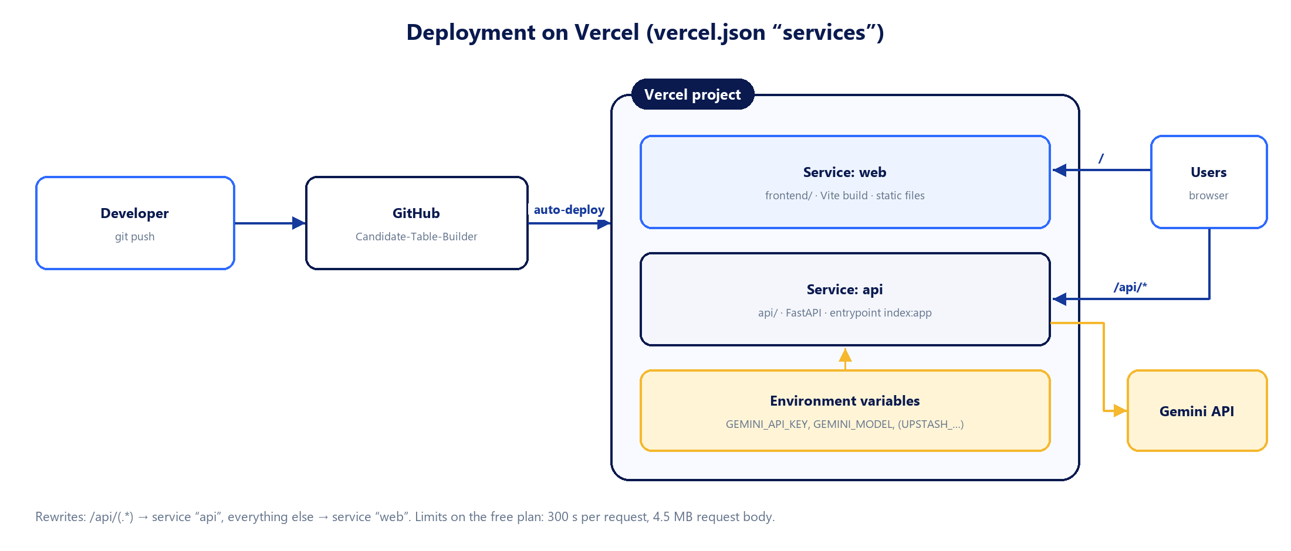
Figure 15. Deployment: GitHub pushes trigger a Vercel build of both services.
vercel.json declares two services in one project and routes requests between them:
{
"services": {
"web": { "root": "frontend/", "framework": "vite" },
"api": { "root": "api/", "framework": "fastapi", "entrypoint": "index:app" }
},
"rewrites": [
{ "source": "/api/(.*)", "destination": { "service": "api" } },
{ "source": "/(.*)", "destination": { "service": "web" } }
]
}

1. Push to the main branch on GitHub.
2. In Vercel, import the repository once as a single project (application preset “Services”).
3. Add GEMINI_API_KEY and GEMINI_MODEL under Environment Variables.
4. Deploy. Later pushes redeploy automatically.
5. Check https://<project>.vercel.app/api/health — it should report key_configured: true.

16. Limits and known constraints
Area | Constraint | Effect / workaround
Gemini free tier | About 20 requests per model per day (measured on the flash models). | The fallback chain gives roughly 60–80 resumes a day. Do large runs early; lite models are less accurate.
Quota bar | An estimate. Calls made with the same key outside the app are not counted. | Limits correct themselves when Google reports a limit reached.
Quota counter | One counter, not separated per API key; on Vercel without Upstash it resets when the instance restarts. | Configure Upstash, or delete .usage.json after changing the key.
Vercel free plan | 300 s per request, 4.5 MB request body. The Hobby plan is intended for non-commercial use. | Batches are capped at 3 MB; each resume has a 240 s budget.
Scanned PDFs | No text layer. | Gemini reads the pages; no highlights and no automatic text checks.
File types | PDF and .docx only. Old .doc files are not supported. | Save as PDF or .docx.
Tracker | Only the first sheet is read. | Put candidates on the first sheet.
Browser tab | The browser schedules the batches. | Keep the tab open during a run.
Access | No login or password. | Share the URL only with the team, or add authentication before wider use.
AI variation | Gemini may copy a title or company slightly differently between runs. | Rules normalise common cases; the review screen and Verify panel catch the rest.

17. How to extend the project
The tables below list the files to touch for the most likely changes. After any change to rules or extraction, run the regression check described in chapter 18.

17.1 Add an output column that comes from the tracker
Step | File | Change
1 | api/_core/tracker.py | Add the field to FIELDS with a header matcher (and to REQUIRED_FIELDS if it must exist).
2 | api/_core/build.py | Add the column name to COLUMNS and fill it in tracker_part().
3 | api/_core/excel.py | Add a width to WIDTHS.
4 | frontend/src/types.ts | Add the key to FieldKey.
5 | frontend/src/components/ReviewStep.tsx | Add a minimum width to WIDTH.
6 | frontend/src/lib/evidence.ts | Add a fromTracker(...) line so the Verify panel shows the source cell.

17.2 Add an output column that comes from the resume
Step | File | Change
1 | api/_core/gemini.py | Describe the new fact in PROMPT and add it to SCHEMA (and to required).
2 | api/_core/rules.py | Write a function that formats the fact.
3 | api/_core/build.py | Add the column to COLUMNS and set its value where resume values are filled.
4 | excel.py, ReviewStep.tsx | Add widths, as in 17.1.
5 | frontend/src/lib/evidence.ts | Add an evidence block with the terms to highlight.

17.3 Other common changes
Goal | Where
Change how a value is formatted | The matching function in api/_core/rules.py.
Change matching strictness | NAME_STRONG (85) and NAME_WEAK (60) in api/_core/build.py.
Use a different Gemini model | GEMINI_MODEL / GEMINI_FALLBACK_MODELS in .env or Vercel settings. No code change.
Use a different AI provider | Replace the body of extract_resume() in gemini.py. It must return the same facts dictionary (chapter 8.1).
Change batch size or pacing | Constants in frontend/src/lib/batches.ts.
Change the Excel look | Fills, fonts and WIDTHS at the top of api/_core/excel.py.
Change colours or animations | @theme block and keyframes in frontend/src/index.css.
Support another file type | readResume() and isResumeFile() in frontend/src/lib/readFile.ts, and the accept attribute in UploadStep.tsx.
Add a login | A FastAPI dependency on the routes in api/index.py, plus a sign-in screen in App.tsx.

18. Testing and troubleshooting

18.1 Regression check
The repository has no automated test suite yet. During development, changes were verified with a regression check that is worth keeping as a habit:
1. Keep one or two sample sets (tracker + resumes) outside the repository, because they contain personal data.
2. Extract each resume once and save the Gemini results to a JSON file. This avoids spending quota on every check.
3. After a change, run build.build_table() on the saved facts and compare every cell with the previous output.
4. Only the differences you intended should appear.
Recommended next step
Add pytest tests for api/_core/rules.py. The functions are pure (text in, text out), so cases such as format_notice_offer("14 Days", "LWD: 20th Oct'26; Have an offer 20 Lpa") are quick to write and protect the client format.

18.2 Troubleshooting
Symptom | Likely cause | Fix
“Row NaN” or empty tracker cells in the Verify panel | The backend is running old code. | Restart the server (close and re-run start.bat).
Rows show “Not read” with a daily-limit message | All Gemini models are out of free quota. | Wait for the reset shown on the quota bar, or use another key.
“Could not read the tracker” | The file is not a real .xlsx, or the first sheet is empty. | Re-save the tracker as .xlsx.
A required tracker column is not found | The header text changed. | Pick the column in “Check detected columns”, or extend the matcher in tracker.py.
Quota bar shows models as used up after changing the key | The counter belongs to the old key. | Delete .usage.json and restart.
start.bat says the port is in use | The app is already running. | Use the open browser tab, or close the other window.
A client name appears in Companies | Gemini did not flag a client project. | Edit the cell in the review table; adjust the prompt in gemini.py if it repeats.
/api/health shows key_configured: false | The key is missing. | Add GEMINI_API_KEY to .env or the Vercel settings and restart / redeploy.

19. Glossary
Term | Meaning
Tracker | The recruiter's Excel file with one row per candidate.
CTC / Lpa | Cost to company (annual salary) in lakhs per annum.
LWD / DOJ | Last working day / date of joining.
Text mode / file mode | Whether a resume was sent to Gemini as extracted text or as the PDF itself (scanned).
Facts | The JSON Gemini returns for one resume, before any formatting.
Mapping | Which tracker column holds which field, e.g. current_ctc → column E.
Evidence | For each output value: where it came from and whether it was found in the source.
Quota day | The 24 hours between two resets of Gemini's free daily quota (midnight US Pacific time).

