
INFINYTY CRM
How a lead travels from the first call to a signed deal
The team, the stages, and everything you can do in the application.
  The team  Three roles and who does what |  |   The journey  Seven stages and two endings |  |   Everything you can do  Every feature, in short lists

The big picture
Every person or company that might become a client is called a lead. Infinyty CRM keeps every lead in one shared place and moves it through seven steps, from the first contact to a signed deal.
A lead ends in one of two ways: Won (the client signs) or Lost (the lead is closed with a reason).
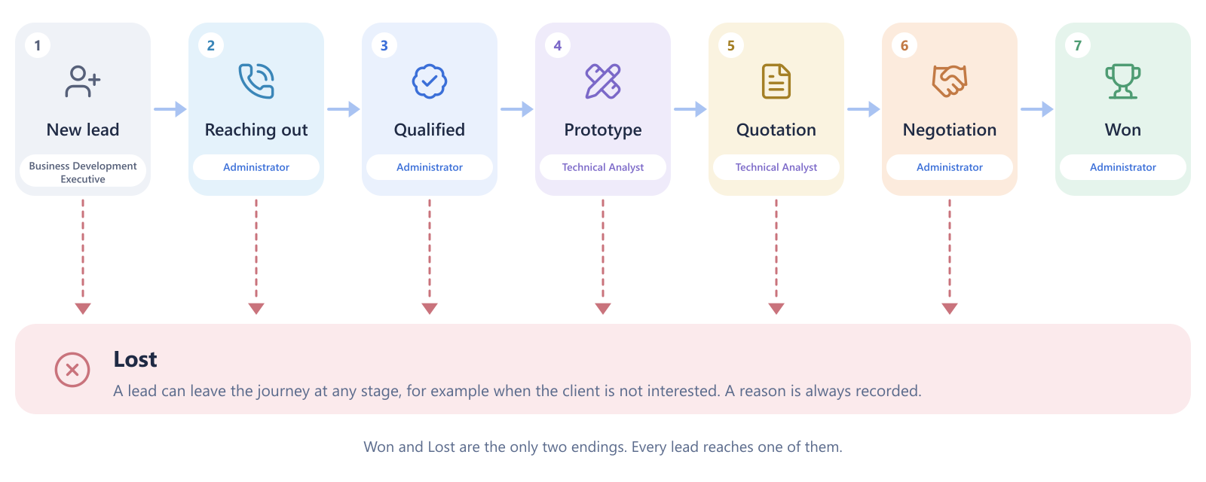
One path for every lead  Everyone follows the same steps, so nobody has to guess where a lead stands. |  |   Every stage has an owner  Each stage belongs to one role. When a lead enters it, the right person is told automatically. |  |   Nothing is forgotten  Calls, notes, follow-ups, files and every move are saved on the lead.

Lost is a clear ending, not a loose end
A lead can be closed as Lost from any stage. A reason is always recorded, so the founders can see why deals do not close.

Your team and their roles
Three roles share the work. Each role sees what it needs and nothing more.
  Business Development Executive  Opens the door  - Adds leads by hand or from a file  - Completes and corrects contact details  - Sees the leads they added or own |  |   CRM Administrator  Builds the relationship  - Calls, qualifies and follows up  - Negotiates and closes deals  - Sees every lead, the dashboard, the team and settings |  |   Technical Analyst  Builds the solution  - Collects the client's requirements  - Builds prototypes and prepares the quotation  - Sees leads from Prototype onward, and any lead assigned to them

Who can do what
 | Administrator | Technical Analyst | Business Development Executive
See leads | All leads | Prototype onward, plus assigned | Their own leads
Add or import leads | ✓ | ✓ | ✓
Log calls, notes and follow-ups | ✓ | ✓ | ✓
Requirements and prototype rounds | ✓ | ✓ | ✓
Move a lead to another stage | ✓ | ✓ | ✓
Hand a lead to a colleague | ✓ | ✓ | –
Delete a lead | ✓ | – | –
Dashboard | ✓ | – | –
Add team members, edit dropdown lists | ✓ | – | –

Who holds the lead at each step
A lead is always held by one person. When it moves into a stage that belongs to another role, the CRM hands it over automatically.
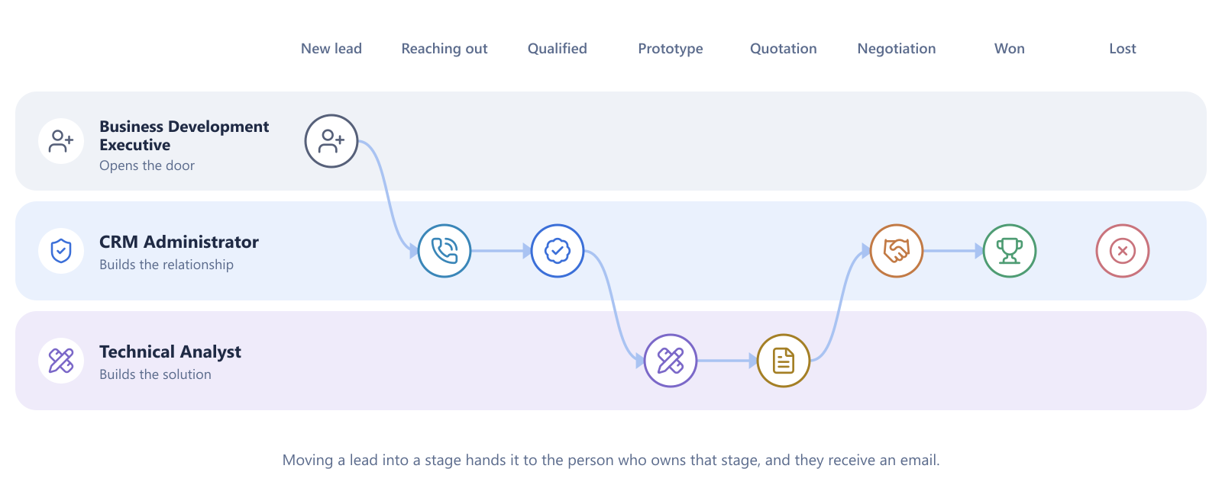
- The new owner is the person with that role who has the fewest open leads.
- If the person moving the lead already has that role, they keep it.
- The new owner receives an email with a link to the lead.
- Won and Lost never hand a lead over. The person who closes the deal stays as the owner.

One lead, from entry to signed deal
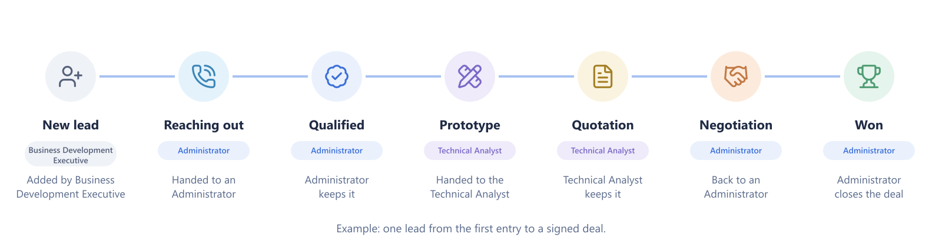

Stage by stage
For each stage: what it is for, what the team does, and what can happen next. Green means the lead moves forward, blue means it stays and the work continues, rose means it becomes Lost.

1 New lead
OWNED BY  Business Development Executive | GOAL  Get the lead into the system with correct contact details.

- A lead arrives from a call, a WhatsApp chat or an Excel sheet.
- It is added by hand (company, contact person, phone, email, source, priority, budget), or imported from a file or pasted from Google Sheets.
- The CRM checks the phone number and email. If the lead already exists, it warns you and offers to open the existing one.
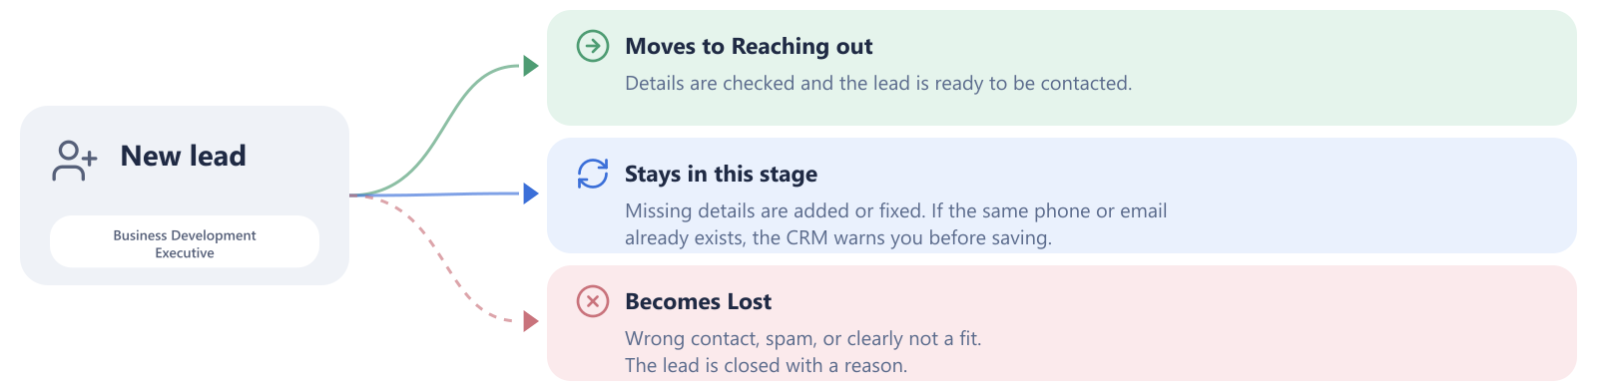

 2 Reaching out
OWNED BY  CRM Administrator | GOAL  Speak to the right person and find out whether there is real interest.

- Every call, WhatsApp, email or note is logged. Calls get an outcome: answered, no answer, busy, interested, not interested or callback requested.
- Every conversation ends with the next follow-up, so no lead is left waiting.
- A reminder email arrives before each follow-up is due.
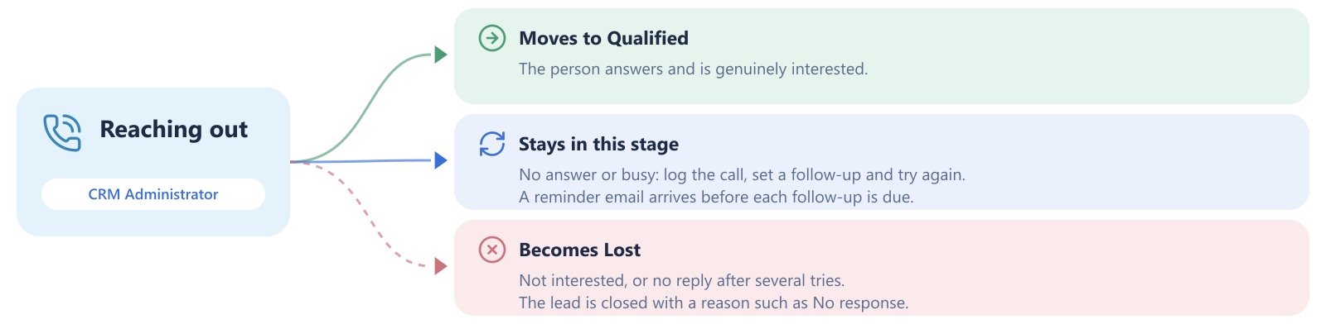

The follow-up cycle
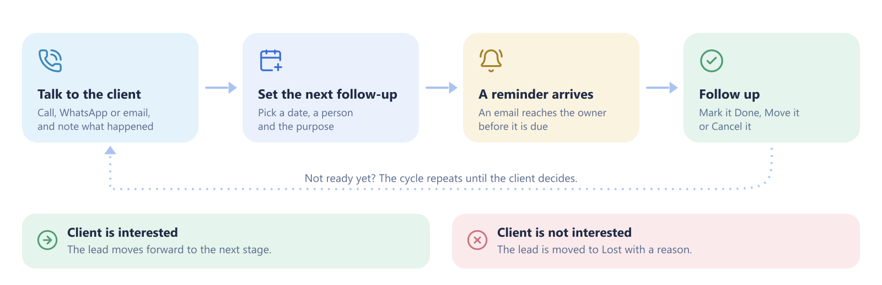

 3 Qualified
OWNED BY  CRM Administrator | GOAL  Confirm that the client has a real need, a budget and a timeline.

- Add everyone involved as contact people on the lead.
- Set the priority (High, Medium or Low) and the estimated budget.
- Hold a meeting if needed and note what was agreed.
- When the picture is clear, the lead moves to Prototype and is handed to the Technical Analyst.
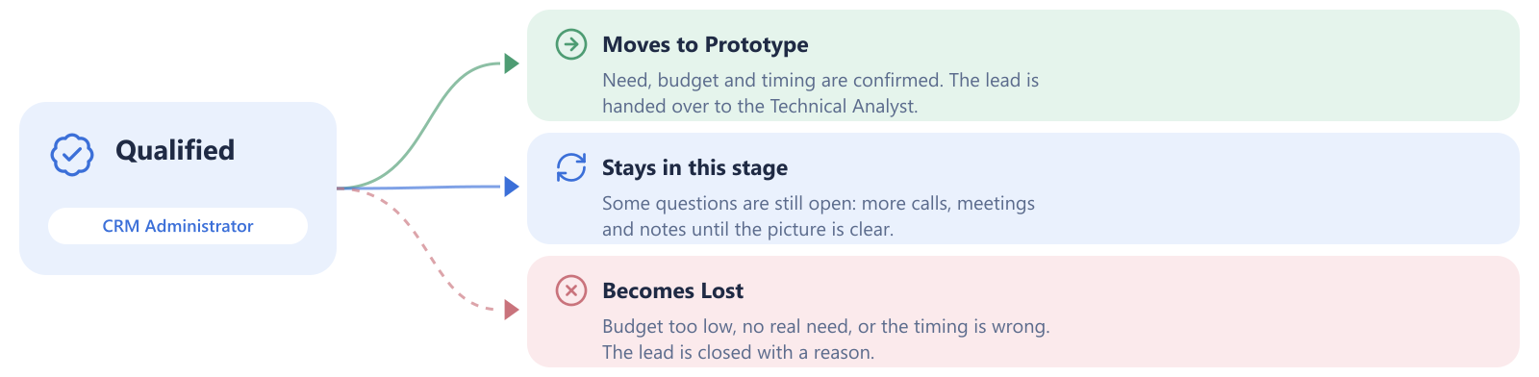

4 Prototype
OWNED BY  Technical Analyst | GOAL  Understand exactly what the client wants, and show it in a prototype.

- Requirements are written down: type of product (website, mobile app, or both), timeline, budget, technology, and a feature list marked Must have, Should have or Nice to have.
- Requirements move from Waiting for client, to Received, to Confirmed with client.
- Prototype rounds are numbered. Each round has a description, a deadline, who builds it, a link, and a status.
- The client's feedback is saved on the round it belongs to.
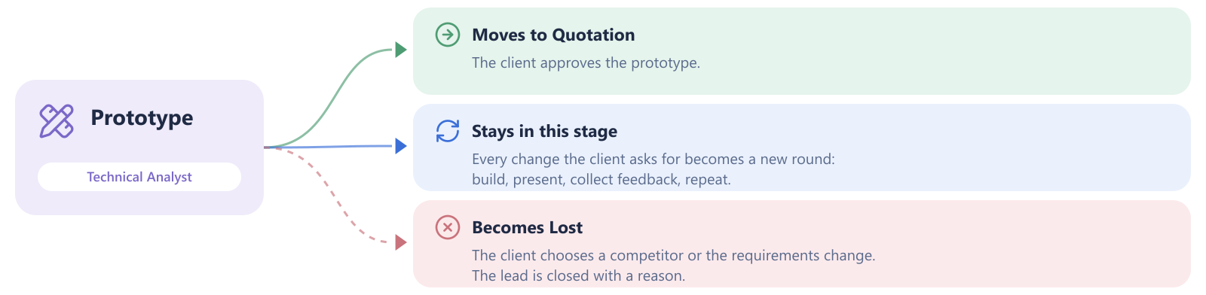

The prototype round cycle
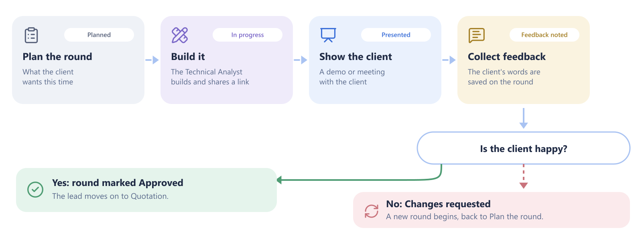

 5 Quotation
OWNED BY  Technical Analyst | GOAL  Send the price and scope to the client in writing.

- Attach the quotation to the lead as a file.
- Set follow-ups to check the client's reply.
- When the client starts discussing price or terms, the lead moves to Negotiation.


 6 Negotiation
OWNED BY  CRM Administrator | GOAL  Agree the final price and terms.

- Calls and meetings are logged as in earlier stages.
- The lead returns to a CRM Administrator, who closes it.
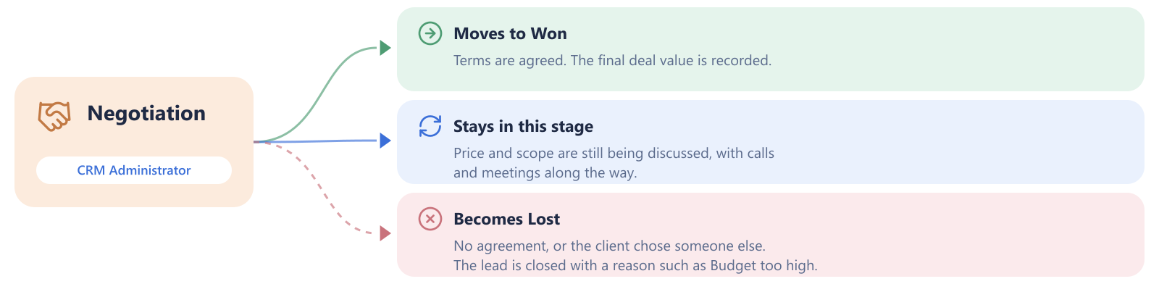

 7 Won
OWNED BY  CRM Administrator | GOAL  The deal is signed.

- The final deal value is entered, and the closing date is saved.
- The lead shows how many days it took to close, and the deal counts towards revenue on the dashboard.
- If something changes later, a won deal can be reopened and moved back to Negotiation.

 8 Lost
OWNED BY  CRM Administrator | GOAL  Close a lead that will not go ahead, and record why.

A lead can become Lost from any stage. The CRM asks for a reason, and it cannot be skipped. The standard reasons are:
Budget too high |  | No response |  | Chose competitor |  | Requirements changed |  | Other

Administrators can add more reasons in Settings. Here is how a lead might be lost at different stages:
Stage | What happened | Reason recorded
New lead | Wrong number, or clearly not a fit | Other
Reaching out | The client never replies | No response
Qualified | The budget is far too small | Budget too high
Prototype | The client's requirements change completely | Requirements changed
Quotation | The client rejects the price | Budget too high
Negotiation | The client signs with another company | Chose competitor

A lost lead is never deleted
It keeps its full history, and a lost lead can be reopened and moved back into the journey if the client returns. Open follow-ups are not cancelled automatically, so cancel them on the lead.

 Tools that work in every stage
These features sit on every lead, whatever stage it is in.
  Follow-ups and reminders  Schedule the next step for yourself or a colleague. An email arrives before it is due, and overdue items show on the bell. |  |   Meetings and calendar  One-time or repeating meetings, a Google Meet link, and calendar invites emailed to the team and the client.
Files  Upload quotations, designs and documents to a lead. Download them any time. |  | Contact people  Add everyone involved at the client's company, each with a role, phone and email.
Activity and history  A timeline of every call and note, and a record of every stage change with who made it and why. |  | Assigning a lead  Administrators and the Technical Analyst can hand a lead to a colleague at any time.
  Search and filters  Find a lead by company, person, phone or email. Filter by stage, owner, source or priority, as a list or a board. |  |   Automatic emails  Handover notices, follow-up reminders and meeting invites are sent for you.

 Three example journeys
Real leads rarely move in a straight line. These three show the most common shapes.
A smooth deal  Won  - Added by Business Development Executive  - Two calls, client interested  - Qualified on the same week  - One prototype round, approved  - Quotation sent, short negotiation  - Won |  | The long road  Won  - Several follow-ups before the client answers  - Prototype goes through three rounds  - Changes requested twice, then approved  - Negotiation takes two weeks  - Won at a slightly lower price |  | An early exit  Lost  - Added from an Excel sheet  - No answer on three calls  - Follow-ups logged each time  - Client never replies  - Lost, reason: No response

What all three have in common
Every call, round, follow-up and move is saved. Anyone who opens the lead later can read its whole story in a minute.

Everything you can do
Everything available in the application, grouped by task. Items marked Administrator are only available to Administrators.
  Add leads  - Add a lead by hand  - Import from Excel or CSV  - Paste rows from Google Sheets  - Download an import template  - Get a warning about duplicates |  | Find and view leads  - Search by name, phone or email  - Filter by stage, owner, source, priority  - Switch between list and board  - Open a lead's full story
Work on a lead  - Edit details, budget and priority  - Add more contact people  - Move it to another stage with a note  - Hand it to a colleague  - Delete it (Administrator) |  |   Record conversations  - Log calls with an outcome  - Log WhatsApp, emails and notes  - Choose who you spoke to  - Read the full timeline
Follow-ups  - Schedule for yourself or a colleague  - Mark done, move or cancel  - Get a reminder email  - See overdue items on the bell  - View Mine or Everyone |  | Requirements and prototypes  - Record product type, timeline, budget  - Choose the technology  - List features by importance  - Add numbered prototype rounds  - Save the client's feedback
Meetings  - Schedule one meeting or a repeating series  - Create a Google Meet link  - Email invites with a calendar file  - Mark done, delete one or the series  - See everything on the calendar |  | Files  - Upload documents to a lead  - Download them again  - Remove a file
  Dashboard (Administrator)  - Total leads and open pipeline value  - Revenue won and win rate  - Average days to win  - Overdue follow-ups, meetings today  - Charts for stages, sources and lost reasons  - Team leaderboard and recent activity |  | Team (Administrator)  - Add a new worker: name, email, phone, role and password  - Change someone's role  - Switch a person off or back on  - Set a new password  - See what each role can do
  Settings (Administrator)  - Edit the dropdown lists: lead sources, lost reasons, call outcomes, activity types, round types, round statuses and technologies  - A value already in use can be renamed but not deleted |  | Your account  - Update your name and phone  - Change your password  - Email yourself a reset link  - Reset a forgotten password from the sign-in page

Finding your way around
The menu on the left is the same for everyone, except that some entries are only shown to Administrators.
Menu | What it is for | Who sees it
Dashboard | The numbers: pipeline, wins, losses, team activity | Administrator
Leads | Every lead you may see, as a list or a board | Everyone
Follow-ups | What needs doing today, what is overdue, what is coming | Everyone
Calendar | Meetings by month, with repeating series and invites | Everyone
Add leads | Add one lead by hand, or import many at once | Everyone
Team | Add workers, change roles, switch people on or off | Administrator
Settings | The dropdown lists the team picks from | Administrator
Profile | Your name, phone and password | Everyone

Quick reference
Stage | Owner | Moves forward when | Can become Lost when
New lead | Business Development Executive | Details are complete | The contact is wrong or not a fit
Reaching out | Administrator | The client shows interest | No interest or no reply
Qualified | Administrator | Need and budget are confirmed | No budget or no real need
Prototype | Technical Analyst | The client approves a round | Competitor or changed requirements
Quotation | Technical Analyst | The client starts discussing terms | Quotation rejected or no reply
Negotiation | Administrator | Terms are agreed | No agreement
Won | Administrator | Deal value is recorded | Not applicable

