azure_cloud_project_using_ETL_pipeline_and_databricks_and_azure_synapse_analytics_and_tableau_using_Brazilian_E-Commerce_Public_Dataset_by_Olist
=> Dataset Overview : Olist Dataset
Olist Dataset Kaggle url: https://www.kaggle.com/datasets/olistbr/brazilian-ecommerce/data
----------------------------------------------------------------------
=> SQL DB & Data Ingestion
Create Data source (any SQL Database ) to ingest data into pipeline for extraction phase using filess.io provider
Url: https://filess.io/
Flow: Home -> shared Databases (free edition) -> + new database ->
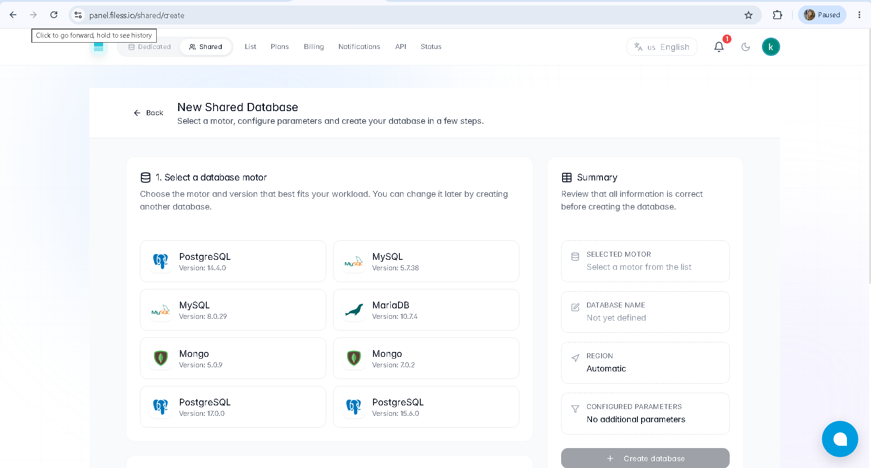
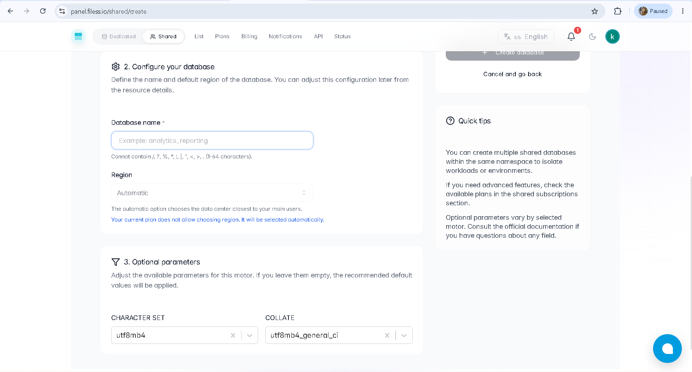

--> mysql db
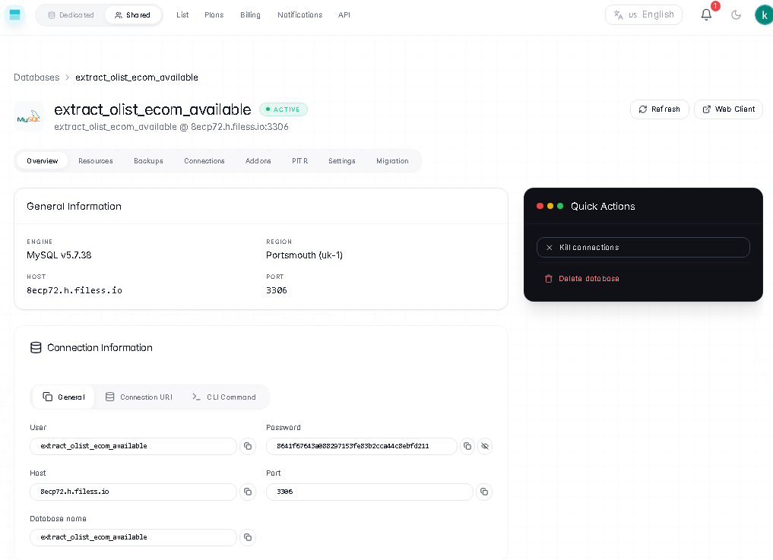
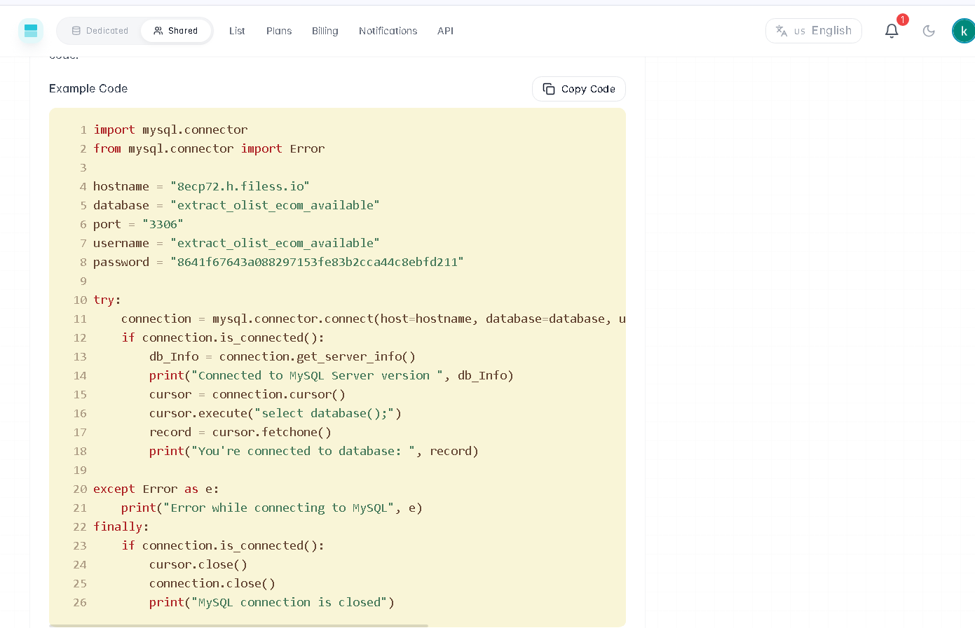
--> mongo db used in data enrichment phase
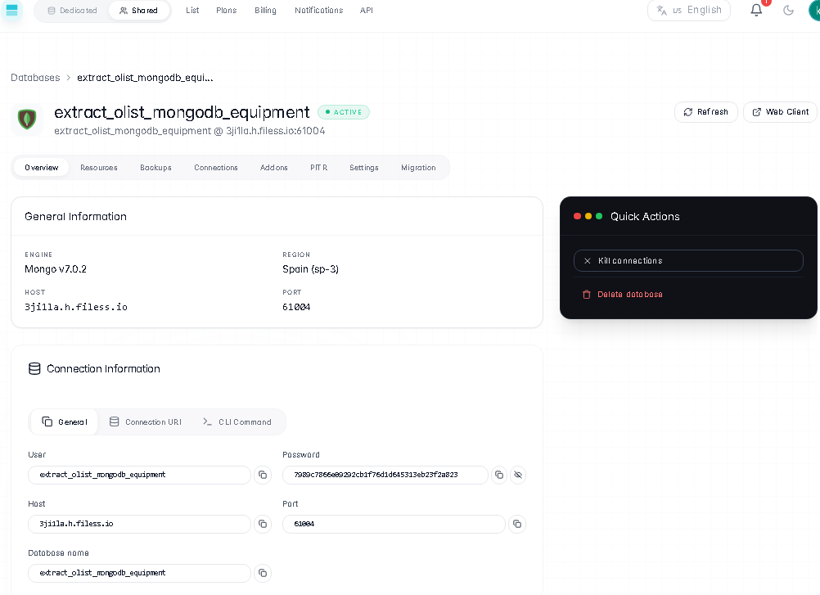
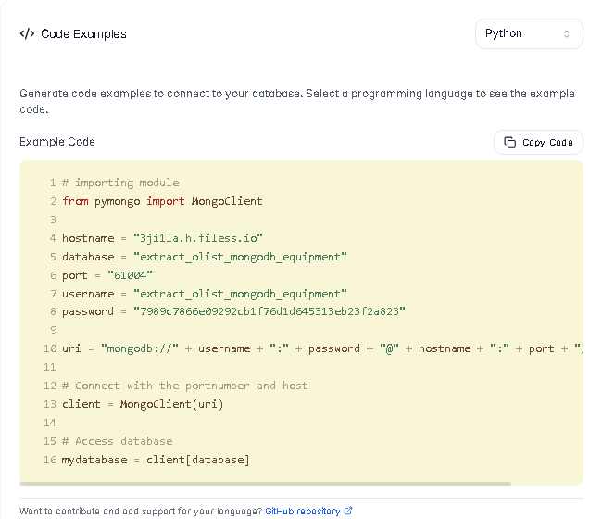
Extraction phase code:
-----> refer google colab Extract_CSV_File_ and_Inject_Data_into_MySQL_and_MongoDB_Database.ipynb
--> after successful insertion of data
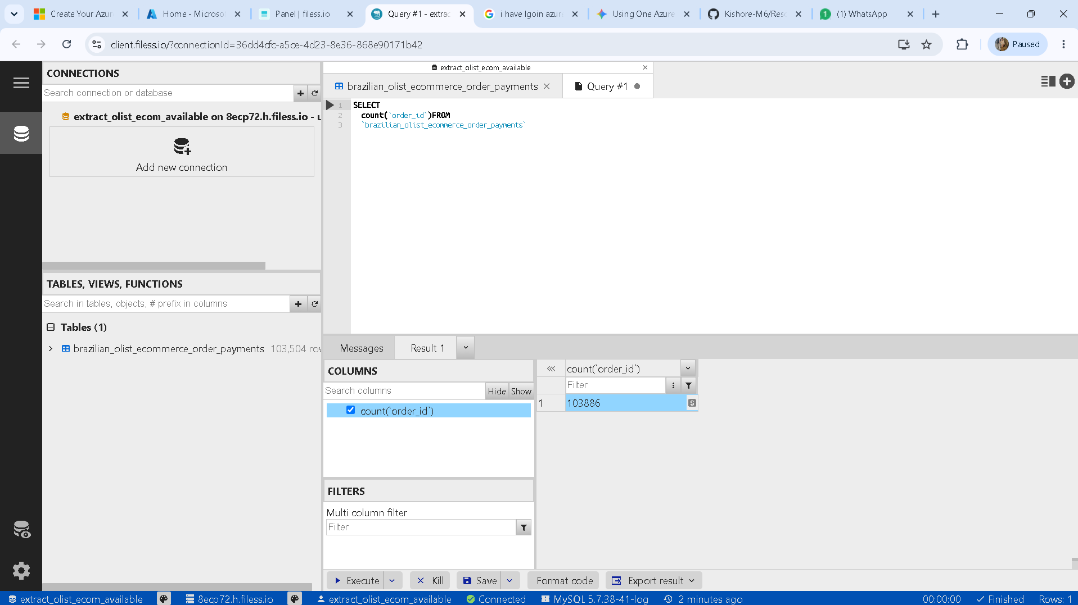
----------------------------------------------------------------------
=> Resource & Resource Group in Azure
Flow: Home -> resource groups -> + create
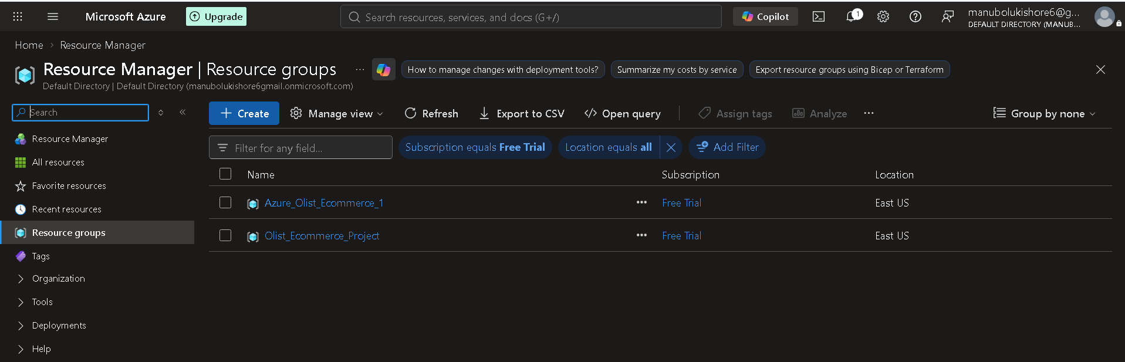
----------------------------------------------------------------
=> Azure Data Factory
--> create data factory in azure portal.
Flow: home -> search bar -> search for Azure Data Factory (V2) -> + create
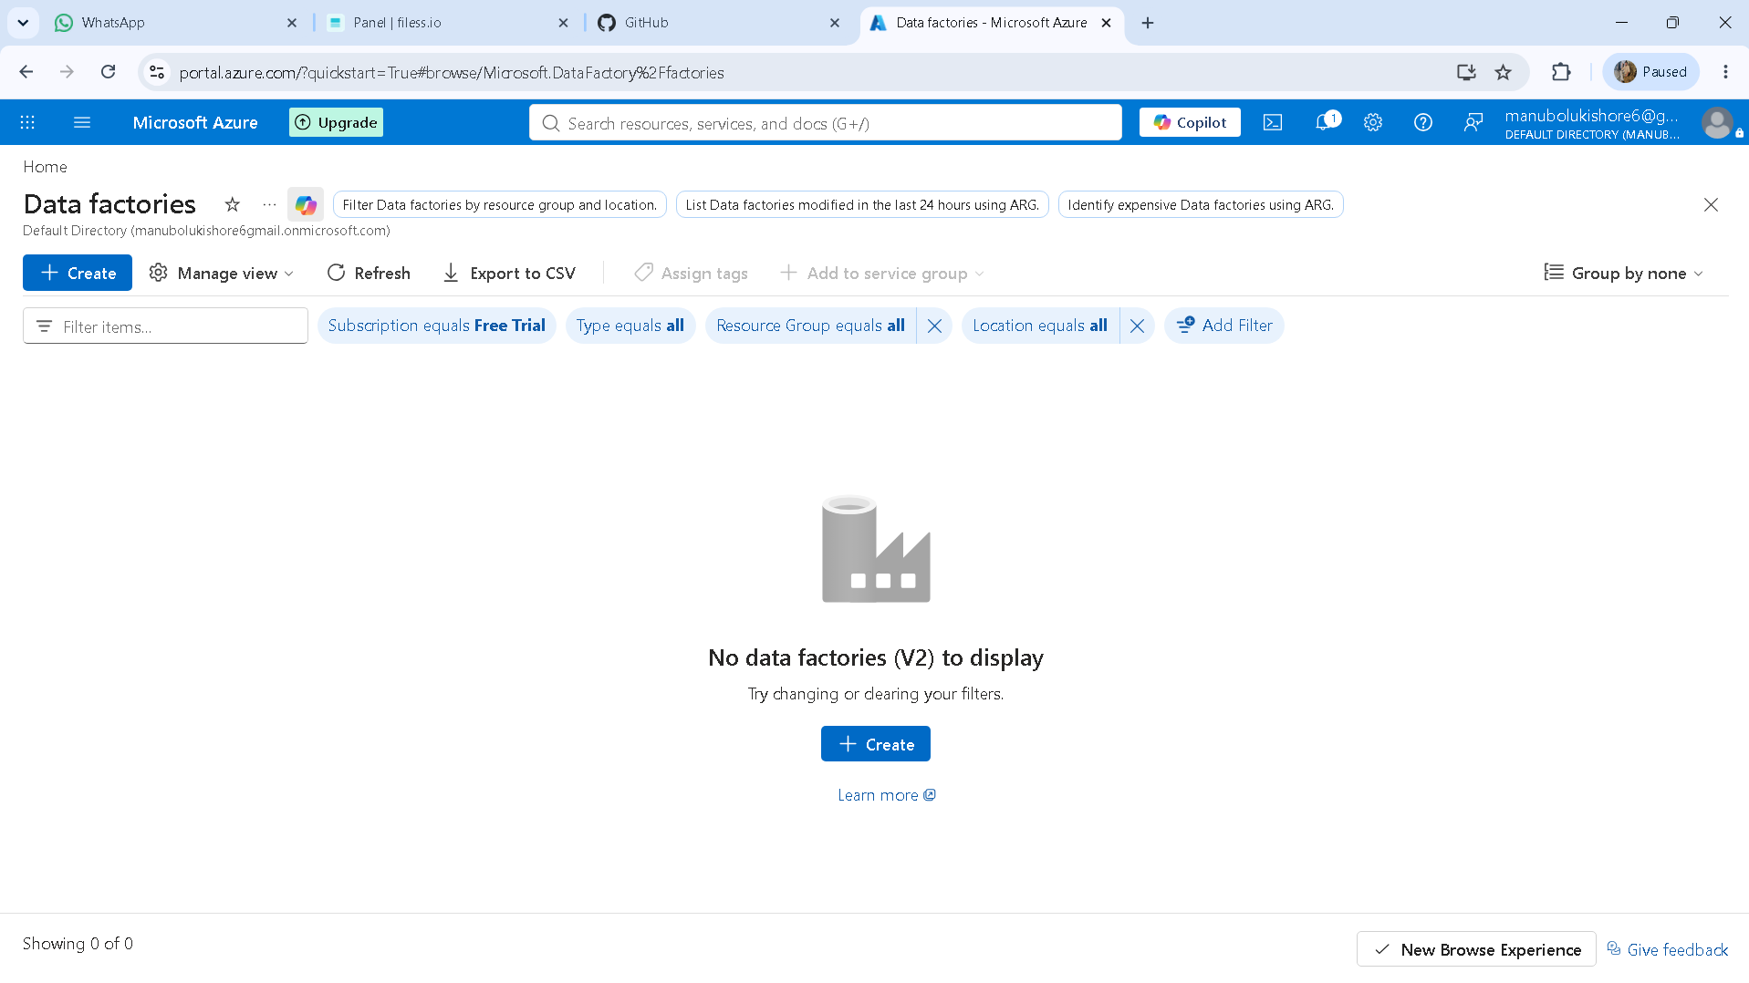
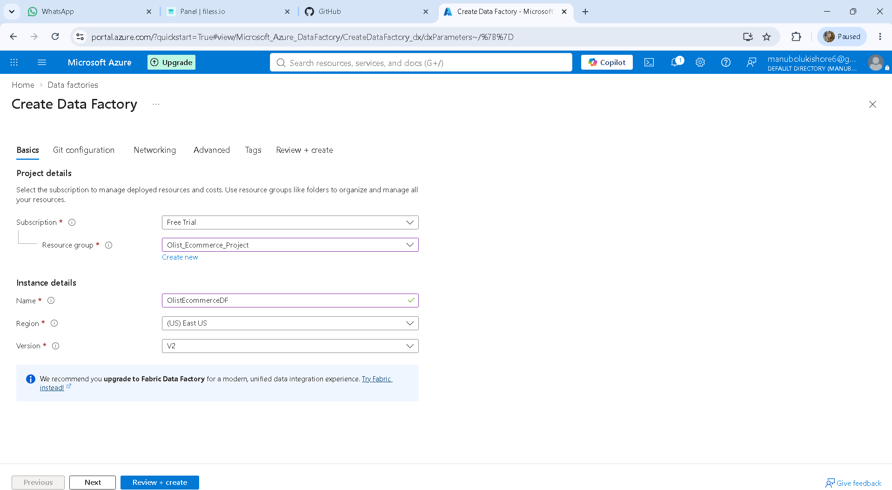
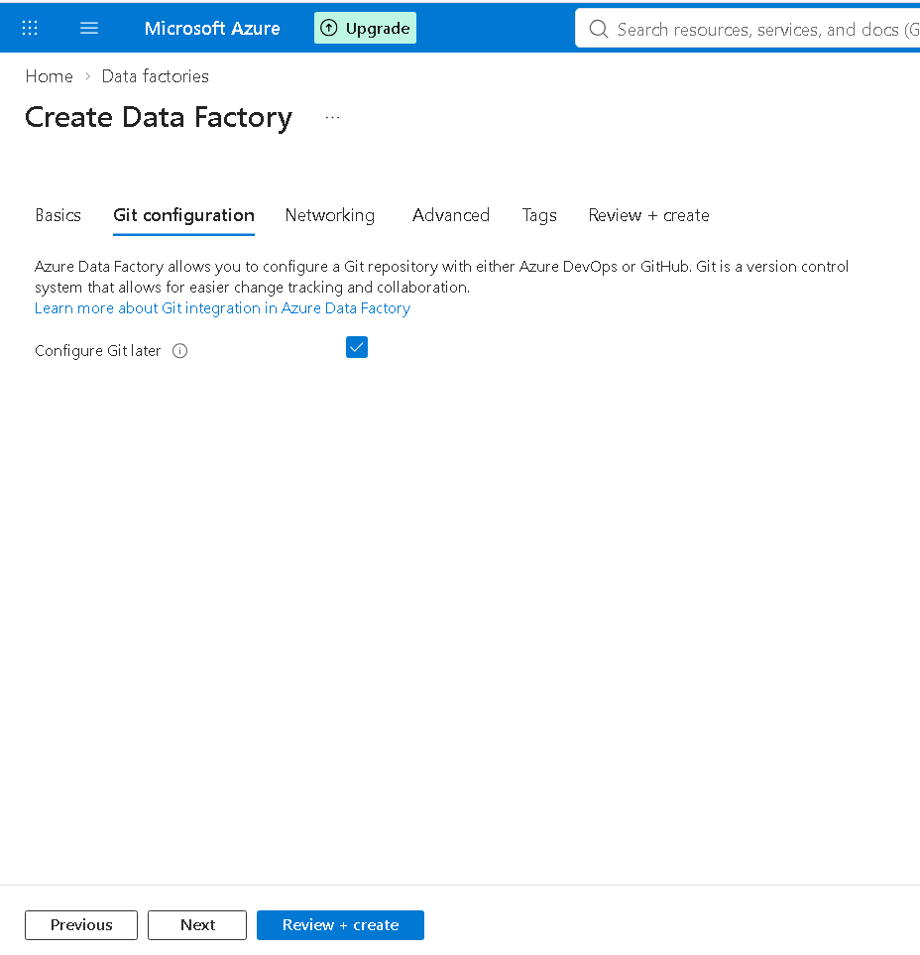
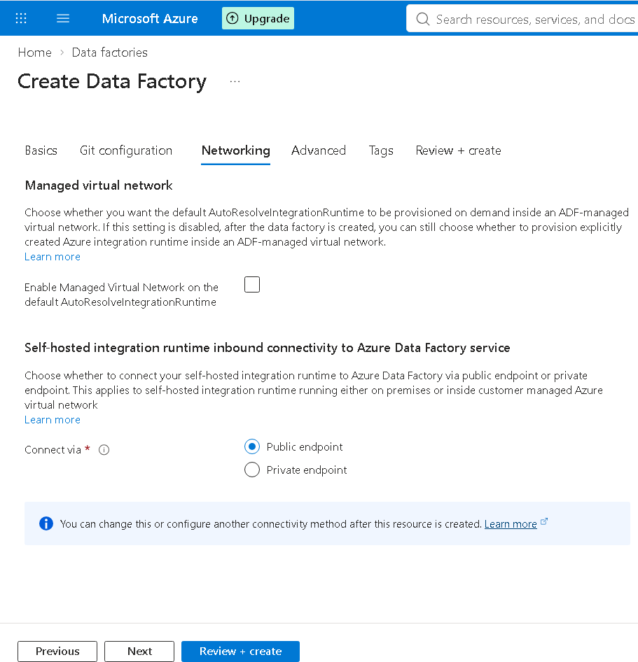
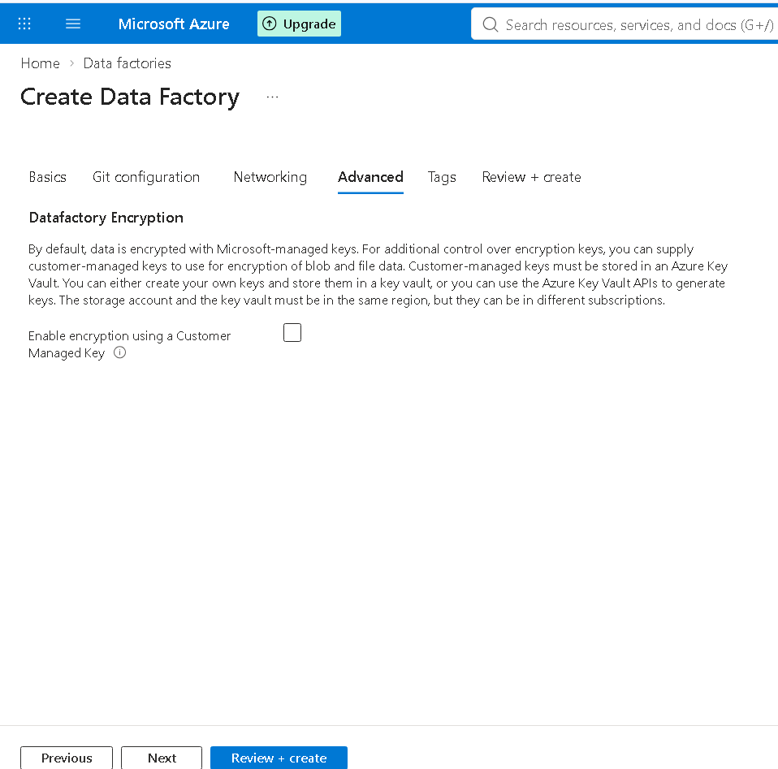
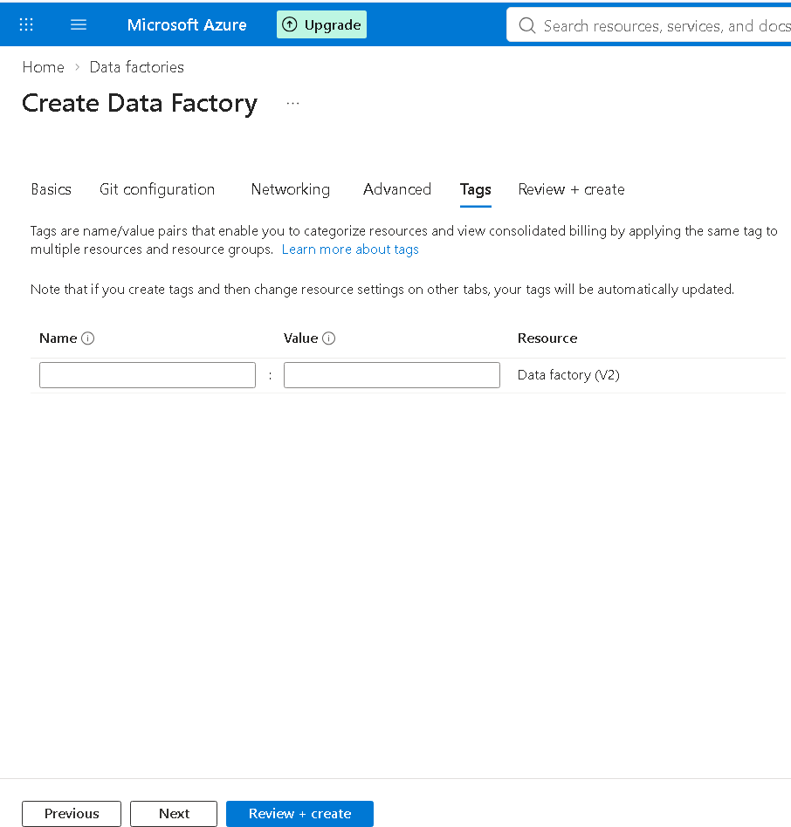
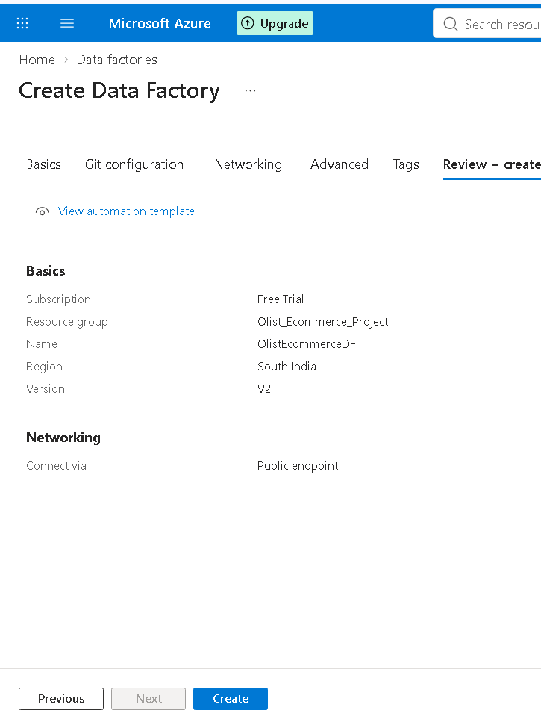
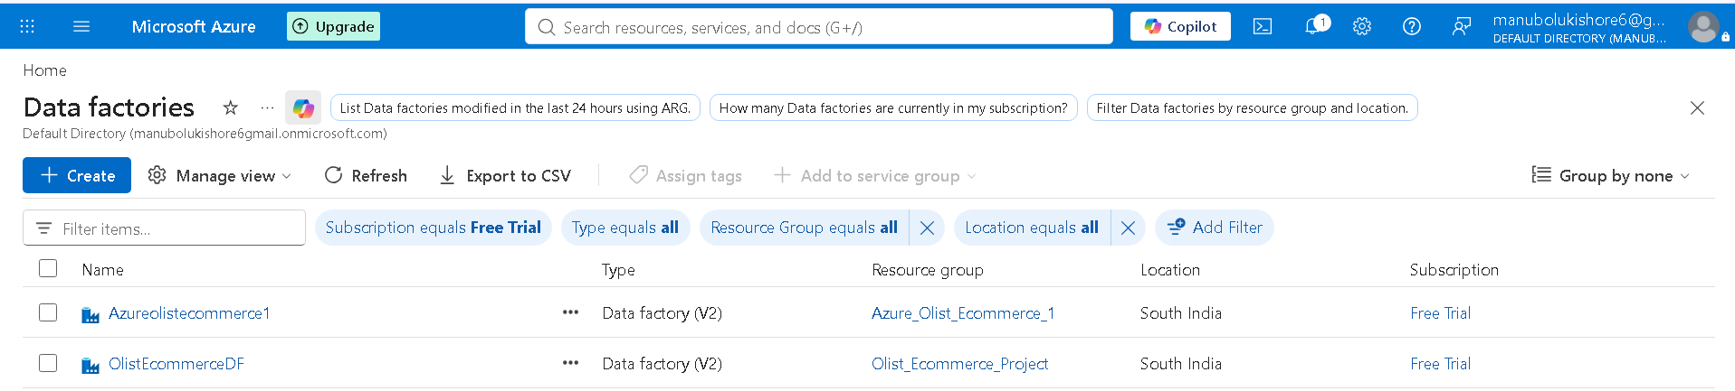
--> go to resource --> launch data factory using launch studio -> azure data factory home

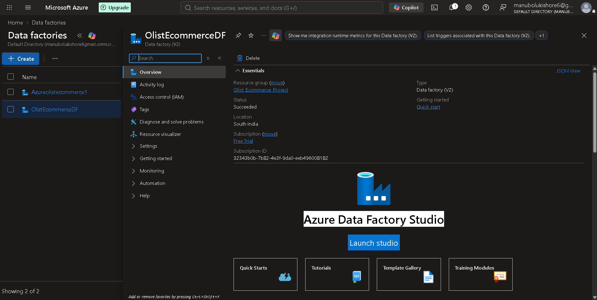
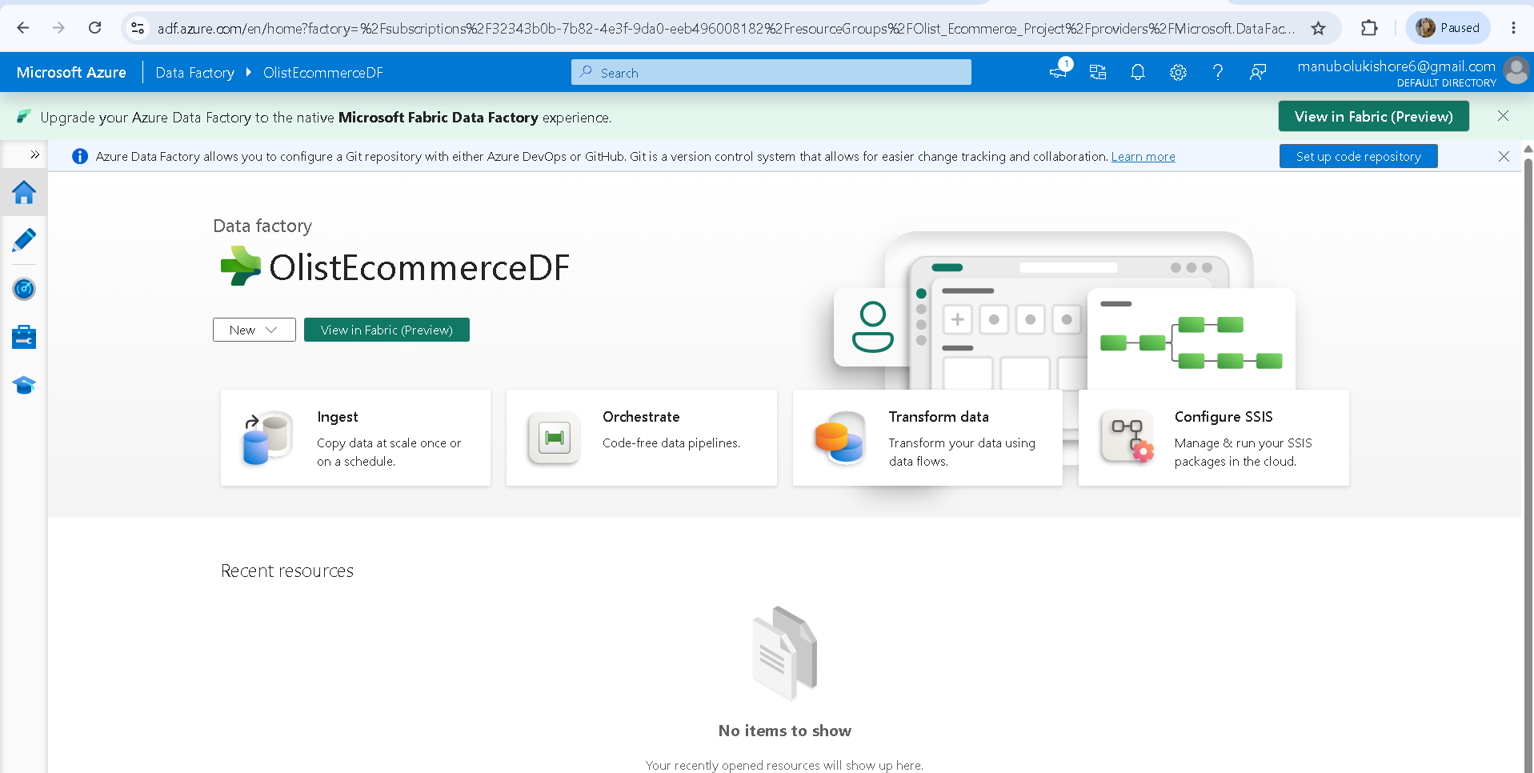
--> create pipeline to view all possible operations we can perform.
Flow: Azure Data Factory Home -> Author -> Pipeline -> 3 dots(…) -> new pipeline -> provide name for pipeline in properties section.
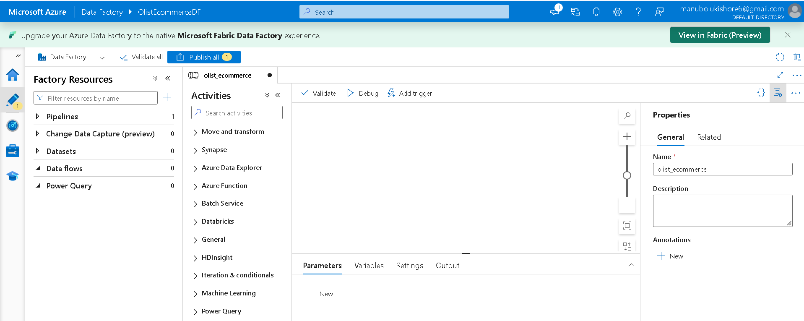
--> creating one activity (Copy data) and connecting ingest data source
Flow: Azure Factory Resources -> Pipelines -> specific pipeline -> move and transform -> copy data or dataflow -> drag copydata activity and place into editor console to configure different setup.
--> Each activity contains different conditions as follows
1.OnSkip
2.On Success
3.On fail
4.On completion
5.Add Activity
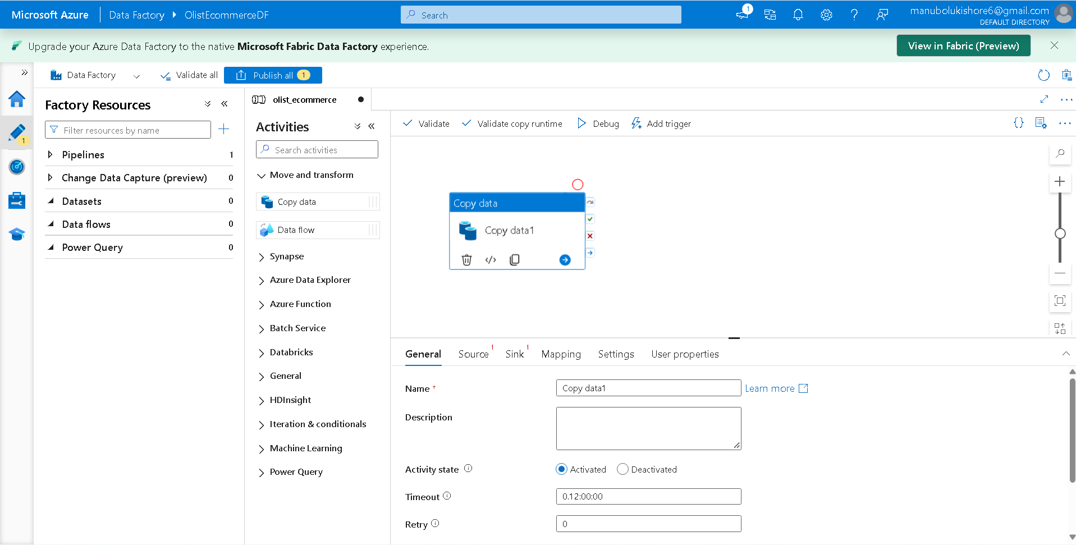
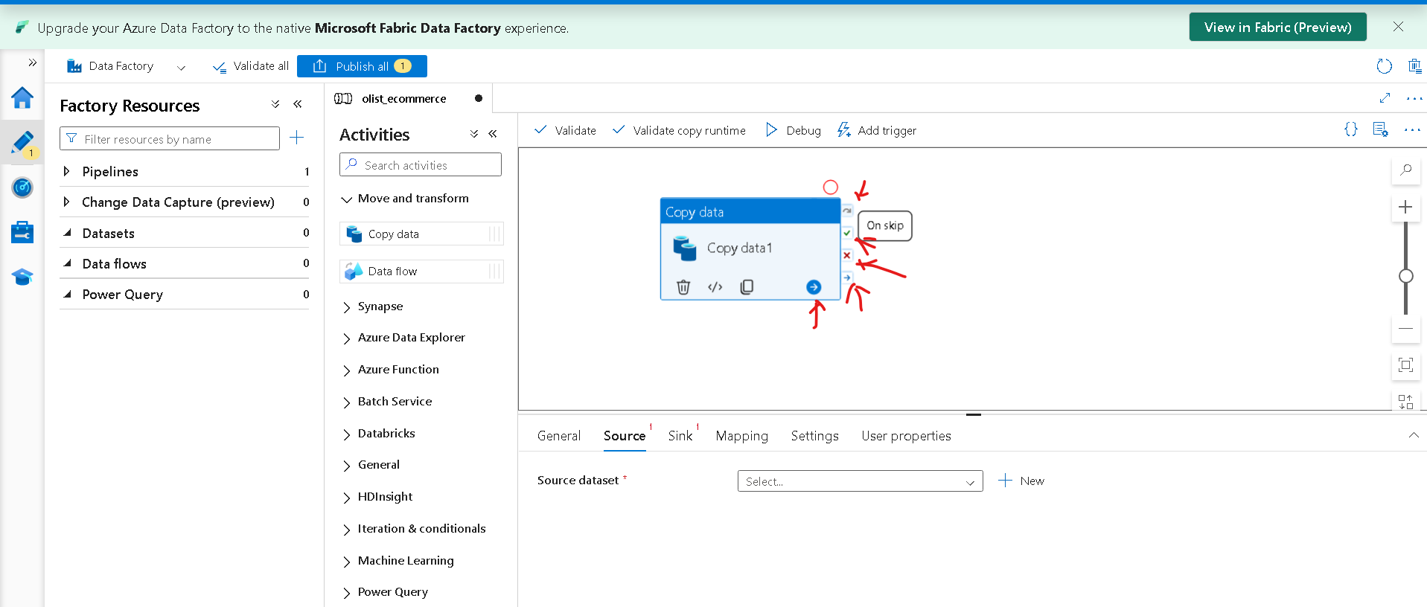
--> connecting source for data ingestion
Flow: Data Factory Home -> Factory Resources -> Pipelines ->Activities -> activity editor (olist_ecommerce) ->Source -> Source dataset -> + New -> New Dataset (with lot of services)
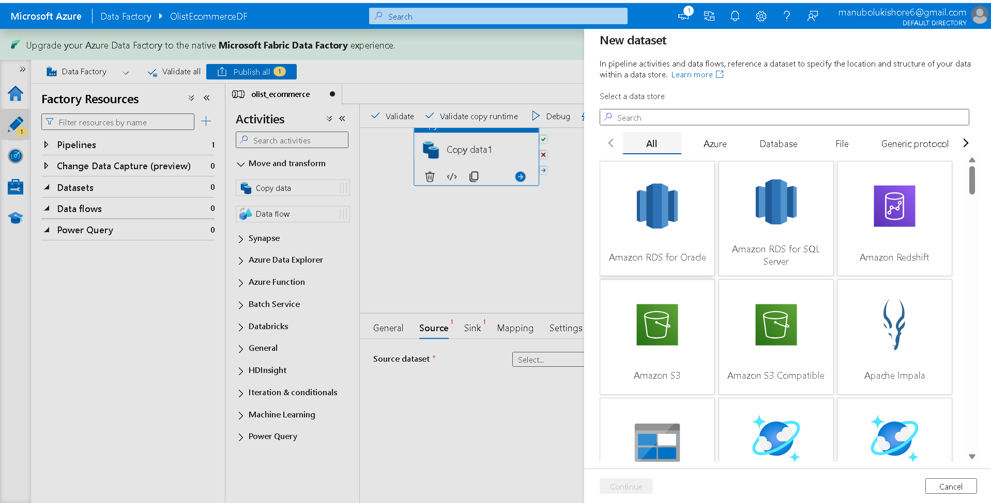
--> establish connectivity for two activities
Flow: drag one more activity into editor then stablish plugins(onskip/onsuccess/onfailure/oncompletion) connection
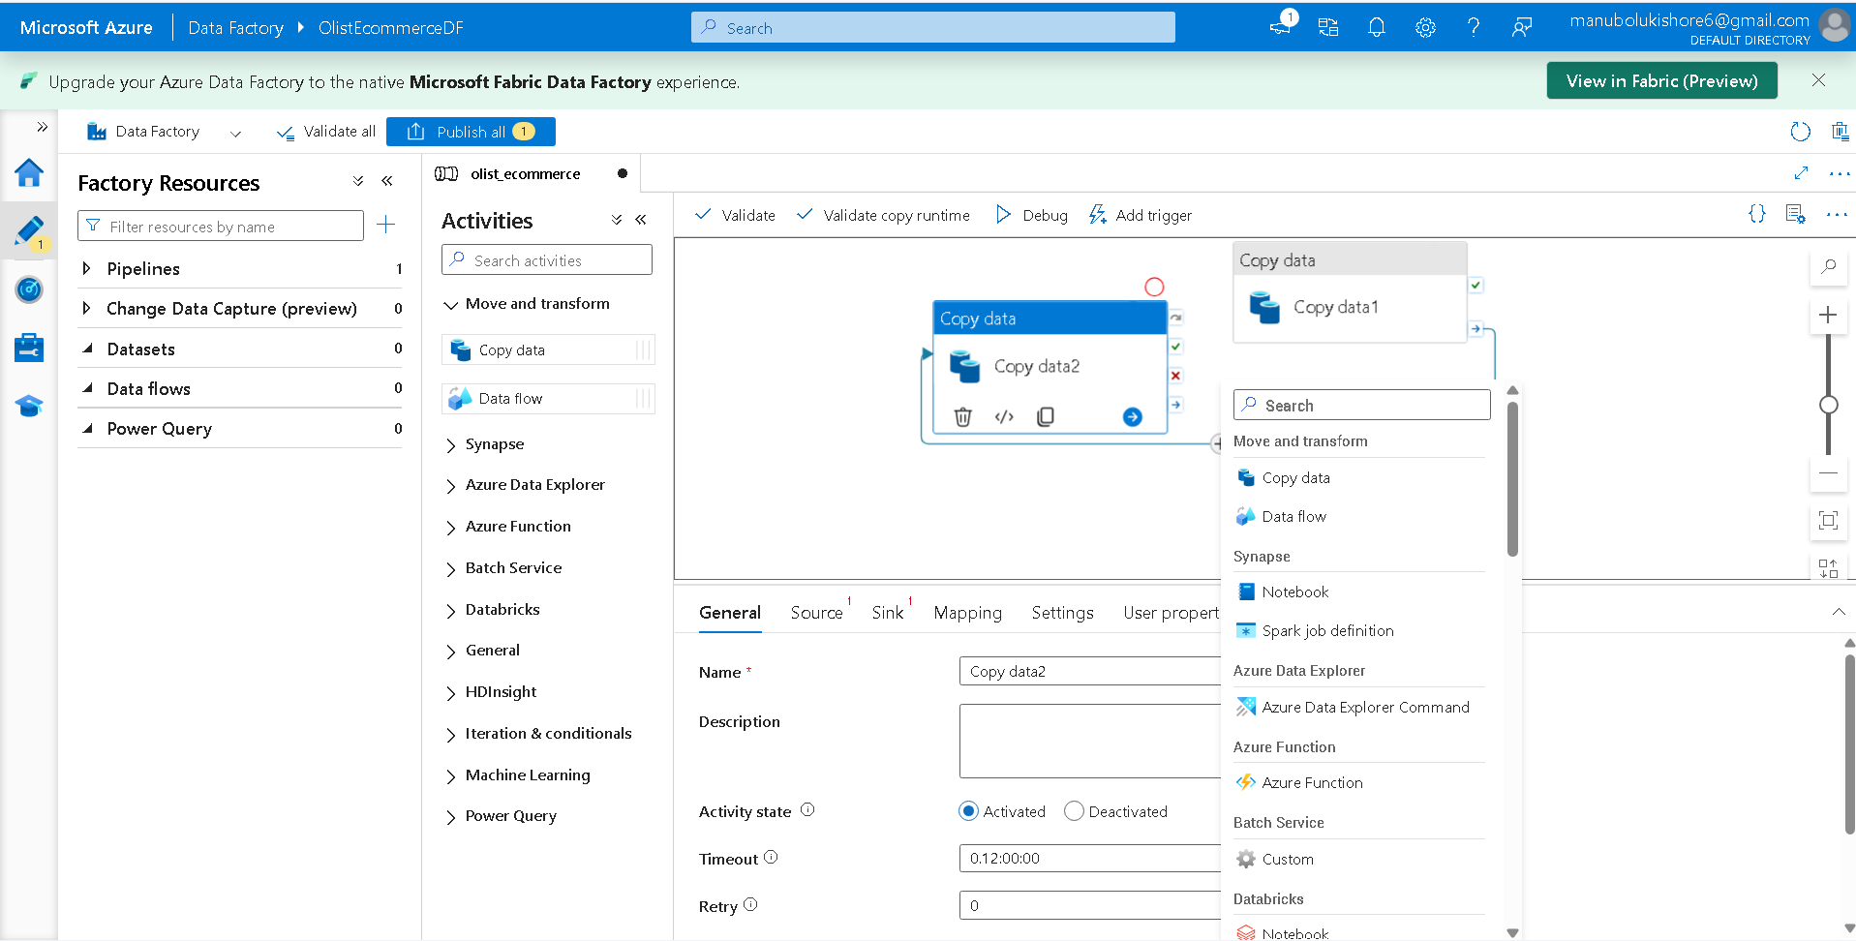
--> configure copydata activity to load data from GitHub repository of Resource_Datasets_of_Brazilian_E-Commerce_Public_Dataset_by_Olist
Flow: ADF home -> Author -> Factory Resources -> Activities -> Editor console -> Source -> Source Dataset -> + New -> choose “HTTP” dataset ->
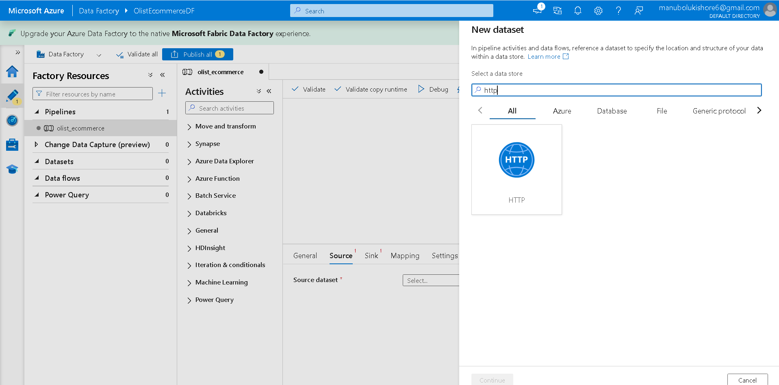
-> select “DelimitedText” format -> Select Properties -> provide name -> Linked Service -> + New ->
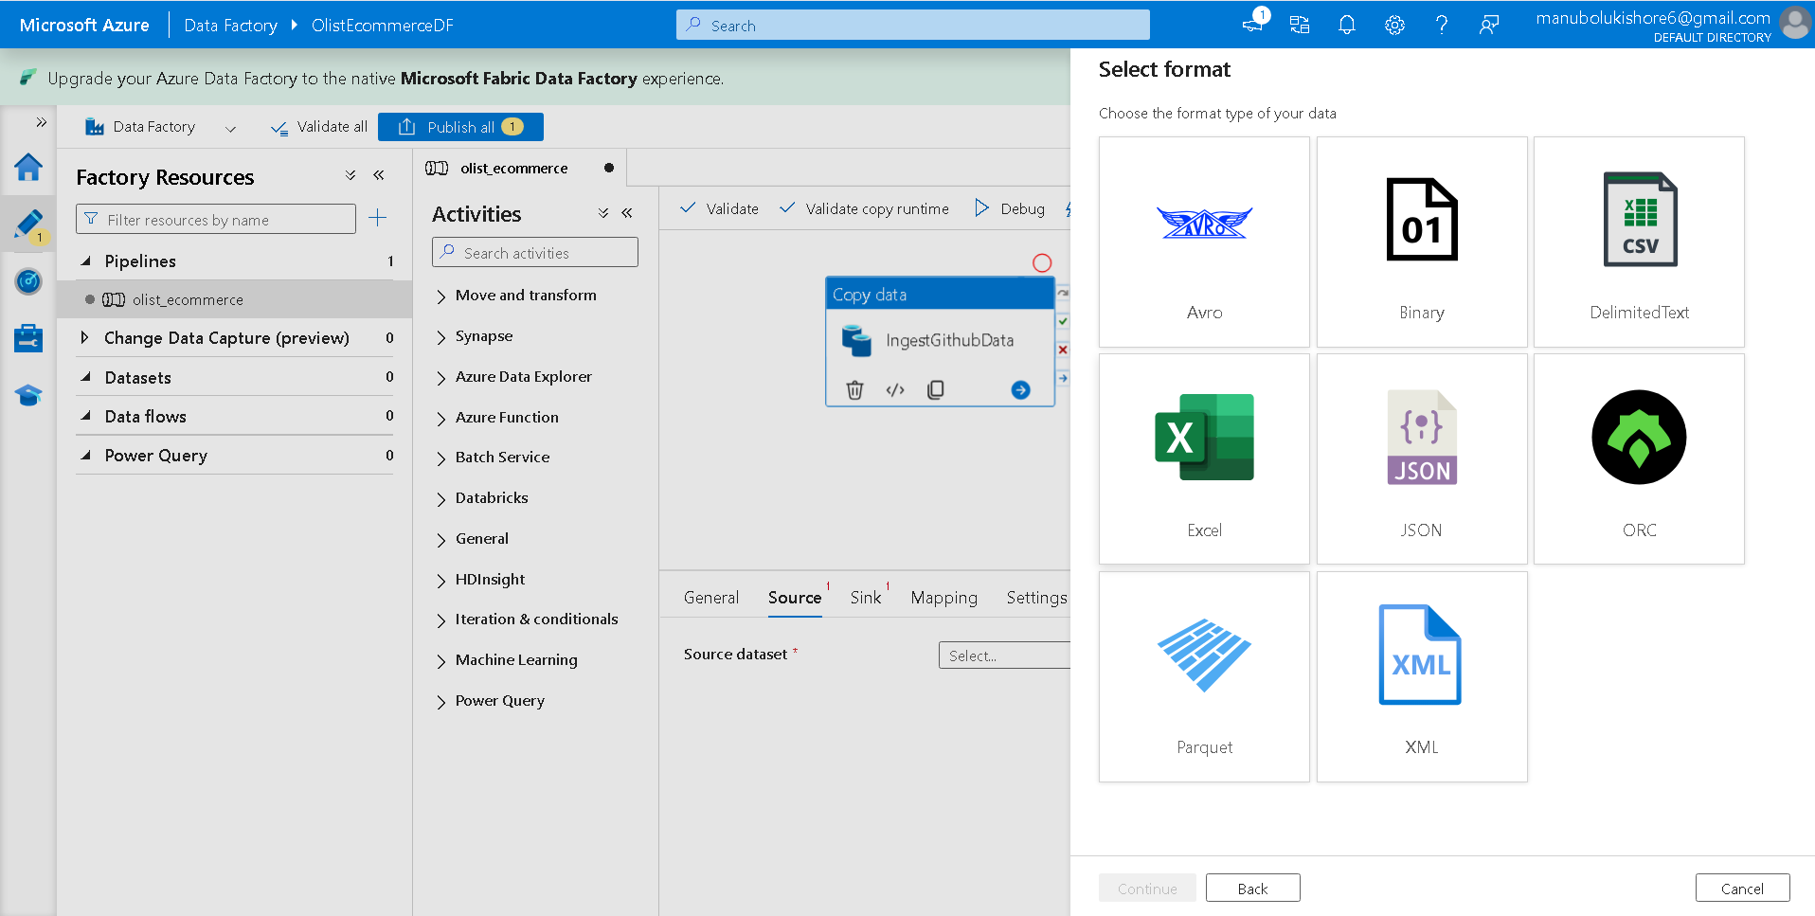
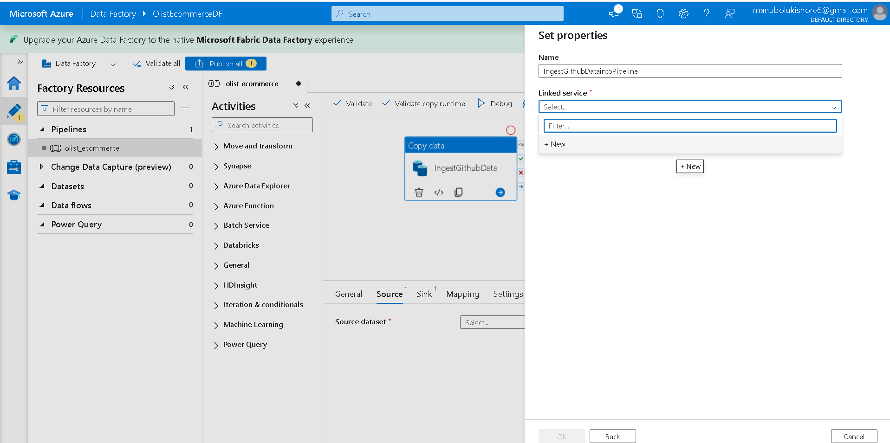
-> configure Linked Service details
Case-1: selecting single file to verify activity workflow
Github Url: https://github.com/Kishore-M6/Resource_Datasets_of_Brazilian_E-Commerce_Public_Dataset_by_Olist/blob/main/olist_customers_dataset.csv
Authentication Type: Anonymous
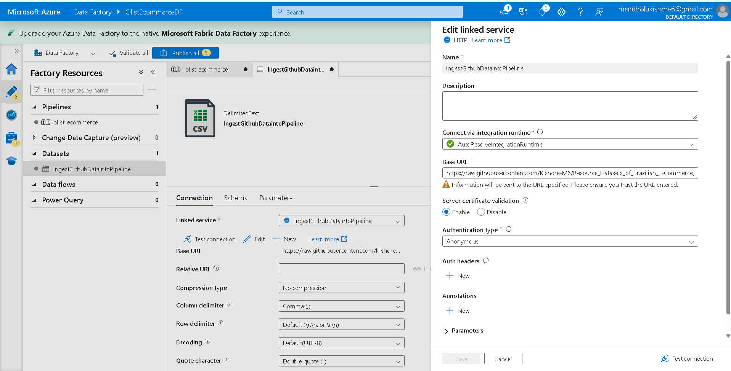
-> check Test connection
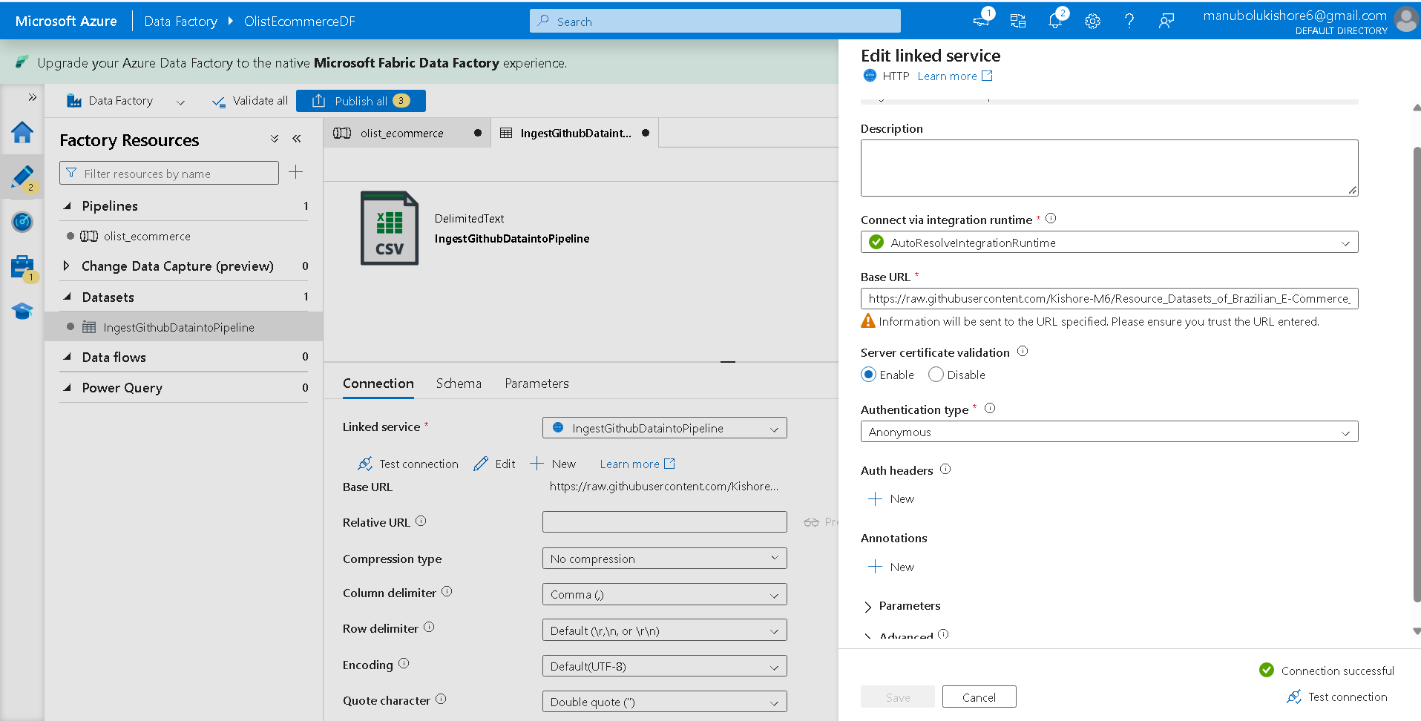
-> click on ok 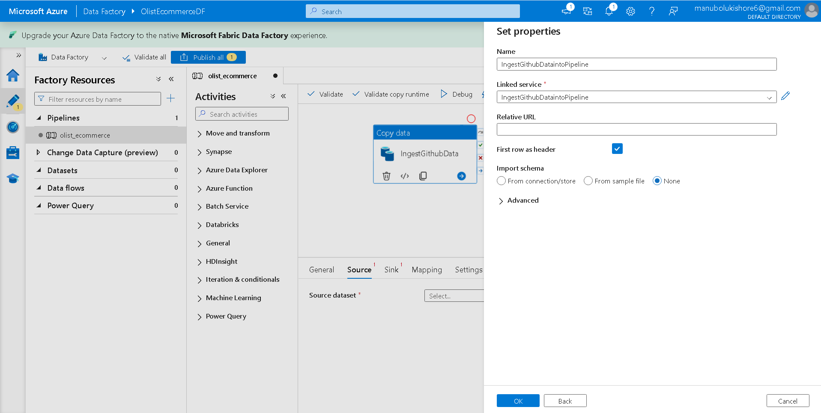
-> check “preview data “to se pipeline read data from Github repository csv file.
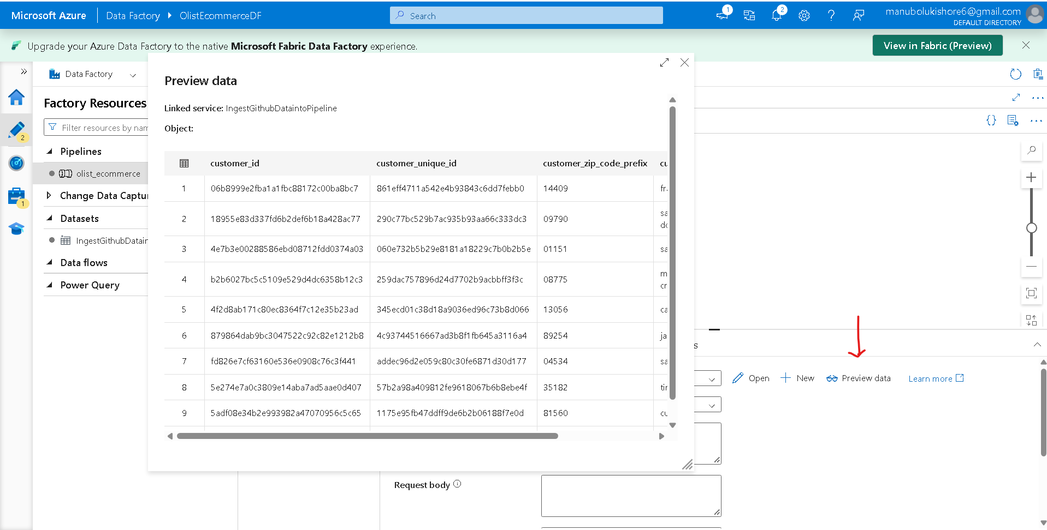
Case-2: using iterations to load multiple csv files by configuring base url, relative url
---------------------------------------------------------------------

=> ADLS Gen 2 Storage Account
Sink: storage location where pipeline data will be stored.
Azure Data Lake Storage (ADLS) is a highly scalable, secure, and cost-effective cloud storage platform provided by Microsoft Azure, specifically designed and optimized for big data analytics.
Create ADLS storage account:
Flow: Azure Home -> Storage Accounts -> Storage Center
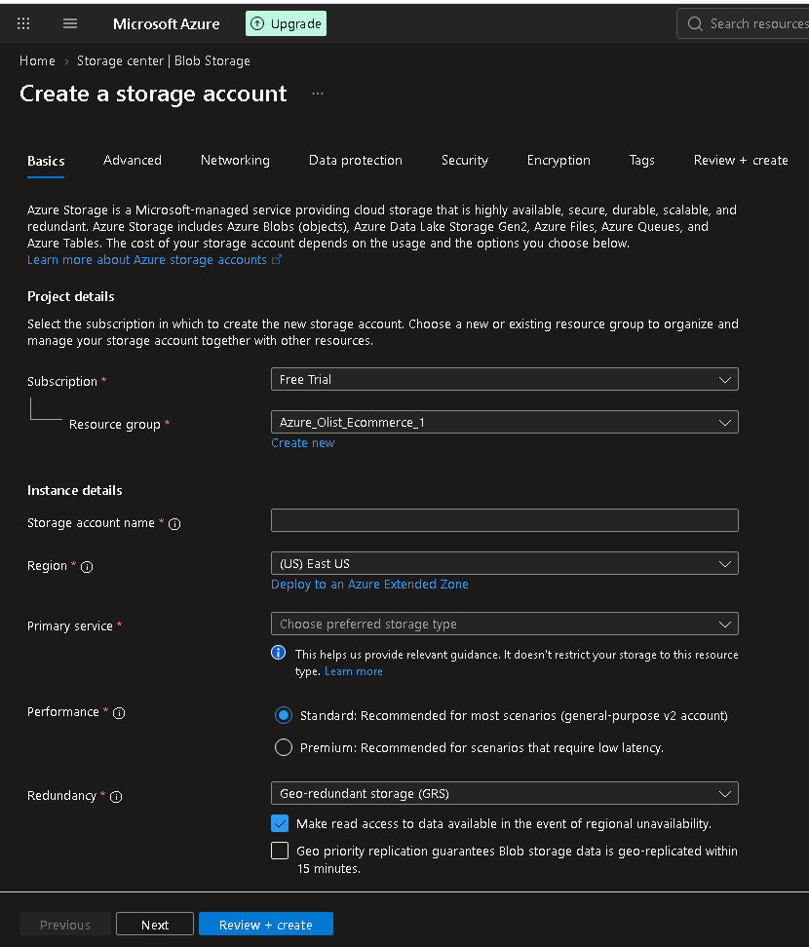
--> creating ADLS storage account
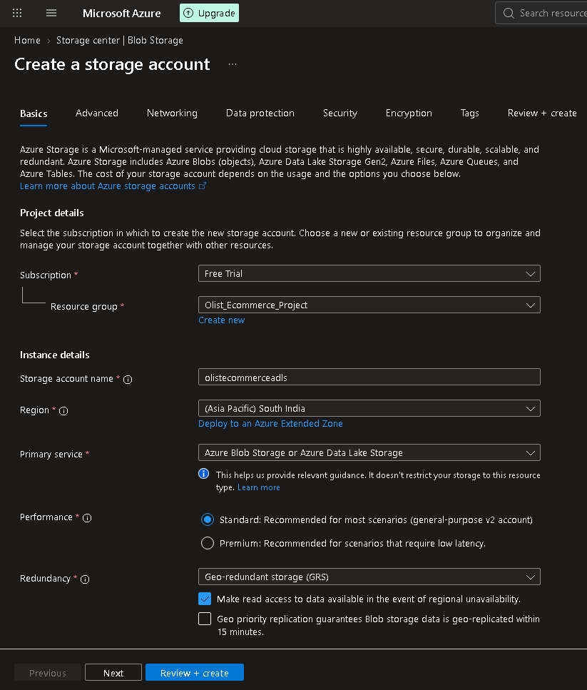
-> Toggle Enable hierarchical namespace to Enabled
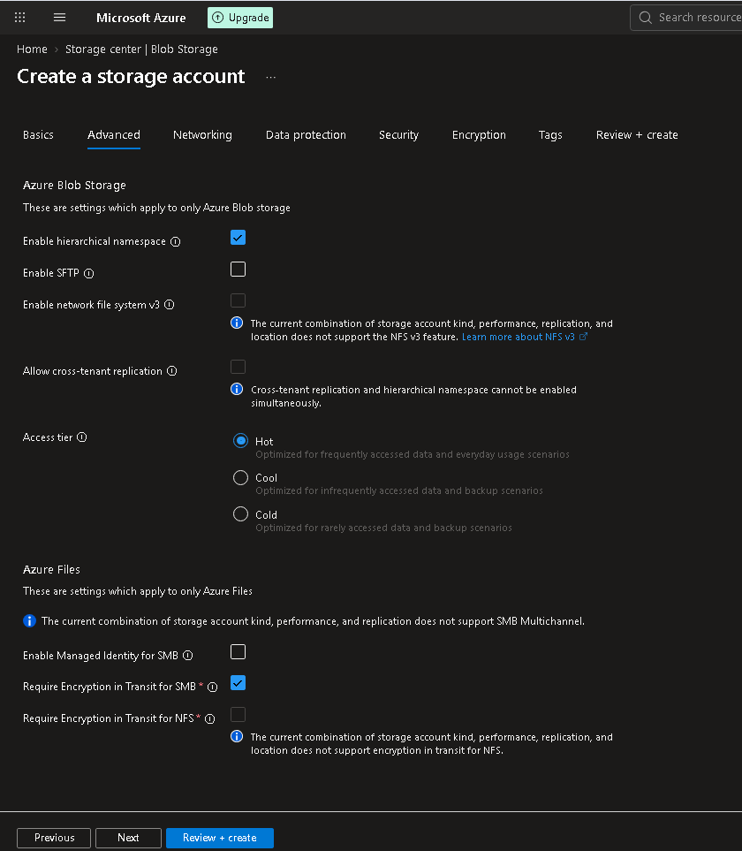
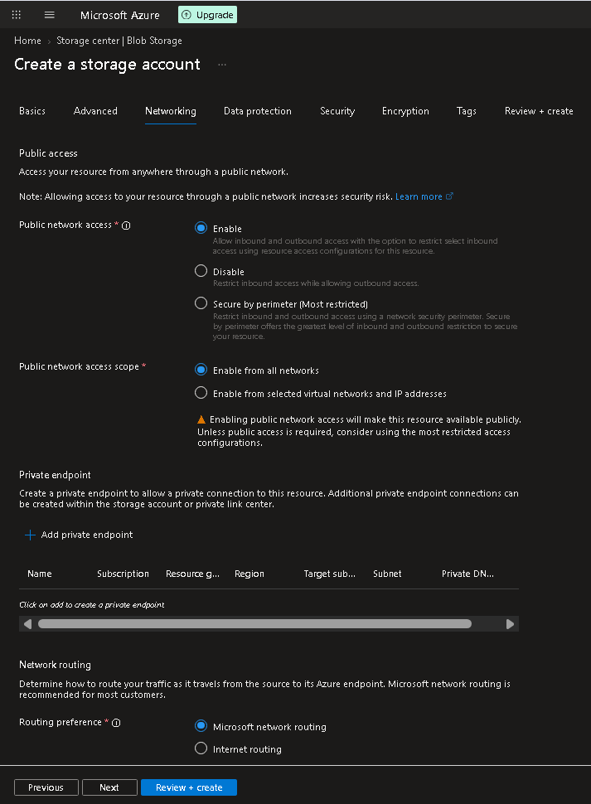
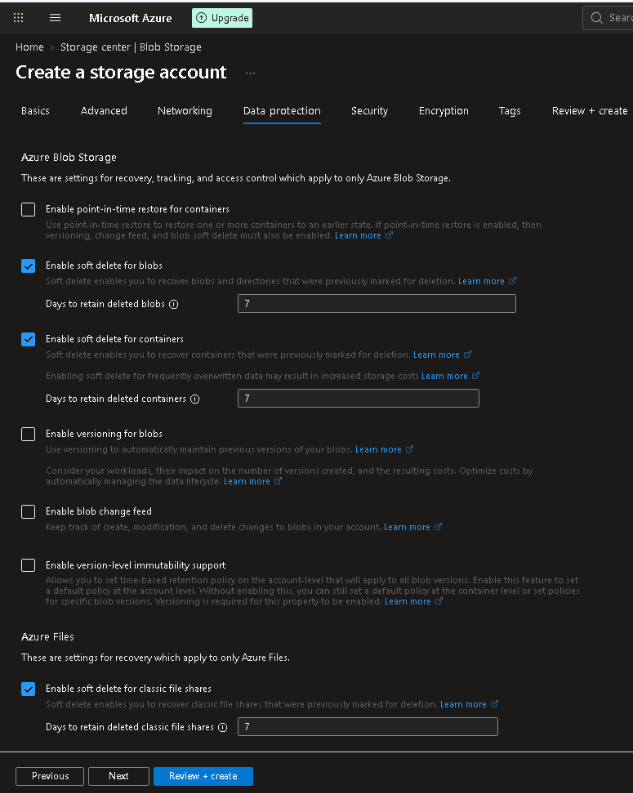
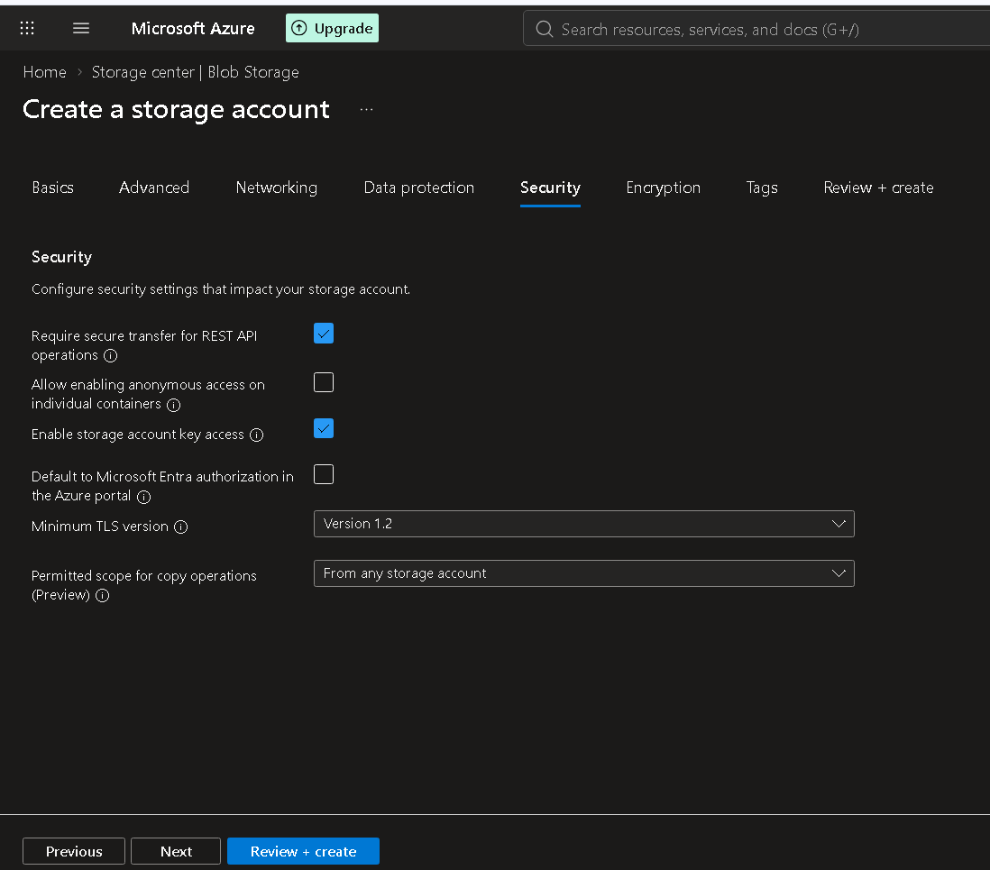
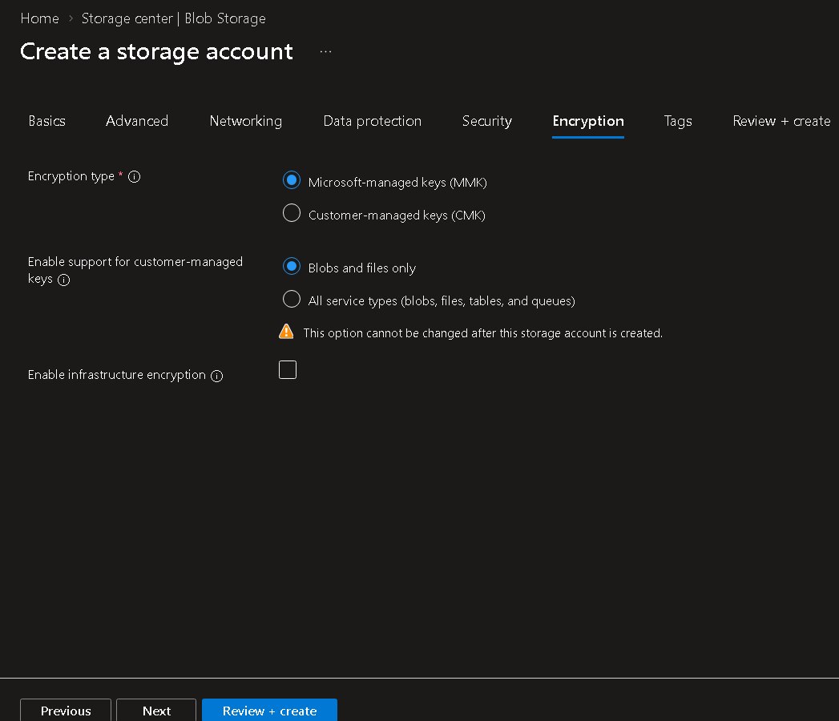
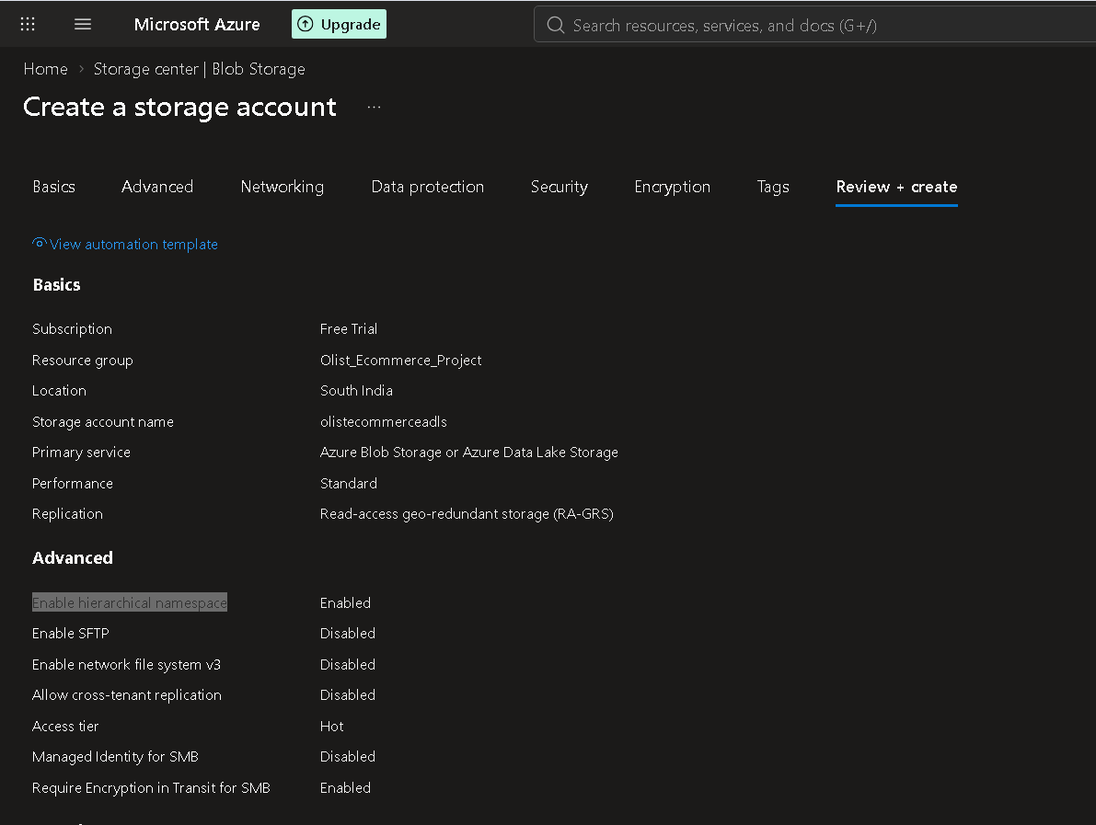
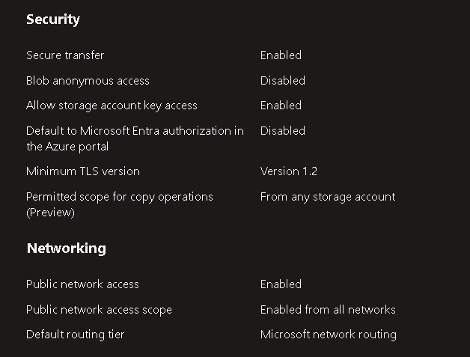
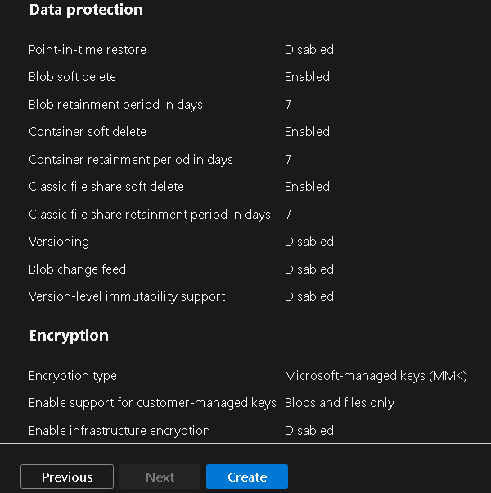
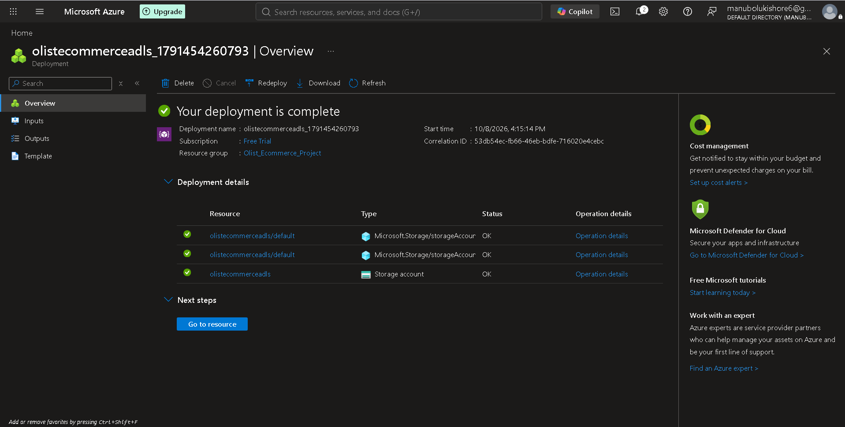
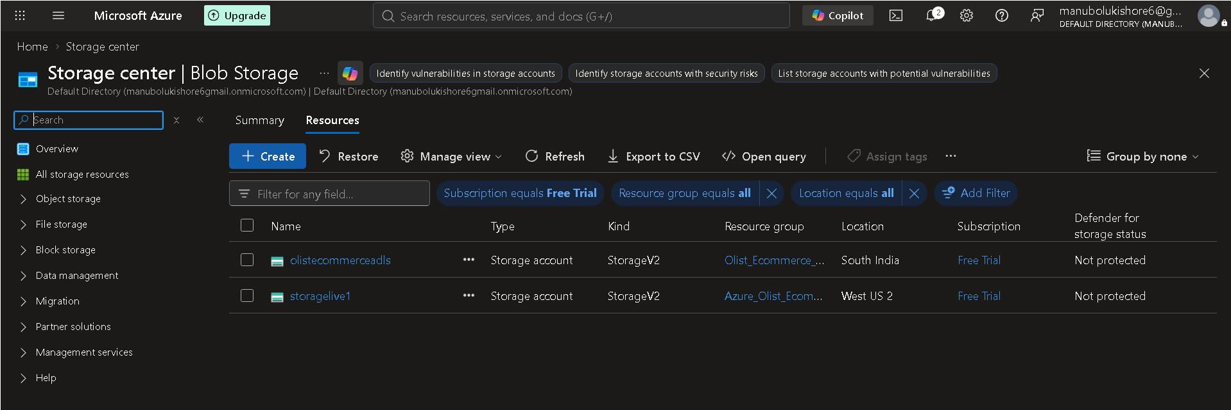
--> create new container to create multiple storage layers/directories (Bronze,Silver,Gold)
Flow: azure home -> storage accounts -> all storage resources -> choose specific (olistecommerceadls) ->
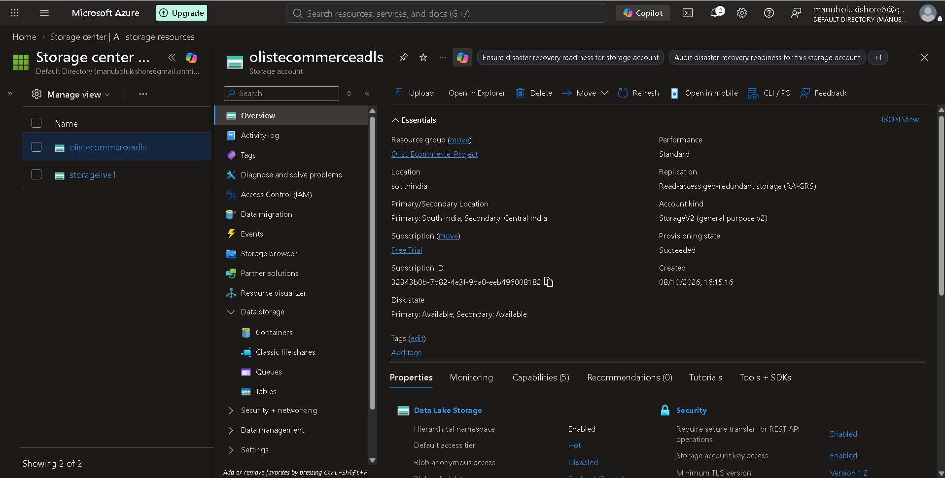
-> Data storage -> containers -> + add container -> create
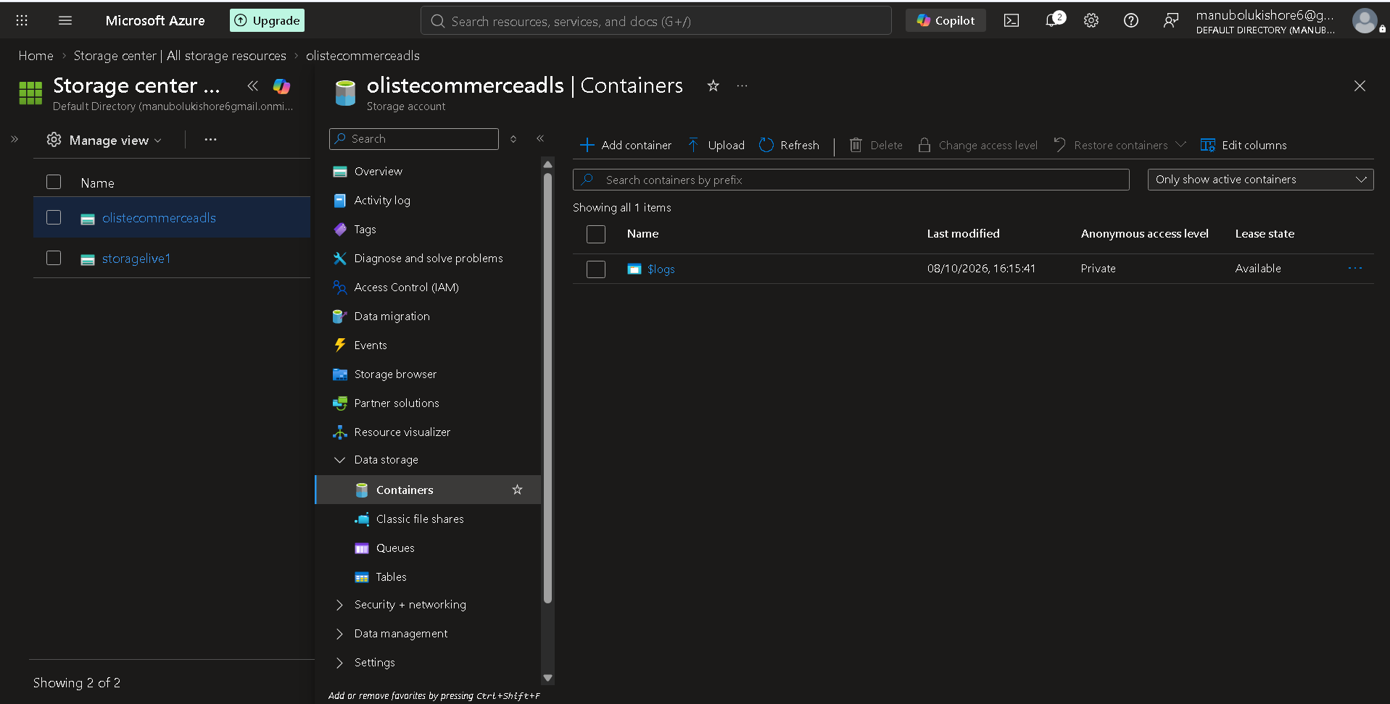
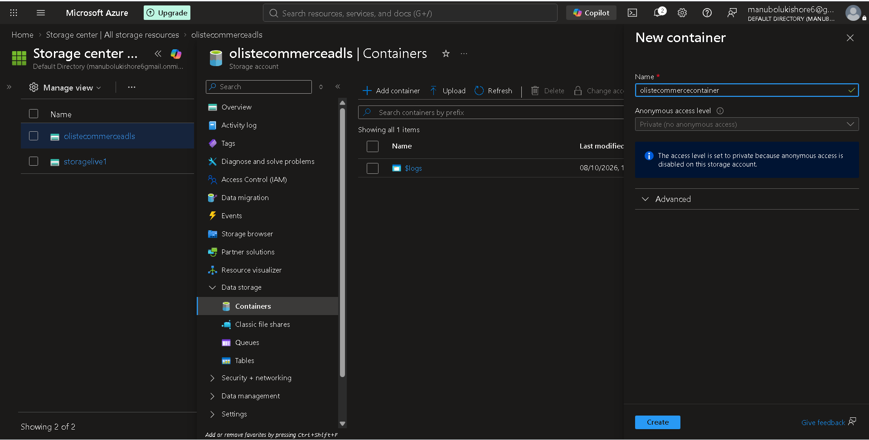
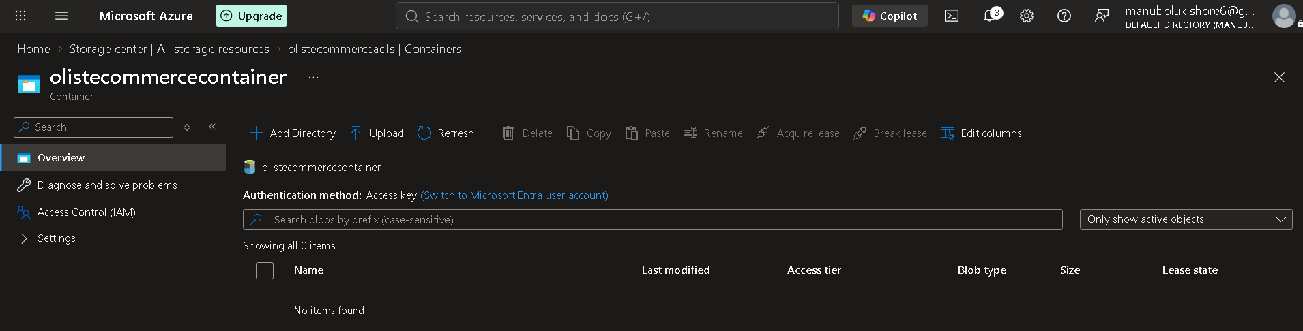
-> + add directory to create storage layers/directories.
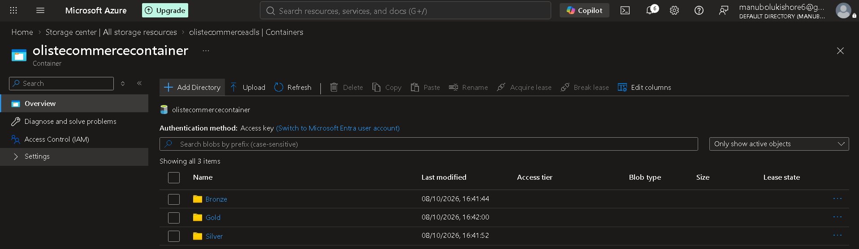
--------------------------------------------------------------------------------------
=> Medallion Architecture Overview
Databricks Documentation: https://www.databricks.com/blog/what-is-medallion-architecture
-------------------------------------------------------------------------------------
=> Ingestion With Azure Data Factory
--> Creating sink dataset to ingest data into data storage layers (Bronze,Silver,Gold):
Flow: azure factory home -> factory resources -> pipelines -> activities -> sink -> sink dataset -> + new -> Azure Data Lake Storage Gen2
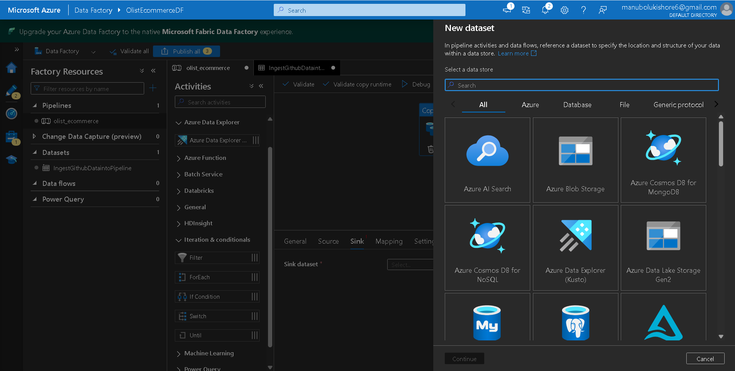
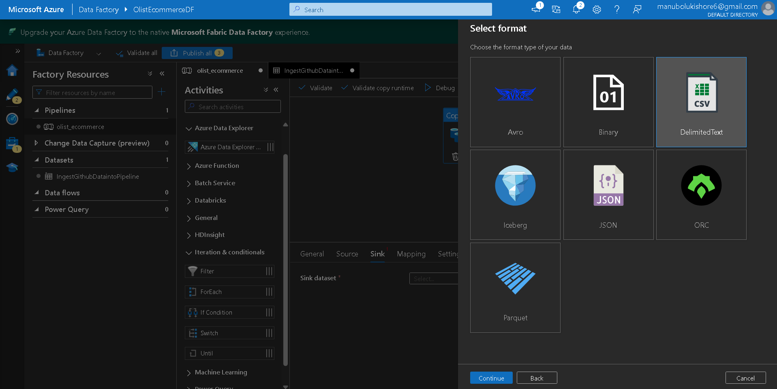
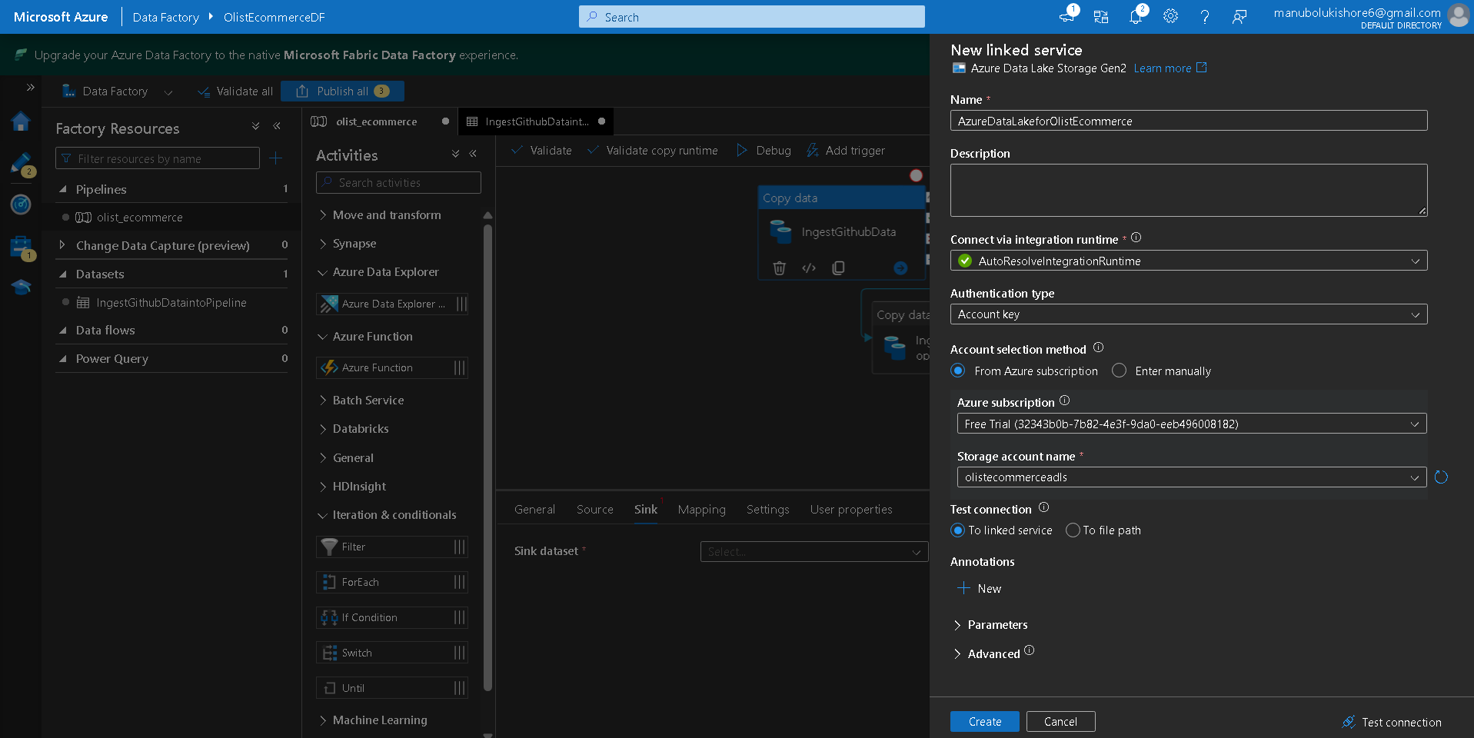-> create -> it will ask for path to the storage data layer for data store
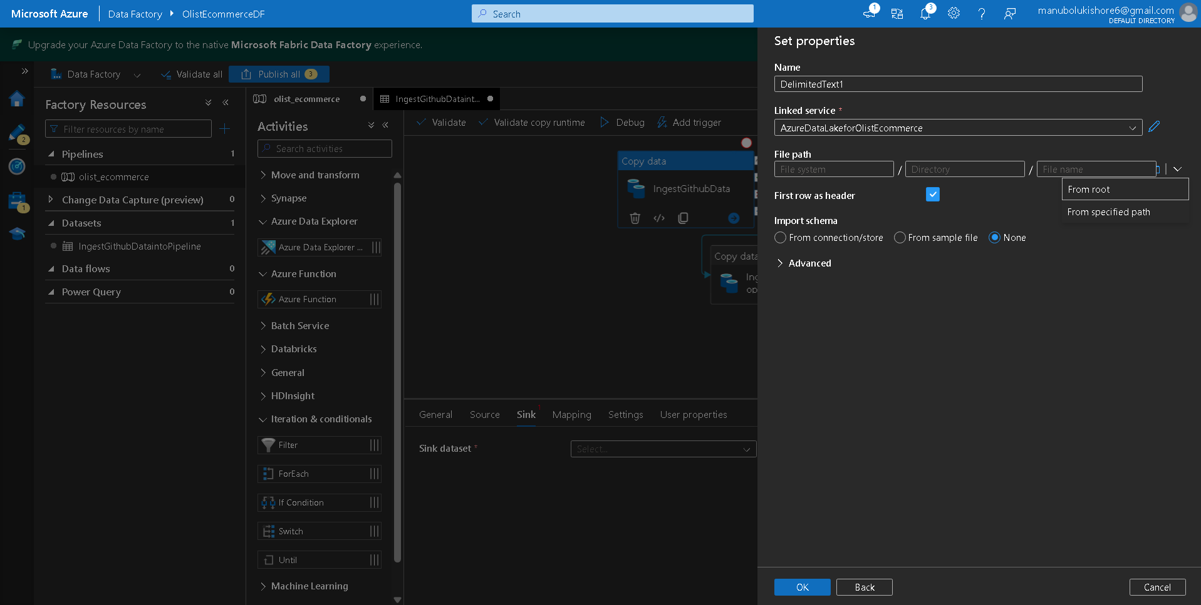
-> select path using down arrow -> choose from specified path ->Browse ->
olistecommercecontainer -> among 3 layers choose Bronze layer to store raw data “as-is” -> choose import schema as none -> click ok
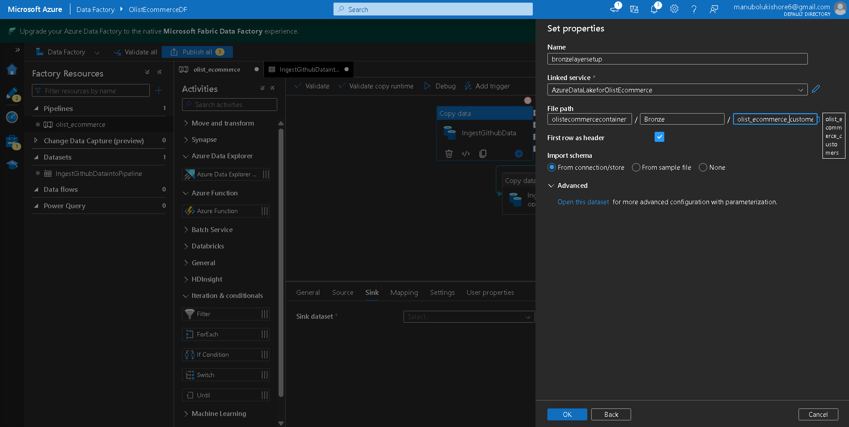
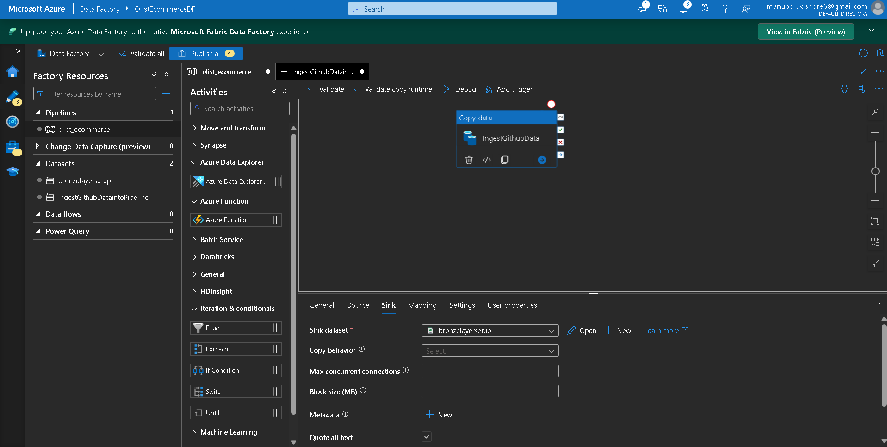
--> validating copydata activity to verify data loaded into datalake bronze layer or not :
Flow :
Step-1: click validate -> after successful validation -> close
Step-2: click debug -> activity running -> successful
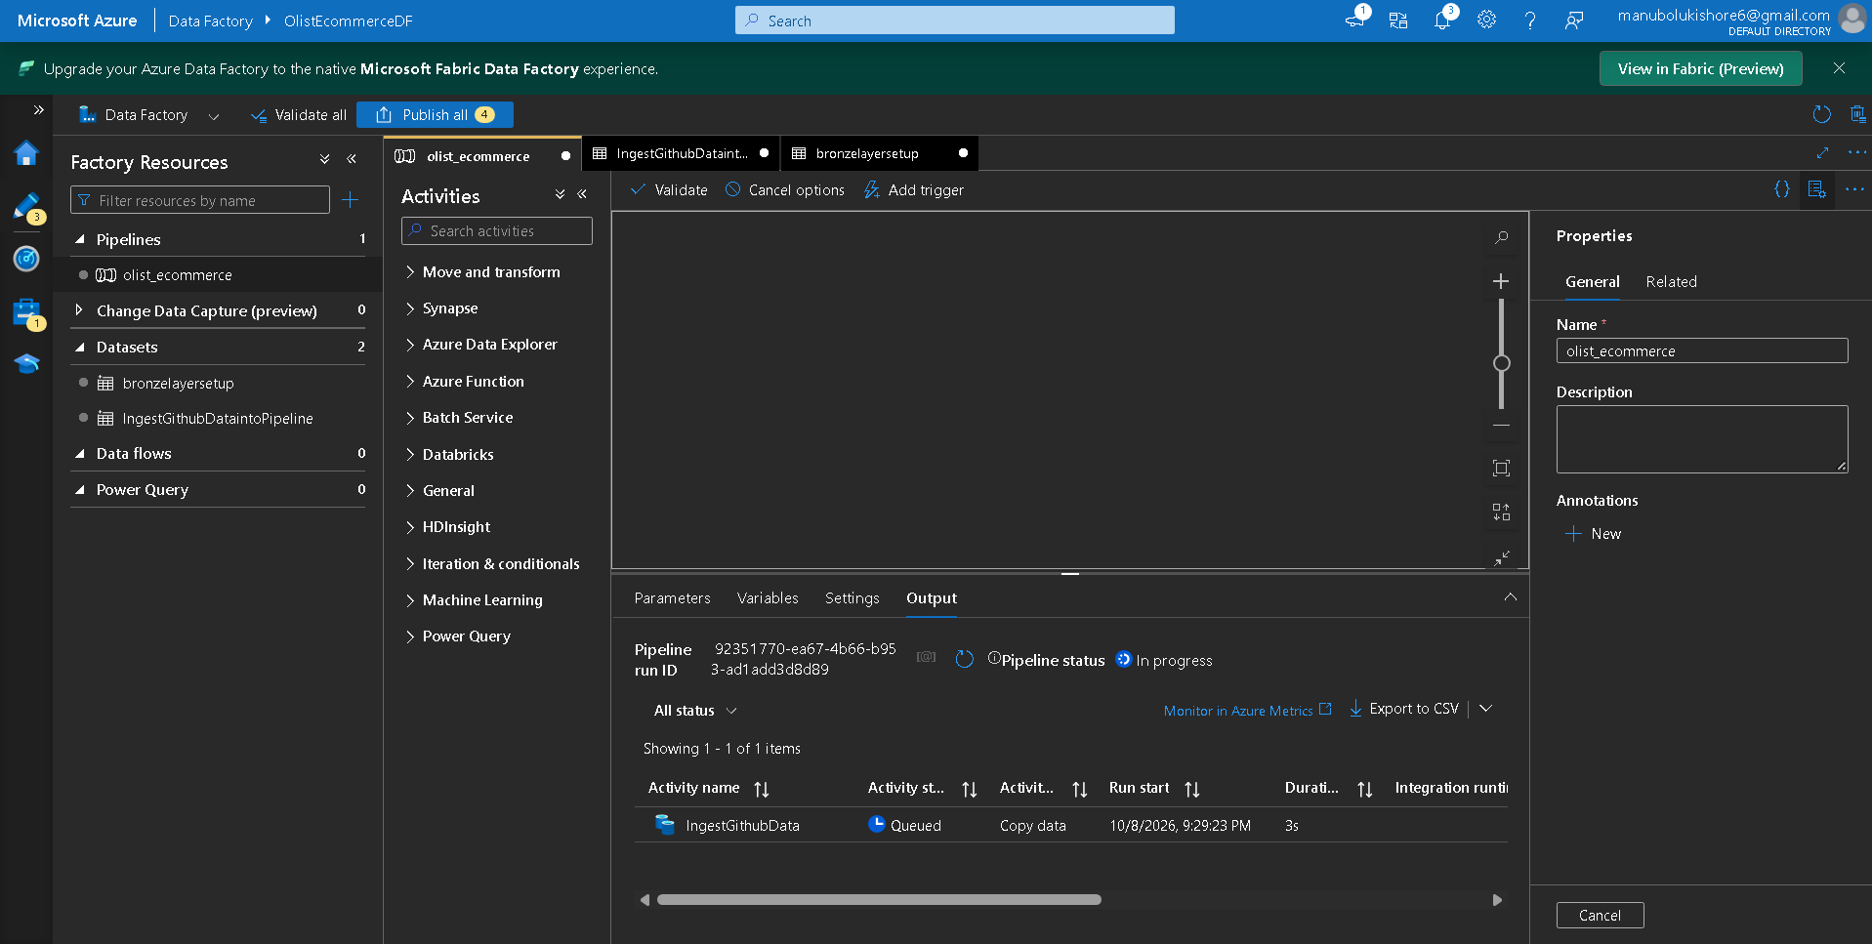
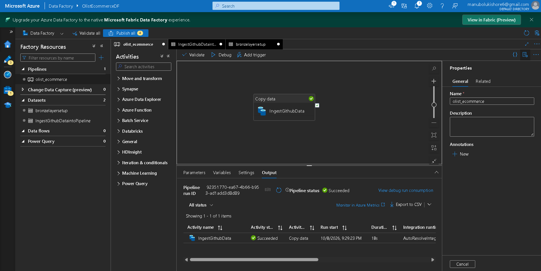
--> Verify containers of storage accounts inside Azure:
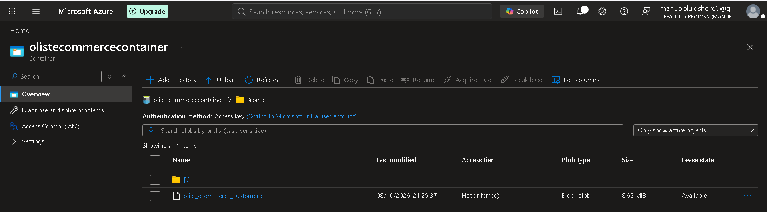
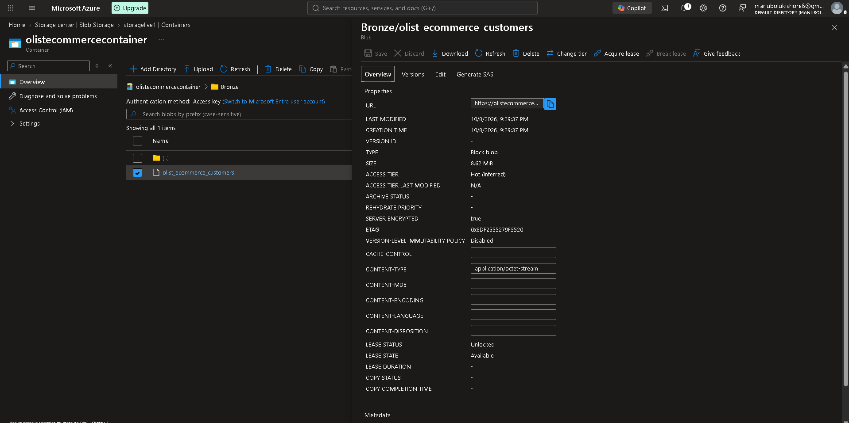
--> Understanding Storage Access Tiers (Contextual Note)
When ingesting data into Azure Blob/Data Lake storage, you must choose an access tier based on how often the data will be used:
- Archive Tier: The cheapest storage option, but retrieving data takes a long time. It is meant for long-term backups (accessed maybe once every 5-10 years). It cannot be immediately queried by analytics tools like Databricks.
- Cold Tier: Moderately priced. Ideal for data that is accessed infrequently (e.g., once a year).
- Hot Tier: The most expensive storage option, but provides immediate, fast access. This is the standard for files that are accessed, read, and processed daily.
Flow: click on -> change tier
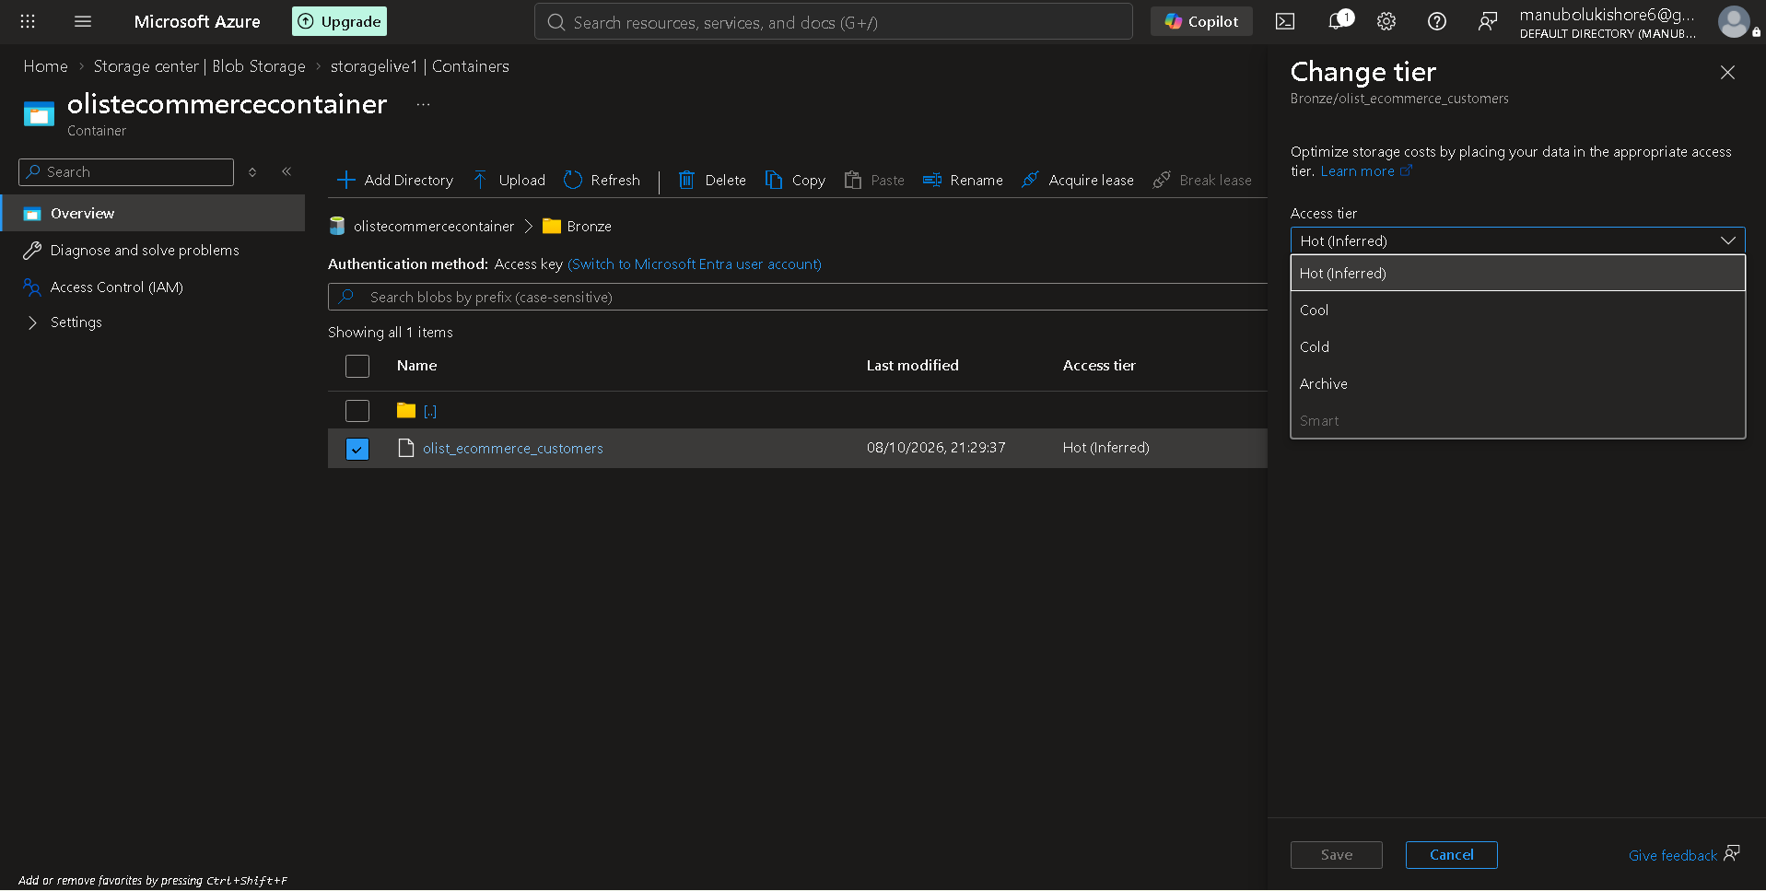
------------------------------------------------------------------------
--> Creating datalake and activities to load csv data from Github, MySQl db located in Filess.io server
1.Github
Flow: azure data factory home -> manage -> linked services -> + New -> HTTP -> new linked service -> test connection -> create
Base Ur: https://raw.githubusercontent.com/Kishore-M6/Resource_Datasets_of_Brazilian_E-Commerce_Public_Dataset_by_Olist/
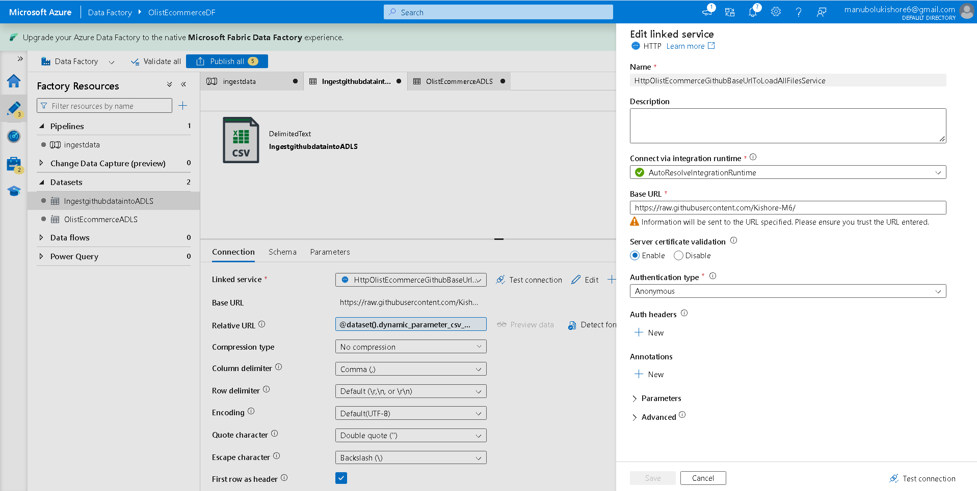
2. MySQL
Flow: azure data factory home -> manage -> linked services -> + New -> MySQL -> new linked service -> test connection -> create
--> Configure connection details from filess.io server MySQL database
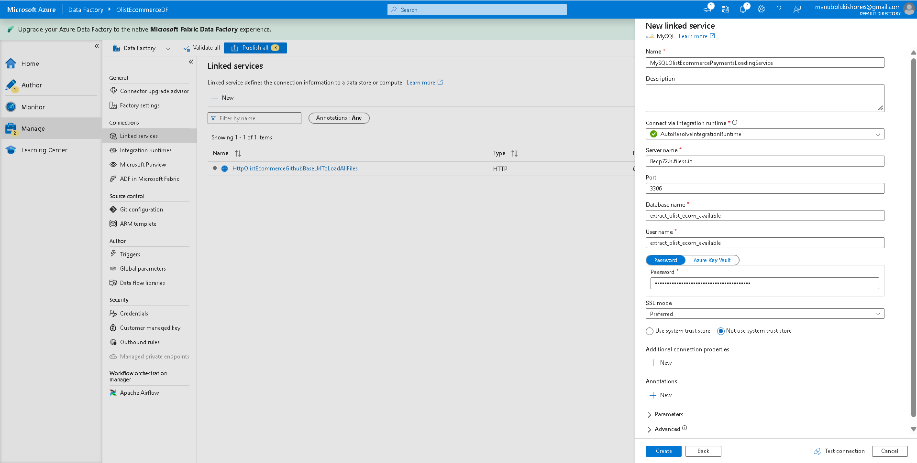
--> current all linked services of data sources to connect with ADLS
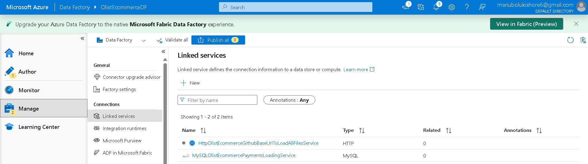

--------------------------------------------------------------------------------------------------------------------
13. Real Time Ingestion with Azure Data Factory
--> creating dynamic prameterized dataset to read all csv files from github.
Step-1: created source then link with linked service HttpOlistEcommerceGithubBaseUrlToLoadAllFilesService
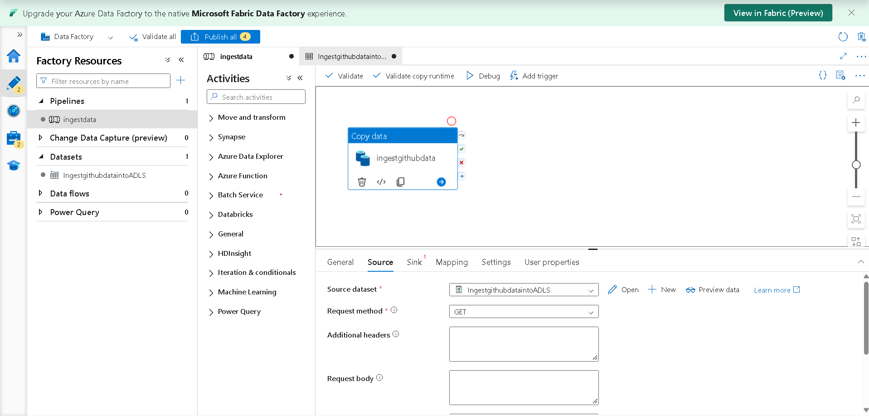
---------------------------------------------------
Step-2: Adding Dynamic Properties and relative URL to Dataset and create Pipeline Expression
Flow: -> click open of source dataset -> click on Relative URL
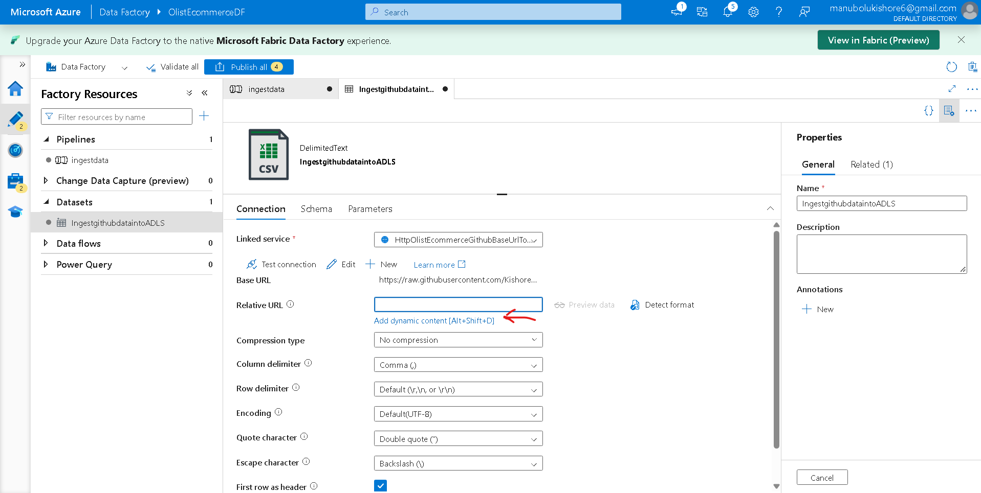
-> Pipeline Expression Builder
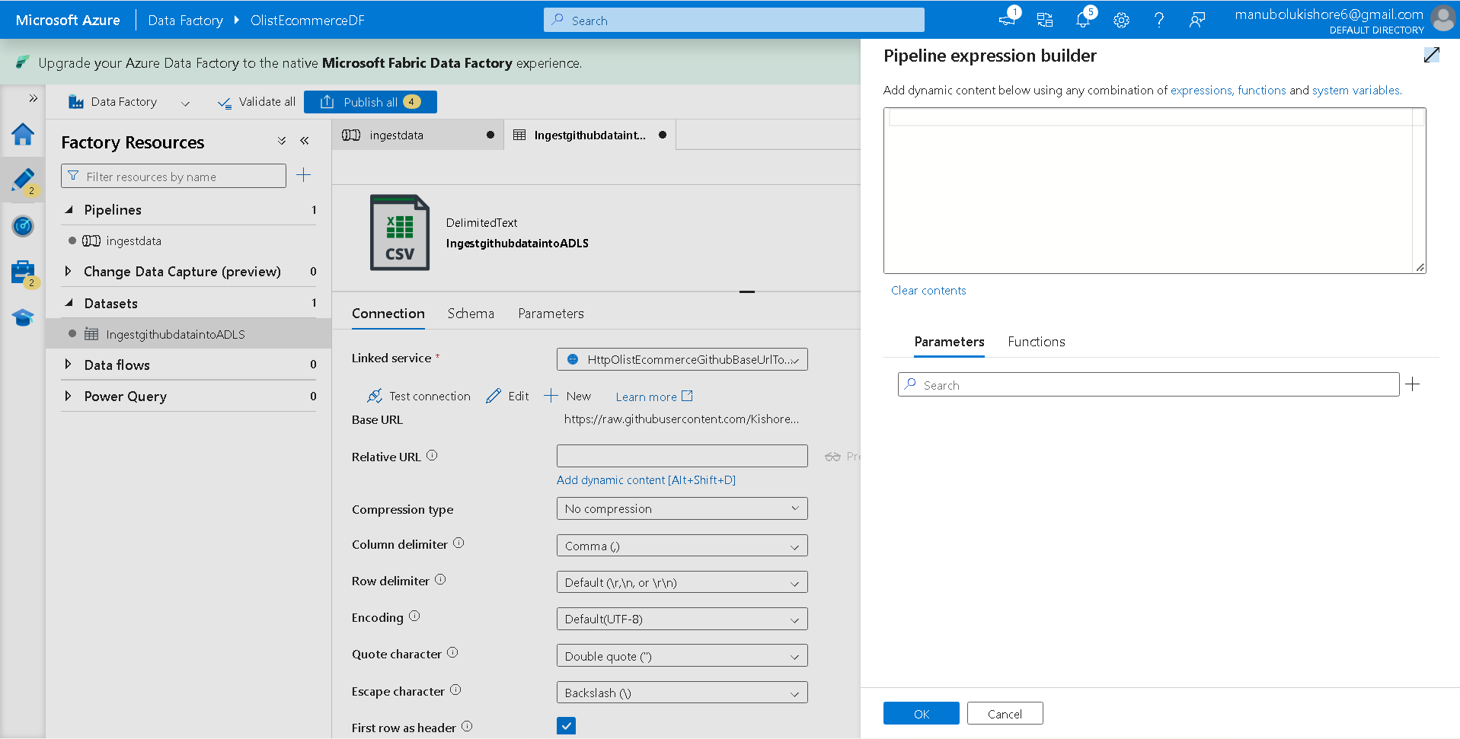
Flow: Pipeline Expression Builder -> Parameters (+) icon -> New Parameter (dynamic_parameter_csv_relative_url) -> save -> re-directed to Pipeline Expression Builder tab -> select Prameters/ dynamic_parameter_csv_relative_url created one -> then dynamic expression becomes @dataset().dynamic_parameter_csv_relative_url -> save
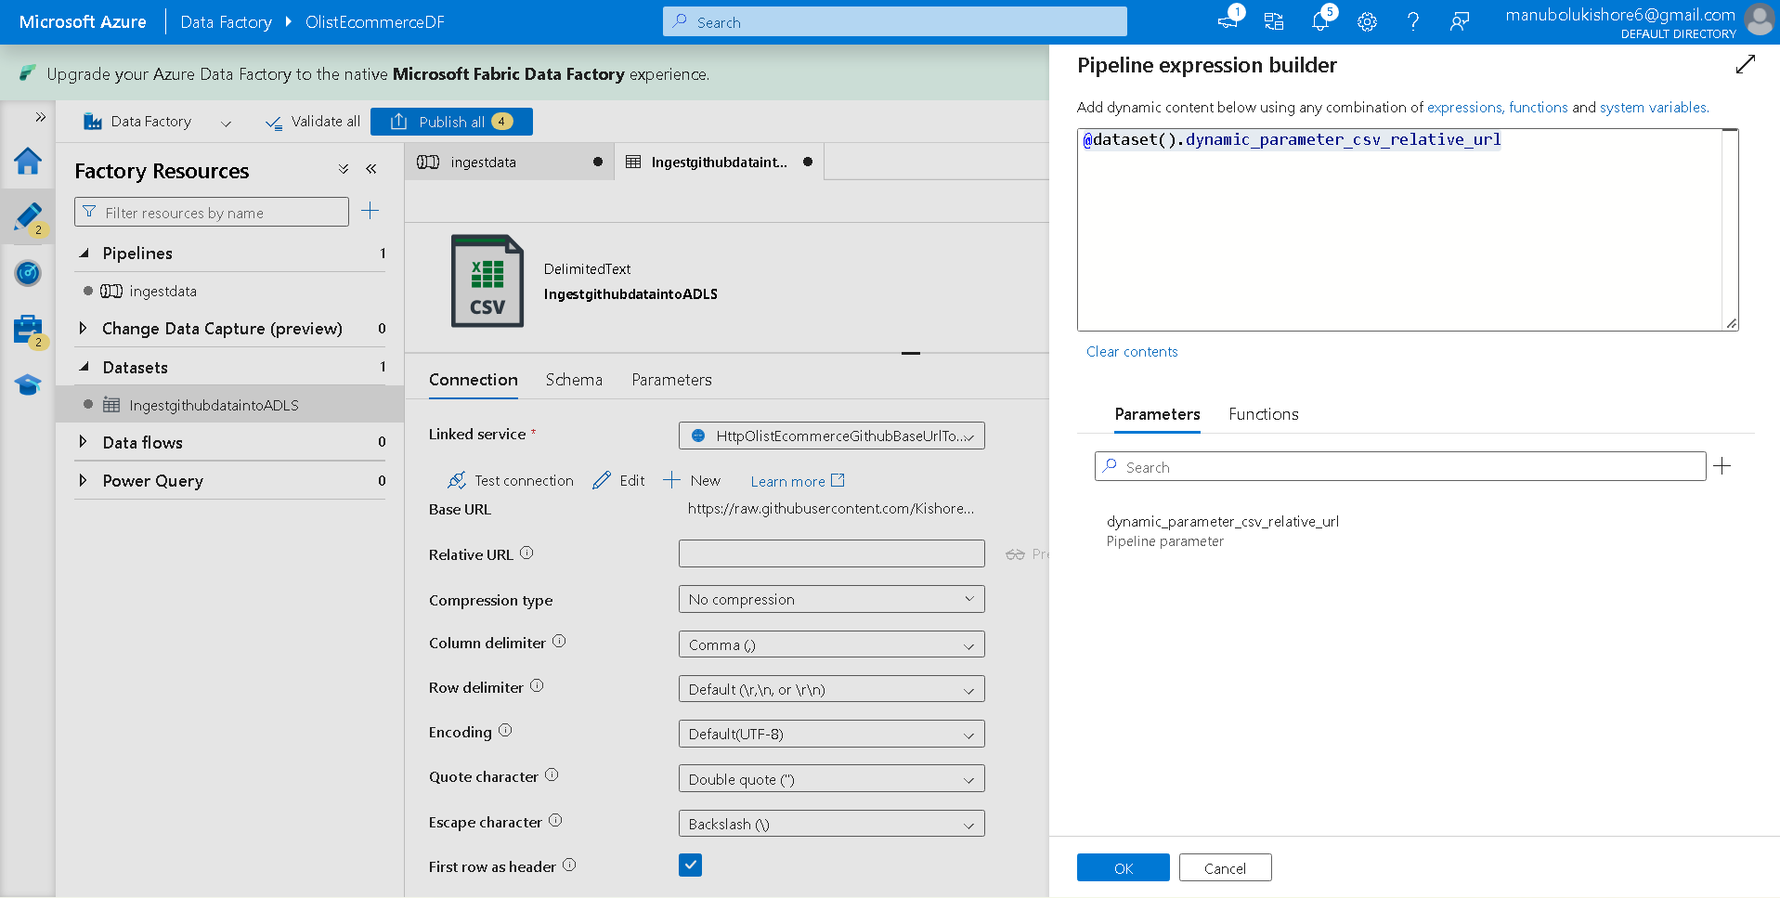
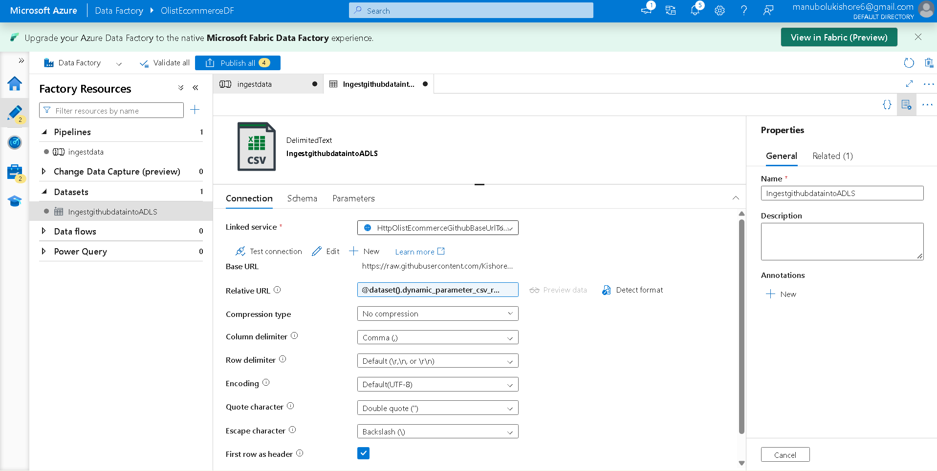
----------------------------------------------------
Step-3: setup ADLS storage to ingestdata pipeline
Flow: azure data factory home -> factory resources -> pipelines -> ingestdata ->Activities -> editor tab -> sink -> sink dataset -> + new -> New Dataset -> select Azure Data Lake Storage Gen2 -> continue -> Delimited Text -> Set Properties
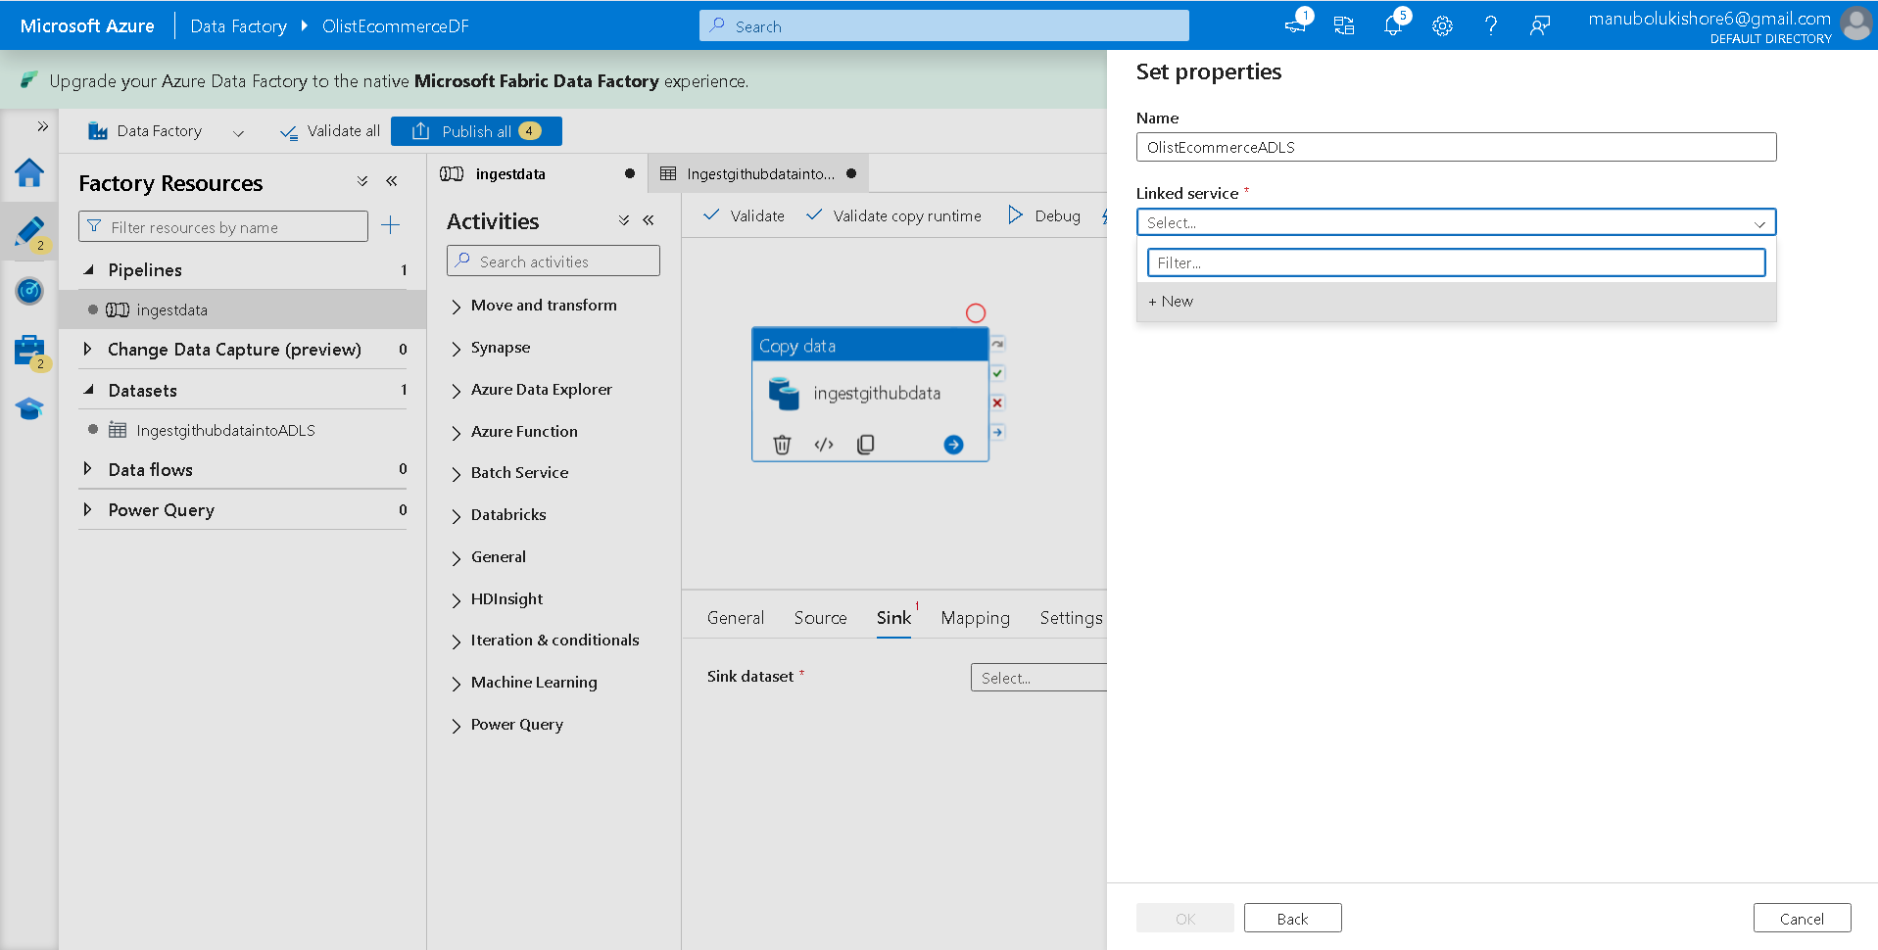
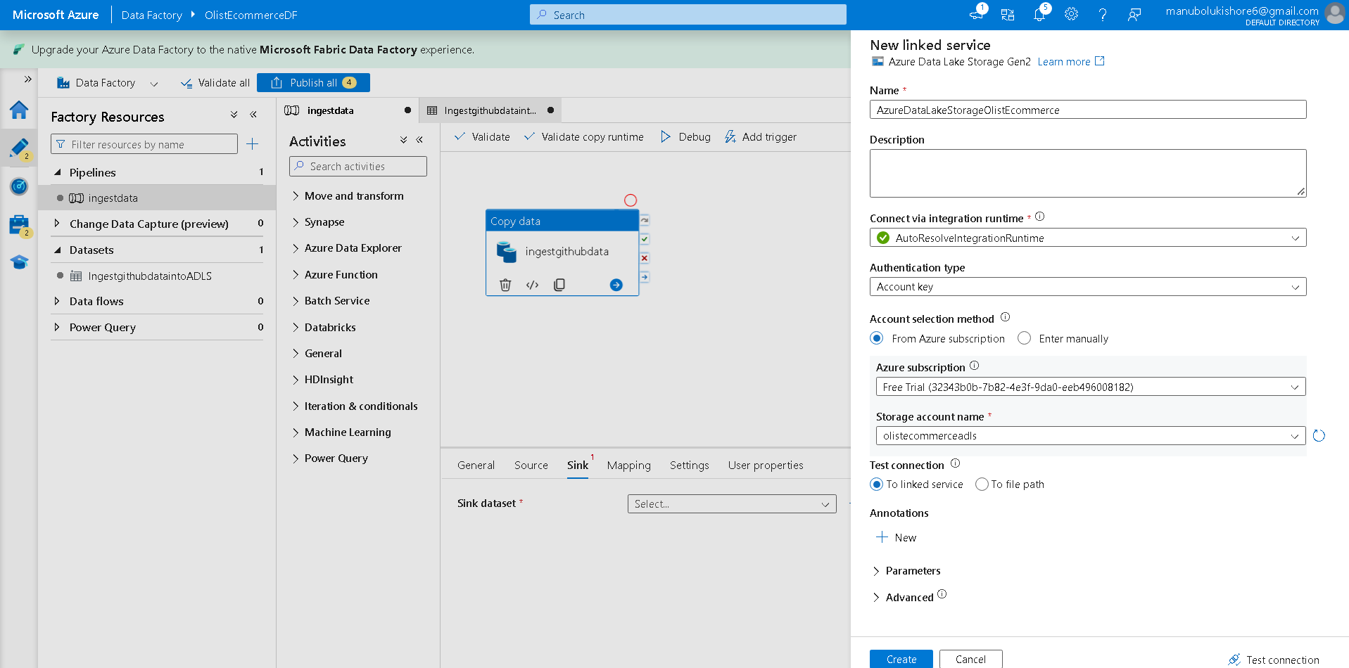
-> create -> FilePath -> From specified path-> Browse -> olistecommercecontainer/Bronze -> ok -> (here did not specified any file name )
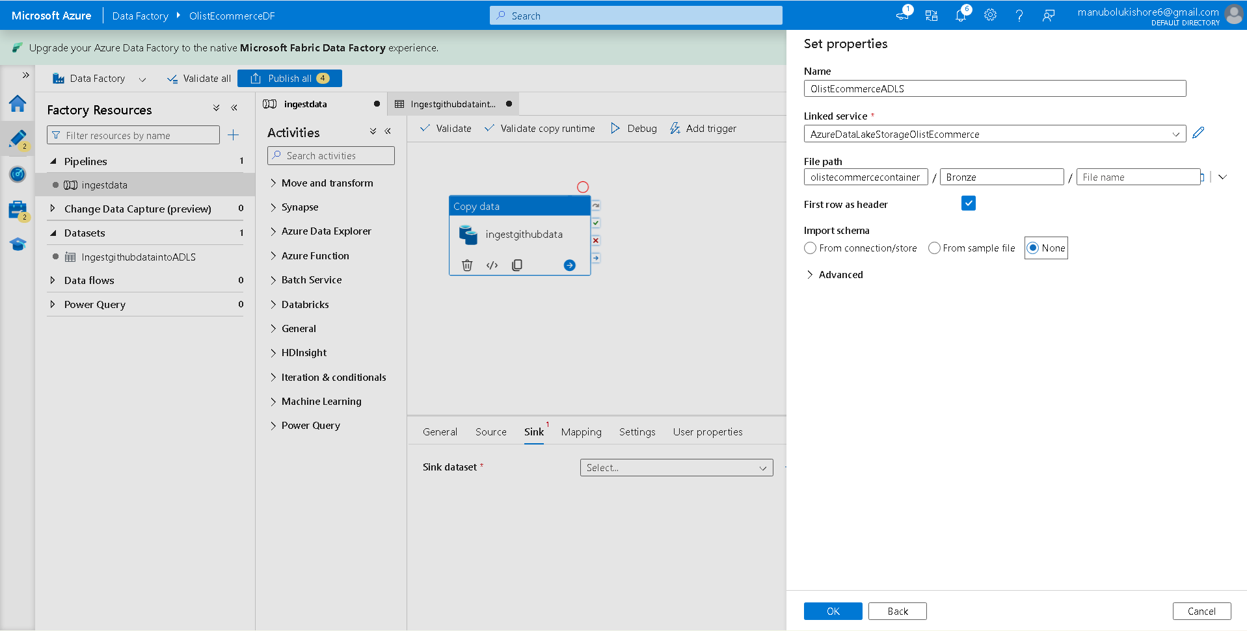
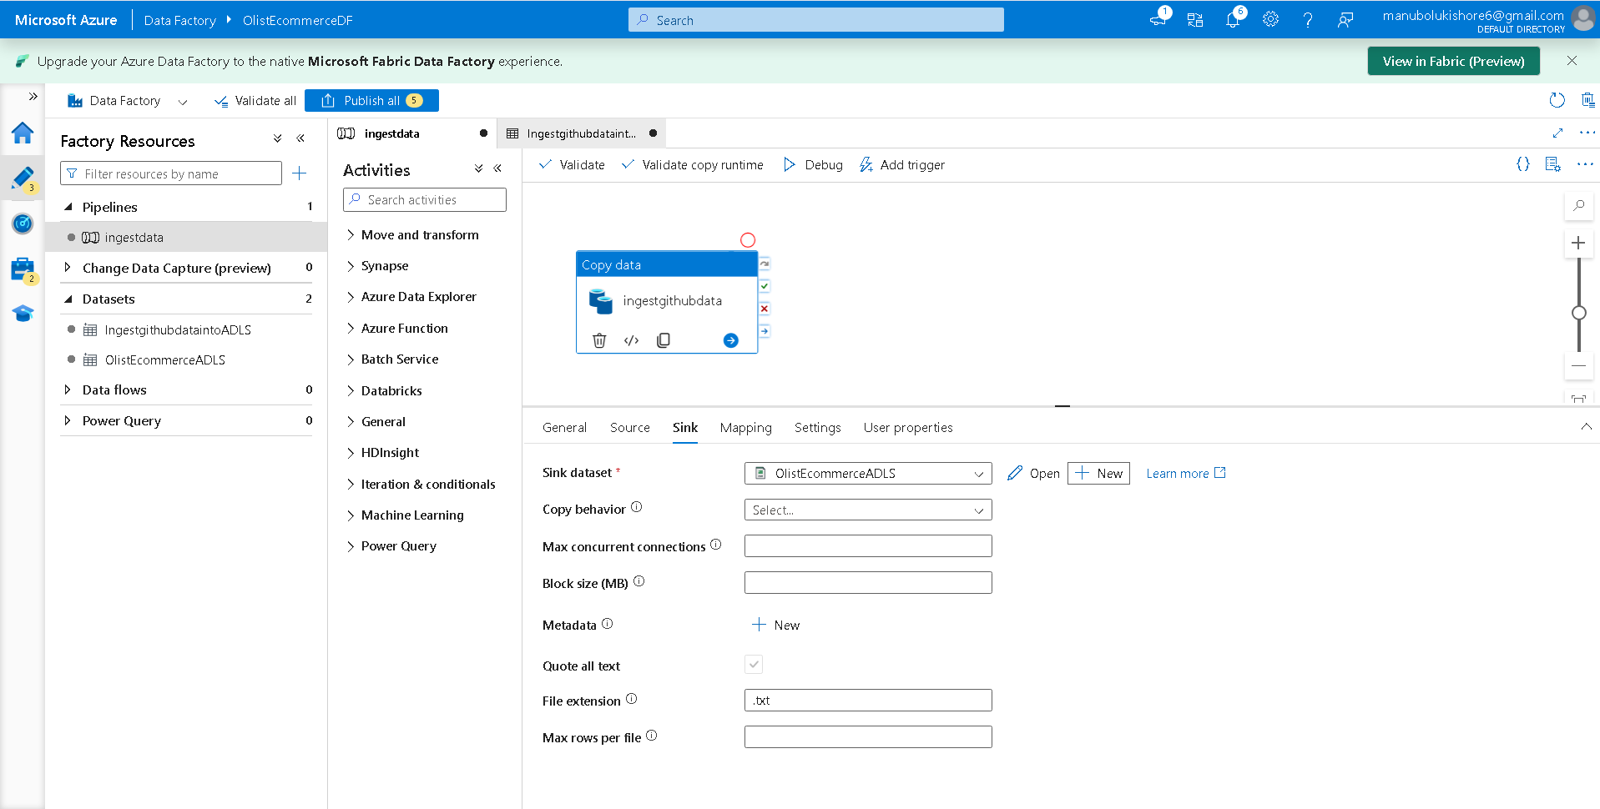
Step-4: create Pipeline Expression with dynamic parameter for file_name of csv files in github
Flow: Sink -> open ->
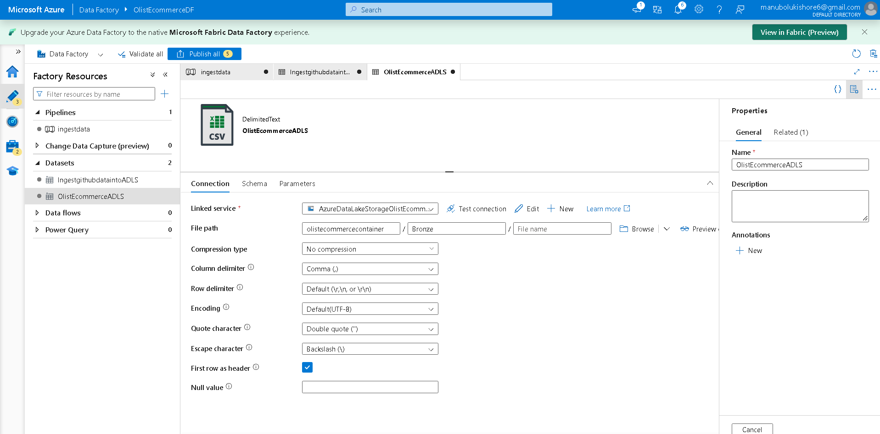
-> select File name text box -> Add dynamic content [Alt+Shift+D]
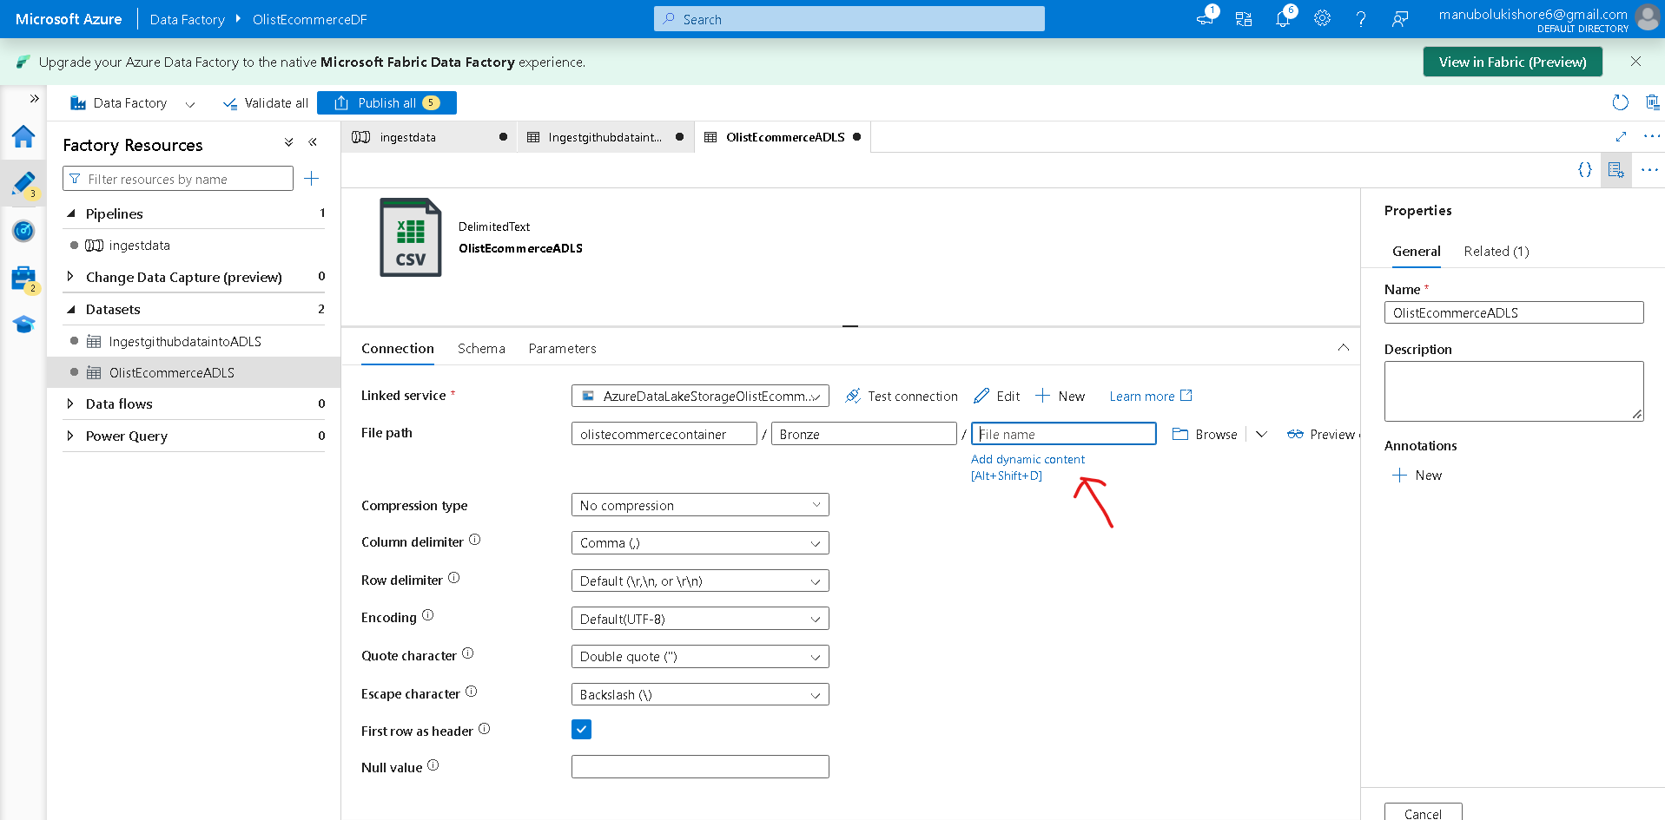
-> Pipeline Expression Builder -> Parameters -> + -> New Parameter -> specify dynamic_file_name
-> ok
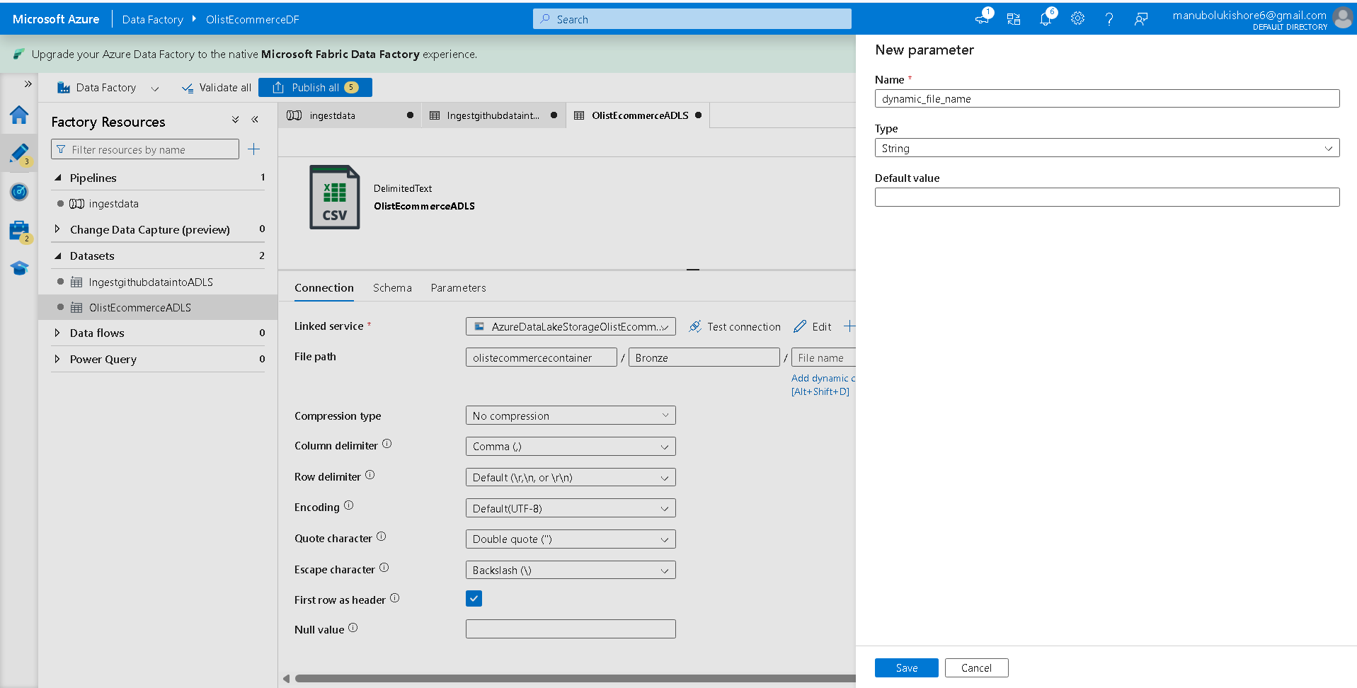
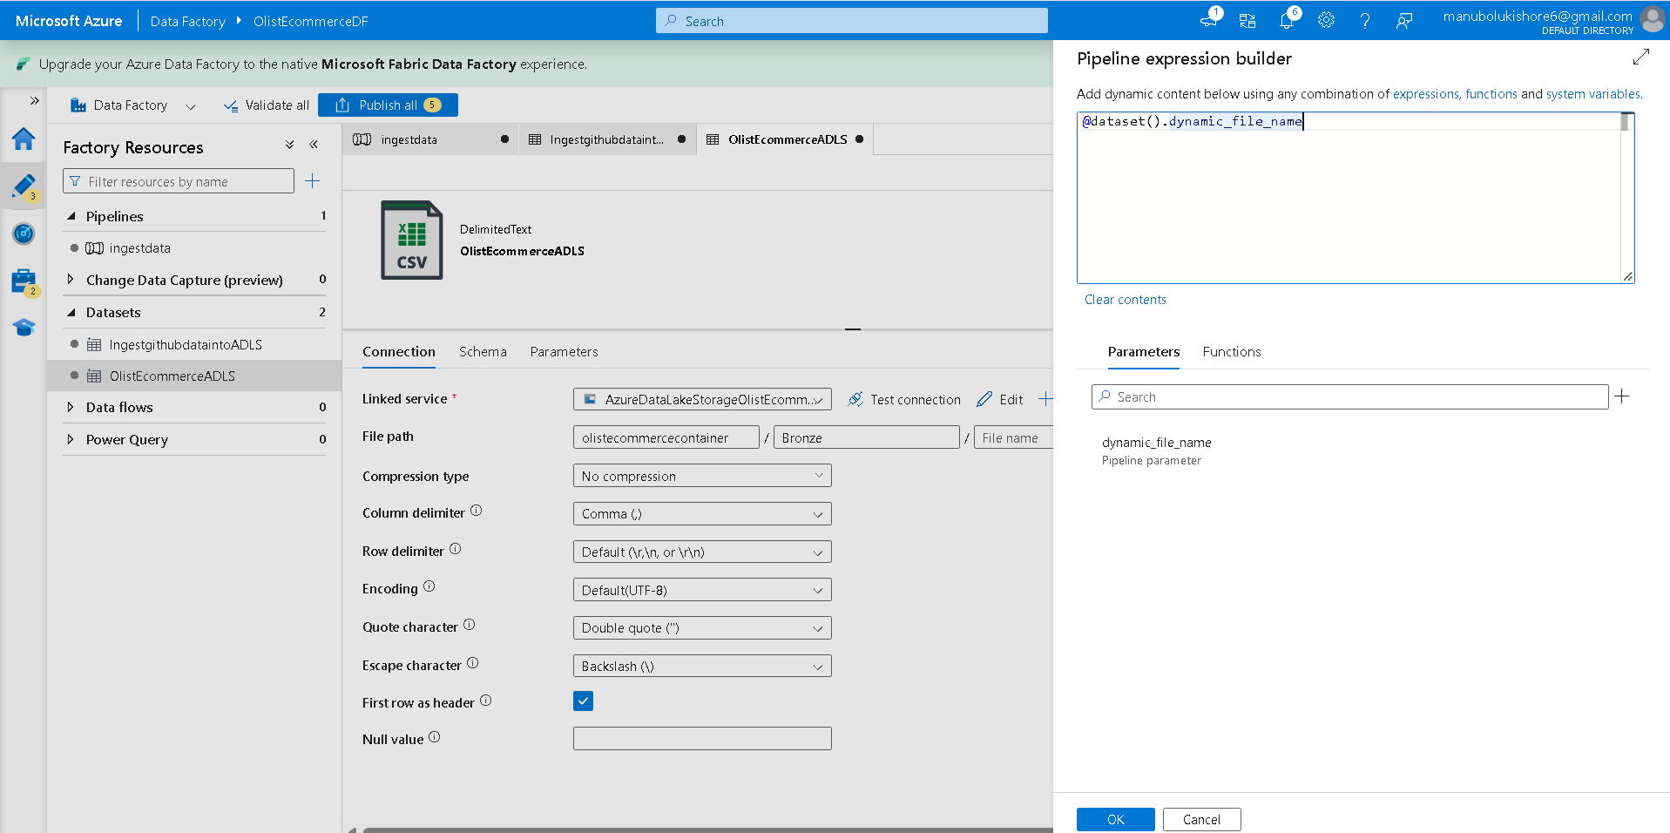
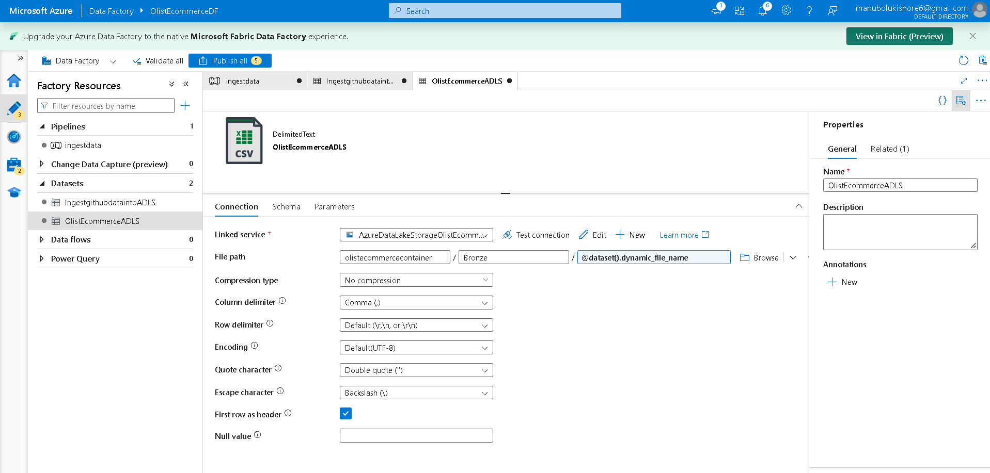
--> the dynamic_file_name parameter will be reflected within pipeline which ask for enter file name.
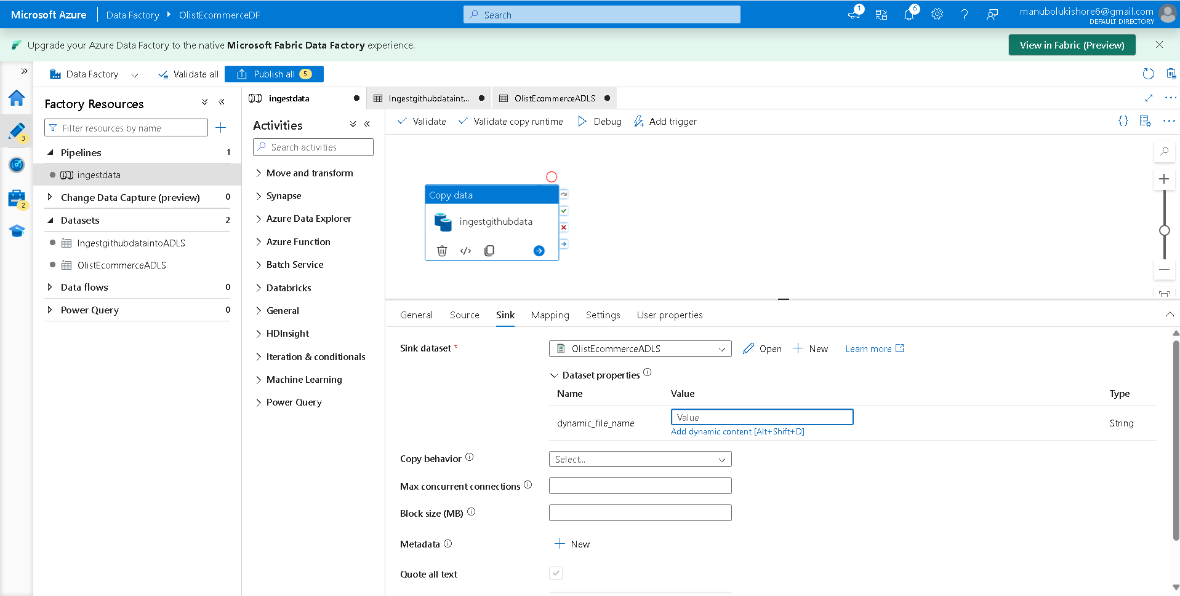
--> creating Array of Tuples collection object with dynamic_parameter_relative_url,dynamic_file_name passing to forEach iteration and activity.
Inputfiles.txt:
[
{
"dynamic_parameter_csv_relative_url": "Resource_Datasets_of_Brazilian_E-Commerce_Public_Dataset_by_Olist/refs/heads/main/olist_customers_dataset.csv",
"dynamic_file_name":"olist_customers_dataset.csv"
},
{
"dynamic_parameter_csv_relative_url": "Resource_Datasets_of_Brazilian_E-Commerce_Public_Dataset_by_Olist/refs/heads/main/olist_geolocation_dataset.csv",
"dynamic_file_name":"olist_geolocation_dataset.csv"
},
{
"dynamic_parameter_csv_relative_url": "Resource_Datasets_of_Brazilian_E-Commerce_Public_Dataset_by_Olist/refs/heads/main/olist_order_items_dataset.csv",
"dynamic_file_name":"olist_order_items_dataset.csv"
},
{
"dynamic_parameter_csv_relative_url": "Resource_Datasets_of_Brazilian_E-Commerce_Public_Dataset_by_Olist/refs/heads/main/olist_order_reviews_dataset.csv",
"dynamic_file_name":"olist_order_reviews_dataset.csv"
},
{
"dynamic_parameter_csv_relative_url": "Resource_Datasets_of_Brazilian_E-Commerce_Public_Dataset_by_Olist/refs/heads/main/olist_orders_dataset.csv",
"dynamic_file_name":"olist_orders_dataset.csv"
},
{
"dynamic_parameter_csv_relative_url": "Resource_Datasets_of_Brazilian_E-Commerce_Public_Dataset_by_Olist/refs/heads/main/olist_products_dataset.csv",
"dynamic_file_name":"olist_products_dataset.csv"
},
{
"dynamic_parameter_csv_relative_url": "Resource_Datasets_of_Brazilian_E-Commerce_Public_Dataset_by_Olist/refs/heads/main/olist_sellers_dataset.csv",
"dynamic_file_name":"olist_sellers_dataset.csv"
}
]
-----------------------------------------------
Flow: Activities -> Iteration & conditionals -> ForEach drag and place into pipeline -> select it then provide name
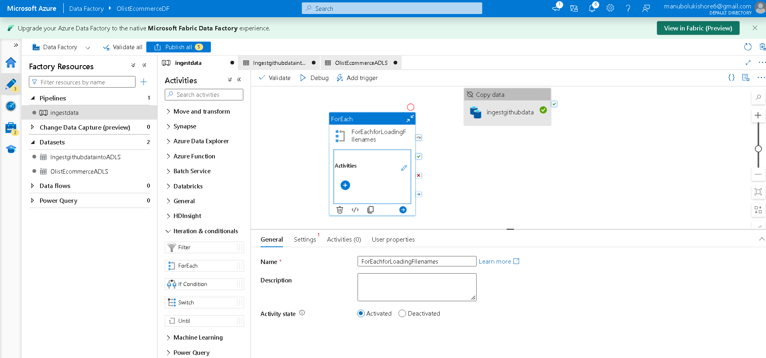
-> move to settings enable sequence checkbox
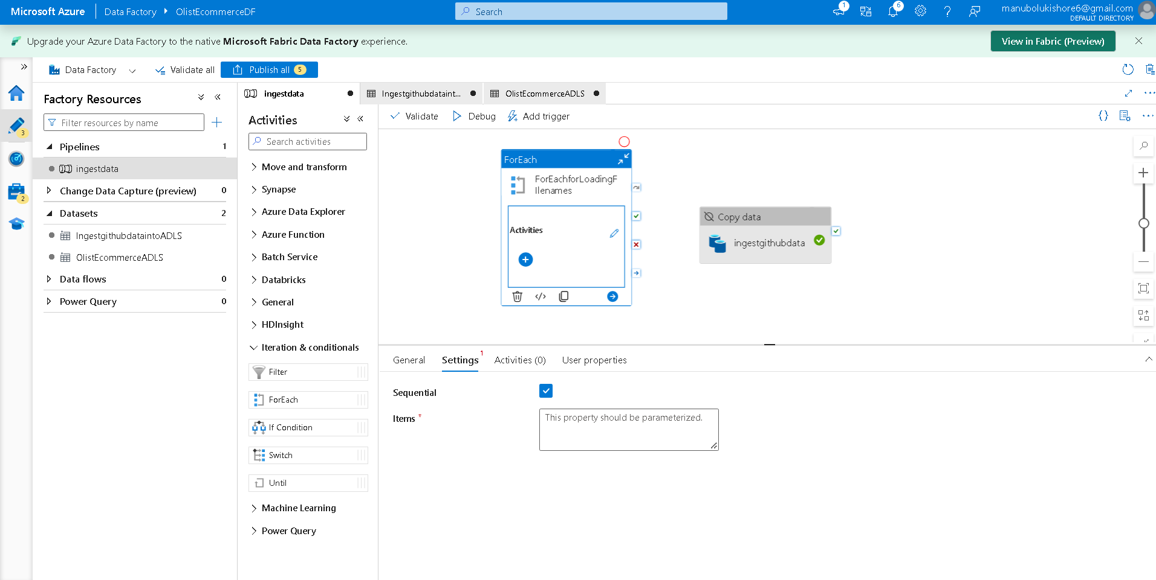
-> click on anywhere within editor to view parameters,variables,settings,output options to setup parameter variable
-> foreach_for_input_filenames type as Array and default value as inputfiles.txt array object as text
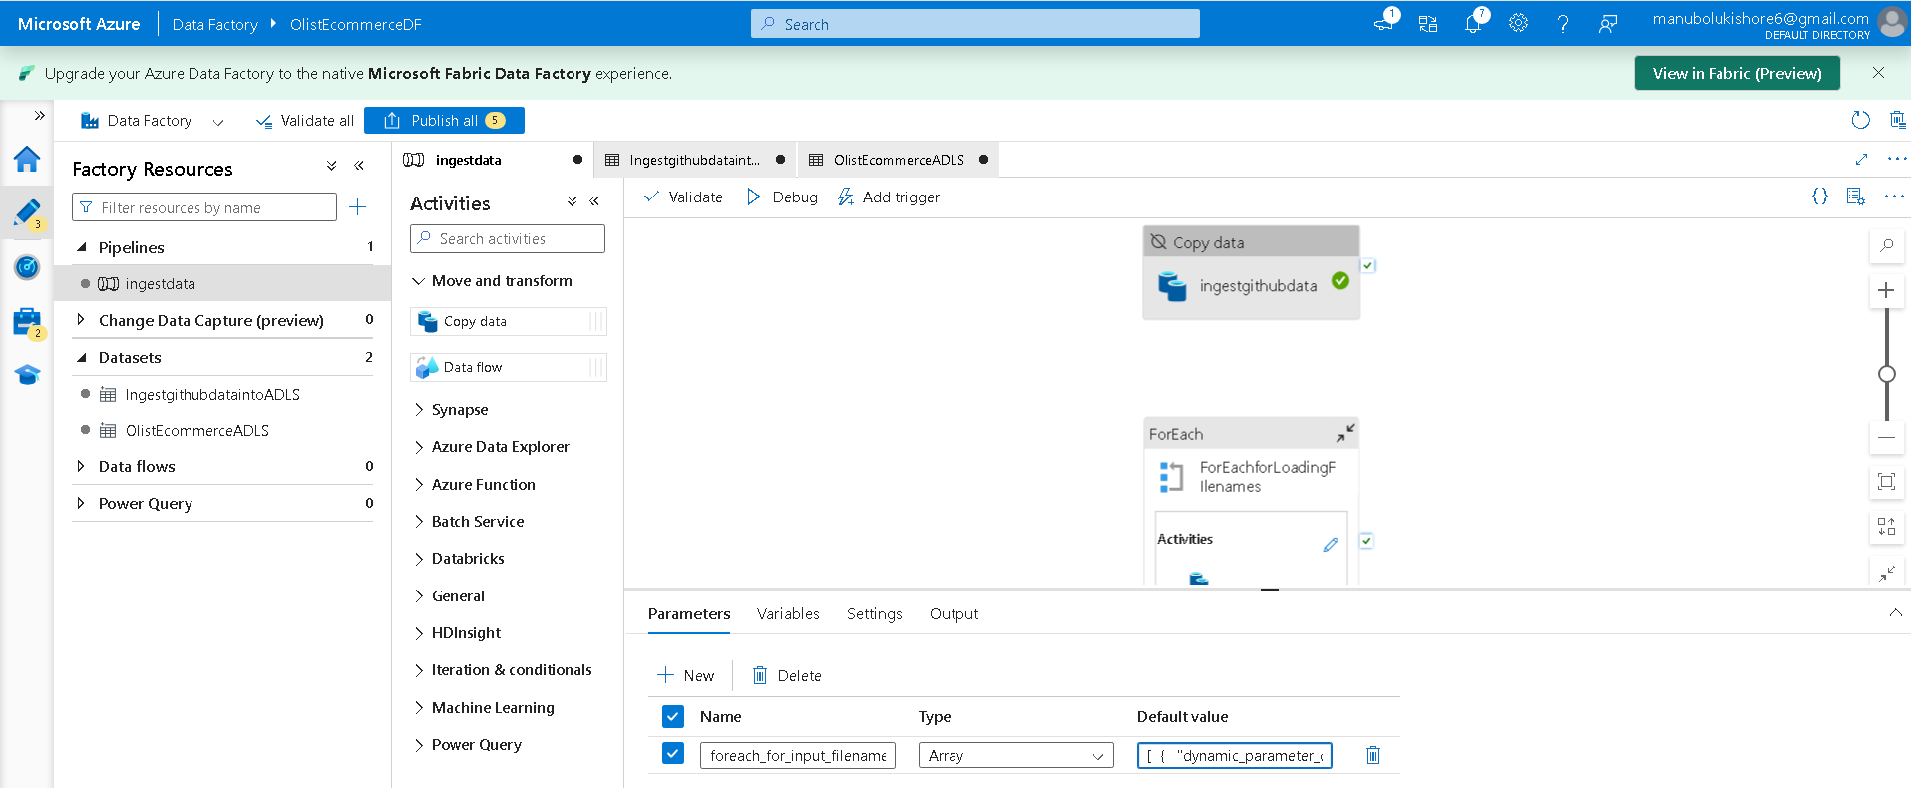
-> select foreach iterator of pipeline -> settings -> items
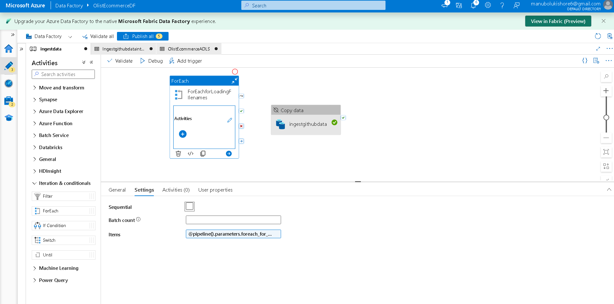
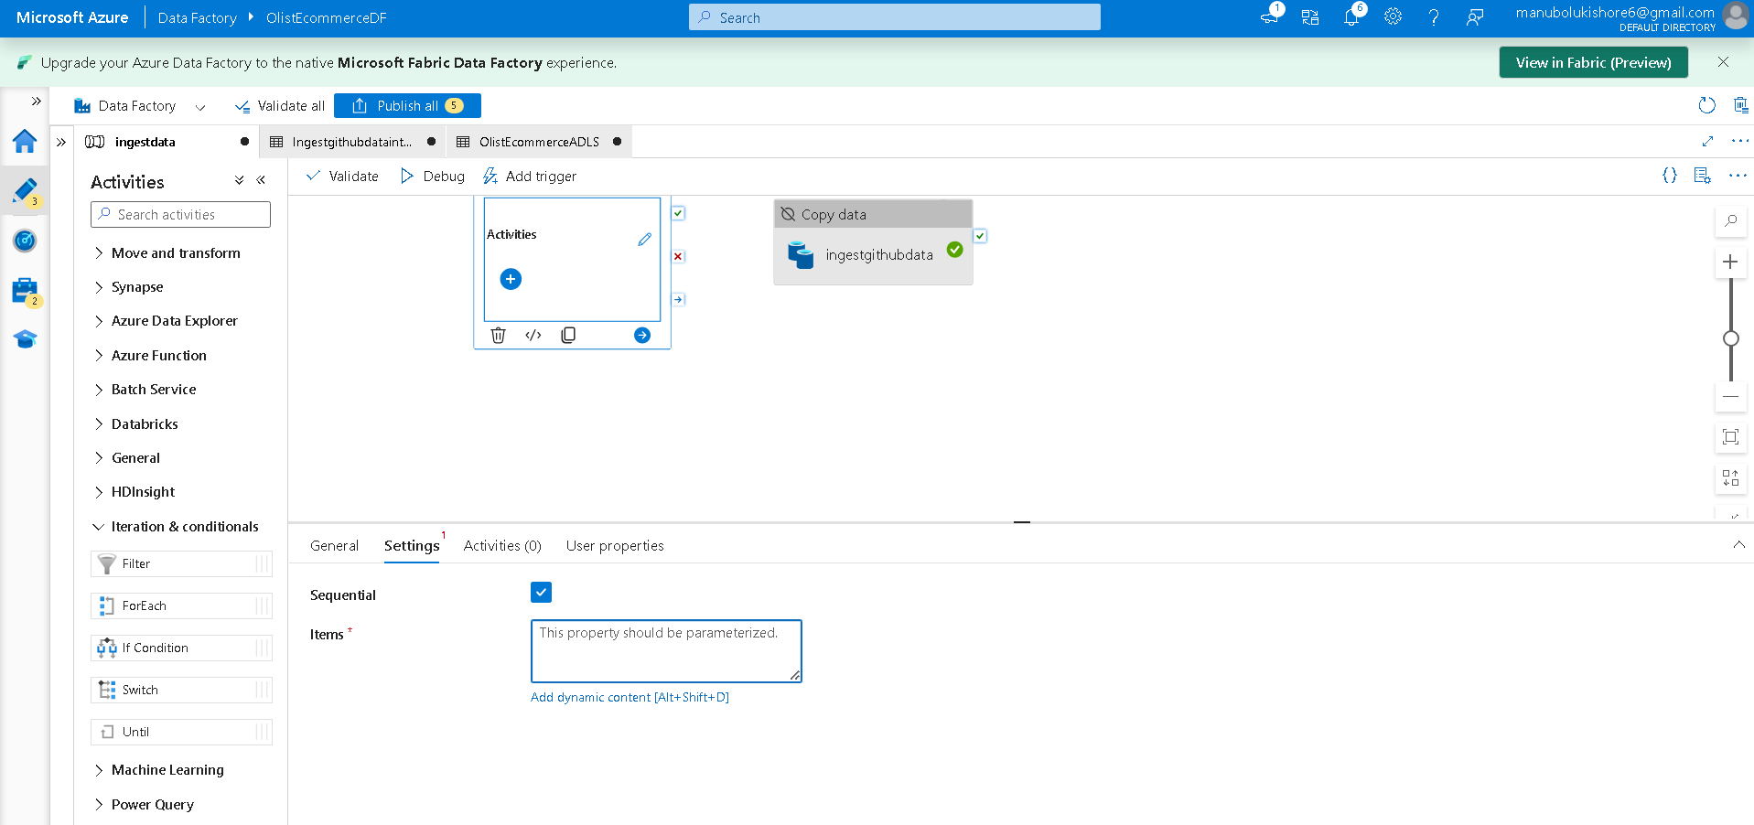
-> click ADD dynamic content [Alt+Shift+D] -> Pipeline expression builder -> select parameter created foreach_for_input_filenames -> ok
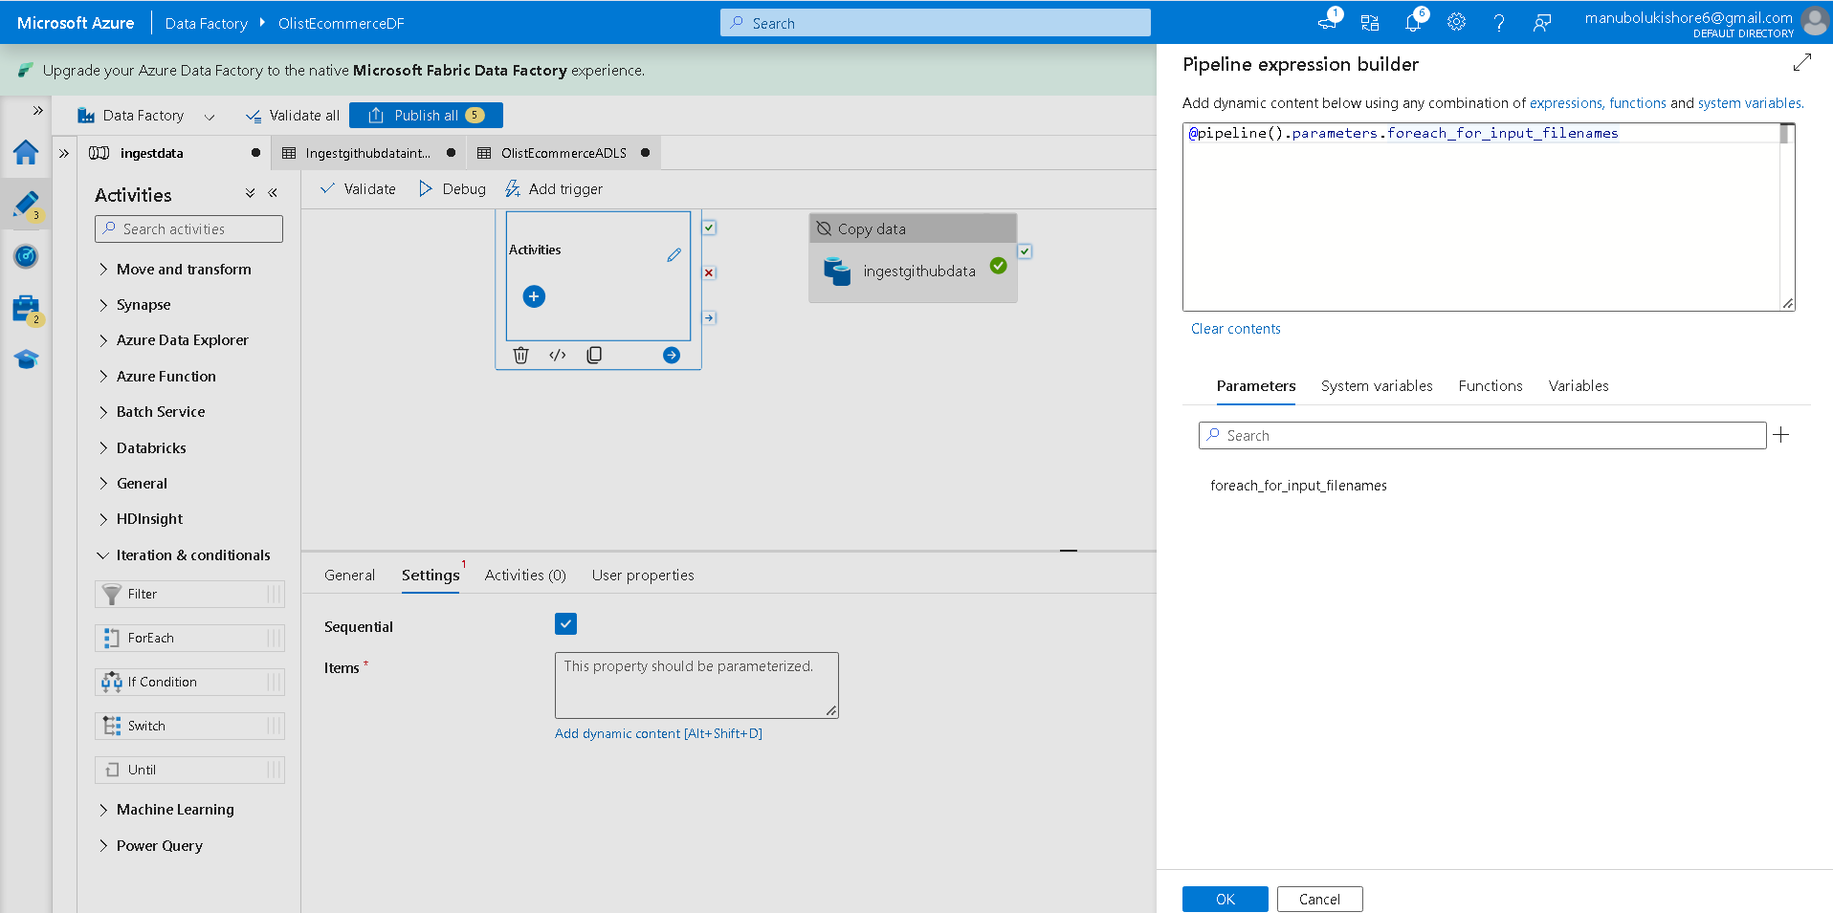
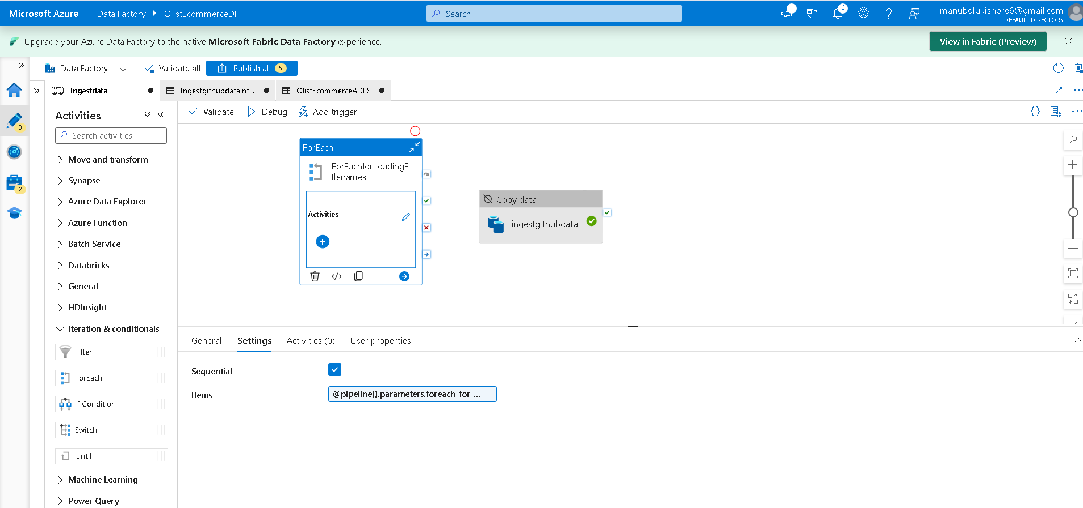
----------------------------------------
---> creating copydata activity for ForEachforLoadingFilenames iterator body logic
Flow: double click on ForEach activity task ForEachforLoadingFilenames -> drag and drop copydata activity into foreach task -> named as processing_filenames
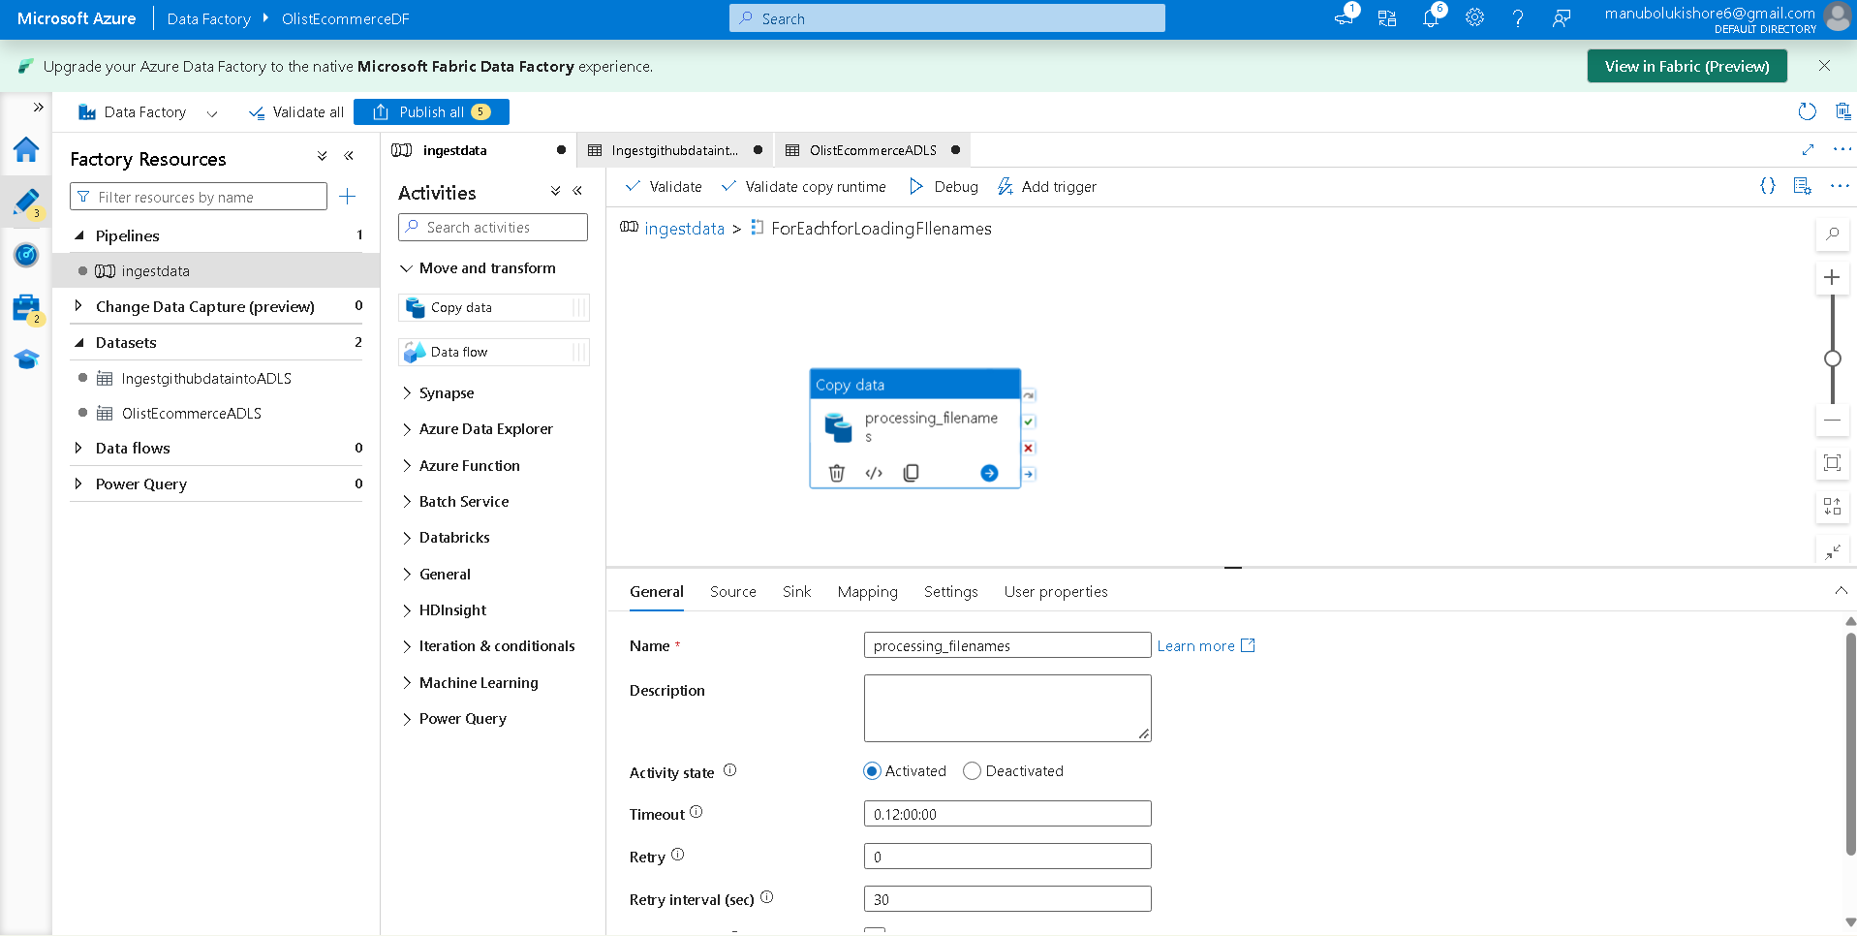
-> go to source -> choose “IngestgithubdataintoADLS” dataset -> go to sink -> choose “OlistEcommerceADLS” dataset
-> configure value by bind foreach_for_input_filenames parameter of FoeeachforLoadingFilenames loop using @item() function in Pipeline Expression Builder console
Source:
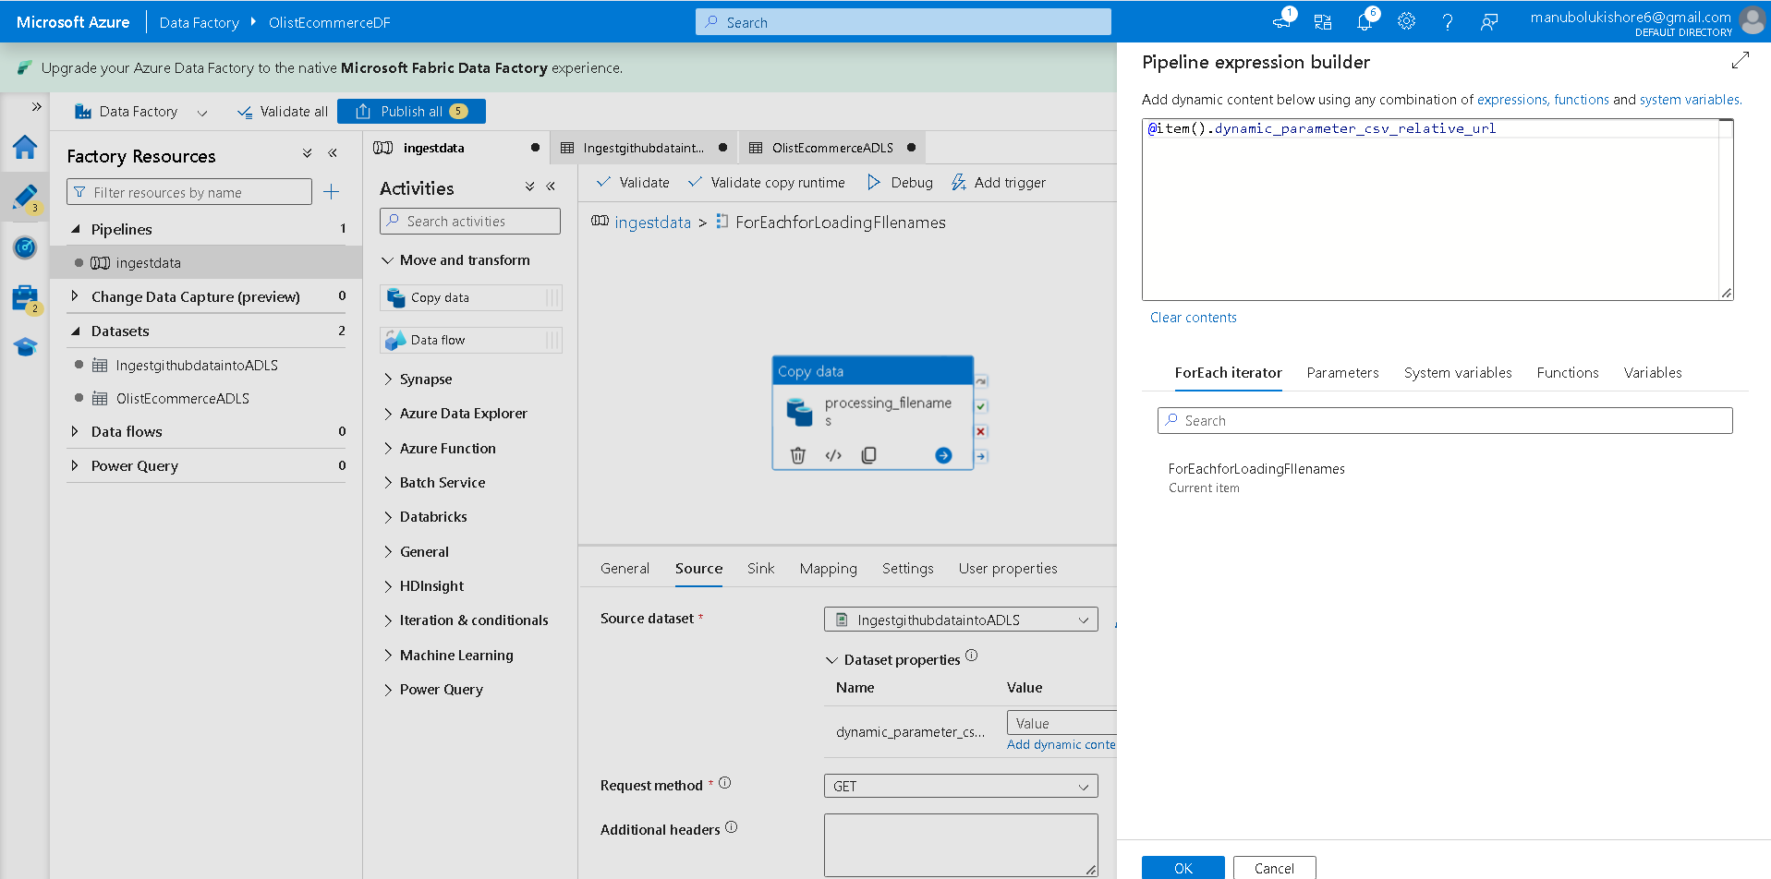
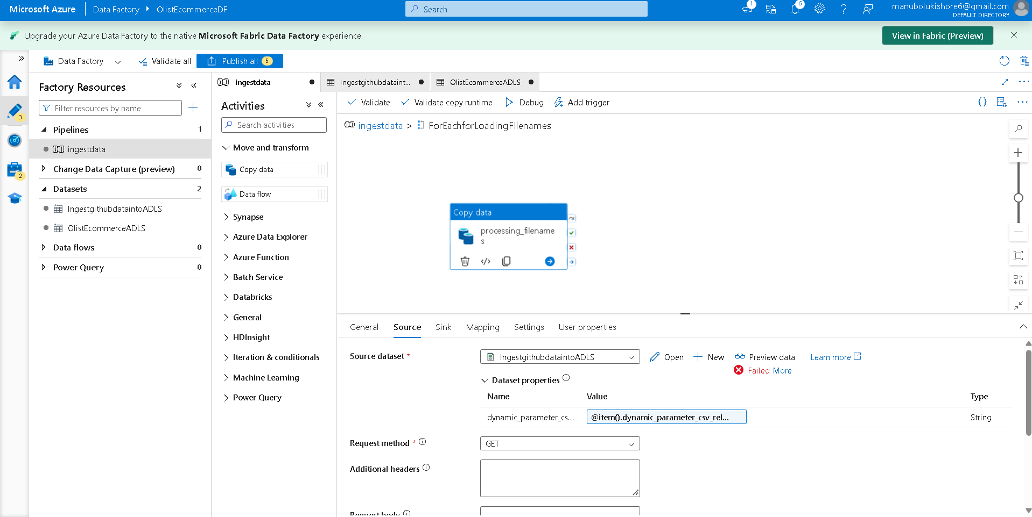
Sink:
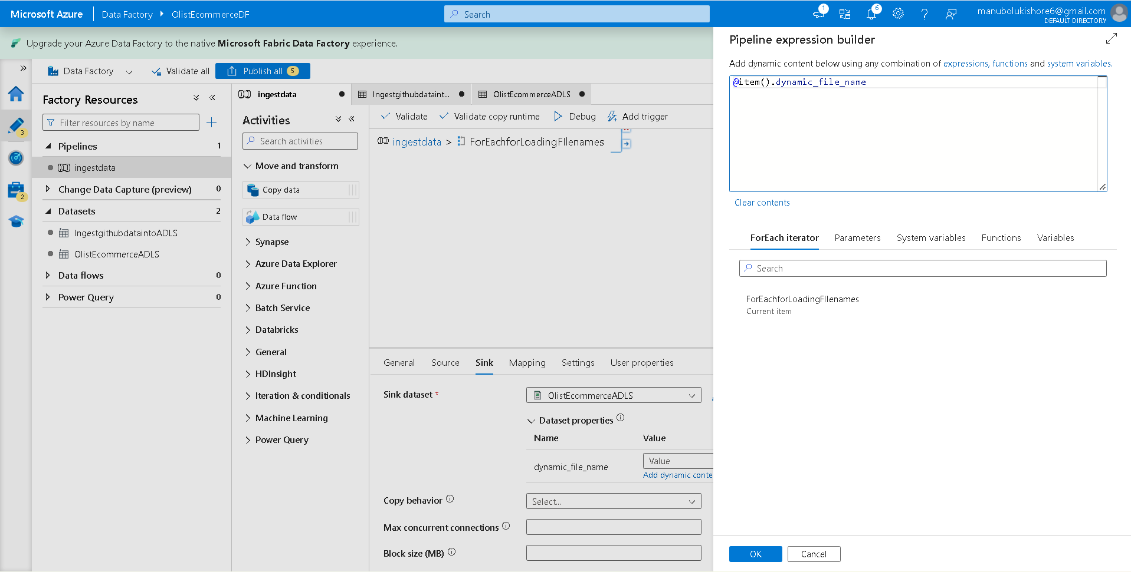
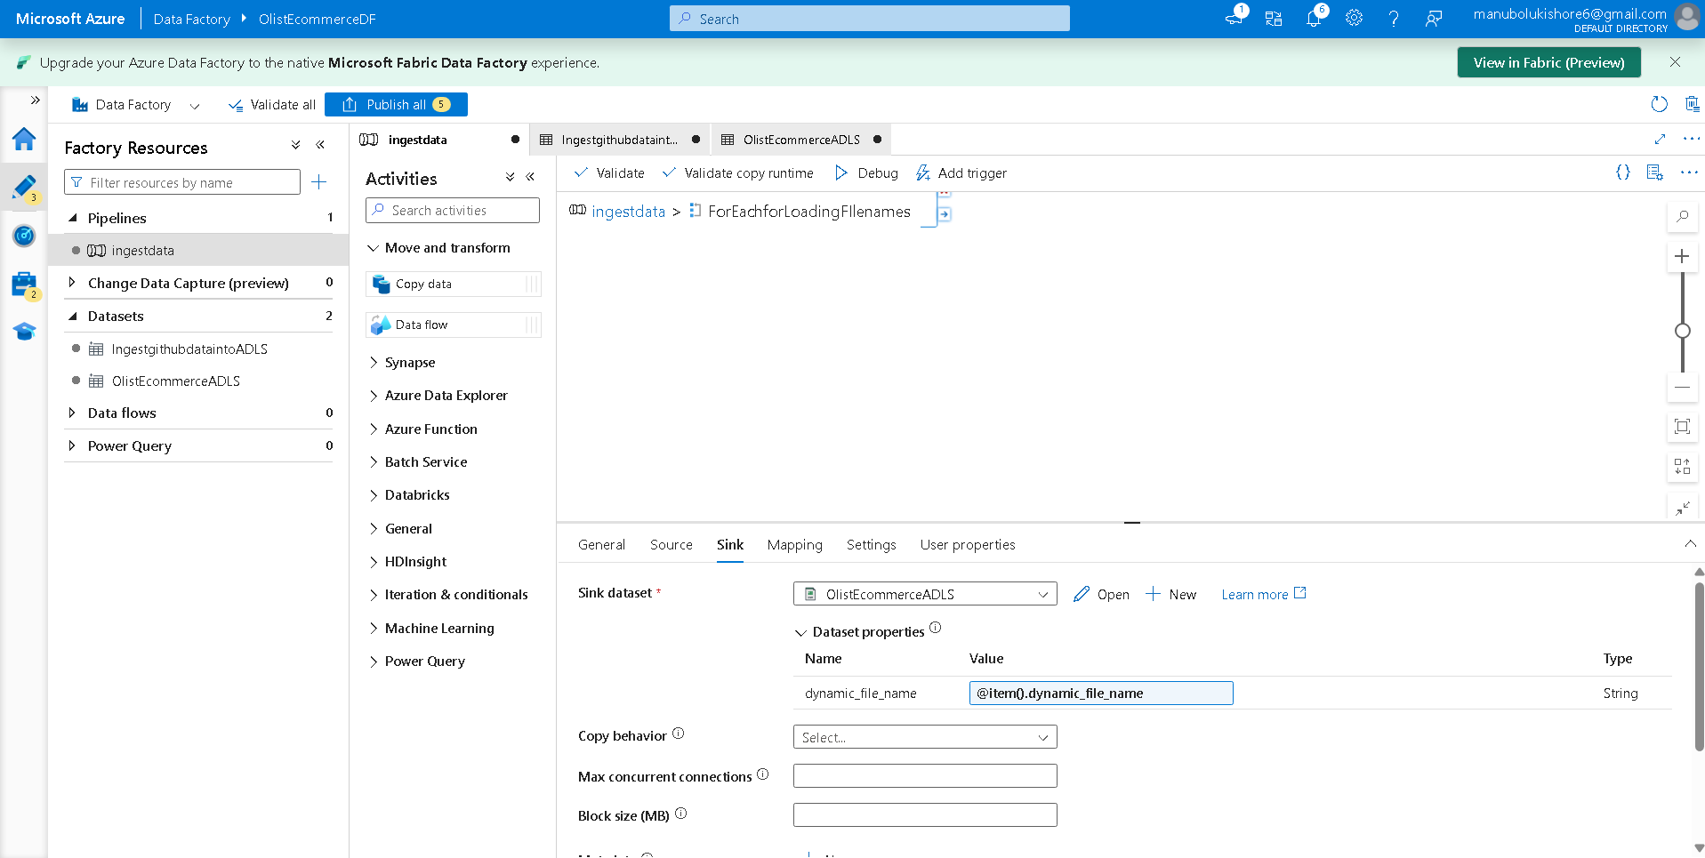
-> validate foreach iterator fuctionality
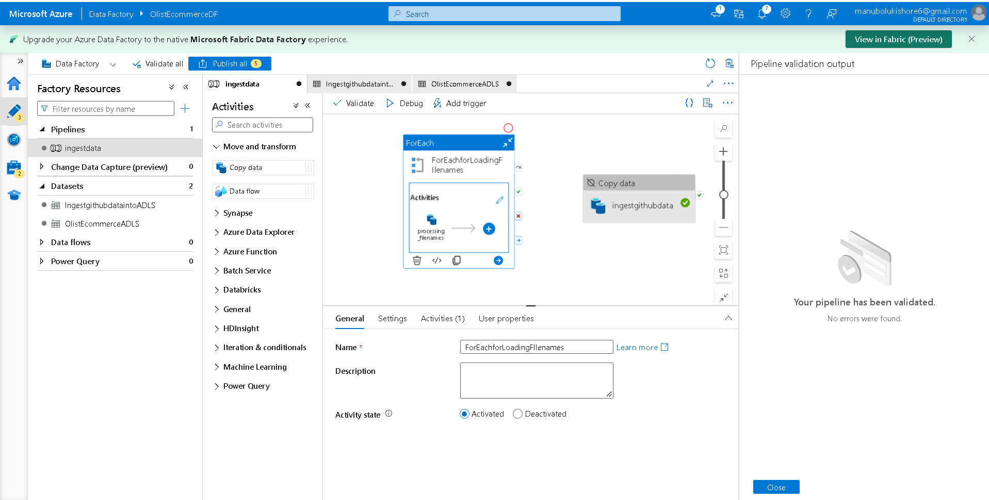
-> validation successful, so foreach iterator configured correctly.
--------------------------------------------------
---> setup activity task inside pipeline editor to connect mysql db of filess.io and ingest data into pipeline
Flow: create new activity by drag and drop copydata into pipeline -> named as “MySQL_DB_Data_Loading”
Setup Source: link created linked service MySQLOlistEcommercePaymentsLoadingService and MySql table as brazilian_olist_ecommerce_order_payments
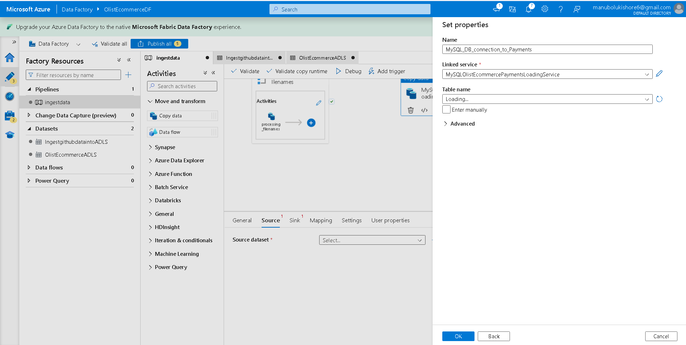
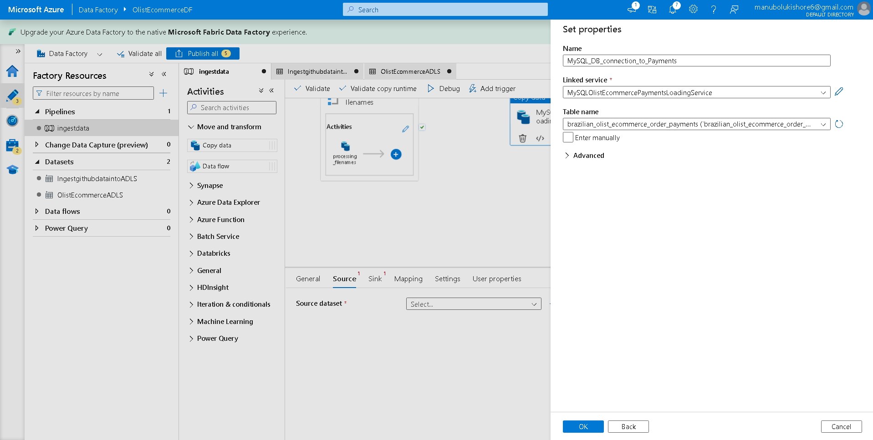
----------------------------------
Setup Sink:
Flow: Sink -> + New -> New Dataset -> Azure Data Lake Storage Gen2 ->select format -> Delimited Text -> Set Properties -> provide name “MySQL_to_ADLS “ -> linked service -> + New -> New Linked Service -> create
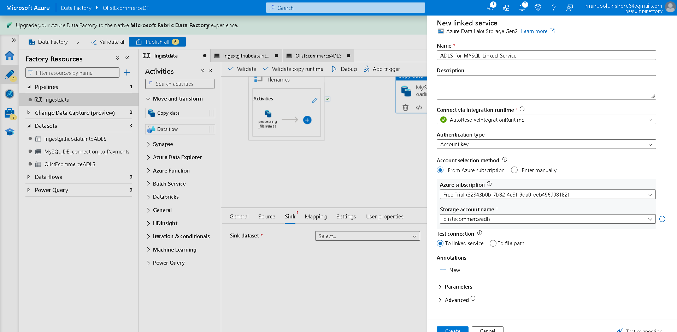
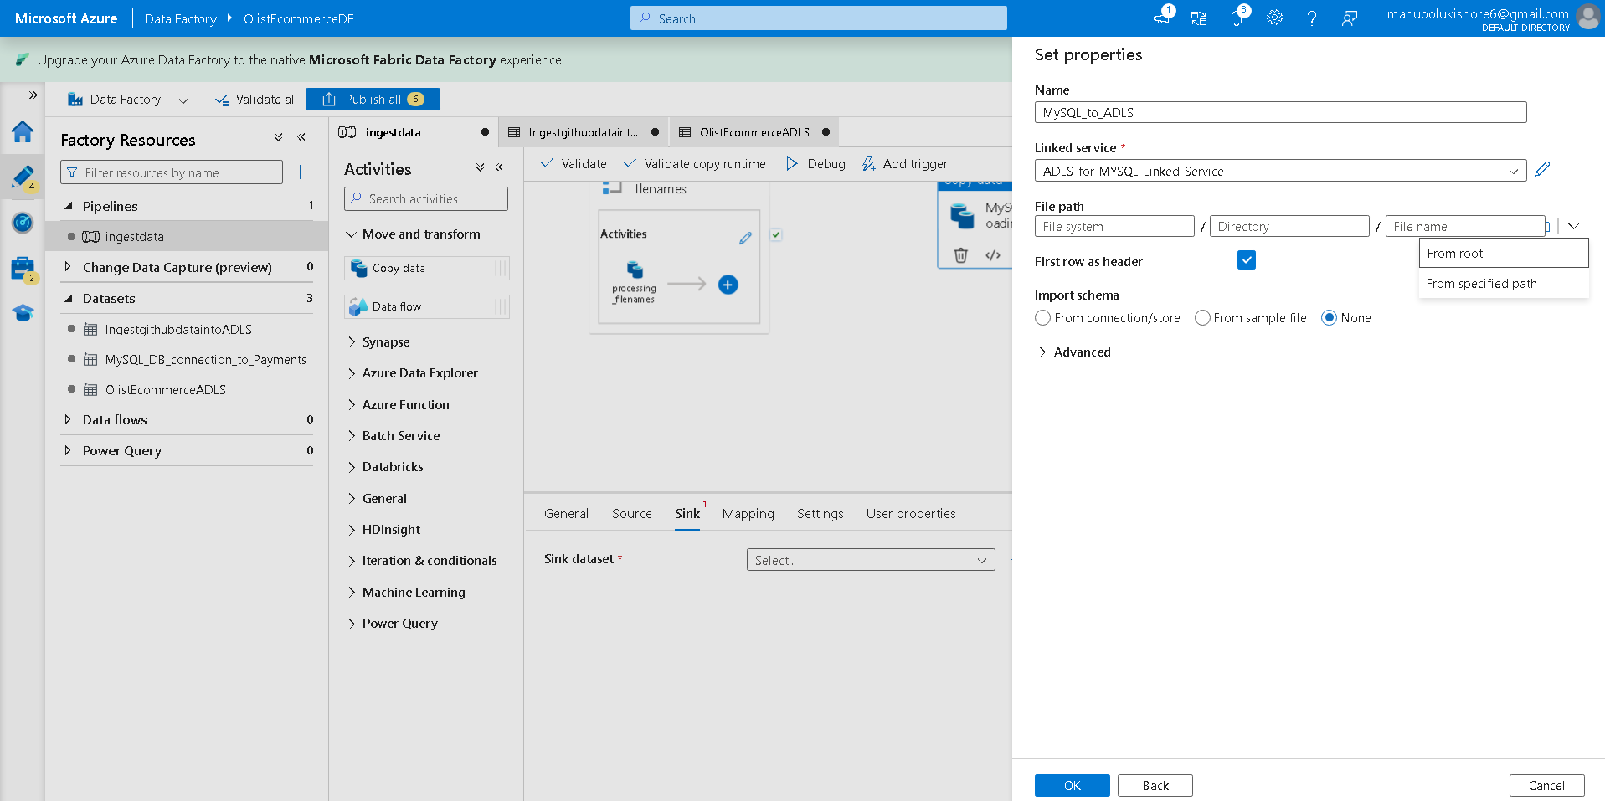
-> configure file path using From specific path ->
olistecommercecontainer/Bronze then mention file name as olist_order_payments_dataset.csv -> import schema as None -> ok
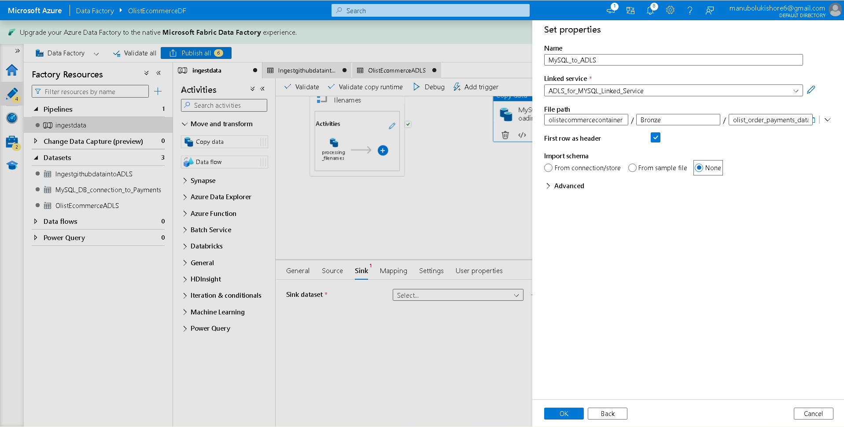
-> connect foreach task and copy data on success case

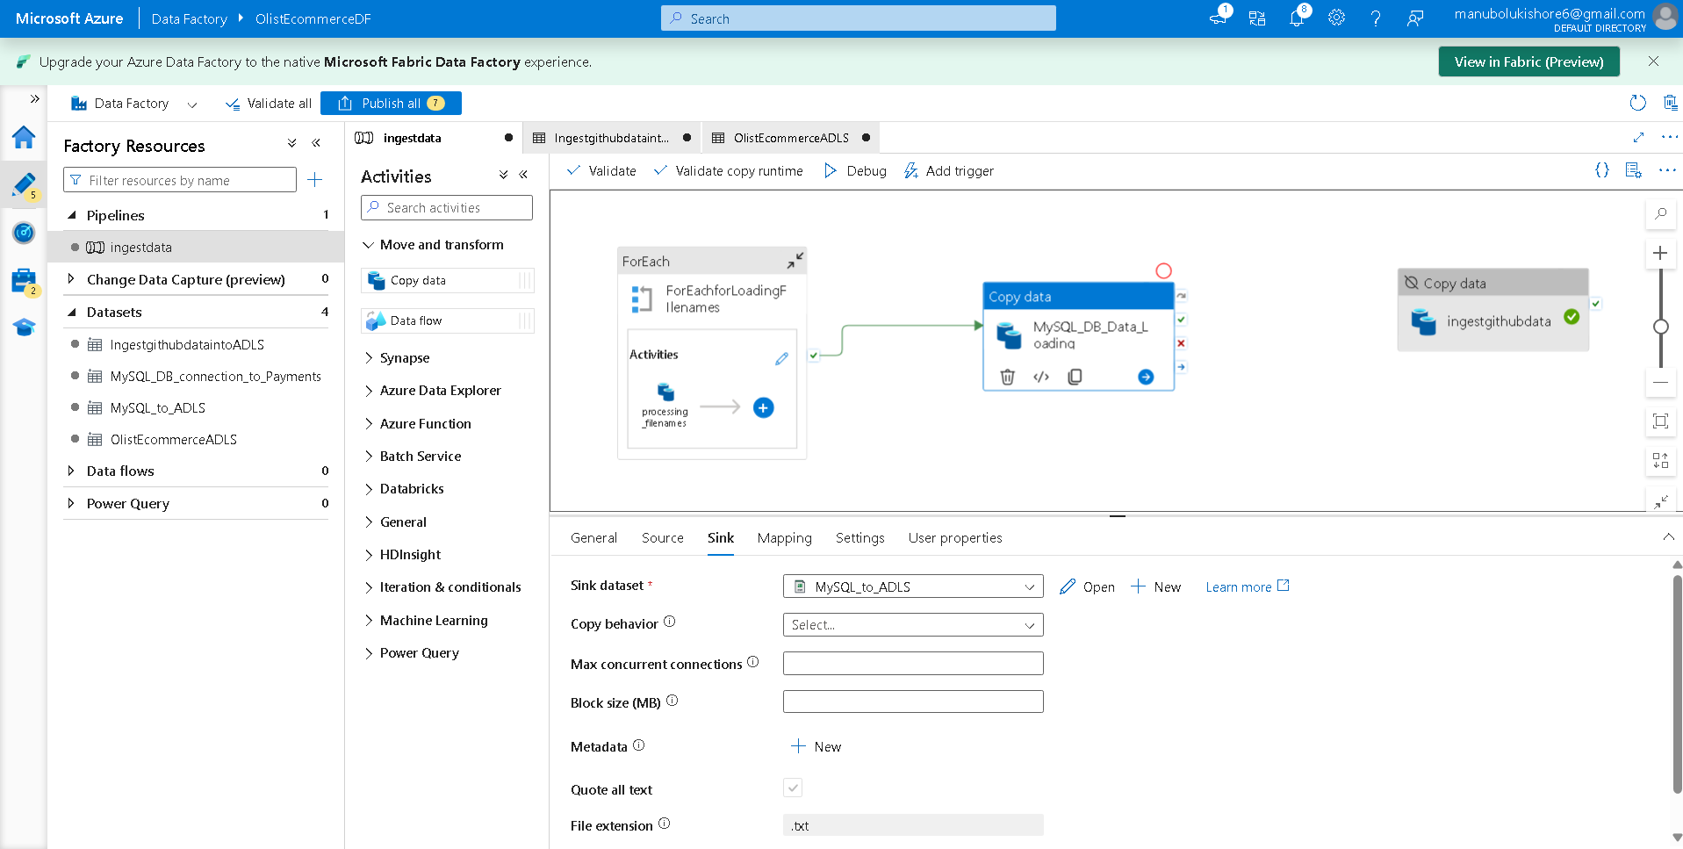
-> validate the pipeline -> validation successful
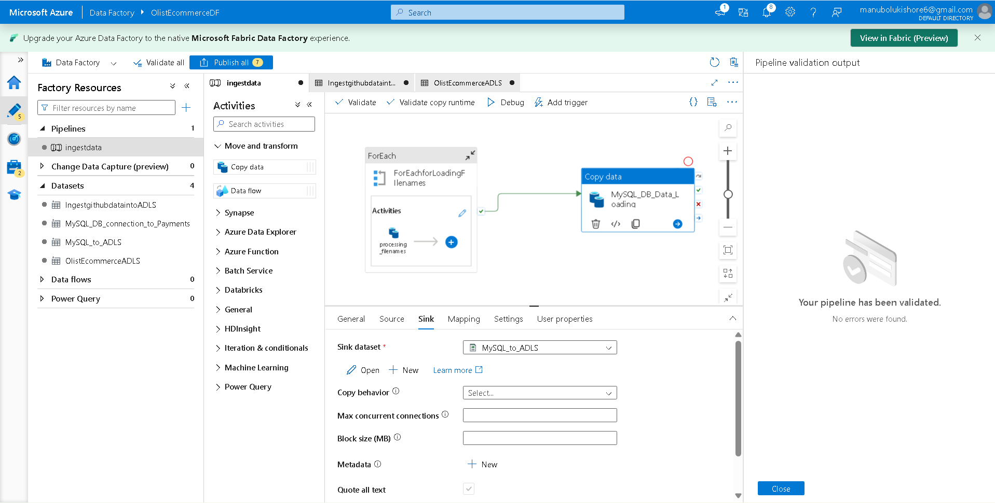
----------------------------
-> running the pipeline to verify setup functionality using debug option -> Pipeline run console with input array data -> ok
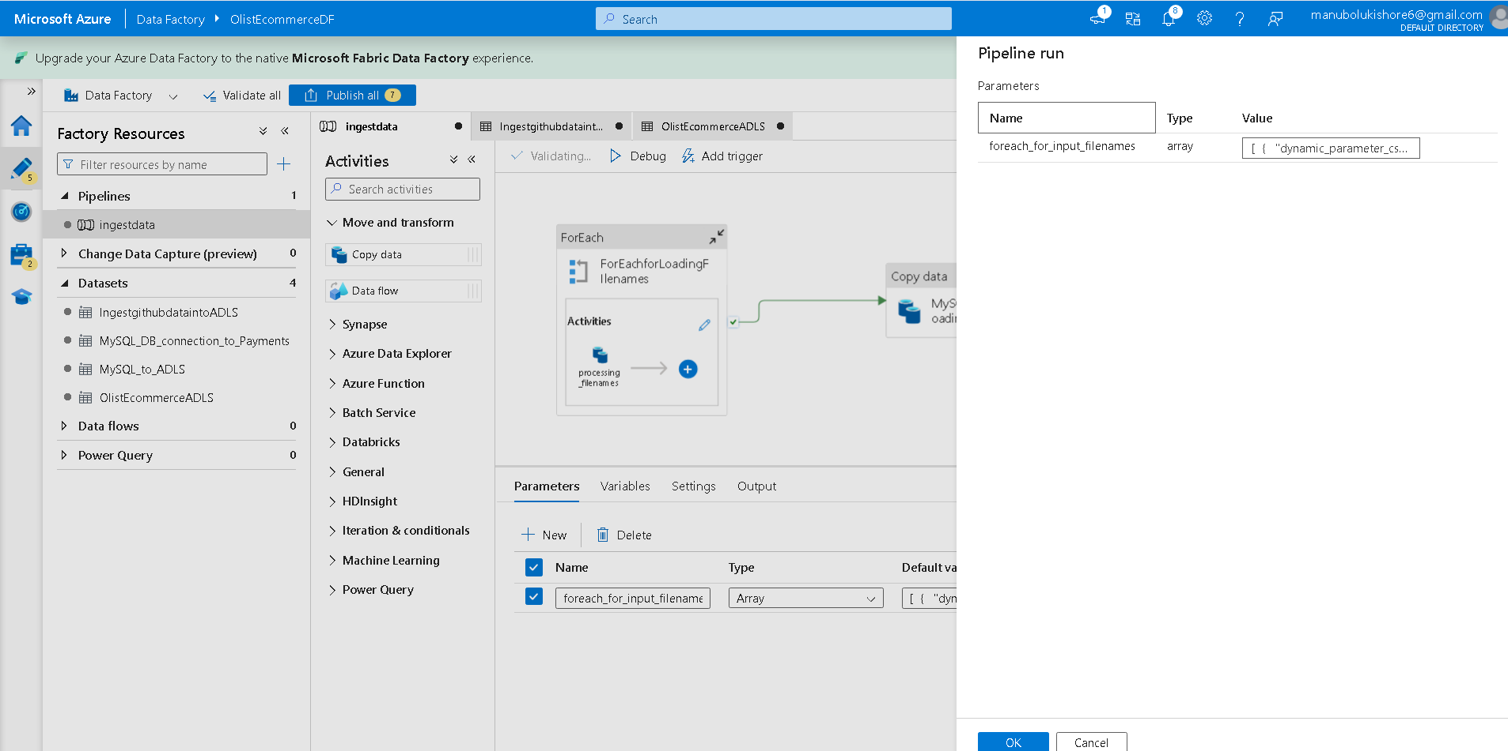
InProgress/Queued case:
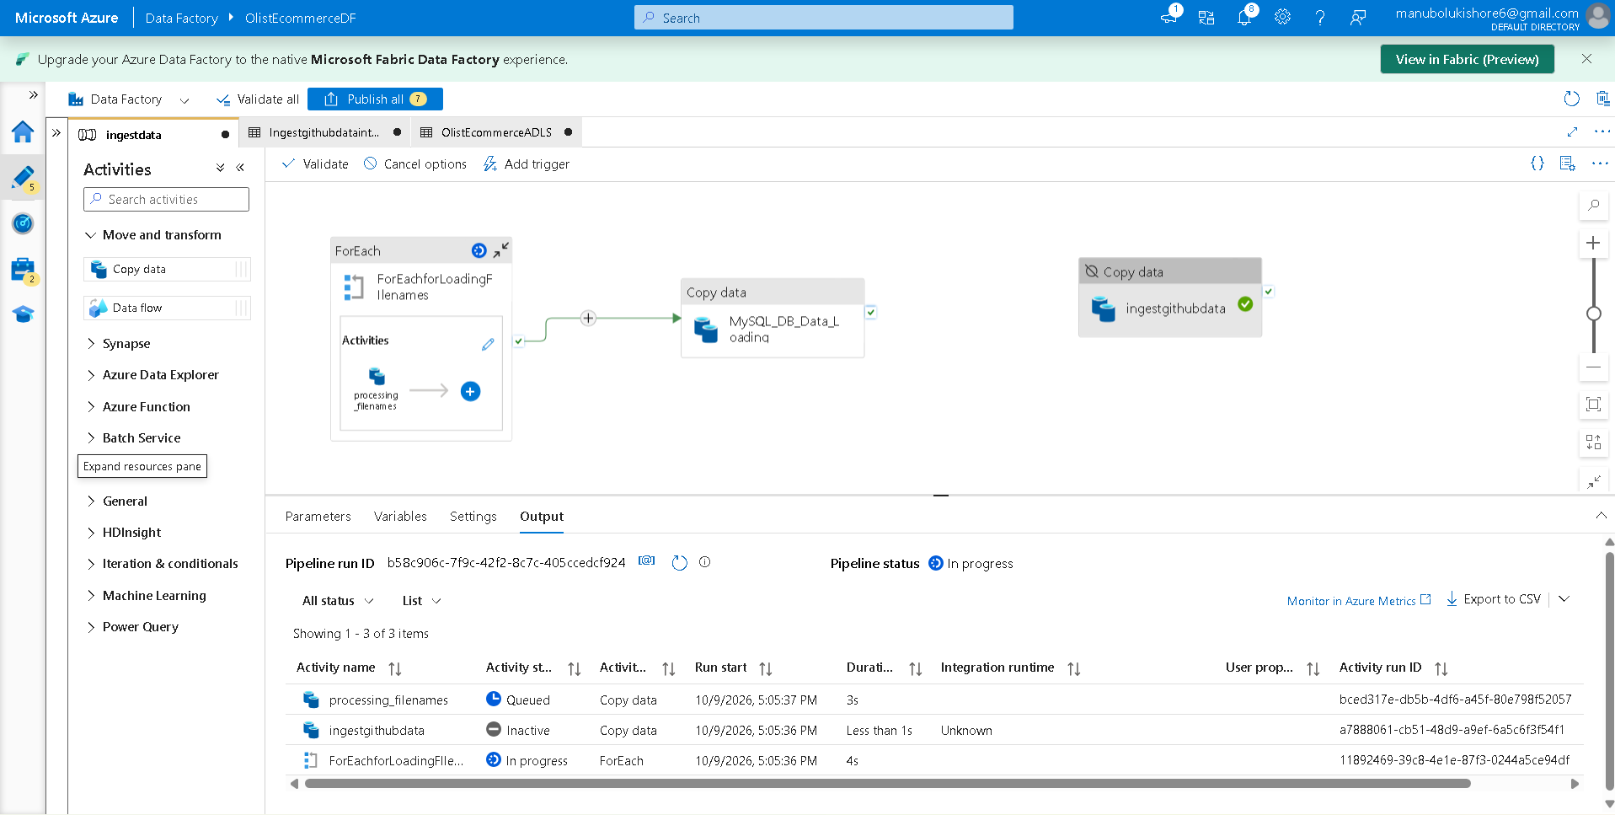
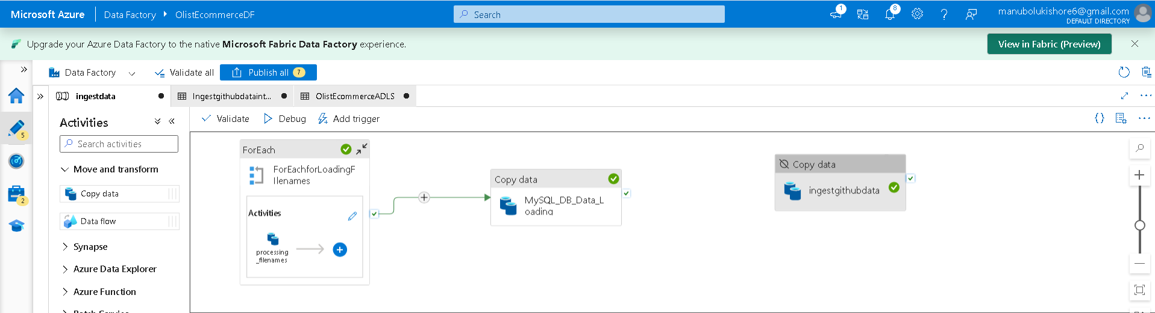
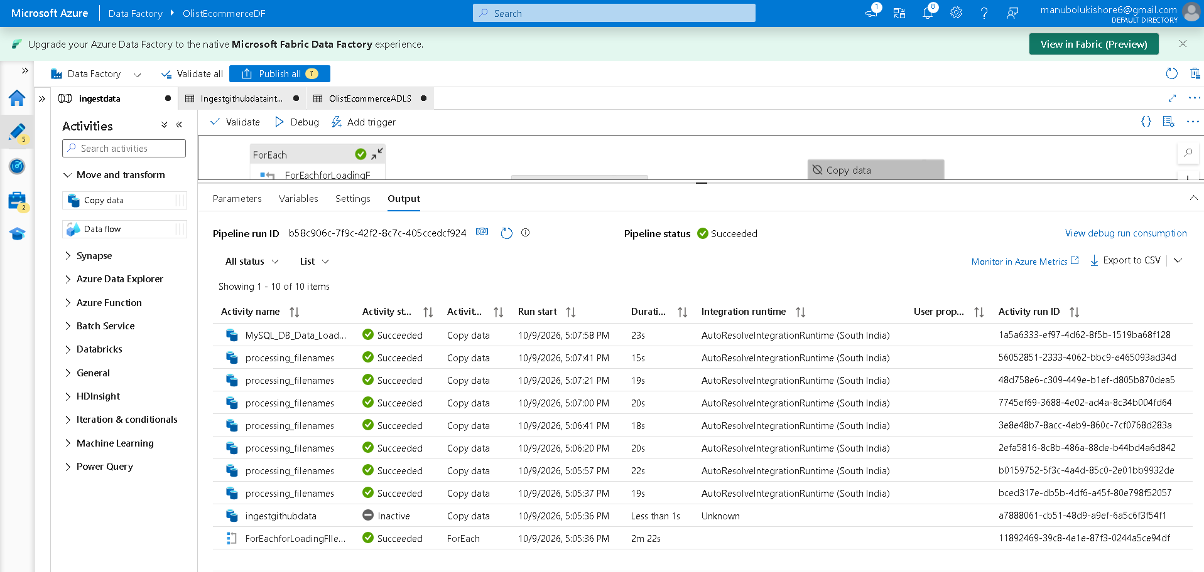
--> verify csv files and mysql db table loaded into ADLS storage container in azure
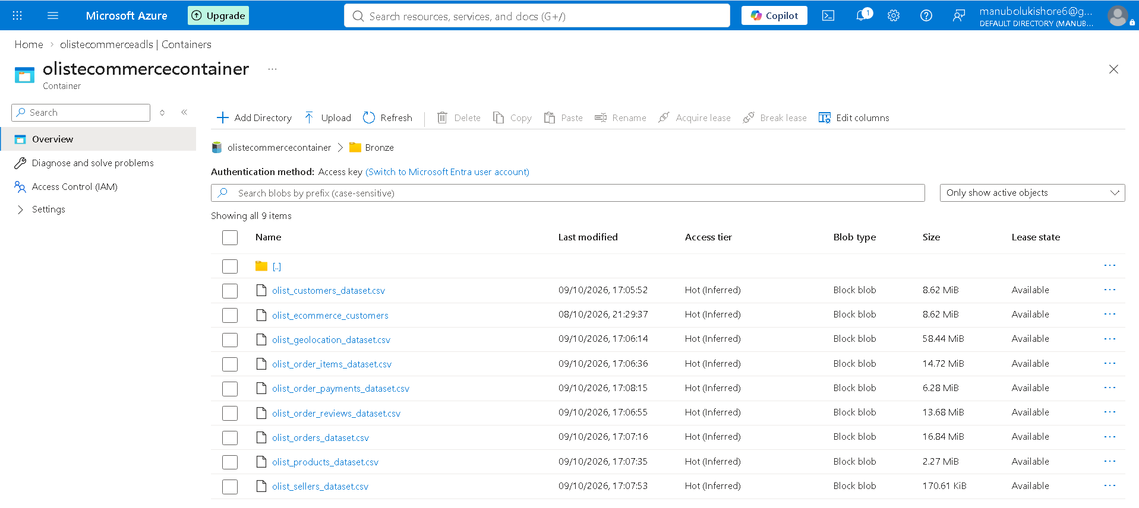
--> verify MySQL_DB_Data_Loading task preview data option
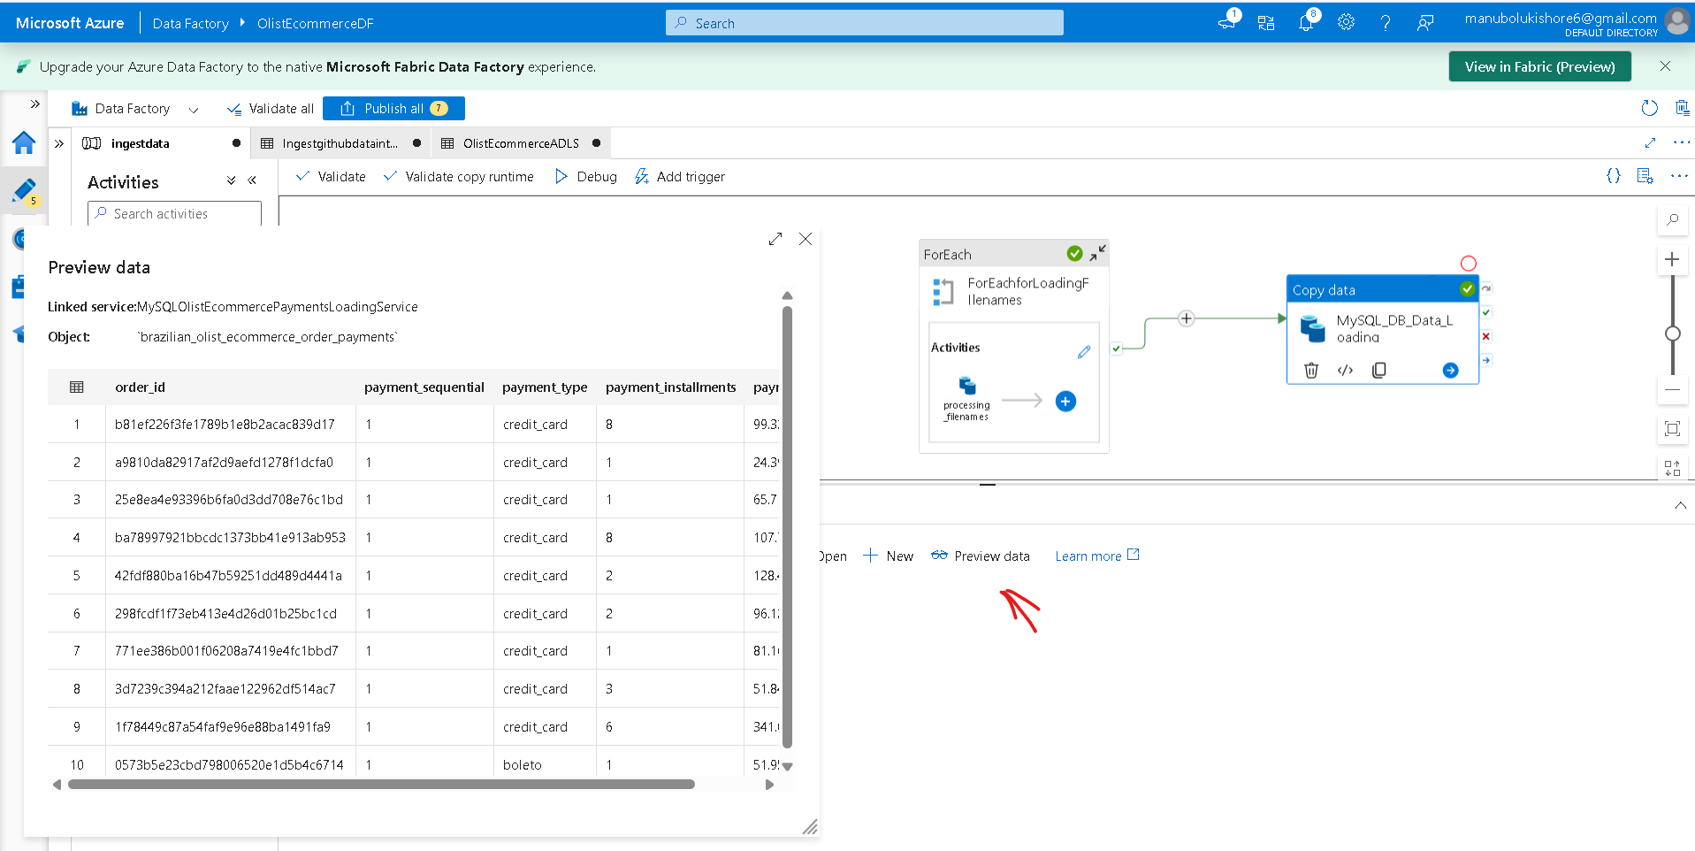
-----------------------------------------------------------

---> How to Activate/Deactivate the pipeline task which not consider for execution when pipeline running?
Flow: azure data factory home -> author -> factory resources -> pipelines -> activities -> select specific task to deactivate (ingestgithubdata) -> General -> Activity state -> Activated/Deactivated
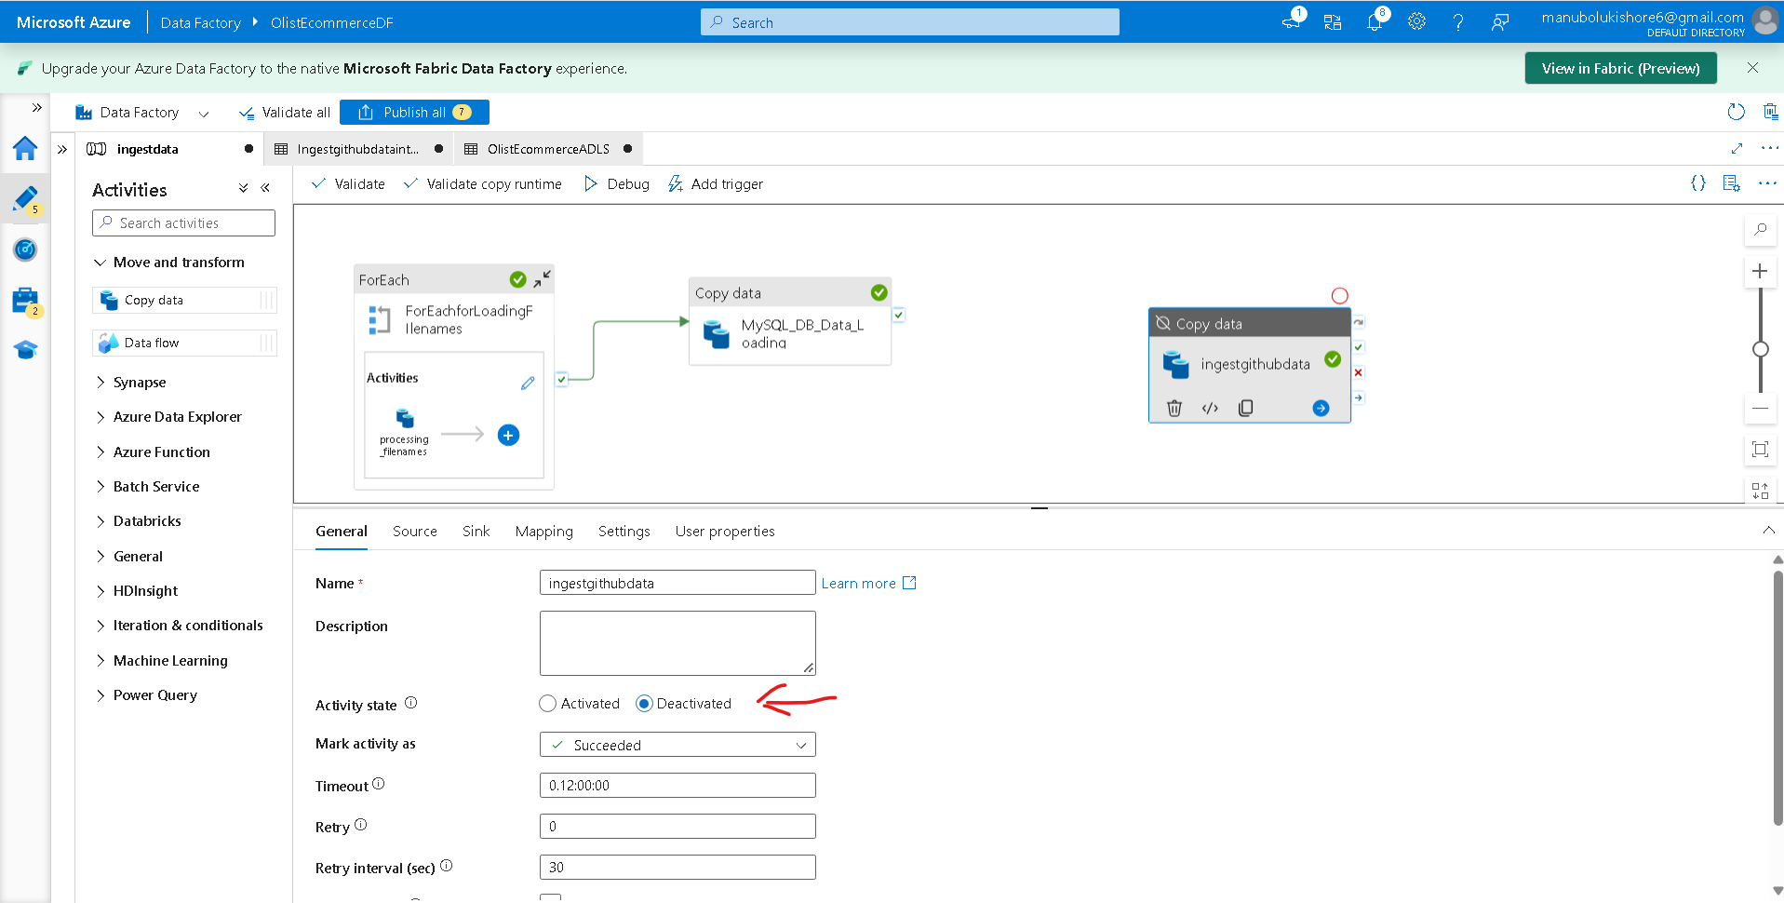
---------------------------------------------------------------------------------------------------------------
=> Parametrized Ingestion with ADF
url for inputfilenames.json: https://raw.githubusercontent.com/Kishore-M6/Resource_Datasets_of_Brazilian_E-Commerce_Public_Dataset_by_Olist/refs/heads/main/inputfilenames.json
Step-1: deactivate foreach loop and copydata for mysql activities
Step-2:
Flow: Activities -> general -> Lookup

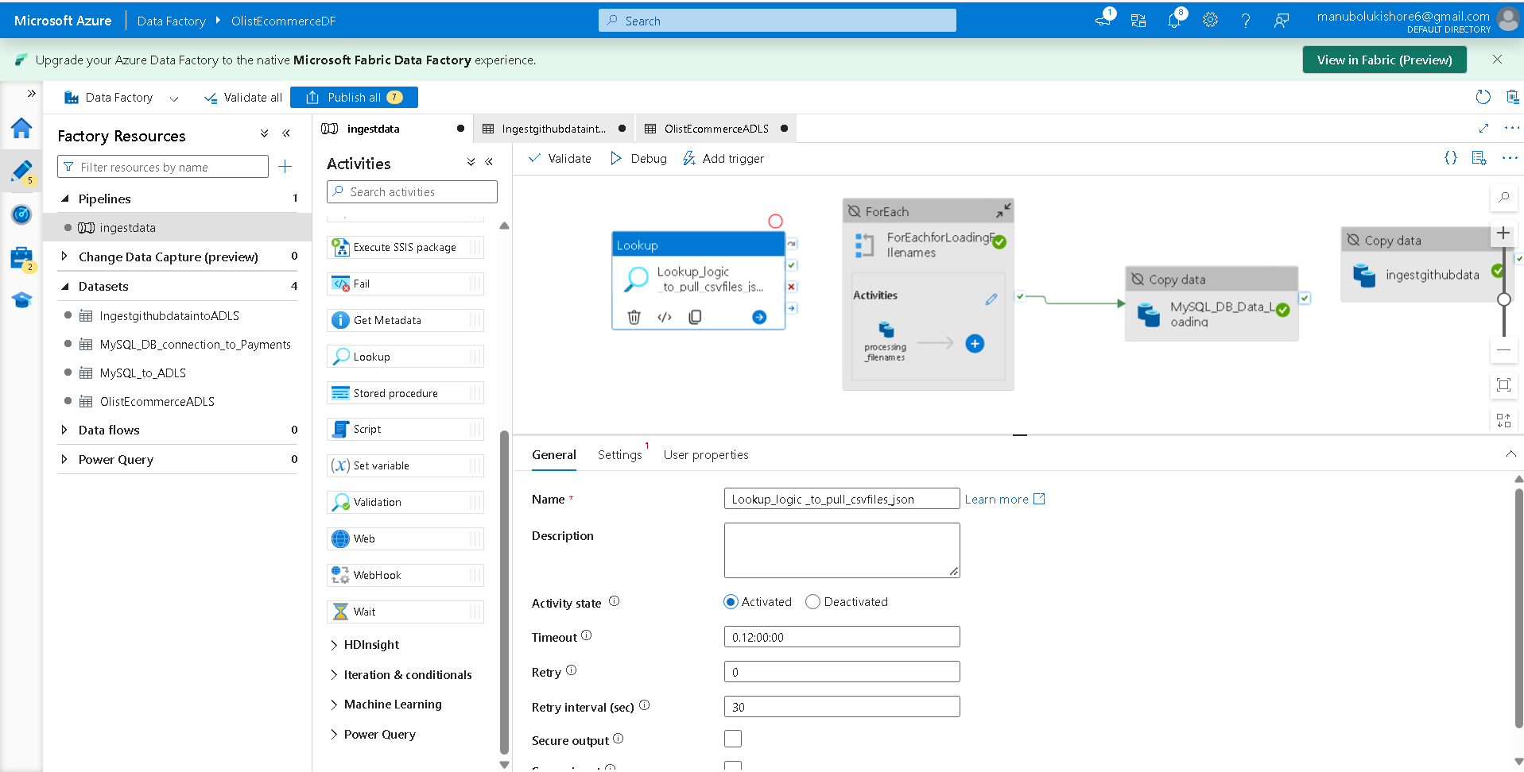
->settings -> Source dataset -> + New -> New Dataset -> HTTP -> select format -> Json -> Set Properties(Read_Json_file_to_load_data) -> Linked Service -> + New -> specify json file url of github
-> validate Lookup activity
-> disable checkbox First row Only
-> debug by passing previous foreachloop input array data
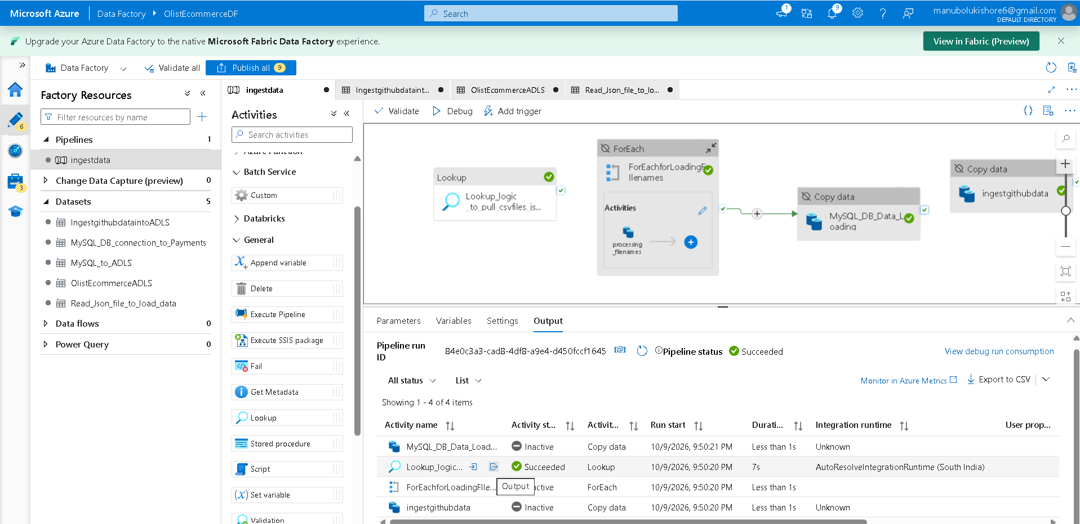
-> click “output” hyperlink to view output of activity execution
Step-3: Activate ForEach loop and MySql CopyData activity to integrate Lookup activity output into ForEach loop as input parameter
Flow: delete Parameter foreach_for_input_filenames with value as plain text array of filenames
-> connect the activities Lookup and foreach loop -> settings -> items -> Add dynamic content [Alt+Shift+D]
-> choose Lookup activity output and use .value to pass all json filenames -> ok
Step-4: delete all csv files inside azure ADLS container to rerun the pipeline
Step-5: validate pipeline -> debug (this time it won.t show any input data console to be passed)
Step-6: Publish all pipelines
-> publish -> Publish successful
----------------------------------------------------------------------------------------------------
=> Azure Databricks Account Creation
--------------------------------------------------------------------------------------------------
=> Azure Databricks Overview
Flow: Azure Home -> search for Azure Databricks -> + create -> Create an Azure Databricks workspace

-> click on Launch Workspace

=> Azure Databricks UI Overview & 18. Creating Compute and Notebook
--> creating compute for hardware resources to run databricks
Flow: Databricks Home -> compute -> Compute - All-purpose -> create compute -> create
-> go into resource -> select Event Log to view resource creation logs
---------------------------------------------------------------------------------------------------
=> MongoDB ingestion to Databricks
--> refer google colab notebook file Extract_CSV_File_ and_Inject_Data_into_MySQL_and_MongoDB_Database.ipynb
---> Connecting Mongo Db created within Filess.io server build python databse connectivity logic to load product_category_name_translation.csv file data into a table.
-> after successful data insertion into mongodb
Note: we can use official Mongo DB database also . here we can use free trail account to create MongoDb database instead of using Filess.io third party server
url: https://www.mongodb.com/
--------------------------------------------------------------------------------------------------------
=> Azure Databricks Workflow Overview
1. Read data from ADLS Gen 2
2. Perform basic transformation like cleaning, renaming & filtering
3. Use join operation to integrate multiple dataset
4. Enrich the data via MongoDB.
5. Perform aggregation & derive insights
6. Write final data back to ADLS Gen 2.
--------------------------------------------------------------------------------------------------------
=> ADLS Gen2 Datalake to Databricks Connection
url: https://learn.microsoft.com/en-us/azure/databricks/archive/storage/tutorial-azure-storage
--> create notebook file inside databricks workspace Olist_Ecommerce_Transition_Phase.ipynb
Step-1: Microsoft Entra Id App registration
Flow-1: Azure Home -> Menu-> Microsoft Entra ID -> Manage -> App registrations -> + New Registration ->register
Flow-2: Azure Home -> search -> app registrations -> App Registrations -> + New Registarion -> register
Step 2: Create a client secret for your service principal
Flow :
- In Manage, click Certificates & secrets.
- On the Client secrets tab, click New client secret.
- In the Add a client secret pane, for Description, enter a description for the client secret.
- For Expires, select an expiry time period for the client secret, and then click Add.
- Copy and store the client secret's Value in a secure place, as this client secret is the password for your application.
- On the application page's Overview page, in the Essentials section, copy the following values:
  - Application (client) ID
  - Directory (tenant) ID
Step-8: Grant your Azure Databricks workspace access to Azure Data Lake Storage
--> Providing Access Control to ADLS
Flow: azure home -> storage accounts -> specific storage account (olistecommerceadls) -> Data Storage -> containers -> choose olistecommercecontainer -> Access Control (IAM) -> + Add -> Add Role Assignment
-> for Role choose Storage Blob Contributor
-> select members -> search with app registration name to select it as members
-> select -> next -> next -> Review + assign
----> verify role assigned successfully or not ?
Flow: Containers console -> Access Control(IAM) -> Role Assignments
- ---> run below code block located within notebook file Olist_Ecommerce_Transition_Phase of Databricks workspace Azure_Databricks_Olist_Ecommerce_Workspace_to_work_on_Spark . then Azure Databricks connect to Azure Data Lake Storage.

-> create dataframe to load and read csv file from ADLS container

Note:
---> abfss stands for Azure Blob File System Storage
---> dfs stands for Distributed File System
-------------------------------------
--->Accessing SparkUI about spark jobs and stages
Flow: Compute -> specific computename (Olist_Ecommerce_Compute_Resource) -> Spark UI
==================================================================================
=>Data Enrichment
--------------------------------------------------------------------------------
=> Accessing Data in Databricks
----------------------------------------------------------------------------------
=> Read Data in Databricks
-> create code blocks to create Dataframes out of all files load and read
---------------------------------------------------------------------------------
= Spark Transformation
----------------------------------------------------------------------------------
=> Mongo DB data for Enrichment
--> Installing Third Party Library into notebook environment using compute resource Library button in Databricks workspace
Flow: Databricks workspace home -> compute -> specific compute (
Olist_Ecommerce_Compute_Resource) -> Libraries -> Install New
-> PyPi -> package= pymongo & Index URL= Optional -> install
---------------------------------------------------------------------------------
=> Data Cleaning
---------------------------------------------------------------------------------
=> Extracting Insights from Data
---------------------------------------------------------------------------------
=> Spark - Transformation vs Action

--------------------------------------------------------------------------------------
=> Joining Data
-------------------------------------------------------------------------------------
=> Enriching Data via MongoDB
-----------------------------------------------------------------------------------
=> Visualizing Data in Databricks
--> creating visualization reports or insights
Flow: Databricks Home -> Notebook file code block display(joined_df) -> Result -> + -> Visualization/Data Profile -> Visulaization -> configure -> save
-> when we ran display(joined_df) where we configured Vizualization configuration.
---> X-axis: customer_id , Y-axis: order_id, condition: count, group_by : order_delivered_customer_date
--> view Data Profile result
Flow: Click on + -> Data Profile
--------------------------------------------------------------------------------------------------
12. Exporting Data to Silver Layer
--> after export data to Silver layer of container
------------------------------------------------------------------------------------------------------------
13. Azure Synapse Overview and Account Creation
Flow: Azure Home -> Azure Synapse Analytics -> + Create
-> configured security credentials for Azure Synapse Analytics Workspace
Kishore’s workspace :
username: olistadminuser
pwd: Admin@123

Dinesh’s workspace :
username : olistusersql
pwd: User@123
-> next -> tags -> Review & create -> Create

------------------------------------------------------------------------------------------
=> Synapse UI Overview
---> open Azure Synapse Analytics Workspace
Flow: Azure Home -> search bar -> Azure Synapse Analytics -> choose specific analytics workspace listed (olist-ecommerce-synapse-analytics) ->
-> click open hyperlink Open Synapse Studio ->
----------------------------------------------------------------------------------------------
=> Synapse To Lake Access
---> Assign Role to azure synapse for accessing data Lake olistecommerceadls/olistecommercecontainer:
Flow: Azure Home -> storage accounts -> azure synapse analytics specific storage account (olistsynapseanalytics) -> Data storage -> containers -> specific container created (olistsynapseanalyticscontainers) -> Access Control (IAM) -> + Add -> Add Role Assignment
---> Default Roles Exist :
---> assign Storage Blob Data Contributor role to azure synapse analytics workspace which connects to ADLS data lake
Flow: choose -> Managed Identity
-> choose olist-ecommerce-synapse-analytics -> select ->
-> choose User, group, or service principal -> select default user /specific user to assign role
-> click Review + Assign
------------------------------------------------------------------------------------------------------
=> SQL Pool - Dedicated vs Serverless
Serverless SQL Pool
- Resource Management: Operates entirely on demand. There is no need to set up or manage servers; resources spin up automatically only when they are needed.
- Pricing Model: Follows a pay-as-you-go structure where you only pay for the specific queries executed.
- Ideal Use Cases: Best suited for occasionally running queries or exploring large datasets (e.g., previewing data in a silver layer or performing basic joins).
- Data Location: Data is not loaded into a separate database; it remains in the data lake (ADLS Gen2) and is queried directly from there.
- Setup Complexity: Very easy to configure with minimal setup required.
Dedicated SQL Pool
- Resource Management: Reserves fixed compute resources that are always available, functioning much like buying and maintaining physical computers.
- Pricing Model: You pay a fixed cost for the reserved compute capacity, regardless of whether you are actively running queries.
- Ideal Use Cases: Best for big data workloads that require consistently fast performance, heavy processing, and predictable speeds.
- Data Location: Data must be actively loaded and stored directly within the dedicated SQL database in Synapse.
- Setup Complexity: Requires more complex configuration, as you must define the specific level of compute resources needed.
---------------------------------------------------------------------------------------------------------------
=> Access Lake Data
-> create workspace to run SQL queries to query the data lake:
Flow: Azure Synapse Analytics Workspace -> Develop -> + -> SQL Script ->
--> uploading sample file to generate sql query for SQL script:
Flow: Azure Synapse Analytics workspace -> Data -> Linked -> Azure Data Lake Storage Gen2 -> olist-ecommerce-synapse-analytics -> WorkspaceDefaultStorage Account name: Primary – olistsynapseanalytics ->
-> upload sample file Customers_1MB .csv -> upload -> New SQL script -> select top 100 rows ->
---> modifying the generated sql pool query to work on olist_ecommerce data lake:
Step-1:Create Serverless Database for ASA workspace
Flow: ASA workspace -> Data -> SQL Database -> choosed olist_asa_db -> create
Step-2: Modifying/Generating Query to query olist lake data
--> create Sql pool query script file:
Flow: ASA Workspace home-> Develop -> SQL scripts -> + -> SQL script -> mention file name as (olist_asa_sql_script)
Case-1: Databricks code contains .format(“delta”) in write operation
Databricks code (Kishore’s workspace ):
# Write joined_df to Silver folder in Azure Storage Account
silver_path = "abfss://olistecommercecontainer@olistecommerceadls.dfs.core.windows.net/Silver/joined_data"
# Remove existing non-Delta (Parquet) files at the path to avoid format conflict
dbutils.fs.rm(silver_path, True)
joined_df.write.format("delta").mode("overwrite").save(silver_path)
print(f"Data successfully written to: {silver_path}")

SQL Script code :
SELECT
TOP 100 *
FROM
OPENROWSET(
BULK 'https://olistecommerceadls.dfs.core.windows.net/olistecommercecontainer/Silver/joined_data/',
FORMAT = 'DELTA'
) AS RESULT1
-> to view bar charts -> click chart option
Case-2: Databricks code contains .format(“delta”) in write operation
Databricks code (Dinesh’s workspace ):
joined_df.write.mode("overwrite").parquet("abfss://olistcontainers@storagelive1.dfs.core.windows.net/silver/joined_df")
SQL Script code :
SELECT
TOP 100 *
FROM
OPENROWSET(
BULK 'https://storagelive1.dfs.core.windows.net/olistcontainers/silver/joined_df/',
FORMAT = 'PARQUET'
) AS result1
----------------------------------------------------------------------------
---> we can get url of blob case from containers console

Note: url link for OPENROWSET api documentation to work with sql pool and queries in azure synapse analytics
https://learn.microsoft.com/en-us/sql/t-sql/functions/openrowset-transact-sql?view=sql-server-ver17
-------------------------------------------------------------------------------------------
=> Create Gold View and Schema
--> create views to explore data as faster and perform read operations on view in SQL Pool script:
--> view gold.final select query result:
--> view gold.final_orderstatus result:
-------------------------------------------------------------------------------------------

19. Azure Synapse Workflow
Core Architecture Concepts
- Lakehouse Model: Utilizes a Medallion architecture structure consisting of Bronze, Silver, and Gold layers, combining data lake storage with data warehouse querying capabilities.
- Storage Separation: Data is not physically stored within the SQL engine. The SQL pool only stores metadata and queries, maintaining a reference to the actual files.
Querying the Silver Layer (Serverless SQL Pool)
- Serverless SQL Pool: Created specifically for reading and querying data on demand without storing a physical copy in a database.
- Security & Setup: Requires creating a database schema, followed by configuring a dedicated username and password for secure access.
- Using OPENROWSET: This function is utilized to read data directly from the Silver layer. It acts strictly as a reference to the underlying files.
- Creating Views: Logical views (e.g., final, final_two) are created on top of the OPENROWSET queries to simplify data reading and abstract the complex query logic.
Migrating Data to the Gold Layer (Serving Layer)
- Migration Objective: Move processed data (from the Silver layer views) into the Gold layer so it can be served to end-users and downstream applications.
- Input Specifications: The source data read from the Silver layer is in Parquet format.
- Output Configuration: Writing to the Gold layer requires specifying the exact destination path, the desired output format, and the source of the output.
- CETAS (CREATE EXTERNAL TABLE AS SELECT):
  - The primary command used for this data migration.
  - Unlike standard views which are just logical queries, CETAS executes a SELECT statement and materializes the results into physical external tables.
  - These resulting physical tables are stored securely inside the Data Lake's Gold layer, making the finalized data accessible for broad querying and reporting.
----------------------------------------------------------------------------------------------
=> CETAS (Create External Table As Select) Understanding
Documentation url:
https://learn.microsoft.com/en-us/azure/synapse-analytics/sql/develop-tables-cetas
---------------------------------------------------------------------------------------------
=> Create External Serving Table in Gold
--->Example Syntax code from documentation:
Note: Drop command SQL queries documentation
Drop Master Key SQL command documentation:
https://learn.microsoft.com/en-us/sql/t-sql/statements/drop-master-key-transact-sql?view=sql-server-ver17
Drop External File SQL command documentation:
https://learn.microsoft.com/en-us/sql/t-sql/statements/drop-external-file-format-transact-sql?view=sql-server-ver17
Drop External Data Source command documentation:
https://learn.microsoft.com/en-us/sql/t-sql/statements/drop-external-data-source-transact-sql?view=sql-server-ver17
Drop External Table command documentation:
https://learn.microsoft.com/en-us/sql/t-sql/statements/drop-external-table-transact-sql?view=sql-server-ver17
---> query to create master key credentials and view database credentials:
--> verify data migrated or not :
---> in azure ADLS container :
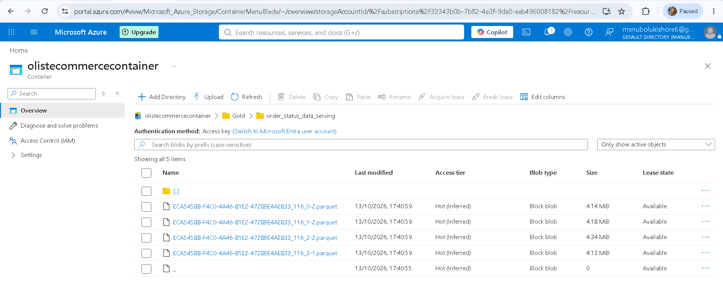
--------------------------------------------------------------------------------------------
=> Visualization Flow
-> Connecting Tableau for Data Visualization:
Step-1: sign up tableau account then create new connection
-> search Azure Synapse Analytics
-> connection console to configure connection details
-> Azure Synapse analytics workspace configuration
---> documentation for Integrate Tableau with Azure SQL Synapse Analytics:
url: https://help.tableau.com/current/pro/desktop/en-us/examples_azure_sql_dw.htm
--> connecting serverless sql pool endpoint with username:olistadminuser password : Admin@123
---> After successful connection:
-> select olist_asa_db to view all azure synapse datasource sql tables
---> connect final_olist_business_data_table (gold.final_olist_business_data_table) to view visualization
-> click on publish -> provide name for connection (tableu_olist_connection)-> select schema (default/External Assets Default Project/Samples) choosed default -> publish
Step-2: Create Tableau workbook to create Tableau Workspace environment for visualization flows of data
Flow: Tableau Home -> Explore
-> default (because I choosed default schema) -> enable checkbox of tableu_olist_connection ->
New ->
-> workbook -> connect to data -> select virtual connection (tableu_olist_connection) -> connect
-> switch to sheet mode by click sheet 1 at bottom left corner -> Tableau workbook is ready to create visualizations
Step-3: create sample chart for data visualization
Usecase-1: This visualization will create a bar chart to identify which product categories are generating the most orders, using the columns visible in your connected dataset.
- Set the Axis: From the Data pane on the left side of your Worksheet, click and drag the Product Category Name field and drop it into the Rows shelf at the top of the screen. This creates a row for each category (e.g., bebes, utilidades_domesticas).
- Calculate the Metric: Drag the Order Id field and drop it into the Columns shelf.
- Change to an Aggregate: Since Order Id is a text field, Tableau might just try to list them. Right-click the Order Id pill in the Columns shelf, hover over Measure, and select Count (Distinct). This changes the visualization into a horizontal bar chart showing the total number of unique orders per category.
- Sort the Chart: Click the Sort Descending icon in the top toolbar (it looks like a bar chart with an arrow pointing down) to arrange your categories from highest order volume to lowest.

- Add Labels (Optional): To make the exact numbers visible on the chart, hold down the Ctrl key, click the CNT(Order Id) pill in your Columns shelf, and drag a copy of it onto the Label square inside the Marks card.

Usecase-2: filter your bar chart to show only the top 20 product categories by order volume.
1.Add the Category to Filters:Filters shelf.
From the Data pane on the left, drag the Product Category Name field and drop it into the Filters shelf (located just above the Marks card).
Verification: A Filter dialog box will immediately pop up on your screen.
2.Navigate to the Top settings:Top tab.
In the pop-up window, click on the Top tab located at the far right of the menu.
3.Configure the Top 20 condition:Filter criteria.
Click the radio button next to By field. Then, configure the drop-down menus in that row to read exactly like this: Top, 20, Order Id, and Count (Distinct).
4.Apply the filter:Apply.
Click OK at the bottom of the dialog box.
Verification: Your bar chart will instantly update, shrinking down to display exactly 10 bars representing your highest-performing categories.

